CSE, BUET
CSE-462 Algorithm Engineering Sessional
Offline 1

Name- Akib Ahmed
Student ID - 1305074
Subsection – 1
Date: 17/04/2018

Problem Definition:
The problem given in our offline is traditionally called Travelling Salesman Problem (TSP). This problem asks the following question: “Given a list of cities and the distances between each pair of cities, what is the shortest possible route that visits each city and returns to the origin city?” It is an NP-Hard problem, meaning there is no polynomial time algorithm for finding the optimal solution. In this offline, we are told to implement the problem in three different ways:
- Exact Exponential Method
- Branch and Bound Method and
- Greedy 2-Approximation Algorithm

Complexity Analysis:
- Exact Exponential Method: This method takes input as n nodes and finds out the best possible combination among (n-1)! paths that can be taken to have a complete path. The running time for this approach lies within a polynomial factor of O(n!).
- Branch and Bound method: Being a pruning based method, the average and best case time complexity are dependent upon a few factors like instance of the TSP, choice of bounding function etc. On the other hand, on the worst case, branch and bound acts more like the exact exponential method. Because, on that occasion, we might not get any node to be pruned.
- Greedy 2-Approximation Algorithm: The greedy 2-approximation algorithm works faster than the exact exponent approach. It’s complexity is O(n²logn).

Test Case Design:

Input Format:

X, Y where,
X = X coordinate of the input point
Y = Y coordinate of the input point
Example:
-3,-1
-2,3
3,4
5,-15
6,5
1,3
6,-6
6,-1

Output Format:
FINAL RESULT: (), (), (),…, ()
COST =
Run Time =
Example:
FINAL RESULT: (-3, -1), (5, -15), (6, -6), (6, -1), (6, 5), (3, 4), (1, 3), (-2, 3), (-3, -1)
COST = 48.70135189802034

Run Time = 0.010319483 sec

Appropriate Charts and Graphs:
Collected data in tabular form:
Node  Count | Exact Exponent  Runtime (sec) | Greedy 2-Approximation  Runtime (sec) | Optimal Cost | Approximate Cost | Approximation  Ratio
1 | 8.24E-04 | 0.007195747 | 0 | 0 | Undefined
2 | 0.002951483 | 0.004370998 | 8.246211251 | 8.246211251 | 1
3 | 0.003692255 | 0.005078301 | 17.03237482 | 17.03237482 | 1
4 | 0.002685074 | 0.007008323 | 44.45161381 | 48.3469926 | 1.087631887
5 | 0.002961748 | 0.019827686 | 48.53390269 | 54.51567441 | 1.123249345
6 | 0.00553035 | 0.007847269 | 48.67095115 | 54.65272288 | 1.122902298
7 | 0.007071691 | 0.005928403 | 48.7013519 | 57.87922266 | 1.188452074
8 | 0.009244471 | 0.006035056 | 48.7013519 | 60.08714886 | 1.233788109
9 | 0.025903351 | 0.005799437 | 49.80838261 | 62.08714886 | 1.246520076
10 | 0.140531044 | 0.004997976 | 50.57231464 | 62.85108088 | 1.242796208
11 | 0.661821753 | 0.006095746 | 56.40326653 | 71.04525432 | 1.259594678
12 | 8.802964603 | 0.009016438 | 59.00881781 | 67.07061242 | 1.136620168
13 | 85.853712 | 0.005947145 | 59.008817 | 67.07061242 | 1.136620184

Run time comparison between Exact Exponential Method and Greedy 2-Approximation Method:
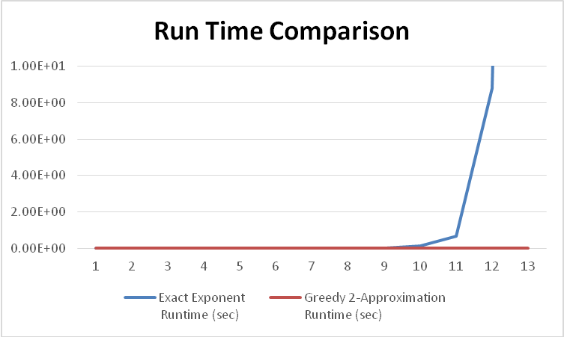

Approximation ration between the approximation cost and optimal cost:
