|  |
| --- |
| CSE, BUET |
| CSE-464 Computational Geometry Sessional |
| Offline 1 |

|  |
| --- |
| Name- Akib Ahmed  Student ID - 1305074  Subsection – 1  Date: 21/04/2018 |

# Problem Definition:

The problem given in our offline is finding out the length of and the points that are on the convex hull. The convex hull is the smallest convex set that contains a set of points in Euclidean space. There are several conceivable types of convex hull outputs:

1. All point on the hull in arbitrary order
2. All points on the hull in boundary order
3. The extreme points in arbitrary order
4. The extreme points in boundary order

In our offline, we have implemented Graham Scan algorithm, which gives an output of the last kind.

# Complexity:

Finding out the rightmost lowest (which is considered as the origin) point takes a $O(n)$ time. Sorting the rest of the points according to the angle made by that point and the origin point with X-axis takes $O(nlogn)$ time.

# Comparison with Gift Wrapping algorithm:

Gift Wrapping, also known as Jarvis March algorithm has the time complexity of $O(nh)$, with h being the number of points on the hull boundary.

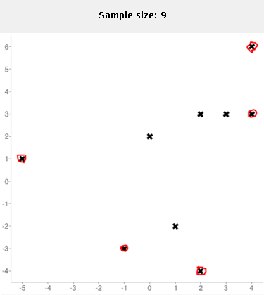So, in order to perform better than Gift Wrapping, Graham Scan has to ensure $nh>nlogn$ or, $h>logn$ or, $n<2^{h}$.

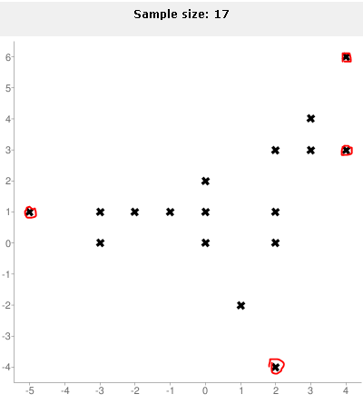Conversely, in order to do worse than Gift Wrapping, $n>2^{h}$ will be necessary

# Comparison with the Quick Hull algorithm:

The quick hull algorithm has best case complexity of $O(nlogn)$, whereas its worst case complexity is $O(n^{2})$. In order to Graham Scan perform better than quick hull, the input points must be positioned asymmetrically between the line formed by the leftmost highest and the rightmost lowest point of the set.

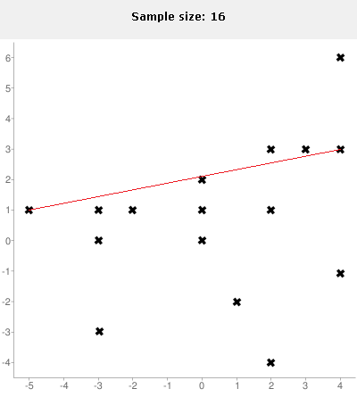

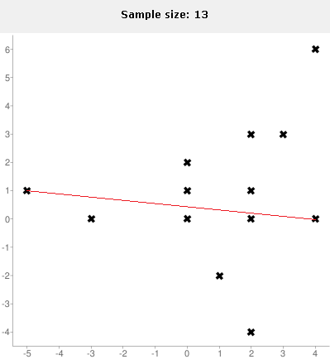On the other hand, there is very little chance of Graham Scan doing worse than the quick hull. Even if it does worse, it may be because of too many internal nodes and all being in a symmetric position between the line formed by two extreme points discussed above.