1. Graphical user interface, application

   Description automatically generatedThe initial GUI (like number 2 in Additional Information below).
2. Graphical user interface, text, application

   Description automatically generatedThe GUI after the user has entered an item number (ID) and quantity and clicked the “Find Item #” button (like number 4 below).
3. The pop-up message box when the user has purchased the selected item (like number 7 below). Graphical user interface, application

   Description automatically generated
4. The pop-up message box when the user has entered an item number (ID) that was not found in the inventory file (like number 6 below). Graphical user interface, text, application

   Description automatically generated
5. The GUI after the user has purchased the selected item (like number 8 below).

1. The GUI after the user has purchased an item and has entered another item and found it, but not yet confirmed it (like number 9 below). 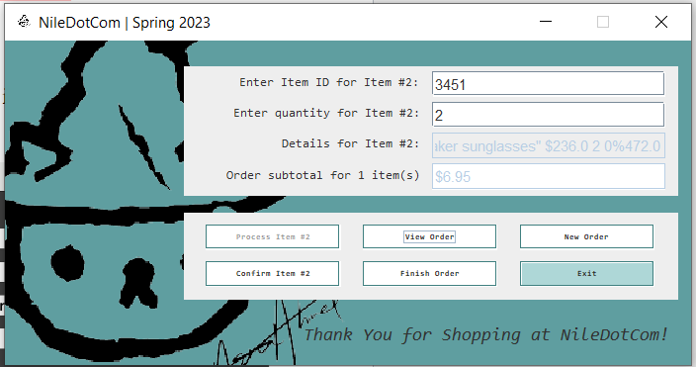
2. The message dialog box when the user clicks the “View Current Order” button with multiple items in the order (like number 11 below). Graphical user interface, text, application

   Description automatically generated
3. The message dialog box when the user clicks the “Complete Order - Check Out” button for an order containing multiple items (like number 12 below). Graphical user interface, application

   Description automatically generated
4. The message dialog box when the user has entered an item number (ID) for an item that is out of stock (like numbers 5 and 14 below).

