USAMA MIR
Islamabad, Pakistan · payoneerusama@gmail.com · linkedin.com/in/usama-mir-08678468
August 21, 2026
Graduate Admissions Committee
Ph.D. Program in Electrical and Computer Engineering
School of Engineering and Computer Science
Oakland University
Rochester, MI 48309
United States
Dear Members of the Graduate Admissions Committee:
I am writing to apply for admission to the Ph.D. program in Electrical and Computer Engineering at Oakland University. My academic and professional trajectory in RF systems, applied electromagnetics, counter-UAS sensing, and scientific machine learning has prepared me to contribute to Oakland’s research strengths in antennas, wireless propagation, and computational sensing—particularly within the Applied EMAG and Wireless Laboratory and related SECS initiatives in vehicular and aerospace wireless systems.
My M.S. thesis at the National University of Sciences and Technology develops a hybrid framework that fuses LiDAR-based GSLAM digital twins, differentiable ray tracing with NVIDIA Sionna RT, Physics-Informed Neural Networks, and Siamese CNNs. The goal is practical and scientifically grounded: suppress multipath distortion in complex environments, recover hardware-level RF fingerprints, and support rogue-emitter identification and power-allocation decisions relevant to emerging 6G architectures. This work sits at the intersection of electromagnetics, channel modeling, and learning—precisely the kind of interdisciplinary problem space Oakland’s ECE doctoral program is designed to cultivate.
Complementing this academic research, I have engineered X-band microwave sensors for non-destructive material characterization in collaboration with aerospace partners, and I have led counter-UAS and modern swarm-warfare efforts focused on anti-drone detection and anti-drone operator localization through RF surveillance and signature analytics. These experiences sharpened my ability to move from electromagnetic first principles to deployable sensing pipelines—processing noisy backscatter and control-link emissions, separating targets from interference, and translating algorithm design into operational concepts. Separately, my satellite array antenna work in CST Microwave Studio, from full-wave optimization through fabrication, reflects a sustained commitment to applied EM practice rather than simulation alone.
I am equally invested in scientific machine learning as a tool for physical systems. My PINN research with SIREN activations and time–space adaptive loss weighting, trained against parameters from the Johns Hopkins Turbulence Database, addresses spectral bias in turbulent flow modeling and forms the basis of a manuscript under review at IEEE Transactions on Neural Networks and Learning Systems. I see strong synergy between this SciML agenda and RF problems involving inverse sensing, channel inference, and physics-constrained learning.
Oakland University is my clear first-choice environment for doctoral study. The university’s depth in applied electromagnetics, antenna measurement and vehicular wireless testing, and industry-connected research culture offers the mentorship and facilities I need to scale my work on RF fingerprinting, computational sensors, and intelligent wireless systems. I would be honored to contribute as a doctoral researcher who bridges hardware, electromagnetics, and machine learning in service of safer and more capable sensing and communication technologies.
Thank you for considering my application. I would welcome the opportunity to discuss how my background can support faculty research agendas in the School of Engineering and Computer Science. My résumé is enclosed for your review.
Sincerely,
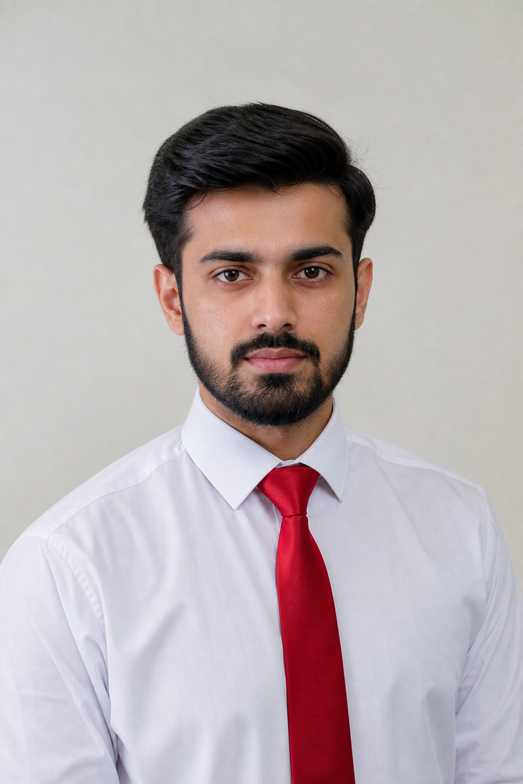 | Usama Mir  M.S. Electrical Engineering Candidate, NUST  Applicant, Ph.D. in Electrical & Computer Engineering  Oakland University

USAMA MIR  Electrical & Telecommunications Engineer | RF Systems · Applied EM · Scientific ML  Islamabad, Pakistan | payoneerusama@gmail.com | linkedin.com/in/usama-mir-08678468  Ph.D. Applicant — Electrical & Computer Engineering, Oakland University | 

ACADEMIC & RESEARCH SUMMARY
Electrical and Telecommunications Engineer specializing in RF systems, applied electromagnetics, counter-UAS sensing, and scientific machine learning. Demonstrated expertise in X-band sensor development, satellite array antenna design, anti-drone operator detection, and 6G-oriented network architectures. Proven ability to integrate Physics-Informed Neural Networks (PINNs), spatial digital twins (GSLAM), and Siamese CNNs for RF fingerprinting, multipath-resilient emitter identification, and fluid-dynamics modeling. Seeking Ph.D. study at Oakland University to advance research in applied electromagnetics, computational sensing, and intelligent RF systems aligned with the Applied EMAG and Wireless Laboratory and related SECS faculty strengths.
EDUCATION
Master of Science in Electrical Engineering (MSEE) 2025 – 2026
National University of Sciences and Technology (NUST), Islamabad, Pakistan
Thesis: Hybrid GSLAM, PINNs & Siamese CNN Framework for Complex Real-World Radio Frequency Fingerprinting. Focus: differentiable ray tracing (NVIDIA Sionna RT), digital-twin CIR modeling, multipath suppression, and hardware-signature extraction for 6G-related rogue-emitter identification and power allocation.
Bachelor of Science in Telecommunications Engineering 2013 – 2017
University of Engineering and Technology (UET), Peshawar, Pakistan
Foundational training in electromagnetics, wireless communications, signal processing, and RF systems. Early research exposure to WLAN optimization, smart antennas, and high-frequency antenna concepts.
PUBLICATIONS & RESEARCH UNDER REVIEW
Mir, U., et al. “A Hybrid TSA-DG Physics-Informed Neural Network Framework for Stable Modeling of Steady and Transient Navier–Stokes Flows.” Under review at IEEE Transactions on Neural Networks and Learning Systems (TNNLS).
RESEARCH & ENGINEERING EXPERIENCE
Head of Modern Swarm Warfare & Counter-UAS Systems
Maxnet Labs (Defense / Aerospace R&D Initiatives) — Islamabad 2023 – Present
- Anti-Drone System Architecture: Led design and integration of multi-sensor counter-UAS pipelines combining RF surveillance, direction finding, and signature analytics to detect, classify, and track unauthorized drones in contested electromagnetic environments.
- Anti-Drone Operator Detection: Developed RF-based operator localization and controller identification methods that fingerprint uplink/downlink emissions, isolate pilot-control links from ambient interference (Wi-Fi/Bluetooth), and support attribution of rogue operators beyond visual line of sight.
- Emitter Classification & Alerting: Applied machine-learning classifiers on transient and I/Q features to distinguish UAV platforms and controllers, improving detection robustness under low-SNR and multipath conditions typical of urban and industrial sites.
- Operational Concept Development: Authored CONOPS and technical proposals for layered counter-UAS response (detect → identify → geolocate → cue), including decentralized swarm-aware sensing concepts connecting RF fingerprinting with multi-agent coordination.
RF & Sensor Systems Engineer
Maxnet Labs (SUPARCO & Institute of Space Technology Collaboration) 2022 – Present
- X-Band Sensor Development for Material Detection: Engineered high-frequency X-band microwave sensor systems for non-destructive material scanning and dielectric characterization, enabling penetration and contrast capabilities for structural and concealed-material analysis.
- Signal Processing & Attenuation Analysis: Processed complex backscatter and RF signatures to detect concealed materials; optimized penetration depth versus resolution trade-offs in high-noise environments.
- R&D Collaboration: Partnered with aerospace and applied-physics teams to integrate advanced sensor arrays into embedded operational frameworks and experimental testbeds.
Principal Researcher — 6G Power Allocation & RF Fingerprinting
NUST M.S. Thesis Research 2025 – 2026
- Digital Twin Generation: Built a framework integrating drone-mounted LiDAR GSLAM to construct high-fidelity 3D digital twins of physical environments for spatially consistent RF simulation.
- Ray Tracing & CIR Computation: Used NVIDIA Sionna RT for differentiable ray tracing to compute Channel Impulse Responses (CIR) across dynamic spatial scenes.
- Machine Learning Integration: Coupled PINNs with Siamese CNNs to suppress multipath distortion and extract hardware signatures for 6G-related rogue-emitter identification and optimized power allocation.
Researcher — Antennas & Wireless Systems
Independent / IEEE-aligned Research Activities 2016 – 2017
- Investigated WLAN optimization, smart antennas, 5G/terahertz antenna concepts, and material effects on wireless propagation as foundational preparation for later RF and sensing research.
KEY TECHNICAL PROJECTS
Satellite Array Antenna Design & Fabrication
Led end-to-end design, simulation, and optimization of high-gain satellite antenna arrays in CST Microwave Studio—from CEM simulation and parameter tuning through physical prototyping and structural fabrication.
Physics-Informed Neural Networks (PINNs) for Fluid Dynamics Apr 2026
Architected scientific ML models using PINNs with SIREN activations and Time–Space Adaptive loss weighting. Processed JHU Turbulence Database parameters to mitigate spectral bias and model turbulent velocity fluctuations (basis of IEEE TNNLS submission).
Hierarchical Post-Quantum Asynchronous Authentication Apr 2026
Designed a zero-trust hardware integration framework for automotive enclaves. Drafted mathematical methodologies for Hardware Security Modules (HSMs) using lattice-based ML-KEM-768 master-seed encapsulation.
Decentralized Drone Swarm Operations & Simulation Aug 2026
Authored a research proposal mapping multi-agent systems with PINNs and Reinforcement Learning. Validated decentralized swarm environments using 3D multi-robot platforms (ARGoS, ROS, Gazebo), connecting swarm autonomy with RF-aware situational awareness.
TECHNICAL SKILLS
RF & Applied Electromagnetics: X-band microwave sensors; NDT / dielectric characterization; satellite antenna arrays; 6G architectures; RF fingerprinting; hardware-signature extraction; power allocation; counter-UAS RF detection; anti-drone operator localization.
Machine Learning & AI: PINNs; Siamese CNNs; reinforcement learning; computer vision; scientific ML (SciML); emitter / UAV classification from RF features.
Simulation & Engineering Software: CST Microwave Studio; MATLAB; NVIDIA Sionna RT; ROS; Gazebo; ARGoS; LiDAR / GSLAM processing; LaTeX.
Systems & Security: Multi-agent / swarm simulation; post-quantum HSM concepts (ML-KEM-768); zero-trust hardware integration for automotive enclaves.
RESEARCH INTERESTS FOR PH.D. STUDY
Applied electromagnetics and antenna systems; wireless channel modeling and measurement; RF / microwave sensing and computational imaging; RF fingerprinting and physical-layer security; scientific machine learning for wave and fluid physics; intelligent sensing for vehicular and aerospace wireless systems.

