COMPUTATIONAL PRACTICUM assignment

Differential Equations

Artur Akhmetshin

Group: BS17-05

y’ = sin(x) + y

Exact solution of IVP(Initial Value Problem)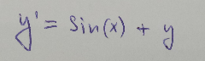

there x0 = 0 and y0 = 1

Given Differential Equation:

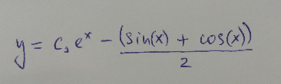  
Solution of DE:

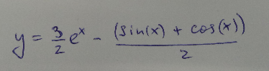Solution of IVP:

There isn’t any point of discontinuity in solution of given differential equation.

System contains 3 classes: Equation, Numeric methods and supporting class Plotting

**UML diagram for Equation and Numeric methods**

|  |
| --- |
| **Equation** |
| **+x0 : Float**  **+y0 : Float**  **+X : Float**  **+n : Integer**  **+h : Integer** |
| **+get_derivative(x : Float, y : Float)**  **+__init__(x0 : Float, y0 : Float, X : Float, n : Integer)**  **+local_errors(ff : Equation)**  **+max_error(ff : Equation)**  **+exact_solution()** |

|  |
| --- |
| **Numeric methods** |
|  |
| **+euler_method(f : Equation)**  **+euler_method_improved(f : Equation)**  **+runge_kutta_method(f : Equation)**  **+total_approximation_errors(start_n : Integer, end_n : Integer, x0 : Float, y0 : Float, X : Float)** |

**Explanation of Equation class attributes and methods**

**Equation class is used to operate with given y’ = sin(x) + y differential equation, change initial values, grid size to solve IVP inside class.**

**Attributes:**

**+x0 : Float Starting point of x-axis of IVP problem segment**

**+y0 : Float Value of function in x0 point y(x0) = y0**

**+X : Float Ending point of x-axis of IVP problem segment**

**+n : Integer Grid size**

**+h : Integer Value of one grid step(depends on x0, X0 and n)**

**Methods:**

**+__init__(x0 : Float, y0 : Float, X : Float, n : Integer)**

**Method initialize initital values, scope and grid size for solving IVP problem, these values are assigned to Equation instance**

**+get_derivative(x : Float, y : Float)**

**+local_errors(ff : Equation)**

**+max_error(ff : Equation)**

**+exact_solution()+get_derivative(x : Float, y : Float**