BONUS TASK 2 — SECOND DESIGN & FLIGHT COMPARISON
Alternative Glider Design, Aerodynamic Analysis, and Flight Trials
1. Second Design Construction & Photo
Overview: As part of the bonus task requirement, a second lightweight glider design was constructed using folded aerodynamic paper/foam board to test alternative aerodynamic profiles and evaluate flight performance through repeatable trials.
2. Aerodynamic Explanation
Aerodynamics: The second design utilizes a sleek, tapered swept-wing . This geometry significantly reduces parasitic drag and increases lift-to-drag ratio, allowing for a flatter glide slope and extended airtime during unpowered glides.
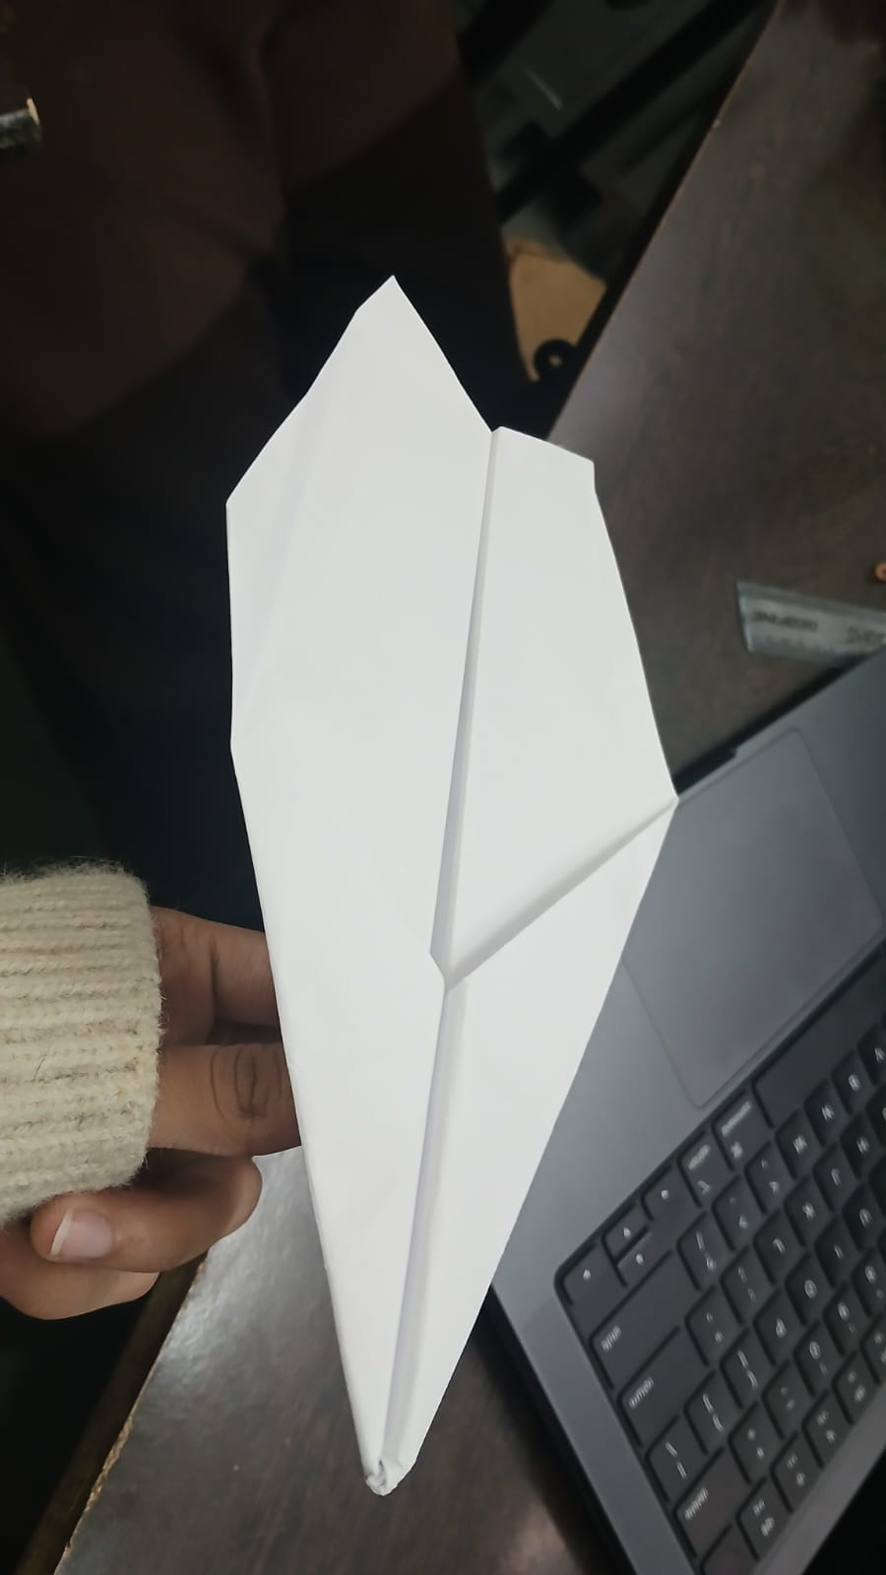
3. Repeatable Trials & Flight Duration Results
Trial Number | Flight time
Trial 1 | 3.7 seconds
Trial 2 | 3.3 seconds
Average Duration | 3.5 seconds

