**CAMOSUN COLLEGE**

**ELECTRONICS DEPTARTMENT**

**ECET 165 - LAB 4**

**Part1**

Design a program that produces a Cylon effect on port C:

<https://youtu.be/6za76h5bEj4?t=23s>

Or a Knight Rider KITT effect:

<https://youtu.be/vnPx5jaRJNo?t=4s>

The effect should run continuous with no user input.

**Part2**

Design a program to generate three square waves in the correct 3 phase sequence using pins on port C. Make the loop as fast as possible. Capture the output with the MPLAB Logic Analyzer. Use RC0 for phase A, RC1 for phase B, and RC2 for phase C.

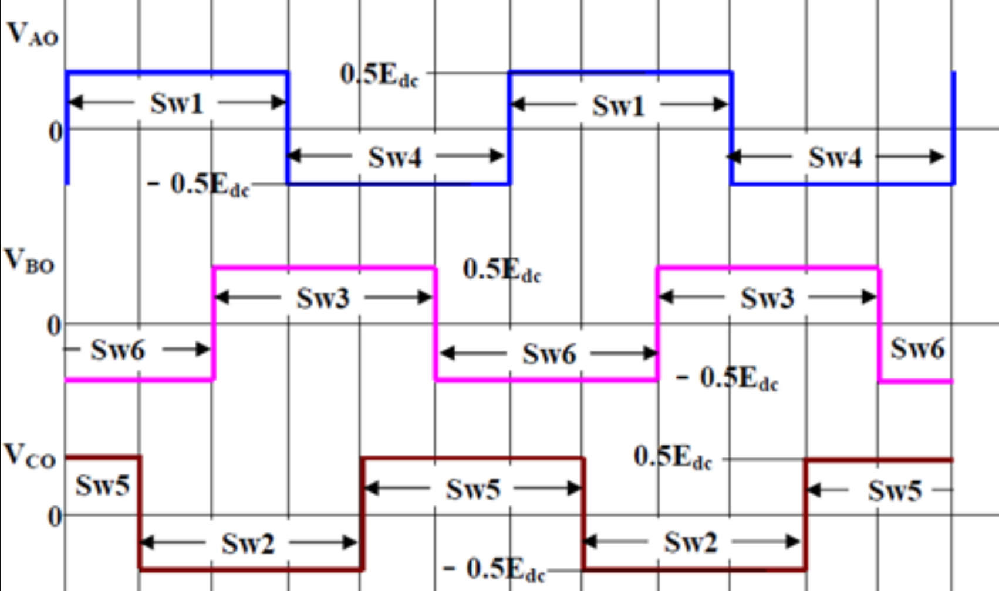

**Optional challenge**

1. Design a program to produce a runway effect in one direction. Use the push button input to change the direction of the effect.

Part1 commented code screen shot:

;*******************************************************************************

;Lab - CYCLON

;ECET165 Embedded Microcontrollers

;E165L03CounterAH.s

;31 Jan 2023

;Aaron Huinink

;Creates a cyclon effect on port C

;*******************************************************************************

PROCESSOR 18F57Q43

; CONFIG1

CONFIG FEXTOSC = ECH ; External Oscillator Selection (EC (external clock) above 8 MHz)

CONFIG RSTOSC = EXTOSC ; Reset Oscillator Selection (EXTOSC operating per FEXTOSC bits (device manufacturing default))

; CONFIG2

CONFIG CLKOUTEN = OFF ; Clock out Enable bit (CLKOUT function is disabled)

CONFIG PR1WAY = ON ; PRLOCKED One-Way Set Enable bit (PRLOCKED bit can be cleared and set only once)

CONFIG CSWEN = ON ; Clock Switch Enable bit (Writing to NOSC and NDIV is allowed)

CONFIG FCMEN = ON ; Fail-Safe Clock Monitor Enable bit (Fail-Safe Clock Monitor enabled)

; CONFIG3

CONFIG MCLRE = EXTMCLR ; MCLR Enable bit (If LVP = 0, MCLR pin is MCLR; If LVP = 1, RE3 pin function is MCLR )

CONFIG PWRTS = PWRT_OFF ; Power-up timer selection bits (PWRT is disabled)

CONFIG MVECEN = ON ; Multi-vector enable bit (Multi-vector enabled, Vector table used for interrupts)

CONFIG IVT1WAY = ON ; IVTLOCK bit One-way set enable bit (IVTLOCKED bit can be cleared and set only once)

CONFIG LPBOREN = OFF ; Low Power BOR Enable bit (Low-Power BOR disabled)

CONFIG BOREN = SBORDIS ; Brown-out Reset Enable bits (Brown-out Reset enabled , SBOREN bit is ignored)

; CONFIG4

CONFIG BORV = VBOR_1P9 ; Brown-out Reset Voltage Selection bits (Brown-out Reset Voltage (VBOR) set to 1.9V)

CONFIG ZCD = OFF ; ZCD Disable bit (ZCD module is disabled. ZCD can be enabled by setting the ZCDSEN bit of ZCDCON)

CONFIG PPS1WAY = ON ; PPSLOCK bit One-Way Set Enable bit (PPSLOCKED bit can be cleared and set only once; PPS registers remain locked after one clear/set cycle)

CONFIG STVREN = ON ; Stack Full/Underflow Reset Enable bit (Stack full/underflow will cause Reset)

CONFIG LVP = ON ; Low Voltage Programming Enable bit (Low voltage programming enabled. MCLR/VPP pin function is MCLR. MCLRE configuration bit is ignored)

CONFIG XINST = OFF ; Extended Instruction Set Enable bit (Extended Instruction Set and Indexed Addressing Mode disabled)

; CONFIG5

CONFIG WDTCPS = WDTCPS_7 ; WDT Period selection bits (Divider ratio 1:4096)

CONFIG WDTE = ON ; WDT operating mode (WDT enabled regardless of sleep; SWDTEN is ignored)

; CONFIG6

CONFIG WDTCWS = WDTCWS_7 ; WDT Window Select bits (window always open (100%); software control; keyed access not required)

CONFIG WDTCCS = SC ; WDT input clock selector (Software Control)

; CONFIG7

CONFIG BBSIZE = BBSIZE_512 ; Boot Block Size selection bits (Boot Block size is 512 words)

CONFIG BBEN = OFF ; Boot Block enable bit (Boot block disabled)

CONFIG SAFEN = OFF ; Storage Area Flash enable bit (SAF disabled)

CONFIG DEBUG = OFF ; Background Debugger (Background Debugger disabled)

; CONFIG8

CONFIG WRTB = OFF ; Boot Block Write Protection bit (Boot Block not Write protected)

CONFIG WRTC = OFF ; Configuration Register Write Protection bit (Configuration registers not Write protected)

CONFIG WRTD = OFF ; Data EEPROM Write Protection bit (Data EEPROM not Write protected)

CONFIG WRTSAF = OFF ; SAF Write protection bit (SAF not Write Protected)

CONFIG WRTAPP = OFF ; Application Block write protection bit (Application Block not write protected)

; CONFIG10

CONFIG CP = OFF ; PFM and Data EEPROM Code Protection bit (PFM and Data EEPROM code protection disabled)

#include <xc.inc>

PSECT udata_acs ;define registers

PSECT resetVec, class=CODE, reloc=2

resetVec:

goto setup

PSECT code

setup: ; setup board using code from datasheet

BANKSEL PORTC ;

CLRF PORTC ;Clear PORTC

BANKSEL LATC ;

CLRF LATC ;Clear Data Latch

BANKSEL ANSELC ;

CLRF ANSELC ;Enable digital drivers

BANKSEL TRISC ;

MOVLW 0b00000000 ;Set RC as input

MOVWF TRISC ;

;set initial voltages

MOVLW 0b00000001 ;turn on right most led

MOVWF LATC

mainLoop:

moveLeft: ; moves on led from right to left

BTFSC LATC7 ; is the far left led on?

goto moveRight ; yes - go moveRight routine

SLEEP ; no - sleep 128ms using WDT

RLNCF LATC ; rotate bits one bit to the left

goto moveLeft ; go back to move left

moveRight: ; moves leds from left to right

BTFSC LATC0 ; is the far right led on?

goto moveLeft ; yes - go to moveLeft routine

SLEEP ; no - sleep 128ms using WDT

RRNCF LATC ; rotate bits one bit to the right

goto moveRight ; continue to move left

end resetVec

Part2 commented code screen shot:

;*******************************************************************************

;Lab - SQUARE WAVE

;ECET165 Embedded Microcontrollers

;E165L03CounterAH.s

;31 JAN 2023

;Aaron Huinink

;Produces three square waves on pins RC0-2, all with a 120deg phase shift

;*******************************************************************************

PROCESSOR 18F57Q43

#include <xc.inc>

#define waveA LATC0

#define waveB LATC1

#define waveC LATC2

PSECT resetVec, class=CODE, reloc=2

resetVec:

goto setup

PSECT code

setup: ; set up ports

BANKSEL PORTC ;

CLRF PORTC ;Clear PORTC

BANKSEL LATC ;

CLRF LATC ;Clear Data Latch

BANKSEL ANSELC ;

CLRF ANSELC ;Enable digital drivers

BANKSEL TRISC ;

MOVLW 0b00000000 ;Set RC as input

MOVWF TRISC ;

mainLoop:

; set initial voltages

MOVLW 0b00000100 ; turn on RC2 and all others off

MOVWF LATC

squareWave:

BSF waveA ; turn on waveA 1 cycle

NOP ; wait 2 cycles

NOP

BCF waveC ; waveC to 0

NOP ; wait 2 cycles

NOP

BSF waveB ; waveB to 1

NOP ; wait 2 cycles

NOP

BCF waveA ; waveA to 0

NOP ; wait 2 cycles

NOP

BSF waveC ; waveC to 1

NOP ; wait 2 cycles

NOP

BCF waveB ; waveB to 0

goto squareWave ; start wave routine again (2 cycles)

end resetVec

Part2 Logic Analyzer screen shot:

