Metabolomics Australia Metabolite Mass Spectral Database
(MAMBO-MS)

SPECIFICATIONS DOCUMENT

Authors
Saravanan Dayalan
Vladimir Likic

5th May 2009 - 9th September 2009

This work is licensed under the Creative Commons Attribution-Noncommercial-Share Alike 2.5 Australia License. To view a copy of this license, visit
http://creativecommons.org/licenses/by-nc-sa/2.5/au/ or send a letter to
Creative Commons, 171 Second Street, Suite 300, San Francisco, California, 94105, USA.

Contents

1 Introduction 4
1.1 User Groups 4
1.2 Modules 4
1.3 Overview, User Groups and Privileges 5
2 User Management System 6
2.1 Use Case - Login, Logoff 6
2.2 Use Case - Edit Personal Details 6
2.3 Use Case - Edit User Details 6
2.4 Use Case - Forgot Password 6
3 NIST Records 7
3.1 Background 7
3.1.1 Introduction 7
3.1.2 Record 7
3.1.3 Nature of Data 8
3.1.4 Building the NIST Database 8
3.2 Use Case - Searching NIST Records 8
4 MA Records (GC) 9
4.1 Background 9
4.2 Node 10
4.2.1 Use Case – Add, Edit, Delete Nodes 10
4.2.2 Table Overview 10
4.2.3 Key Information 10
4.2.4 Table Details 10
4.3 Chromatography Type 11
4.3.1 Use Case – Add, Edit, Delete Chromatography Type 11
4.3.2 Table Overview 11
4.3.3 Key Information 11
4.3.4 Table Details 11
4.4 MS Geometry 12
4.4.1 Use Case – Add, Edit, Delete MS Geometry 12
4.4.2 Table Overview 12
4.4.3 Key Information 12
4.4.4 Table Details 12
4.5 Ionization Mode 13
4.5.1 Use Case – Add, Edit, Delete Ionization Mode 13
4.5.2 Table Overview 13
4.5.3 Key Information 13
4.5.4 Table Details 13
4.6 Instrument 14
4.6.1 Use Case – Add, Edit, Delete Instruments 14
4.6.2 Table Overview 14
4.6.3 Key Information 14
4.6.4 Table Details 14
4.7 Method 15
4.7.1 Use Case – Add, Edit, Delete Methods 15
4.7.2 Table Overview 15
4.7.3 Key Information 15
4.7.4 Table Details 16
4.8 Column 18
4.8.1 Use Case – Add, Edit, Delete Columns 18
4.8.2 Table Overview 18
4.8.3 Key Information 18
4.8.4 Table Details 19
4.9 Biological Systems 21
4.9.1 Use Case – Add, Edit, Delete Biological Systems 21
4.9.2 Table Overview 21
4.9.3 Key Information 21
4.9.4 Table Details 21
4.10 GCMS MA Metabolite Record 22
4.10.1 Use Case - Add, Edit, Delete GCMS MA Metabolite Records 22
4.10.2 Table Overview 23
4.10.3 Key Information 24
4.10.4 Table Details 25
4.11 Use Case - Searching MA Records 32
5 Search 33
5.1 By Keyword 33
5.1.1 Search Query - Screen Suggestions 33
5.1.2 Search Query – Details 34
5.1.3 Search Results 35
5.2 By Spectra 36
5.2.1 Search Query - Screen Suggestions 36
5.2.2 Search Query - Screen Details 36
5.2.3 Spectral Search Algorithm 37
5.2.4 Spectral Search Algorithm - Example 39
5.2.5 Spectral Search Algorithm - Notes 41
5.2.6 Search Results 42
6 Appendix I – Extract of the NIST Database 43
7 Appendix II – A GC Metabolite Spectrum Entry / Spectral Search Query 45

Introduction
The aim of this project is to create a mass spectral database for Metabolomics Australia (MA). Following are the high-level requirements for this database.
- Is accessible across all Nodes.
- Has a user management system with different user privileges and functionalities.
- Allows upload, edit, delete and search functionalities of mass spectral data of compounds.

User Groups
The system consists of the following user groups,
- Admin
- Node Rep
- MA Staff
- Client

Each of these user groups consists of the following fields,
- Email address : This field is the username.
- First name
- Last name
- Password
- Node : This field is used to differentiate between the user groups “MA Staff” and “Client. As in MADAS, if this field contains as its value one of the Nodes, then it depicts that the user is of the “MA Staff” category. On the other hand, if this field contains “None”, then the user belongs to the “Client” category.
- Node Rep (Y/N) : As in MADAS, a checkbox would present and determine this field.
- Admin (Y/N) : As in MADAS, a checkbox would present and determine this field.

Of the above shown fields, Email address, First name, Last name, Password and Node needs to be retrieved from MADAS. The value of the fields Node Rep and Admin shall NOT be retrieved from MADAS but determined in MAMBO-MS.

Modules
This project is made up of three modules,
- The User Management System: This module consists of functionalities involving managing users.
- NIST Records: This module consists on functionalities involving building the NIST database and searching NIST by the different user groups.
- MA Records: This module consists of functionalities involving uploading, editing and deleting and searching MA records by the different user groups.

Overview, User Groups and Privileges

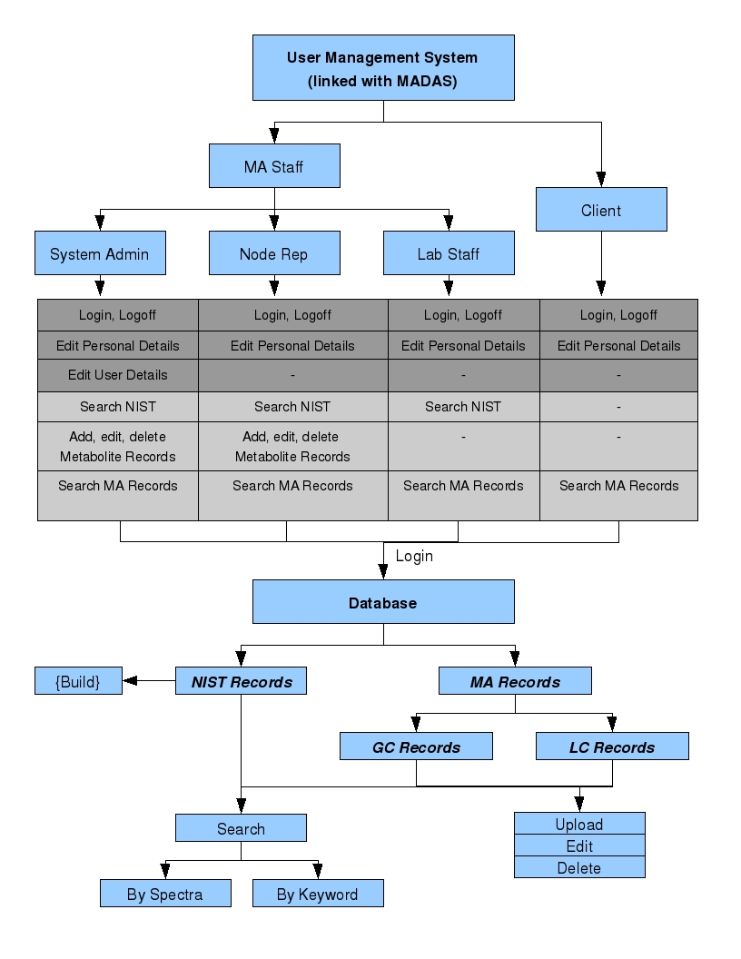

User Management System

Use Case - Login, Logoff
User Groups: Admin, Node Rep, MA Staff, Client

Detail: Users are able to login and logoff the MAMBO-MS system.

Use Case - Edit Personal Details
User Groups: Admin, Node Rep, MA Staff, Client

Detail: This functionality lets the users to edit the following fields: First name, Last name, Password. Note that a change in these fields should reflect in the MADAS system as well.

Use Case - Edit User Details
User Groups: Admin

Detail: The Admin should be able to edit all fields (First name, Last name, Password, Node, Node Rep (Y/N) and Admin (Y/N)) of a user.

Use Case - Forgot Password
User Groups: Admin, Node Rep, MA Staff, Client

Detail: A “Forgot password” option needs to be provided for all user groups.

NIST Records
This section presents background information of the NIST database, its records structures and the different functionalities to be performed on the NIST records.

Background

Introduction
This is a database of mass-spectral data of compounds. Currently this database resides as a single text file (~500MB) of the format shown in Appendix I. This database has a total of 220,460 records. A sample recird is shown below,

##TITLE=Library Entry 3 in d:\nist08.l
##JCAMPDX=Revision 4.10
##DATA TYPE=MASS SPECTRUM
##SAMPLE DESCRIPTION=NIST MS# 61313, Seq# M30
##NAMES=NIST 2008
##CAS NAME=Methane
##MOLFORM=CH4
##CAS REGISTRY NO=000074-82-8
##MP= -300
##BP= -300
##MW= 16.031
##$RETENTION INDEX=0
##$CONDENSED SPECTRUM=NO
##NPOINTS= 6
##XYDATA=(XY..XY)
12 380
13 1060
14 2040
15 8870
16 9999
17 160

This record shows the mass spectral data (the list of numbers under ##XYDATA) for the compound Methane. All records of compounds of this database contain the same set of headers (line starting with ##).

Record
In a record, we can ignore the following headers and hence do NOT store its related information,
##TITLE=
##JCAMPDX=
##DATA TYPE=
##SAMPLE DESCRIPTION=
##NAMES=
##MP=
##BP=
##$RETENTION INDEX=
##$CONDENSED SPECTRUM=

Therefore, in each record we are interested only in the following headers and its related values,
##CAS NAME=
##MOLFORM=
##CAS REGISTRY NO=
##MW=
##NPOINTS=
##XYDATA=(XY..XY)
X1 Y1
X2 Y2
X3 Y3
X4 Y4

##CAS NAME: This field presents the name of the compound.
##MOLFORM: This field presents the compound's molecular formula.
##CAS REGISTRY NO: This field shows the unique CAS registry number for this compound.
##MW: This field shows the molecular weight of the compound.
##NPOINTS: This field shows the number of points of XYDATA (spectral data) this record has.
##XYDATA=(XY..XY): The lines following this header (the next ##NPOINTS lines) in the record represent the actual XY pair of values that is the spectral data.

Nature of Data
- The unique property that identifies a compound is its CAS REGISTRY NO.
- Each compound can have different CAS NAMES and therefore have different records, but these records would bear the same CAS REGISTRY NO.
- NIST also contains different records for the same compound containing the same CAS NAME and the same CAS REGISTRY NO. The differing factor in these entries are the XYDATA (the spectra).
- Some CAS NAMES are long and are entered in multiple lines.

Building the NIST Database
As one of the functionalities of MAMBO-MS is the option of searching the NIST database, the NIST records has to be stored in a database. Note that only the fields of interest needs to be stored and the nature of the NIST data needs to be taken into account while designing the database.

Use Case - Searching NIST Records
User Groups: Admin, Node Rep, MA Staff

Detail: The users are provided with a search functionality to search the NIST records. This option is discussed in detail under the Search Section.

MA Records (GC)

Background
Uploading, editing, deleting and searching of MA records is the most crucial aspect of MAMBO-MS. These records are generated at the different MA labs and would be uploaded into MAMBO-MS.
Detailed below are the different tables that together would be used to upload and store a GCMS Metabolite record.

Node

Use Case – Add, Edit, Delete Nodes

User Groups: Admin

Detail: Admin should be able to add, edit and delete Nodes.

Table Overview

Node Name | User Entered Text

Key Information

Primary Key: Node Name

Table Details

Field: Node Name
Values:-University of Melbourne
-University of Queensland
-University of Western Australian
-Murdoch University
-AWRI

Chromatography Type

Use Case – Add, Edit, Delete Chromatography Type

User Groups: Admin

Detail: Admin should be able to add, edit and delete Chromatography Type values.

Table Overview

Chromatography Type | User Entered Text

Key Information

Primary Key: Chromatography Type

Table Details

Field: Chromatography Type
Values: User entered text

MS Geometry

Use Case – Add, Edit, Delete MS Geometry

User Groups: Admin

Detail: Admin should be able to add, edit and delete MS Geometry values.

Table Overview

MS Geometry | User Entered Text

Key Information

Primary Key: MS Geometry

Table Details

Field: MS Geometry
Values: User entered text

Ionization Mode

Use Case – Add, Edit, Delete Ionization Mode

User Groups: Admin

Detail: Admin should be able to add, edit and delete Ionization Mode values.

Table Overview

Ionization Mode | User Entered Text

Key Information

Primary Key: Ionization Mode

Table Details

Field: Ionization Mode
Values: User entered text

Instrument

Use Case – Add, Edit, Delete Instruments

User Groups: Admin, Node Rep

Detail: Admin and Node Reps should be able to add, edit and delete the instruments in their Nodes.

Table Overview

Node Name | Pull-down menu  (Node: Node Name)
Instrument Name | User Entered Text

Key Information

Primary Key: Node Name, Instrument Name

Table Details

Field: Node Name
Values: Values for this field is obtained from the table Node (Node: Node Name)
Implementation for Use Case: This field needs to be auto-filled, which is obtained from the user's login information.

Field: Instrument Name
Values: User Entered Text
Implementation for Use Case: The user is provided with a text field to enter a value for this field.

Method

Use Case – Add, Edit, Delete Methods

User Groups: Admin, Node Rep

Detail: Admin and Node Reps should be able to add, edit and delete Methods information.

Table Overview
Node Name | Auto generated
Method Name | User Entered Text
Chromatography Type | Pull-down menu  (Chromatography Type: Chromatography Type)
MS Geometry | Pull-down menu  (MS Geometry: MS Geometry)
Ionization Mode | Pull-down menu  (Ionization Mode: Ionization Mode)
Polarity | Pull-down menu  (Values: Positive, Negative)
Derivitization Agent | User Entered Text
Mass of Expected Derivitization Adducts | User Entered Text
Mass Range Acquired | User Entered Text

Key Information

Primary Key: Node Name, Method Name

Table Details

Field: Node Name
Values: Auto generated
Implementation for Use Case: The value for this field should be auto generated. The “Node Name” should be obtained through the logged in user details. That is, this field should contain the name of the Node to which the user belongs to.

Field: Method Name
Values: User Entered Text
Implementation for Use Case: The user is provided with a text field to enter this field.

Field: Chromatography Type
Values: The values for this field is obtained from the table Chromatography Type (Chromatography Type: Chromatography Type)
Implementation for Use Case: The user is provided with a pull-down menu with values for this field.

Field: Ionization Mode
Values: The values for this field is obtained from the table Ionization Mode (Ionization Mode: Ionization Mode)
Implementation for Use Case: The user is provided with a pull-down menu with values for this field.

Field: Polarity
Values:- Positive
- Negative
Implementation for Use Case:The user is provided with a pull-down menu with values for this field.

Field: Derivitization Agent
Values: User Entered Text.
Implementation for Use Case: The user is provided with a text field to enter this field.

Field: Mass of Expected Derivitization Adducts
Values: User Entered Text.
Implementation for Use Case: The user is provided with a text field to enter this field.

Field: Mass Range Acquired
Values: User Entered Text.
Implementation for Use Case: The user is provided with a text field to enter this field.

Column

Use Case – Add, Edit, Delete Columns

User Groups: Admin, Node Rep

Detail: Admin and Node Reps should be able to add, edit and delete Columns information.

Table Overview

Node Name | Auto generated
Chromatography Type | Pull-down menu  (Chromatography Type: Chromatography Type)
Column Name | User Entered Text
Manufacturer | User Entered Text
Length | User Entered Text
Type | User Entered Text
Dimension | User Entered Text
Guard Column Used | User Entered Text
Product Number | User Entered Text

Key Information

Primary Key: Node Name, Column Name, Length, Dimension

Table Details

Field: Node Name
Values: Auto generated
Implementation for Use Case: The value for this field should be auto generated. The “Node Name” should be obtained through the logged in user details. That is, this field should contain the name of the Node to which the user belongs to.

Field: Chromatography Type
Values: The values for this field is obtained from the table Chromatography Type (Chromatography Type: Chromatography Type)
Implementation for Use Case: The user is provided with a pull-down menu with values for this field.

Field: Column Name
Values: User Entered Text.
Implementation for Use Case: The user is provided with a text field to enter this field.

Field: Manufacturer
Values: User Entered Text.
Implementation for Use Case: The user is provided with a text field to enter this field.

Field: Length
Values: User Entered Text.
Implementation for Use Case: The user is provided with a text field to enter this field.

Field: Type
Values: User Entered Text.
Implementation for Use Case: The user is provided with a text field to enter this field.

Field: Dimension
Values: User Entered Text.
Implementation for Use Case: The user is provided with a text field to enter this field.

Field: Guard Column Used
Values: User Entered Text.
Implementation for Use Case: The user is provided with a text field to enter this field.

Field: Product Number
Values: User Entered Text.
Implementation for Use Case: The user is provided with a text field to enter this field.

Biological Systems

Use Case – Add, Edit, Delete Biological Systems

User Groups: Admin, Node Rep

Detail: Admin and Node Reps should be able to add, edit and delete Biological Systems information.

Table Overview
Kingdom | User Entered Text
Species | User Entered Text

Key Information

Primary Key: Kingdom, Species

Table Details

Field: Kingdom
Values: User Entered Text.
Implementation for Use Case: The user is provided with a text field to enter this field.

Field: Species
Values: User Entered Text.
Implementation for Use Case: The user is provided with a text field to enter this field.

GCMS MA Metabolite Record

Use Case - Add, Edit, Delete GCMS MA Metabolite Records

User Groups: Admin, Node Rep

Detail: Admin and Node Reps should be able to add, edit and delete GCMS MA Metabolite records.

Table Overview
Unique Metabolite ID | Auto generated
Type | GC
Known/Unknown | Pull-down menu  (Values:Known, Unknown)
Node Name | Auto generated
Instrument Name | Pull-down menu  (Instrument: Instrument Name)
Method Name | Pull-down menu  (Method: Method Name)
Platform Name | Auto filled  (Method:Chromatography Type - Method:MS Geometry - Method:Ionization Mode - Method:Polarity)
Derivitization Agent | Auto filled  (Method: Derivitization Agent)
Mass of Expected Derivitization Adducts | Auto filled  (Method: Mass of Expected Derivitization Adducts)
Mass Range Acquired | Auto filled  (Method: Mass Range)
Column | Pull-down menu  (Column:Column Name – Column:Length - Column:Dimension)
Sample Run By | Pull-down menu  (User Management System)
Record Uploaded By | Auto filled  (User Management System)
Record Uploaded Date | Auto filled
Record Vetted By | Pull-down menu  (User Management System)
Record Vetted Date | Auto filled
Compound Name | User Entered Text
Synonyms | User Entered Text  (Multiple entries)
Biological Systems | Pull-down menu  (Biological System:Kingdom – Biological System:Species)
CAS Name | User Entered Text  (N/A for Unknown)
CAS Registration Number | User Entered Text  (N/A for Unknown)
Molecular Formula | User Entered Text  (N/A for Unknown)
Molecular Weight | User Entered Text  (N/A for Unknown)
Retention Time | User Entered Text
Retention Index | User Entered Text
KEGG ID | User Entered Text  (N/A for Unknown)
KEGG Link | User Entered Text  (N/A for Unknown)
Mass Spectra | User Entered Text
Quant Ion | User Entered Number
Qualifying Ion 1 | User Entered Number
Qualifying Ion 2 | User Entered Number
Qualifying Ion 3 | User Entered Number
Qualifying Ion Ratio  (Ion 1 : Ion2) | Auto generated
Qualifying Ion Ratio  (Ion 2 : Ion 3) | Auto generated
Extract Description | User Entered Text
Structure | User Uploaded File

Key Information

Primary Key: Unique Metabolite ID

Table Details

Field: Unique Metabolite ID
Values: Auto generated
Explanation: This is the ID that would uniquely identify a GC metabolite record.
Implementation for Use Case: The value for this field should be auto generated. A sequential numbering system should suffice.

Field: Type
Value: GC
Explanation: This field is primarily used to differentiate between the GCMS MA metabolite records and the LCMS MA metabolite records that is to be defined at a later stage.
Implementation for Use Case: To be implemented as a fixed value for GCMS records.

Field: Known/Unknown
Values: Known, Unknown
Explanation: This field is used to differentiate between the two types of GCMS MA metabolite records, known and unknown.
Implementation for Use Case: The user is provided with a pull-down menu with values for this field.

Field: Node Name
Values: Auto generated
Explanation: This field identifies the Node at which the metabolite record originated.
Implementation for Use Case: The value for this field should be auto generated. The “Node Name” should be obtained through the logged in user details. That is, this field should contain the name of the Node to which the user belongs to.

Field: Instrument name
Values: The values for this field is obtained from the table Instrument (Instrument: Instrument Name).
Implementation for Use Case: The user is provided with a pull-down menu with values for this field. Note that only the Instruments under the specific Node should be displayed in the pull-down menu. For example, a user from AWRI attempting to create a GC metabolite record should see only Instruments from the AWRI Node in the menu.

Field: Method Name
Values: The values for this field is obtained from the table Method (Method: Method Name).
Implementation for Use Case: The user is provided with a pull-down menu with values for this field. Note that only the Methods under the specific Node should be displayed in the pull-down menu. For example, a user from AWRI attempting to create a GC metabolite record should see only Methods from the AWRI Node in the menu.

Field: Platform Name
Values: Auto generated
Implementation for Use Case: The value for this field should be auto generated in the following format.
Method:Chromatography Type - Method:MS Geometry - Method:Ionization Mode – Method:Polarity

For example, for the selected Method for the current record,

Method: Chromatography Type = GC
Method: MS Geometry = QQQ
Method: Ionization Mode = ESI and
Method: Polarity = Positive

then, 'Platform Name' = GC-QQQ-ESI-Positive

Field: Derivitization Agent
Values: Auto generated
Implementation for Use Case: The value for this field should be auto generated using the Method: Derivitization Agent for the selected Method Name.

Field: Mass of Expected Derivitization Adducts
Values: Auto generated
Implementation for Use Case: The value for this field should be auto generated using the Method: Mass of Expected Derivitization Adducts for the selected Method Name.

Field: Mass Range Acquired
Values: Auto generated
Implementation for Use Case: The value for this field should be auto generated using the Method: Mass Range Acquired for the selected Method Name.

Field: Column
Values: The values for this field is obtained from the table Column.
Implementation for Use Case: The user is provided with a pull-down menu with the values in the following format,
Column:Column Name – Column:Length – Column:Dimension

Field: Sample Run By
Values: The values for this field is obtained from the User Management System
Implementation for Use Case: The user is provided with a pull-down menu with the list of users under the specific Node (User Management System: First name Last name).

Field: Record Uploaded By
Values: Auto generated from User Management System.
Implementation for Use Case: The value for this field is auto generated where it contains the First name Last name of the logged in user.

Field: Record Uploaded Date
Values: Auto generated
Implementation for Use Case: The value for this field is auto generated with the date on which the user uploads the current record.

Field: Record Vetted By
Values: The values for this field is obtained from the User Management System
Implementation for Use Case: This field is a pull-down menu made up of
- a blank entry (this is the default selection)
- the First Name Last Name of the user (MA Staff) who is logged in.

This field exists in order for users to vet a record entered by someone else and is optional.

Hence, if the logged in MA Staff would like to vet a record uploaded by someone else, then the user needs to select their name using the pull-down menu and select a push-button confirming their vetting process.

Note that the same user cannot upload a record as well as vet it. Hence, the fields
Record Uploaded By and Record Vetted By should not be allowed to have the same value.

Field: Record Vetted Date
Values: Auto generated
Implementation for Use Case: The value for this field is auto generated with the date on which a user vet's the current record.

Field: Compound Name
Values: User Entered Text.
Implementation for Use Case: The user is provided with a text field to enter this field.

Field: Synonyms
Values: User Entered Text.
Implementation for Use Case: The compound under consideration may be known by several other names and hence this field can have multiple entries. That is, the user can at different times edit a record and add additional values to these fields. Also note that each of these synonyms can be used as a keyword to search metabolite records.

Field: Biological Systems
Values: The values for this field is obtained from the table Biological Systems.
Implementation for Use Case: The user is provided with a pull-down menu with the values in the following format,
Biological System:Kingdom – Biological System:Species

Field: CAS Name
Values: User Entered Text.
Implementation for Use Case: The user is provided with a text field to enter this field.

Field: CAS Registration Number
Values: User Entered Text.
Implementation for Use Case: The user is provided with a text field to enter this field.

Field: Molecular Formula
Values: User Entered Text.
Implementation for Use Case: The user is provided with a text field to enter this field.

Field: Molecular Weight
Values: User Entered Text.
Implementation for Use Case: The user is provided with a text field to enter this field.

Field: Retention Time
Values: User Entered Text.
Implementation for Use Case: The user is provided with a text field to enter this field.

Field: Retention Index
Values: User Entered Text.
Implementation for Use Case: The user is provided with a text field to enter this field.

Field: KEGG ID
Values: User Entered Text.
Implementation for Use Case: The user is provided with a text field to enter this field.

Field: KEDD Link
Values: User Entered Text.
Implementation for Use Case: The user is provided with a text field to enter this field.

Field: Mass Spectra
Values: User Entered Text.
Implementation for Use Case: The user is provided with a text field to enter this field. Note that this is the field that would store the compound's (mass, intensity) pair values and would be entered in the following format,
51.10 5641.0
52.10 2028.0
53.00 9711.0
54.10 9035.0
55.10 163392.0
56.10 60168.0
57.00 181312.0
58.00 9376.0
58.90 9166.0
59.90 2686.0
61.10 3506.0
...

A complete entry is shown in Appendix II (Note the large number of entries of this mass spectra). The users would make this entry by simply copying these values from their instrument's software and paste it in the text field MAMBO-MS interface provides.
Also note that these values needs to be stored similar to the way the NIST (mass, intensity) values were stored.

Field: Quant Ion
Values: User Entered Number.
Implementation for Use Case: The user is provided with a text field to enter this field.

Field: Qualifying Ion 1
Values: User Entered Number.
Implementation for Use Case: The user is provided with a text field to enter this field.

Field: Qualifying Ion 2
Values: User Entered Number.
Implementation for Use Case: The user is provided with a text field to enter this field.

Field: Qualifying Ion 3
Values: User Entered Number.
Implementation for Use Case: The user is provided with a text field to enter this field.

Field: Qualifying Ion Ratio (Ion 1 : Ion 2)
Values: Auto generated
Implementation for Use Case: The value for this field is auto generated as follows,
Qualifying Ions 1 and 2 entered by the users in the above fields are specific masses in the mass spectra.

Qualifying Ion Ratio (Ion 1 : Ion 2) =
Intensity of Qualifying Ion 1 / Intensity of Qualifying Ion 2

Consider the following example,

If the mass, intensity values of a spectrum is,
51.10 5641.0
52.10 2028.0
53.00 9711.0
54.10 9035.0
55.10 163392.0
56.10 60168.0
57.00 181312.0
58.00 9376.0
58.90 9166.0
59.90 2686.0

and
Qualifying Ion 1 = 51.10
Qualifying Ion 2 = 52.10
then
Qualifying Ion Ratio (Ion 1 : Ion 2) = 5641.0/2028.0 = 2.781

Field: Qualifying Ion Ratio (Ion 2 : Ion 3)
Values: Auto generated
Implementation for Use Case:
Qualifying Ion Ratio (Ion 2 : Ion 3) =
Intensity of Qualifying Ion 2 / Intensity of Qualifying Ion 3

Field: Extract Description
Values: User Entered Text.
Implementation for Use Case: The user is provided with a text field to enter this field.

Field: Structure
Values: User Uploaded File
Implementation for Use Case: The user is provided with an option to upload a small file that would contain the structure of the metabolite (format is yet to be decided).

Use Case - Searching MA Records
User Groups: Admin, Node Rep, MA Staff, Client

Detail: The users are provided with a search functionality to search the MA records. This option is discussed in detail under the Search Section.

Search

By Keyword
An option needs to be provided in MAMBO-MS to search the NIST and MA metabolite records. The user should be allowed to perform a keyword based search as detailed below.

Search Query - Screen Suggestions

Version 1
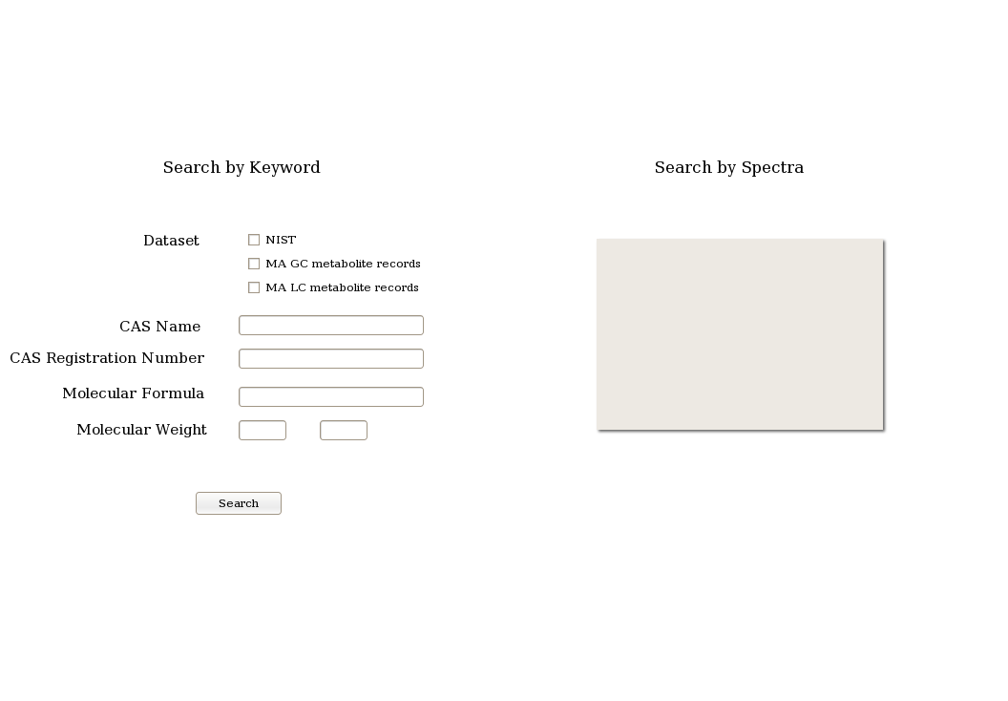

Search Query – Details

Note that the following fields are only a partial list with which we start our implementation. The following fields would suffice to search the NIST records but keyword based search would contain many more fields once the GC Metabolite records are built. This section would be updated as the GC and later components are designed and built.

Dataset
An option to select different datasets needs to be provided.
- Clients should not be able to search the NIST records and hence the NIST check-box should be unchecked and disabled or absent when an user logs in as Client.
- For all other user groups, all three check-boxes should be selected by default.

CAS Name
This is a string based search option that compares against the records' CAS NAME field. Since many records in the database could have the search string as part of the CAS NAME entry, a simple grep returns thousands of results. Therefore, a search option can be included that would reduce the number of matches. One of the methods would be to include with the search criteria, the following three options to choose from, the search string is “exact”, “starts with” or “contains”.

CAS Register Number
This is a perfect match search option against the CAS REGISTRY NO. field.

Molecular Formula
This is a perfect match search option against the MOLFORM field.

Molecular Weight
In this option, the user should be able to enter a range of values (from, to) and the search should produce a list of all compounds whose MW field falls within the search range.

Search Results
A search using any of the above discussed fields should produce a list of hits displaying the following information,
- Name (CAS NAME)
- CAS REGISTRY NO.
- Molecular Formula (MOLFORM)
- Molecular Weight (MW)

Since multiple matches are expected for an average search, the above information of each match needs to be displayed as a single line with a clickable link to the spectra. Once the user selects the line (clicks the link to view the spectra), the following information is to be displayed in a separate window,
- Name (CAS NAME)
- CAS REGISTRY NO.
- Molecular Formula (MOLFORM)
- Molecular Weight (MW)
- the spectra (set of XY values). This should be displayed in a graphical format.

Displaying Spectra

Display a zoomable graph.

By Spectra
In this option, the user uploads a range of (mass, intensity) pair values and searches the metabolite records for similar spectra.

Search Query - Screen Suggestions

Version 2
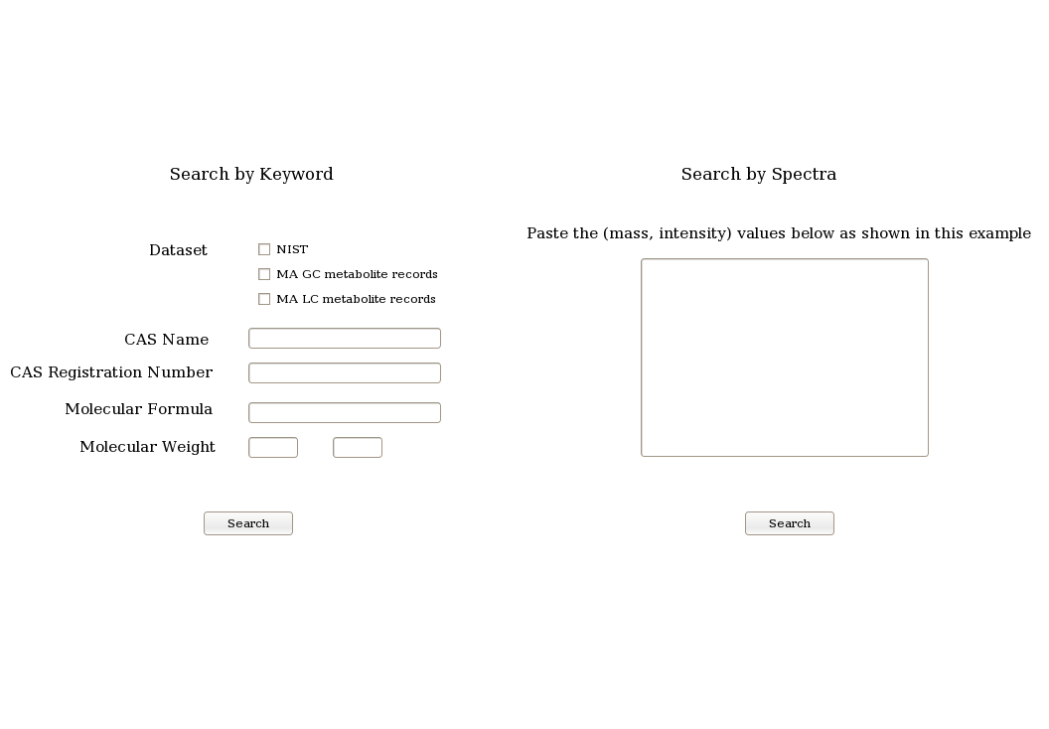

Search Query - Screen Details
The user copies and pastes the spectra (as mass, intensity pair values) that needs to be searched in the text box. The user is also provided with a sample file showing the format in which the query spectra information needs to be uploaded. The format is similar to the one shown in Appendix II – A GC Metabolite Spectrum Entry / Spectral search query.
Once the user uploads the query spectra, it is searched against the metabolite records using the spectral search algorithm detailed in the next Section.

Spectral Search Algorithm

Similarity between two spectra is calculated using the following formula

where,

is the total number of common masses between the query spectra and the library spectra.

is the total number of masses in the query spectra.

is the total number of masses in the library spectra.

This factor is calculated ONLY for common masses, where Iq is the intensity in the query spectra of the common mass and Il is the intensity of the library spectra of the common mass.

is the sum of the squares of the intensities of the query spectra for ONLY the common masses.

is the sum of the squares of the intensities of the library spectra for ONLY the common masses.

Spectral Search Algorithm - Example

Assume the query spectra to be ((mass, intensity) pairs),
5 10
10 15
15 5
20 5

Similarly, assume a library record to be,
2 10
10 5
15 5

Then,

would be calculated as follows,

(the total number of common masses between the query spectra and the library spectra)

(the total number of masses in the query spectra)

(the total number of masses in the library spectra)

(This factor is calculated ONLY for common masses, where Iq is the intensity in the query spectra of the common mass and Il is the intensity of the library spectra of the common mass)

(the sum of the squares of the intensities of the query spectra for ONLY the common masses)

(the sum of the squares of the intensities of the library spectra for ONLY the common masses)

Spectral Search Algorithm - Notes

Rounding Mass Values for NIST records

The following is an extract from Appendix II – A GC Metabolite Spectrum Entry / Spectral Search Query.
51.10 5641.0
52.10 2028.0
53.00 9711.0
54.10 9035.0
55.10 163392.0
56.10 60168.0
57.00 181312.0
58.00 9376.0
58.90 9166.0
59.90 2686.0
61.10 3506.0

Note that the mass values are not integers but are floating point numbers, whereas the NIST entries (Appendix I – Extract of the NIST Database) have mass values as integers (round numbers).

Therefore, in the query spectra the mass values needs to be rounded using the following range: (-0.3 to +0.6). For example,

51.0 = 51.0
51.2 = 51.0
51.3 = 51.0
51.4 = 51.0
51.5 = 51.0
51.6 = 51.0
51.7 = 52.0
51.8 = 52.0
51.9 = 52.0
52.0 = 52.0
52.1 = 52.0
52.2 = 52.0
52.3 = 52.0
52.4 = 52.0
52.5 = 52.0
52.6 = 52.0
52.7 = 53.0

Search Results

The top 10 matches needs to be presented to the user. Temporarily, it would suffice to present a link to these compounds, clicking on which would take the user to the compound's mass spectra.

Appendix I – Extract of the NIST Database
##TITLE=Library Entry 1 in d:\nist08.l
##JCAMPDX=Revision 4.10
##DATA TYPE=MASS SPECTRUM
##SAMPLE DESCRIPTION=NIST MS# 245692, Seq# M1
##NAMES=NIST 2008
##CAS NAME=Hydrogen
##MOLFORM=H2
##CAS REGISTRY NO=001333-74-0
##MP= -300
##BP= -300
##MW= 2.016
##$RETENTION INDEX=0
##$CONDENSED SPECTRUM=NO
##NPOINTS= 2
##XYDATA=(XY..XY)
1 210
2 9999
##TITLE=Library Entry 2 in d:\nist08.l
##JCAMPDX=Revision 4.10
##DATA TYPE=MASS SPECTRUM
##SAMPLE DESCRIPTION=NIST MS# 61316, Seq# M2
##NAMES=NIST 2008
##CAS NAME=Deuterium
##MOLFORM=D2
##CAS REGISTRY NO=007782-39-0
##MP= -300
##BP= -300
##MW= 4.028
##$RETENTION INDEX=0
##$CONDENSED SPECTRUM=NO
##NPOINTS= 2
##XYDATA=(XY..XY)
2 150
4 9999
##TITLE=Library Entry 3 in d:\nist08.l
##JCAMPDX=Revision 4.10
##DATA TYPE=MASS SPECTRUM
##SAMPLE DESCRIPTION=NIST MS# 61313, Seq# M30
##NAMES=NIST 2008
##CAS NAME=Methane
##MOLFORM=CH4
##CAS REGISTRY NO=000074-82-8
##MP= -300
##BP= -300
##MW= 16.031
##$RETENTION INDEX=0
##$CONDENSED SPECTRUM=NO
##NPOINTS= 6
##XYDATA=(XY..XY)
12 380
13 1060
14 2040
15 8870
16 9999
17 160

Appendix II – A GC Metabolite Spectrum Entry / Spectral Search Query

51.10 5641.0
52.10 2028.0
53.00 9711.0
54.10 9035.0
55.10 163392.0
56.10 60168.0
57.00 181312.0
58.00 9376.0
58.90 9166.0
59.90 2686.0
61.10 3506.0
62.10 1291.0
62.90 787.0
63.90 599.0
65.10 3022.0
65.80 1072.0
66.20 1095.0
67.10 14519.0
68.00 12303.0
69.00 49224.0
70.10 170624.0
71.10 126648.0
72.10 11490.0
73.10 15242.0
74.00 2901.0
74.90 2209.0
76.10 848.0
77.00 5188.0
77.90 5097.0
79.00 5107.0
80.10 1821.0
81.10 8618.0
82.10 16736.0
83.10 89512.0
84.10 55728.0
85.10 11822.0
86.00 3320.0
87.10 24576.0
87.90 1436.0
88.20 1267.0
89.20 912.0
90.80 2672.0
91.30 3443.0
92.00 1014.0
93.00 1978.0
94.10 1871.0
95.00 6839.0
96.10 6662.0
97.10 13517.0
98.00 4511.0
99.10 4039.0
100.00 26208.0
101.00 37272.0
102.10 13969.0
102.90 3984.0
104.10 2837.0
105.00 5396.0
106.30 873.0
107.00 2412.0
108.00 2772.0
108.90 4091.0
110.00 4929.0
111.00 75320.0
112.10 157440.0
113.10 63936.0
114.10 5533.0
115.10 2949.0
116.10 378.0
117.20 709.0
118.00 1013.0
119.10 2730.0
120.00 1298.0
120.90 2347.0
122.00 2382.0
122.90 1365.0
124.00 997.0
124.90 1452.0
126.00 1680.0
127.10 5516.0
128.10 25520.0
129.00 510656.0
130.10 24712.0
131.00 4532.0
132.00 1213.0
133.00 2333.0
134.00 565.0
135.20 2175.0
136.20 935.0
136.90 1624.0
138.00 553.0
139.10 1249.0
140.00 1316.0
141.10 1302.0
142.00 11791.0
143.00 4343.0
144.00 915.0
145.10 2853.0
146.00 14981.0
147.00 103816.0
148.10 6232.0
149.00 10940.0
150.00 3016.0
150.90 2211.0
152.10 835.0
152.80 416.0
153.30 1351.0
154.10 2231.0
155.00 2785.0
155.90 1196.0
156.90 4788.0
158.10 2140.0
159.00 884.0
160.00 3901.0
160.90 2054.0
161.70 688.0
162.20 648.0
162.90 2077.0
164.00 908.0
164.90 1828.0
166.20 781.0
167.10 1326.0
168.10 1303.0
169.10 693.0
170.10 643.0
171.20 175.0
171.90 1112.0
172.70 500.0
173.10 664.0
174.00 627.0
175.00 1003.0
176.00 512.0
177.20 1712.0
177.70 617.0
178.00 581.0
178.90 1754.0
180.20 500.0
180.70 502.0
181.10 453.0
182.10 322.0
183.10 1428.0
184.00 318.0
185.10 529.0
185.90 590.0
186.80 220.0
188.90 759.0
189.90 232.0
191.10 2195.0
192.00 1795.0
192.90 2472.0
193.70 484.0
194.30 676.0
195.10 1412.0
195.80 1039.0
196.30 295.0
196.90 926.0
198.30 1448.0
199.10 5311.0
199.90 750.0
201.80 385.0
202.90 150.0
204.10 505.0
204.80 968.0
206.00 181.0
207.00 20992.0
208.00 5032.0
209.10 3900.0
210.00 1833.0
211.10 1963.0
212.10 8724.0
213.10 1439.0
214.30 589.0
215.20 946.0
215.90 234.0
217.00 686.0
217.90 677.0
218.90 494.0
220.80 1024.0
221.10 1075.0
222.00 170.0
222.90 1866.0
224.10 719.0
225.20 1593.0
228.30 365.0
228.90 561.0
229.90 586.0
231.20 206.0
232.00 173.0
233.00 554.0
235.10 166.0
236.10 443.0
237.00 578.0
238.60 390.0
239.10 569.0
240.10 2039.0
241.10 39064.0
242.20 6118.0
243.10 1910.0
245.10 674.0
247.00 421.0
248.90 919.0
251.00 1352.0
252.20 688.0
253.20 1738.0
253.80 935.0
254.90 1326.0
256.10 257.0
256.90 769.0
258.30 893.0
259.20 24584.0
260.20 3744.0
261.20 1068.0
262.20 279.0
264.10 358.0
264.80 835.0
265.70 433.0
266.20 935.0
266.90 1647.0
267.90 624.0
269.10 1645.0
270.00 735.0
272.30 825.0
274.30 179.0
276.70 269.0
281.10 6371.0
282.00 2479.0
283.20 1458.0
283.90 1559.0
284.80 368.0
285.40 228.0
288.10 189.0
296.10 1282.0
296.90 669.0
298.90 312.0
300.40 496.0
301.30 358.0
302.30 463.0
307.00 234.0
308.90 162.0
311.10 353.0
313.20 2383.0
314.80 468.0
315.30 638.0
317.30 597.0
324.80 866.0
325.40 266.0
326.30 994.0
327.10 2192.0
328.20 889.0
329.00 393.0
330.90 547.0
331.40 344.0
331.80 502.0
332.30 456.0
332.90 188.0
338.40 664.0
339.50 555.0
341.10 3463.0
342.00 1211.0
343.00 1559.0
344.10 311.0
344.90 461.0
346.30 408.0
346.90 723.0
354.20 308.0
354.90 599.0
356.10 669.0
357.00 824.0
358.00 415.0
370.00 246.0
370.60 373.0
372.00 373.0
373.70 332.0
383.70 338.0
384.80 371.0
386.40 491.0
390.20 321.0
391.20 298.0
399.00 439.0
400.20 220.0
403.20 597.0
405.20 735.0
405.90 425.0
406.30 400.0
417.30 606.0
429.20 1260.0
431.10 151.0
431.70 237.0
444.90 890.0
446.20 751.0
479.10 176.0
492.80 575.0
533.00 1292.0
534.10 244.0

