**Task1) Backend connectivity**

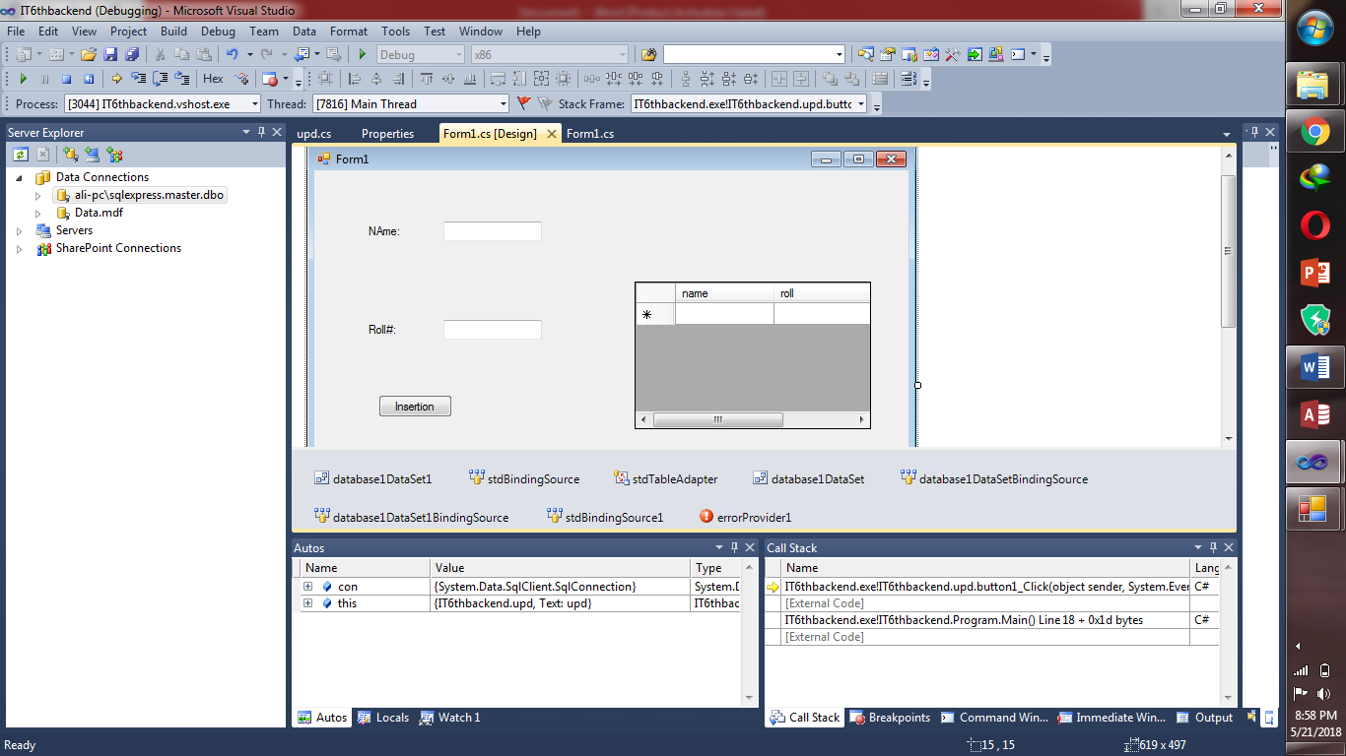

**Code:**

using System;

using System.Collections.Generic;

using System.ComponentModel;

using System.Data;

using System.Drawing;

using System.Linq;

using System.Text;

using System.Windows.Forms;

using System.Data.SqlClient;

namespace IT6thbackend

{

public partial class Form1 : Form

{

public Form1()

{

InitializeComponent();

}

private void Form1_Load(object sender, EventArgs e)

{

// TODO: This line of code loads data into the 'database1DataSet1.std' table. You can move, or remove it, as needed.

this.stdTableAdapter.Fill(this.database1DataSet1.std);

}

//if user lets text box b empty ..it will show an alert

private void button1_Click(object sender, EventArgs e)

{

if (textBox1.Text == "")

{

errorProvider1.SetError(textBox1, "plz enter name");

}

else

{

//establish connection with database

SqlConnection con = new SqlConnection("Data Source=.\\SQLEXPRESS;AttachDbFilename=C:\\Users\\ali\\Documents\\Visual Studio 2010\\Projects\\IT6thbackend\\IT6thbackend\\Data.mdf;Integrated Security=True;User Instance=True");

con.Open();

//string queryy = "insert into std(name,roll) values('"+textBox1.Text+"','"+textBox2.Text+"')";

SqlCommand cmd = new SqlCommand("insert into std(name,roll) values(@fname,@rolln)", con);

cmd.Parameters.AddWithValue("@fname", textBox1.Text);

cmd.Parameters.AddWithValue("@rolln", textBox2.Text);

cmd.ExecuteNonQuery();

con.Close();

MessageBox.Show("values inserted successfully");

}

}

//when user click on update button a new form named “update” will b opened

private void button2_Click(object sender, EventArgs e)

{

upd update = new upd();

update.Show();

}

}

}

//code behind update form

using System;

using System.Collections.Generic;

using System.ComponentModel;

using System.Data;

using System.Drawing;

using System.Linq;

using System.Text;

using System.Windows.Forms;

using System.Data.SqlClient;

namespace IT6thbackend

{

public partial class upd : Form

{

public upd()

{

InitializeComponent();

}

private void button1_Click(object sender, EventArgs e)

{

SqlConnection con = new SqlConnection("Data Source=.\\SQLEXPRESS;AttachDbFilename=C:\\Users\\DELL\\Documents\\Visual Studio 2010\\Projects\\IT6thbackend\\IT6thbackend\\Data.mdf;Integrated Security=True;User Instance=True");

con.Open();

//this will provide a dialog box in which we search the required value which is to b updated

SqlDataAdapter ad = new SqlDataAdapter("Select * from std where roll='" + textBox1.Text + "'", con);

DataSet ds = new DataSet();

ad.Fill(ds);

int i = ds.Tables[0].Rows.Count;

if (i == 0)

{

label4.Visible = true;

}

else

{

groupBox2.Visible = true;

textBox2.Text = ds.Tables[0].Rows[0].ItemArray[1].ToString();

textBox3.Text = ds.Tables[0].Rows[0].ItemArray[0].ToString();

}

}

//code of updating database

private void button2_Click(object sender, EventArgs e)

{

SqlConnection con = new SqlConnection("Data Source=.\\SQLEXPRESS;AttachDbFilename=C:\\Users\\DELL\\Documents\\Visual Studio 2010\\Projects\\IT6thbackend\\IT6thbackend\\Database1.mdf;Integrated Security=True;User Instance=True");

con.Open();

SqlCommand cmd = new SqlCommand("update std set name='" + textBox3.Text + "',roll='" + textBox2.Text + "'where roll='"+textBox1.Text+"'", con);

cmd.ExecuteNonQuery();

MessageBox.Show("successfully updated");

}

}

}

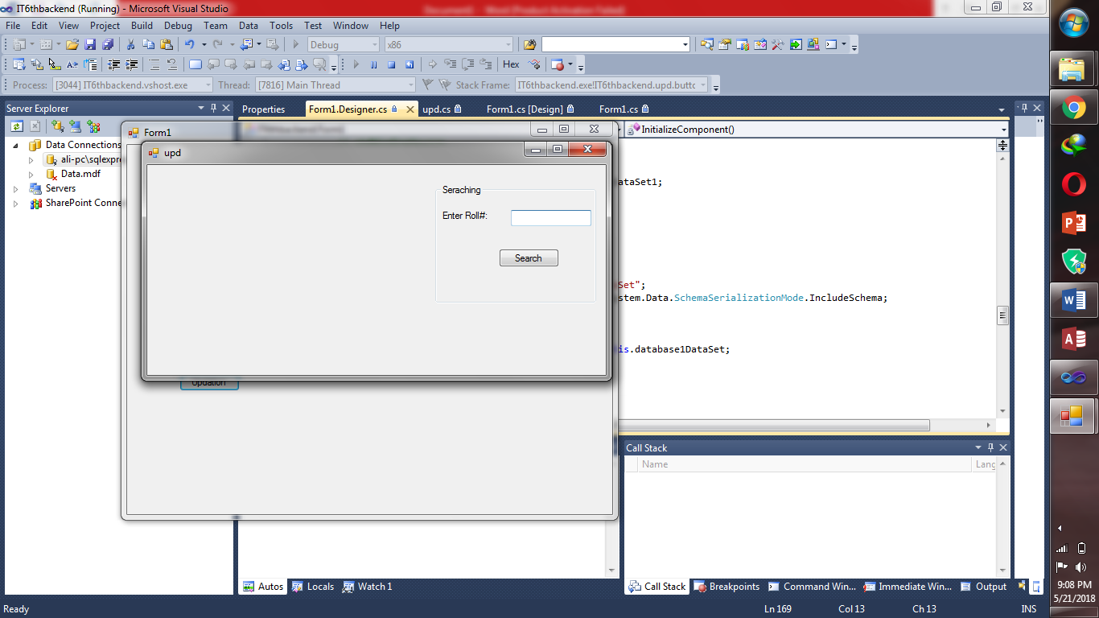

**Task2:Notepad**

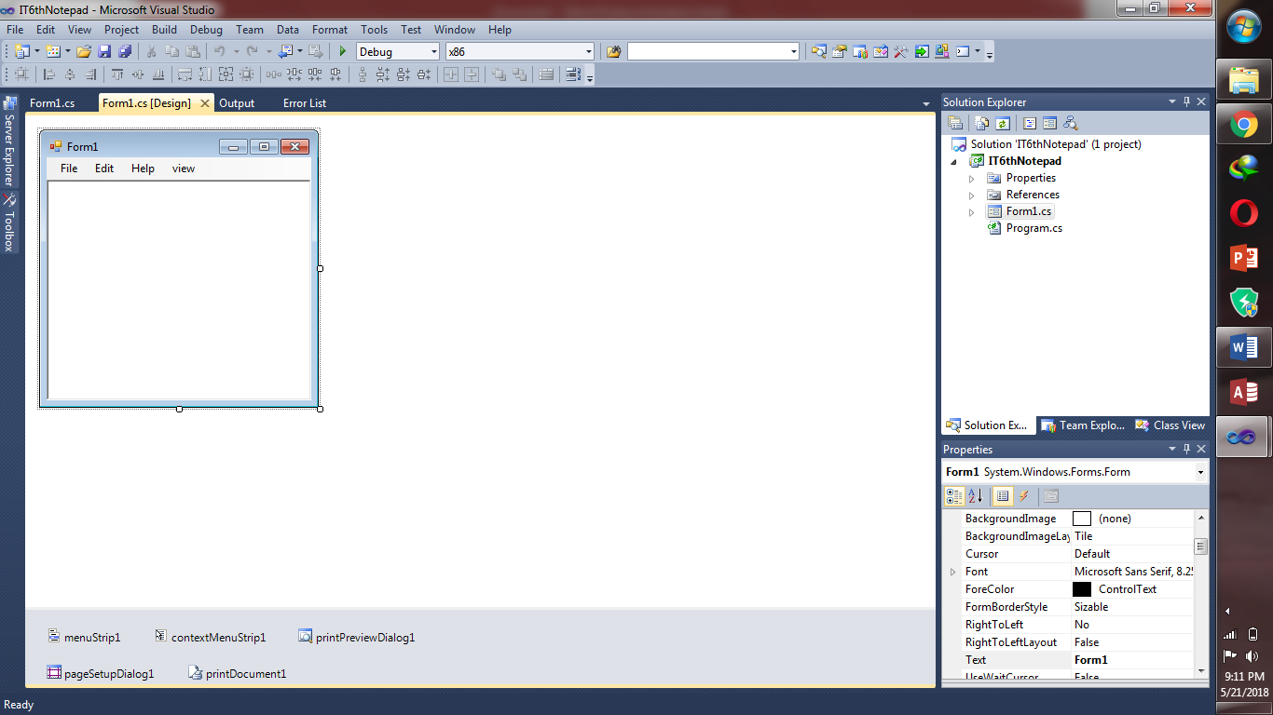

**Code:**

using System;

using System.Collections.Generic;

using System.ComponentModel;

using System.Data;

using System.Drawing;

using System.Linq;

using System.Text;

using System.Windows.Forms;

namespace IT6thNotepad

{

public partial class Form1 : Form

{

public Form1()

{

InitializeComponent();

}

private void newToolStripMenuItem_Click(object sender, EventArgs e)

{

richTextBox1.Clear();

}

private void exitToolStripMenuItem_Click(object sender, EventArgs e)

{

Application.Exit();

}

private void cutToolStripMenuItem_Click(object sender, EventArgs e)

{

richTextBox1.Cut();

}

private void openToolStripMenuItem_Click(object sender, EventArgs e)

{

OpenFileDialog op = new OpenFileDialog();

if (op.ShowDialog() == DialogResult.OK)

{

richTextBox1.LoadFile(op.FileName, RichTextBoxStreamType.PlainText);

}

this.Text = op.FileName;

}

private void saveToolStripMenuItem_Click(object sender, EventArgs e)

{

SaveFileDialog sa = new SaveFileDialog();

sa.Filter = "Text document(*.text)|*.txt|html file|*.htm";

if (sa.ShowDialog() == DialogResult.OK)

{

richTextBox1.SaveFile(sa.FileName, RichTextBoxStreamType.PlainText);

}

MessageBox.Show("File Has been Saved", "Notepad", MessageBoxButtons.OKCancel, MessageBoxIcon.Information);

}

private void printToolStripMenuItem_Click(object sender, EventArgs e)

{

printPreviewDialog1.Document = printDocument1;

printPreviewDialog1.Show();

}

private void printSetupToolStripMenuItem_Click(object sender, EventArgs e)

{

PrintDialog p1 = new PrintDialog();

if (p1.ShowDialog() == DialogResult.OK)

{

var d = richTextBox1.Text;

}

}

private void printDocument1_PrintPage(object sender, System.Drawing.Printing.PrintPageEventArgs e)

{

Font f=new Font("Times New Roman",16);

var b=Brushes.Blue;

PointF pp=new PointF();

pp.X=50;

pp.Y=100;

e.Graphics.DrawString(richTextBox1.Text,f,b,pp);

}

private void printPreviewDialog1_Load(object sender, EventArgs e)

{

// do ur own

}

}

}

**Task3:there are 3 forms in this app**

**Form1,form2,form3**

**First have a look at “form1”**

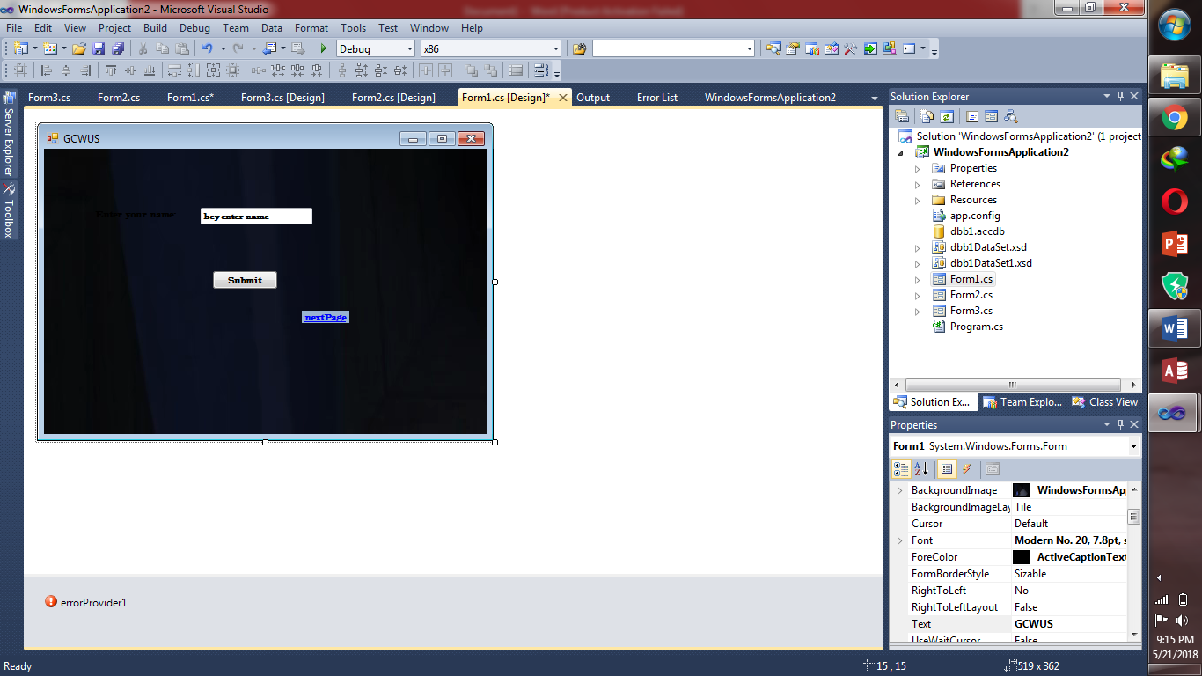

**Code behind form1:**

using System;

using System.Collections.Generic;

using System.ComponentModel;

using System.Data;

using System.Drawing;

using System.Linq;

using System.Text;

using System.Windows.Forms;

using System.Data.SqlClient;

using System.Data.OleDb;

namespace WindowsFormsApplication2

{

public partial class Form1 : Form

{

public Form1()

{

InitializeComponent();

}

// public static string Conect()

/*OleDbConnection con = new OleDbConnection("Provider=Microsoft.ACE.OLEDB.12.0;Data Source=C:\\Users\\DELL\\Documents\\Visual Studio 2010\\Projects\\New folder\\WindowsFormsApplication2\\WindowsFormsApplication2\\dbb1.accdb");

string a = con;

return a;*/

private void submit_Click(object sender, EventArgs e)

{

if (name.Text == "")

{

errorProvider1.SetError(name, "please enter name");

}

else

{

var a = name.Text;

MessageBox.Show("you enetred " + a);

try

{

OleDbConnection con = new OleDbConnection("Provider=Microsoft.ACE.OLEDB.12.0;Data Source=C:\\Users\\DELL\\Documents\\Visual Studio 2010\\Projects\\New folder\\WindowsFormsApplication2\\WindowsFormsApplication2\\dbb1.accdb");

// string cone = Conect();

OleDbDataAdapter cmd = new OleDbDataAdapter("select * from std ", Properties.Settings.Default.connectionn);

DataSet ds = new DataSet();

cmd.Fill(ds);

int i = ds.Tables[0].Rows.Count;

if (i > 0)

{

MessageBox.Show("done");

Form3 fr = new Form3();

fr.Show();

}

else

MessageBox.Show("sorry");

}

catch (Exception ex)

{

MessageBox.Show("error" + ex);

}

}

}

private void linkLabel1_LinkClicked(object sender, LinkLabelLinkClickedEventArgs e)

{

Form2 Form2 = new Form2();

Form2.Show();

}

}

}

**Form2:**

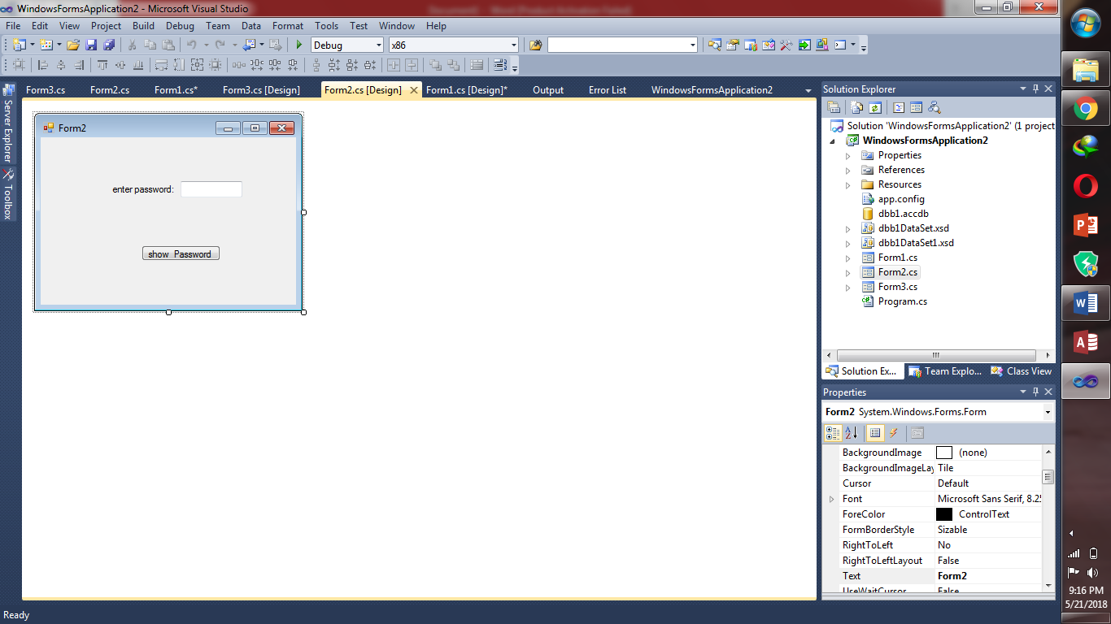

**Code of form2:**

using System;

using System.Collections.Generic;

using System.ComponentModel;

using System.Data;

using System.Drawing;

using System.Linq;

using System.Text;

using System.Windows.Forms;

namespace WindowsFormsApplication2

{

public partial class Form2 : Form

{

public Form2()

{

InitializeComponent();

}

private void sh0wme_Click(object sender, EventArgs e)

{

label2.Text = password.Text;

}

}

}

**Form3:**

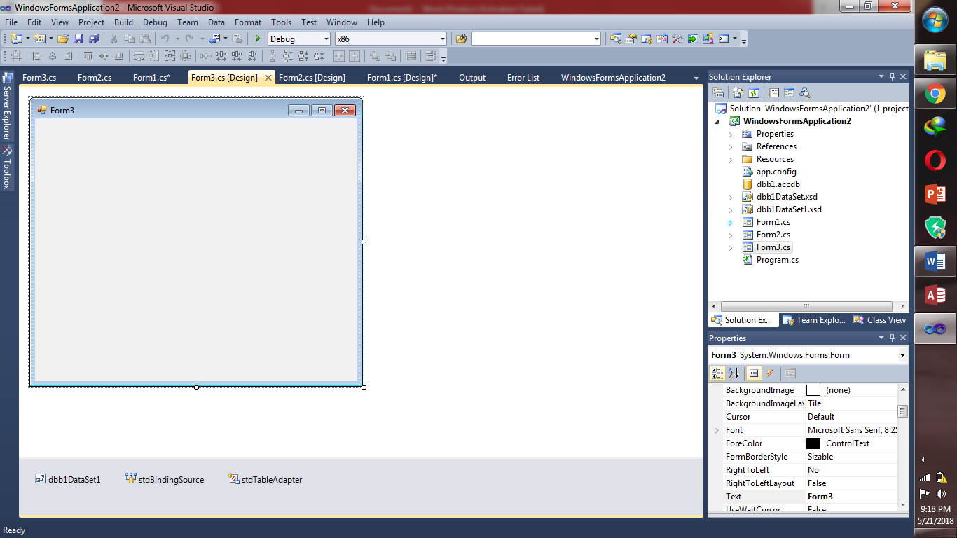

**Code of form3:**

using System;

using System.Collections.Generic;

using System.ComponentModel;

using System.Data;

using System.Drawing;

using System.Linq;

using System.Text;

using System.Windows.Forms;

using System.Data.OleDb;

namespace WindowsFormsApplication2

{

public partial class Form3 : Form

{

public Form3()

{

InitializeComponent();

}

public static OleDbConnection conect()

{

OleDbConnection con = new OleDbConnection("Provider=Microsoft.ACE.OLEDB.12.0;Data Source=C:\\Users\\DELL\\Documents\\Visual Studio 2010\\Projects\\New folder\\WindowsFormsApplication2\\WindowsFormsApplication2\\dbb1.accdb");

con.Open();

}

private void Form3_Load(object sender, EventArgs e)

{

// TODO: This line of code loads data into the 'dbb1DataSet1.std' table. You can move, or remove it, as needed.

//this.stdTableAdapter.Fill(this.dbb1DataSet1.std);

DataGridView gr = new DataGridView();

gr.DataSource =;

this.Controls.Add(gr);

}

private void stdBindingSource_CurrentChanged(object sender, EventArgs e)

{

}

}

}

**Task4:onload provides a field to enter name(runtime changes)**

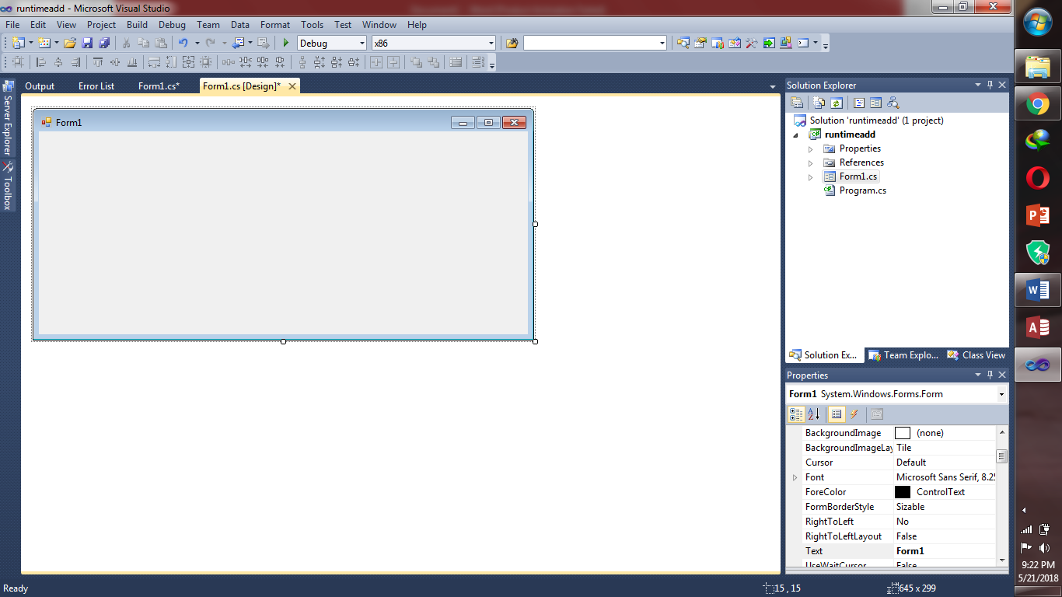

**Code:**

using System;

using System.Collections.Generic;

using System.ComponentModel;

using System.Data;

using System.Drawing;

using System.Linq;

using System.Text;

using System.Windows.Forms;

namespace runtimeadd

{

public partial class Form1 : Form

{

private TextBox t = new TextBox();

private Label l1 = new Label();

public Form1()

{

/* InitializeComponent();

TextBox t = new TextBox();

t.Name = "tname";

t.Text = "Enter Name";

t.Location=new System.Drawing.Point(50,2);

Label l1 = new Label();

l1.Name = "namel";

l1.Text = "Name:";

this.Controls.Add(t);

this.Controls.Add(l1);

} */

private void Form1_Load(object sender, EventArgs e)

{

t.Name = "Name";

t.Text = "Name";

t.Location = new System.Drawing.Point(70, 2);

l1.Name = "lname";

l1.Text = "Enter Name:";

this.Controls.Add(t);

this.Controls.Add(l1);

}

}

}

**If we enable the commented area**

**Then output will b like that:**

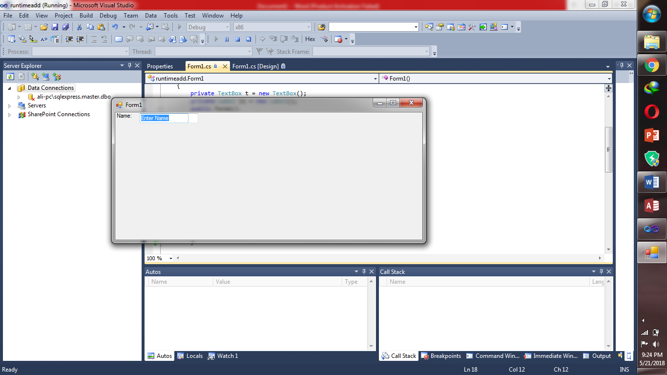

**Task5:**

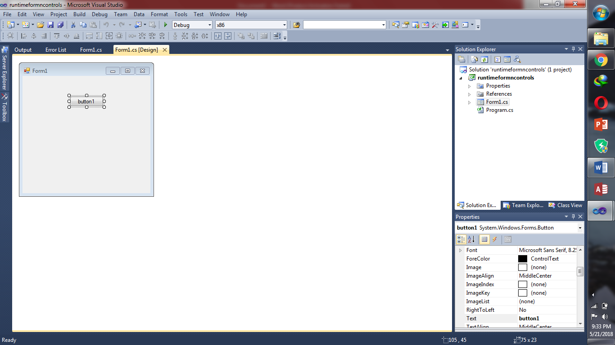

**Code:**

using System;

using System.Collections.Generic;

using System.ComponentModel;

using System.Data;

using System.Drawing;

using System.Linq;

using System.Text;

using System.Windows.Forms;

namespace runtimeadd

{

public partial class Form1 : Form

{

private TextBox t = new TextBox();

private Label l1 = new Label();

public Form1()

{

InitializeComponent();

TextBox t = new TextBox();

t.Name = "tname";

t.Text = "Enter Name";

t.Location=new System.Drawing.Point(50,2);

Label l1 = new Label();

l1.Name = "namel";

l1.Text = "Name:";

this.Controls.Add(t);

this.Controls.Add(l1);

}

private void Form1_Load(object sender, EventArgs e)

{

t.Name = "Name";

t.Text = "Name";

t.Location = new System.Drawing.Point(70, 2);

l1.Name = "lname";

l1.Text = "Enter Name:";

this.Controls.Add(t);

this.Controls.Add(l1);

}

}

}

**Task6:**

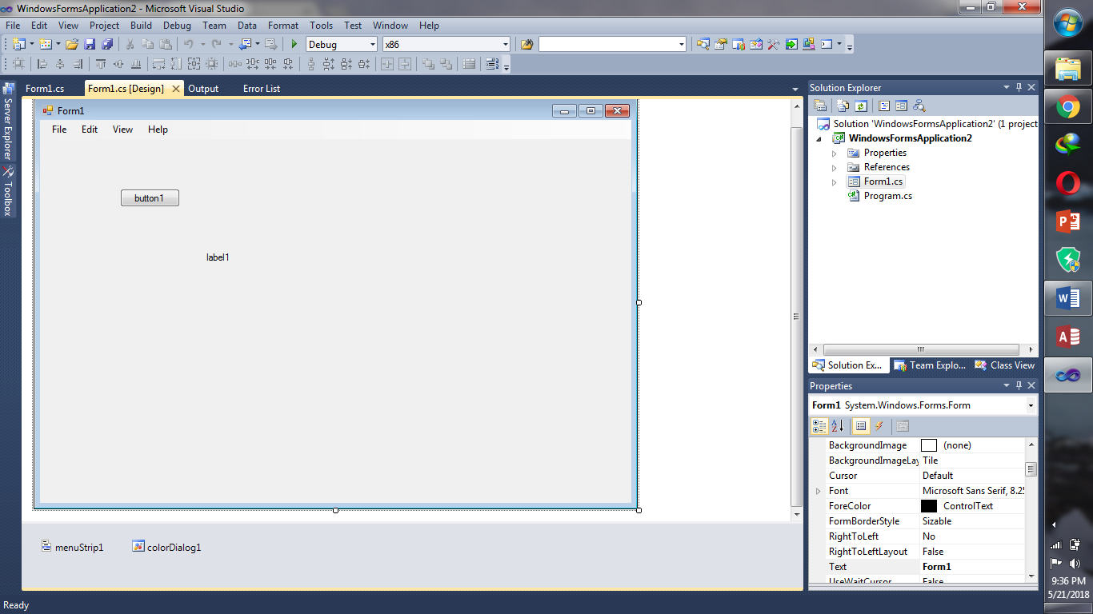

**Code:**

using System;

using System.Collections.Generic;

using System.ComponentModel;

using System.Data;

using System.Drawing;

using System.Linq;

using System.Text;

using System.Windows.Forms;

namespace WindowsFormsApplication2

{

public partial class Form1 : Form

{

private Label b = new Label();

public Form1()

{

InitializeComponent();

}

private void button1_Click(object sender,System.EventArgs e)

{

((Button)sender).Text = "Clicked!";

label1.Visible = true;

label1.Text = "this is clicked";

Button b = new Button();

b.Name = "b2";

b.Text = "New Button!";

this.Controls.Add(b);

MessageBox.Show("hey", "ok", MessageBoxButtons.YesNoCancel, MessageBoxIcon.Exclamation);

}}}

**Output: if we click the button**

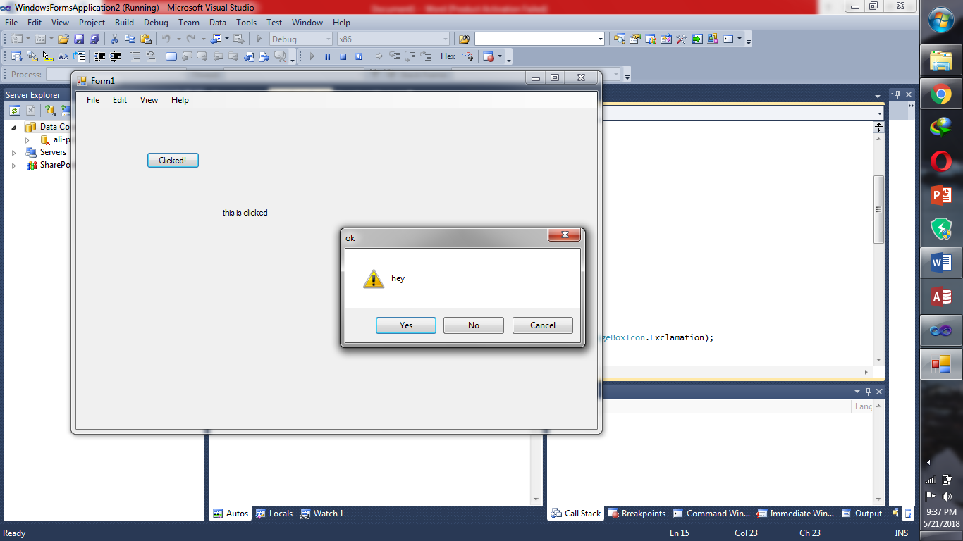

**Task7:there are also 2 forms… first we’ll go through form1**

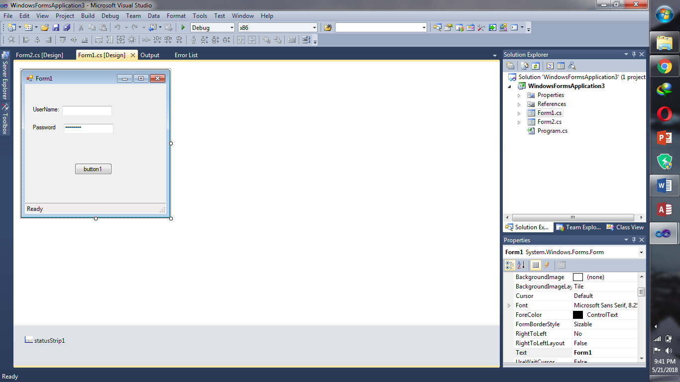

**Code:**

using System;

using System.Collections.Generic;

using System.ComponentModel;

using System.Data;

using System.Drawing;

using System.Linq;

using System.Text;

using System.Windows.Forms;

namespace WindowsFormsApplication3

{

public partial class Form1 : Form

{

public string name

{

get

{

var a= nam.Text;

return a;

}

}

public string pword

{

get

{

return p.Text;

}

}

public Form1()

{

InitializeComponent();

}

public void button1_Click(object sender, EventArgs e)

{

var a = nam.Text;

var b = p.Text;

Form2 f = new Form2(a,b);

f.Show();

}

}

}

**Form2:**

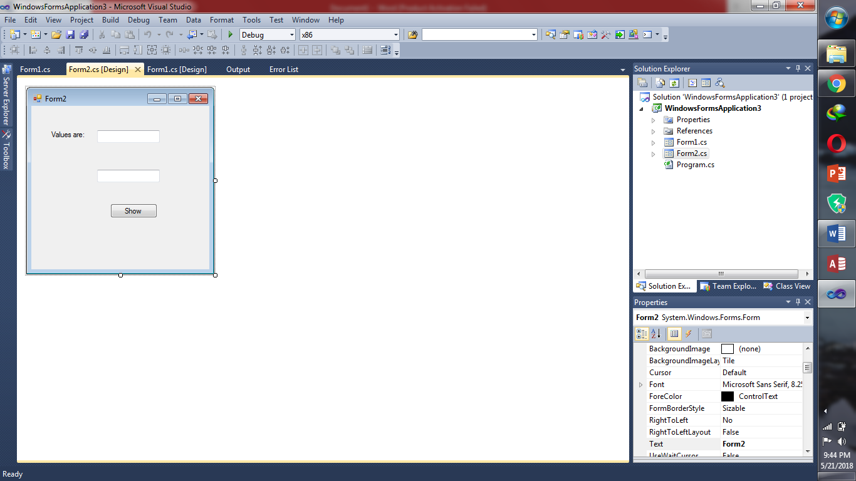

**Code:**

using System;

using System.Collections.Generic;

using System.ComponentModel;

using System.Data;

using System.Drawing;

using System.Linq;

using System.Text;

using System.Windows.Forms;

namespace WindowsFormsApplication3

{

public partial class Form2 : Form

{

public Form2()

{

InitializeComponent();

//textBox1.Text = n;

//textBox2.Text = pa;

}

public string uname

{

set

{

textBox1.Text = value;

}

}

public string password

{

set

{

textBox2.Text = value;

}

}

private void button1_Click(object sender, EventArgs e)

{

Form1 f = new Form1();

textBox1.Text = f.nam.Text;

textBox2.Text = f.p.Text;

// uname = f.name;

// password = f.pword;

}

}

}

**Task8: tWO forms**

**Form1:**

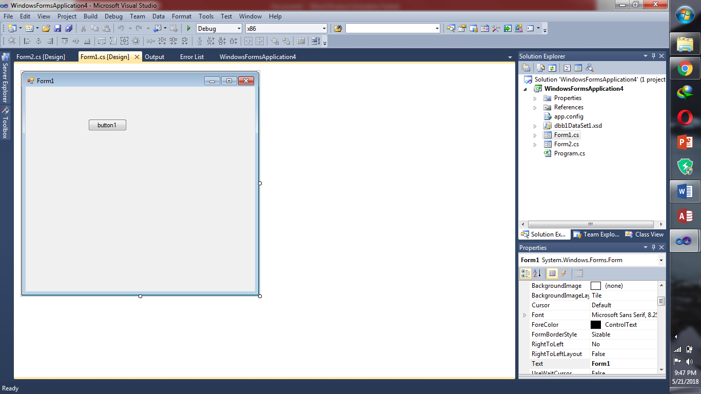

**Code:**

using System;

using System.Collections.Generic;

using System.ComponentModel;

using System.Data;

using System.Drawing;

using System.Linq;

using System.Text;

using System.Windows.Forms;

using System.Data.OleDb;

namespace WindowsFormsApplication4

{

public partial class Form1 : Form

{

public Form1()

{

InitializeComponent();

}

private void button1_Click(object sender, EventArgs e)

{

OleDbDataAdapter dpp = new OleDbDataAdapter("select * from std", Properties.Settings.Default.connectionn);

DataSet ds = new DataSet();

dpp.Fill(ds);

int i = ds.Tables[0].Rows.Count;

if (i > 0)

{

/* Form2 fr = new Form2();

fr.Show();*/

DataGrid g1 = new DataGrid();

g1.DataSource("dbb1DataSet");

g1.Show();

this.Controls.Add(g1);

}

else

MessageBox.Show("sorry");

}

}

}

**Form2:**

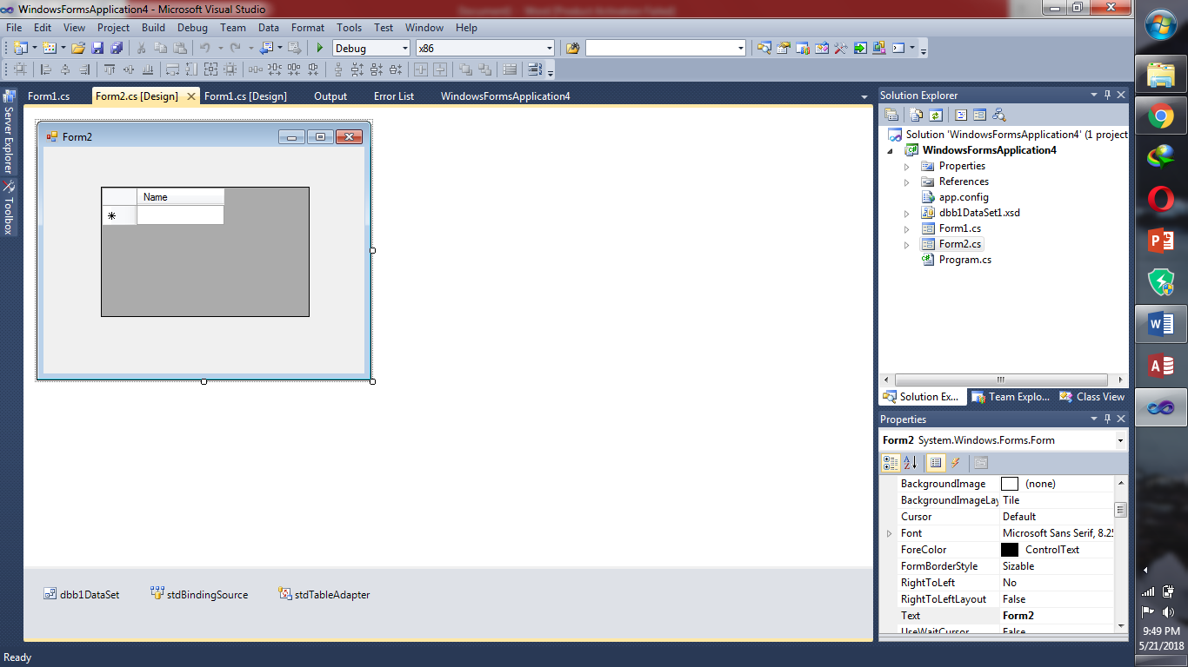

**Code:**

using System;

using System.Collections.Generic;

using System.ComponentModel;

using System.Data;

using System.Drawing;

using System.Linq;

using System.Text;

using System.Windows.Forms;

namespace WindowsFormsApplication4

{

public partial class Form2 : Form

{

public Form2()

{

InitializeComponent();

}

private void Form2_Load(object sender, EventArgs e)

{

// TODO: This line of code loads data into the 'dbb1DataSet.std' table. You can move, or remove it, as needed.

this.stdTableAdapter.Fill(this.dbb1DataSet.std);

}

}

}