**Design Documentation**

**Submitted to: Madam Sidra**

**Submitted by: Ayeza,Wafa & sheeza**

**Roll nos. 21,24,25**

**Department IT 5th semester**

**GCWUS**

**Activity diagram:**

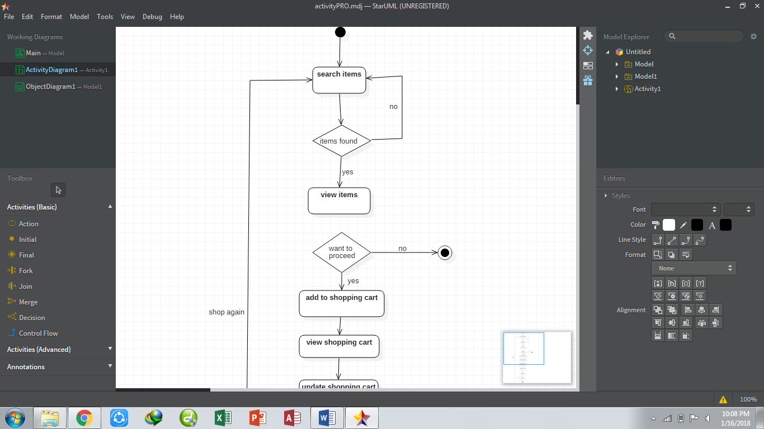

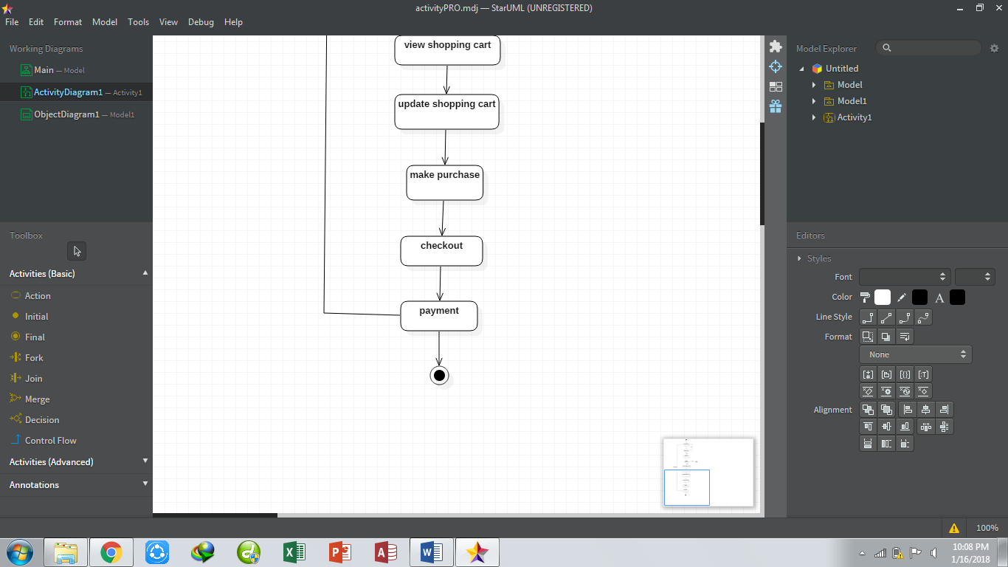

**Class diagram:**

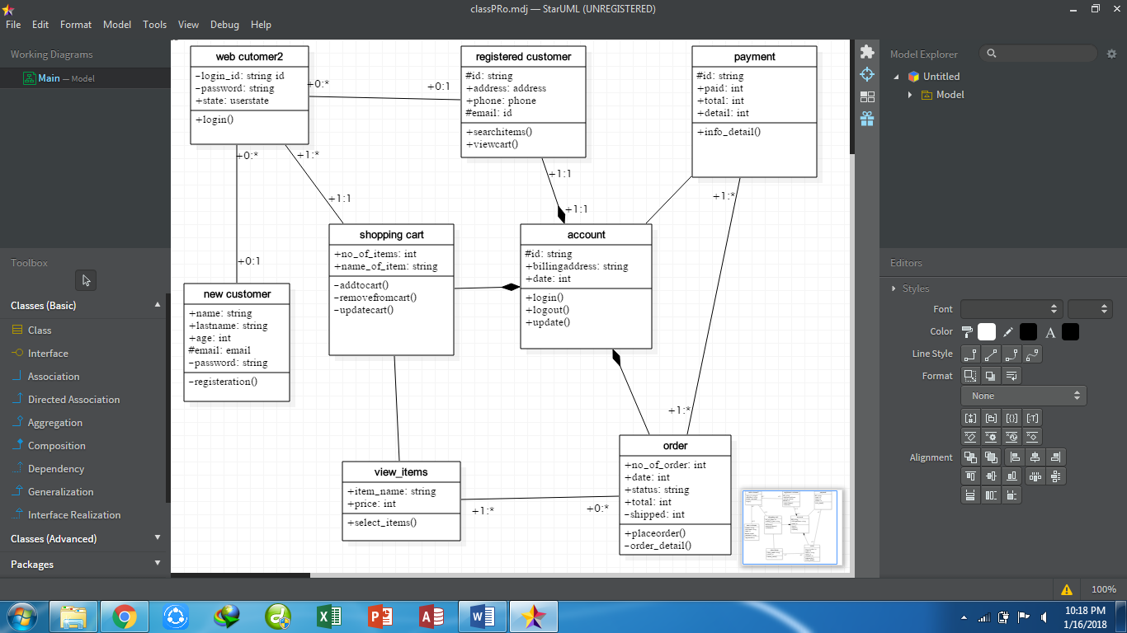

**Component diagram:**

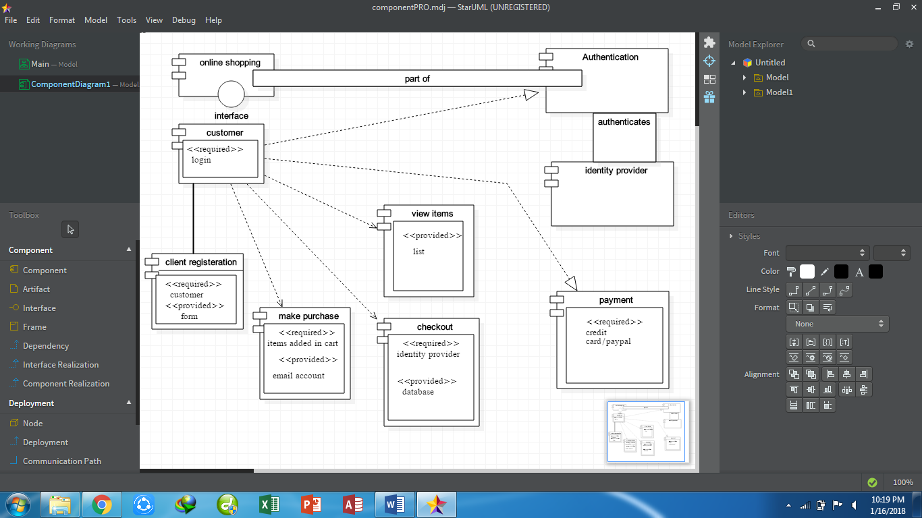

**Deployment diagram:**

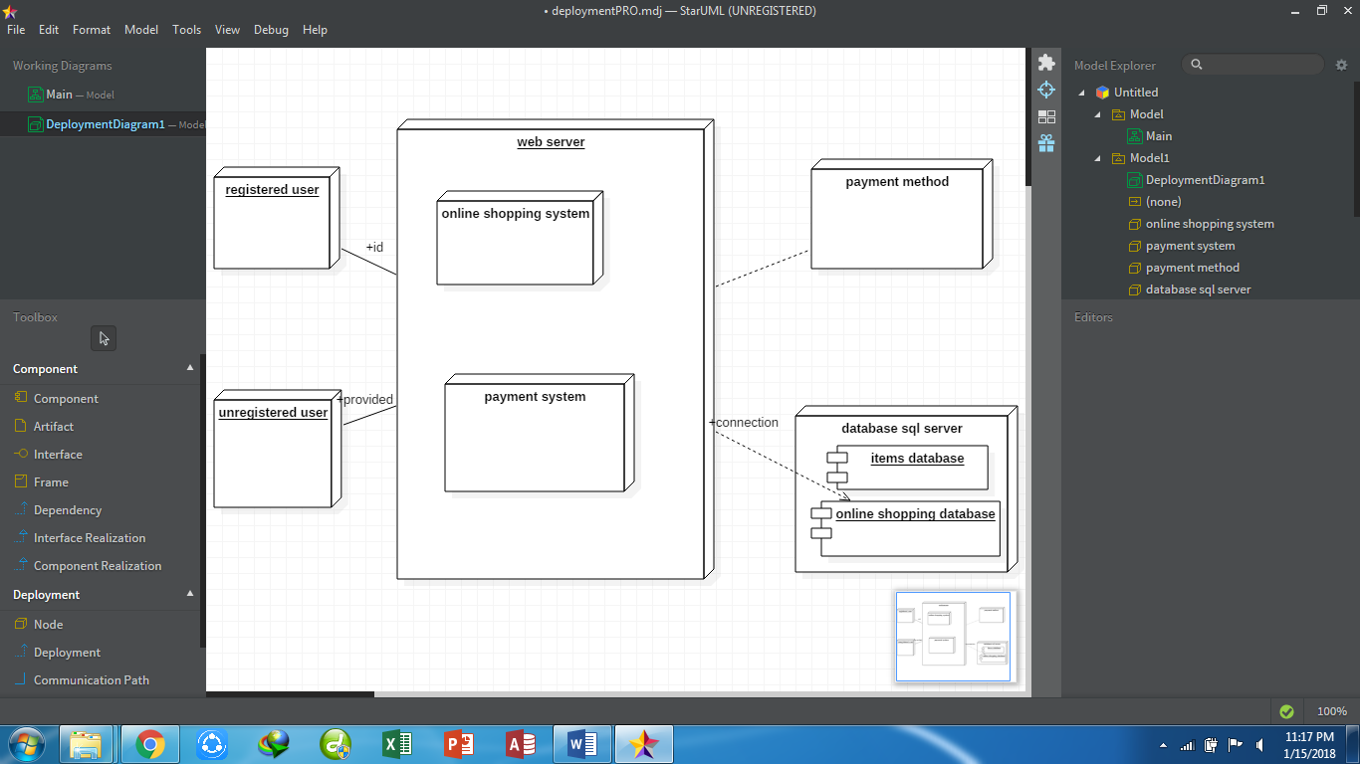

**Sequence diagram:**

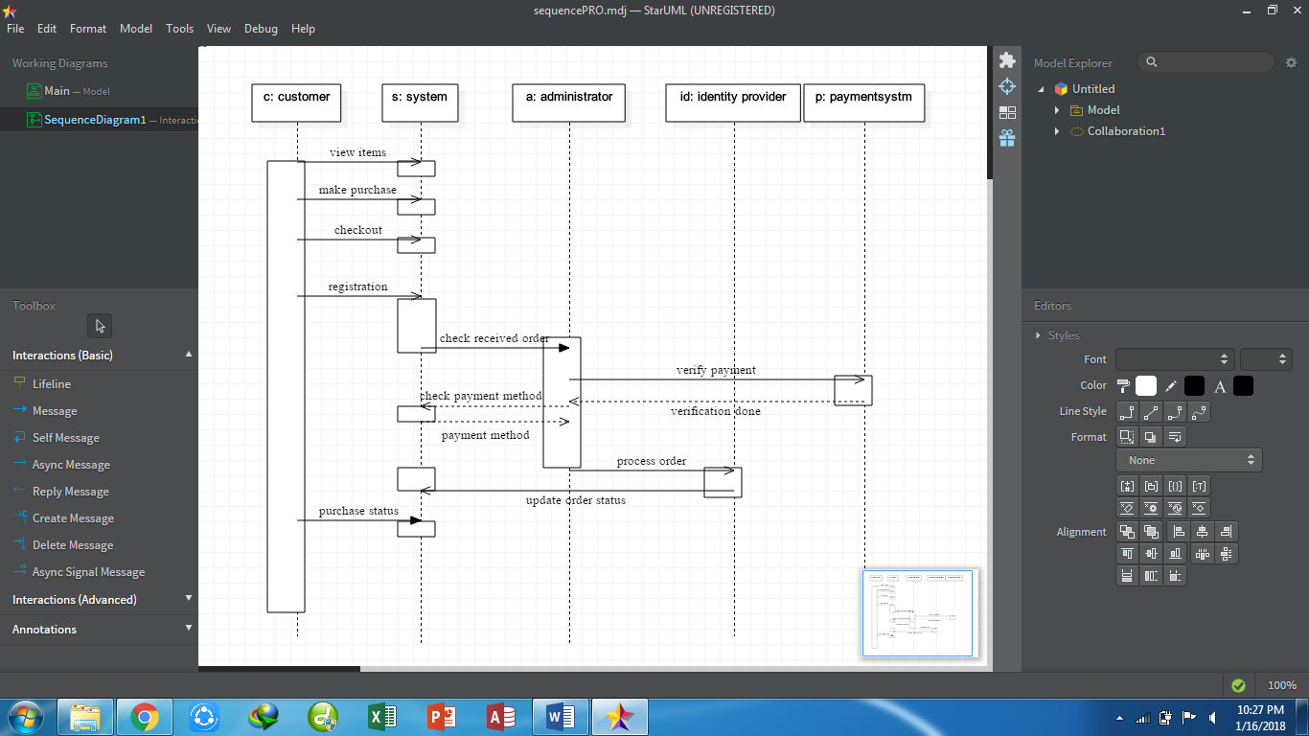

**State diagram:**

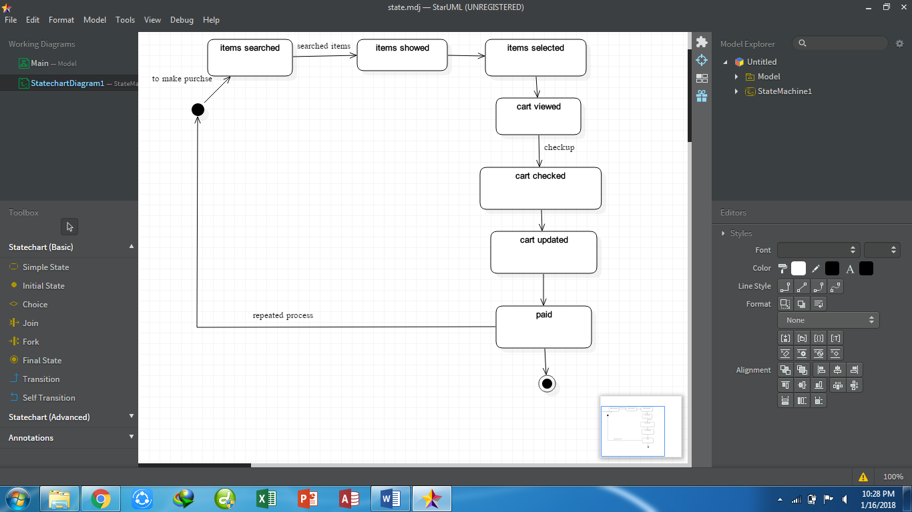

**Object diagram:**

**D#1:**

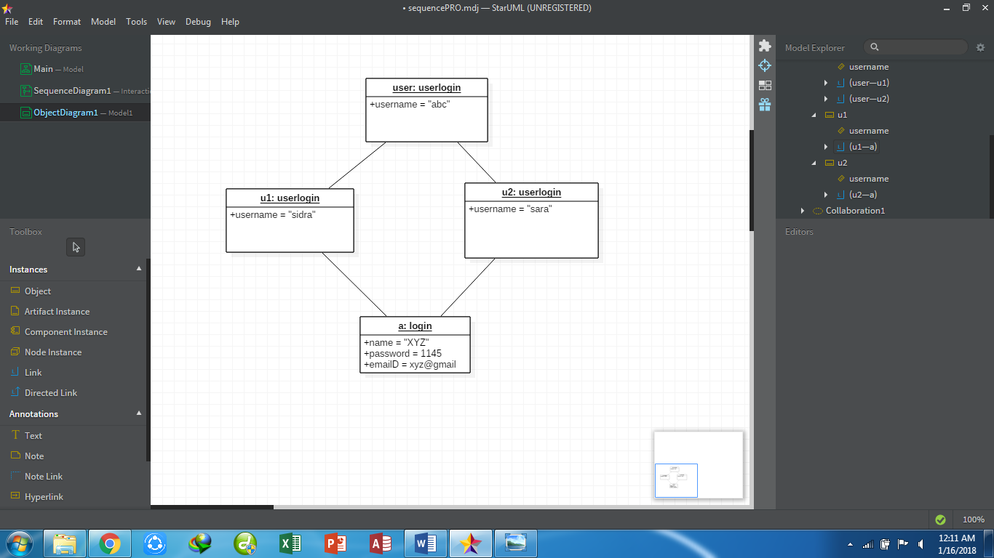

**D#2:**

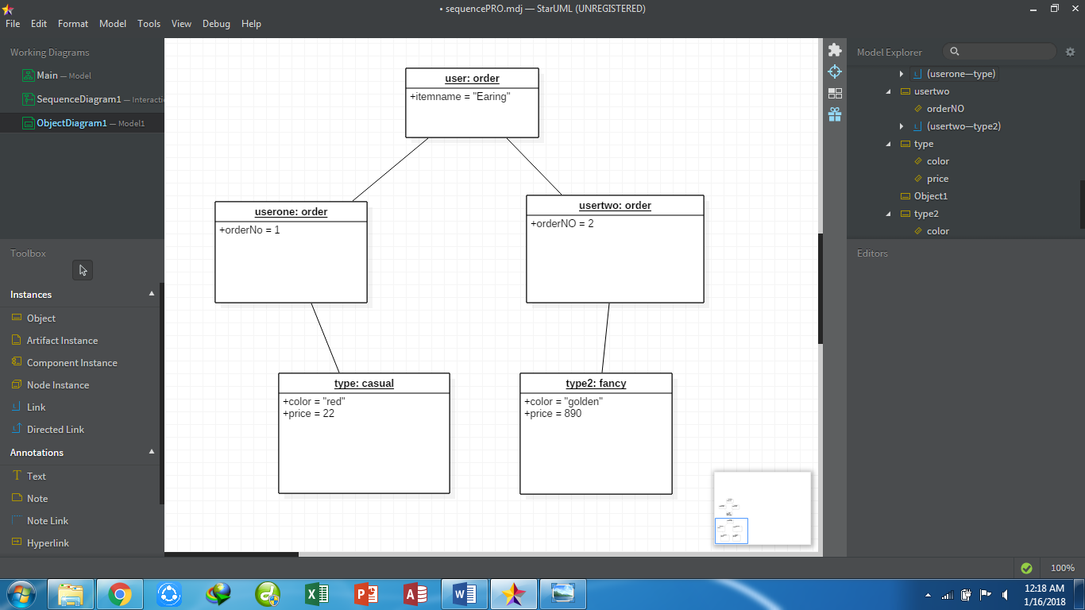

**D#3:**

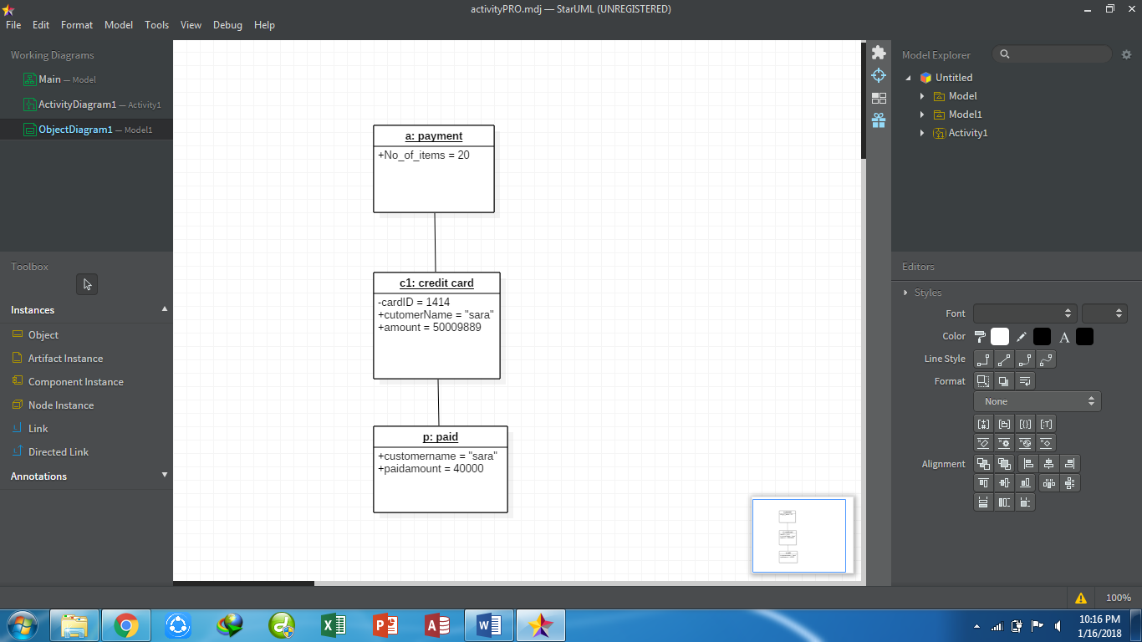

**Collaboration diagram:**

