TO-DOLIST

2025


January 22

SUBMITTED TO: SIR MUZAHIR SALEEM
SUBMITTED BY: AAIMA GHALIB (S2023266115)
CH. M. HASHIR (F2022065252)



Abstract
The "To-Do List Website Using Web Technologies" project showcases a modern web-based application designed to simplify daily task management. By utilizing technologies such as HTML, CSS, JavaScript,BOOTSTRAP, PHP,DOM and SQL, it offers a user-centric platform for creating, editing, organizing, and tracking tasks. Key pages include the homepage, task dashboard, user profile, authentication modules, and feedback sections. This system delivers real-time interactivity and robust data handling while addressing challenges like live updates and validation. Future improvements may include task prioritization, reminders, and enhanced interactivity.

Introduction
Purpose
In today's dynamic environment, managing tasks effectively is vital. This project aims to provide a streamlined, user-friendly solution to enhance personal productivity.
Key Objectives
- Enable effective task management with CRUD operations.
- Offer a responsive, intuitive interface for users.
- Ensure data security through secure user authentication.
- Integrate real-time updates using AJAX for a smooth user experience.
Scope
- Categorized task management for better organization.
- Multi-platform responsiveness for mobile and desktop users.
- Secure login and session management.
- Integration of feedback mechanisms.
Constraints
- Dependence on stable internet connectivity.
- Limited advanced security measures.
- Absence of automated reminders.

Technological Overview
Frontend Framework
- HTML: Provides page structure with semantic tags and task organization.
- CSS: Enhances design with responsiveness, animations, and layout optimizations.
- JavaScript & jQuery: Adds interactivity, validates input dynamically, and manages AJAX functionality.
Backend Framework
- PHP: Manages server-side logic, session handling, and data operations.
- SQL: Stores and queries user and task information, maintaining relational integrity.
- AJAX: Supports real-time data exchange, ensuring minimal server load and seamless interaction.

System Design
Core Architecture
- Frontend Layer: Interactive UI created with HTML, CSS, and JavaScript.
- Backend Layer: Secure and efficient data processing through PHP.
- Database Layer: Structured data storage using SQL for reliable access and integrity.
Operational Flow
- User registration/login for personalized access.
- Task management in the dashboard with CRUD functionalities.
- Dynamic updates rendered through AJAX calls.
- User profiles for a personalized experience.
- Feedback module to improve system interactivity.

Conclusion and Future Prospects
The To-Do List Website demonstrates the power of integrating web technologies to meet everyday organizational needs. Potential future upgrades include:
Incorporation of task reminders and push notifications.
Strengthened data security measures.
Enhanced customization and interactivity for users.
Wireframes:
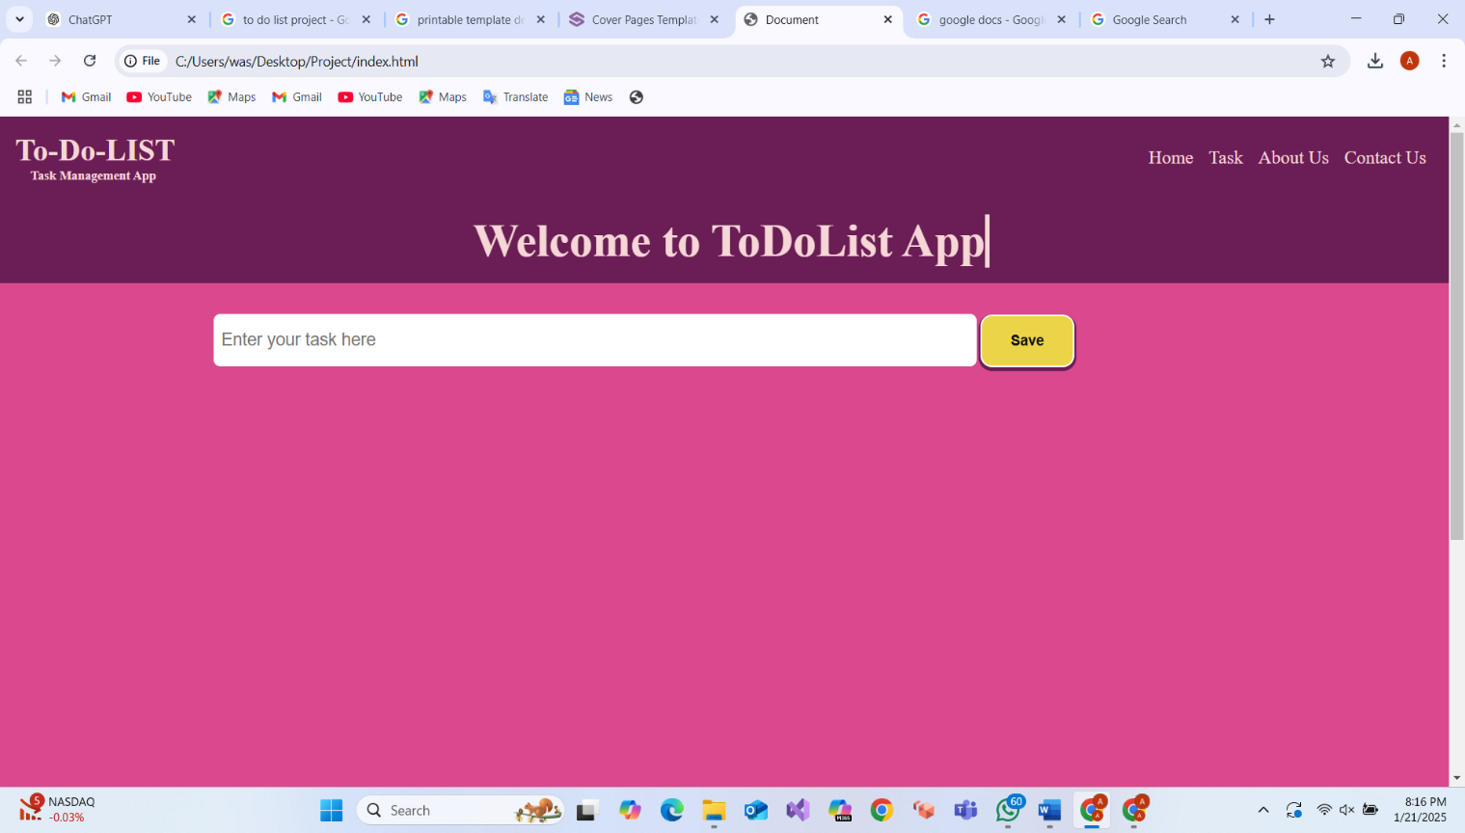

Tasks Dashboard:

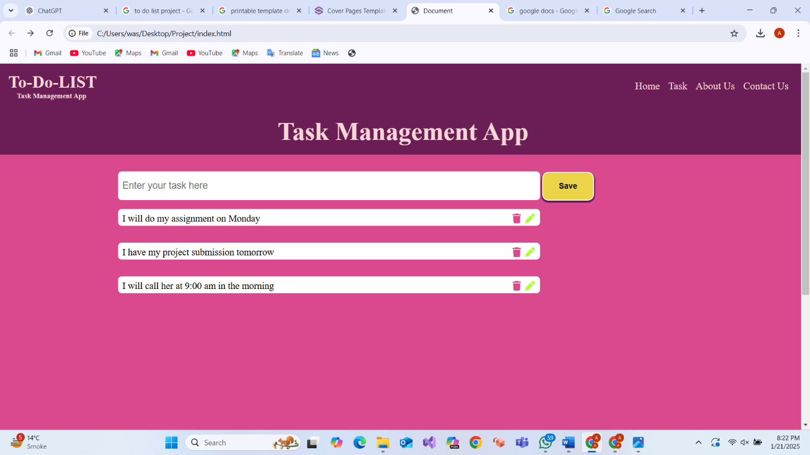

Why These Keys and Relationships Are Necessary
User authentication and task management form the backbone of a secure and efficient system. The unique key in the users table acts as an identifier that ties a user to their session. When a user logs in, this key is stored in the session, enabling the system to associate the user with their tasks in the tasks table. To uphold the integrity of this connection, the tasks table includes a foreign key, user_unique_key, which links each task to its corresponding user.
This design eliminates the possibility of unauthorized access by ensuring users cannot view or modify tasks that don’t belong to them, thus addressing potential privacy and security concerns. The foreign key constraint also enforces data consistency, making it impossible to create tasks for non-existent users or delete users who still have tasks assigned to them. These relationships empower users to manage their tasks securely and independently, ensuring task ownership and organized task handling.

The Issue of Shared Task Visibility
Without the user_unique_key foreign key in the tasks table, there would be no mechanism to restrict task access to specific users. This lack of restriction could lead to significant issues:
- Privacy Violations: Users might access and edit tasks that don’t belong to them.
- Data Integrity Risks: Tasks would lack a clear owner, increasing the likelihood of unauthorized modifications and data corruption.
For example, multiple users with distinct credentials (email, username) might see the same set of tasks, disrupting the system's functionality and violating privacy standards.

How the Relationship Resolves the Issue
The foreign key relationship between user_unique_key in the tasks table and the unique key in the users table addresses these challenges:
- It ensures each task is explicitly linked to its owner via the user's unique identifier.
- Queries executed against the tasks table automatically filter tasks by user, ensuring only the rightful owner can view or manage them.
For instance, the following query restricts task visibility to the logged-in user:
$stmt = $pdo->prepare("SELECT * FROM tasks WHERE user_unique_key = ?");
$stmt->execute([$user_unique_key]);
This setup guarantees that users can only access their tasks, fostering privacy, security, and efficient task management.
Detailed Pages:
STYLE.CSS:
This CSS code defines the styling for a task management web application, focusing on creating a user-friendly and visually appealing interface. The global styles ensure consistent padding and margin using the box-sizing property. The navbar is styled with a purple background and light pink text, featuring hover effects for interactivity. The main container is a flexbox layout designed for central alignment and organized content display. A dynamic heading includes a typing animation for an engaging visual effect. The input field for saving notes is styled with a clean, modern design and rounded corners. The save button uses vibrant colors, hover effects, and subtle animations to enhance interactivity. Task items are presented as neatly styled cards with interactive icons for delete and update actions, each featuring specific hover color transitions. Finally, the footer ties the design together with a consistent background, well-styled social icons, and navigation links, ensuring a cohesive and accessible user experience.

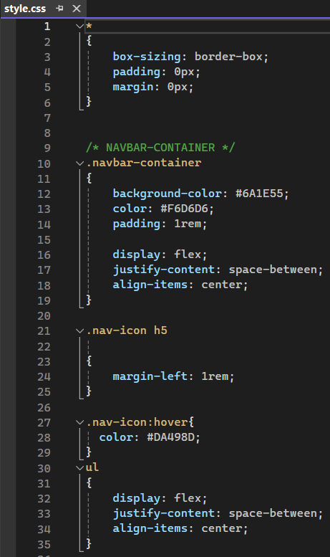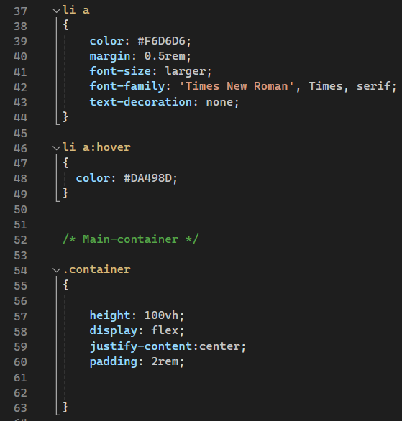
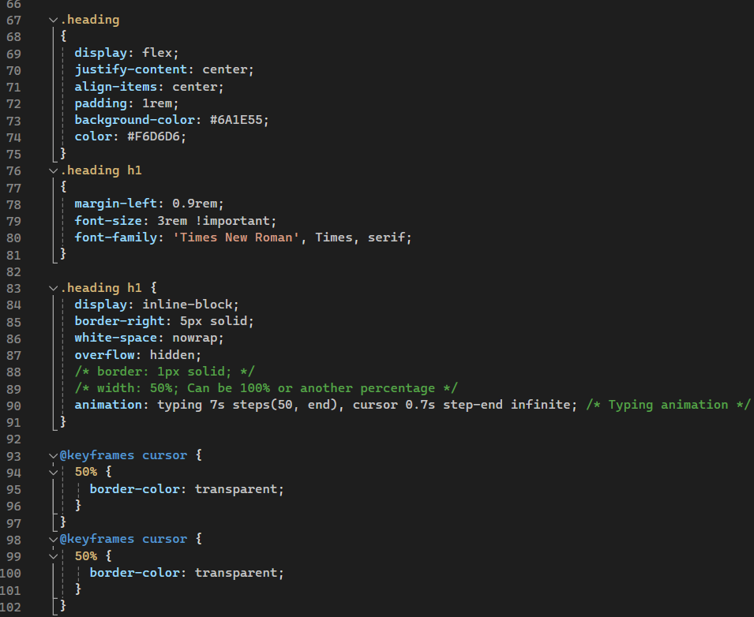
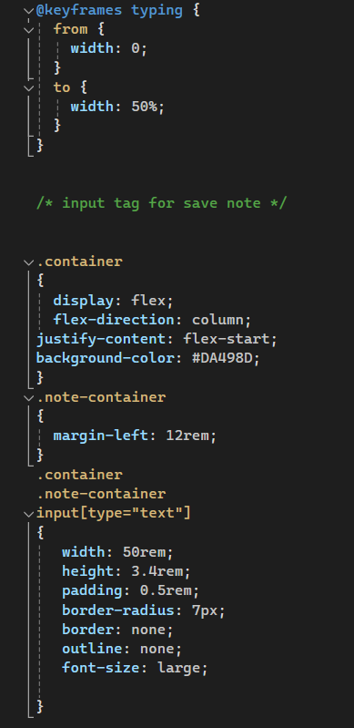
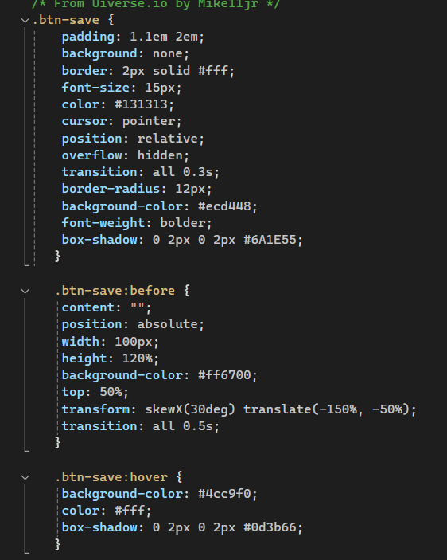
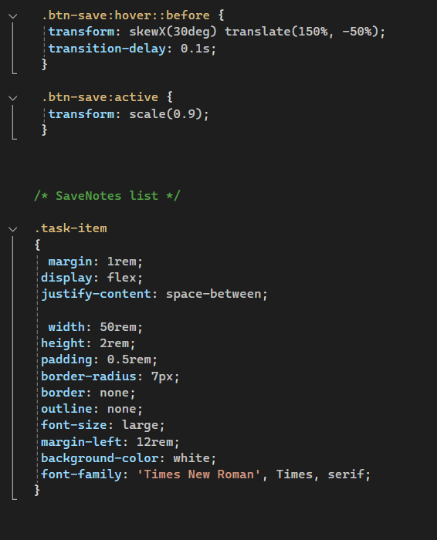
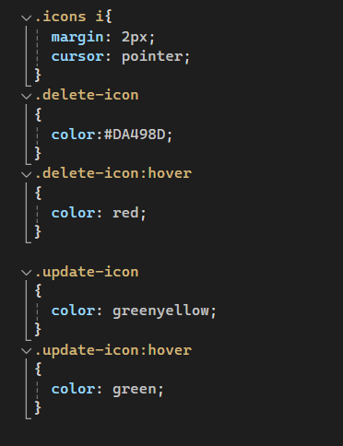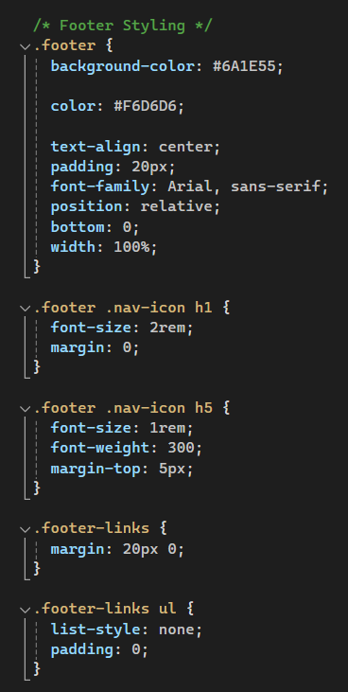
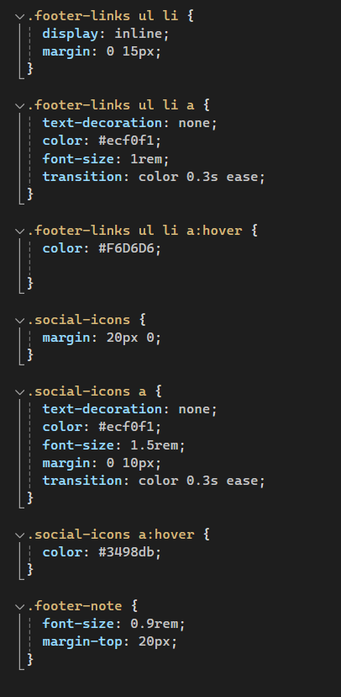

SIGNUP.CSS:

This CSS code provides the styling for a clean and simple login or registration form. The body is styled to center the form vertically and horizontally within the viewport using flexbox, with a light gray background (#f4f4f9) to provide a subtle contrast against the white form container. The form-container is given a white background with 30px padding, rounded corners, and a soft shadow for a modern, card-like effect. The h2 heading, centered at the top of the form, uses a dark gray color (#333) and has a margin below to separate it from the form elements. Each form-group has a margin at the bottom to ensure space between fields, and labels are styled with a small font size and matching color for consistency. The input fields (text, email, and password) are designed with a width of 100%, padding, and a light gray border for a clean, minimalistic look. The submit button has a green background (#5cb85c), rounded corners, and white text, with a hover effect that darkens the button color for better interactivity. Lastly, the form-footer section contains a link styled in green that turns underlined when hovered, encouraging user interaction for actions like password recovery or switching between login/registration pages. Overall, the design aims to be both aesthetically pleasing and easy to navigate.

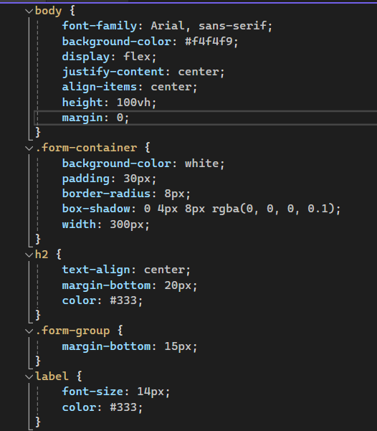

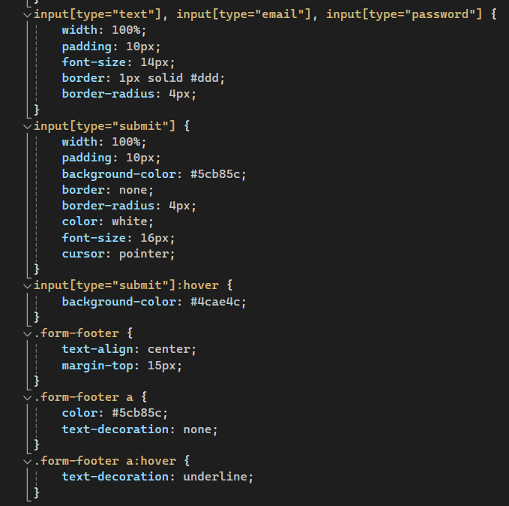
LOGIN.CSS:
This CSS code is designed to style a clean and modern form, likely for login or registration purposes, with an emphasis on usability and visual appeal.
- The general body styling ensures that the entire page has a light background color (#f4f7fc), and sets the font to Arial, providing a clean and modern look. Padding and margins are reset to 0 for consistency across browsers.
- The form container is centered horizontally with a width of 400px and vertically with a 100px margin from the top. It has a white background (#fff), padding for spacing, rounded corners, and a subtle shadow for a modern and professional feel.
- The heading (h2) is centered with a dark color (#333), and a generous margin is provided at the bottom to separate it from the form fields.
- Each form group is given a 20px bottom margin to create space between different input fields.
- Labels are styled with a smaller font size (14px) and a medium gray color (#555), providing a clear and simple presentation. Each label is displayed as a block to ensure proper alignment with the input fields.
- Input fields (text, email, password) are set to be full-width with consistent padding, and a soft border (#ccc) for a minimalist design. The box-sizing: border-box rule ensures the padding and borders don't affect the element’s width, maintaining layout consistency. When an input is focused, the border color changes to a blue shade (#5b9bd5), enhancing the user experience by providing visual feedback.
- The submit button has a blue background (#5b9bd5), white text, and a subtle transition effect on hover. On hover, the background color darkens to #3578a8, indicating that the button is interactive.
- Lastly, the footer link is styled with a blue color and no underlining by default. Upon hovering, the text becomes underlined, which is a common design pattern to indicate clickable links.
Overall, this CSS code ensures a modern, clean, and responsive form with clear input fields, visual feedback, and an attractive call-to-action button.

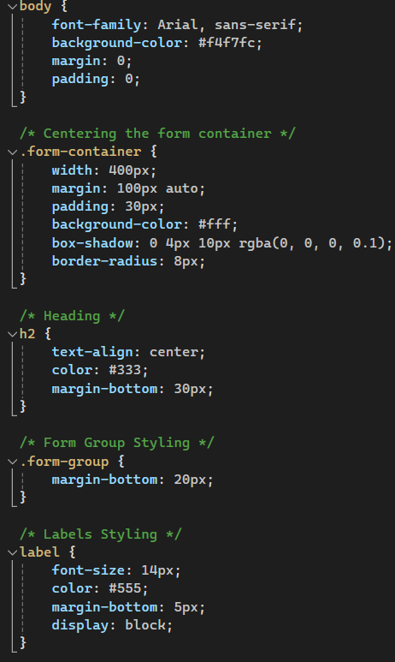
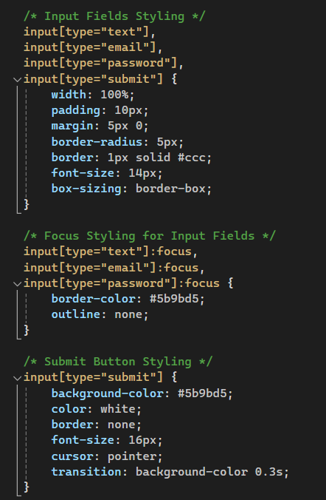
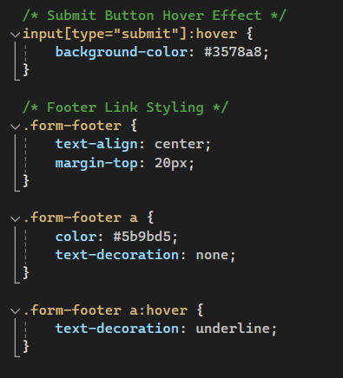
LOGIN.PHP:
This CSS code provides a comprehensive and visually appealing design for a form, focusing on user-friendliness and aesthetics. The page background is set to a light, neutral color (#f4f7fc), ensuring a calm and professional look. The form container is styled to be centered on the page, both horizontally and vertically, with a width of 400px, padding for internal spacing, rounded corners, and a soft shadow to create a modern card-like appearance. The heading (h2) is centrally aligned with a dark text color, providing a clear and welcoming title for the form. Each form group is spaced apart for clarity, and labels are styled with a smaller font and medium gray color to complement the inputs. The input fields (text, email, and password) are full-width, with consistent padding and a subtle border, offering a clean and easy-to-navigate structure. Focused input fields change their border color to a friendly blue (#5b9bd5), giving users feedback as they interact with the form. The submit button features a vibrant blue background with white text, and a hover effect that darkens the button, signaling interactivity. A footer link styled in blue with an underline hover effect is included, maintaining consistency with the overall theme. This design is modern, intuitive, and responsive, ensuring an excellent user experience.
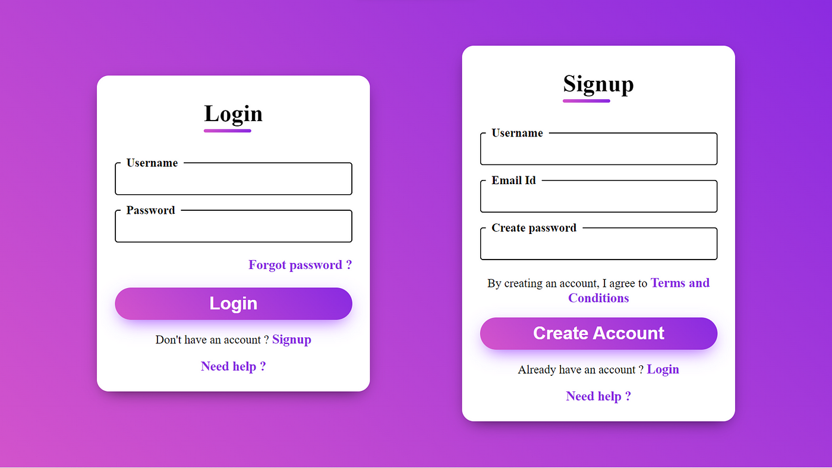
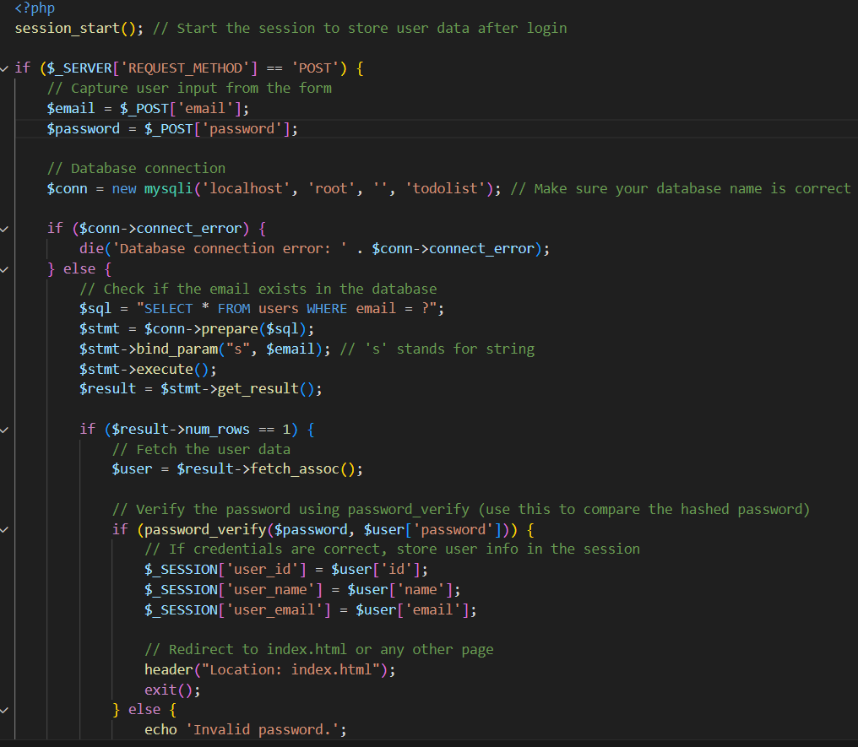
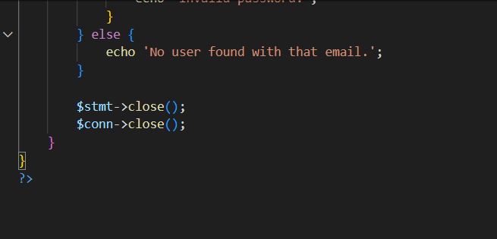
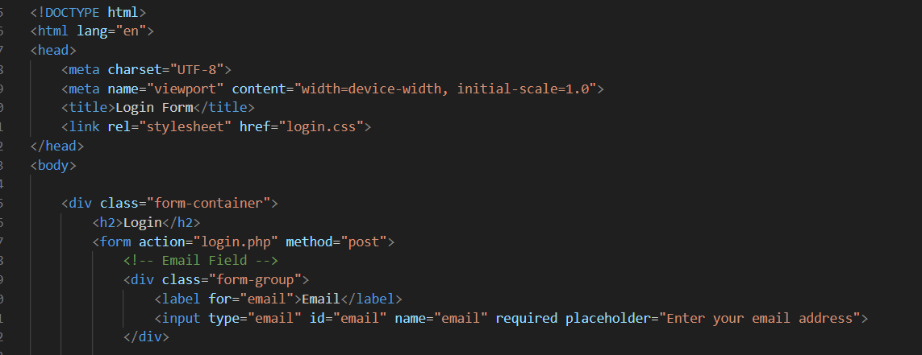
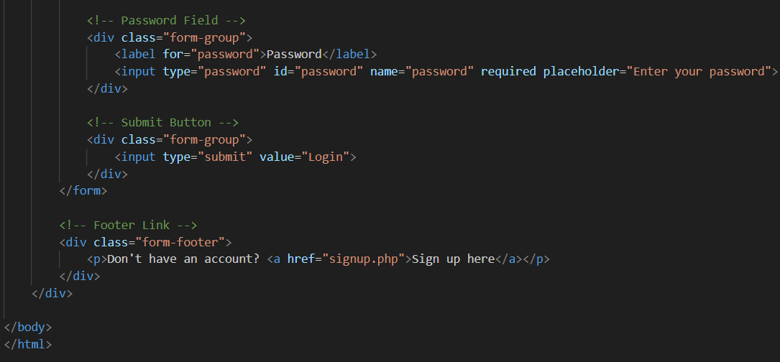
INDEX.PHP:
This PHP and HTML code represents a secure and functional user signup form integrated with a database. The PHP script processes the form submission, ensuring that the data entered is validated and stored securely in a database. Upon a POST request, the user's name, email, and password are retrieved from the form. The password is hashed using PHP's password_hash() function to enhance security by storing a non-reversible version of the password. A connection to a MySQL database (todolist) is established using mysqli, with error handling for connection failures. If the fields are not empty, the user data is inserted into the users table with the hashed password. Successful registration redirects the user to the index.html page, while errors display appropriate messages. The database connection is closed after execution.
The accompanying HTML provides a structured form within a styled container. It features input fields for the user's full name, email, and password, each with placeholders and validation (required attribute). The form uses a POST method for secure data submission. A submit button triggers the signup process. A footer link guides users who already have an account to the login page. The form is visually appealing, relying on an external CSS file (signup.css) for design, and is responsive, ensuring usability across devices.

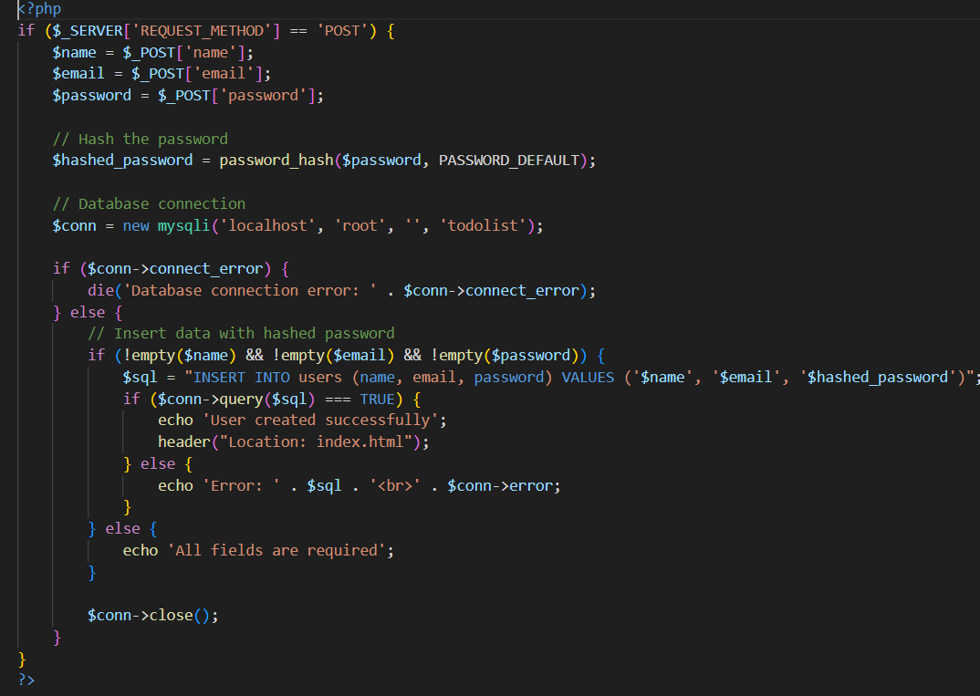
APP.JS:
This JavaScript code enables functionality for a simple task management application. It allows users to create, delete, and update tasks dynamically in the browser.
- Variables and Elements:
  - SaveBtn: References a button with the class .btn-save.
  - notepad: Refers to a text input area (#note) where users enter tasks.
  - container: A container element (.container) where the tasks are displayed.
- Save Button Click Event:
  - When the user clicks the save button, the code checks if the notepad (#note) is empty.
  - If empty, an alert notifies the user to write something.
  - If the input is not empty, the following steps are executed:
    - A new div element (taskItem) is created, styled with the class .task-item.
    - The innerHTML of taskItem includes:
      - A span containing the task's value.
      - Two action icons: a trash icon (.delete-icon) for deleting tasks and a pen icon (.update-icon) for updating tasks.
    - The taskItem is appended to the container.
- Delete Functionality:
  - The trash icon is set up with an event listener.
  - When clicked, it removes the associated task (taskItem) from the container.
- Update Functionality:
  - The pen icon allows users to edit the task.
  - When clicked:
    - The task's text is placed back into the notepad.
    - The task (taskItem) is removed from the container, allowing the user to update and re-save it.
- Input Clearing:
  - After successfully saving a task, the notepad input field is cleared to prepare for a new task.
This code provides a straightforward way to manage tasks, utilizing DOM manipulation and event handling. It ensures real-time interaction by adding, deleting, or updating tasks dynamically without requiring a page reload.

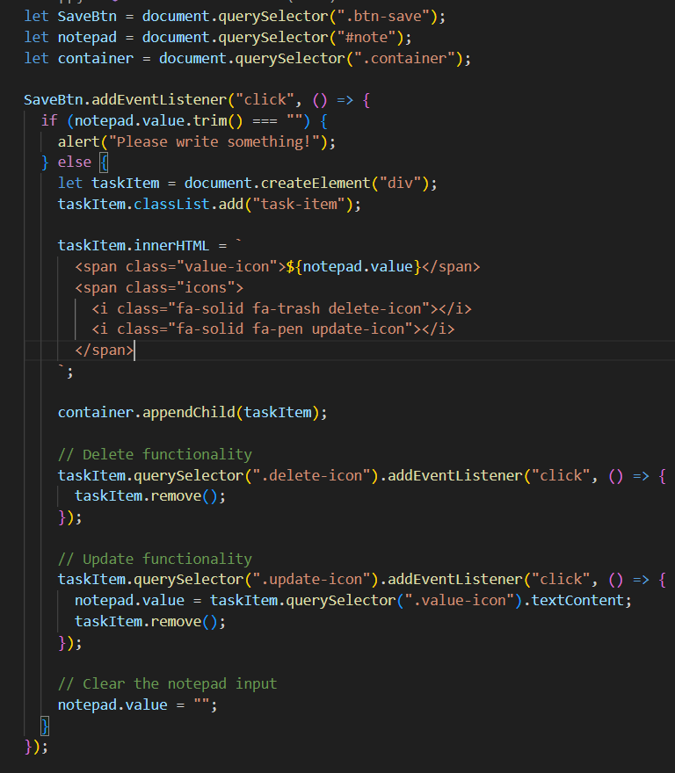
HEADING.JS:
This JavaScript code creates a dynamic, animated text feature for displaying a series of testimonials (or headings) in rotation. It employs DOM manipulation and CSS animations to achieve a visually engaging effect.
Key Points of the Code:
- Selecting the Target Element:
  - testimonialText references an h1 element inside an element with the class .heading.
- Array of Testimonials:
  - testimonials is an array containing the messages to be displayed:
    - "Welcome to ToDoList App".
    - "Task Management App".
    - "Set Reminders for your daily Tasks".
- Index Tracking:
  - currentIndex keeps track of which testimonial is currently displayed. It starts at 0 and cycles through the array.
- Functionality in changeTestimonial:
  - Reset Animation:
    - The style.animation property is set to none temporarily to reset any ongoing typing animation.
  - Update Text Content:
    - After a short delay (100ms), the textContent of testimonialText is updated with the current testimonial.
  - Reapply Animation:
    - The style.animation property is updated to include two CSS animations:
      - typing: Simulates typing out the text over 2s with steps(30, end).
      - cursor: Creates a blinking cursor effect.
  - Update Index:
    - The currentIndex is incremented, looping back to the start when it reaches the end of the array using the modulo operator (%).
- Testimonial Cycling:
  - setInterval is used to call changeTestimonial every 3000ms (3 seconds), cycling through the testimonials.
- Initial Call:
  - changeTestimonial() is called once immediately to trigger the animation and display the first testimonial.
Outcome:
The testimonials appear one at a time with a typing animation, cycling every 3 seconds. When the animation finishes for one testimonial, the next one seamlessly starts, creating an engaging user experience for the app interface.

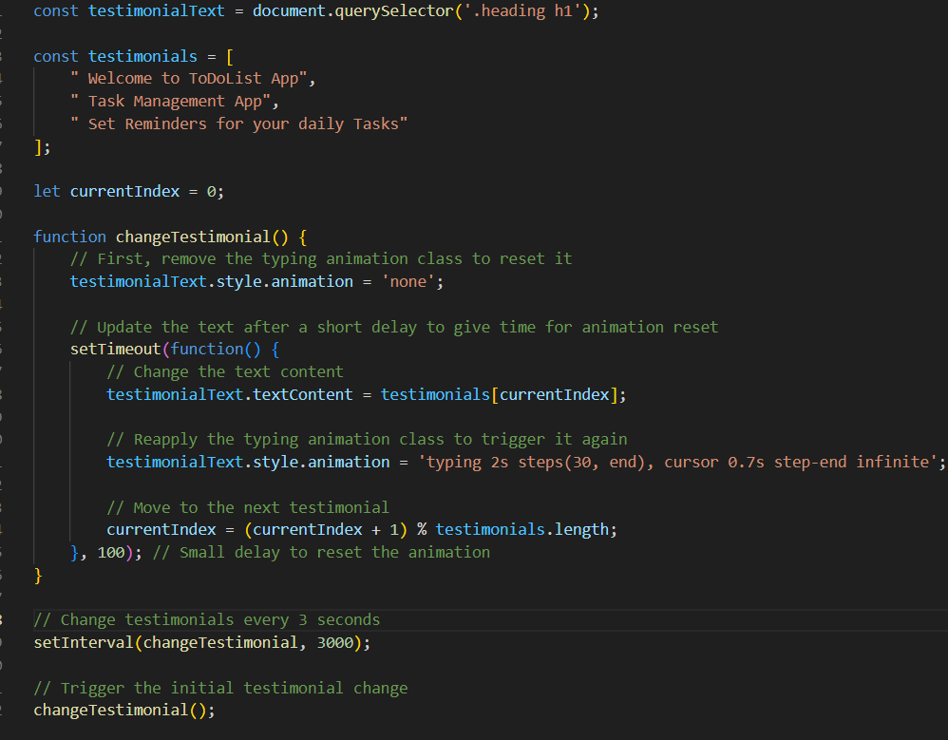
Future Improvements:
- Dynamic Testimonials:
  - Fetch testimonials dynamically from an external source (e.g., a database or API) to make the app more scalable and customizable.
  - Add a feature for users to submit their testimonials directly.
- Enhanced Animations:
  - Use a library like GSAP or Anime.js for more advanced and smoother animations.
  - Introduce fade-in and fade-out effects between testimonial transitions.
- Responsive Design:
  - Adjust text size and animation duration based on screen size for better usability on smaller devices.
- Customization Options:
  - Allow users to control the rotation speed or pause/play the animation.
  - Provide options to switch between different styles of animation (typing, fading, sliding).
- Improved Accessibility:
  - Add ARIA roles or labels to ensure that screen readers can read out the testimonials effectively.
  - Provide a way to navigate testimonials manually (e.g., "Next" and "Previous" buttons).
- Error Handling:
  - Add error handling for scenarios where the target element (.heading h1) is not found in the DOM.
- Multilingual Support:
  - Introduce support for multiple languages to make the testimonials appealing to a global audience.

Conclusion:
This code demonstrates an effective and simple way to create an engaging testimonial section with a typing animation. By leveraging modern JavaScript techniques and CSS animations, it delivers a smooth user experience that is visually appealing and functional. However, the code can be further improved for scalability, accessibility, and usability. Adding features like dynamic content, responsive design, and customization would significantly enhance its versatility and make it suitable for larger-scale applications. As it stands, it is an excellent foundation for a dynamic, rotating text feature that adds interactivity and professionalism to a web application.

