Results — Soil Nitrogen Projection Model v2.1 (with SPEI)
Nine-plot rotational grazing / cover crop trial, 2019–2023. Response variables: NH4+ and NO3- (0–10 cm and 10–20 cm).

Figures 1 & 2 — Mean Trajectories and Distribution by Year
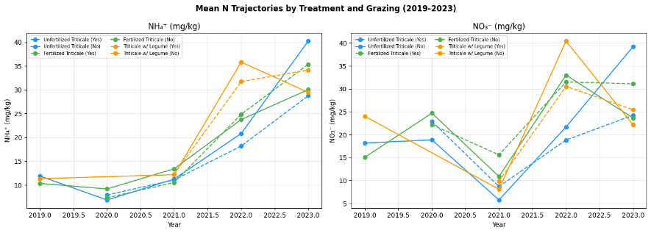
Figure 1. Mean NH4+ and NO3- trajectories by treatment, 2019–2023.

NH4+
All three treatments follow a similar trajectory: values remain low and comparatively stable from 2019 to 2021, followed by a marked increase in 2022–2023. Treatment-level differences are minimal across the series. This pattern is consistent with the increase being driven primarily by a system-wide factor — such as post-drought recovery, cumulative organic matter decomposition, or grazing timing — rather than by treatment-specific effects.

NO3-
Trajectories differ more by treatment. Triticale interseeded with Legume begins at the highest concentration in 2019 (approximately 24 mg/kg) before declining. All three treatments reach a low point in 2021, followed by an increase in 2022. The 2021 decline coincides with documented severe drought conditions in Nebraska, a period associated with reduced nitrification rates, consistent with a climate-driven signal rather than sampling noise.
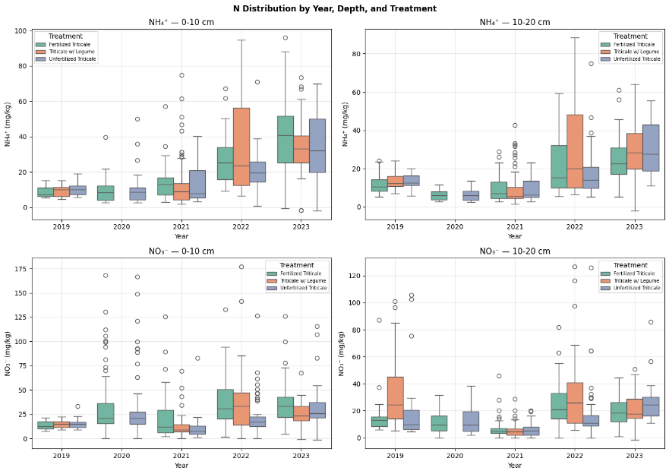
Figure 2. Boxplots of NH4+ and NO3- concentrations by year and depth.

Figure 2 — Boxplots
Three observations are notable:
- Within-treatment variability is high, particularly in 2022–2023. This is consistent with grazed and non-grazed subplots being aggregated within treatment groups at this stage of analysis; the width is reflected in the corresponding GPR uncertainty bands.
- NO3- shows extreme values in 2019–2020 (up to 170 mg/kg at 0–10 cm). These are consistent with localized inorganic nitrogen hotspots rather than measurement error, and contribute to elevated GPR mean estimates for those years.
- No boxes are present for the 10–20 cm depth in 2020, consistent with the previously identified 2020 depth-coverage gap in the dataset.

Figures 3 & 4 — Random Forest Feature Importance
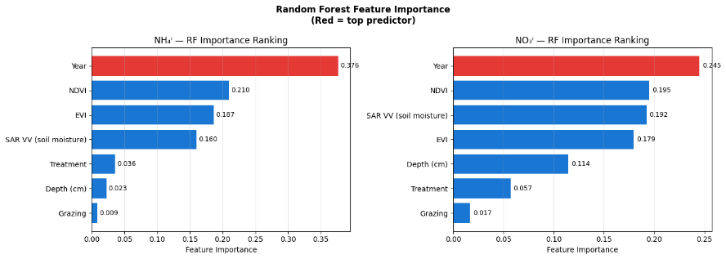
Figure 3. RF feature importance rankings, base model (without SPEI).

Feature importance (base model)
Feature | NH4+ | NO3- | Interpretation
Year | 0.376 | 0.245 | Temporal trend dominates, consistent with a five-year rising trajectory.
NDVI | 0.210 | 0.195 | Vegetation cover is a strong proxy for N uptake and cycling.
EVI | 0.187 | 0.179 | Correlated with NDVI; both capture the biomass signal.
SAR VV | 0.160 | 0.192 | Reflects soil moisture, which is linked to nitrification rate.
Treatment | 0.036 | 0.057 | Low importance; treatments have not diverged substantially over five years.
Depth | 0.023 | 0.114 | More important for NO3-, consistent with downward leaching.
Grazing | 0.009 | 0.017 | Lowest importance; grazing is not a strong predictor of bulk N pool size.

Cross-validation results
Five-fold cross-validated R²: −0.198 (NH4+) and −0.199 (NO3-), indicating that RF predictions underperform relative to predicting the mean. This is consistent with the limited number of years (5) relative to the number of folds, leaving approximately 3–4 training years per fold.
Leave-one-year-out cross-validation was used as an alternative:
NH4+ RF results
Cross-validated R² (5-fold): −2.592
Feature importances: year 0.3765, ndvi 0.2097, evi 0.1869, sar_vv 0.1604, treatment_code 0.0355, depth_numeric 0.0225, grazing_binary 0.0085
Leave-one-year-out R² scores: −1.377, −8.379, −0.010, −1.482, −1.711
Mean leave-one-year-out R²: −2.592
NO3- RF results
Cross-validated R² (5-fold): −0.868
Feature importances: year 0.2451, ndvi 0.1951, sar_vv 0.1922, evi 0.1793, depth_numeric 0.1145, treatment_code 0.0570, grazing_binary 0.0168
Leave-one-year-out R² scores: −0.702, −0.130, −2.031, −1.092, −0.385
Mean leave-one-year-out R²: −0.868

Interpretation of negative R²
All leave-one-year-out folds return negative R², including the best-performing fold (−0.01, NH4+, likely 2021). This indicates that RF does not predict nitrogen values in an unseen year more accurately than the training-set mean. The lowest-performing fold (−8.379) corresponds to the 2021 drought year: when 2021 is held out as the test set, no comparable anomaly is present in the training years.
This outcome reflects a structural limitation of the dataset — five annual time points — rather than an implementation error. RF cross-validation is expected to perform poorly with this few training examples per fold regardless of model configuration.

Role of RF in the pipeline
Role | Valid | Basis
Predictive model | No | Negative R² indicates the model does not predict unseen years.
Feature selection / ranking tool | Yes | Importance rankings are stable and interpretable independent of R².
Covariate prioritization for GPR | Yes | Identifies which covariates to weight; GPR handles uncertainty explicitly.

Recommended framing for methods/abstract
“Random Forest feature importance ranking was used to prioritize covariates for GPR, given the limited temporal replication inherent in a five-year observational dataset.”
Suggested methods note: “Due to the five-year temporal extent of the dataset, leave-one-year-out cross-validation yielded negative R² values, indicating that RF does not generalize to unseen years at this sample size. RF importances were therefore used for covariate prioritization rather than as a standalone predictive model.”
Recommendation: report feature importance rankings rather than R² values in presentation materials.
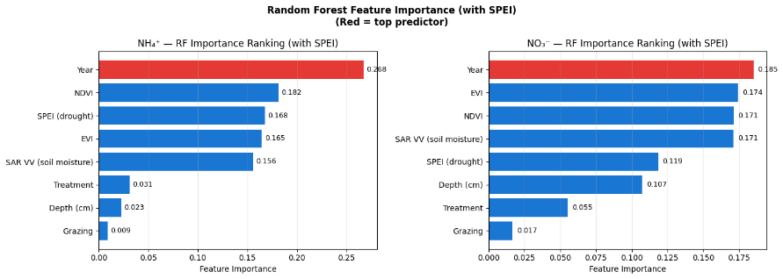
Figure 4. RF feature importance rankings with SPEI included.

Feature importance with SPEI
Feature | NH4+ rank | NO3- rank
Year | 1st (0.268) | 1st (0.185)
NDVI | 2nd | 3rd
SPEI | 3rd (0.168) | 5th (0.119)
EVI | 4th | 2nd
SAR VV | 5th | 4th
Treatment | 6th | 7th
Depth | 7th | 6th
Grazing | Last (0.009) | Last (0.017)
SPEI ranks third for NH4+ and fifth for NO3-, indicating that drought conditions provide explanatory value for ammonium dynamics beyond noise. Grazing ranks last for both response variables, consistent with a small effect size at the bulk pool level.

Figures 5 & 6 — NH4+ Forecasts by Depth and Grazing Status
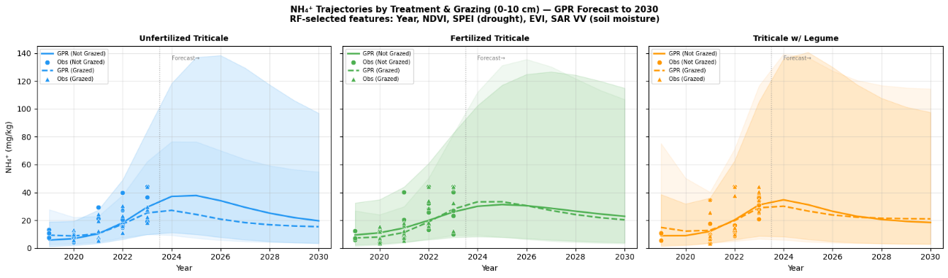
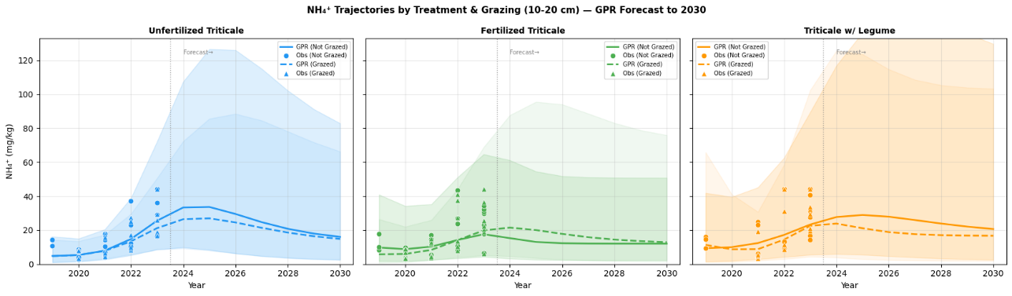
Figures 5–6. GPR forecasts for NH4+ at 0–10 cm and 10–20 cm, grazed vs. not grazed.
A consistent pattern is observed across both depths:
- Non-grazed plots forecast higher NH4+ than grazed plots, particularly within Unfertilized Triticale, consistent with ammonium removal by grazing exceeding accumulation in the absence of an external N input.
- Fertilized Triticale shows the smallest difference between grazed and non-grazed forecasts, consistent with fertilizer N input offsetting removal by grazing.
- Triticale with Legume shows near-overlapping grazed/non-grazed trajectories, consistent with legume N fixation compensating for grazing removal.
Confidence intervals remain wide for both NH4+ and NO3- following the addition of SPEI, reflecting the limited number of plot-level observations per year rather than a modeling deficiency. Band width is comparable between the two response variables. For presentation purposes, mean trajectories without confidence bands are recommended for both NH4+ and NO3-.

Figures 7 & 8 — NO3- Forecasts by Depth and Grazing Status
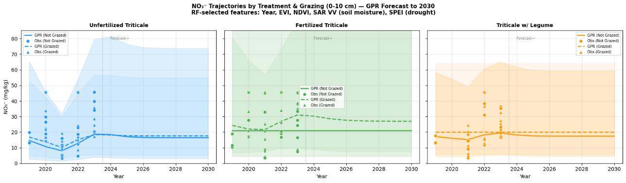
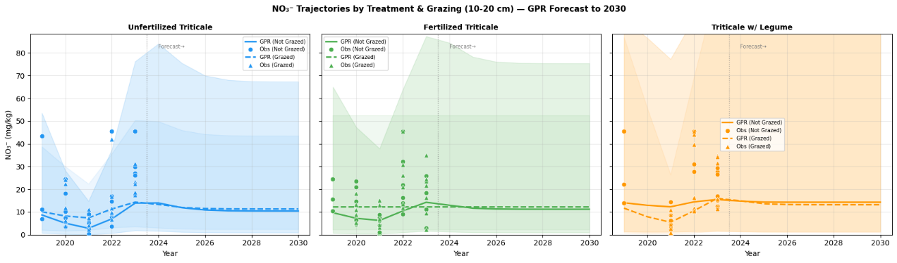
Figures 7–8. GPR forecasts for NO3- at 0–10 cm and 10–20 cm, grazed vs. not grazed.

0–10 cm
- Fertilized Triticale: grazed plots forecast higher NO3- than non-grazed plots, consistent with grazing accelerating N cycling through dung inputs undergoing nitrification.
- Unfertilized Triticale: grazed and non-grazed trajectories converge, consistent with grazing having minimal net effect on NO3- at this depth in the absence of an external N input.
- Triticale with Legume: grazed and non-grazed trajectories are nearly identical, consistent with legume N fixation dominating over grazing effects.

10–20 cm
- Concentrations are lower overall across treatments, consistent with downward leaching of NO3-.
- Grazed Unfertilized plots trend higher than non-grazed plots at this depth, consistent with greater accumulation of leachable NO3- under grazing.

Figure 9 — Grazing Effect Heatmap
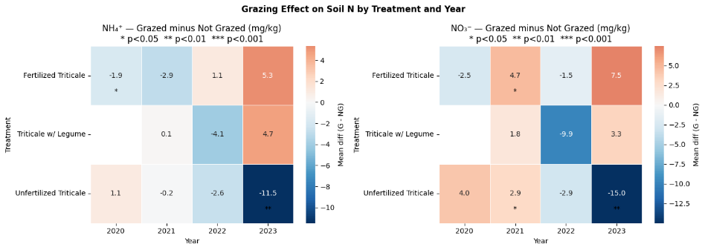
Figure 9. Estimated grazing effect on NH4+ and NO3- by treatment and year.

NH4+
- Unfertilized, 2023: −11.5 mg/kg (p < 0.01) — statistically significant depletion of ammonium under grazing in plots without fertilizer or legume input.
- Fertilized, 2023: +5.3 mg/kg (not significant) — a modest increase associated with grazing, consistent with dung deposition.
- Triticale with Legume, 2023: +4.7 mg/kg (not significant) — a comparable non-significant increase.

NO3-
- Unfertilized, 2023: −15.0 mg/kg (p < 0.01) — significant depletion, larger in magnitude than the corresponding NH4+ effect.
- Triticale with Legume, 2021: −9.9 mg/kg — a large negative effect during the drought year, potentially reflecting reduced legume N fixation under drought stress combined with continued grazing pressure.
- Fertilized, 2021: +4.7 mg/kg (p < 0.05) — grazing associated with increased N mineralization in fertilized plots under drought conditions.

Summary
The grazing effect on soil N pools depends on the presence of an external N input. In plots receiving fertilizer or legume-associated N inputs, the effect of grazing on NH4+ and NO3- is neutral to slightly positive. In unfertilized plots, grazing is associated with statistically significant depletion of both NH4+ and NO3-, an effect that increases in magnitude through 2023.

Model v2.1 — Overall Summary
Three findings are highlighted from this analysis:
- Year and remote sensing indices (NDVI, EVI, SAR VV) are the strongest predictors of soil N dynamics; treatment alone accounts for a small proportion of variance over the five-year period.
- The SPEI drought index captures the 2021 decline in nitrogen concentrations, indicating climate variability as a confounding factor in treatment comparisons.
- The grazing × treatment interaction is the most consistent biological signal in the dataset: grazing is associated with significant soil N depletion in unfertilized plots (p < 0.01), while remaining neutral to slightly positive in fertilized and legume-interseeded plots.

