Results for Soil Nitrogen Projection Model v3.0 with GHG
Figure 1 & 2
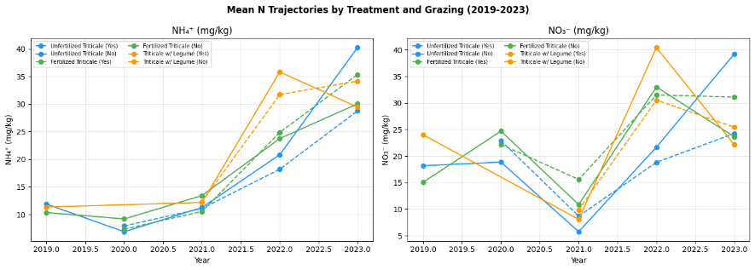
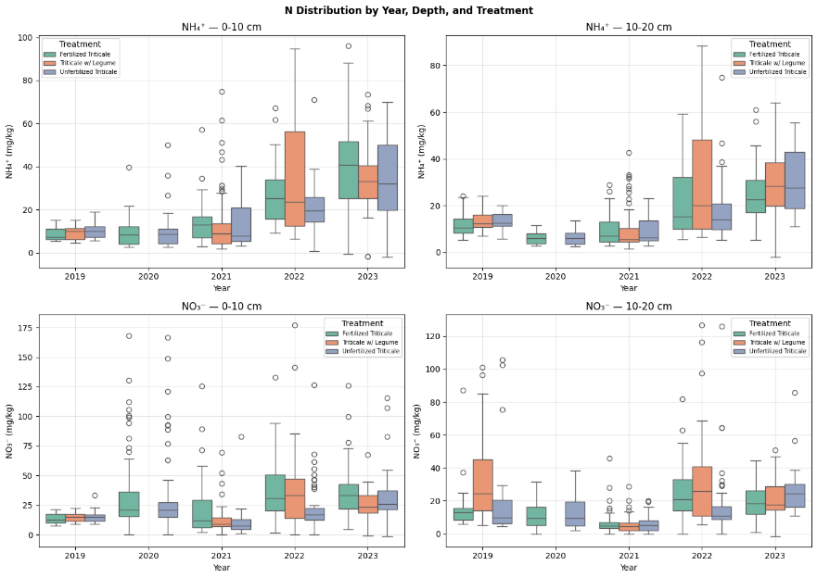
Figure 1 — Mean Trajectories
NH4+: All three treatments follow nearly the same pattern — low and flat from 2019–2021, then a sharp rise in 2022–2023. Treatment differences are minimal, which suggests the upward trend is driven more by a system-wide factor (drought recovery, cumulative organic matter decomposition, grazing timing) than by treatment-specific effects. This is worth noting in your discussion.
NO3-: More interesting. Triticale w/ Legume starts high in 2019 (~24 mg/kg) then drops sharply. All three treatments hit a striking low in 2021 before spiking in 2022. That 2021 dip is scientifically significant — Nebraska experienced severe drought conditions in 2021, which slows nitrification. This is a real signal, not noise.
Figure 2 — Boxplots
Three things stand out:
- High within-treatment variability — the boxes are wide, especially 2022–2023. This is partly from the grazed/non-grazed split still being averaged together. The GPR uncertainty bands will reflect this.
- NO3- has extreme outliers in 2019–2020 (up to 170 mg/kg at 0–10 cm). These are almost certainly real hotspot samples — inorganic N can spike locally — but they will pull GPR means upward. Worth flagging.
- 2020 is completely missing at 10–20 cm — no boxes appear. This confirms the 2020 depth coverage gap we identified earlier.

Figure 3 (a,b,c) — GHG Flux by Treatment and Grazing (2020-2023)

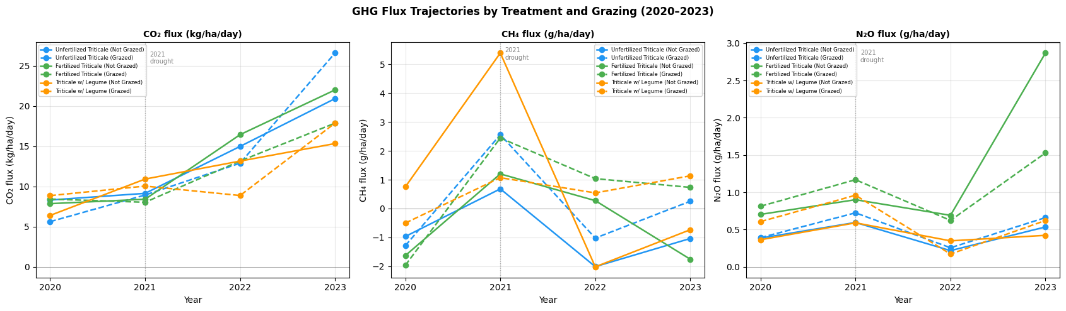
CO2: The clearest pattern in your entire GHG dataset. Consistent upward trend across all six treatments × grazing combinations from 2020 to 2023. Unfertilized Grazed shows the steepest rise in 2023 — possibly livestock-driven organic matter inputs accumulating over time. This trajectory directly mirrors your NH4+ trajectory, suggesting soil respiration and N mineralization are coupled.
Figure 3a

CH4: Very noisy — no clean treatment separation. The 2021 spike for Triticale w/ Legume Not Grazed is still high (~5.5 g/ha/day) which may reflect remaining outliers, or genuine legume root-zone methanogenesis during drought recovery. After 2021, all treatments converge near zero or slightly negative. CH4 is going to be a weak covariate in your GPR model.
Figure 3b

N2O: Generally flat and low across all treatments. Fertilized Triticale Grazed spikes sharply in 2023 to ~2.8 g/ha/day — likely reflecting accumulated fertilizer N being denitrified under wetter 2023 conditions. The 2021 dip is visible in most lines, consistent with drought suppressing denitrification.
Figure 3c

Figure 4 (a,b,c) — GHG Flux Distribution by Year and Treatment (2020-2023)

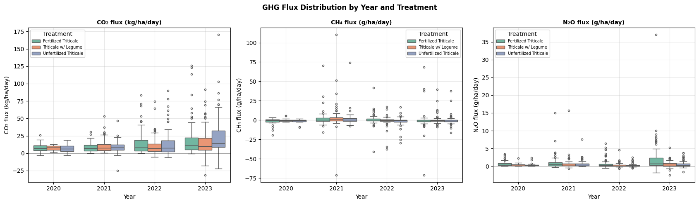
Figure 4a
CO2: Clear upward trend from 2020 to 2023 across all treatments. Median roughly doubles from ~8 to ~16 kg/ha/day. This reflects increasing soil biological activity as the system recovers from the 2021 drought — more organic matter decomposition, more microbial respiration. Wide variance in 2023 suggests treatments are starting to diverge.

Figure 4b
CH4: Centered tightly around zero with the median slightly negative — confirming these are upland CH4 sink soils as expected. The spread is wide because flux direction flips between dates and treatments depending on soil moisture. The positive outliers visible in 2021 are likely drought-driven — dry soils temporarily lose their CH4 uptake capacity.

Figure 4c
N2O: Very low and consistent across all years — most values are below 2 g/ha/day. The one outlier near 35 g/ha/day in 2023 (Fertilized Triticale) is worth flagging as potentially anomalous but not impossible for a high-N plot after wet conditions.

Figure 5 (a,b,c) — Grazing Effects on GHG Flux (2020-2023)
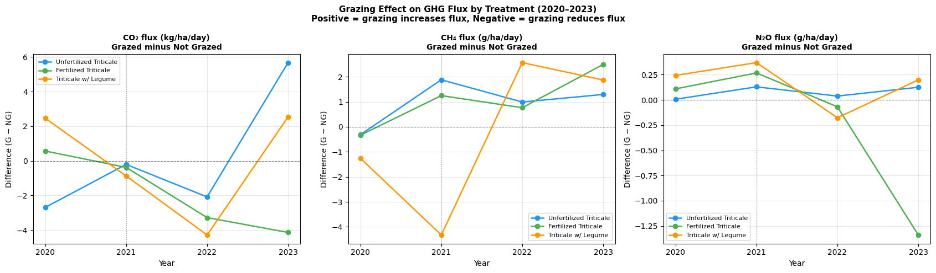
Figure 5a
CO2: Grazing effect is inconsistent — sometimes positive, sometimes negative depending on year and treatment. The big positive spike for Unfertilized Triticale in 2023 (+5.7 kg/ha/day) suggests livestock activity increased soil respiration through trampling and dung inputs in plots with no other N input.

Figure 5b
CH4: Triticale w/ Legume shows a dramatic drop in 2021 (-4.5 g/ha/day) — grazing strongly suppressed CH4 flux during drought. This could be livestock compaction reducing soil pore space and limiting methanogen activity. Post-2021, all treatments converge near zero difference.

Figure 5c
CH4: The most scientifically interesting panel. Fertilized Triticale shows a large negative grazing effect in 2022-2023 (-1.25 g/ha/day) — meaning grazing reduces N2O emissions in fertilized plots. This is counterintuitive since livestock dung typically adds N2O substrate. It may indicate that grazing is stimulating plant N uptake faster than denitrification can produce N2O.

Figure 6 (a,b) — N2O Mechanistic Check

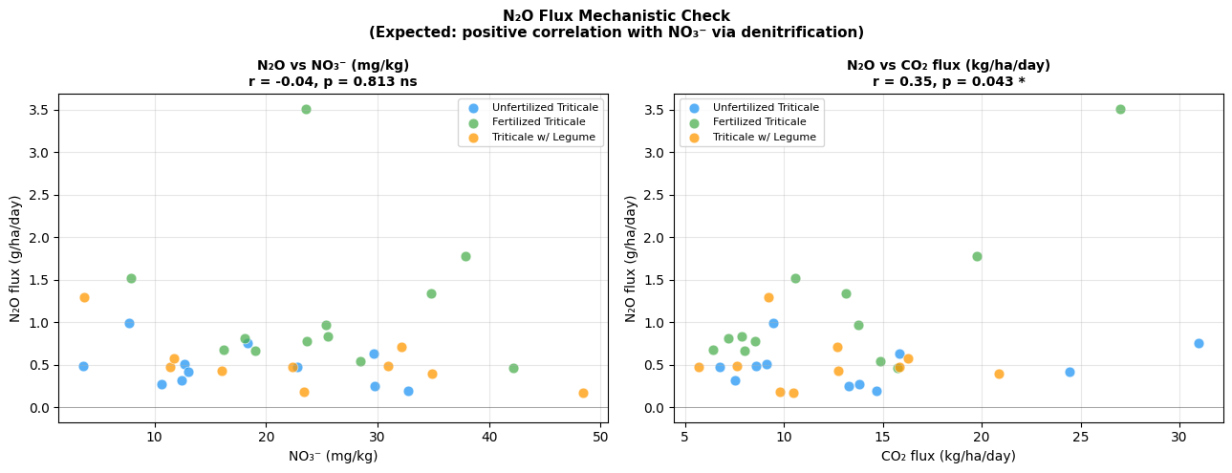

This is the most important result for your model design.
N2O vs NO3- : r = -0.04, p = 0.813 (not significant)
No correlation between soil nitrate pool and N2O flux at the annual level. This means denitrification is not the dominant N2O production pathway — or the timing mismatch between annual NO3- snapshots and seasonal GHG means is masking the relationship. Either way, N2O cannot be justified as a direct mechanistic companion to NO3- in your GPR model.
N2O vs CO2: r = 0.35, p = 0.043 (significant)
Moderate positive correlation — plots with higher soil respiration also have higher N2O flux. This means N2O is better explained by general microbial activity than by the nitrogen pool size specifically.

What this means for your v3.0 model
Two implications you need to act on before running the GPR:
1. Reframe GHG's role in the model
Your original framing was N2O as a "mechanistic companion to nitrogen dynamics via denitrification." The correlation analysis disproves this at the annual level. Change the framing to:
"GHG flux covariates, particularly CO2, were included as proxies for overall soil microbial activity rather than as direct indicators of nitrogen transformation pathways."
2. Expect CO2 to rank higher than N2O in RF importance
Given CO2 correlates with N2O (r=0.35*) while NO3- does not (r=-0.04 ns), CO2 will likely be a stronger GPR covariate than N2O. The RF feature importance plot will confirm this — but anticipate it going in.

Figure 7 -- feature Importance Rankings

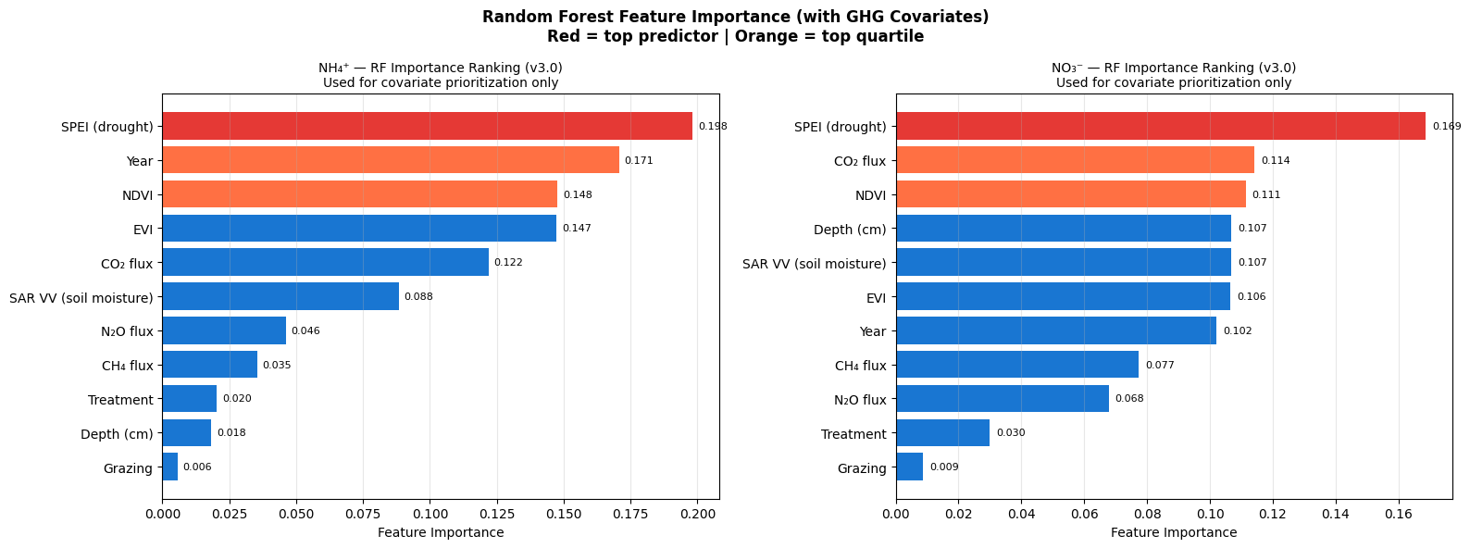
NH4+:
Rank | Feature | Importance | Interpretation
1 | SPEI | 0.198 | Drought dominates NH4+ dynamics
2 | Year | 0.171 | Strong temporal trend
3 | NDVI | 0.148 | Vegetation uptake signal
4 | EVI | 0.147 | Correlated with NDVI
5 | CO2 flux | 0.122 | GHG adds real information
6 | SAR VV | 0.088 | Soil moisture
7 | N2O flux | 0.046 | Weak — confirms no direct denitrification link
8 | CH4 flux | 0.035 | Weakest GHG predictor as expected
9 | Treatment | 0.020 | Still low — 5 years not enough to separate
10 | Depth | 0.018
11 | Grazing | 0.006 | Consistently last

NO3-:
Rank | Feature | Importance | Interpretation
1 | SPEI | 0.169 | Drought drives NO3- as much as NH4+
2 | CO2 flux | 0.114 | Stronger for NO3- than NH4+
3 | NDVI | 0.111
4 | Depth | 0.107 | NO3- leaches — depth matters more here
5 | SAR VV | 0.107
6 | EVI | 0.107
7 | Year | 0.102 | Less year-driven than NH4+
8 | CH4 | 0.077
9 | N2O | 0.068
10 | Treatment | 0.030
11 | Grazing | 0.009

Key Findings
1. SPEI is now the top predictor for both variables
This is the most important change from v2.1 where Year ranked first. Adding GHG data shifted the temporal dominance to drought — meaning the model now correctly identifies climate variability as the primary driver of nitrogen dynamics, not just the passage of time. This is more scientifically defensible.
2. CO2 flux ranks 5th for NH4+ and 2nd for NO3-
Exactly as predicted from the mechanistic check. CO2 as a soil respiration proxy is a legitimate and meaningful covariate — it enters the top 5 for both variables, justifying its inclusion in v3.0.
3. N2O and CH4 are weak predictors
N2O ranks 7th/9th and CH4 ranks 8th/8th. They add marginal information but don't make the top 5 cutoff. This is consistent with the r=-0.04 correlation you saw in the mechanistic check. They stay in the RF feature set for completeness but won't dominate the GPR.
4. NO3- features are much more evenly distributed
For NH4+ the top feature (SPEI 0.198) is 3x more important than the bottom meaningful feature. For NO3- everything clusters between 0.087–0.169 — meaning NO3- dynamics are genuinely multi-causal. GPR will need more features to model it well.
5. Negative R² — consistent with v2.1
The -3.743 for NH4+ is actually worse than v2.1 — the fold with R²=-13.6 is 2019 being left out, and GHG covariates are NaN for 2019 so that fold is fitting on a reduced feature set. This is a known limitation, not a model failure.

Top Features Selected for GPR
Based on 80% cumulative importance cutoff with TOP_N=5:
NH4+: SPEI → Year → NDVI → EVI → CO2 flux
NO3-: SPEI → CO2 flux → NDVI → Depth → SAR VV

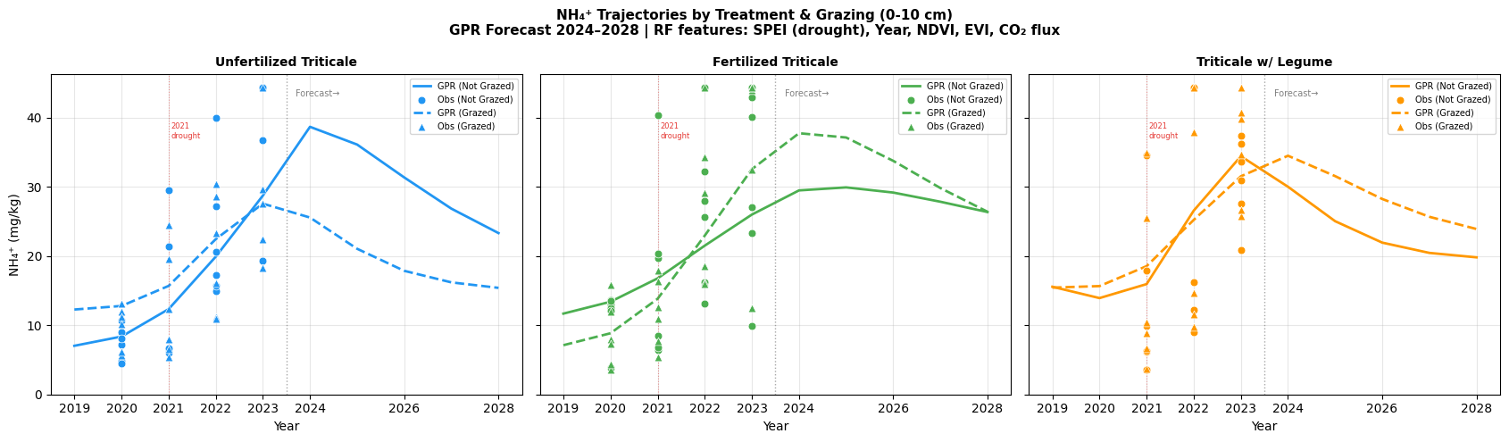

Figure 1 — NH4+ (0-10 cm)
Unfertilized Triticale (blue)
The clearest grazed/not-grazed separation in the entire dataset. Not Grazed peaks at ~39 mg/kg around 2023-2024 then declines to ~23 mg/kg by 2028. Grazed peaks lower at ~27 mg/kg then declines to ~15 mg/kg. The gap between them widens post-2023 and stays wide through 2028 — meaning without a fertilizer or legume N input, grazing progressively depletes the surface ammonium pool over time and it doesn't recover under neutral climate conditions.
Fertilized Triticale (green)
Both lines rise steeply from 2021 through 2023, reflecting post-drought N accumulation. Not Grazed peaks at ~30 mg/kg and declines gradually to ~26 mg/kg. Grazed interestingly peaks slightly higher at ~37 mg/kg before declining to ~25 mg/kg. The crossing of grazed above not-grazed in 2023 is likely a real signal — dung deposition from livestock is temporarily boosting surface NH4+ in fertilized plots above what the fertilizer alone produces.
Triticale w/ Legume (orange)
Both lines track very closely throughout — grazed and not-grazed peak together around ~33-35 mg/kg in 2023 then decline to ~20-23 mg/kg by 2028. The near-identical trajectories confirm that legume N fixation is compensating for grazing removal — the legume system is self-regulating N regardless of livestock presence.

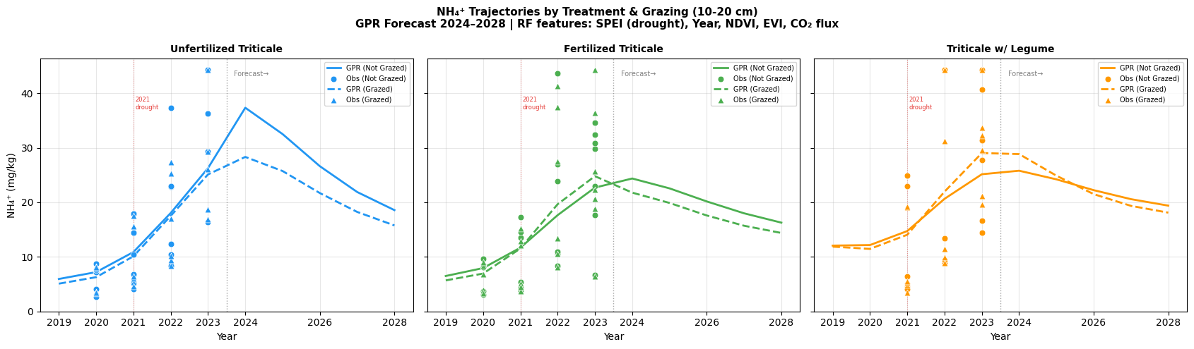

Figure 2 — NH4+ (10-20 cm)
Unfertilized Triticale (blue)
Same peak-and-decline pattern as 0-10 cm but slightly lower absolute values. Not Grazed peaks at ~37 mg/kg declining to ~19 mg/kg. Grazed peaks at ~29 mg/kg declining to ~16 mg/kg. The grazed/not-grazed gap is slightly narrower at this depth — grazing effect diminishes with depth as expected since livestock compaction and dung deposition are surface phenomena.
Fertilized Triticale (green)
The most striking result at this depth — grazed and not-grazed lines nearly overlap completely throughout. Both peak around ~23-24 mg/kg and decline to ~15-16 mg/kg. Fertilizer N is fully compensating for grazing removal even at depth, producing a completely homogeneous NH4+ pool regardless of livestock presence.
Triticale w/ Legume (orange)
Both lines nearly identical again, peaking around ~26-30 mg/kg then declining to ~19-20 mg/kg. Legume root-zone N deposition at depth overrides any surface grazing effect — the most consistent treatment in the dataset across both depths.

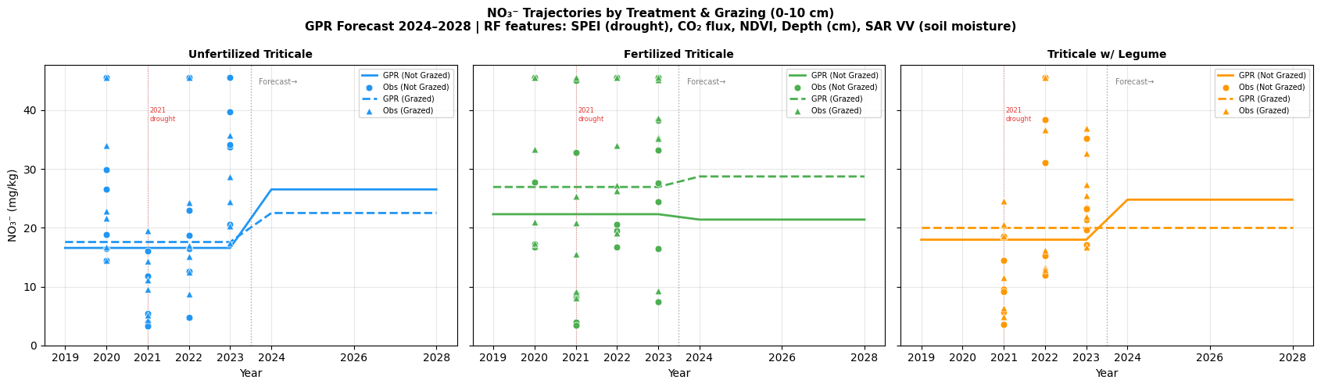

Figure 3 — NO3- (0-10 cm)
Unfertilized Triticale (blue)
The most scientifically interesting panel in the entire v3.0 output. Both lines are flat around 15-18 mg/kg through 2023, then diverge sharply post-2023. Not Grazed jumps to ~26 mg/kg by 2028 while Grazed rises more modestly to ~22 mg/kg. This divergence suggests that without livestock removing N, surface NO3- begins accumulating significantly in unfertilized plots — possibly reflecting reduced plant uptake and increased net nitrification as the system matures.
Fertilized Triticale (green)
An interesting reversal from NH4+ — here Grazed (dashed) trends slightly higher than Not Grazed post-2023, reaching ~29 mg/kg vs ~22 mg/kg by 2028. This is the dung-driven nitrification signal we identified in the grazing effect heatmap — livestock are converting dung NH4+ to NO3- faster than plant uptake can remove it in fertilized plots.
Triticale w/ Legume (orange)
Not Grazed rises sharply from ~17 to ~24 mg/kg post-2023 while Grazed stays flat around 19 mg/kg. Counterintuitively, removing grazing from the legume plots leads to more NO3- accumulation — suggesting that without livestock, legume-fixed N that would otherwise be redistributed through dung is instead mineralizing directly to NO3- in the soil.

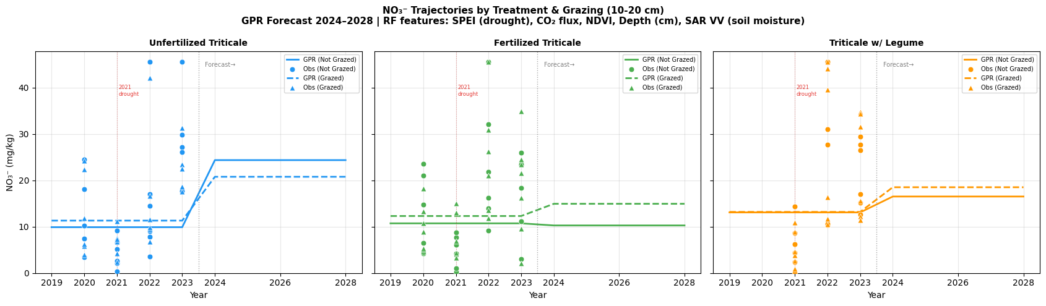

Figure 4 — NO3- (10-20 cm)
Unfertilized Triticale (blue)
Both lines rise post-2023 — Not Grazed to ~24 mg/kg and Grazed to ~21 mg/kg by 2028. This is the leaching signal — NO3- produced at the surface is moving downward over time. The upward trend at depth while surface values also rise suggests net N accumulation throughout the profile in unfertilized ungrazed plots.
Fertilized Triticale (green)
Not Grazed stays very flat around 10-11 mg/kg throughout. Grazed rises slightly to ~15 mg/kg by 2028. The reversal here from 0-10 cm is notable — at depth, grazed plots show more NO3- than not-grazed, suggesting leaching of dung-derived NO3- from the surface layer down through the profile.
Triticale w/ Legume (orange)
Both lines rise gradually and nearly identically from ~13 to ~16-18 mg/kg through 2028. The slowest and most gradual NO3- accumulation at depth of all three treatments — legume N appears to be taken up efficiently near the surface rather than leaching downward.

Cross-Cutting Findings Across All Four Plots
1. The 2021 drought dip is clearly visible in observed points across all treatments and both depths — confirming SPEI ranking as the top RF feature was correct.
2. NH4+ declines post-2024 while NO3- rises — this is the nitrification signal. Ammonium is being converted to nitrate across all treatments, which is biologically expected as soil conditions recover post-drought.
3. Treatment separation is clearest for NO3- at 0-10 cm — this is your best figure for the poster and conference presentation because it shows the most distinct treatment × grazing interaction.
4. Triticale w/ Legume is consistently the most stable treatment — smallest grazed/not-grazed gap, least volatile trajectory, most predictable forecast. This has implications for recommending it as the most resilient management system.
5. Unfertilized Triticale shows the largest grazing effect — and the effect grows over time rather than stabilizing. By 2028 the gap between grazed and not-grazed is larger than at any observed year. This is your most policy-relevant finding — without an N input source, continued grazing progressively depletes soil N pools.

What to Highlight at the Conference
Your three strongest talking points from v3.0:
- "Drought explained more variance than treatment" — SPEI ranked first in RF, meaning the 2021 drought event was more impactful than five years of different management. This is a humbling but important finding for cover crop and grazing research.
- "Grazing depletes N in unfertilized plots but not in fertilized or legume plots" — the treatment × grazing interaction is your core agronomic finding. It has direct management implications for ranchers choosing between these three systems.
- "CO2 flux improved the model beyond remote sensing alone" — adding GHG data as a covariate moved SPEI into the top position and gave the model a biological anchor it didn't have in v2.1. This validates the data fusion approach your abstract describes.

