
School: ............................................................................................................. Campus: ....................................................... Academic Year: ...................... Subject Name: ........................................................... Subject Code: ..........................
Semester: ............... Program: ........................................ Branch: ......................... Specialization: .......................... Date: .....................................
(Learning by Doing and Discovery)
* Coding Phase: Pseudo Code / Flow Chart / Algorithm
Procedure to set up IPFS on Pinata, generate API keys, upload files via Windows CLI (PowerShell), and use JavaScript with .env to automate file uploads and hash generation:

1. Sign Up on Pinata & Generate API Keys
Step 1: Create a Pinata Account
- Go to Pinata.cloud → Sign up.
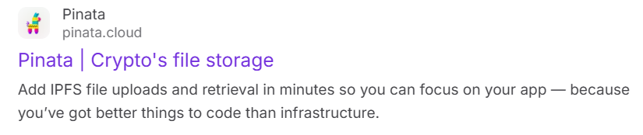
- Verify your email.
Step 2: Generate API Keys
- Go to API Keys → New Key.
- Enable:
  - pinFileToIPFS (for file uploads)
  - pinJSONToIPFS (optional, for metadata)
- Copy:
  - API Key
  - API Secret
  - JWT Token (Bearer token for authentication)
2.JavaScript Automation (Node.js)
Step 1: Set Up Project
- Install Node.js.
- Create a folder and initialize npm:
In the powershell:
mkdir pinata-upload
cd pinata-upload
npm init -y
- Install required packages:
In the powershell:
npm install @pinata/sdk dotenv axios form-data
Step 2: Create .env File
Create a .env file in your project root:
PINATA_API_KEY=your_api_key
PINATA_API_SECRET=your_api_secret
PINATA_JWT=your_jwt_token
Step 3: JavaScript Code (upload.js)

Coding Phase: Pseudo Code / Flow Chart / Algorithm
addFile.js :
require('dotenv').config();
const axios = require('axios');
const FormData = require('form-data');
const fs = require('fs');

async function uploadToIPFS(filePath) {
const form = new FormData();
form.append('file', fs.createReadStream(filePath));

const res = await axios.post('https://api.pinata.cloud/pinning/pinFileToIPFS', form, {
maxBodyLength: "Infinity",
headers: {
...form.getHeaders(),
pinata_api_key: process.env.PINATA_API_KEY,
pinata_secret_api_key: process.env.PINATA_SECRET_API_KEY,
},
});

console.log("File pinned to IPFS.");
console.log("Hash:", res.data.IpfsHash);
}

uploadToIPFS("sample.txt");

Step 4: Run the Script
In the powershell:
node addFile.js

Output:
You’ll get the IPFS Hash (CID) and a link to view the file.

* Softwares used
Development Environment / Tools: Frontend (React):
- VS Code React.js
- Node.js and NPM HTML/CSS
- Browser
- Terminal
Backend (Node.js):
- Node.js and Express.js
- Axios, Multer,Form-data
- Dotenv, CORS

- Testing Phase: Compilation of Code (error detection)
No Error

- Implementation Phase: Final Output (no error)
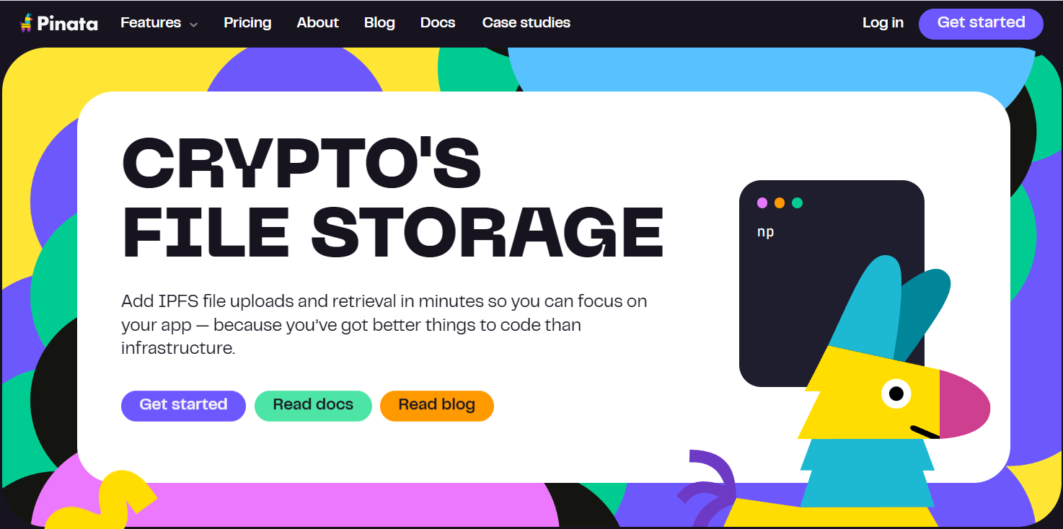

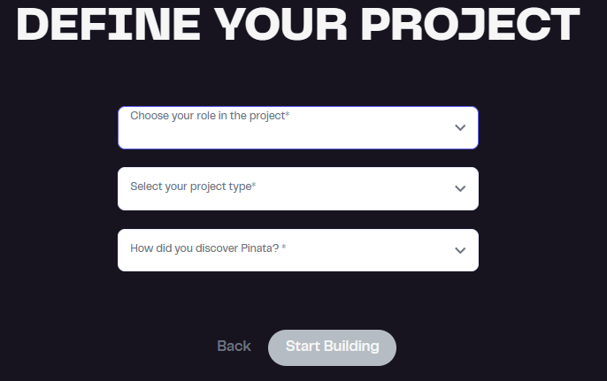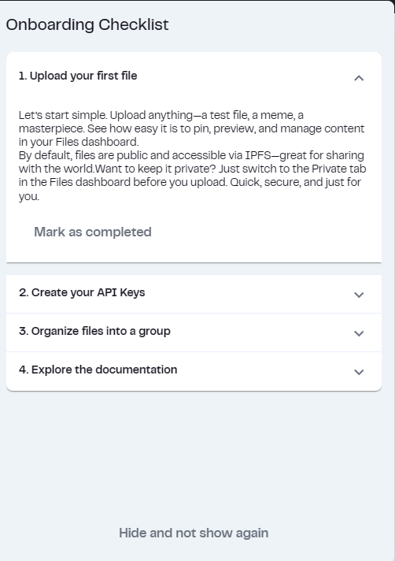

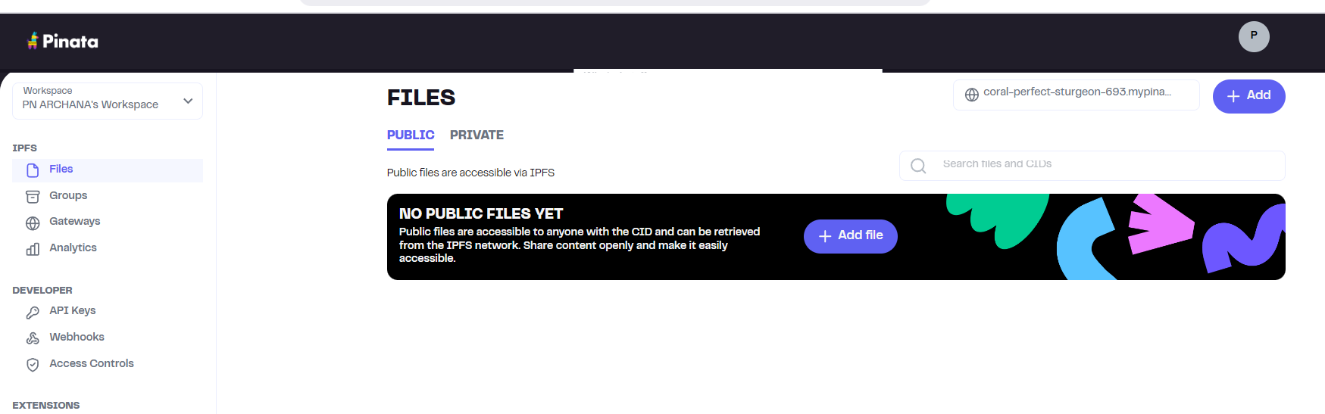

Implementation Phase: Final Output (no error)
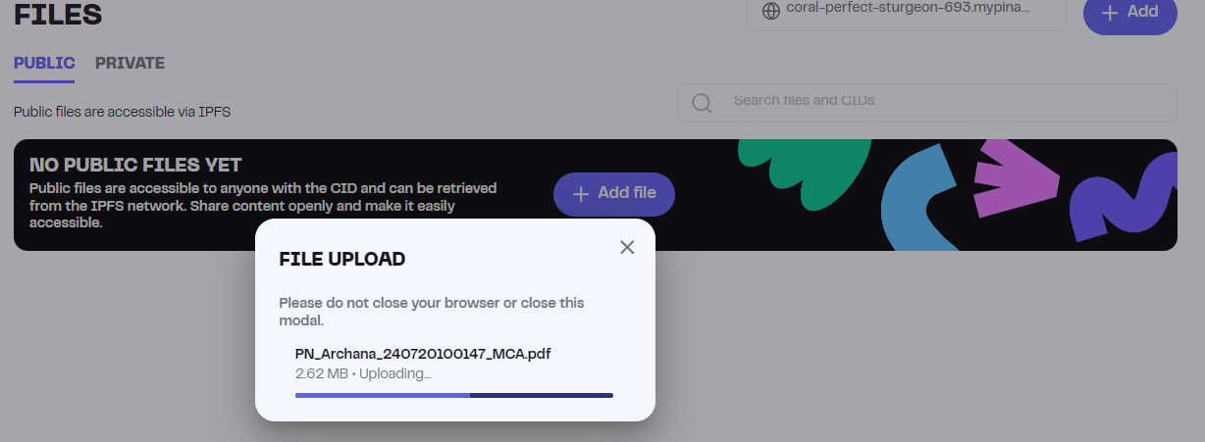

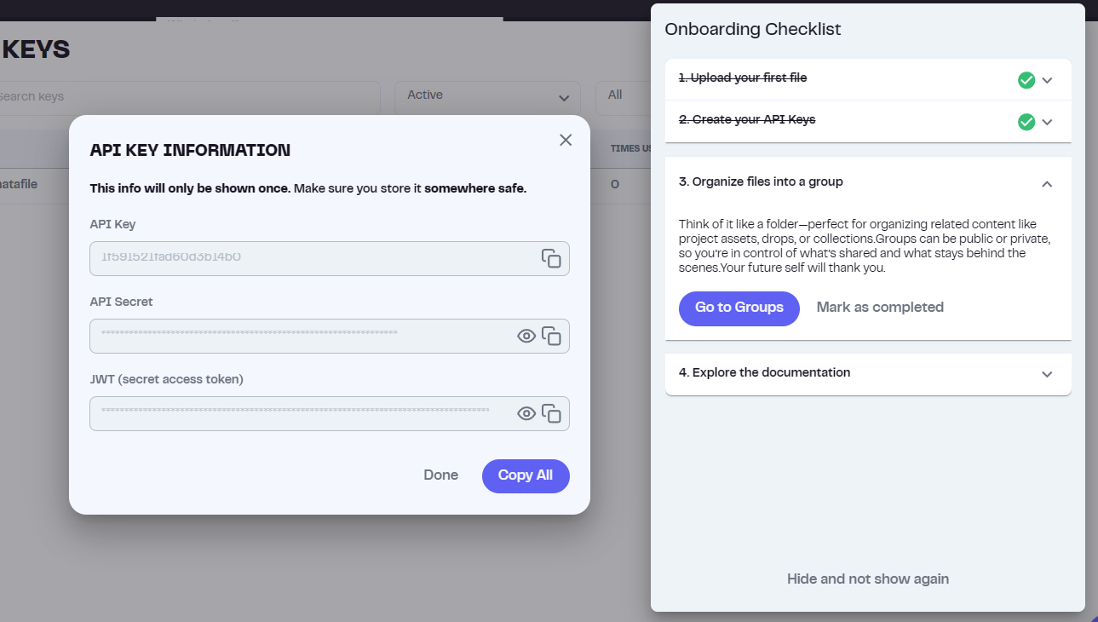

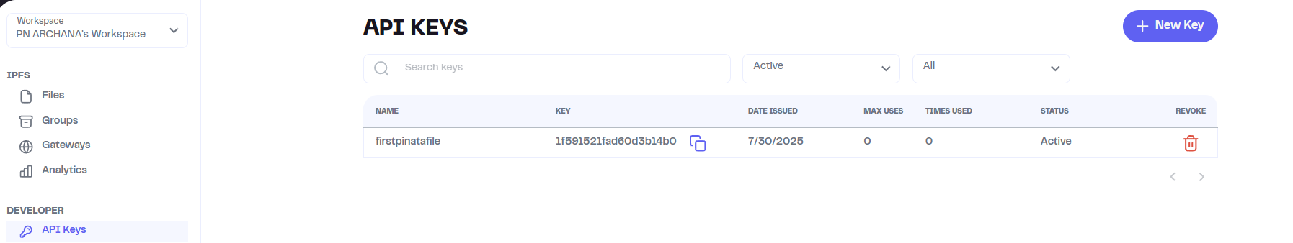

Implementation Phase: Final Output (no error)


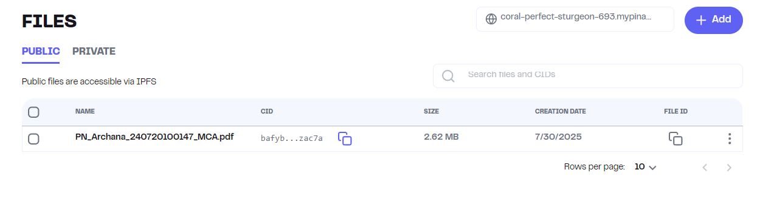
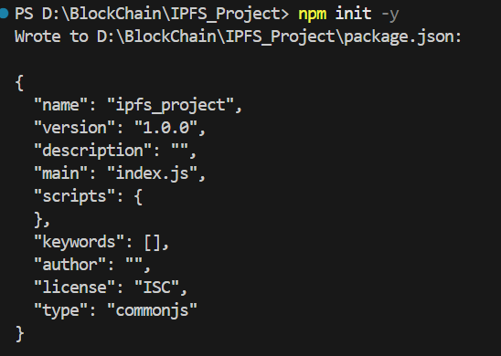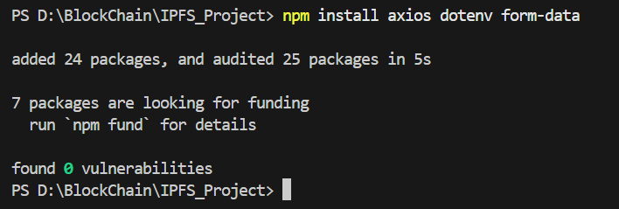

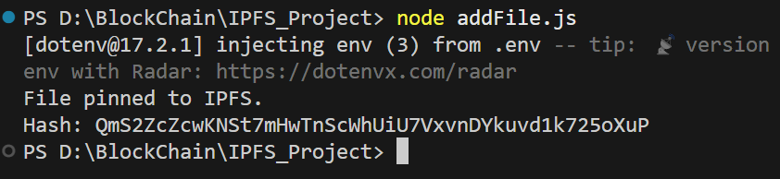

Hash: QmS2ZcZcwKNSt7mHwTnScWhUiU7VxvnDYkuvd1k725oXuP

Implementatation Phase: Final Output (no error)
View the File Through CLI :

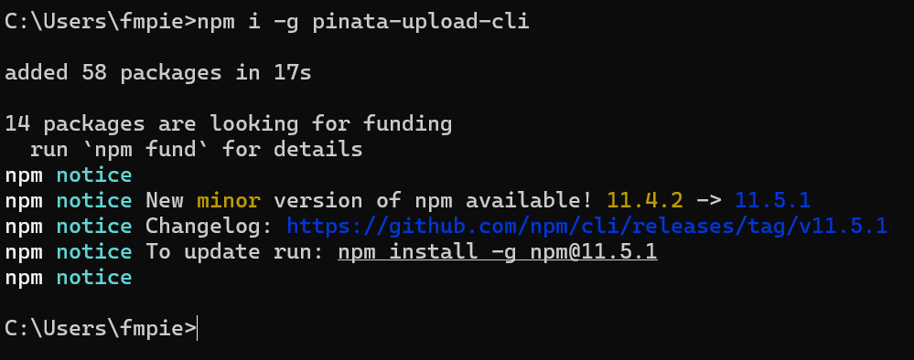

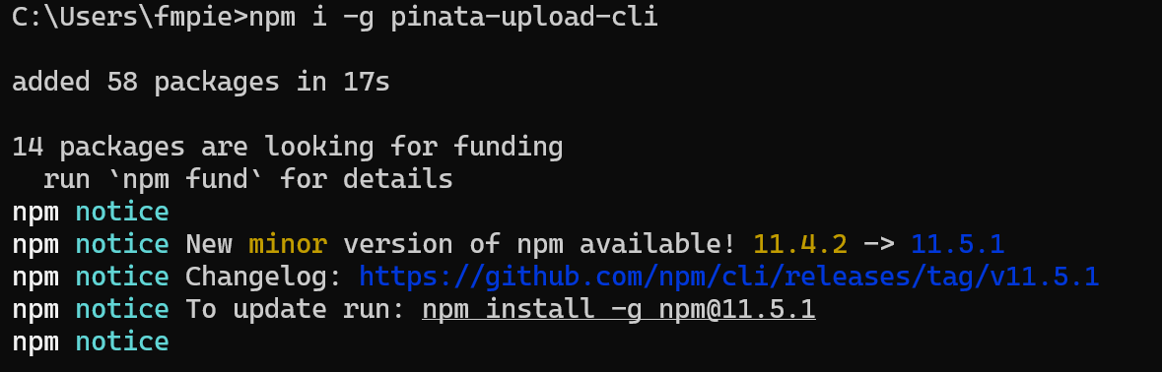

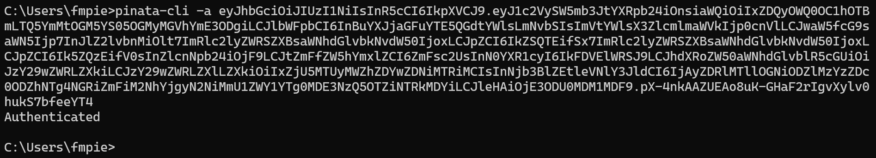

- Implementation Phase: Final Output (no error)
Applied and Action Learning

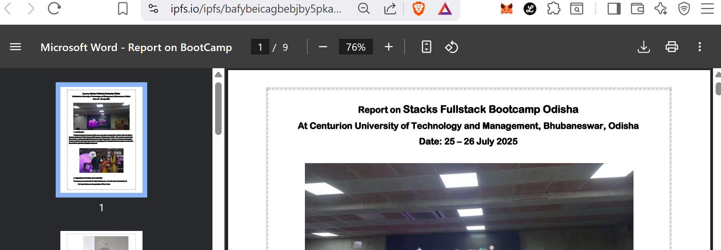

* Observations
We can upload files from a browser UI to a decentralized storage system (IPFS) and retrieve them using a globally unique hash (CID), without relying on centralized cloud providers.

ASSESMENT

Rubrics
Concept | 10
Planning and Execution/  Practical Simulation/ Programming | 10
Result and Interpretation | 10
Record of Applied and Action Learning | 10
Viva | 10
Total | 50


Signature of the Student:
Signature of the Faculty:

