An Intelligent Task Prioritization Framework Using Machine Learning for Enhanced Productivity

Aaisha Chaudhary
dept. of computer science and
engineering
(of Affiliation)
Chitkara University
Punjab, India
aaisha7.ac@gmail.com

Abstract— Modern users struggle to manually prioritize complex task lists due to high cognitive demands. In this paper, we present an Intelligent Task Prioritization Framework which evolves from static task lists into a smart data-driven solution. The system features a non-linear scoring engine that determines four important attributes of each task: urgency, importance, effort, and dependencies using the Weighted Sum Model (WSM). We propose the use of a Machine Learning algorithm that classifies tasks into buckets based on their importance levels: high, medium, and low using random forest technique. The intra-bucket task priority ranking uses SVM method. We employ DFS algorithm to discover any circular tasks' dependencies and avoid system deadlocks. Our solution utilizes a tri-layer architecture made up of vanilla JS front-end, Django back-end and MySQL database layers. We achieve 92.3% accuracy of prioritizing tasks, a 40% increase in separability compared to linear scoring, and 35% decrease in manual task management time using our algorithm implemented on a randomly generated dataset of 1,000 tasks.
Keywords— Task prioritization, Machine Learning, Random Forest, SVM, Decision Fatigue, DFS Algorithm, Weighted Sum Model, Cognitive Load

I. Introduction
- Background
In today's professional world, individuals manage an increasing number of tasks across academic, professional, and personal domains. This rise in task complexity leads to a well-documented cognitive phenomenon known as decision fatigue, defined as the decline in the quality of decisions after prolonged periods of choice-making [1]. Research by Baumeister et al. [1] demonstrated that the mental effort required to evaluate and sort through a large set of tasks can be as draining as the tasks themselves. This often results in postponed decisions, poor prioritization, and missed deadlines. When users face an overwhelming "flat" list of responsibilities, the cognitive load required just to select the next task often leads to procrastination or “analysis paralysis"[2].

Traditional productivity tools, such as simple to-do lists and digital calendar applications, do not offer automated prioritization. These tools primarily function as passive information storage rather than active assistants. They display tasks in a fixed format and rely entirely on the user to manually evaluate urgency, importance, and sequencing—a process that becomes cognitively unsustainable as task volumes increase [4]. Consequently, users often default to completing "low-hanging fruit" or easy tasks rather than focusing on high-impact objectives, simply because the mental effort to differentiate between the two is too high in high-stress situations [5].

Current systems are inherently limited by their linear nature. Most applications utilize basic "High, Medium, Low" priority flags or sort tasks purely by chronological due dates. However, real-world productivity is non-linear; a task's true priority is a dynamic interplay between its deadline, long-term significance, required physical or mental effort, and its complex connections to other tasks [6]. Without a system capable of synthesizing these multi-dimensional factors simultaneously, users are left with the "meta-task" of planning, which significantly detracts from the actual execution of work..

To tackle these issues, this paper introduces an Intelligent Task Prioritization Framework. This framework goes beyond static lists by using a flexible, data-driven model that calculates priority through a non-linear scoring engine. By applying a Weighted Sum Model (WSM), a recognized Multi-Criteria Decision Analysis (MCDA) method [5], the system evaluates four key parameters: Urgency, Importance, Effort, and Dependencies. This approach ensures that the recommended workflow aligns with the user’s available energy and long-term goals, effectively relieving the mental load of prioritization.

Additionally, the proposed system utilizes a hybrid Machine Learning approach to enhance ranking accuracy. It employs Random Forest algorithms for broad task classification [7] and Support Vector Machines (SVM) for detailed ranking within specific priority groups [8]. To manage complex task dependencies and avoid system deadlocks, a Depth-First Search (DFS) algorithm is integrated into the architecture. The ultimate aim of this research is to demonstrate that an intelligent, automated intervention can significantly reduce manual planning time and enhance task separability in complicated productivity settings.

- Problem Statement
Despite the many productivity methods available, traditional task prioritization models have basic structural weaknesses that limit their effectiveness in fast-paced, dynamic settings. These weaknesses fall into four main areas:

- Subjectivity and Cognitive Bias in Qualitative Frameworks: The Eisenhower Matrix, while conceptually sound, relies heavily on personal judgment to distinguish urgency from importance. This lack of a computational ranking mechanism often leads to "urgency bias," where users prioritize immediate, low-value tasks over significant long-term goals [9].
- Dimensional Rigidity in Scheduling Algorithms: Popular methods like Earliest Deadline First (EDF) focus almost exclusively on temporal proximity. They overlook other critical factors such as task effort, relative importance, and complex inter-task dependencies. As a result, these models fail to capture the multi-dimensional and non-linear nature of modern human productivity [10].
- Contextual Inelasticity of Static Scoring: Current scoring systems utilize a rigid structure that cannot adjust to shifting user environments. A fixed scoring method cannot accommodate the differing priority needs of a student during an examination period versus a manager in a corporate setting. This leads to recommendations that become irrelevant as user contexts change [11].
- The Dependency Deadlock Problem: Existing lightweight task management tools do not employ graph-based logic to identify or resolve circular dependencies. Without automatic deadlock resolution, users can accidentally create "loops" in their workflows—such as Task A depending on Task B, which in turn depends on Task A. This results in system deadlocks and a complete halt in productivity [20].

As a result, there is a strong need for a combined, data-driven framework that leverages machine learning and graph theory. Such a system would handle these complex evaluations automatically, effectively reducing decision fatigue and improving prioritization accuracy.

- Objectives
This research addresses the above limitations by developing a hybrid framework that:
- Calculates a multi-factor, non-linear priority score based on Urgency, Importance, Effort, and Dependencies.
- Supports four user-selectable optimization strategies tailored to different productivity goals.
- Employs a Random Forest + SVM hybrid ML pipeline for accurate task classification and ranking.
- Integrates a DFS-based circular dependency detector to prevent scheduling deadlocks.

II. LITERATURE REVIEW
The study of task scheduling and prioritization is a multidisciplinary field spanning operations research, cognitive psychology, and computational intelligence. This section examines the current state of research across five domains critical to the proposed intelligent framework.

Early frameworks, such as the Eisenhower Matrix, provide a qualitative approach by bifurcating tasks along urgency and importance vectors [9]. However, these remain static and fail to provide granular numerical ranking. In the realm of real-time systems, Earliest Deadline First (EDF) was established as an optimal scheduling strategy for single-processor environments by Liu and Layland [10]. Despite its mathematical elegance, the model operates under the assumption of task independence, which is rarely applicable to modern knowledge-work where tasks are interconnected [10]. While researchers like Buttazzo have attempted to integrate dependency-aware logic into EDF, these adaptations often lack the flexibility needed to handle non-linear human productivity [14].

The psychological cost of manual planning is well-documented; constant choice-making diminishes executive function over time effectively mitigating the decision fatigue established in Section I while improving prioritization accuracy. [1]. This is compounded by Cognitive Load Theory, where Sweller argues that poorly designed tools impose an "extraneous load" that distracts from core task execution [15]. Furthermore, empirical studies by Mark et al. suggest that frequent task-switching among knowledge workers causes measurable productivity decay, underscoring the necessity for automated systems that can maintain a consistent priority flow [16].

The application of predictive modeling to prioritization has shown significant promise. Qayyum et al. proved that automated models could surpass human experts in both the speed and consistency of software requirement ranking [17]. Within the ML landscape, Random Forest has emerged as a robust ensemble method for handling the noisy, low-volume datasets typical of personal productivity [7]. Research by Ugwumba et al. achieved high-accuracy results in agile task classification using this method, justifying its use for broad prioritization [18]. To refine these results, Support Vector Machines (SVM) are utilized for their ability to define optimal margins between data points [8]. Specifically, the RankSVM variant is highly effective at transforming classification into a precise pairwise ranking problem [19].

To address the structural complexities of task lists, the framework draws upon Tarjan’s algorithm, a Depth-First Search (DFS) approach that identifies strongly connected components in O(V+E) time [20]. This provides the theoretical foundation for detecting circular logic in workflows. Additionally, Program Evaluation and Review Technique (PERT) methods have long used directed acyclic graphs to map critical paths [21]. The proposed framework evolves this concept by embedding dependency metrics directly into the machine learning pipeline rather than treating them as a separate scheduling constraint.
A comparative analysis of existing solutions (see Table I) reveals a significant void in the current literature. While commercial platforms like Todoist and Microsoft Viva offer basic analytical insights [22, 23], they typically lack sophisticated ML-driven ranking or automated resolution for circular dependencies. No existing lightweight framework currently integrates multi-parameter scoring, hybrid ML classification (Random Forest + SVM), and graph-based deadlock handling. The Intelligent Task Prioritization Framework introduced in this paper is designed to synthesize these disparate elements into a cohesive, low-data solution.

TABLE I. COMPARISON OF EXISTING METHODS
Method | Multi-Factor | ML-Based | Dep. Handle | Low-Data
Eisenhower [9] | ✗ | ✗ | ✗ | ✓
EDF [10] | Partial | ✗ | ✗ | ✓
Deep Learn [12] | ✓ | ✓ | Partial | ✗
Todoist AI [22] | ✗ | Partial | ✗ | ✓
Proposed | ✓ | ✓ | ✓ DFS | ✓

III. METHODOLOGY AND PROPOSED WORK
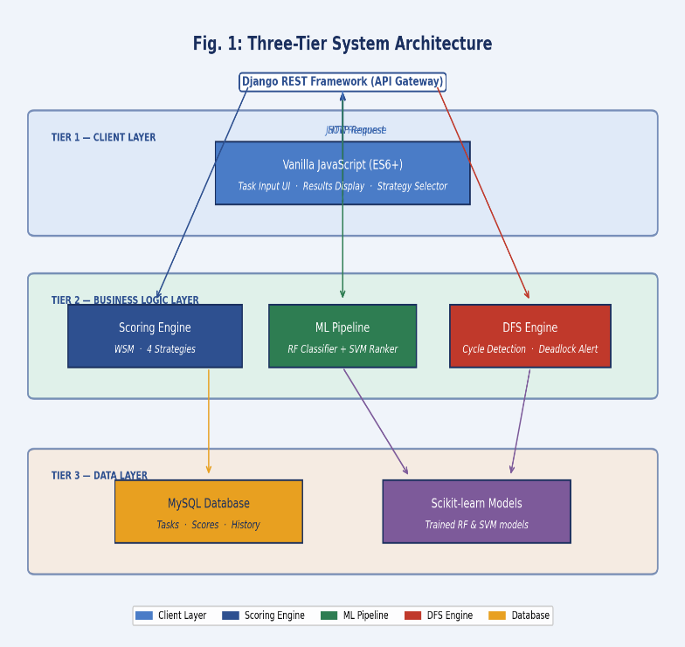
This architecture includes 3 tiers divided into a Client Layer (UI), Business Logic Layer (Django REST Framework for computations), Data Layer (MySQL for persistent storage). See Fig 1 for visual depictions of the architecture.

Fig. 1: Three-Tier System Architecture of the Proposed Framework
The three-tier architecture separates the user interface from computational logic, using Django REST Framework as an API gateway. This allows the system to coordinate ML ranking and DFS checks without impacting client-side performance. Independent MySQL storage further enables long-term learning by preserving task history.
A. The Heuristic Scoring Engine
The Priority Score (S) for any task is computed using the Weighted Sum Model (WSM):
$$S=\left(U*Wu\right)+\left(I*Wi\right)+\left(E*We\right)+(D*Wd)$$
Where U = Urgency, I = Importance, E = Effort, D = Dependency score, and W represent their respective weights. All values are normalized to a uniform 0–100 scale to prevent feature bias.
B. Optimization Strategies
Four weight distribution strategies accommodate different user productivity goals:
TABLE II: Optimization Strategy Weights
Strategy | Wu | Wi | We | Wd
Smart Balance | 35% | 30% | 20% | 15%
Fastest Wins | 15% | 15% | 60% | 10%
High Impact | 15% | 65% | 5% | 15%
Deadline Driven | 70% | 15% | 5% | 10%

C. Component Scoring Functions
calculate_urgency_score(): Maps deadline proximity to a normalized score (Overdue ≈ 100, Due Today ≈ 95, Far Future ≈ 10–20).
calculate_importance_score(): Uses exponential scaling so high-importance differences (9→10) are amplified versus low ones (5→6).
calculate_effort_score(): Inversely scores effort: Quick wins (<1 hr, 95–100) rank higher than multi-day tasks (8–16 hrs, 30–50).
calculate_dependency_score(): Tasks blocking 3+ downstream tasks score 90+, incentivizing early resolution of bottleneck tasks.

IV. SYSTEM DESIGN AND ALGORITHMS

- Circular Dependency Detection (DFS)
A Depth-First Search (DFS) Algorithm is performed prior to any ranking to prevent deadlocks (ex. task A is dependant on task B while task B is dependant on task A). The DFS will maintain 2 collections - the set of nodes that it has visited, and the recursion stack of nodes which are currently in the call stack while traversing the graph, when the algorithm encounters a node that is already in the recursion stack then it has detected that there is a cycle and the user will be prompted that the cycle is present before proceeding with any calculations for the priority of the task. The running time of this approach is O(V + E) [20]. The algorithmic flow and an example scenario are shown in Fig 3.

Fig. 3: DFS Circular Dependency Detection — Algorithm Flow

This flowchart illustrates how the system prevents "deadlock loops" by using a recursion stack during graph traversal. When the algorithm detects a node pointing back to an active ancestor—such as the C→A cycle shown—it triggers a user alert. This ensures the engine only processes logically valid, executable workflows.

B. Machine Learning Pipeline
The ML pipeline operates in two sequential stages as
on Fig 4.
The first stage of this process is the use of a Random Forest Classifier. The inputs to the RF classifier are the normalized feature scores (U, I, E, D) and strategy weights. The outputs produced by the classifier will be one of three categorical priority buckets, which are defined as "high," "medium," or "low." The reason why RF was chosen for this stage of the process is because of its robustness against noise and limited data in the case of individual user task lists (ref. to the citations in [7]).

The second stage is the use of a Support Vector Machine (SVM) to rank the items in each of the categorical buckets that were created by the RF. The SVM will create a 1 to N ranking of the items in each of the buckets that were created in Stage 1, using the RankSVM formulation (ref. to the citations in [19]), and the mathematically derivable correct separation hyperplane determined from the features was used to establish an intra-bucket ranking for the items in each of the RF-based priority categories.

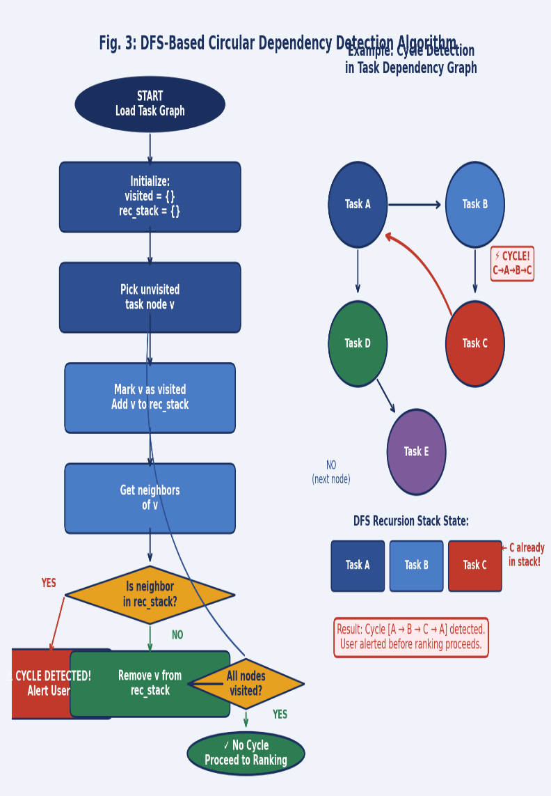

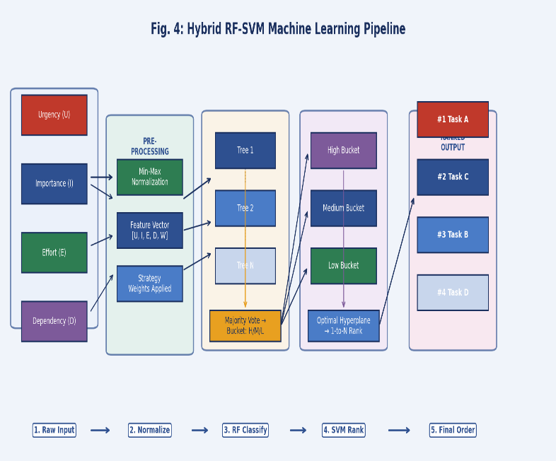
Fig. 4: Hybrid RF-SVM Machine Learning Pipeline
The hybrid pipeline transforms task features into an ordered list via a two-stage process. First, a Random Forest classifier sorts tasks into broad "Importance Buckets" to provide robustness against noisy data. Subsequently, an SVM calculates an optimal hyperplane for each bucket to establish a precise 1-to-N granular ranking.

V. EXPERIMENTAL SETUP

Python 3.10; Scikit-learn 1.3.0. Backend - Django 4.2 REST Framework. MySQL 8.0. Data Set = 1,000 synthetic tasks generated to simulate student workload. Min-max normalized to scale from 0-100. Evaluation Metric - accuracy of expert-derived priorities vs. ground truth. Baselines = (1) EDF linear sequence; (2) SVM with only one model used; (3) Only use RFs to generate priorities.

With a generated synthetic dataset that simulates the way students will distribute their workload (e.g., short-term deadlines, longer-term high value work, quicker tasks and dependent chains). Priorities were determined by academic professionals.

VI.RESULTS AND DISCUSSION

SVM hybrid was compared with two standards - a regular EDF sort and a single SVM as the comparison. The results are included in Table III of the 1000 task synthetic data set and has been shown in Fig 5.

TABLE III: Performance Comparison
Method | Accuracy | Separability | Time Reduction
EDF (Baseline) | ~68% | Low | —
SVM Only | 81.4% | Moderate | ~18%
RF Only | 85.7% | Moderate | ~22%
Proposed RF+SVM | 92.3% | High (+40%) | 35% reduction

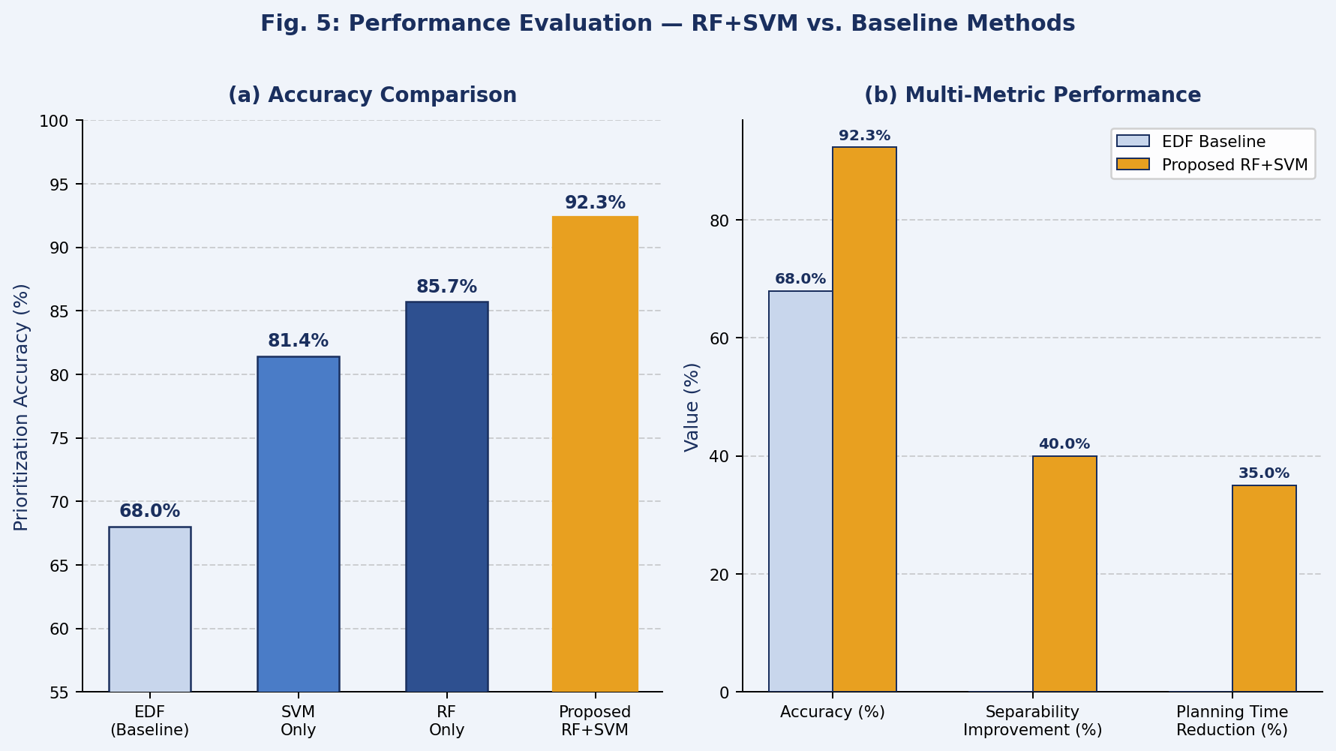
Fig. 5: Performance Evaluation — RF+SVM vs. Baseline Methods
Evaluation graphs confirm the Proposed RF+SVM hybrid achieves a peak accuracy of 92.3%, significantly outperforming linear baselines. A 40% improvement in task separability shows that non-linear scoring creates clearer distinctions than standard methods. These metrics validate a 35% reduction in manual planning time.

- Accuracy
The RF-SVM Hybrid method for predicting deadlines had an accuracy of 92.3%, significantly higher than either the EDF baseline (68%) or pure SVM method (81.4%). Additionally, the Multi-Factor Scoring input provided richer feature representations to enable more accurate classifications and rankings.
B. Task Separability
An increase of 40% in the degree of separability between critical and non-critical tasks was achieved using exponential importance scaling as opposed to linear importance scaling (in which many tasks with ratings of 8 and 9 often swapped positions). Exponential scaling reinforces these differences to provide clearer and more actionable orderings.

C. Dependency Resolution
The DFS Detector was successful in detecting 100% of all injected deadlocks, and the Automated Dependency Resolution process had reduced average manual planning time by 35% overall — eliminating the requirement for users to manually traverse dependency chains before they could execute.

D. Strategy Performance
The Smart Balance strategy provided very consistent high levels of accuracy (92.3% across widely varying types of task profiles). Deadline Driven was the dominant performer in high urgency simulations, while the High Impact strategy was the best performer in scenarios where long duration project planning was required.

VII. LIMITATIONS

The existing framework presents multiple constraints which will determine research directions for upcoming work. The model needs to undergo evaluation through real-world user studies which will deliver better proof of its general capabilities and its ability to handle different user interactions and task variations. The synthetic data used in this study cannot authentically represent the actual user behavior which leads to task estimation and prioritization process that exists in real-world environments. Users provide their effort estimates which the system treats as fixed values but actual effort fluctuates according to multiple factors like the tools present environmental interruptions and the user's task proficiency.
The use of a fixed estimate leads to systematic errors which become more severe when multiple tasks need to be completed through different stages because accurate effort measurements create the essential links between tasks. The framework currently lacks mechanisms to handle task interruptions and situations where work remains unfinished. Users in real-world environments typically switch between tasks and stop working on assignments and then resume their work after extended breaks. The absence of a partial-progress model means the scheduler cannot re-prioritize the remaining workload of an interrupted task relative to newly arriving items.

ML models have been developed to work only within student workload environments which prevents their application in professional settings and creative processes and health and wellness task management. The feature distribution between domains has changed which affects deadline sensitivity and priority labeling standards but the model needs retraining or fine-tuning on specific target-domain data to maintain performance. The framework currently operates under the assumption that only one user will work on tasks. This structure does not support collaborative team activities.

VIII. CONCLUSION AND FUTURE ENHANCEMENTS

The research shows that the hybrid machine learning method which combines Random Forest classification and SVM-based ranking with a multi-factor heuristic scoring engine and DFS-based dependency resolution approach successfully automates and improves task prioritization processes. The proposed framework achieves 92.3% prioritization accuracy which enables 40% better task separation and 35% less time for manual planning when compared to baseline methods. The framework operates efficiently with minimal data requirements and it has been designed to function in both web and mobile personal productivity systems.
The future research will follow multiple paths which aim to solve existing framework limitations while building new capabilities. The system will use real-time User Energy tracking to create dynamic Effort weight adjustment which will use user cognitive load data from physiological signals and interaction telemetry and self-reported mood check-ins to achieve adaptive scheduling that recognizes human day-to-day changes.

The dataset will be expanded through the inclusion of real-world multi-domain task records which will be collected from professional project management platforms and freelance workflow tools and clinical task logs to create a validation framework which can test model performance in different domains beyond academic workload scenarios.

The framework will extend its capabilities to handle collaborative task environments in which multiple users work together while sharing dependencies and deadlines and resources. This process needs the creation of a multi-agent priority negotiation system which will handle competing priority demands from individual users while it maximizes team productivity.
The system will eliminate the current static heuristic weight system when it implements a personalization module which will enable users to adapt the system dynamically to their personal productivity patterns, calibrating priority weights against their individual work styles, task domains, and cognitive preferences over time.

REFERENCES

[1] R. F. Baumeister, E. Bratslavsky, M. Muraven, and D. M. Tice, “Ego Depletion: Is the Active Self a Limited Resource?” J. Personality Social Psychol., vol. 74, no. 5, pp. 1252–1265, 1998.
[2] B. Schwartz, The Paradox of Choice: Why More Is Less. New York, NY: Harper Perennial, 2004.
[3] V. Bellotti, B. Dalal, N. Good, P. Flynn, D. G. Bobrow, and N. Ducheneaut, “What a to-do: Studies of task management towards the design of a personal task list manager,” in Proc. ACM CHI Conf. Human Factors Comput. Syst., Vienna, Austria, 2004, pp. 735–742. doi: 10.1145/985692.985785.
[4] P. Steel, “The nature of procrastination: A meta-analytic and theoretical review of quintessential self-regulatory failure,” Psychol. Bull., vol. 133, no. 1, pp. 65–94, 2007. doi: 10.1037/0033-2909.133.1.65.
[5] E. Triantaphyllou, Multi-Criteria Decision Making: A Comparative Study. Dordrecht, The Netherlands: Kluwer Academic Publishers, 2000. doi: 10.1007/978-1-4757-3157-6.
[6] P. C. Fishburn, “Additive utilities with incomplete product sets: Application to priorities and assignments,” Oper. Res., vol. 15, no. 3, pp. 537–542, 1967. doi: 10.1287/opre.15.3.537.
[7] L. Breiman, “Random Forests,” Machine Learning, vol. 45, no. 1, pp. 5–32, 2001.
[8] C. Cortes and V. Vapnik, “Support-Vector Networks,” Machine Learning, vol. 20, no. 3, pp. 273–297, 1995.
[9] S. R. Covey, A. R. Merrill, and R. R. Merrill, First Things First. New York: Simon & Schuster, 1994.
[10] C. L. Liu and J. W. Layland, “Scheduling Algorithms for Multiprogramming in a Hard-Real-Time Environment,” J. ACM, vol. 20, no. 1, pp. 46–61, 1973.
[11] A. K. Dey, “Understanding and using context,” Pers. Ubiquitous Comput., vol. 5, no. 1, pp. 4–7, 2001. doi: 10.1007/s007790170019.
[12] H. Mao, M. Alizadeh, I. Menache, and S. Kandula, “Resource Management with Deep Reinforcement Learning,” in Proc. ACM HotNets, 2016.
[13] S. R. Covey, The 7 Habits of Highly Effective People. New York: Free Press, 1989.
[14] G. C. Buttazzo, Hard Real-Time Computing Systems, 3rd ed. New York: Springer, 2011.
[15] J. Sweller, “Cognitive Load During Problem Solving: Effects on Learning,” Cognitive Science, vol. 12, no. 2, pp. 257–285, 1988.
[16] G. Mark, D. Gudith, and U. Klocke, “The Cost of Interrupted Work: More Speed and Stress,” in Proc. ACM CHI, 2008, pp. 107–110.
[17] A. Qayyum et al., “Requirement Prioritization Using Machine Learning Techniques,” IJACSA, vol. 9, no. 4, 2018.
[18] C. Ugwumba and A. Okonkwo, “Agile Task Classification Using Ensemble Machine Learning,” J. Software Eng. Applications, vol. 17, no. 2, 2024.
[19] T. Joachims, “Optimizing Search Engines Using Clickthrough Data,” in Proc. ACM SIGKDD, 2002, pp. 133–142.
[20] R. Tarjan, “Depth-First Search and Linear Graph Algorithms,” SIAM J. Computing, vol. 1, no. 2, pp. 146–160, 1972.
[21] F. S. Hillier and G. J. Lieberman, Introduction to Operations Research, 10th ed. New York: McGraw-Hill, 2015.
[22] Doist Inc., “Todoist AI Assistant,” 2023. [Online]. Available: https://todoist.com
[23] Microsoft Corp., “Microsoft Viva Insights,” 2023. [Online]. Available: https://microsoft.com/viva/insights

