# Offsite Assessment – Python Script for Stock Price Monitoring

## Introduction

This document explains the solution developed for monitoring the stock price of Apple Inc. (AAPL) using web scraping techniques and email notifications via Python.

The script fetches live stock data from Yahoo Finance and triggers an email alert when the stock price exceeds a specified threshold. This is useful for portfolio monitoring or real-time investment alerts.

Solution Flow

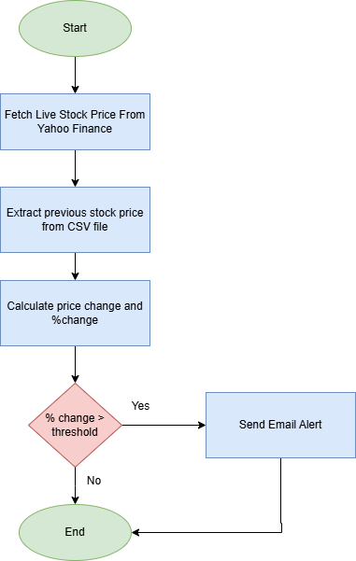

Tools and Libraries Used

* **Python 3.x**
* **Libraries:**
  + requests – For HTTP requests
  + BeautifulSoup – To parse HTML content
  + pandas – For data handling
  + smtplib, email.mime – To send emails
  + dotenv – For securely loading environment variables when sending emails

Code Explanation

1. **Import All Required Libraries**

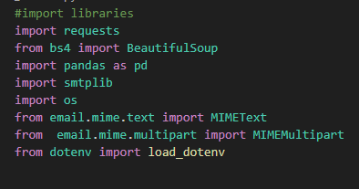

1. ****Web Scraping****

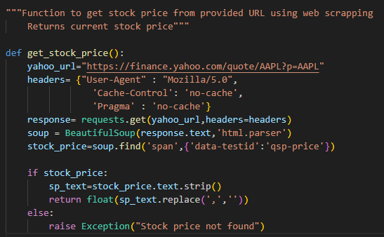

This function scrapes the current Apple (AAPL) stock price from Yahoo Finance using requests and BeautifulSoup, and returns it as a float. If the price is not found, it raises an exception.

1. ****Data Reconciliation****

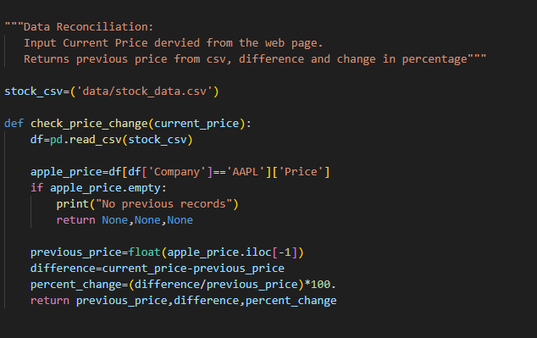

This function reads the last recorded Apple stock price from a CSV file and calculates the difference and percentage change compared to the current price. It returns the previous price, price difference, and percentage change.

1. **Email Alert**

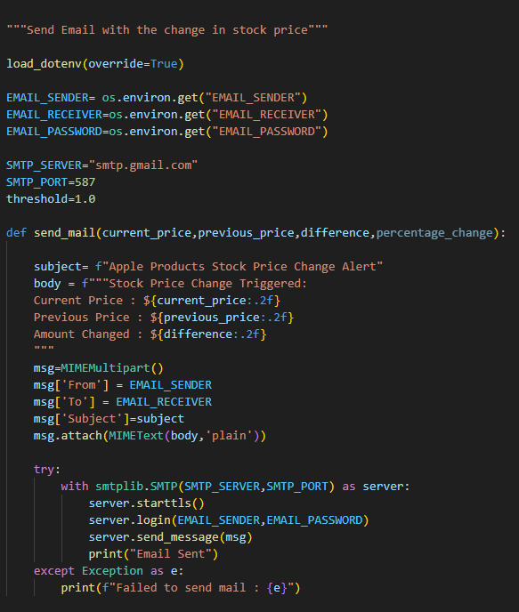

This function sends an email alert via Gmail SMTP , using credentials and details loaded securely from environment variables.

1. **Main Function**

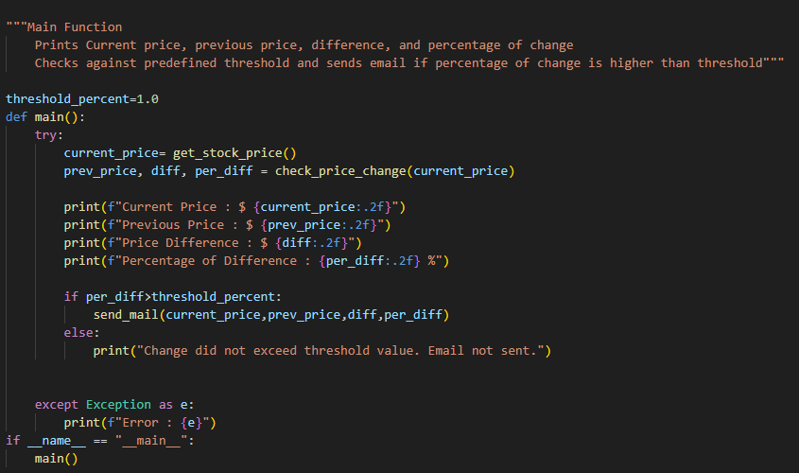This is the entry point of the script that fetches the current stock price, compares it with the previous price, calculates the percentage change, and sends an email alert if the change exceeds the defined threshold.

Output:

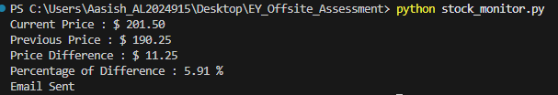

Email Alert:

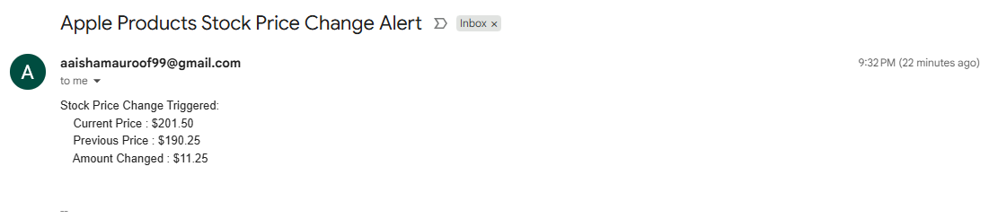

Schedular Screenshots:

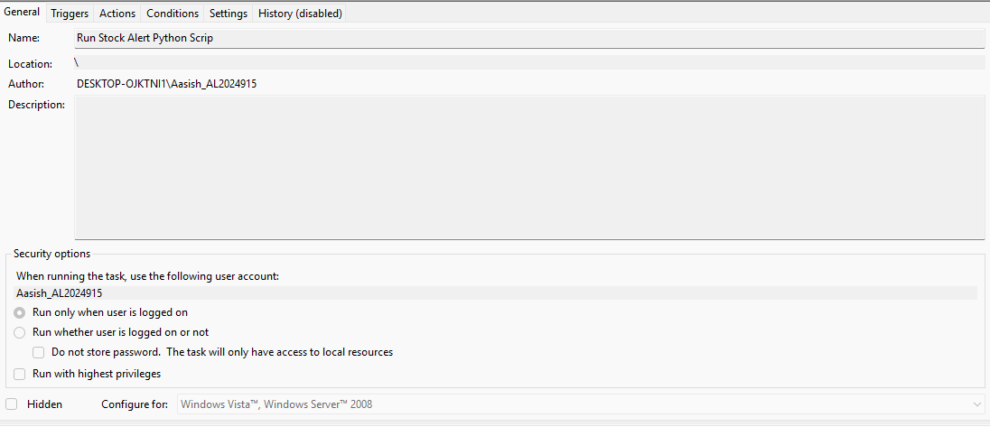

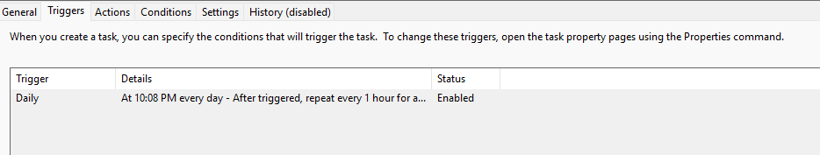

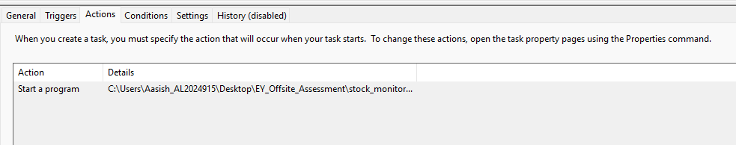

GitHub Repository Link:

<https://github.com/aaishaM/Aaisha_offsite_test>