Assignment #5: Introduction to JavaScript

# Report

Team Information

 **Team Name:** Balgyn & Ayana

 **Group:** SE-2404

 **Team Members:**

 Balgyn  Ayana

# Task 1: Form Validation

**Implemented by:** Balgyn

Code Implementation

document.addEventListener('DOMContentLoaded', function() {

const contactForm = document.getElementById('contactForm');

if (contactForm) {

contactForm.addEventListener('submit', function(event) { event.preventDefault();

// Clear previous error messages clearErrors();

let isValid = true;

// Validate Name

const name = document.getElementById('name'); if (name.value.trim() === '') {

showError('name', 'Name is required'); isValid = false;

} else if (name.value.trim().length < 2) {

showError('name', 'Name must be at least 2 characters'); isValid = false;

}

// Validate Email

const email = document.getElementById('email');

const emailPattern = /^[^\s@]+@[^\s@]+\.[^\s@]+$/; if (email.value.trim() === '') {

showError('email', 'Email is required'); isValid = false;

} else if (!emailPattern.test(email.value)) {

showError('email', 'Please enter a valid email address'); isValid = false;

}

// Validate Message

const message = document.getElementById('message'); if (message.value.trim() === '') {

showError('message', 'Message is required'); isValid = false;

} else if (message.value.trim().length < 10) {

showError('message', 'Message must be at least 10 characters'); isValid = false;

}

// If form is valid, show success message if (isValid) {

showSuccessMessage(); contactForm.reset();

}

});

}

});

function showError(fieldId, message) {

const field = document.getElementById(fieldId); const errorDiv = document.createElement('div');

errorDiv.className = 'error-message text-danger mt-1'; errorDiv.textContent = message;

field.parentElement.appendChild(errorDiv); field.classList.add('is-invalid');

}

function clearErrors() {

const errorMessages = document.querySelectorAll('.error-message'); errorMessages.forEach(error => error.remove());

const invalidFields = document.querySelectorAll('.is-invalid');

invalidFields.forEach(field => field.classList.remove('is-invalid'));

}

function showSuccessMessage() {

const successDiv = document.createElement('div');

successDiv.className = 'alert alert-success alert-dismissible fade show mt-3'; successDiv.innerHTML = `

<strong>Success!</strong> Your message has been sent successfully.

<button type="button" class="btn-close" data-bs-dismiss="alert"></button>

`;

document.getElementById('contactForm').parentElement.insertBefore( successDiv,

document.getElementById('contactForm')

);

setTimeout(() => {

successDiv.remove();

}, 5000);

}

Screenshot

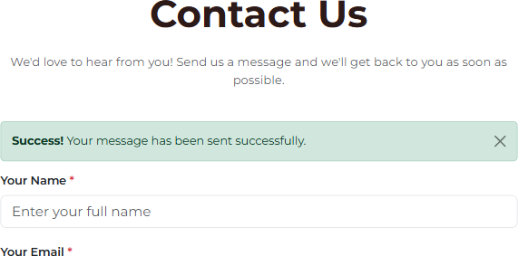

# Task 2: Accordion for FAQs

**Implemented by:** Ayana

Code Implementation

document.addEventListener('DOMContentLoaded', function() {

const accordionItems = document.querySelectorAll('.accordion-item-custom');

accordionItems.forEach(item => {

const header = item.querySelector('.accordion-header-custom'); const content = item.querySelector('.accordion-content-custom');

if (header && content) {

header.addEventListener('click', function() {

const isActive = item.classList.contains('active');

// Close all accordion items accordionItems.forEach(i => {

i.classList.remove('active');

const c = i.querySelector('.accordion-content-custom'); if (c) {

c.style.maxHeight = null;

}

});

// Toggle current item if (!isActive) {

item.classList.add('active');

content.style.maxHeight = content.scrollHeight + 'px';

}

});

}

});

});

Screenshot

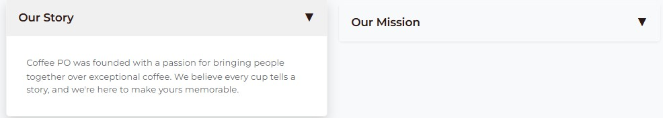

# Task 3: Popup Subscription Form

**Implemented by:** Balgyn

Code Implementation

document.addEventListener('DOMContentLoaded', function() {

const subscribeBtn = document.getElementById('subscribeBtn'); const popup = document.getElementById('subscriptionPopup');

const closePopup = document.getElementById('closePopup');

const popupOverlay = document.getElementById('popupOverlay'); const subscribeForm = document.getElementById('subscribeForm');

// Open popup

if (subscribeBtn && popup) {

subscribeBtn.addEventListener('click', function() { popup.style.display = 'block';

popupOverlay.style.display = 'block';

document.body.style.overflow = 'hidden';

});

}

// Close popup

function closeSubscriptionPopup() { if (popup && popupOverlay) {

popup.style.display = 'none';

popupOverlay.style.display = 'none'; document.body.style.overflow = 'auto';

}

}

if (closePopup) {

closePopup.addEventListener('click', closeSubscriptionPopup);

}

if (popupOverlay) {

popupOverlay.addEventListener('click', closeSubscriptionPopup);

}

// Handle subscription form submit if (subscribeForm) {

subscribeForm.addEventListener('submit', function(event) { event.preventDefault();

const email = document.getElementById('popupEmail').value; const emailPattern = /^[^\s@]+@[^\s@]+\.[^\s@]+$/;

if (emailPattern.test(email)) {

alert('Thank you for subscribing! We will send updates to ' +

email);

subscribeForm.reset();

closeSubscriptionPopup();

} else {

alert('Please enter a valid email address');

}

});

}

// Close popup on Escape key

document.addEventListener('keydown', function(event) {

if (event.key === 'Escape' && popup && popup.style.display === 'block') { closeSubscriptionPopup();

}

});

});

Screenshot

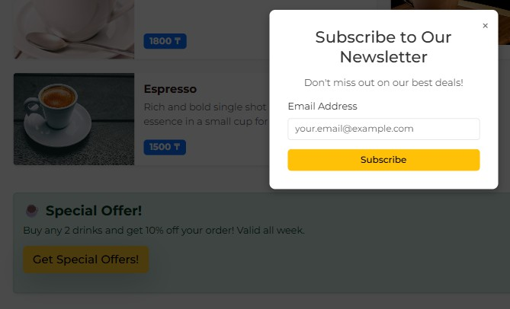

# Task 4: Dark/Light Mode Toggle

**Implemented by:** Ayana

Code Implementation

document.addEventListener('DOMContentLoaded', function() {

const colorChangeBtnMobile = document.getElementById('colorChangeBtn'); const colorChangeBtnDesktop = document.getElementById('colorChangeBtn-

desktop');

const buttons = [];

if (colorChangeBtnMobile) buttons.push(colorChangeBtnMobile);

if (colorChangeBtnDesktop) buttons.push(colorChangeBtnDesktop); const body = document.body;

function updateMode(isDark) { if (isDark) {

body.classList.add('dark-mode');

buttons.forEach(btn => btn.textContent = '☀ Light Mode'); localStorage.setItem('colorMode', 'dark');

} else {

body.classList.remove('dark-mode');

buttons.forEach(btn => btn.textContent = '🌙 Dark Mode'); localStorage.setItem('colorMode', 'light');

}

}

const savedMode = localStorage.getItem('colorMode');

if (savedMode === 'dark') { updateMode(true);

} else {

updateMode(false);

}

buttons.forEach(btn => {

btn.addEventListener('click', function() {

const isDark = body.classList.contains('dark-mode');

updateMode(!isDark); // Переключаем на противоположный режим

});

});

});

Screenshot

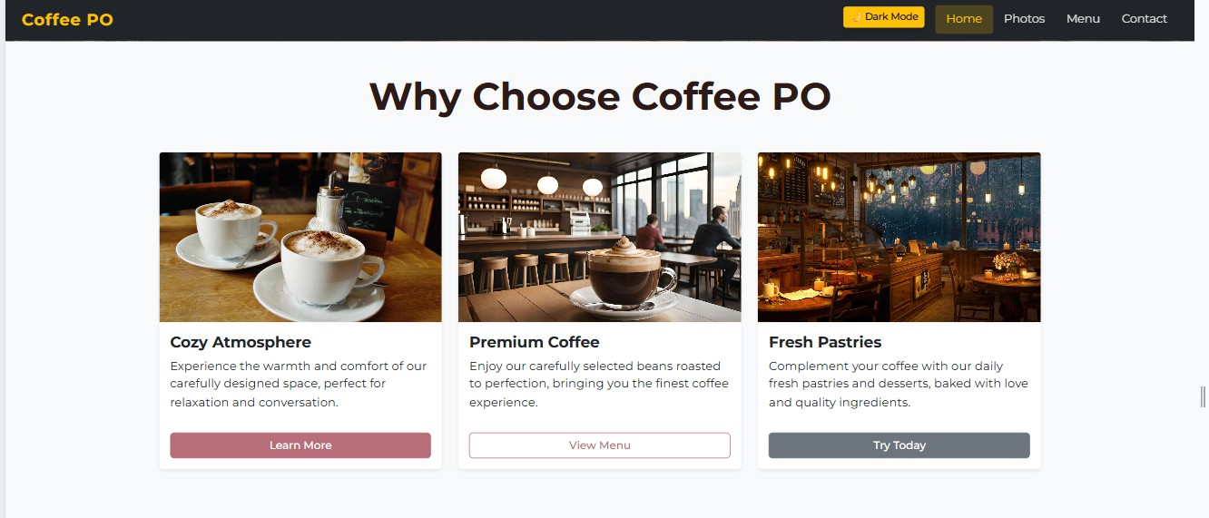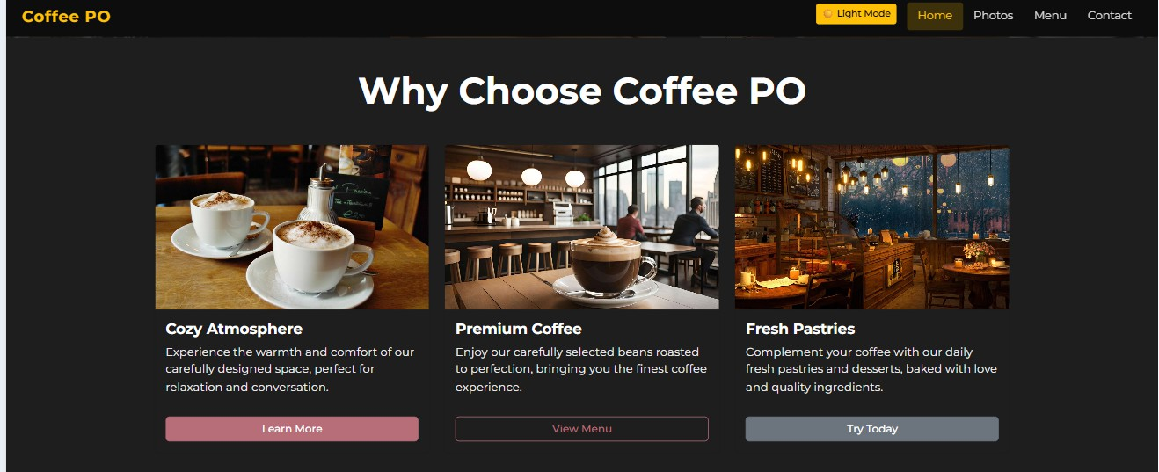

# Task 5: Display Current Date and Time

**Implemented by:** Balgyn

Code Implementation

document.addEventListener('DOMContentLoaded', function() {

const dateTimeDisplay = document.getElementById('dateTimeDisplay');

if (dateTimeDisplay) { updateDateTime();

// Update every second

setInterval(updateDateTime, 1000);

}

});

function updateDateTime() {

const dateTimeDisplay = document.getElementById('dateTimeDisplay'); if (!dateTimeDisplay) return;

const now = new Date();

// Format date

const options = {

year: 'numeric', month: 'long', day: 'numeric', weekday: 'long'

};

const dateStr = now.toLocaleDateString('en-US', options);

// Format time

let hours = now.getHours();

const minutes = now.getMinutes().toString().padStart(2, '0'); const seconds = now.getSeconds().toString().padStart(2, '0'); const ampm = hours >= 12 ? 'PM' : 'AM';

hours = hours % 12;

hours = hours ? hours : 12; // Convert 0 to 12

const timeStr = hours + ':' + minutes + ':' + seconds + ' ' + ampm;

// Update display

dateTimeDisplay.innerHTML = `

<div class="date-display">

<i class="bi bi-calendar3"></i> ${dateStr}

</div>

<div class="time-display">

<i class="bi bi-clock"></i> ${timeStr}

</div>

`;

}

Screenshot



# Deployment

**Deployed Website URL:** [Insert your URL here]

# Conclusion

In this assignment, we successfully implemented five JavaScript features:

1. Form validation with error handling
2. Interactive accordion for FAQs
3. Popup subscription form with multiple close methods
4. Dark/Light mode toggle with localStorage persistence
5. Real-time date and time display

All features work correctly and enhance user experience on the website.

**Submitted by:** Balgyn & Ayana

**Group:** SE-2404