1. I used the curve fitting tool in Matlab to a fourier series with two terms (ie. y(x) = a0 + a1*cos(x*w) + b1*sin(x*w) + a2*cos(2*x*w) + b2*sin(2*x*w) as the resulting function). This resulted in the following values for a0, a1, a2, b1, b2 and w with 95% confidence interval in parentheses:

a0 = 6.551 (6.549, 6.554)
a1 = -0.01973 (-0.02688, -0.01259)
b1 = -0.03736 (-0.04305, -0.03167)
a2 = 0.02363 (0.017, 0.03025)
b2 = 0.01372 (0.004723, 0.02271)
w = 1.527 (1.504, 1.549)

Fitted function together with the original data points:
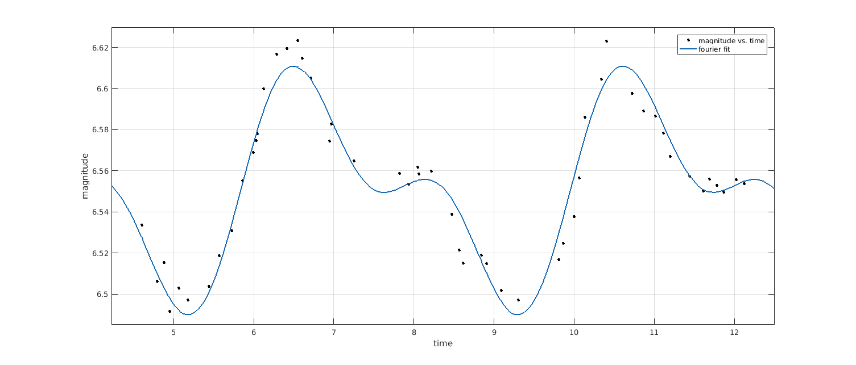

2&3. Plots on next page. Axis are identical so differences between runs with different values of h are not visible. Outputs with numbers are also shown below. From them, it is easy to see that accuracy of Euler worsens drastically when h gets larger whereas for RK4 the effect is much smaller.

2a) h=0.200000: 0.327680
time spent on 1 000 000 runs: 0.065612 s
2a) h=0.100000: 0.413811
time spent on 1 000 000 runs: 0.108617 s
2a) h=0.010000: 0.366032
time spent on 1 000 000 runs: 0.846473 s
2a) h=0.001000: 0.367695
time spent on 1 000 000 runs: 8.552178 s
3) h=0.200000: 0.367885
time spent on 1 000 000 runs: 0.132945 s
3) h=0.100000: 0.432871
time spent on 1 000 000 runs: 0.316364 s
3) h=0.010000: 0.367879
time spent on 1 000 000 runs: 3.023124 s
3) h=0.001000: 0.367879
time spent on 1 000 000 runs: 30.421997 s

The output also includes timing results using standard C function clock(). We can see that both functions seem to scale as O(n) as their code would suggest, but RK has larger constant factor and is therefore slower. This is expected, as RK4 evaluates df(x, y) four times per loop whereas Euler does that only one. In general RK4 needs more operations per loop and the number of loops is same for both RK4 and Euler for same h.

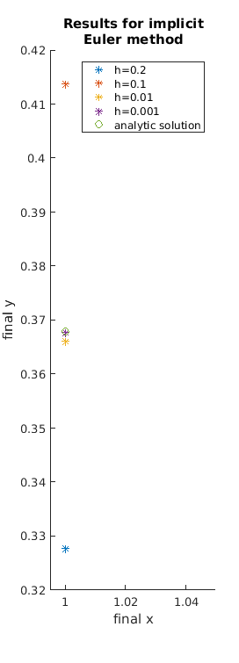
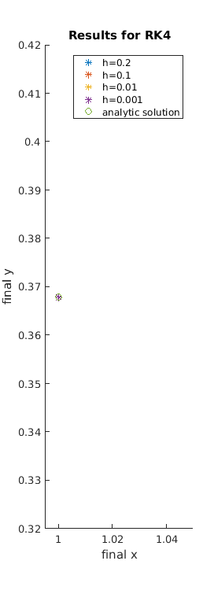

4)

