1. a) My program can be found in file boundaryproblem.c where the shooting method is defined as

double shooting(double x0, double xf, double y0, double yf, double h, bool print, FILE *out)

where y(x0)=y0, y(xf)=yf, h is the step size, print is boolean determining whether to save the best found curve and out is pointer to file used for writing output. Returns shooting best found shooting angle and prints pairs of x and y values, one point on one row, x and y separated by tab into given file. First point (the initial value) is not written.

b) Main file that uses h=pi/2/127 and writing the output to shooting.dat can be found in returned files together with makefile. This value of h results in 128 points including the ends.
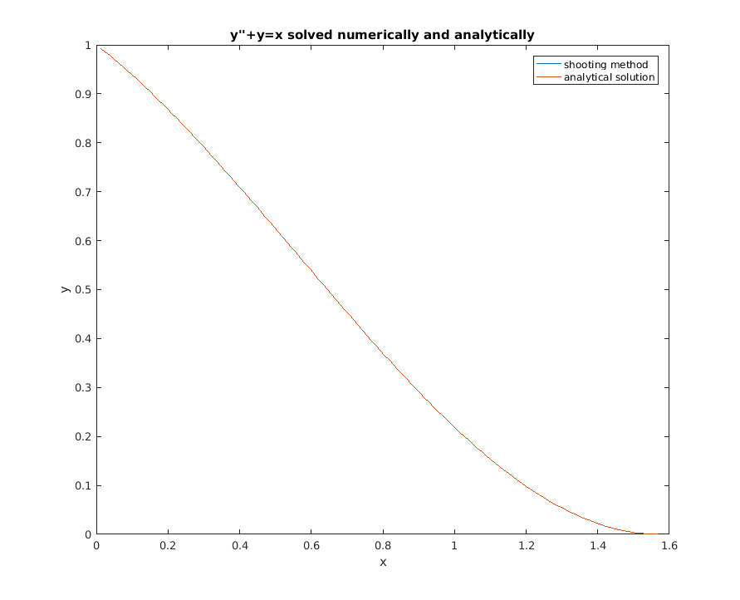
Curves overlap as can be expected.
3. a) I implemented FFT as given in Numerical Recipes in C. I used information in http://www.staff.vu.edu.au/msek/frequency%20analysis%20-%20fft.pdf to patch together a code snippet to truncate and scale the spectrum and extract angular frequencies but I’m very unsure of that part of my work. My FFT plot can be seen below, peak being at ω=1 which corresponds to f=1/(2pi). My code is part of the tar.

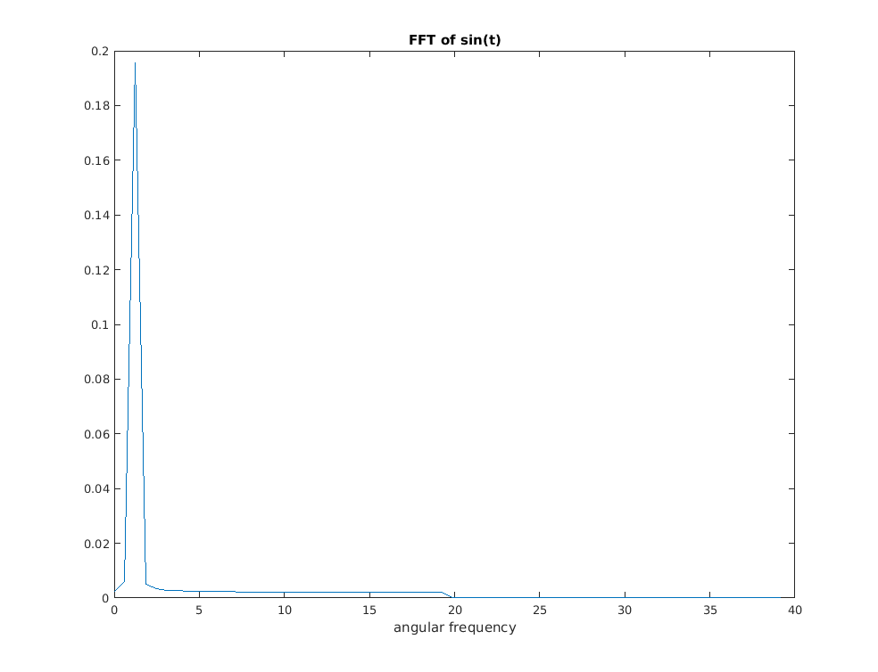
b) Plot for only random data below
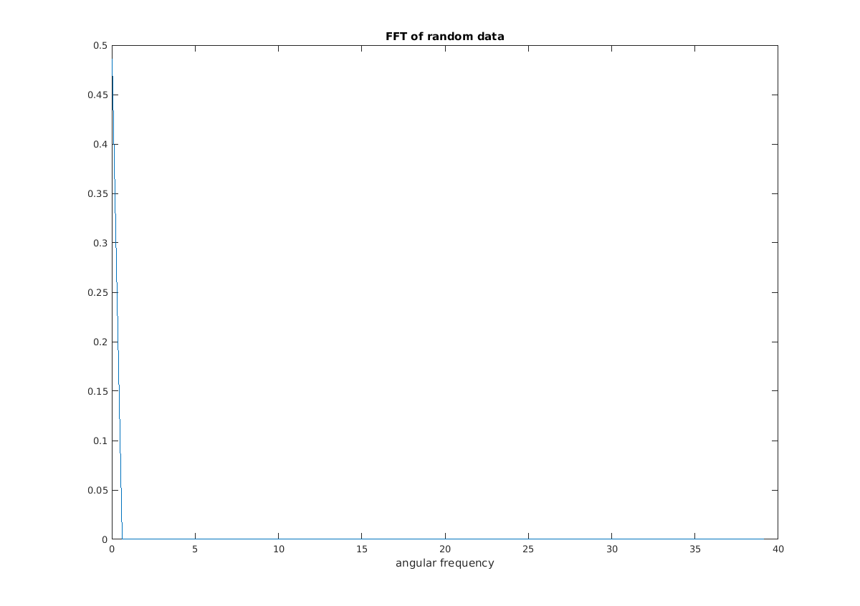
For combination of random and sinusoidal data I got figures that look quite same for all values of b (I used constant seed for the rng) but larger b results in larger amplitude over the whole curve, which I am compelled to interpret as the magnitude of the randomness not having an effect but I also find that hard to believe because it seems very unintuitive. Maybe there’s an error in my program.

4. a) Plot below. The spikes do not seem to correspond to 10 and 11 very well which again makes me suspect an error or misunderstandment.

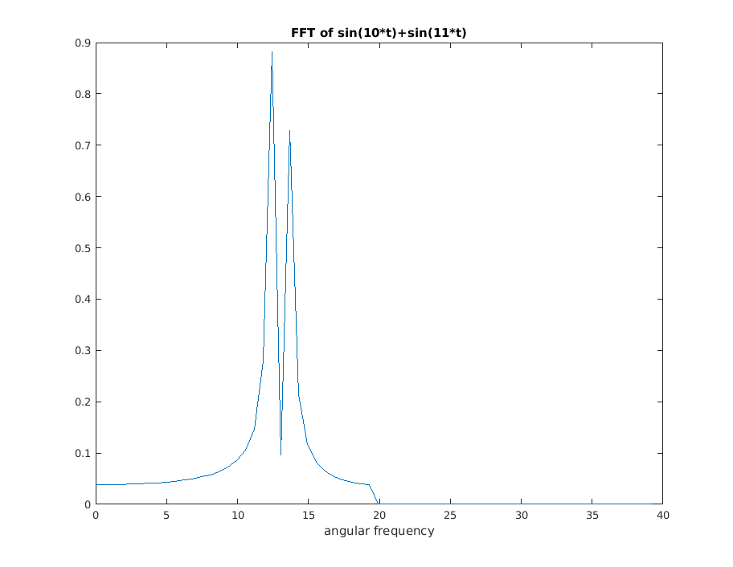

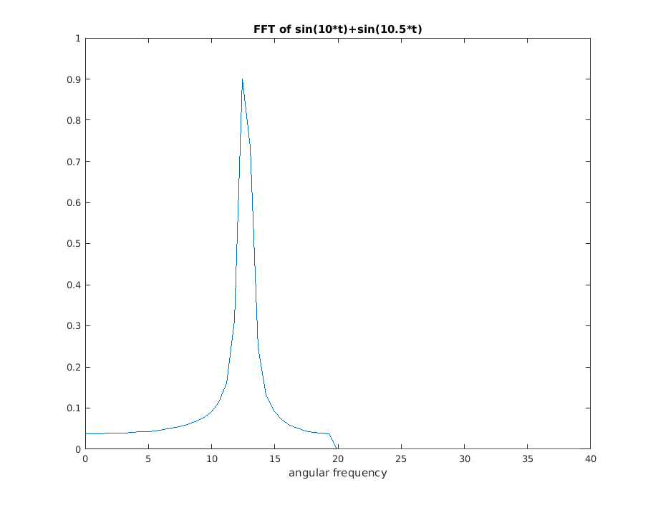
b) Now the spikes have merged as can be seen from the plot. Slight asymmetry is visible in the resulting spike.

