**Aim:**  To implement Fractal (Koch Curve).

**Objective:**

A Koch curve is a fractal curve that can be constructed by taking a straight-line segment and replacing it with a pattern of multiple line segments. Then the line segments in that pattern are replaced by the same pattern.

**Theory**:

1) Draw an equilateral triangle.

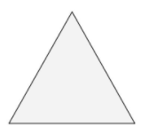

2) Divide each side in three equal parts.

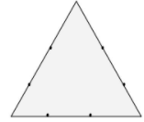

3) Draw an equilateral triangle on each middle part. Measure the length of the middle third to know the length of the sides of these new triangles.

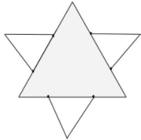

4) Divide each outer side into thirds. You can see the 2nd generation of triangles covers a bit of the first. These three line-segments shouldn’t be parted in three.

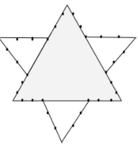

5) Draw an equilateral triangle on each middle part.

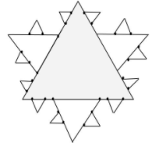

**Program:**

#include<stdio.h>

#include<conio.h>

#include<graphics.h>

#include<math.h>

void kosh(int,int,int,int,int);

void main()

{

int gd=DETECT,gm;

int i,x1=100,y1=100,x2=400,y2=400,a;

initgraph(&gd,&gm,"C:\\TURBOC3\\BGI");

printf("ENTER ITR: ");

scanf("%d",&a);

for(i=0;i<a;i++)

{

kosh(x1,y1,x2,y2,a);

getch();

}

closegraph();

}

void kosh(int x1,int y1,int x2,int y2,int itr)

{

float angle=60.3*3.14/180;

int x3=(2*x1+x2)/3;

int y3=(2*y1+y2)/3;

int x4=(x1+2*x2)/3;

int y4=(y1+2*y2)/3;

int x=x3+(x4-x3)*cos(angle)+(y4-y3)*sin(angle);

int y=y3-(x4-x3)*sin(angle)+(y4-y3)*cos(angle);

if(itr>0)

{

kosh(x1,y1,x3,y3,itr-1);

kosh(x3,y3,x,y,itr-1);

kosh(x,y,x4,y4,itr-1);

kosh(x4,y4,x2,y2,itr-1);

}

else

{

line(x1,y1,x2,y2);

}

}

**Output:**

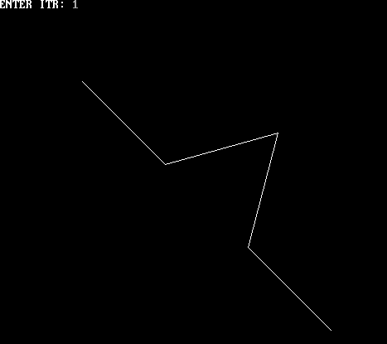

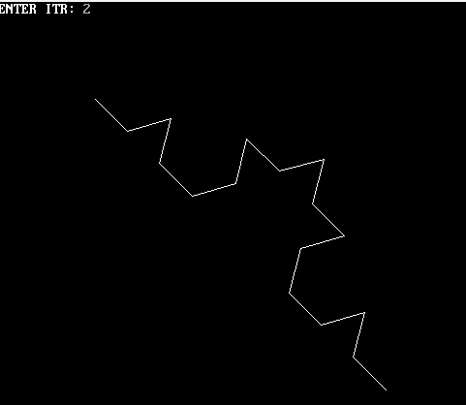

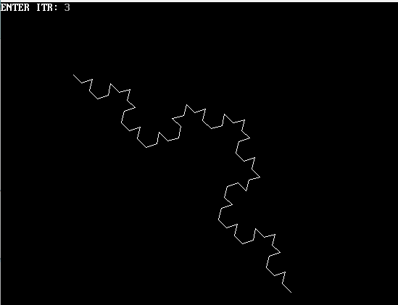

**Conclusion** - Comment on

1. Difference from Bezier Curve.

A Bezier curve is like a magic line you draw in CG, connecting points to create smooth and curved shapes. It's like using a special pen that can make beautiful curves on a computer. On the other hand, a character in CG is like a virtual actor in a story, brought to life using these Bezier curves and other techniques, making it move, emote, and tell the tale.

1. Application

Bezier curves are like flexible ropes used to shape and define smooth lines and curves. They're handy for drawing and animating characters, creating realistic motions, and designing objects with smooth edges, like cars or logos. It's like using a magical pen to make everything look sleek and polished.