SYSC 4907 Final Report
Video Store System
3/12/2012

Group 14
Group Members
Kelechi Nnorom 100783816
Kerrie Newton 100748041
Aniekan Akai 100751295
Mostafa Hussen 100661280

Supervisor Dr Yvan Labiche
Carleton University
TABLE OF CONTENTS

1 Abstract 5
2 Introduction 6
3 The Engineering Project 8
3.1 Engineering professionalism 8
3.2 Project Management 8
3.3 Individual Contributions 8
3.4 Report Contributions 9
4 Video Store System 10
5 Software Architecture 12
5.1 Requirement Elicitation: 13
5.2 Requirement Specification: 16
5.3 Use Case Descriptions: 19
6 Component Diagram 38
7 System Analysis 39
8 Graphical User Interface (GUI) 42
8.1 Rent Item(with a some sample input): 45
8.2 The employee can scan Return Item: 45
9 Data Dictionary 48
10 Implementation 52
10.1 Database Server 52
10.2 Entity Relationship Design 53
10.3 Relational SQL Database Definition 54
10.4 Database Schema 59
10.5 PHP 60
11 Website 62
12 Future Work 63
13 Conclusion 64
Appendix I Complete use case descriptions 65
Appendix II Definitions, acronyms, abbreviations 66
Appendix III Code Excerpts 67
III.1 Code excerpt for login validation 67
III.2 Code excerpt for register 70
III.3 Code excerpt for forgot password 73
III.4 Code excerpt for search 76

LIST OF FIGURES

Figure 1 Customer's view Use Case Diagram 18
Figure 2 Employee's view Use Case Diagram 19
Figure 3Figure 3 System Component Diagram 38
Figure 4 41
Figure 5 41
Figure 6 Rent item (a) and Return item (b) interfaces 45
Figure 7 60
Figure 8 Login 61

Abstract
This report describes our group's implementation of a video store management system. We used the Entity-Relationship model to design a database that will store and organize the store's data. We have created the database using SQL and populated it with some sample data. The system can keep track of video, games, stock levels, rentals, reservations, customers, members, employees, store locations and the relationships between them. Using Java, Netbeans IDE and JDBC, we have created an Internet-based graphical user interface that allows members and employees of the video store to access the system remotely.

Introduction
This document discusses the result of the 4th Year project entitled “A Video Store System” during the 2011/2012 academic year at Carleton University. The team consisted of Kelechi Nnorom, Kerrie Newton, Aniekan Akai and Mostafa Hussen, supervised by Dr Yvan Labiche. The objective of this project was to design and implement a Video Store System using proper software engineering methodology. The project was divided into three different components, which were the video store employee interface, the video store administrator interface and an online store for clients.
The report is divided into sections: In section 2 we provide a brief discussion about the project.
The Engineering Project – discussion about engineering professionalism, project management and individual project/report contributions
Background- an overview of the Video Store System
Software Architecture- discusses how we approached the project and which design pattern was used
Requirement Elicitation – The report will cover the functional and non-functional requirements, the scope, actors (i.e. who is using the system) and the use cases, which explain the functionalities of the system and what is the system should do.
System Analysis - It discusses the entity, boundary and the control objects using class diagrams and sequence diagrams.
Data Dictionary- It explains the entity, control and boundary classes, including their attribute, pre and post condition and the definitions of each operation.
Implementation – how the database was designed and implemented and the use of PHP to embed dynamic text
Website

The Engineering Project
This chapter is an overview of the engineering project and discusses the various professional techniques that were used during the course of the project. The third part of this chapter discusses how proper management skills were utilized to manage the project. The last section indicates the individual work performed by the team members both in the project along with the final report.

Engineering professionalism
Through the academic year our group exemplified a professional demeanour. We attended the scheduled meetings punctually with prepared material. In addition all major project deadlines were met. The group members also acted in a professional manner when dealing with each other during the course of the project.

Project Management
Project management is a very important factor in the success of any project. The first order of business was to devise a detailed schedule to ensure all project deliverables are met. We divided the project into components and estimated the timeline for each component. This allowed each member to be prepared, resulting in effective work being performed.
In addition, we set up bi-weekly (weekly in some instances) meetings with our supervisor Dr. Yvan Labiche, where we discussed completed work and upcoming tasks.

Individual Contributions
Team Member | Contribution
All | - Requirement Elicitation  - Analysis and Design
Aniekan Akai | - GUI Implementation  - Boundary class implementation  - JDBC Implementation
Mostafa Hussen | - Entity classes Implementation  - Control Classes implementation
Kerrie Newton | - Database implementation  - PHP implementation
Kelechi Nnorom | - Website Design  - Component Diagram

Report Contributions
Team Member | Contribution
All | - Introduction  - The Engineering Project  - Future Work  - Lessons Learned  Conclusion
Aniekan Akai | - System Analysis  - GUI implementation  - Boundary classes  - Software Architecture
Mostafa Hussen | - Requirement Elicitation  - Data Dictionary
Kerrie Newton | - Video Store System  - Software Architecture  - Database Server  - Relational Database Schema  - Entity Relationship Design
Kelechi Nnorom | - Website  - Component Diagram

Video Store System
The Video Store system to be designed herein called VSS is to be used in a video store that rents and sells video copies and games. Both games and videos have a title and the store may have many copies of a given game or video.
The VSS only allows members of the store to rent copies of videos and games, however anyone may purchase a copy of a game or video. VSS members have a membership card which has a barcode and is used when trying to rent a video or game.
Video store employees may create new memberships. Employees may utilize the VSS to help customers search for a copy of a video or game. The VSS is also used to add and remove copies of videos or games, reserve copies and to sell copies of videos or games. When a customer rents an item their membership card and the item are scanned using the barcode scanner. This allows the employee to retrieve customer account information and information on the copy such as whether it is a game or video, how much it rents for, what would be the return date, the selling price and if it has been reserved.
In addition to employees, there are administrators who are able to renew or suspend privileges, add or remove titles from the database, and update account information.
When members return items, an employee scans the items to clear it from the member’s account. At the same time, the item is checked to see if it is overdue.
Members returning an items late will incur a late fee for every additional day past the scheduled return date. The VSS checks daily for overdue items and updates the corresponding members account to ban them from renting additional items. The VSS also automatically emails an overdue notice to overdue customers reminding them that the item they rented is overdue and requesting them to return it.
Members can reserve an item for which there is currently no copy in stock. A reservation can be held for a week after the item copy becomes available. When the item becomes available, if the member’s account information contains an email, the email system would automatically notify the member of the availability of the item. After a week of being on hold, the item is available for rent or purchase.
There is also an online aspect to the VSS where customers can search for both games and videos. Members can log in to access their account details where they will be able to see current and past rentals along with making reservations.

Software Architecture
This software is a stand alone program; it is implemented as a client-side application only. This software will require a designated database server to operate. This software is designed to be efficient, error-free, and user-friendly. The architecture pattern used is Centralized Client-Server Architecture.
This software is also designed to achieve the goal of modularity. In order to support object-oriented design, JAVA (an object-oriented language) is used as our core language; and to ensure the independency of the objects, each object is carefully designed to support a group of data that is only relevant to the object that carries them. To extend the independency of our objects, we also divide the software components into three model groups (transaction, GUI, internal). This way, the actions of each group are completely isolated.
We have designed the system such that we have separated different aspects of it. We have abstracted the system to have an in-store system, the online system (website) and a server side where the database lies. The in-store system was then implemented and separated such that, there is a GUI part and interfaces, stored information section and the controllers for certain groups of functionalities. This was done for ease of use, and ease of debugging. Indeed, when there is an error with one the printer interface one can easily fix that up without changing much in the other parts.
For the server side, only SQL-tables and relations are defined and implemented. Since a JAVA library is available for accessing the data structures in the server. The Software is mostly the client side application.
AT THIS STAGE OF THE INTRODUCTION TO SECTION 5 IT WOULD BE NICE TO TELL THE READER WHAT S/HE CAN EXPECT. PLEASE HAVE SENTENCES SUCH AS: IN SECTIO 5.1. WE … IN SECTION 5.2 WE …

Requirement Elicitation:
Requirements can have several sources [reference to Bruegge&Dutoit]:
-
Functions, specifically the functionlities described in the requirements—In our case, these include
managing members, titles and reservations. Handling rental and return of rental items. Sending automatic reminders and notifications by e-mail.
-
Application domain, specifically requirements that are specific to the domain of stores)—In our case, these include
Managing of members, titles and reservations.

Conditions
- Development will be done in close collaboration with the users.
- The system should be easy to use.

Technology
- The system should be able to run on any PC.
- Internet is required for automatically sending e-mails.
Similarly, non-functional requirements, which are

restrictions on the system that limits our choices for constructing a solution, can be related to different qualities of the software end-product [same reference as above]:
- Usability: Customer or member rent, reserve, or search items with ease using the user interface.
- Maintainability: The product can be corrected from defects, meet new requirements, make future maintenance easier, or cope with a changed environment (e.g., from Windows to Linux or to Mac).
- Security: The system maintains high level security through its database, and authentication of the user during the transaction process.
- Extensibility: (adding features, and carry-forward of customizations at next major version upgrade) where the implementation takes into consideration future growth. Extensions can be through the addition of new functionality or through modification of existing functionality. For example extending the video store system for a library application.
- Reusability: it means majority of the objects can be reused for various kind of applications.
- Reliability: the ability of a system or component to perform its required functions under stated conditions for a specified period of time. We want the system to work as specified.
- Availability: we want the system to be available when needed. We want to increase reliability and thus increasing availability.
- Backup: a backup is making copies of data which may be used to restore the original after a data loss event. We want to manually keep copies of the databases in case of data loss.

Requirement Specification:
Given the functional and non-functional requirement discussed above, we further specified the software requirements under the form of actors, use cases and a use case diagram.
We identified the following actors:
-

Customer: any person, who is a non-member, can create an account and search for items.
- Member: any person who has paid membership fees and has a valid membership card . They can reserve items, return items, pay overdue, purchase items, cancel reservation or rent items.
- Employee: an employee of the store who can handles account memberships, item reservation, item purchases, item returns, item updates and queries, and item overdue.
- Administrator: an employee of the store who can update membership information, modify video and game titles, bar/reinstate member privileges
- DBMS: a management system that stores all item information such as titles, price and number of copies along with the member and employee information
- Calendar and Clock System: provides system information such as time and date and is used to trigger the automatic email notification of overdue rentals.

- Email System: sends emails to members notifying them of the status of their rentals and reservations
- Printer: prints receipts and memberships card.
- Bar code reader: used to scan the barcode on membership cards, video and game copies.
- Delivery system: Handles item delivery to a specific destination.
The use cases and their relationships are specified under the form of several use case diagrams: for illustration purposes we split the use case diagrams into two parts, focussing on the use cases triggered by a customer of the video store system (Figure 1) and the use cases triggered by the video store employee (Figure 2

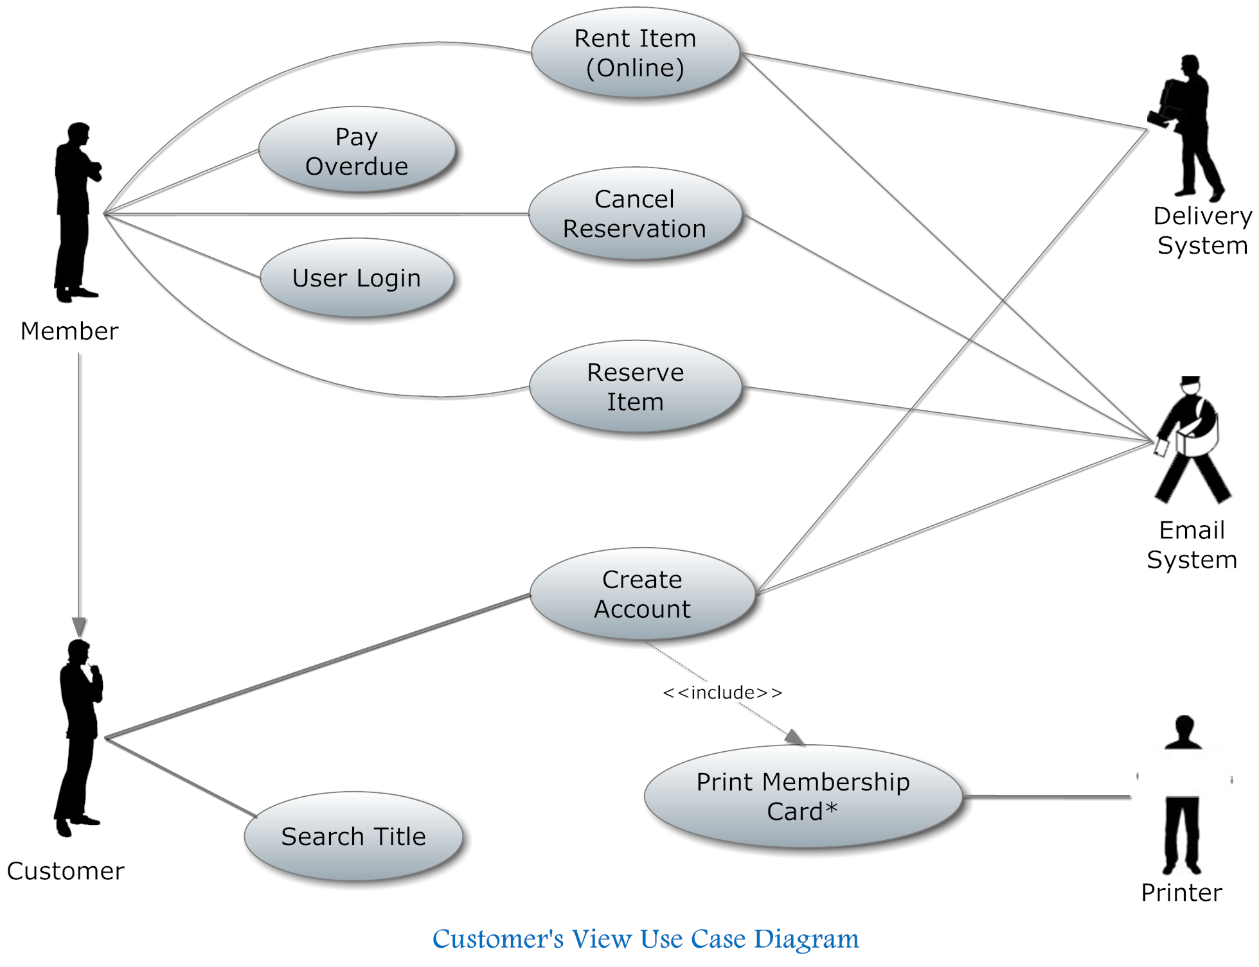
Figure 1 Customer's view Use Case Diagram
In Figure 1 we show a use case diagram for the customer’s view of the system. Here we see a customer can also be a member. Members are allowed to rent and reserve items and pay fees, while customers can only search for a title and create an account.
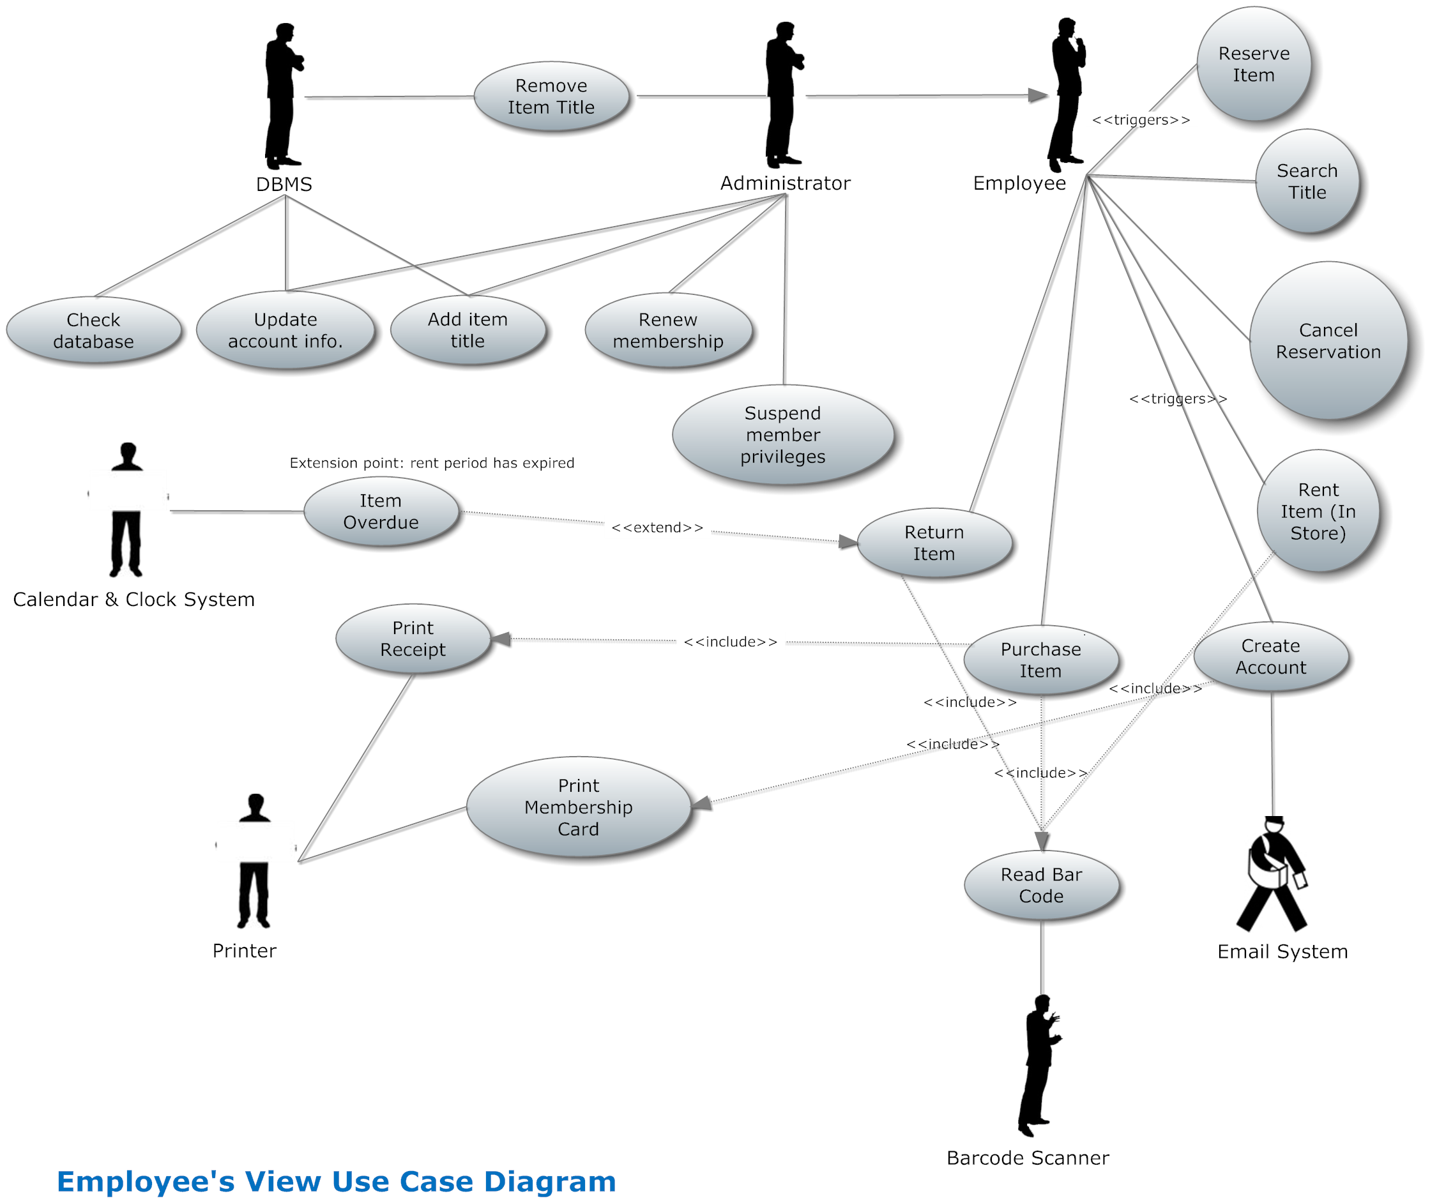
Figure 2 Employee's view Use Case Diagram
In 2 we show a use case diagram for the employee’s view. There we have an administrator who is a special type of employee. In addition to account creation and maintenance, rentals and reservations, the administrator can remove an item title from the database, renew membership and suspend member privileges.

Use Case Descriptions:
We further specified each use case, following the use case specification template discussed in SYSC-4800. We provide and discuss below a couple of representative examples. All the use case descriptions can be found in Appendix I.

Use Case Descriptions
Use case name: Rent Item (Online)
Primary actor: Member
Secondary Actors(s): Delivery system, Email system
Precondition: Member has logged into his/her account on the Video Store website
Basic flow
- Member selects item(s) to rent.
- The system queues items until Member clicks “DONE” button.
- The system checks the status of all selected items.
- If all items are in-stock, the system displays the pricing for renting each item and also the total.
- Member accepts fees.
- The system credits fees to the Member's account.
- The system sends list of items to be delivered to Member's address.
- Delivery system queues the order.
- Email system sends the Member the details of his/her order, including date for when delivery would be made, pricing details, and members account details as well.
Postcondition: Delivery system has confirmed receipt of list of items to be rented by Member, and prepares for delivery.
Specific Alternative flow
BFS #4
If one of the items selected is unavailable i.e. all copies are off the shelf,
- The system displays price to rent in-stock items and prompts Member of the option to reserve the unavailable item.
- If Member selects option to reserve item, the system INCLUDES USE CASE Reserve Item.
- Return to BFS #5.

BFS #4 (SAF #2)
If Member doesn't wish to reserve item,
- The system dequeues unavailable item.
- Calculates new balance without unavailable item.
- Returns to BFS #5.

Global Alternative flow

Use case name: Search Title
Primary actor: Customer
Secondary Actor(s): None
Precondition: Customer clicks on 'search' option on website
Basic flow

- Customer types in title of item.
- Customer selects whether video or videogame.
- Customer presses 'enter' key

Postcondition: The system displays all search results and gives options on what actions can be taken on each item.

Specific Alternative flow: None
Global Alternative flow: None

Use case name: Create account
Primary actor: Customer
Secondary Actor(s): Email system
Precondition: Customer does not have an account.
Basic flow
- The system asks for customer's information.
- Customer enters all requested information.
- The system VALIDATES all entered information.
- IF customer's information is valid, the system stores customer's information
- The system via Email System sends an email to the email entered by Customer, given the details the account and a temporary card for the Customer to print out.

Postcondition: Customer is a Member.

Specific Alternative flow
BFS #4
If customer's information is invalid,
- The system displays error message “Invalid <entry section>”
- Return to BFS #1

Global Alternative flow: None
Use case name: Cancel reservation
Primary actor: Member
Secondary Actors(s): Email system
Precondition: Member has an item reserved for him/her.
Basic flow
- Member clicks on item that has been reserved.
- The system displays items status and reservation details.
- Member clicks cancel reservation button.
- The system removes the reservation on the item.
- The system via the Email system sends an email to Member, confirming the cancellation of the reservation.

Postcondition: The item is no more on reserve for Member

Specific Alternative flow: None

Global Alternative flow: None
Employee side Use Case Diagram
Use case name: Rent Item (In-store)
Primary actor: Employee
Secondary Actors(s): Member, Barcode Scanner
Dependency: INCLUDES USE CASE Read Barcode
Precondition: Member has presented the Employee with an item(s) to rent.
Basic flow
- Employee requests Membership card.
- Employee scans membership card, INCLUDES USE CASE Read Barcode
- The system VALIDATES the Membership card
- If card is valid, the system returns the member's account information.
- Employee scans the item(s), INCLUDE USE CASE Read Barcode.
- The system returns the price(s) to rent video.
- The system adds item(s) to members account.
- The system returns a return date for rented item.

Postcondition: Item is ready for member to take home, after payment.

Specific Alternative flow
BFS #4
If the membership card is not valid,
- Then Employee does not allow Customer to rent the item(s).
- Employee gives Customer option of purchasing item(s).

Global Alternative flow: None
Use case name: Renew Membership
Primary actor: Employee
Secondary Actors(s): None
Precondition: Membership has reached expiry date
Basic flow
- The system prompts for membership card to be scanned.
- Employee scans membership card.
- The system displays account details and amount for renewal
- The system INCLUDES USE CASE Pay Dues

Postcondition: Membership card is made valid and expiry date is returned

Specific Alternative flow: None
Global Alternative flow: None
Use case name: Return Item
Primary actor: Employee
Secondary Actors(s): Barcode Scanner
Precondition: Employee obtains item(s) from Member
Basic flow
- Employee scans membership card.
- The system displays list of items the Member is yet to return.
- The system prompts the Employee to scan item(s)
- Employee scans item, and the system INCLUDES USE CASE Read Barcode
- The system matches the scanned item(s) with item(s) on the list of items that have not been returned.
- IF the scanned item matches with any of the items on the displayed list, the item is removed from the list of items not returned.

Postcondition: The system status the status of all returned items to “in-stock”

Specific Alternative flow
BFS #6
IF the scanned item does not match any item on the displayed list,
- The system displays message “ Item has already been returned ”
- Return to BFS #3
Use case name: Print Receipt

Primary actor: Printer
Secondary Actors(s): Employee
Dependency: INCLUDES USE CASE Purchase Item
Precondition: A Member purchases an item
Basic flow
- Member selects an item to purchase.
- Employee requests Membership card,
- Employee scans membership card, INCLUDES USE CASE Purchase Item
- The printer prints the receipt

Postcondition: The receipt for the item is printed

Use case name: Update Account Info
Primary actor: Administrator
Secondary Actors(s): DBMS
Precondition: Administrator must be connected to the database
Basic flow
- The Administrator searches the system for the customer account .
- The Administrator updates the required customer account information values.
- The system VALIDATES the entered customer Account information.
- The DBMS saves the changes made

Postcondition: The receipt for the item is printed

Use case name: Remove Item Title
Primary actor: Administrator
Secondary Actors(s): DBMS
Precondition: An item is no longer available by Video Store
Basic flow
- Administrator searches DBMS for item title
- Administrator removes item title from DBMS
- DBMS saves the changes

Postcondition: The item title is removed from DBMS

Use case name: Add Item Title
Primary actor: Administrator
Secondary Actors(s): DBMS
Precondition: An item is to be added to the Video Store
Basic flow
- Administrator adds item title from DBMS
- DBMS saves the changes

Postcondition: The item title is added to DBMS

Use case name: Read Barcode
Primary actor: Employee
Secondary Actors(s): Barcode Scanner
Dependency: INCLUDES USE CASE(S) Return Item, Purchase Item, Rent Item (in store)
Precondition: Employee obtains item(s) from Member
Basic flow
- Employee scans membership card.
- Employee scans item barcode.
- IF the Member is returning item(s) THEN Employee scans the item(s) barcode using Barcode Scanner
- INCLUDES USE CASE Return Item

Postcondition: The barcode of the item(s) is scanned

Specific Alternative flow

BFS #3
ELSE IF the Member is purchasing an item(s) THEN INCLUDE USE CASE Purchase Item
ELSE the Member is renting item(s) in-store INCLUDE USE CASE Rent Item (in store)

Postcondition: The barcode of the item(s) is scanned

Employee Side:

Use case name: Return Item
Primary actor: Employee
Secondary Actors(s): Member, bar code Scanner, calendar and clock system
Dependency: INCLUDES USE CASE Read Barcode.
EXTENDED BY USE CASE Item overdue.
Precondition: Member has presented the Employee with an item(s) to return.
Generalization: None

Basic flow
- Employee requests Membership card.
- Employee scans membership card, INCLUDES USE CASE Read Barcode
- The system VALIDATES the Membership card
- If card is valid, THEN the system returns the member's account information.
- Employee scans the item(s), INCLUDE USE CASE Read Barcode.
- EXTENDED BY USE CASE Item overdue.
- The system removes item(s) from members account.
- The Employee returns the item(s) back to shelf.

Postcondition: Item has been successfully returned.
Specific Alternative flow
BFS #4
If the membership card is not valid,
- Employee gives Customer an option of creating or renewing his/her membership.

Use case name: Purchase Item
Primary actor: Employee
Secondary Actors(s): Member, bar code Scanner, Printer
Dependency: INCLUDES USE CASE Print receipt.
INCLUDES USE CASE Read bar code
Precondition: Member or customers has presented the Employee with an item(s) to purchase.
Generalization: None
Basic flow
- Employee requests Membership card.
- Employee scans membership card, INCLUDES USE CASE Read Barcode
- The system VALIDATES the Membership card
- If the card is valid, THEN the system returns the member's account information.
- Employee scans the item(s), INCLUDE USE CASE Read Barcode.
- The system returns the price(s) of the item(s).
- The employee receives the items(s) payment from the member.
- INCLUDES USE CASE Print receipt.

Postcondition: Item has been successfully purchased.
Specific Alternative flow
BFS #4
If the membership card is not valid or available,
- Employee gives Customer an option of creating or renewing his/her membership.
ELSE
- Employee scans the item(s), INCLUDE USE CASE Read Barcode.
- The employee receives the items(s) payment from the customer.
- INCLUDES USE CASE Print receipt.
Use case name: Search title
Primary actor: Employee
Secondary Actors(s): None
Dependency: None.
Precondition: A Customer or a member asks about a specific title(s)
Generalization: None
Basic flow
- The system prompts the employee to enter the title name.
- The employee enters the title(s) name.
- The system VALIDATES if the title name is valid.
- IF the title name is valid, THEN the system returns the item(s) information.

Postcondition: The employee has successfully searched for the title(s).
Specific Alternative flow
BFS #3
If the title not valid,
- The System requests to re-enter title name.
ELSE
- The employee reports to the customer or member that the specified title is not available on the system.

Use case name: Create Account
Primary actor: Employee
Secondary Actors(s): Customer, Email System, Printer.
Dependency: INCLUDES USE CASE Print membership card.
Precondition: Customer requests that if he/she can create a Video store account.
Generalization: None
Basic flow
- The Employee enters the required customer account information values.
- The system VALIDATES the entered customer Account information.
- The system notifies the employee that the account has been created.
- INCLUDES USE CASE Print membership card.
- The system notifies the customer by email that his/her account has been created.

Postcondition: the account has been created.

Specific Alternative flow
BFS #4
If the account information is not valid,
- The system requests to re-enter the account information.

Use case name: Cancel Reservation
Primary actor: Employee
Secondary Actors(s): Bar code scanner.
Dependency: INCLUDES USE CASE Read bar code.
Precondition: Member requests that if he/she could cancel item reservation.
Generalization: None

Basic flow
- Employee requests Membership card.
- Employee scans membership card, INCLUDES USE CASE Read Barcode
- The system VALIDATES the Membership card.
- If the card is valid, THEN the system returns the member’s reservation detail.
- The employee clicks on cancel reservation button.
- The system removes the reservation on the item.

Postcondition: The reservation has been cancel.

Specific Alternative flow
BFS #4
If the membership card is not valid or available,
- Employee gives Customer an option of creating or renewing his/her membership.

Member Side:

Use case name: Reserve Item
Primary actor: Member
Secondary Actors(s): Email System.
Dependency: None.
Precondition: Member is authenticated
Generalization: None
Basic flow
- Member enters the item’s title.
- The system VALIDATES if the title is available.
- Member activates the reserve function.
- The system VALIDATES if the member has a reservation privileges.
- The system creates a pending reservation for that item.
- The system notifies the member by email that the item has been reserved.

Postcondition: an item has been reserved.
Specific Alternative flow
BFS #4 the title is not available.
- The system displays a message that the item is not available.

BFS #4 the member has not a reservation privilege.
- The reservation is cancelled.

Component Diagram
The component diagram's main purpose is to show the structural relationships between the components of a system. Component diagrams allow an architect to verify that a system's required functionality is being implemented by components, thus ensuring that the eventual system will be acceptable.
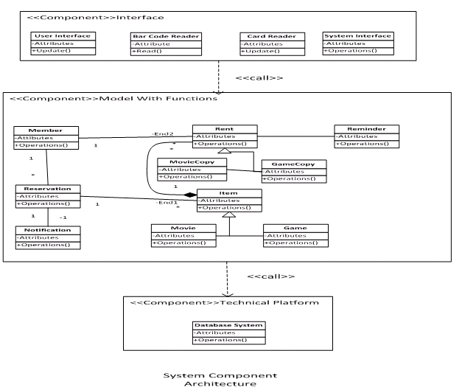
Figure 3 System Component Diagram
3 depicts how components are wired together to form the software system

System Analysis

The Video Store system was developed such that the user, whether a customer at home or an employee in the store, can perform the actions he or she wants to perform with ease. The system has therefore two sides: User direct access to the system (implemented as a Website) and In store direct system access by an employee.
There is a side where the user directly performs the main functionalities of the system such as Rent Video/Game, Buy Video/Game, Reserve Video/Game, Create Account, Edit Account Information, and Search Video/Games available. This side is implemented as a website, with PHP programming. In the other hand, the in store system is for the employee use, where the employee performs these main functionalities on behalf of the customer and when and administrator logs in, more can be done, such as Adding Items to the store database, Removing Items from the store database, Suspending a member’s privileges and Renewing memberships. The in store system is implemented in Java/JDBC.
Before the implementation and after the requirement analysis, i.e. defining use cases and modelling the use case diagram, we as a group came together to analyse the system, defining the entity, boundary and control classes needed to implement the system. We have created two class diagrams which show the connections between the different classes. w shows the relationships between the control classes and the entity classes. The Entity classes are those that are used to store information that would be used in the future. Entity classes are usually the data being stored in the database, as seen in this case, where we have databases information for games, videos, member accounts, employees and reservations. The attributes of the entity classes are usually the columns in the respective databases.The control classes control certain groups of functionalities, for example we have the MembershipControl class, which deals with functionalities that affect a member’s account. 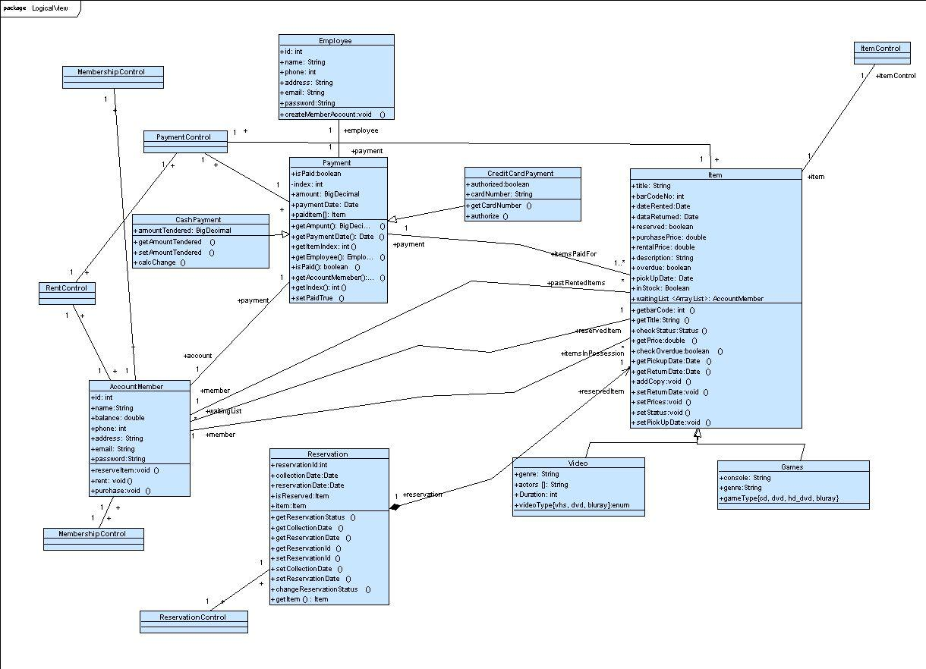
Figure 4
The following class diagram (Figure 5) shows the boundary/interface classes. These classes show the interface between the employee and the system (GUI), and interface between external devices and the system (BarcodeScannerInterface and PrinterInterface).
MISSING CLASS DIAGRAM HERE.
Figure 5

Graphical User Interface (GUI)
The Graphical User Interface (GUI) is implemented with Java Swing components. We used Netbeans IDE to create the window format, as it has an easy drag-and-drop interface to create the display window. This GUI was created was the intention of making the use of the system an easy task for the employee. Any functionality the employee wishes to do are just a click awayas can be seen in Main Menu window & Main Menu window for an administrative employee which show the main menu page. First, the employee has to log in through the page shown below.

The page that follows is dependent on whether or not the employee is an administrator or just a normal employee. An administrator would refer to a manager or supervisor and anyone in higher ranks. As shown in the screenshots below the Administrator has more functionalities that only an administrative staff can perform. Illustration 2 shows the Main Menu window for a normal employee. These are the only functionalities these employees can handle.

Otherwise, if an administrator logs in, he/she would get this page.

In Illustration 3, you can see the fourextra functionalities that can only be done by an administrator.These are functionalities that include more dignified decision, such as “Suspend Privileges”, we would not want a new staff member, to be able to perform such actions, as they may be malicious, or may play pranks. Whereas someone in a higher position is believed to be a dilligent worker who will follow company policies and would only perform such an actions if the right criteria is met. The same goes for “Renew Membership”. “Add Item” and “Remove Item” should also be done by only an administrator, as these functions make permanent changes to the inventory of the video store, and we would not want this in the hands of just anyone, but only the dignified and authorized personnel. “Add Item” allows the administrator to add a new item (video or game) to the video store database and inventory. “Remove Item” allows for the administrator to remove an item(video or game) from the database and inventory. It can be seen in Employee's view Use Case Diagram , that only the Administrator, who is a subtype of Employee, has direct access to those use cases.
From the Figure 7: Main Menu window, the employee can choose any of the displayed actions and the appropriate windows will be displayed, asking for whatever information that may be needed to be entered. Most of the actions require the member’s information, and so the system would prompt for the Membership card to be scanned. For now we simulate that action by just asking for the Member ID to be manually entered.

After the Membership card has been scanned and validated, the window corresponding to the button pushed is displayed. We discuss two possible operations selected below(Rent Item & Rent Item):

:

After the membership card has been scanned, if the”Rent Item” button was clicked, the employee can scan the barcode of the items to be rented. We simulate this with another prompting dialog shown in Figure 11: Scan Item Dialog except titled “Rent” instead. The database is then queried to get the title corresponding to that scanned item, which is then displayed as those 3 shown in Figure 10: Rent Item(with sample input)

If the “Return Item” button was clicked, the employee can scan the items being returned. This is simulated with another prompting dialog shown in Figure 11: Scan Item Dialog. This confirms that it is fact from our video store and that the item is what it appears to be, by displaying the title as in Figure 12: Return Item(with sample input)
Create Account:

If the employee clicks the button, “Create Account”, Figure 13: Create Account window is opened. The employee then fills in the text fields with the appropriate information provided by the customer. The employee then clicks the “Enter” button when all fields are filled. The customer information is then inserted in the database, and then displayed in a new window as shown below in Figure 14: New Member Information Display.

After performing the actions, the customer has to pay for, and so most of these pages lead to the payment page shown below with sample data, this is how it would show in the case of a purchase or rent. The previously scanned items’ information is transferred and there the price is also displayed.

In the case of just paying without any scanned items, the scanned item list would simply be empty and the total would equal to the Member’s account balance.

There are still some actions to be added to the GUI. we need to implement a button to take one back to the Main menu window instead of having to close and enter login info again, when doing another action and/or working with another customer.

Data Dictionary
Entity classes

Employee:

This class represents the employee inside the video store. He/she can rent, reserve, receive payment, and create a membership account for the customer.

Attributes:
id: int Employee unique identifier
name: String Name of the employee
phone: int Phone of the employee
address: String Address of the employee
email: String The email of the employee
password: String Password of the employee

Methods:
createMemeberAccount(): void
- This method adds a new member to the list of member.

Item:
This class represents an item in the video store.

Attributes:
title: String title of the item.
barCodeNo: int The bar code on the item
dateRented:Date The returned date of the item
reserved: boolean Is the item reserved or not?
purchasePrice: doube The price of the purchased item.
rentalPrice: double The price of the rented item
decription: String short description about the item
overdue: Boolean Is the item overdue?
pickUpDate: Date The pickup date of the item
inStock: Boolean Is the item available on stock?
waitingList<ArrayList>: Accountmember The list of members how are waiting for the
Reservation.

Methods:
getBarCode():int get the bar code of the item
getTitle(): String get the title of the item
checkStatus(): Status set the status (i.e. Rented, or reserved) of the item
getPrice: double get the price of the item
checkOverdue(): Boolean if the item is returned late, and overdue is applied, returns true.
getPickupDate():Date get the pickup date for the item if purchased online or reserved.
getReturnDate(): Date get the return date of the item
addCopy: void add a item copy to the list of items.
setReturnDate: void set the return date of the item if rented.
setPrices(): void set the price of the item.
setStatus(): void change the status of the item.
setPickUpDate: void set the pickup date for the item

Payment:
This class represents the payment information about a specific item.

Attributes:
isPaid: Boolean is the item paid for during the transaction.
index: int item index.
amount: BigDecimal amount paid for an item.
paymentDate: Date the date of the payment
paidItem[]: Item the list of paid items.
Methods:
getAmount(): BigDecimal returns amount paid for the item
getPaymentDate(): Date returns the date of the payment
getItemIndex(): int returns the item
getEmployee(): Employee return the employee how handled the payment.
isPaid(): boolean returns true if the payment made successfully.
getAccountMember(): AccountMeember returns the member who made the payment
getIndex(): int returns the payment Index (i.e. Id) of a specific item.
setPaidTrue(): void sets the payment condition to true if its false.

Cash Payment:
This class represents the cash payment of the item if the member or the customer chooses to pay in cash.

Attributes:
amountTendered: BigDecimal the amount of cash the customer or member is paying
Methods:
getAmountTendered(): amount returns amount of cash paid for.
setAmountTendered(): void sets the amount of cash to pay for.
clacChange(): void calculates the remaining change.

Video:
This class represents the video (DVD, CD, etc.) in the video store.
Attributes:
Genre: String the genre of the video.
Actors[]: String the actors of the video
Duration: int the duration or the length of the video.
videoType{ VHS, DVD, Blueray}: enum the type of the video.

Methods:
None for now.

Game:
This class represents the games in the video store

Attributes:
Console: String the console used to run the games, xbox, PS3 Wii, etc.
Genre: String the genre of the game
gameType{CD, DVD, Blueray} the type of the game.
Methods:
None for know.

Credit Card Payment:
This class represents the credit payment of the item if the member or the customer chooses to pay using a credit card.

Attributes:
Authorized: Boolean is the credit card authorized.
cardNumber: String the credit card number.

Methods:
getCardNumber(): int returns the credit card number
authorize(): Boolean checks if the card is authorized or not.

Reservation:
This class represents the reservation information o a specific item
Attributes:
ReservationId: int the reservation unique id.
collectionDate: Date the date that the member can collect the reserved item.
reservationDate: Date the date that item is available for reservation
isReserved: Boolean is the item available for reservation
item:Item the reserved item.

Methods:
getReservationStatus(): Boolean returns true if the item is on reserve.
getCollectionDate(): Date returns the collection date of the item.
getReservationDate(): Dare returns the reservation date the item.
getReservationID(): int returns the unique id of the reservation.
setCollectionDate: void sets the collection date for the reserved item.
setReservationDate: void sets the reservation date of the reserved item.
changeReservationStatus: void changes the reservation statues to reserved or not reserved.
getItem(): Item return the reserved item.

Account Member:
This class represents the account member of the video store.
Attributes:
Id: int a unique member identifier.
Name: String the name of the member
Balance: double the balance remaining on the member’s account
Phone: int the member’s phone number
Address: String the member’s address
Email: String the member’s email
Password: String the member’s password

Methods:
reserveItem(): void member reserves an item
rentItem(): void member rents an item
purchaseItem: void member purchases an item.

Implementation
PLEASE PROVIDE A DESCRIPTION OF THE CONTENTS OF THE SUB-SECTIONS OF SECTION 10.

Database Server
To store the system data we decided to use a database server implemented on a web server instead of creating a local file system to store the data. A database server was utilised due to the secure data accessing environment and since it is hosted on a web server that allows easier access from different locations (stores). If a local file system is used, we would need to build communication between all stores, an implementation which would prone to errors; this can also be very inefficient since terminals need to create connections to multiple store to get the information in every store. Database servers also provide security, allowing for restricted access to the data.
The only disadvantage of the database server implementation is that if the server ever crashes, all store terminals will not be able to function. This is a very serious problem. However this
may be resolved by combining database server with local file system. But due to time constraints, this implementation is not possible.
In choosing a database management system (DBMS), we used the open source database management system MySQL 5. We chose MySQL over other open source database management systems such as PostgreSQl because it was more widely used, providing us with more tutorials.

A database management system allows us to easily:
- Create/delete tables
- Modify tables (adding, deleting, editing and rearranging records, changing the table structure)
- Retrieve data from a table or number of tables (finding and displaying an individual record, answering queries)
We used a Relational Database Management System, where the data is organised in tables and there are relationships expressed between tables and data elements.
Advantages of a Relational DBMS:
- Efficient data entry and modification
- Efficient data retrieval and reporting
- Changes to the database schema are easy
- Concurrency control
- Java support - JDBC

Entity Relationship Design
Objects such as customers, members, items and store locations correspond to entities in the Entity-Relationship model and the operations performed on those entities: reservations, rentals correspond to the relationships. However, a good design will minimize redundancy and attempt to store all the required information in as small a space as possible. After some consideration, we have decided on the following design:

Relational SQL Database Definition
We created 6 databases and populated them with sample data. Below is the following code to create the tables.
-- Table structure for table `games`

CREATE TABLE IF NOT EXISTS `games` (
`id` int(11) NOT NULL AUTO_INCREMENT,
`title` text,
`rating` text NOT NULL,
`category` text NOT NULL,
`developer` text NOT NULL,
`publisher` text NOT NULL,
`system` set('PS3','Xbox 360') NOT NULL,
PRIMARY KEY (`id`)
) ENGINE=InnoDB DEFAULT CHARSET=latin1 AUTO_INCREMENT=26 ;
--
-- Dumping data for table `games`
--
INSERT INTO `games` (`id`, `title`, `rating`, `category`, `developer`, `publisher`, `system`) VALUES
(1, 'The Elder Scrolls V: Skyrim', 'M', 'Role-Playing', 'Bethesda Game Studios', '2K Games', 'PS3,Xbox 360'),
(2, 'The Elder Scrolls IV: Oblivion', 'M', 'Role-playing', 'Bethesda Game Studios', '2k Games', 'PS3,Xbox 360'),
(3, 'Halo 3', 'M', 'First-person Shooter', 'Bungie', 'Microsoft Studios', 'Xbox 360'),

-- Table structure for table `movies`

CREATE TABLE IF NOT EXISTS `movies` (
`id` int(11) NOT NULL AUTO_INCREMENT,
`Title` text NOT NULL,
`Actors` text,
`Director` text,
`Rating` text,
`Runtime` text,
`Category` text,
`Medium` set('BluRay','DVD') DEFAULT NULL,
PRIMARY KEY (`id`)
) ENGINE=MyISAM DEFAULT CHARSET=latin1 AUTO_INCREMENT=26 ;
--
-- Dumping data for table `movies`
--

INSERT INTO `movies` (`id`, `Title`, `Actors`, `Director`, `Rating`, `Runtime`, `Category`, `Medium`) VALUES
(1, 'Fast Five', 'Vin Diesel, Paul Walker, Jordana Brewster, Dwayne Johnson, Tyrese Gibson, Ludacris, Tego Calderón, Don Omar, Gal Gadot, Elsa Pataky', 'Justin Lin', '7.3', '130', 'Action', 'BluRay,DVD'),
(2, 'The Descendants', 'George Clooney, Shailene Woodley, Robert Forster, Judy Greer, Amara Miller, Beau Bridges, Matthew Lillard, Nick Krause', 'Alexander Payne', '8.0', '115', 'Comedy', 'BluRay,DVD'),
(3, 'Hobo With A Shotgun', 'Rutger Hauer, Molly Dunsworth, Brian Downey, Gregory Smith, Robb Wells', 'Jason Eisener', '6.3', '86', 'Thriller', 'BluRay,DVD'),

-- Table structure for table `client`
CREATE TABLE IF NOT EXISTS `client` (
`id` int(11) NOT NULL AUTO_INCREMENT,
`location` text,
`store number` int(11) DEFAULT NULL,
PRIMARY KEY (`id`)
) ENGINE=InnoDB DEFAULT CHARSET=latin1 AUTO_INCREMENT=18 ;

--
-- Dumping data for table `client`
--

INSERT INTO `client` (`id`, `location`, `store number`) VALUES
(1, '830 Industrial Avenue, Ottawa, ON K1G 4B8', 32),
(2, '3658 east 33nd lane', 556),

-- Table structure for table `employee`

CREATE TABLE IF NOT EXISTS `employee` (
`id` int(11) NOT NULL AUTO_INCREMENT,
`name` text,
`phoneNumber` bigint(10) DEFAULT NULL,
`address` text,
`email` text,
`status` set('active','on holiday','inactive') DEFAULT NULL,
PRIMARY KEY (`id`)
) ENGINE=InnoDB DEFAULT CHARSET=latin1 AUTO_INCREMENT=20 ;

--
-- Dumping data for table `employee`
--

INSERT INTO `employee` (`id`, `name`, `phoneNumber`, `address`, `email`, `status`) VALUES
(1, 'John Wilson', 6138486259, '98 Woodridge Crescent', 'johnw@companyemail.com', 'on holiday'),
(2, 'Henry Wilcox', 6132526898, '1000 Castle Hill Crescent', 'henryw@companyemail.com', 'on holiday'),
(3, 'Jason Emerich', 3021569985, '55241 northwest 1st lane', 'jasone@companyemail.com', 'inactive'),

-- Table structure for table `members`

CREATE TABLE IF NOT EXISTS `members` (
`MemberID` int(5) unsigned zerofill NOT NULL AUTO_INCREMENT,
`email` text NOT NULL,
`FirstName` text NOT NULL,
`LastName` text NOT NULL,
`Address` text NOT NULL,
`PhoneNumber` bigint(10) NOT NULL,
`currentItems` text NOT NULL,
`pastItems` text NOT NULL,
`reservations` text NOT NULL,
PRIMARY KEY (`MemberID`)
) ENGINE=InnoDB DEFAULT CHARSET=latin1 AUTO_INCREMENT=18 ;

--
-- Dumping data for table `members`
--

INSERT INTO `members` (`MemberID`, `email`, `FirstName`, `LastName`, `Address`, `PhoneNumber`, `currentItems`, `pastItems`, `reservations`) VALUES
(00001, 'johndoe@email.com', 'John', 'Doe', '311 Bell Street South', 6138514405, 'Halo 3', 'Gears of War 3, Gears of War 2', 'Halo: Reach'),
(00002, 'janesmith@email.com', 'Jane', 'Smith', '5685 West 24th Court', 1245412547, 'The Elder Scrolls V: Skyrim', 'Hanna, Duke Nukem Forever', 'Bulletstorm, Infamous 2, Inception'),
(00003, 'jackysaint@email.com', 'Jack', 'Santana', '180 Lees Avenue', 612527894, 'Fight Club, Inception', 'L.A. Noire, Duke Nukem Forever', 'X-Men: First Class, Halo 3'),
--
-- Table structure for table `reservations`
--

CREATE TABLE IF NOT EXISTS `reservations` (
`itemNo` int(11) NOT NULL AUTO_INCREMENT,
`reservationDate` date DEFAULT NULL,
`pickUp Date` date DEFAULT NULL,
`MemberID` int(5) unsigned zerofill DEFAULT '00000',
PRIMARY KEY (`itemNo`)
) ENGINE=InnoDB DEFAULT CHARSET=latin1 AUTO_INCREMENT=18 ;

--
-- Dumping data for table `reservations`
--

INSERT INTO `reservations` (`itemNo`, `reservationDate`, `pickUp Date`, `MemberID`) VALUES
(1, '2012-02-07', '2012-03-06', 00002),
(2, '2012-02-07', '2012-03-01', 00006),
(3, '2012-02-16', '2012-03-19', 00015),

Database Schema
Analysis of the Entity-Relationship diagram highlighted special relationships found in the design. This allowed us to condense the information in the database to six tables.
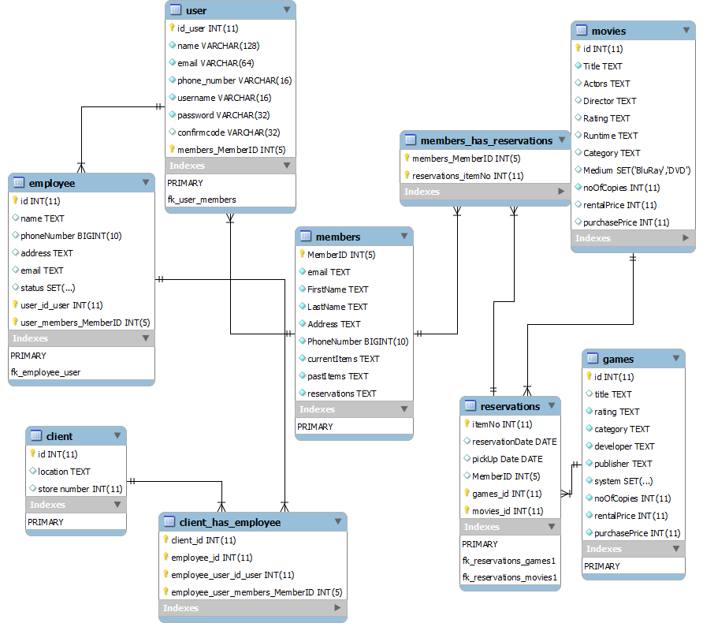
Figure 6

PHP
We used PHP to embed dynamic text into static text. PHP is easily used with HTML forms making it useful for the web server application. PHP is compatible with our MySQL database, which allows PHP code to create and query the tables in the database. PHP is also cross platform compatible. Also using PHP we can create our own functions for actions that will be repeated often. With PHP being a server side language, all the code execution is done on the server and the user never has to worry about it.
PHP is also very easy to learn and there are a wealth of tutorials available online, giving in depth details and support on the language.
To dynamically link the website queries to the database we used PHP to code the sections for login, search, rent, buy, reserve and check account.

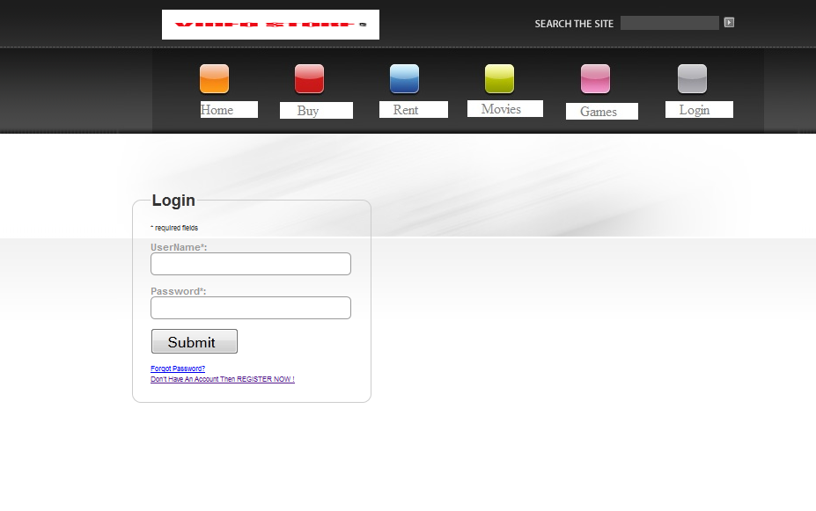
Figure 7 Login
- Created the login panel and validation with the database - uses the excellent form validation script from JavaScript-coder.com (see Appendix Excerpt 1)
- Created the register panel and request the user email to validate their account database - uses the excellent form validation script from JavaScript-coder.com (see Appendix Excerpt 2)
- Created a forgot password case (see Appendix Excerpt 3)

Website
“Video store” was originally designed to be a program that the company employees would interact with in order to execute functionalities such as rentals, sales, and account management to walk-in customers. However, after careful consideration and further research, the team decided that in order to improve customer satisfaction and keep up with the current standards in the video rental industry, a website was needed.
The website was created using the Adobe Dreamweaver CS5.5 web authoring and editing software. This is because it is easy to use, provides CSS and HTML support, and is very compatible with the PHP development environment (i.e. web server, PHP and database).
The website was designed with the customer in mind. Therefore, simplicity, quality and design were taken into account. We ensured that the primary functionalities of the system are laid out for the user and that the operations were a simple click away. Also, a “search” function is implemented on the website that allows for the user to easily query the database to find video or game items. In order to ensure the user account is easily managed, a “login” function is also implemented to provide security and enable members have access to their personal accounts.

Future Work
Left to be done are:
- sequence diagrams
- state charts
- entity relationship diagram (need correct CASE tool)

Conclusion

- Complete use case descriptions

- Definitions, acronyms, abbreviations
Terms | Definition
Database (DB) | A collection of information organized in such a way that a computer program can quickly select desired pieces of data.
DBMS | Database Management Systems: a collection of applications that enables you to store, modify, an extract information from a database.
VSS | Video Store System, described in this document
SQL | Abbreviation of structured query language. Standardized query language for requesting information from a database.
MySQL | Software which is using SQL language and allows users to create databases. Available under Open Source license and commercial licenses.
PHP | Hypertext Preprocessor, an open source, server-side, HTML embedded scripting language used to create dynamic Web pages.
E-R | Entity Relationship Diagram; a graphical representation of entities and their relationships to each other.
HTML | HyperText Markup Language, the authoring language used to create documents on the World Wide Web.
CSS
Dreamweaver
CASE tool | Computer Aided Software Engineering Tools, class of software that automate many of the activities involved in various life cycle phases.
Java
NeatBeans IDE

- Code Excerpts
  - Code excerpt for login validation
First validates that user clicked on the login button and then redirects to the login page
<?PHP
require_once("./include/membersite_config.php");

if(isset($_POST['submitted']))
{
if($fgmembersite->Login())
{
$fgmembersite->RedirectToURL("login-home.php");
}
}

Prompts the user to enter their login details and uses a validation script to verify the entered information
<!-- Form Code Start -->
<div id='fg_membersite'>
<form id='login' action='<?php echo $fgmembersite->GetSelfScript(); ?>' method='post' accept-charset='UTF-8'>
<fieldset >
<legend>Login</legend>

<input type='hidden' name='submitted' id='submitted' value='1'/>

<div class='short_explanation'>* required fields</div>

<div><span class='error'><?php echo $fgmembersite->GetErrorMessage(); ?></span></div>
<div class='container'>
<label for='username' >UserName*:</label><br/>
<input type='text' name='username' id='username' value='<?php echo $fgmembersite->SafeDisplay('username') ?>' maxlength="50" /><br/>
<span id='login_username_errorloc' class='error'></span>
</div>
<div class='container'>
<label for='password' >Password*:</label><br/>
<input type='password' name='password' id='password' maxlength="50" /><br/>
<span id='login_password_errorloc' class='error'></span>
</div>

<div class='container'>
<input type='submit' name='Submit' value='Submit' />
</div>
<div class='short_explanation'><a href='reset-pwd-req.php'>Forgot Password?</a></div>
<div class='short_explanation'><a href='register.php'>Don't Have An Account Then REGISTER NOW !</a></div>
</fieldset>
</form>
<!-- client-side Form Validations:
Uses the excellent form validation script from JavaScript-coder.com-->

<script type='text/javascript'>
// <![CDATA[

var frmvalidator = new Validator("login");
frmvalidator.EnableOnPageErrorDisplay();
frmvalidator.EnableMsgsTogether();

frmvalidator.addValidation("username","req","Please provide your username");

frmvalidator.addValidation("password","req","Please provide the password");

// ]]>

  - Code excerpt for register

Once the user has registered it redirects the user to a “thank you” page

<?PHP
require_once("./include/membersite_config.php");

if(isset($_POST['submitted']))
{
if($fgmembersite->RegisterUser())
{
$fgmembersite->RedirectToURL("thank-you.html");
}
}

Prompts the user to enter their login details and uses a validation script to verify the entered information. Emails confirmation link to the users given email.

<!-- Form Code Start -->
<div id='fg_membersite'>
<form id='register' action='<?php echo $fgmembersite->GetSelfScript(); ?>' method='post' accept-charset='UTF-8'>
<fieldset >
<legend>Register</legend>

<input type='hidden' name='submitted' id='submitted' value='1'/>

<div class='short_explanation'>* required fields</div>
<input type='text' class='spmhidip' name='<?php echo $fgmembersite->GetSpamTrapInputName(); ?>' />

<div><span class='error'><?php echo $fgmembersite->GetErrorMessage(); ?></span></div>
<div class='container'>
<label for='name' >Your Full Name*: </label><br/>
<input type='text' name='name' id='name' value='<?php echo $fgmembersite->SafeDisplay('name') ?>' maxlength="50" /><br/>
<span id='register_name_errorloc' class='error'></span>
</div>
<div class='container'>
<label for='email' >Email Address*:</label><br/>
<input type='text' name='email' id='email' value='<?php echo $fgmembersite->SafeDisplay('email') ?>' maxlength="50" /><br/>
<span id='register_email_errorloc' class='error'></span>
</div>
<div class='container'>
<label for='username' >UserName*:</label><br/>
<input type='text' name='username' id='username' value='<?php echo $fgmembersite->SafeDisplay('username') ?>' maxlength="50" /><br/>
<span id='register_username_errorloc' class='error'></span>
</div>
<div class='container' style='height:80px;'>
<label for='password' >Password*:</label><br/>
<div class='pwdwidgetdiv' id='thepwddiv' ></div>
<noscript>
<input type='password' name='password' id='password' maxlength="50" />
</noscript>
<div id='register_password_errorloc' class='error' style='clear:both'></div>
</div>

<div class='container'>
<input type='submit' name='Submit' value='Submit' />
</div>

</fieldset>
</form>
<!-- client-side Form Validations:
Uses the excellent form validation script from JavaScript-coder.com-->

<script type='text/javascript'>
// <![CDATA[
var pwdwidget = new PasswordWidget('thepwddiv','password');
pwdwidget.MakePWDWidget();

var frmvalidator = new Validator("register");
frmvalidator.EnableOnPageErrorDisplay();
frmvalidator.EnableMsgsTogether();
frmvalidator.addValidation("name","req","Please provide your name");

frmvalidator.addValidation("email","req","Please provide your email address");

frmvalidator.addValidation("email","email","Please provide a valid email address");

frmvalidator.addValidation("username","req","Please provide a username");

frmvalidator.addValidation("password","req","Please provide a password");

// ]]>

  - Code excerpt for forgot password

While at the login page and the user clicks on forgot password it redirects the user to a change password screen.

<?PHP
require_once("./include/membersite_config.php");

if(!$fgmembersite->CheckLogin())
{
$fgmembersite->RedirectToURL("login.php");
exit;
}

if(isset($_POST['submitted']))
{
if($fgmembersite->ChangePassword())
{
$fgmembersite->RedirectToURL("changed-pwd.html");
}

Prompts the user to enter their email and a new password, uses a validation script to verify the entered information. Emails confirmation link to the users given email.

<!-- Form Code Start -->
<div id='fg_membersite'>
<form id='changepwd' action='<?php echo $fgmembersite->GetSelfScript(); ?>' method='post' accept-charset='UTF-8'>
<fieldset >
<legend>Change Password</legend>

<input type='hidden' name='submitted' id='submitted' value='1'/>

<div class='short_explanation'>* required fields</div>

<div><span class='error'><?php echo $fgmembersite->GetErrorMessage(); ?></span></div>
<div class='container'>
<label for='oldpwd' >Old Password*:</label><br/>
<div class='pwdwidgetdiv' id='oldpwddiv' ></div><br/>
<noscript>
<input type='password' name='oldpwd' id='oldpwd' maxlength="50" />
</noscript>
<span id='changepwd_oldpwd_errorloc' class='error'></span>
</div>

<div class='container'>
<label for='newpwd' >New Password*:</label><br/>
<div class='pwdwidgetdiv' id='newpwddiv' ></div>
<noscript>
<input type='password' name='newpwd' id='newpwd' maxlength="50" /><br/>
</noscript>
<span id='changepwd_newpwd_errorloc' class='error'></span>
</div>

<br/><br/><br/>
<div class='container'>
<input type='submit' name='Submit' value='Submit' />
</div>

</fieldset>
</form>
<!-- client-side Form Validations:
Uses the excellent form validation script from JavaScript-coder.com-->

<script type='text/javascript'>
// <![CDATA[
var pwdwidget = new PasswordWidget('oldpwddiv','oldpwd');
pwdwidget.enableGenerate = false;
pwdwidget.enableShowStrength=false;
pwdwidget.enableShowStrengthStr =false;
pwdwidget.MakePWDWidget();

var pwdwidget = new PasswordWidget('newpwddiv','newpwd');
pwdwidget.MakePWDWidget();

var frmvalidator = new Validator("changepwd");
frmvalidator.EnableOnPageErrorDisplay();
frmvalidator.EnableMsgsTogether();

frmvalidator.addValidation("oldpwd","req","Please provide your old password");

frmvalidator.addValidation("newpwd","req","Please provide your new password");

  - Code excerpt for search

