ABSTRACT

Reversible logic is pivotal in the realm of low-power computing as it eliminates power dissipation associated with information loss, a critical factor in modern electronics where energy efficiency is paramount. The importance of reversible logic extends to quantum computing, where reversible operations are essential for the construction of quantum gates and circuits. Adders play a crucial role in multipliers, especially in digital signal processing (DSP) applications. Vedic multiplication using the Urdhva Triyambakam method is an ancient Indian technique that performs multiplication by vertically and crosswise combining digits. In this research work, the design and implementation of a 4x4 reversible gate known as an ASK gate is presented. This gate is subsequently utilised in the construction of a full adder as well as a 4-bit Vedic multiplier. In terms of factors such as garbage outputs (GO), ancilla input (AI), and the number of gates (GC) that are utilised, the design that was developed performs better than earlier designs.

CONTENTS

S No. | Particulars | Page Nos.
1 | Introduction | 3
2 | Literature Survey | 4 - 5
3 | Existing Work | 6
4 | Proposed Work | 7 - 8
5 | Simulation Results | 9
6 | Conclusion | 10
7 | Future Work | 10
8 | References | 11 - 12

INTRODUCTION

The necessity for energy-efficient computing has led to a surge in interest in reversible logic, which prevents data loss during computation, resulting in zero power usage. This characteristic is advantageous for low-power circuit development in quantum computing, optical computing, and VLSI design. Reversible logic ensures unique input state recovery from the output state, enabling the creation of energy-efficient quantum circuits capable of complex tasks. Beyond quantum computing, reversible logic benefits nanotechnology and optical computing by minimizing heat generation and energy consumption, enhancing the longevity of devices. Reversible gates also improve arithmetic circuits like adders and multipliers, essential in DSP and computational systems, by reducing garbage outputs and improving efficiency. Integrating Vedic mathematics algorithms, such as Urdhva-Triyakbhyam, with reversible logic can further enhance efficiency in multipliers. A novel 4x4 reversible gate is introduced for efficient arithmetic circuits like full adders and Vedic multipliers, showcasing improvements in performance metrics. In multiplication processes, reversible logic gates maintain functional correctness while achieving better efficiency in digital systems. Reversible logic gates operate within specific properties to function effectively in reversible computing systems.

LITERATURE SURVEY

The significance of reversible logic extends beyond quantum computing into fields like nanotechnology and optical computing. In these domains, the ability to minimize heat generation and energy consumption is paramount, especially as devices continue to shrink in size. Reversible gates enable the development of circuits that produce minimal heat, thereby enhancing the longevity and reliability of nanoscale devices. Additionally, optical computing, which relies on light for data transmission and processing, benefits from the low-energy dissipation properties of reversible gates, leading to faster and more efficient optical circuits. One of the primary advantages of reversible logic gates is their application in designing efficient arithmetic circuits, such as adders and multipliers, which are fundamental components in digital signal processing (DSP) and various computational systems. Traditional adder circuits often generate excessive garbage outputs—unnecessary intermediate data that do not contribute to the final result. Reversible logic gates also adhere to specific properties:
They do not allow fan-out, where a gate’s output is used as input to multiple gates, and they often require additional constant inputs and produce extra ”garbage” outputs to maintain reversibility. Applications of reversible logic are vast, ranging from quantum computing, where many quantum gates are naturally reversible, to low-power CMOS design and cryptography. Multipliers are fundamental components in digital signal processing (DSP) and various arithmetic operations. Traditional multipliers, however, are power-hungry and contribute to significant energy consumption in digital systems. The advent of Vedic mathematics, with its efficient algorithms for multiplication, provides an opportunity to design multipliers that are both fast and energy-efficient. When integrated with reversible logic, Vedic multipliers can further enhance computational efficiency by minimizing power dissipation.
Urdhva-Triyakbhyam, also known as the Vertically and Crosswise Sutra, is an example of such an algorithm that originates from Vedic mathematics. This particular algorithm is well-known for its ease of use and effectiveness in the process of conducting multiplication. The Urdhva-Triyakbhyam sutra breaks down the multiplication process into smaller, more manageable parts by performing operations both vertically and crosswise. This method not only speeds up the multiplication process but also simplifies the implementation of complex multipliers, making it an excellent candidate for integration with reversible logic.
Consider two 2-bit values, A(A1,A0) and B(B1,B0), for 2 x 2 multiplication. One of the first steps in the procedure is multiplying the least significant bits (LSBs) of both A (A0) and B (B0). (s0 = A0B0) is the value that is saved for the outcome. After that, we multiply A0 by the next bit in B1 and vice versa (A1 x B0 and vice versa). These products are added together and stored as c1s1 (c1s1 = A1B0 + A0B1). The carry bit (c1) from the previous step is added to the products of multiplying the remaining bits i.e (A1 x B1).Reversible logic gates rely on specific properties to function within reversible computing systems. Here’s a breakdown of some key parameters:
Quantum Cost (QC): Quantum cost refers to the total resources required to implement a reversible gate in a quantum computing system. This includes the number of basic quantum operations (such as quantum gates) needed, the depth of the circuit, and the complexity of the gates used.
Garbage Outputs (GO): Garbage outputs are the additional output lines produced by a reversible gate that do not directly contribute to the intended computation but are necessary to ensure the reversibility of the gate. Despite the fact that these outputs are not a part of the usable output, they are necessary in order to maintain the one-to-one mapping of input to output in reversible logic computing.
Gate Count (GC): This refers to the number of basic building block gates (either 1-input, 1-output or 2-input, 2-output) required to create the entire circuit.
Ancillae Inputs (AI): Ancillae (or Ancilla Inputs) refer to the additional input bits required in a reversible logic circuit to assist in the computation. These extra inputs are necessary for the construction of the reversible design, often used to facilitate certain operations while maintaining the reversibility of the circuit.

EXSITING WORK

In order to achieve the best performance in a low-power mode, Sujata S. Chiwande et al., designed a full adder using reversible logic architecture. One of the characteristics that is typical of very large scale integration (VLSI) systems is reversible logic, which contributes to the optimisation of efficiency. This study presents an overview and comparison of two different types of full adder circuits: a conventional full adder circuit and a reversible full adder circuit that utilises the use of a Peres gate. When comparison with the conventional adder circuit, the overall thermal power dissipation features a 44% improvement. Sarangam K et al., proposed the method of opts for low-power architectures, including quantum computing and the Internet of Things. An improved low-power reversible full adder for energy-efficient applications is presented in this paper. Commonly used measurements for energy dissipation in complementary metal-oxide semiconductor (CMOS) circuits are 0.5C*Vdd ^2, which is similar to 0.5C*VThr ^2 in reversible logic. The amount of energy lost is equal to (VThr/Vdd) ^2. In addition, the size of ancillae and trash outputs has been reduced by 16.67%. There are also 16.67% fewer transistors than before. For the reversible implementation of a 4-bit Vedic multiplier circuit, Vandana Shukla et al. detailed a novel approach with optimal performance characteristics. The fundamental principles of Vedic mathematics form the basis for Vedic multipliers. The multiplier is very efficient since it just takes one step to compute the sum of all the partial products. Implementing this multiplier using a reversible approach will also lead to the construction of digital system multiplier circuits that are efficient, fast, and loss-less. Several criteria are studied in order to determine the circuit’s performance. These include the quantum cost (QC), the number of gates (TC), the constant inputs (CI), the garbage outputs (GO), and the suggested multiplier design. Applications requiring low power consumption and high performance utilise the benefits of the 4-bit reversible Vedic multiplier introduced by R Saligram et al.,. One method for evaluating the aforementioned architecture is the Total Reversible Logic Implementation Cost, or TRLIC for acronym. Using this approach yields a 33% TRLIC compared to related literature works.

PROPOSED WORK

This work presents a novel reversible logic gate, designated as the ASK Gate. A key strength of this gate lies in its inherent capability to operate independently as a reversible full adder, as demonstrated in Fig. 3. By setting the input SEL to zero, the design exhibits full adder behavior. This paradigm shift in design methodology condenses the realization of full adders with two garbage outputs into a single, unified gate, demonstrably yielding performance improvements over prior architectures.
A. Implementation of 4-Bit Vedic Multiplier (4 x 4 VM) using proposed ASK reversible gate
The term “4-bit Vedic multiplier” refers to a digital circuit that is meant to execute multiplication via the Vedic mathematics approach, which is especially developed for binary values with four bits. In comparison to the conventional methods of multiplication, the Vedic multiplication methodology, which was derived from ancient Indian mathematics, provides a variant approach. The design also includes two ripple carry adders with four bits each. Using the Urdhva Tiryagbhyam sutra, the building of a four-by-four multiplier is discussed in Fig. 2. The first partial product is obtained by multiplying the lowest two bits of a (a[1:0]) with the lower two bits of b (b[1:0]). This results in the first imperfect product. Multiplying a[3:2] and b[1:0] creates the second partial product that is created. The third partial product is that which is obtained by multiplying a[1:0] and b[3:2]. Multiplication is the fourth partial product that may be obtained by multiplying a[3:2] and b[3:2]. The second and third partial products, which are presumed to have the same amount of bits, are combined by means of a complete adder that operates on four bits in this architecture. This adder’s output is then mixed with the output of another adder that is also four bits in size. The two least significant bits (LSBs) from the fourth partial product and the two most significant bits (MSBs) from the first partial product are supplied as input1 to the second adder. Additionally, the sum output of the first adder is used to derive an additional input. By the end of the process, a 2-bit adder combines the carry that was generated by the second 4-bit adder with the two most significant bits of the fourth partial product.

Fig1. Implementation of 2-bit Vedic multiplication process using Urdhvaka Triyakbhyam Principle

Fig. 2. Implementation of 4-bit Vedic multiplier (VM) using proposed ASK Gate

Fig. 3. Implementation of full adder using proposed reversible ASK Gate

SIMULATION RESULTS
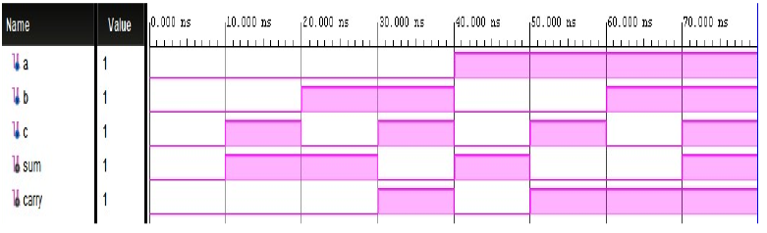
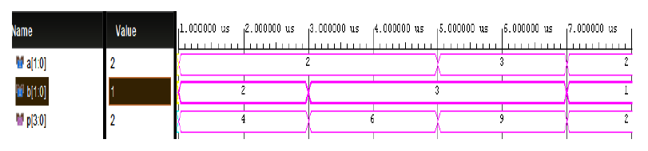
Fig. 4. Simulation output of full adder using proposed ASK Gate
Fig.5 Simulation output of full adder using proposed ASK Gate
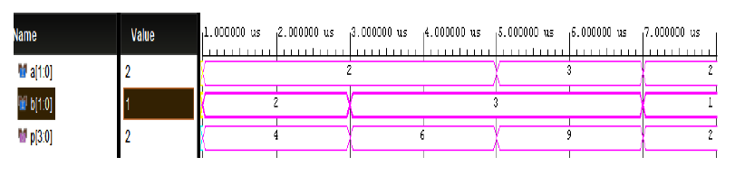
Fig. 6. Simulation output of 4-bit Vedic multiplier using proposed ASK Gate

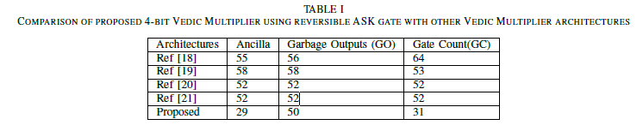

CONCLUSION

The number of reversible gates required, the amount of garbage outputs (GO) generated, and the ancilla inputs for the 4-bit Vedic multiplier designed using ASK gate against existing architectures. The proposed circuit uses 29 ancilla bits, employs a total of 31 reversible gates, and produces 50 garbage outputs. This study emphasises the considerable benefits of reversible logic in low-power computing, especially for energy efficient applications and in the field of quantum computing, where reversible operations are essential. An effective complete adder and a 4-bit Vedic multiplier based on the Urdhva Triyambakam technique are constructed using the 4x4 ASK reversible gate, which is demonstrated in the proposed design and implementation. The novel approach reduces the amount of garbage outputs, minimises the ancilla bits, and decreases the number of gates required, compared to conventional reversible designs.

FUTURE WORK

The importance of reversible logic extends to quantum computing, where reversible operations are essential for the construction of quantum gates and circuits. Adders play a crucial role in multipliers, especially in digital signal processing (DSP) applications. Our future aim is to create a double precision floating-point Vedic multiplier for advanced DSP applications. This will be achieved by leveraging the suggested full adder design that incorporates the proposed reversible logic gates.

REFERENCES

[1] A. Roohi, R. Zand, S. Angizi and R. F. DeMara, A Parity-Preserving Reversible QCA Gate with Self-Checking Cascadable Resiliency, in IEEE Transactions on Emerging Topics in Computing, vol. 6, no. 4, pp. 450- 459, 1 Oct.-Dec. 2018.

[2] S. Raveendran, P. J. Edavoor, N. Y. B. Kumar and M. H. Vasantha, An Approximate Low-Power Lifting Scheme Using Reversible Logic,in IEEE Access, vol. 8, pp. 183367-183377, 2020.

[3] E. Fredkin and T. Toffoli, Conservative logic, in Collision-based computing. Springer, pp. 47–81, 2002.

[4] T. Toffoli, “Reversible computing,” in Automata, Languages and Programming, ser. Lecture Notes in Computer Science, J. de Bakker and J. van Leeuwen, Eds. Springer Berlin Heidelberg, 1980, vol. 85, pp. 632–644, 1980.

[5] D. P. Vasudevan, P. K. Lala, J. Di, and J. P. Parkerson, Reversible-logic design with online testability, IEEE transactions on instrumentation and measurement, vol. 55, no. 2, pp. 406–414, 2006.

[6] H. M. H. Babu, N. Saleheen, L. Jamal, S. M. Sarwar, and T. Sasao, Approach to design a compact reversible low power binary comparator, IET Computers Digital Techniques, vol. 8, no. 3, pp. 129–139, 2014.

[7] M. Alioto and G. Palumbo, “Modeling of power consumption of adiabatic gates versus fan in and comparison with conventional gates, in International Workshop on Power and Timing Modeling, Optimization and Simulation. Springer, pp. 265–275, 2000.

[8] Aruru Sai Kumar, T.V.K. Hanumantha Rao, An Adaptive Core Mapping Algorithm on NoC for Future Heterogeneous System-on-Chip, Computers and Electrical Engineering, Volume 95, October 2021.

[9] Aruru Sai Kumar et al., “Nanosheet Field Effect Transistor Device and Circuit Aspects for Future Technology Nodes,”ECS Journal of Solid State Science and Technology, Vol. 12, No. 8, 2023.

[10] S. S. Chiwande and P. K. Dakhole, ”Design and Analysis of Low Power Full Adder using Reversible Logic,” 2022 6th International Conference on Electronics, Communication and Aerospace Technology, Coimbatore, India, pp. 146-150, 2022.

[11] Sarangam K et al., ”Design and Energy Dissipation Analysis of Full- Adder for Low Power Applications Using Reversible Logic Gates”,3rd International Conference on Emerging Frontiers in Electrical and Electronic Technologies (ICEFEET- 2023), NIT Patna, 2023.
[12] Shukla, V., Singh, O. P., Mishra, G. R., & Tiwari, R. K., ”A novel approach for reversible realization of 4× 4 bit vedic multiplier circuit,”In Advances in VLSI, Communication, and Signal Processing: Select Proceedings of VCAS 2018 (pp. 733-745). Springer Singapore, 2020.

[13] R. Saligram and T. R. Rakshith, ”Optimized reversible vedic multipliers for high speed low power operations,” 2013 IEEE Conference on Information & Communication Technologies, Thuckalay, India, pp. 809-814, 2013.

[14] J. Pujar, S. Raveendran, T. Panigrahi, M. H. Vasantha and N. Kumar Y.B.,”Design and Analysis of Energy Efficient Reversible Logic based Full Adder,” 2019 IEEE 62nd International Midwest Symposium on Circuits and Systems (MWSCAS), USA, pp. 339-342, 2019.

[15] M. Aditya, Y. B. N. Kumar and M. H. Vasantha, ”Reversible full/half adder with optimum power dissipation,” 2016 10th International Conference on Intelligent Systems and Control (ISCO), Coimbatore, India, pp. 1-4, 2016.

[16] C Ganesh et al., ”A Novel Design of Area Efficient Full Adder Architecture using Reversible Logic Gates”,7th International Conference on Devices, Circuits, and Systems(ICDCS), 2024.

[17] J. Bruce et al., Efficient adder circuits based on a conservative reversible logic gate, in Proceedings IEEE Computer Society Annual Symposium on VLSI, pp. 74-79, 2002.

[18] Thapliyal, H., M.B. Srinivas and H.R. Arabnia, ”A Reversible Version of 4×4 Bit Array Multiplier with Minimum Gates and Garbage Outputs,” Int. Conf. Embedded System, Applications (ESA’05), pp: 106-114, 2005.

[19] H. Thapliyal and M. B. Srinivas, ”Novel Reversible Multiplier Architecture Using Reversible TSG Gate,” IEEE International Conference on Computer Systems and Applications, pp. 100-103, 2006.

[20] F. Naderpour and A. Vafaei, ”Reversible multipliers: Decreasing the depth of the circuit,” 2008 International Conference on Electrical and Computer Engineering, pp. 306-310, 2008.

[21] M. Ehsanpour, P. Moallem and A. Vafaei, ”Design of a novel reversible multiplier circuit using modified full adder,” 2010 International Conference On Computer Design and Applications, China, pp. V3-230-V3-234, 2010.

