Low Level Design (LLD)

Store Sales Prediction

|  |  |
| --- | --- |
| Written By | Aakanksha Jadhav |
| Document Version | Initial LLD -V1.0 |
| Last Revised Date |  |

**Document Control**

**Change Record:**

|  |  |  |  |
| --- | --- | --- | --- |
| **Version** | **Date** | **Author** | **Comments** |
|  |  |  |  |
|  |  |  |  |
|  |  |  |  |
|  |  |  |  |
|  |  |  |  |

**Reviews:**

|  |  |  |  |
| --- | --- | --- | --- |
| **Version** | **Date** | **Reviewer** | **Comments** |
|  |  |  |  |

**Approval Status :**

|  |  |  |  |  |
| --- | --- | --- | --- | --- |
| **Version** | **Review Date** | **Reviewed By** | **Approved By** | **Comments** |
|  |  |  |  |  |

# Contents

1.Introduction.....................................................................................................................4

1.1 What is Low-Level design document........................................................................4

1.2 Scope..........................................................................................................................4

2. Architecture...................................................................................................................5

3. Architecture Description...............................................................................................6

3.1 Data Description..........................................................................................................6

3.2 Data Pre-processing ....................................................................................................6

3.3 Model Building ...........................................................................................................6

3.4 Deployment.................................................................................................................6

4. Unit Test Cases ............................................................................................................7.

1. Introduction

1.1. What is Low-Level design document?

The goal of LLD or a low-level design document (LLDD) is to give the internal logical design of the actual program code for Food Recommendation System. LLD describes the class diagrams with the methods and relations between classes and program specs. It describes the modules so that the programmer can directly code the program from the document.

1.2. Scope

Low-level design (LLD) is a component-level design process that follows a step-by-step refinement process. This process can be used for designing data structures, required software architecture, source code and ultimately, performance algorithms. Overall, the data organization may be defined during requirement analysis and then refined during data design work.

2. Architecture

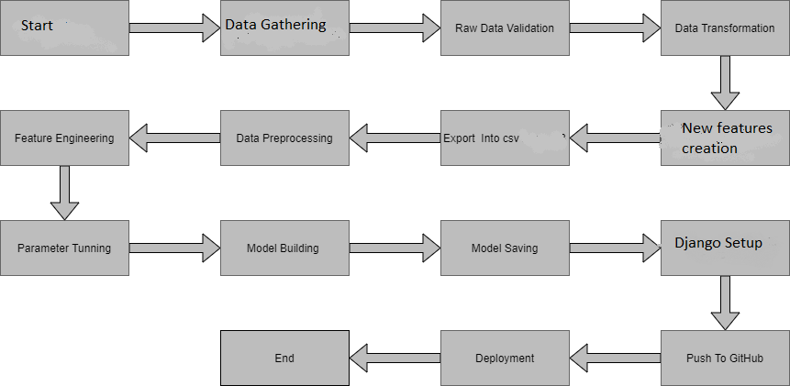

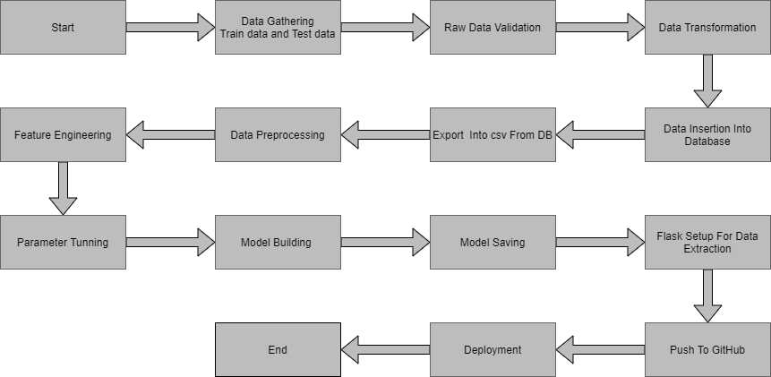

2. Architecture Description

2.1. Data Description

Given is the variable name, variable type, the measurement unit, and a brief description. The concrete compressive strength is the regression problem. The order of this listing corresponds to the order of numerals along the rows of the database.

|  |  |  |
| --- | --- | --- |
| Name | Data Type | Measurement |
| Item_Identifier | String | Unique product ID |
| Item_Weight | Float | Weight of product |
| Item_Fat_Content | String | Whether the product is low fat or not |
| Item_Visibility | Float | The % of a total display area of all products in a store allocated to the particular product |
| Item_Type | String | The category to which the product belongs |
| Item_MRP | Float | Maximum Retail Price (list price) of the product |
| Outlet_Identifier | String | Unique store ID |
| Outlet_Establishment_Year | Integer | The year in which the store was established |
| Outlet_Size | String | The size of the store in terms of ground area covered |
| Outlet_Location_Type | String | The type of city in which the store is located |
| Outlet_Type | String | Whether the outlet is just a grocery store or some sort of supermarket |
| Item_Outlet_Sales | Float | Sales of the product in the particular store. This is the outcome variable to be predicted. |

**2.2 Data Gathering**

Data source: [**https://www.kaggle.com/brijbhushannanda1979/bigmart-sales-data**](https://www.kaggle.com/brijbhushannanda1979/bigmart-sales-data)

Train and Test data are stored in .csv format.

**2.3 Data Preprocessing**

In data preprocessing all the processes required before sending the data for model building are performed. Like, here the ‘Item Visibility’ attributes are having some values equal to 0, which is not appropriate because if an item is present in the market, then how its visibility can be 0. So, it has been replaced with the average value of the item visibility of the respective ‘Item Identifier’ category. New attributes were added named ‘’Outlet years”, where the given establishment year is subtracted from the current year. A new “Item Type” attribute was added which just takes the first two characters of the Item Identifier which indicates the types of the items. Then mapping of “Fat content” is done based on ‘Low’, ‘Reg’ and ‘Non-edible’

**2.4 Feature Engineering**

After preprocessing it was found that some of the attributes are not important to the item sales for the particular outlet. So those attributes are removed. Even one hot encoding is also performed to convert the categorical features into numerical features.

**2.5.Parameter Tuning**

Parameters are tuned using Randomized searchCV. Four algorithms are used in this problem, Linear Regression, Gradient boost, Random Forest, and XGBoost regressor. The parameters of all these 4 algorithms are tunned and passed into the model.

**2.6 Model Building**

After doing all kinds of preprocessing operations mention above and performing scaling and hyperparameter tuning, the data set is passed into all four models, Linear Regression, Gradient boost, Random Forest, and XGBoost regressor. It was found that Gradient boost performs best with the smallest RMSE value i.e. 587.0 and the highest R2 score equals 0.55. So ‘Gradient boost’ performed well in this problem.

**2.7 Deployment**

The cloud environment was set up and the project was deployed from GitHub into the Heroku cloud platform.

App link- https://store-predection.herokuapp.com/

3. Unit Test Cases

|  |  |  |
| --- | --- | --- |
| Test Case Description | Pre-Requisite | Expected Result |
| Verify whether the Application URL is  accessible to the user | 1. Application URL  should be defined | Application URL should be  accessible to the user |
| Verify whether the Application loads  completely for the user when the URL  is accessed | 1. Application URL  is accessible  2. Application is  deployed | The Application should load  completely for the user when the  URL is accessed |
| Verify whether user is able to see input  fields | 1. Application is  accessible | User should be able to see input  fields |
| Verify whether user gets Submit  button to submit the inputs | 1. Application is  accessible | User should get Submit button to  submit the inputs |
| Verify whether the recommended  results are in accordance to the  selections user made | 1. Application is  accessible | The recommended results should  be in accordance to the selections  user made |