Store Sales Prediction

Wireframe Documentation

Store Sales Prediction

User Interface:

1. The user can view the following web page once entering the web application.

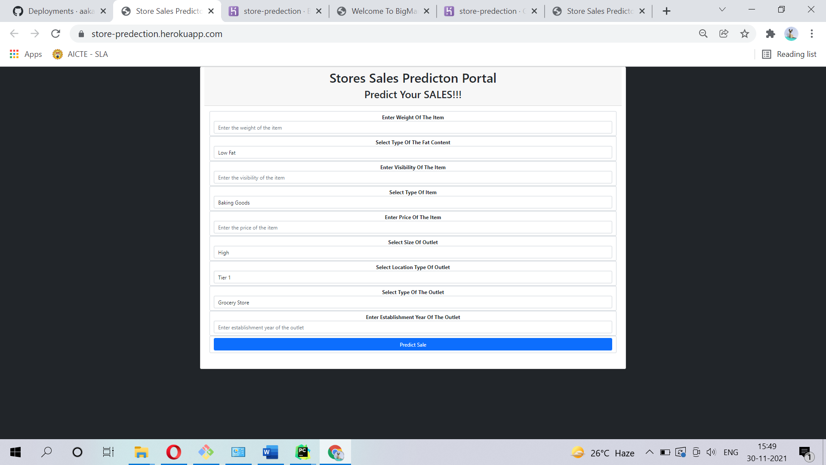

2. After entering the values in the fields:

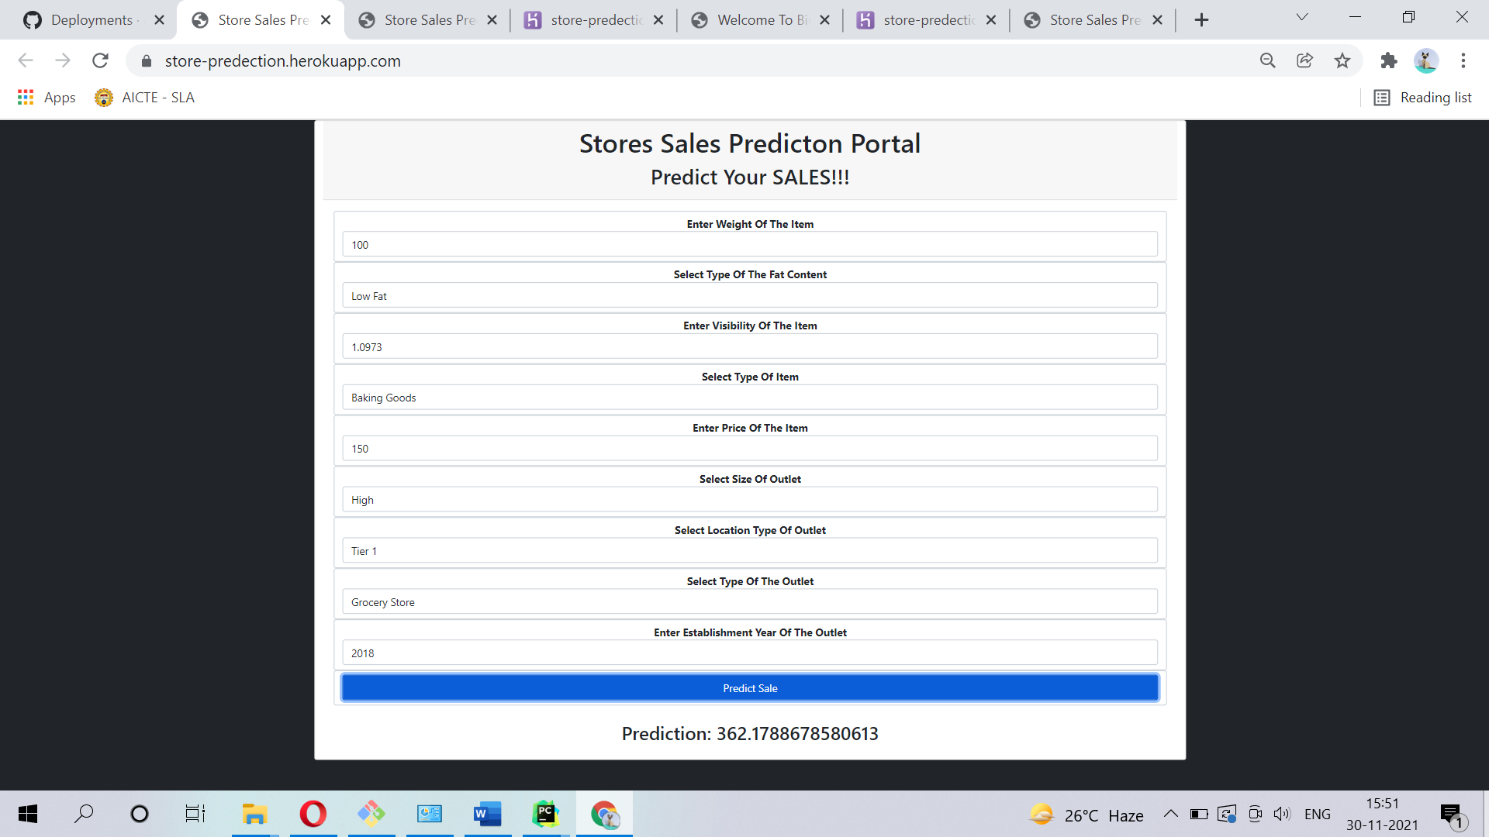

3.After clicking the “Predict sale ” button, user can see the prediction.



Based on User Inputs, Store Sales Prediction will predict the Item Outlet Sales and user will get predicted