**Capstone Project 1**

**Title:** Friendship Zone – A Simple Website to Make Friends

**Objective of the Project:**

To design and develop a basic, user-friendly web application that allows individuals to connect, register, and maintain a list of friends. The project serves as a foundation for understanding the creation of interactive, multi-page websites using HTML only.

**Problem Statement:**

In an increasingly digital world, the ability to stay socially connected is vital. However, many platforms are overly complex or require heavy backend systems for even simple interactions. There is a need for a minimal, lightweight, static solution that simulates basic social networking features like friend registration, viewing friend lists, and simple user interaction without relying on databases or servers.

**GitHub link**: [Click Here](https://github.com/UdayIge/HtmlCapstoneProjects)

**Output screenshots:**

Home Page

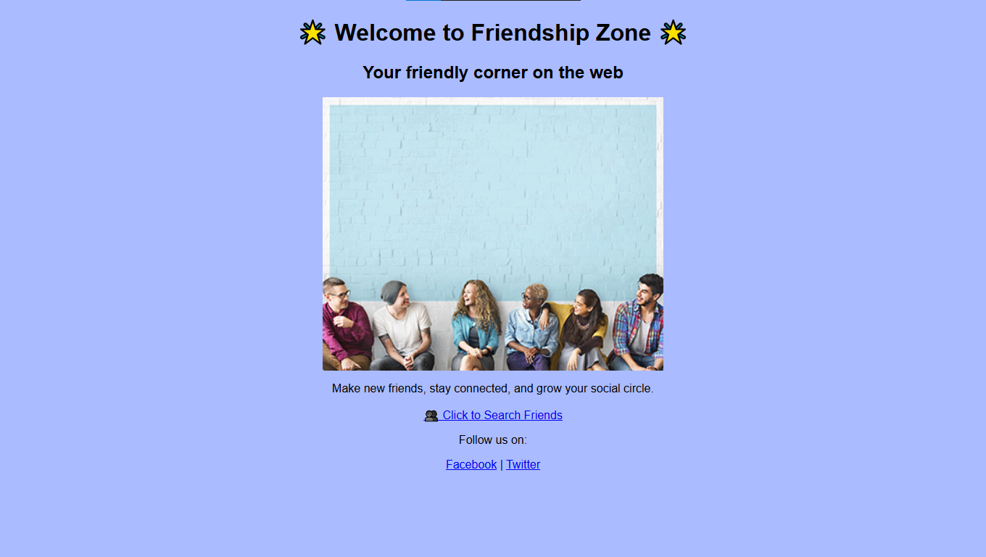

Add New Friend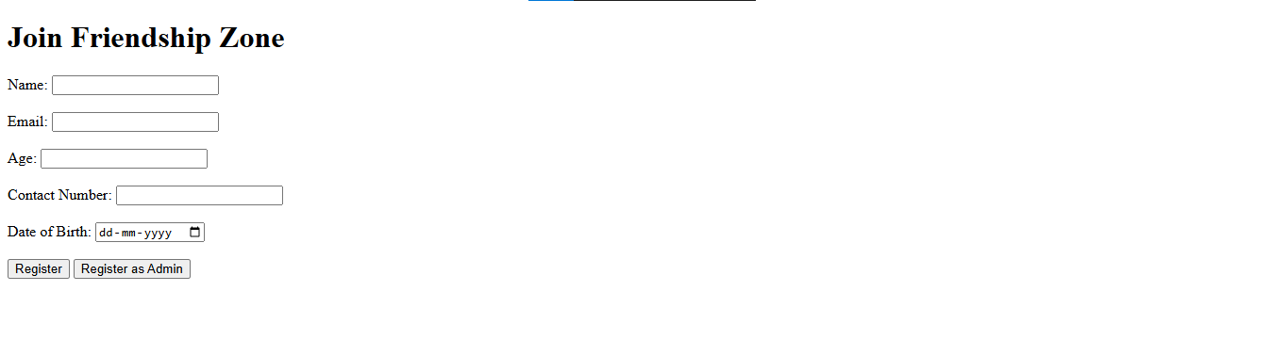****

Friend List

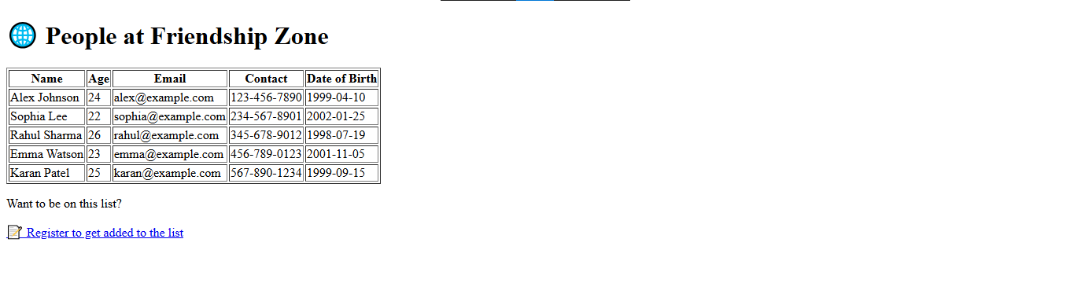

**Conclusion / Outcome:**

The Friendship Zone project successfully implements a multi-page static website with essential features like homepage navigation, user registration, friend listing, and confirmation pages. It demonstrates how HTML can be used to structure a basic front-end system for a social application prototype. The project also lays a groundwork that can later be expanded with CSS for styling and JavaScript for interactivity and backend integration.

**Capstone Project 2**

**Title:** AutoMob-Mechanic – A Car Service Web Application

**Objective of the Project:**

To design a basic website that showcases the services of a car repair center and allows users to book appointments online. The goal is to help users understand how to build multi-page websites using only HTML.

**Problem Statement:**

Car owners often face issues finding nearby service options or knowing what services are available. Without a website, small garages miss the chance to connect with customers online. This project aims to provide an easy solution for both service providers and customers.

**GitHub link**: [Click Here](https://github.com/UdayIge/HtmlCapstoneProjects)

**Output screenshots:**

Home page

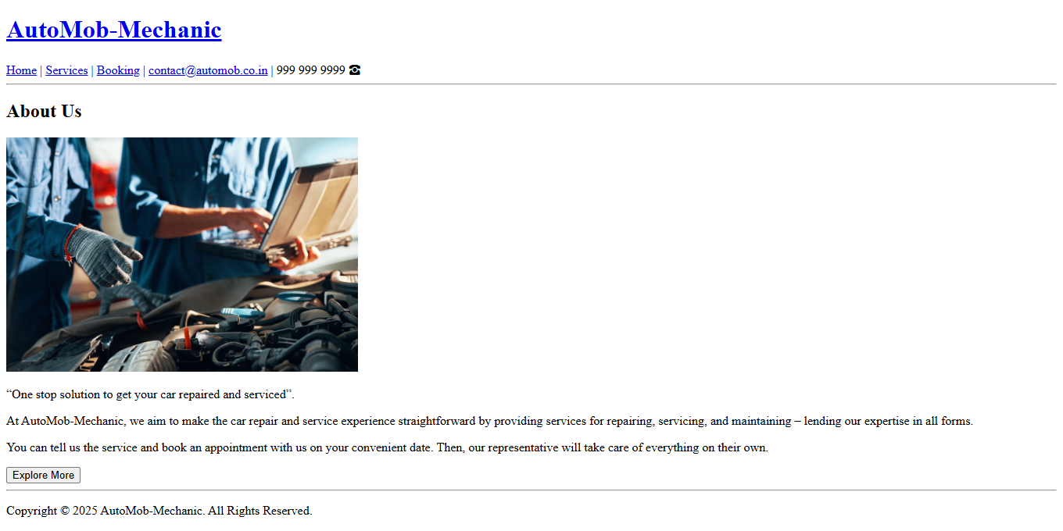

services

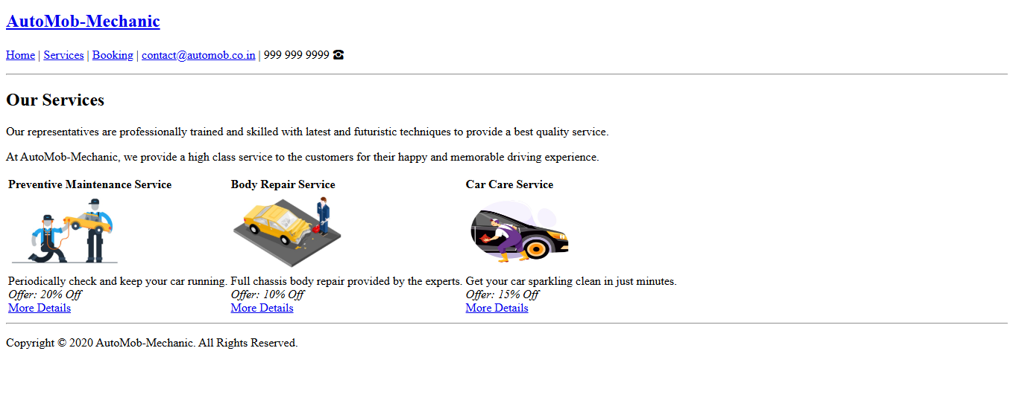

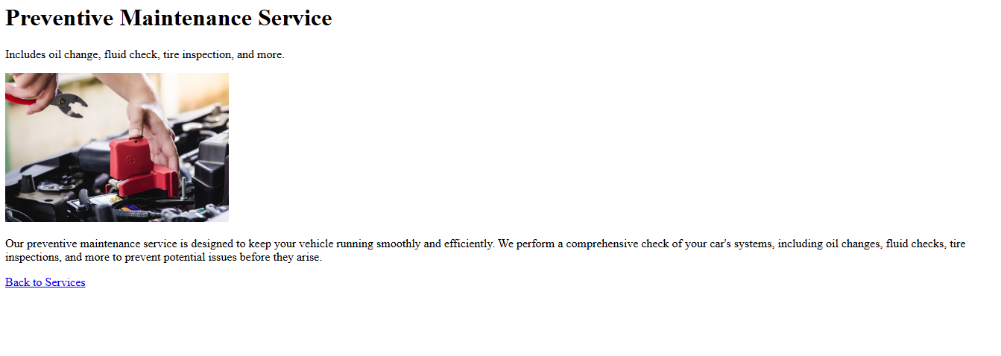 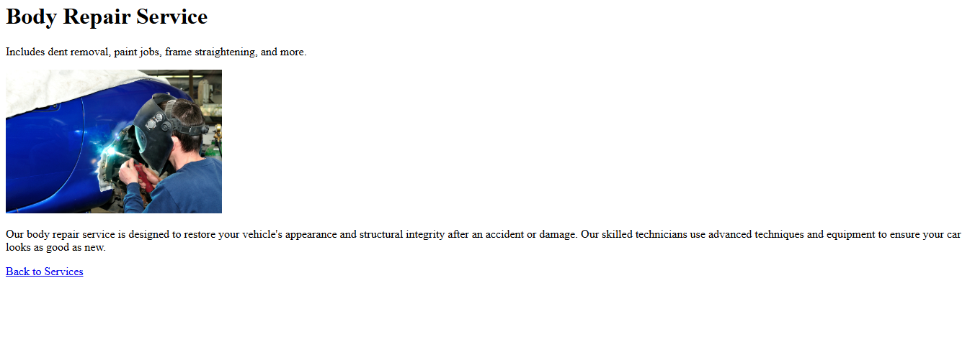

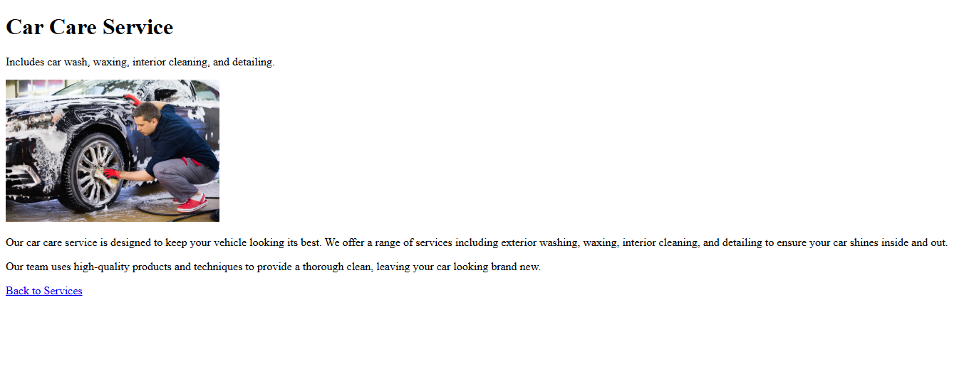

**Conclusion / Outcome:**

The project results in a working HTML-based web application for an automobile service center. It includes a homepage, services listing, booking page, and confirmation screen. It's simple but functional and can be expanded further with styling or interactivity. It serves as a good starting point for web development beginners.