### **Capstone Project 1**

### **Title**

### **MegaCart - E-commerce Web Application**

### **Objective of the Project:**

The goal of the **MegaCart** project is to develop a simple, mobile-responsive e-commerce website using only HTML, CSS, and JavaScript. It aims to provide a seamless shopping experience with features like dynamic product display, user authentication, real-time cart management, and mobile-friendly design—all implemented without external libraries or frameworks.

### **Problem Statement:**

Many e-commerce websites are often heavy, slow, and lack mobile responsiveness, leading to poor user experiences. Additionally, the complexity of integrating back-end systems and maintaining real-time cart updates can be challenging. The **MegaCart** project solves these issues by:

* Offering a lightweight, fast-loading platform.
* Ensuring mobile responsiveness through simple CSS and HTML.
* Allowing real-time cart updates and product management using localStorage.

**Code link**

**Output Screenshots:** 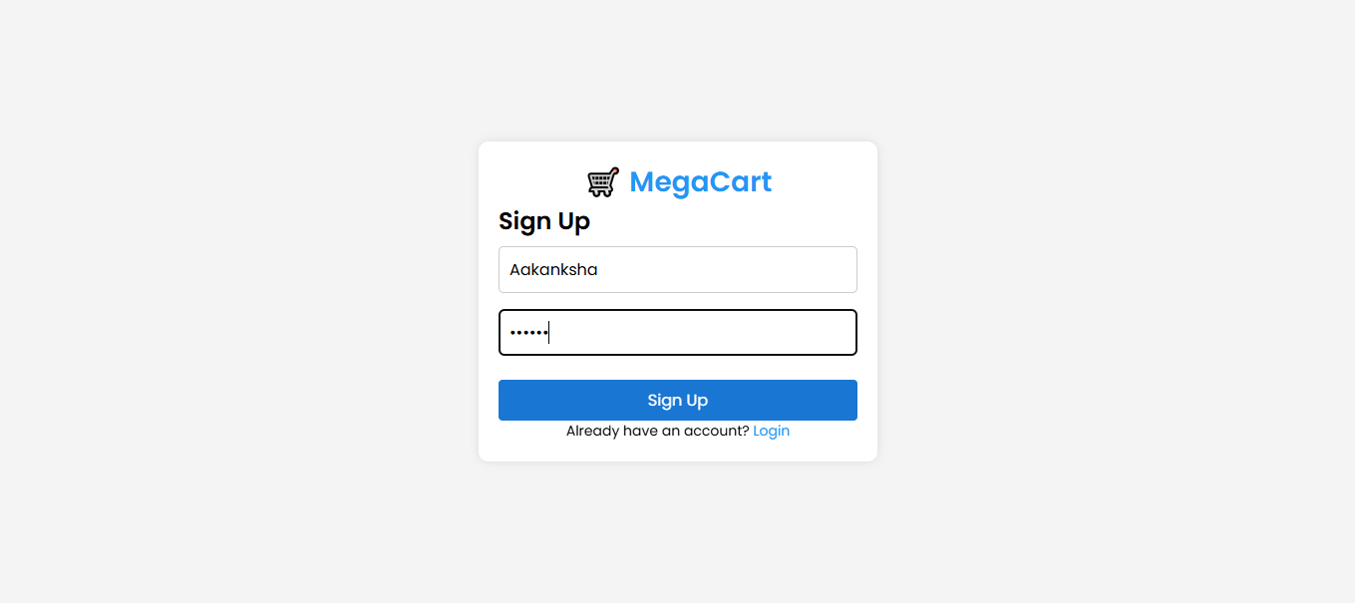 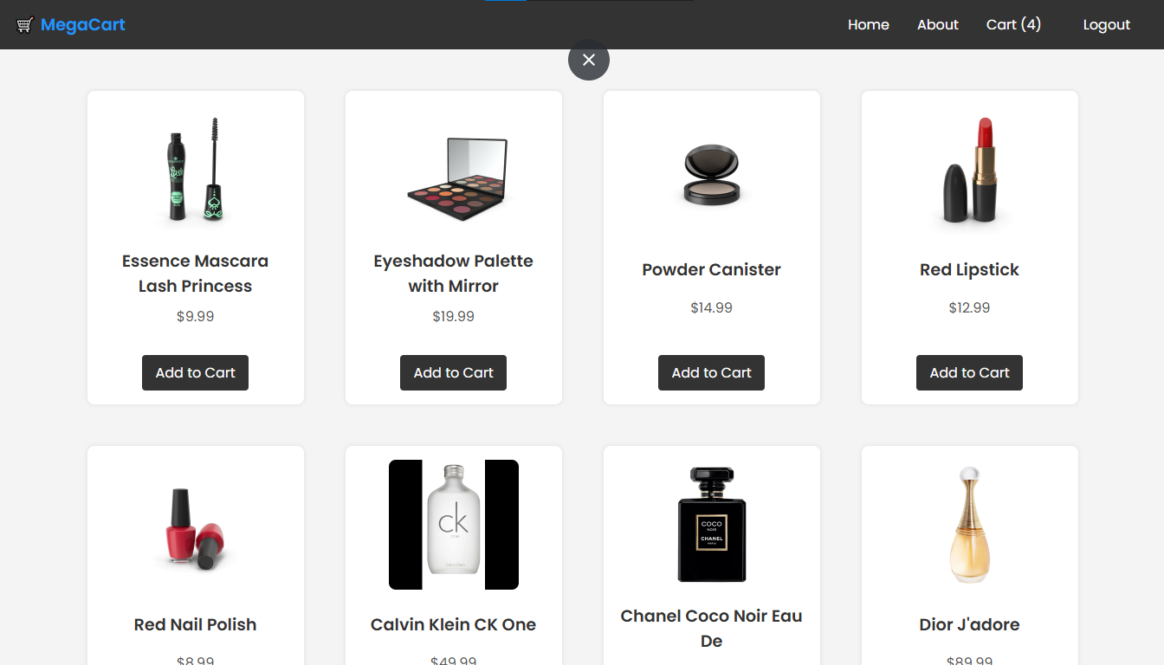 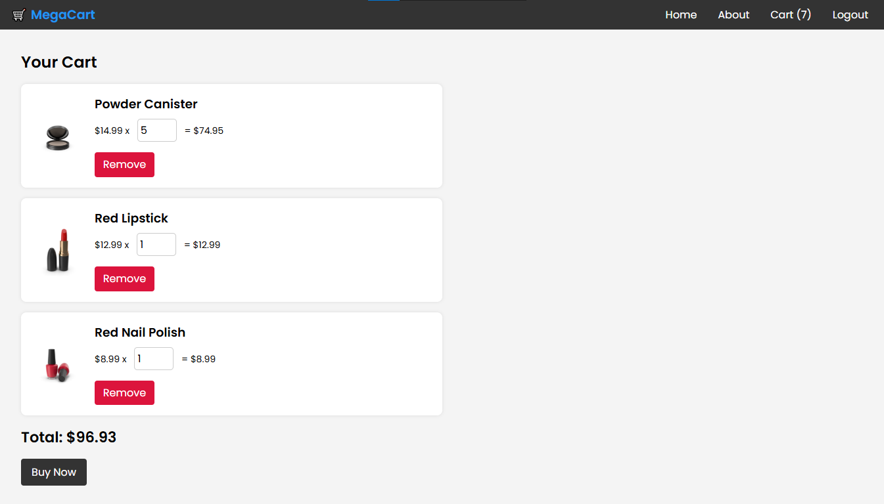 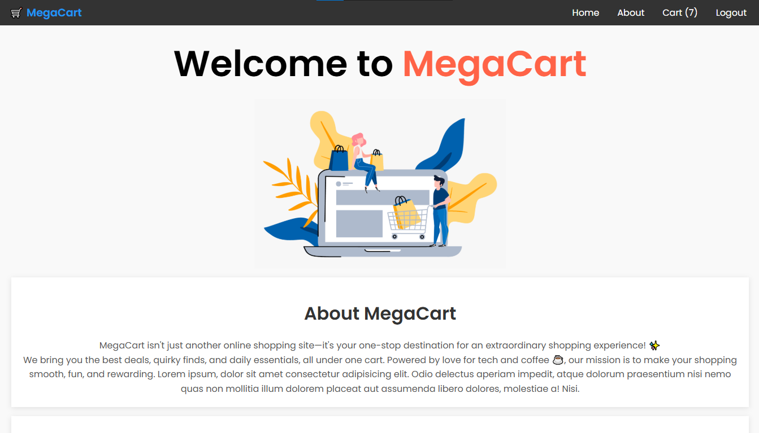 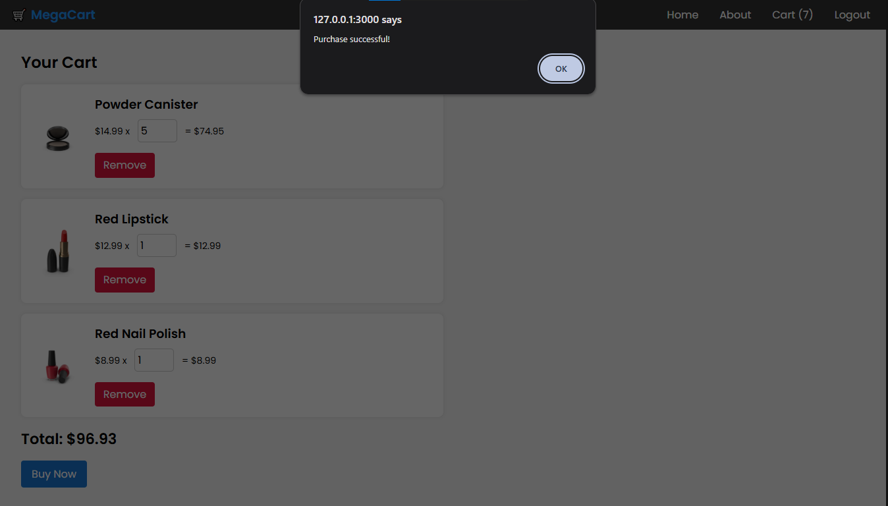

### **Conclusion or Outcome:**

The **MegaCart** web application effectively addresses common challenges in e-commerce platforms. It provides a smooth, responsive shopping experience and a straightforward user interface, utilizing localStorage for cart and user management. The project demonstrates how an e-commerce platform can be built using only front-end technologies while ensuring usability and functionality. By focusing on simplicity and responsiveness, **MegaCart** serves as a scalable foundation for future e-commerce solutions.

## Capstone Project 2

## Title

Portfolio Management: Interactive Stock Trading and Tracking Platform

## Objective of Project

To create a standalone, user-friendly web application that allows investors to monitor their stock portfolios, execute trades, and receive investment recommendations through an intuitive interface. The project aims to deliver a fully responsive solution using only HTML, CSS, and vanilla JavaScript, with client-side data persistence and without dependencies on external frameworks or libraries.

## Problem Statement

Individual investors face several challenges when managing their portfolios:

* Difficulty tracking investments across multiple platforms
* Limited access to comprehensive trading tools without subscription fees
* Lack of personalized investment recommendations
* Concerns about data privacy and security
* Need for consistent access across different devices

Current solutions in the market are often overly complex, expensive, or fail to provide a cohesive experience that combines portfolio tracking, trading functionality, and personalized insights in one accessible platform.

**Code link:**

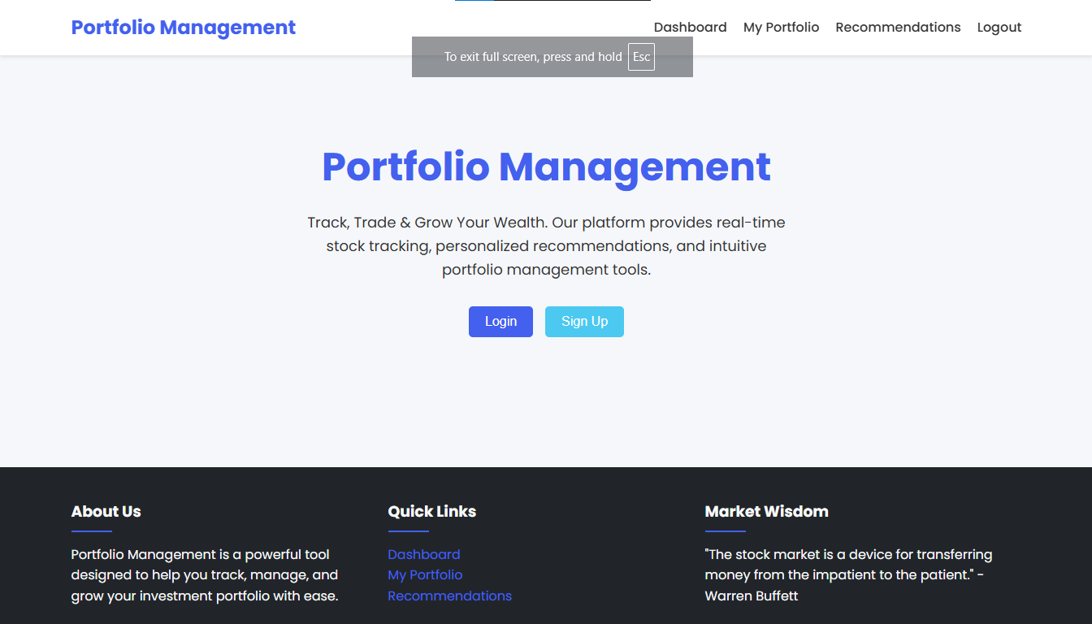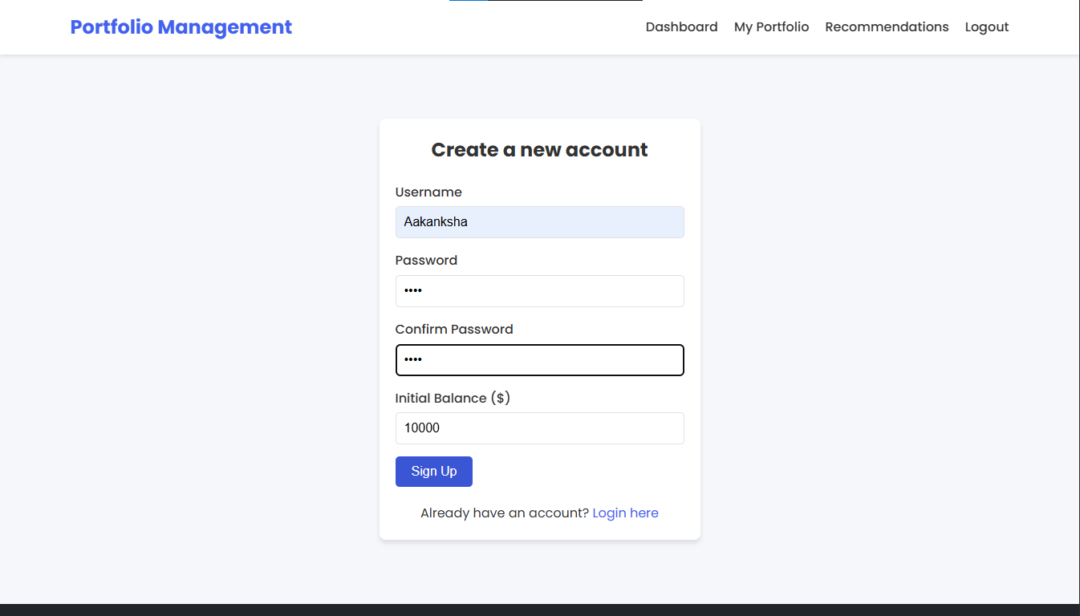**Output Screenshots:** 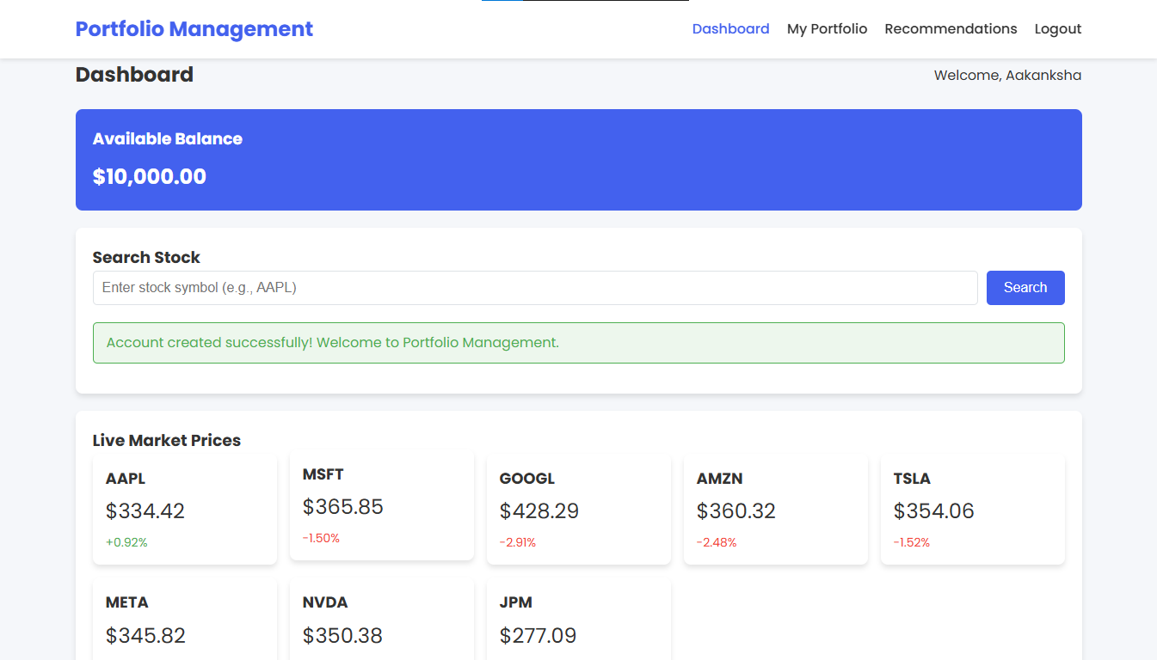 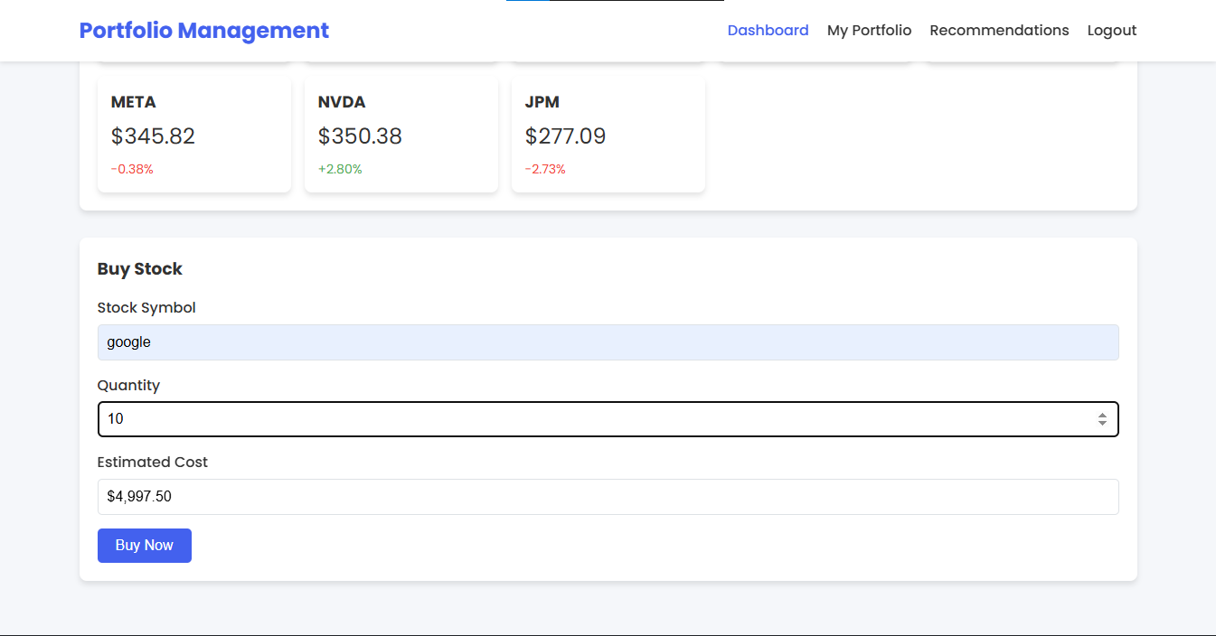 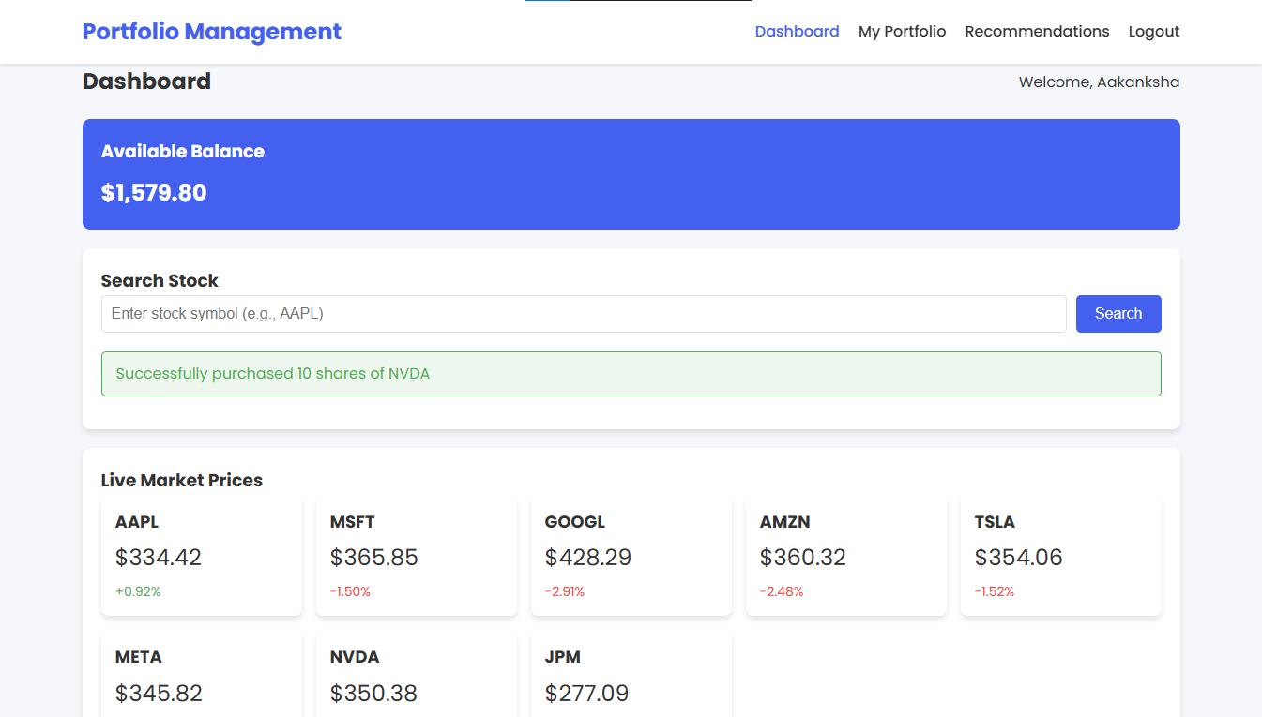 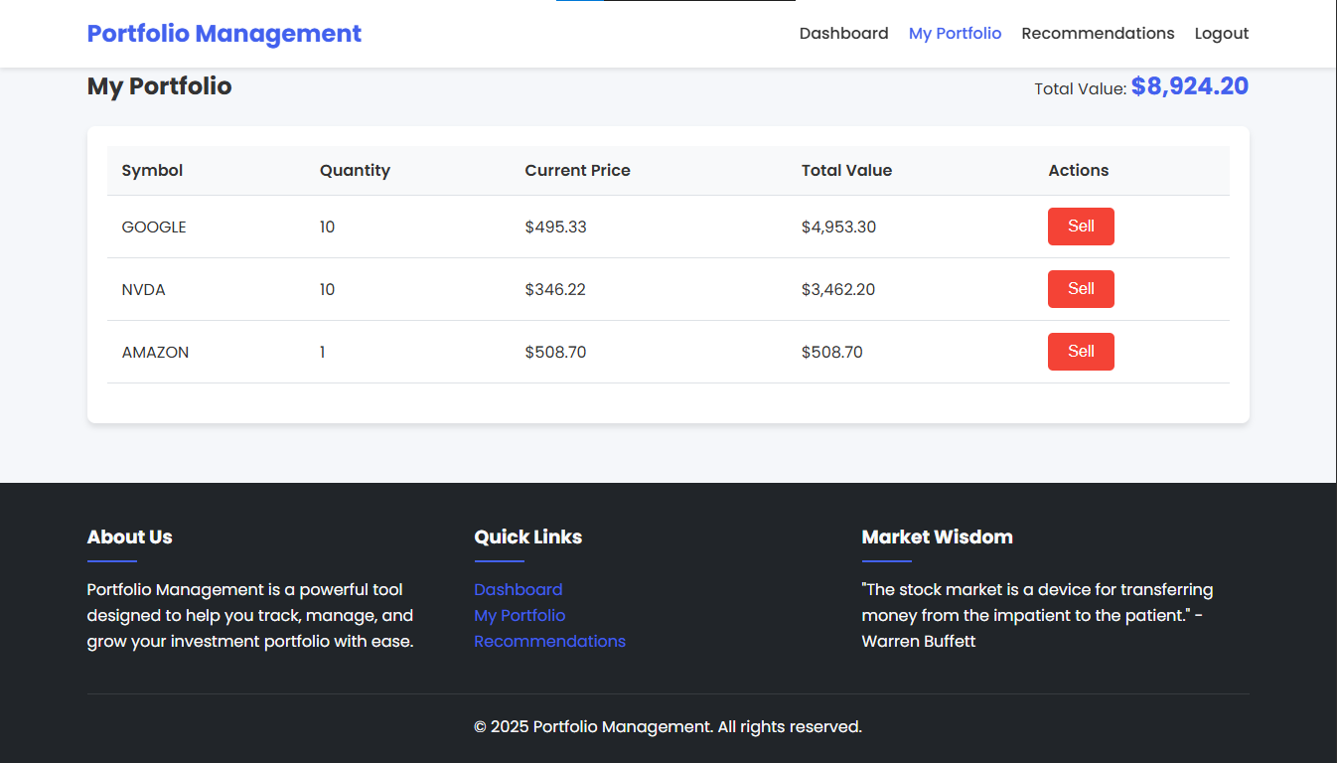 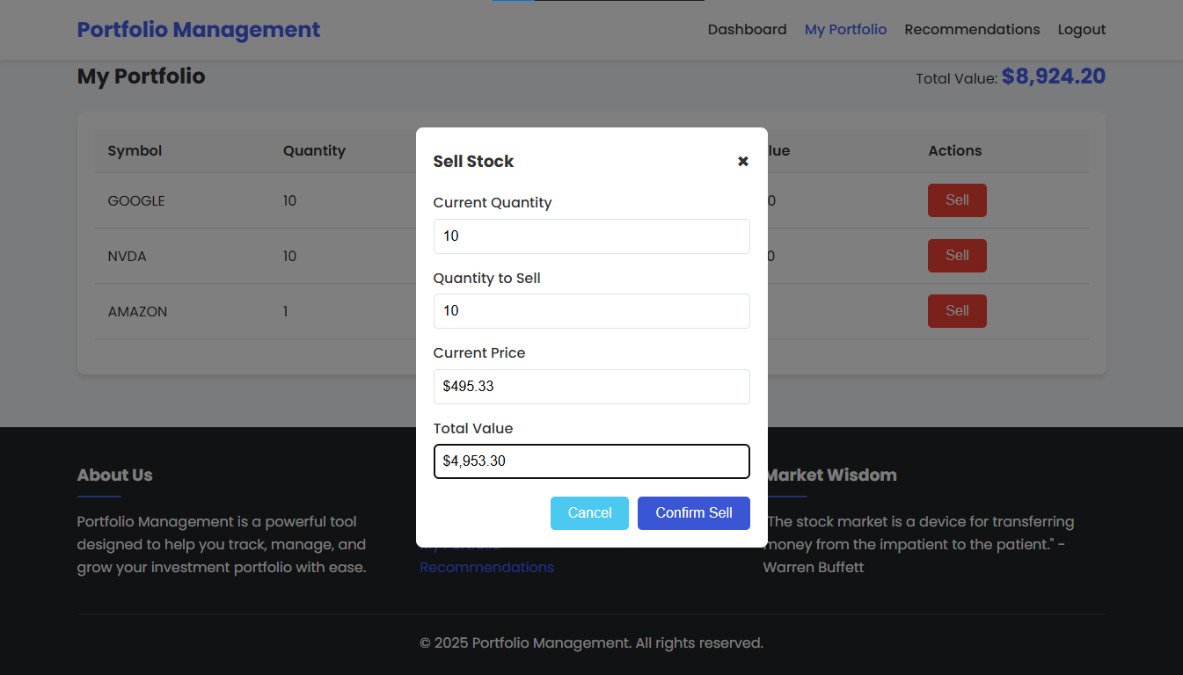 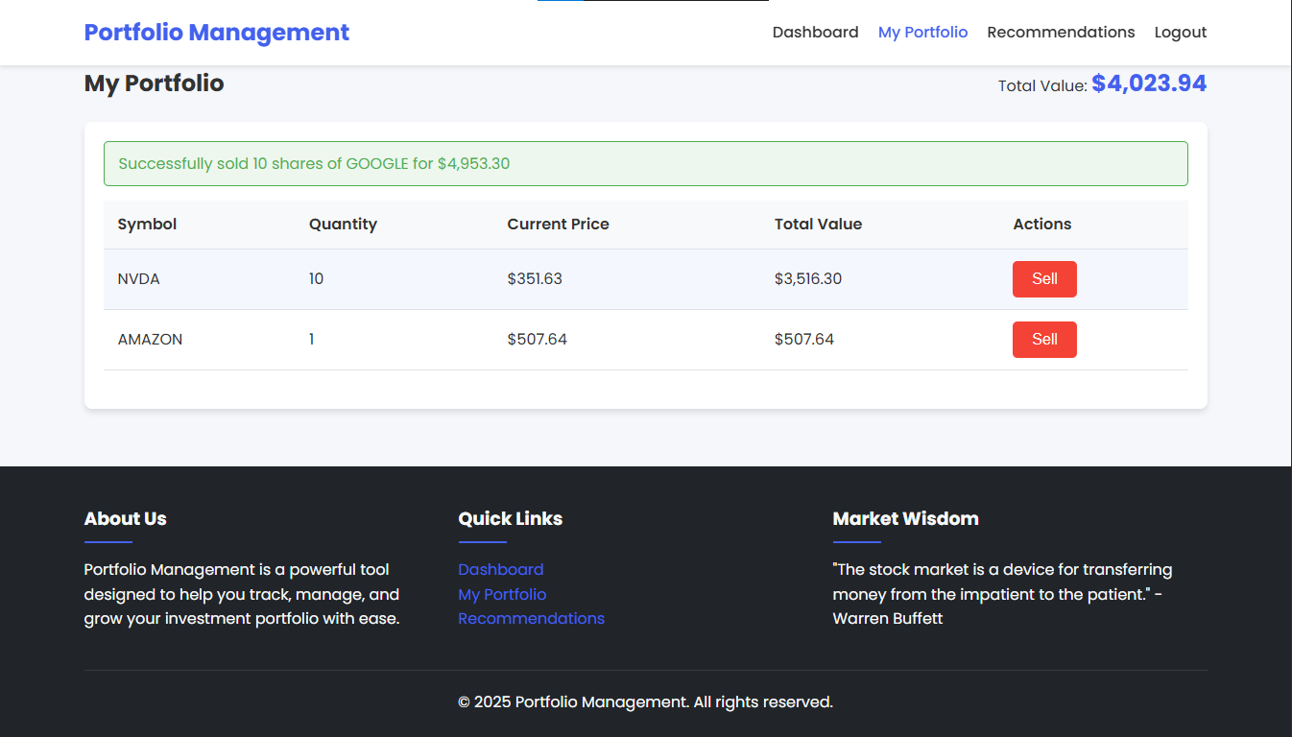 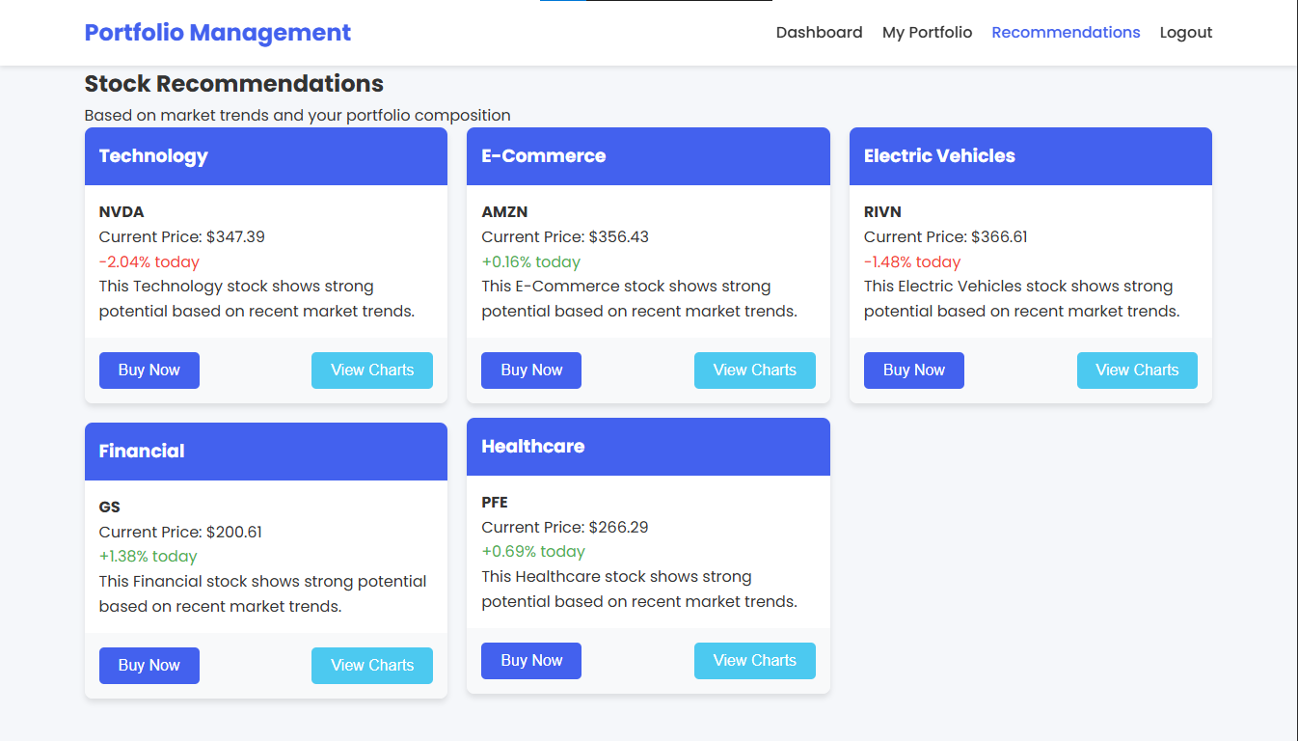

## Conclusion/Outcome

The Portfolio Management web application successfully delivers a comprehensive solution that addresses the identified challenges through:

1. A secure, localStorage-based authentication system with basic encryption
2. An interactive dashboard featuring live stock price updates and portfolio valuation
3. Intuitive trading interfaces for buying and selling stocks with automatic balance management
4. Sector-based stock recommendations to guide investment decisions
5. Fully responsive design ensuring seamless functionality across desktop and mobile devices

The implementation demonstrates that effective portfolio management tools can be built with fundamental web technologies, providing investors with a lightweight yet powerful platform to manage their investments independently. The application achieves its goal of combining security, functionality, and ease of use in a single, framework-free solution that runs entirely in the browser.

## Capstone Project 3

## Title

AutoMob-Mechanic: Client-Side Automobile Service Booking System

## Objective of Project

* Create a responsive web application for automobile service booking management
* Implement client-side data storage using localStorage
* Provide service visibility and booking functionality for customers
* Enable service centers to manage bookings without complex infrastructure

## Problem Statement

* Small automobile service centers lack affordable booking management tools
* Customers need convenient ways to schedule services without phone calls
* Service centers require solutions that work across devices without servers
* Basic customer data and booking history need to be accessible and organized

**Code link:**

**Output Screenshots:** 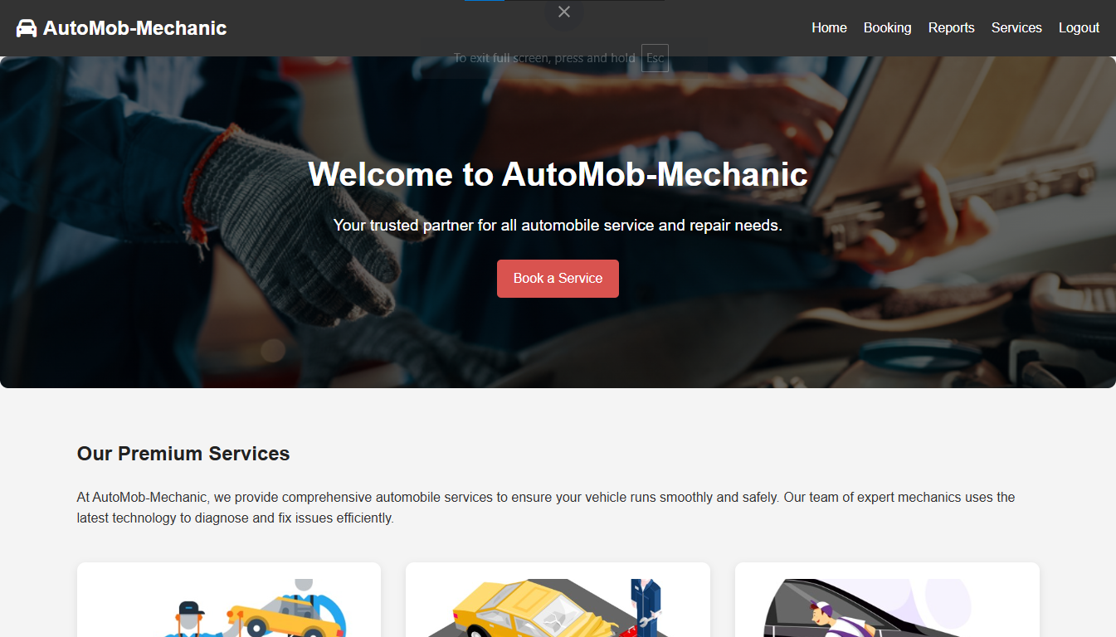 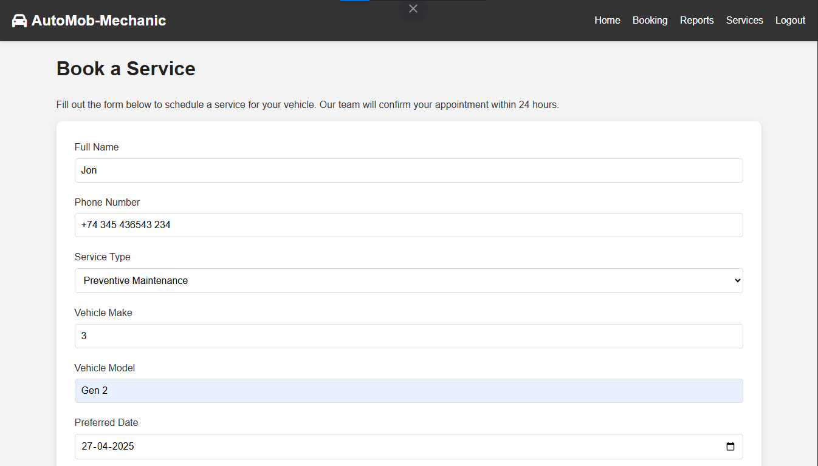  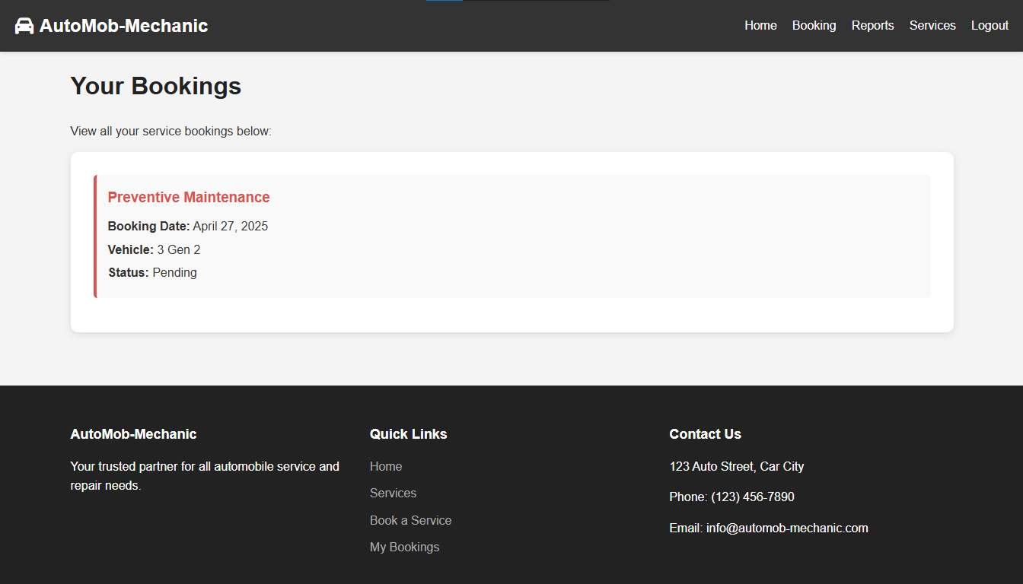 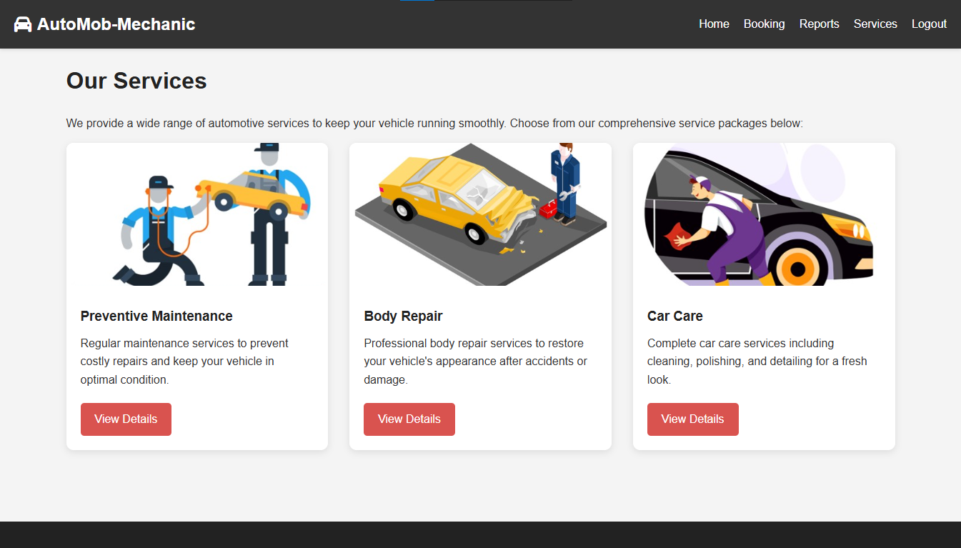 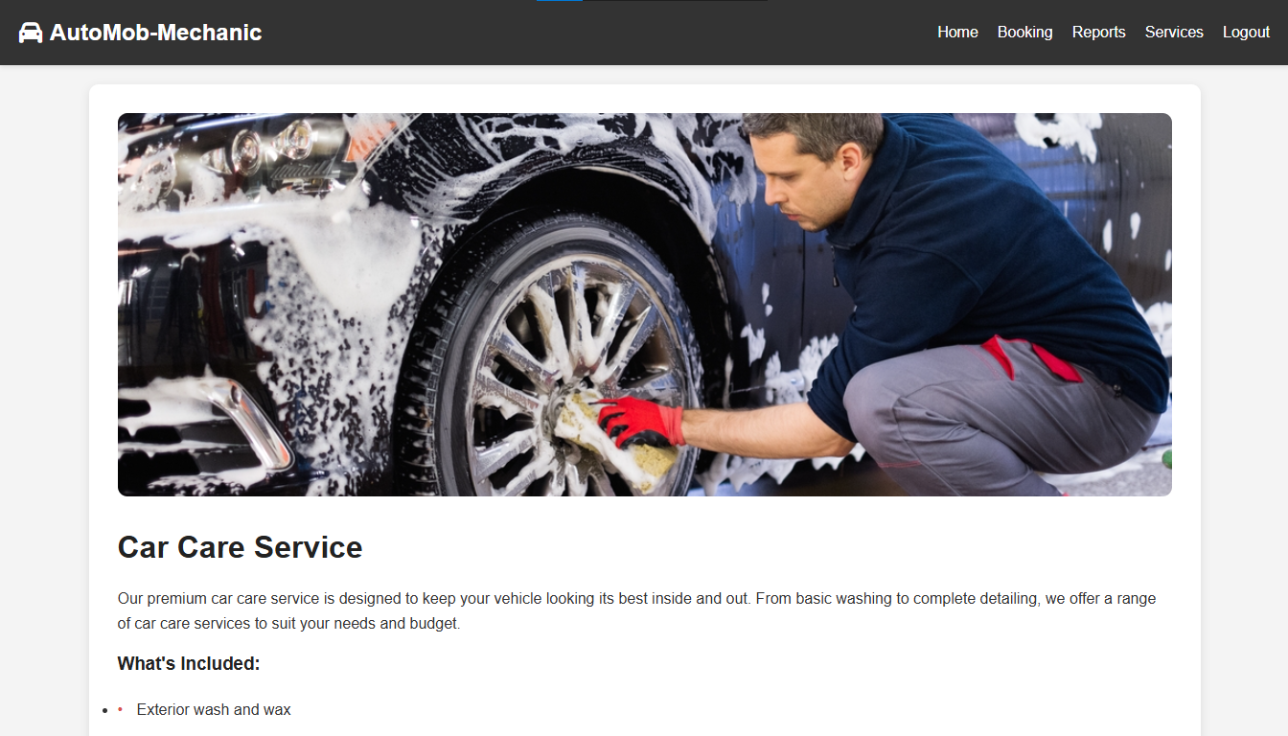

## Conclusion/Outcome

* Developed a complete web application using HTML, CSS, and JavaScript
* Implemented user authentication system with secure localStorage data management
* Created detailed service pages for Preventive Maintenance, Body Repair, and Car Care
* Built an intuitive booking system with confirmation and history tracking
* Designed a responsive interface that adapts to both desktop and mobile devices
* Eliminated the need for server-side processing while maintaining functionality
* Provided a cost-effective solution for service centers to digitize their booking process