**Assessing Fire Damage**

|  |
| --- |
| 1.    If not already present, create a folder (which you will name using your login name) under drive **D:** (e.g. D:/login_name/)  2.    Under your personal folder, create another folder called **FireAssessment**.  3.    [Download the data](Assessing_fire_damage_files/FireAssessment.zip) for this exercise and [extract the files](http://gisserver0.colby.edu/10/Opening_zip_files.htm) from the FireAssessment.zip file to your newly created **FireAssessment** directory. |

*This exercise is adapted from ESRI's "Learning ArcGIS Desktop" Virtual Campus module*

Lightning sparked a wildfire in a national forest. After two days, the fire was finally contained. Now it's time to assess the damage. Of particular concern is the fire's impact on riparian habitat (the land adjacent to water bodies such as rivers, streams, and creeks) as well as the amount of forest that was lost.

In this exercise, your job is to determine how much riparian habitat and forest was burned. Geoprocessing tools you will use for the analysis include:

* Merge
* Buffer
* Clip
* Intersect
* Dissolve
* Extract by mask

Contents

Step 1: Open the map document 2

Step 2: Merge land cover types 2

Step 3: Buffer the creeks 6

Step 4: Clip the burned area 7

Step 5: Intersect the FirePerimeter and Vegetation layers 10

Step 6: Dissolving the Fire_veg_inter layer 11

Step 7: Clipping a raster to a polygon layer 15

1. Open the map document

Start ArcMap and open **Assessment.mxd** from your **FireAssessment** folder.

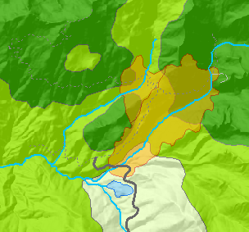

The map includes layers representing the area's infrastructure (roads and trails), vegetation types, and water bodies. The **shadedrelief** raster layer represents the terrain of the area. The FirePerimeter layer represents the area that was burned.

Your task is twofold:

* You will assess the damage to riparian habitat, which is prone to erosion, along the creeks. You are going to map the area within 200 meters of the creek.
* In addition to riparian habitat, the fire also burned a broader wilderness area. You will find the amount of forest that burned on each day.

For each task, you will use different geoprocessing tools.

1. Merge land cover types

You may have noticed that land cover types are split into four separate layers: **lakes**, **scrub**, **grass** and **forest**. Since these layers (or land cover types) do not overlap (i.e. any location within the extent can only have one land cover type designation), you will merge the four layers into a single layer.

From the **Geoprocessing** pull-down menu, select **Merge**.

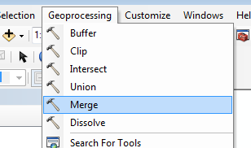

In the Merge window, add all four land cover types by selecting each layer individually from the Input Datasets pull-down selection.

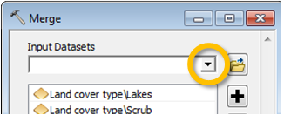

You will name the output feature class **Vegetation** and save it in the **Fire.gdb** geodatabase.

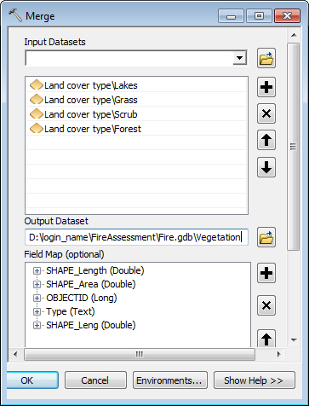

Click **OK** to run the geoprocess.

When complete, ArcMap will add the new Vegetation layer to the table of contents (TOC). If it does not, add the layer manually.

The **Merge** geoprocess combines all vector layers as well as feature attributes. Since all four land cover layers had a “Type” attribute field, their values were merged into a single column.

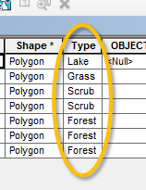

Next, symbolize the newly created Vegetation layer by **Type** (open the layer’s **Properties** window and select the **Symbology** tab.

Select **Unique values** under the **Categories** section.

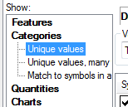

Click on thebutton.

Modify each Value’s color scheme to match the following figure.

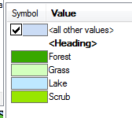

Select the **Display** tab in the properties window and set the layer’s transparency to 20%.

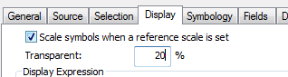

**Close** the layer’s **Properties** window.

If the Vegetation layer is above of the FirePerimeter layer in the TOC, move the latter above the Vegetation layer in the TOC

Finally, **remove** the **Land cover type** group from the map layout by **right-clicking** it and selecting **Remove**.

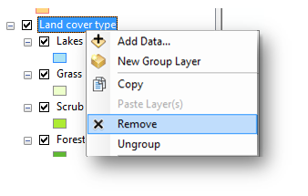

1. Buffer the creeks

The first task in the analysis is to create a 200 meter zone around the creeks. To complete this task, you will use the buffer tool.

From the **Geoprocessing** pull-down menu, select the **Buffer** tool.

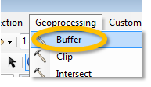

In the Buffer window, select **Creeks** as the input feature, name the output **Creek_buffer** (save it to the **Fire.gdb** geodatabase) and set the buffer unit to **200** **meters**. Note: to change output location, click on the *folder*  link to the right of the *Output Feature Class* field.

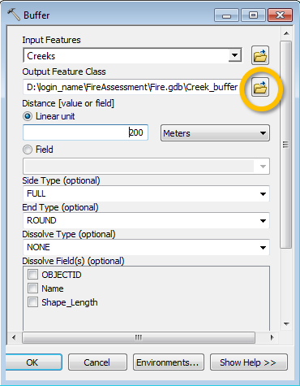

Note that the buffer tool is sensitive to distortions in distance. It is therefore important to always choose a coordinate system that preserves distance when using this tool.

Click **OK** to run the Buffer tool.

The Creeks_Buffer layer displays on the map with a random color.

If Creeks_Buffer appears at the top of the table of contents, drag it below the Creeks layer.

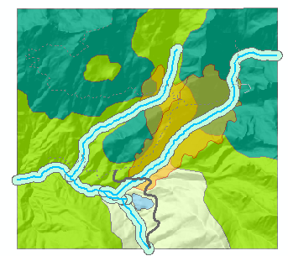

1. Clip the burned area

The Clip tool works like a cookie cutter--features in one layer that fall within the extent of another (polygon) layer are extracted and saved to a new layer whose extent is the same as the clipping layer.

The FirePerimeter layer is a polygon layer representing the boundaries of the burned area; therefore, it will be used as the clipping layer.

From the **Geoprocessing** pull-down menu, select the **Clip** tool.

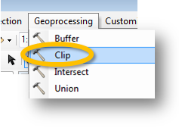

In the Clip tool window, set the **Creek_buffer** layer as the input features, the **FirePerimeter** layer as the clip features and name the output **Clip_buffer** (save the output in the **Fire.gdb** geodatabase).

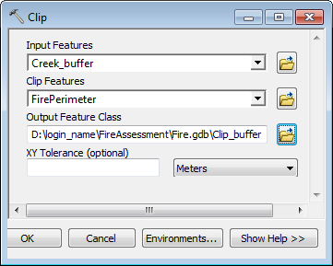

Click **OK** to run the geoprocess.

Turn off the Creek_buffer layer.

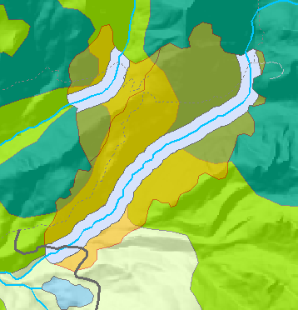

Next, you will find the surface area of the 200 meter buffer inside the burned region by viewing statistics for the **Shape_Area** field in the layer attribute table.

**Shape_Area** is a field automatically added to all vector layers stored inside of a Geodatabase only (i.e. shapefiles do not create nor update Shape_Area fields). This field is automatically populated with surface area values for each record. The surface area units inherit the layer’s map units (e.g. if the layer’s coordinate system is in meters, the area unit will be in m2).

Right-click **Clip_buffer** and choose **Open Attribute Table**.

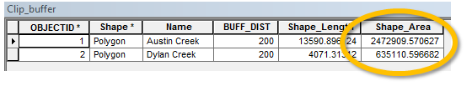

The area of the burned riparian area is the sum of the values in the Shape_Area field.

Right-click the **Shape_Area** field name and choose **Statistics**.

Examine the information in the Statistics area, what is the *sum* of total area?

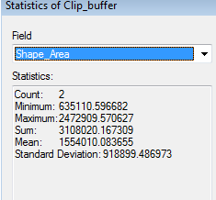

The total area of the burned riparian areas is about **3.1 Million** square meters.

**Close** the Statistics window, then **close** the attribute table.

1. Intersect the FirePerimeter and Vegetation layers

Next, you will combine the FirePerimeter and Vegetation layers while only keeping the areas that overlap. You will use the [intersect](http://help.arcgis.com/en/arcgisdesktop/10.0/help/index.html#//00080000000p000000.htm) tool to accomplish this task.

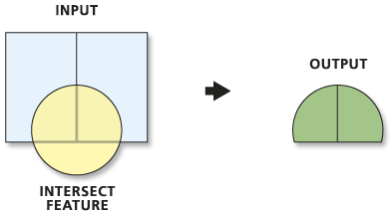

*Src: ESRI online help*

From the **Geoprocessing** pull-down menu, select the **Intersect** tool.

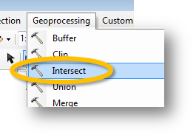

In the **Intersect** tool dialog box choose **FirePerimeter** for **Input Features**,.

The layer is added to the Features list.

Next, add the **Vegetation** layer to the Features list.

Name the output **Fire_veg_inter** (save it in the geodatabase).

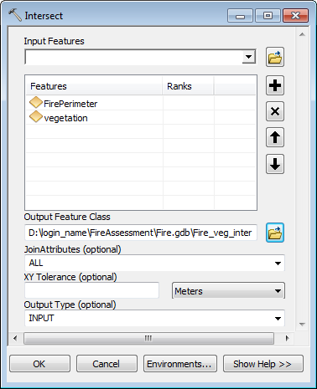

Click **OK** to run the geoprocess.

The FirePerimeter_Intersect layer is added to the map.

Turn **off** the FirePerimeter and Vegetation layers.

**Zoom** to the **extent** of the Fire_veg_inter layer.

1. Dissolving the Fire_veg_inter layer

Next, you will aggregate Fire_veg features based on vegetation type. You will use the [dissolve](http://help.arcgis.com/en/arcgisdesktop/10.0/help/index.html#//00170000005n000000) tool to accomplish this task.

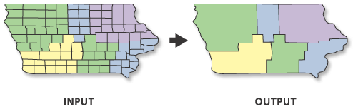

*Src: ESRI online help*

**Right-click** Fire_veg_inter and choose **Open Attribute Table**.

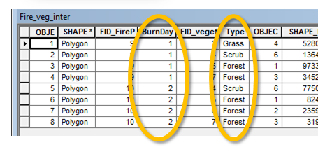

You’ll notice that attribute values from both layers have been added to the newly created feature class. These attributes include **BurnDay** (inherited from the FirePerimeter layer) and **Type** (inherited from the Vegetation layer). We are interested in knowing how much of each vegetation type has burned on both days. We will therefore dissolve features (polygons) of same vegetation type creating a ‘multi-part’ feature class (i.e. individual polygons sharing the same vegetation type will share a unique record in the attribute table).

From the **Geoprocessing** pull-down menu, select the **Dissolve** tool.

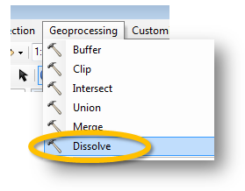

Fill out the fields as shown in the following graphic.

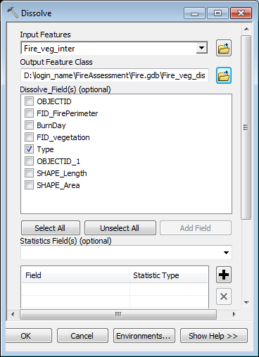

Click **OK** to run the geoprocess.

Open the **Fire_veg_dis** attribute table.

You’ll notice that we’ve gone from 9 records to 3 records (you can display the labels in the map by right-clicking *Fire_veg_dis* and selecting **label feature**).

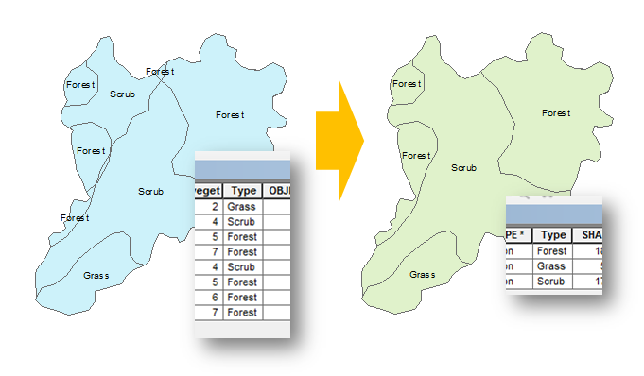

You can extract the areas burned for each vegetation type from the attribute table’s **SHAPE_Area** field.

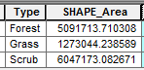

Change the symbology of the Fire_veg_dis layer to match that of the Vegetation layer. Don’t forget to set its transparency to 20%.

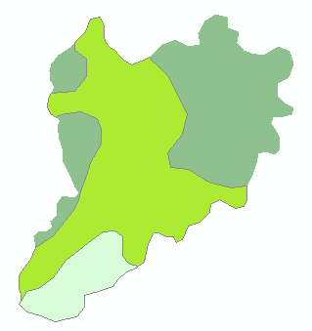

1. Clipping a raster to a polygon layer

In this last step, you will create a final map layout that will only show the burned area extent. You have already clipped out most layers to this extent except for the hillshade raster. To clip a raster to a polygon you must use the **Extract by Mask** tool available in **Spatial Analyst**. You will therefore need to enable the **Spatial Analyst extension**.

From the **Customize** pull-down menu, select **Extensions**.

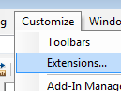

In the Extensions window, make sure that **Spatial Analyst** is checked.

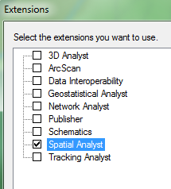

Click **Close**.

Open **ArcToolbox** by clicking on the **ArcToolbox** icon in the Standard toolbar.

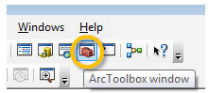

In the ArcToolbox window, expand **Spatial Analyst Tools** then expand **Extractions**.

Double-click on **Extract by Mask**.

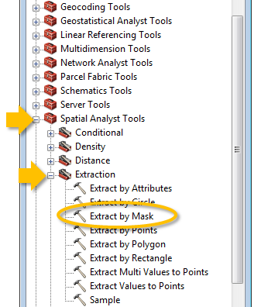

In the **Extract by Mask** window, set the *input raster* to **shaderelief** and the *feature mask* to **FirePerimeter**. Name the output **Clip_relief** and make sure to save it in the working geodatabase.

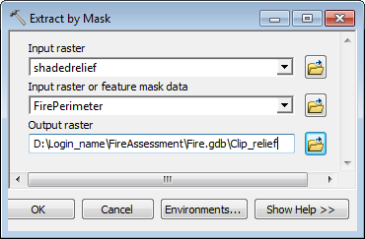

Click **OK** to run the geoprocess.

You should now see a clipped version of the *shaderelief* layer.

Turn off all layers in the TOC except for the **Clip_relief**, the **Fire_veg_dis** and the **Clip_buffer** layers.

You may need to rearrange the order of these layers in the TOC to have them display properly in the layout view.

You may also want to change the color and transparency of the Clip_**buffer** layer.

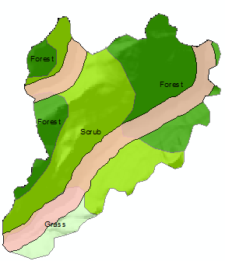

**Save** your work and exit ArcMap.

© Manuel Gimond, 8/20/2013