# Downloading Landsat Data

|  |
| --- |
| If you need to figure out which Landsat scene(s) will be needed for your study area, download the Row/Path [**wrs2.zip**](wrs2.zip) file. Instructions are presented in Step1. |

The following instructions assume that you are using a **Firefox** browser. Instructions may differ on another browser.

Contents

1

Step 1: Identifying Landsat scenes needed for your study area 1

Step 2: Downloading Landsat scenes from Glovis 1

1. Identifying Landsat scenes needed for your study area

Before downloading Landsat imagery, you will need to identify which Landsat scene(s) you will need to cover your study area.

In a Map Document of your study area, add the **wrs2.shp** shapefile (which you extracted from the wrs2.zip file. Use this layer to identify the **Row** and **Path** IDs for the scenes that overlap your region (these are referenced as **ROW** and **PATH** attribute names). Note that Landsat scenes overlap.

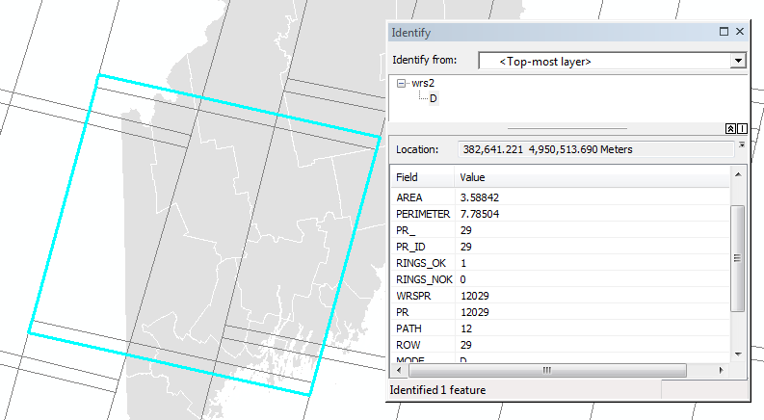

Once you have identified the Landsat scene(s) needed for your study area, move on the Step 2.

1. Downloading Landsat scenes from Glovis

In a web browser, navigate to <http://glovis.usgs.gov/>.

The website runs on Java so you might be prompted with a warning asking if you wish to continue running the java code. Depending on the web browser used, you might see the following message:

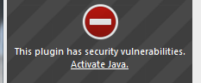

Click **Activate Java**, as needed.

You might be presented with another warning window. Look for an option to allow the Java plugin.

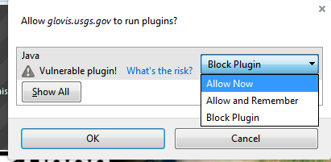

The above two steps may have to be repeated a second time for the main web browser window pane.

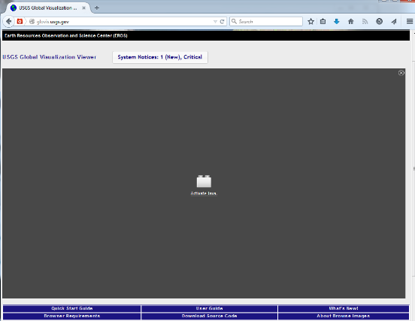

After allowing the plugins to run, you might need to reload the entire page.

Next, type the **Path** and **Row** ID in the query window. Then click **Go**.

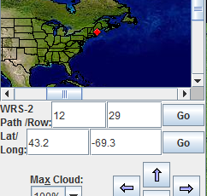

Next, you will probably want a satellite scene having little cloud cover.

Select a Max Cloud cover of 10%.

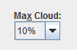

You can select a specific month/year of image acquisition or you can scroll from scene to scene using the **Prev Scene** or **Next Scene** buttons.



When you find a scene you would like to download click the **Add** button



Be careful not to add too many scenes at once since the files can be big (some may be as big as 1 GB).

Scenes that can be downloaded immediately will show a download icon to the right of the scene name.



Scenes that *cannot* be downloaded immediately will show no download icons in which case you will be e-mailed a download link within a few hours to a few days (this is explained in subsequent steps).

After selecting the scene or scenes you wish to download, click **Send to Cart**.

.

The website will want to open a **pop-up** window that may be **blocked** by the web browser.



Change the options to allow the pop-up from glovis.

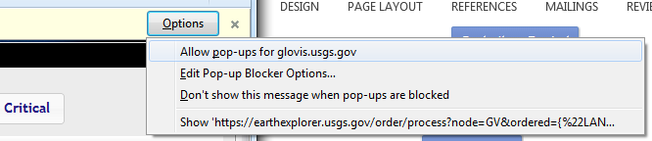

You will be prompted for a username and password. If you have not created one for the USGS site, click on the **register** link found near the upper right-hand corner.

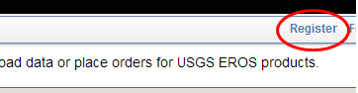

When registering, make sure that you provide a valid e-mail address (use your Colby e-mail); this will be used by the server to e-mail links to files not immediately downloadable. Also, avoid using a password that you use for sensitive websites like Google Mail or bank accounts.

Once logged in, you will see the list of satellite scenes displayed in a table. Full scenes that are ready to download will have the checkbox in the *Order* column ghosted out.

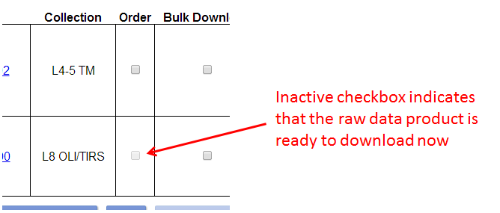

For the scenes that are ready for download, click on the download link Screen Clipping and select **Level 1 GeoTIFF Data Product**.



Note: If the Level 1 product is ghosted out, then the scene is no ready for immediate download and will therefor need to be ordered.

For all satellite scenes whose *Order* **checkbox** is active, check it off then click on **Apply**.

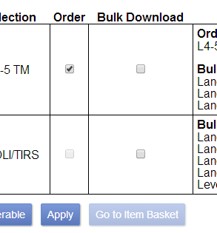

Next click on **Go to Item Basket** Screen Clipping.

Next, click on Proceed To Checkout .

Next, click on **Submit Order** .

The order may take hours or several days to process. When complete, you will receive an e-mail providing you with a link to the download site.

 Manuel Gimond, last modified on 1/30/2015