**Downloading and mapping Census data**

|  |
| --- |
| * *Note that there are no files to download for this exercise. You will be provided instructions on how to download census data from the Census Bureau’s website in later steps.* * *Also note that a professional subscription to the socialexplorer.com website may be needed to download the data. If you are on the UT network, you will have full access to socialexplorer.com.* |

In this exercise, you will learn how to query, download and map census data. You will use 2010 American Community Survey (ACS) data which is a sample survey collected continuously between decennial censuses.

This tutorial assumes that you have some familiarity with Excel. If you don’t—that’s okay! You will be the end.

Contents

Step 1: Open Social Explorer website 1

Step 2: Selecting the spatial extent 2

Step 3: Selecting and downloading census attributes 3

Step 4: Modifying the census data table in Excel 4

Step 5: Downloading Census shapefile 6

Step 6: Loading the census table and shapefile in ArcMap 6

Step 7: Joining non-spatial census table to a spatial layer 8

Step 8: Symbolizing the shapefiles by census data 8

1. Open Social Explorer website

In a browser, navigate to the website <http://www.socialexplorer.com/>.

Note that certain services are only accessible via a subscription. UT Austin has a “professional access” subscription which offers unfettered access to census data.

Click on the **Tables**  tab.

Next, expand the **American Community Surveys (5-Year Estimates)**.

Click on **Begin Report** link next to **American Community Survey (ACS) 2013--2017 (5-Year Estimates)**.

This places you in the *data query* environment.

1. Selecting the spatial extent

You will download educational attainment data for each **county** in the **US** in a tabulated form. In subsequent steps, you will join this table to a shapefile of the US counties. Note that you can download data aggregated down to the census block-group level with the ACS five-year data sets.

Under ***select a geographic type*** select **County**.

Do not change the ***select a state*** option. However, if you wanted to restrict the analysis to a single state, you would define the state in this step.

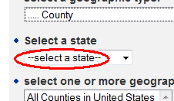

Under ***select one or more geographic areas***, select **All Counties** then click on the ***Add*** link just beneath the selection window.

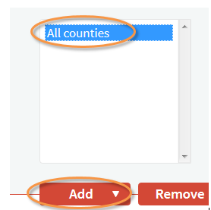

Click on **Proceed to Tables** to proceed to the attribute selection step.

1. Selecting and downloading census attributes

The Social Explorer website provides you with both the original census data tables and a ‘filtered’ version of these data tables. The census ACS dataset is based on sample surveys (not total enumeration) and is therefore provides only *estimated* total counts.

The Census bureau provides an estimate of the error along with its dataset. The filtered version of the tables excludes the margin of error (MoE) data. It’s always good practice to work with both the *estimate* and the *MoE* data, so in keeping with good practice you will choose to select the original census data table (note that this tutorial will *not* make use of the MoE).

Search for table **B15002** (Sex by educational attainment for population 25 years and over) then add it to the **Table Selections** window.

Click on **Show Result** to proceed to the next page.

On the next page, select the **Data Download** tab.

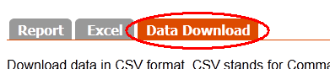

Click on the **County data (CSV)** link to download the data.

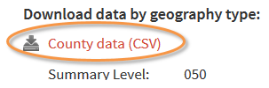

Note the file *name* you are downloading! You will need this information when locating the file in the Downloads Folder on your PC.

You will also want to download the **data dictionary** which provides descriptive information on the table’s attribute values.

Click on the **Data dictionary** link near the bottom of the page.

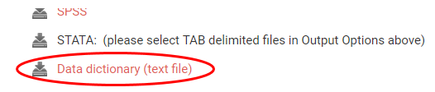

If prompted, select the **Open with Notepad** option.

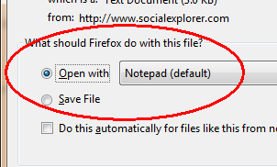

The column (attribute) information for your dataset is defined in this file.

Make sure to save the data dictionary file in your project folder for future reference.

1. Modifying the census data table in Excel

The file you downloaded from the Social Explorer website is in a comma delimited (CSV) file format. The file *name* is randomly generated so the filename shown in this tutorial will not necessarily match that of the file you downloaded.

A CSV file can be opened in either Excel or ArcMap. If data manipulation is needed before joining to a GIS layer, it is best to accomplish this in Excel.

Locate the CSV file you downloaded and open it with Excel.

You’ll note that the file has many columns (attributes). To decipher the column names, you will need to refer to the data dictionary file you downloaded in the previous step.

The data columns are broken down into three groups:

* Ancillary geographic data information (IDs and locations for the most part)
* Count data for each educational attainment/gender combinations
* Error estimates for each educational attainment/gender combinations

For this tutorial, we will focus solely on the count data for educational attainment. The error data will not be used.

Column **ACS_10_5yr_B15002001** (or simply B15002001 in the data dictionary file) represents total population 25 years or older for each county. This value will be used to normalize population having attained a bachelor’s degree or greater.

In Excel, for each county, you will sum all members of the population having a bachelor’s degree or greater for both the male and female population, then divide this sum by the total population to generate the fraction of the population that has attained at least a bachelor’s degree.

Create a new column in your spreadsheet called Frac_Bac (make sure there is no space in the variable name).

This column will be populated with the fraction of individuals having attained a bachelor’s degree or greater.

Write an Excel formula that calculates the share of the population in each county that has at least a Bachelor’s degree or higher. (Hint: Once you write the equation for a single county, you can “Fill down” to populate all other rows. The easiest way to do this is to double click on the square at the bottom right of the active cell cursor.



This should populate all cells in the Frac_bac column with unique values for each county.

If you are struggling with this step, you might want to read through this [Microsoft Excel help page](http://office.microsoft.com/en-us/excel-help/fill-data-automatically-in-worksheet-cells-HA102749020.aspx?CTT=1).

Save your Excel spreadsheet to a new Excel file in your data folder. Name the new Excel file **education_acs.xlsx** or something similarly descriptive. If you edit an Excel file to calculate new columns, it is usually a good idea to save it as an .xlsx file so that the formula is stored.

Also export the file as a .csv. Call it education_acs.csv. You will import this file into ArcMap.

In the following step, you will download the shape file that delineates the US county boundaries.

1. Downloading Census shapefile

In a web browser, navigate to the Census Bureau’s Tiger shapefiles website: <http://www.census.gov/cgi-bin/geo/shapefiles2010/main>.

From the ***Select a layer type*** pull-down menu, select **Counties (and equivalent)**.

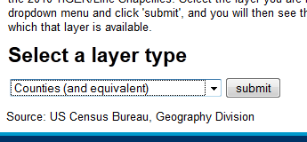

Click **submit**.

On the next web page, select ***All states in one national file*** in the *County and Equivalent (2010)* field, then click **Download**.

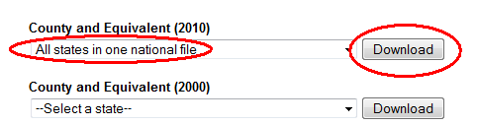

**Unzip** and save the contents of the file to your data folder (the file is just over 70 MB in size and may therefore take up to a minute or two to download).

1. Loading the census table and shapefile in ArcMap

If you are new to ArcMap, it is strongly suggested that you work through the [Exploring a GIS map tutorial](http://gisserver0.colby.edu/10/Exploring_a_GIS_map.htm).

Open the ArcMap application.

Open a new (blank) ArcMap document.

Load the **tl_2010_us_county10** shapefile into your new map document.

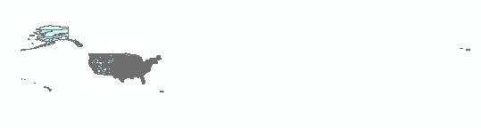

You’ll note that US territories (non-states) are also represented in the shapefile.

Zoom in on the 50 states.

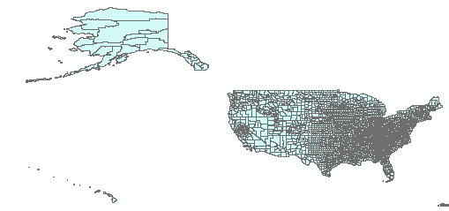

Add your .csv file to the ArcMap document and view the table.

In the TOC, **right-click** on the spreadsheet and select **Open**.

Scroll across the table, you should see the Frac_Bac column you created in the previous steps.

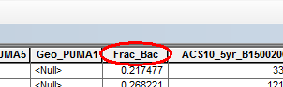

In the next section, you will join this table to the counties shapefile.

1. Joining non-spatial census table to a spatial layer

The census table will be joined to the shapefile using a common attribute.

Identify the common attribute across the shapefile and the .csv.

Make any adjustments needed so that the common fields can be used in a table join.

Next, you will perform the *table-to-shapefile* join.

Join the .csv data to the shapefile using any method you deem appropriate.

1. Symbolizing the shapefiles by census data

In this last step, you will symbolize the counties shapefile using the Frac_bac attribute you computed in the Excel file.

Right-click on the shapefile layer and open its **Properties** window.

Select the **Symbology** tab, then **Quantities**. Select **Frac_bac** as the *Value* to symbolize.

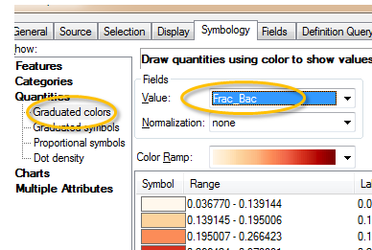

Click **OK** to see the results in the data view window.

This map is pretty unsightly! Can you make its area and shape more closely represent the way it looks on the surface of the earth?

This ends this exercise.

 Manuel Gimond, last modified on 7/11/2018