**Exploring a GIS map**

|  |
| --- |
| 1. Create a folder called **Explore_GIS_Map** somewhere under your personal directory (e.g. C:\Users\jdoe\Documents\Tutorials\ Explore_GIS_Map\). 2. [Download the data](Exploring_a_GIS_map_files/Map.zip) for this exercise then [extract the contents](https://mgimond.github.io/ArcGIS_tutorials/Opening_zip_files.htm) of **map.zip** into your newly created **Explore_GIS_Map** directory. |

In this exercise, you will explore an ArcMap document. You will be introduced to the following tools and concepts:

* adding data,
* symbolizing features,
* navigation tools,
* data view vs. layout view,
* layer properties,
* identify tool,
* measurement tool.

Contents

Step 1: Opening an ArcMap document 1

Step 2: Creating a folder connection 1

Step 3: Adding data 1

Step 4: Changing a layer’s symbology 1

Step 5: Introduction to ArcCatalog 1

Step 6: More on symbolizing features 1

Step 7: Getting attribute information from map features 1

Step 8: Measuring surface areas and distances 1

Step 9: Data View vs. Layout View 1

1. Opening an ArcMap document

Click on the **Windows** icon  in the lower left-hand corner of your desktop, expand the **ArcGIS** folder and open **ArcMap 10.7** application.



If you are presented with a **Getting Started** window, dismiss it.

From the **File** pull down menu, click **Open**.

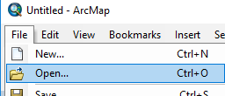

Navigate to your **Explore_GIS_map** folder and open **Map.mxd**.

The file *Map.mxd* is a map document that contains information about the different data layers drawn as well as the different symbology schemes used to represent the data in the map.

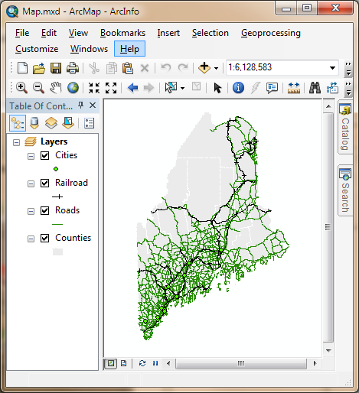

Table of contents

Map Display

Main menu toolbar

Toolbars

The different map elements (aka **layers**) used to build the map are listed in the **Table of contents** (**TOC**). The TOC, like many other ArcMap elements, can be undocked from the window by clicking on the bluish-gray horizontal bar and dragging it away from the window. It can be re-docked by dragging it back inside the ArcMap window; in doing so, you will notice four blue arrows . These arrows point at locations where the TOC element can be docked (just drag-and-drop the element on top of one of the arrows).

Toolbars can also be docked/undocked. To undock a toolbar, click on the toolbar’s vertical gray bar to the left of the toolbar and drag the toolbar to its desired location.

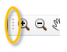

One toolbar that you should become intimately familiar with is the **Tools toolbar**. This has most of the functions you will be using when exploring a map in a *Map Display* environment.



1. Creating a folder connection

GIS data come in many different file formats and data models (i.e. raster or vector), however they are all added to an ArcMap document in a similar way.

In the ArcMap document, click on the **Add Data**  button.

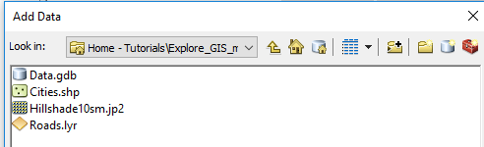

The **Add Data** file navigation window is not the typical Windows file browser you may be familiar with. The **Add Data** window will *only* display data files that ArcMap recognizes as a *valid* GIS data files or data table.

If this is the first time that ArcMap is opened under your login account, you will also note that drive letters (such as C: or D:) are not directly accessible from the **Look in** pull-down menu.

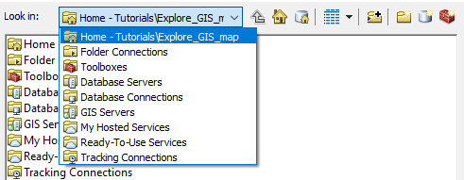

ArcMap requires that you make “connections” to folders, network, databases or internet map services before accessing their content. By default, ArcMap will connect to the folder that houses the current MXD document *(~/Tutorials/Explore_GIS_map/* in our working example). But if you wanted to access data files under the *~/Tutorials/* folder you would need to create a folder connection as follows:

Click on the **Connect To Folder** button .

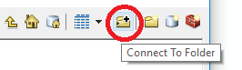

In the *Connect to Folder* window, navigate to your data folder, for example **This PC >**> **c:\Users\jdoe\Documents\Tutorials** (where you need to replace *jdoe* with your login name).

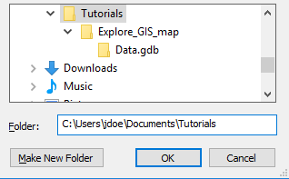

Click **OK**.

In the **Add Data** window, expand the **Look In** pull-down menu. You should now see your project directory listed as a connection (you may need to expand the Folder Connections to see your project folder).

Since all the data used in this tutorial reside in the *Explore_GIS_map/* folder, the above folder connection step is not needed since ArcMap will always make the MXD’s home directory available as a folder connection for that session. However, going forward, this connection will prove useful when adding more tutorial exercises to the ./*Tutorials* folder since this folder connection will persist in future sessions (as long as you are logging into the same PC).

1. Adding data

Next, we’ll add a hillshade raster of Maine’s topographic features to the map.

In the **Add Data** window, navigate to your project directory and select **Hillshade10sm.jp2**.

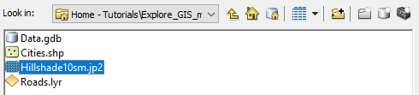

Click **Add** to add the data to ArcMap.

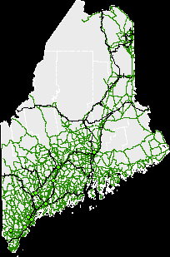

You’ll note that the hillshade layer is placed at the *bottom* of the TOC layers list.

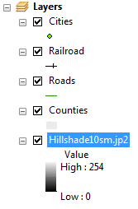

At this point, the Map Display window does not display anything new (except for a black background). ArcMap draws *each* layer following the **order** listed in the TOC. The bottom layer is drawn first (Hillshade10sm), then the second layer from the bottom of the TOC (Counties) is drawn, then the next layer above that is drawn, etc…

There are many different strategies that can be adopted to enable simultaneous display of overlapping layers. We will explore one such method next.

1. Changing a layer’s symbology

You will modify the way the County features are displayed in the map. Instead of having the county polygons filled in grey, you will make them invisible with just the outline boundaries showing. This will help us see the underlying hillshade.

**Right-click** on the **Counties** layer in the TOC and select **Properties** (alternatively, you can **double-click** on the layer to access the Layer Properties window).

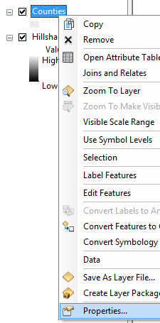

In the **Layer Properties** window, select the **Symbology** tab.



Click on the gray symbol.

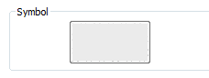

The above action should open the **Symbol Selector** window.

In the **Symbol Selector** window, **click** on the **Fill Color** symbol and select **No Color**.

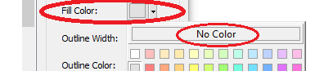

Next, click the **Edit Symbol** button.



This will open the **Symbol Property Editor** window.

In the **Symbol Property Editor** window click on the **Outline** button.



This will open the **Symbol Selector** window.

In the **Symbol Selector** windowlook for and select the **Boundary County** symbol from the list of symbols (you may have to scroll down a line or two to find it).

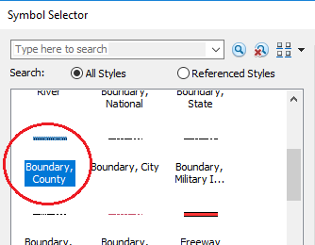

Click **OK** to close the **Symbol Selector** window.

In the **Symbol Property** **Editor** window, change the **Outline Width** to **2**.

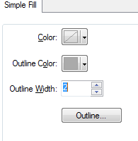

Click **OK** to close the **Symbol Property Editor** window.

Click **OK** again to close the **Symbol Selector** window.

This should bring you back to the **Layer Properties** window.

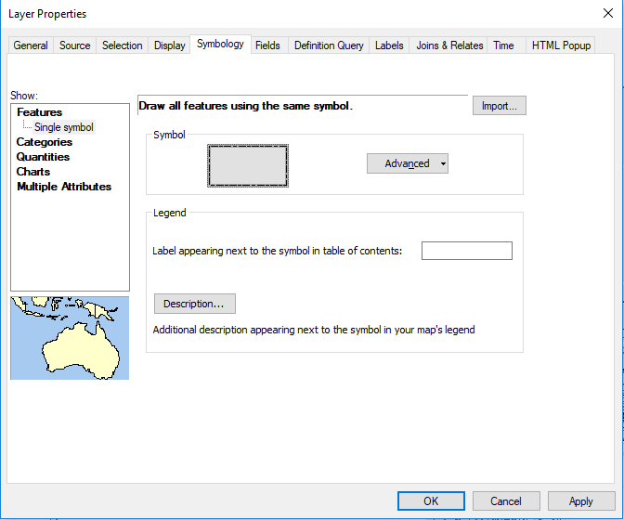

Click **OK** to close **the Layer Properties** window.

At this point the symbology for the Counties layer will have changed. You should now see the underlying hillshade map.

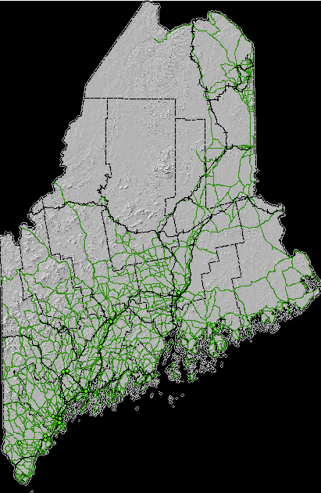

The black background is too distracting. We will modify the *Hillshade* symbology.

**Right-click** on the **Hillshade10sm.jp2** layer in the **TOC** and select **Properties**. Remember that alternatively, you can **double-click** on the layer to access the Layer Properties window.

In the **Layer Properties** window, select the **Symbology** tab.



Check the box next to **Display Background** **Value** and make sure that the value is set to 0 and that the **as** symbol is set to **No Color** (this should be the default).

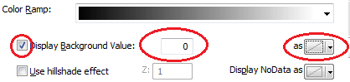

Click **OK** to close the **Layer Properties** window.

The above step instructs ArcMap not to display pixels in the hillshade layer that have a value of 0 (these are the pixels that generated a black background).

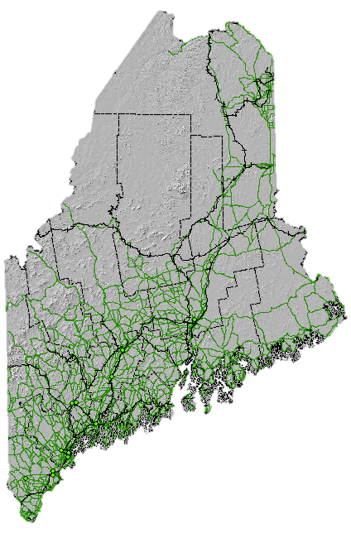

1. Introduction to ArcCatalog

You can manage your project folder from within ArcMap using ArcCatalog. ArcCatalog is one of many applications that make up the ArcGIS software suite. ArcCatalog can also be accessed as a stand-alone application from the Windows’ **Start** menu.

**Click** on the **Catalog** tab that is docked to the right of the Map Display.

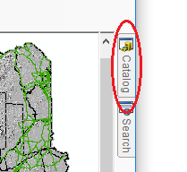

The catalog window will expand. This window can be docked/undocked just like the TOC. But this can only be done if it is “pinned”. You pin a window by clicking on the **pin** icon  in the upper right-hand side of the catalog window. If the window is pinned, the pin icon will be vertical . If the window is unpinned, it will be horizontal  meaning that if you move the cursor away from the window (or press the ESC key), that window will snap back to a tab on the left-hand or right-hand side of the ArcMap display.

*Note that the TOC is, by default, pinned, however, you can unpin the TOC to have it snap back to a tab to maximize the map display window (though this is not recommended in this course).*

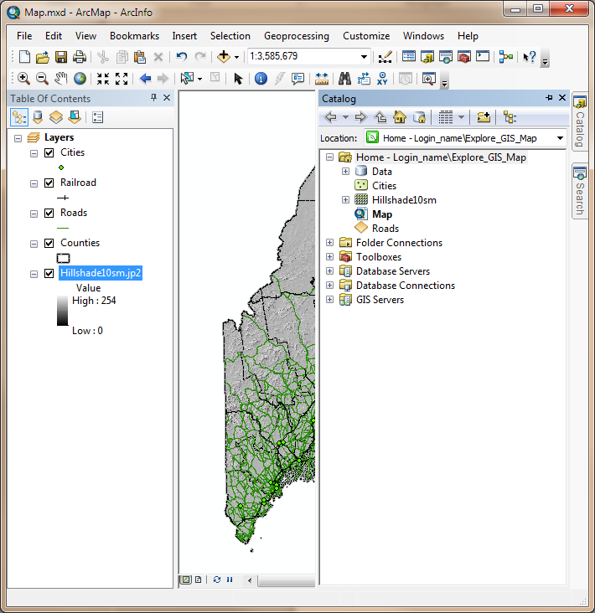

In the **Catalog** window, navigate to your map project folder and expand the **Data** geodatabase .

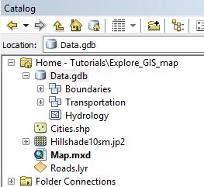

A geodatabase is a data storage system unique to ArcGIS that provides another way to store GIS data.

Expand the *Boundaries* feature data set, , and click and drag **Parks** into the TOC.

Dragging and dropping is yet another way to add data to your map document (recall that the other method of adding data is to click on the **Add Data** button).

Follow the same aforementioned step to add **Places** and **Waterville** features.

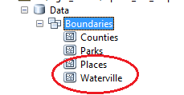

Rearrange the layers in the TOC such that they match the following order from bottom to top: Hillshade10sm, Parks, Places, Waterville, Counties, Roads, Railroad, Cities.

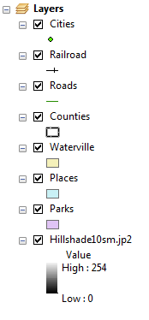

1. More on symbolizing features

Next, you will change the symbology for the Parks layer.

**Right-click** the **Parks** layer in the TOC and select **Properties**.

Select the **Symbology** tab.

Click on the **Symbol** color (your default color may be different from the one shown in this tutorial).

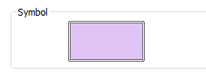

Select the **Green** symbol in the **Symbol Selector** window.

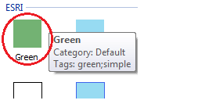

Click on the **Outline Color** symbol  and select **No Color**.

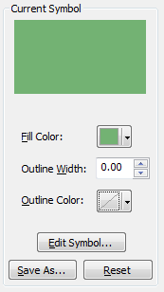

Click **OK** to close the **Symbol** Selector window.

Next, we’ll set the Parks layer to a 50% transparency. This will allow the background hillshade to show through the Parks polygons.

In the **Layer Properties** window, click on the **Display** tab.



In the *Transparent* value box, type **50**.



Click **OK** to close the **Layer Properties** window.

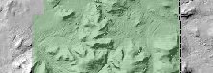

Now it’s your turn to change the symbologies for the **Places** and **Waterville** layers using the techniques outlined in this step. You will set the **Waterville** symbol color to **Yellow** and the **Places** symbol color to **Rose** with the latter displaying **no outline color**.

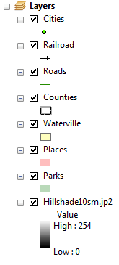

So far, you have symbolized all features within a layer the same way (e.g. all **Places** features are symbolized using the same color). There may be instances when you might want certain layers to be symbolized differently based on an attribute value.

**Right-click** the **Cities** point layer and select **Open Attribute Table**.

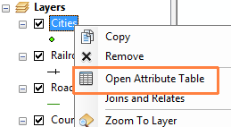

The Attribute Table lists all of the layer’s attributes and associated values.

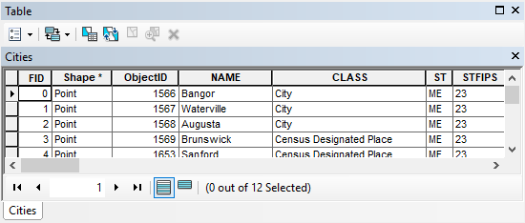

In the **Table** window, scroll to the right until you find the **POP2000** field.

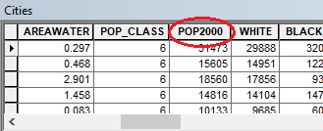

This column lists the population count for the year 2000 for each point feature in the Cities layer. Next, you will learn to symbolize the points based on the city’s population size.

**Close** the **Table** window.

**Right-click** the **Cities** layer and access its **Properties** window.

The 2000 population count field is a numeric (quantity) field. We will therefore use the **Quantities** scheme in the Symbology tab.

In the **Layer Properties** window, click the **Symbology** tab (if not already active) and select **Quantities>> Graduated symbols** from the list of schemes in the **Show** box.

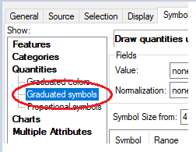

In the **Value** field, select the **POP2000** attribute.

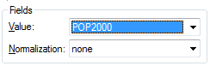

This will assign different sized point symbols based on the population value in the POP2000 field.

Click the **Template** symbol and select an orangecolor (in this example, electron gold is chosen 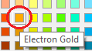



Click **OK** to **Close** the Symbol Selector window.

This color will be assigned to all points.

Click the **Display** tab and set the **transparency** to **40 %**.



Click **OK** to close the **Layer Properties** window.

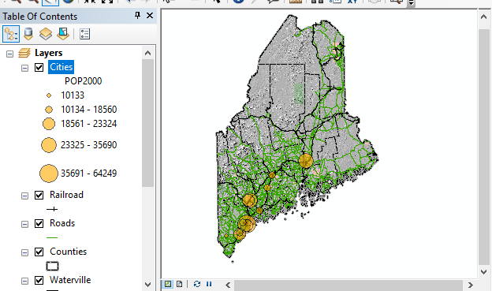

Symbolizing features can be time consuming, it can therefore be desirable at times to save the symbology information to a layer file (.lyr) for use in another map document. Note that the symbology you define in an ArcMap session is only stored in the Map document (the .mxd file) and not with the layer’s original data source.

You will use an existing layer file (Roads.lyr) to symbolize the Roads layer.

In the TOC, **right-click** on the **Roads** layer and open its **Properties** window.

In the Layer Properties’ **Symbology** tab, click on **Import**.

In the Import Symbology window, select the **Open file** icon .

In the file manager window, select **Roads.lyr** located inside your map project folder.

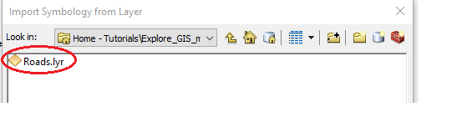

Click on the **Add** button.

Click **OK** to close the **Import Symbology** window.

A window will pop up asking for the Roads’ attribute that will be used to identify which road classes will be symbolized with the pre-defined symbology scheme that is stored in the layer file (Roads.lyr).

Make sure that **CLASS** is selected from the pull-down menu.

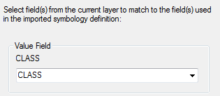

Click **OK** to close the **Import Symbology Matching Dialog**.

Click **OK** to close the **Layer Properties** window.

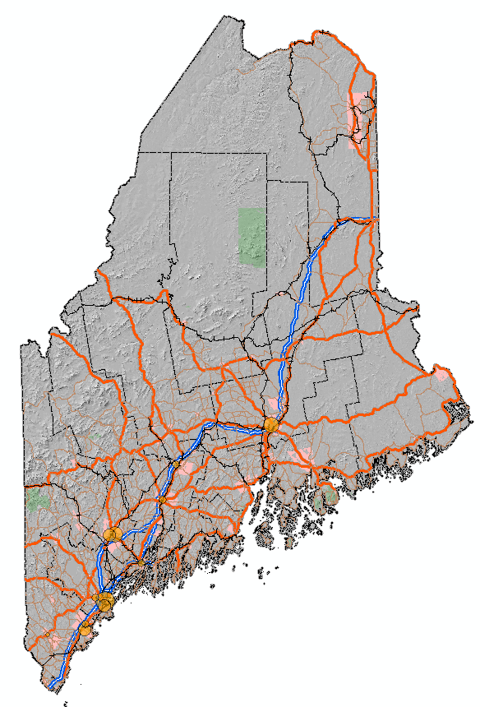

1. Getting attribute information from map features

In the **Tools** toolbar, click on the **Identify** tool .

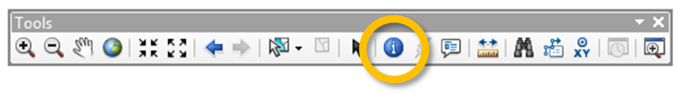

The cursor changes to the  icon.

**Click** on the **Baxter State Park** green polygon which is the northern most park feature on the map.

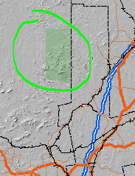

The above step should open an Identify window. By default, the Identify window will display feature information for the top most layer in the TOC. However, you can have ArcMap display feature information for *one* or *all* layers in the map document.

In the **Identify** window, select **Visible layers** from the **Identify from** pull down menu.

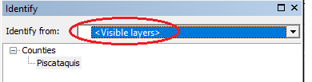

**Click** on the **Baxter State Park** polygon feature again.

The Identify window now returns information for the three visible layers that have features at the location just selected with the identify pointer. For each layer, information about the selected feature (or pixel) appears just below the layer name.

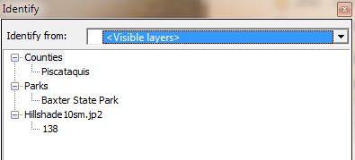

**Click** on **Baxter State Park** (under the Parks layer) in the **Identify** window.

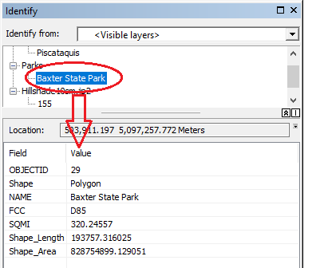

All attribute information associated with the Parks feature is displayed in the Identify window’s bottom pane. The information displayed is pulled from the layer’s attribute table.

1. Selecting features

You can select one or multiple features in a data layer by using the **Selection** tool. You can also export selected features to a new GIS data file for future analysis.

In the **TOC**, select the **List By Selection** icon located near the top of the TOC’s window.

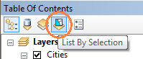

Notice how the TOC’s content changes. This is where you tell ArcMap which features are to be selected in the map display. This is a very useful option when you have many layers overlapping one another but you only want to select features for a single layer.

For *all* but the **Parks** layer, make the layers (under the Selectable section) non-selectable by clicking on the left-most icon next to the layer’s name.

This will place the un-selectable layers under the Not Selectable section of the TOC. Make sure that the *Parks* layer is the *only* selectable layer.

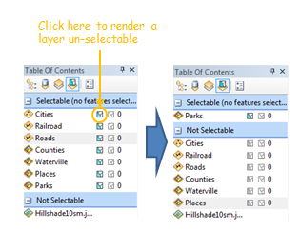

In the **Map display** window, **zoom in** (using the zoom tool ) on the down-east section of Maine (around the cluster of islands in Hancock County inside the orange box in the following figure).

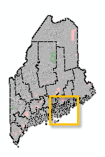

Note that if you want to pan around the map, you can use the **pan** tool or **click and hold** the **middle mouse button** then move around your map.

Expand the **Select Features** icon in the **Tools** toolbar and select **Select by Lasso**.

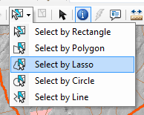

The lasso option allows you to select areas on the map using a freehand.

With the selection tool selected, **delineate** an area that encompasses the cluster of islands as shown in the following figure.

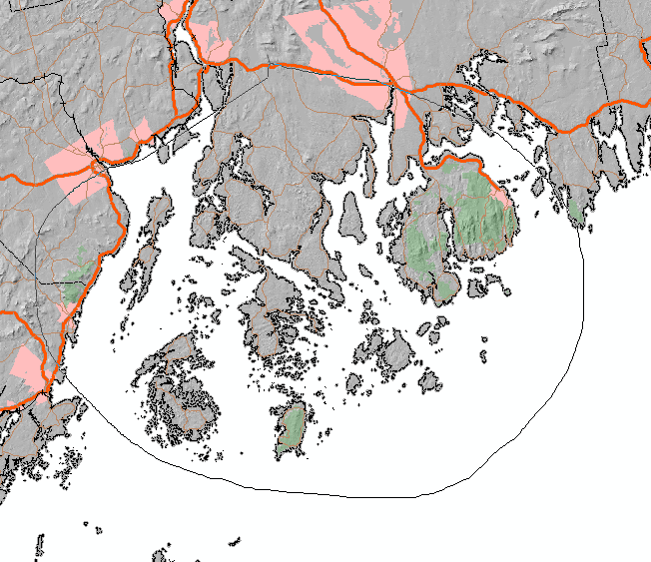

When you are done drawing the “lasso”, you’ll notice polygons highlighted in cyan. These are the selected park features (remember that you instructed ArcMap to only select features belonging to the Parks layer and no other layers in the map document).

*Note that the number of features selected on your map may be different from the one shown in the graphic below if your selection lasso encompassed a slightly different area.*

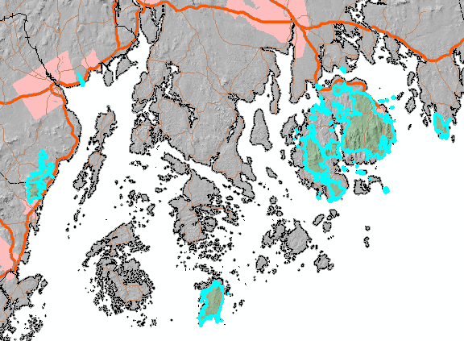

In your TOC, click on the **List By Drawing Order** button (this brings you back to the original TOC environment).

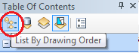

**Right-click** on the **Parks** layer in the TOC and select **Open Attribute Table**.

The records associated with the selected features should also be selected in the table (they are highlighted in cyan).

At the bottom of the table, click on the **Show selected records** button.



Now, only the selected features are displayed (note that your number of selected features may differ).

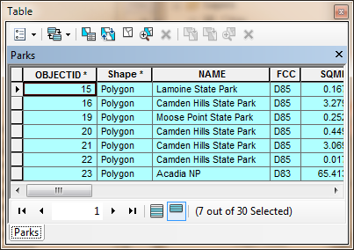

**Close** the attribute table.

Finally, unselect all features by clicking on **the Clear Selected Features** located on the **Tools** toolbar.



Note that if there are no features selected in your map then the *Clear Select Features* icon will be ghosted out .

1. Measuring surface areas and distances

You can measure **distances** between features as well as **surface** **areas** of polygon features.

First, let’s declutter the map, so **uncheck** the **Hillshade**, **Places** and **Waterville** layers in the TOC.

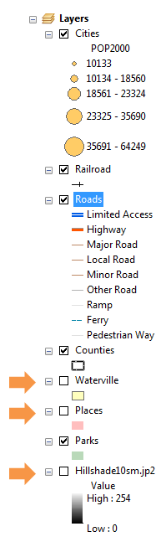

**Zoom** out to the entire map extent by clicking on the **Full Extent** button  in the **Tools** toolbar.

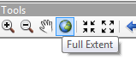

In the **Tools** toolbar, click on the **Measure** tool .



A **Measure** window will pop-up.

In the **Measure** window click on the **Measure A Feature** icon, .

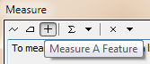

In the same **Measure** window, select the first pull down arrow to the right of the *Measure A Feature* button, then select **Area >> Acres**.

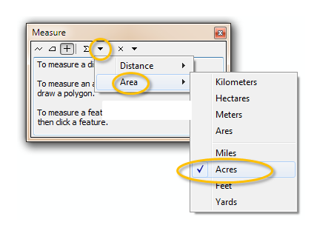

At this point, all areal measurements will be displayed in units of Acres.

**Click** anywhere within the top county (Aroostook) boundaries.

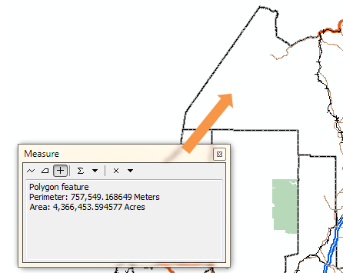

The measure tool should display the polygon’s **area** and **perimeter** measurements (4,366,453 acres and 757,549 meters respectively).

You will now use the distance measurement tool to measure distances between cities.

Uncheck the **Roads** and **Railroad** layers from the TOC to declutter the map.

In the **Measure** window, click on the **Measure Line** button.

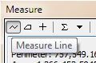

**Click** on one of the **cities** point features (e.g. Bangor). You will know when your cursor is hovering over a Cities point feature when the **Cities: Point** tip pops up.

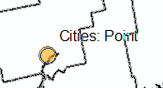

**Double-click** on a second city point (e.g. Waterville).

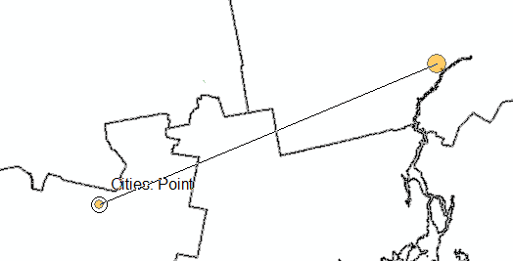

Double-clicking stops the measurement tool. If you click just once, the tool will expect you to click on a third location to add a second distance segment to the first.

At this point, the linear distance between both cities will display in the Measure window.

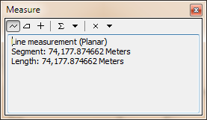

The software defaults to the coordinate system’s units for distance measurements. You can change the linear units in the Measure window like you previously did for the area units.

Click the **ESC** key to stop measurements.

Click on the **Select Elements** button in the Tools toolbar to exit measurement mode and revert back to general mode.



Zoom back to the map’s full extent by clicking on the **Full Extent** button of the **Tools** toolbar.



Turn the **Roads** and **Railroad** layers back on.

1. Data View vs. Layout View

So far, you have been working in a **Data View** mode. When you want to prepare you map for publishing (e.g. print or PDF export), you need to switch your Map display from Data View to **Layout View** mode.

In the bottom left corner of the **Map** display window, click on the **Layout View** button.

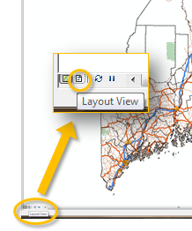

Your map is now enclosed in a new border. This border defines the page’s edge. You can modify the page size in the **Page and Print Setup** option under the **File** pull-down menu. For this exercise, we will stick with the default page dimensions of 8.5” by 11”.

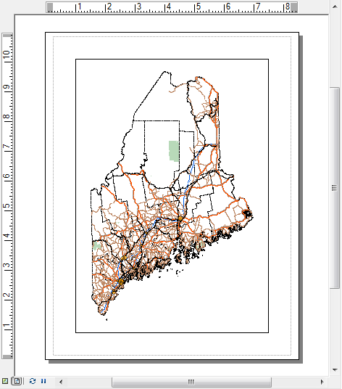

You may also have noticed the addition of a new toolbar in your working environment. This is the **Layout** toolbar. It should not be confused with the **Tools** toolbar which you have been using so far since the tools in the Layout toolbar have completely different functions. The Layout toolbar tools only operate on the page layout and not the map’s content. For example, the **Zoom In** icon  in the Layout toolbar will zoom in on the page, but the features within the map still maintain their original scale/extent relative to the page layout.



In layout view, you can add elements such as scale bars and legend boxes to the map.

From the **Main** **menu** toolbar, click on **Insert** and select **Legend**.

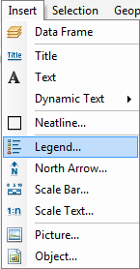

A **Legend Wizard** window will pop up.

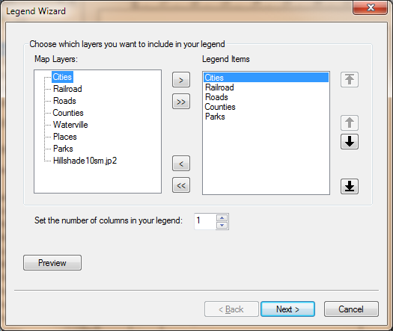

You will keep the default legend settings.

Click on the **Next** button **four** times until you reach the end of the Wizard window, then click **Finish** to exit the Legend Wizard and add the legend element to your map.

Once the legend element is added to your map, you can move it somewhere to the lower right-hand side of the map. If needed, you can resize the window so that it doesn’t overlap the map.

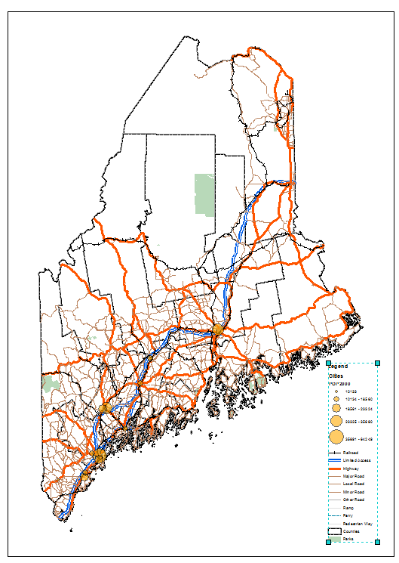

The legend box is dynamically linked to the layer names defined in the TOC. For example, if you change the **POP2000** sub-title for the Cities layer in the TOC, that change will be reflected in the legend element

Click once on the **POP2000** sub-title in the TOC, then click on it again after waiting a few seconds to place it in edit mode.



Change its name to Population 2000.



Note the change reflected in the legend element.

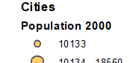

Next, you will add a scale bar.

From the **Main** **menu** toolbar, click on **Insert** and select **Scale Bar**.

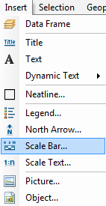

In the **Scale Bar Selector** window, click **OK** to accept the defaults.

Position the scale bar somewhere near the bottom of the page layout.

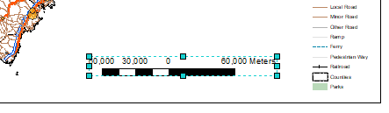

Feel free to rearrange the newly added scale bar in your map layout.

You might also want to change its units and intervals. An example of the scale bar’s properties modification follows.

**Double-click** the scale bar to bring up its properties.

Select **Adjust number of divisions,** set the division units to **Miles,** then set the division value to **20 mi**. Set the number of subdivisions to **2**.

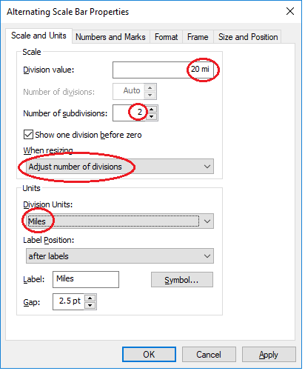

Click **OK** to close the scale bar properties.



From the **Insert** pull-down menu, you will add the **North Arrow**.

Choose any north arrow from the list of options (it’s best to pick the simplest arrow symbol) and click **OK** to close the North Arrow Selector window.

The north arrow may be placed in the middle of the map which may take some squinting to find. Move it somewhere to the bottom of the map.

Finally, you will add a Title to your map.

From the **Main** **menu** toolbar, click on **Insert** and select **Title**.

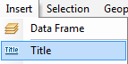

In the **Insert Title** window, type **The State of** **Maine**.

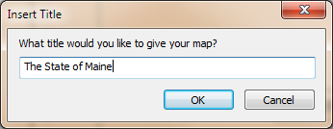

Click **OK**.

Position the title somewhere near the top of the map.

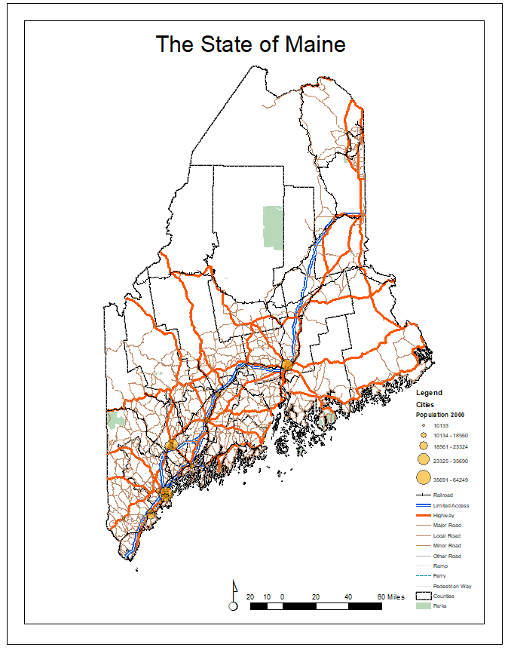

This ends this exercise.

© Manny Gimond, last modified on 8/12/2019