**Calculating average income by distance**

|  |
| --- |
| 1. Create a folder called **Income_dist**somewhere under your personal directory (e.g. C:\Users\jdoe\Documents\Tutorials\Income_dist). 2. [Download the data](Income_distance_files/Income_dist.zip) for this exercise and extract the files from the Income_dist.zip file to your newly created **Income_dist** directory. |

In this exercise, you will compute the weighted mean income for various distance bands from Augusta. Geoprocessing tools you will use for the analysis include:

* Buffer (multi-ring buffer)
* Clip
* Intersect
* Dissolve

Contents

Step 1: Open the map document 1

Step 2: Creating distance bands 1

Step 3: Computing the distance bands area 1

Step 4: Intersect distance bands with income 1

Step 5: Computing weighted income values 1

Step 6: Dissolving polygons by distance band 1

1. Open the map document

Start ArcMap and open **Income_dist.mxd** from your **Income_dist** folder.

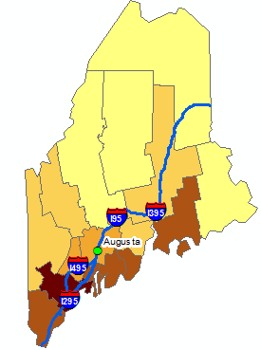

The document consists of three layers: A point layer showing the location of Augusta (the state capital), median per-capita income for 2010 (aggregated at the county level), and the interstate system (used in this exercise as a geographic reference only).

In the following steps, you will create distance bands centered on Augusta, clip the distance bands to the State of Maine then intersect the clipped bands with the income layer. The exercise will finish off by dissolving the intersected polygons by distance then computing the weighted mean income values within each distance band.

1. Creating distance bands

You will create distance bands by using one of ArcMap’s buffer tools--the multiple ring buffer tool.

From the **Toolbox**, select **Analysis Tools >> Proximity >> Multiple Ring Buffer**.

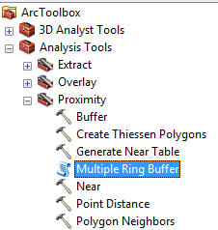

You will select **Augusta** as the input feature and **Distances** as the output shapefile.

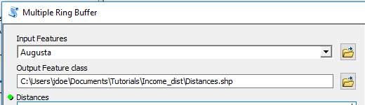

Next, you will specify the distance bands. The first distance band is 100 km. The tool adopts the map coordinate system’s XY units (meters in this example) thus the distance will need to be converted to meters. Type **100000** in the **Distances** field then click the icon.

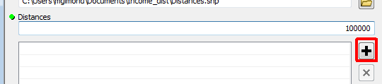

Add three more distance bands: **200** km, **300** km and **400** km.

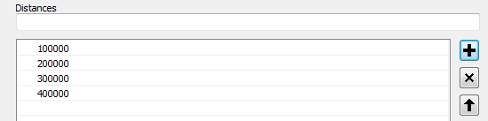

Click **OK** to run the geoprocess.

The output should look like a bullseye.

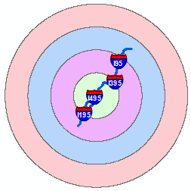

Next, you will clip the distance bands to the State of Maine.

From the pull-down menu select **Geoprocessing >> Clip**.

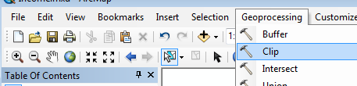

The input layer (layer to be clipped) is **Distances** and the *Clip Features* layer is **Income**. Name the output **Distances_clip**.

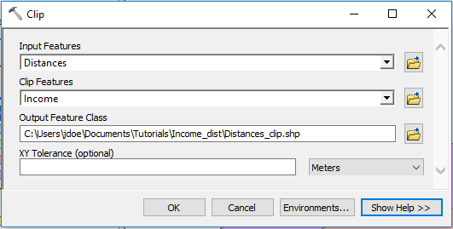

Click **OK** to run the geoprocess.

Your Distances_clip layer should look like this (you might want to turn off the Distances layer in the TOC):

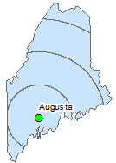

In the next step, you will create an area field.

1. Computing the distance bands area

Open the Distances_clip **attribute** **table**. Click the top-left icon and select **Add Field**.

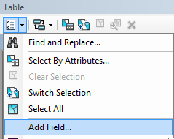

Name the new field **Area** and set its data type to **Float**.

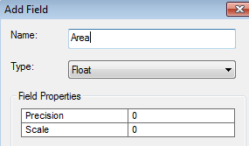

Click **OK**.

**Right-click** on the new field and select **Calculate Geometry**. You might be presented with a window warning you that any calculation made in this session cannot be undone, press **Yes** to proceed.

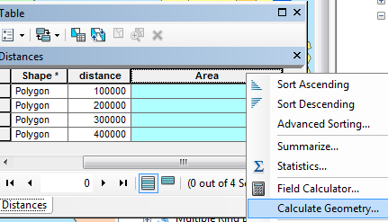

Select **Area** as the *Property* type and **Square Miles US** as the output units.

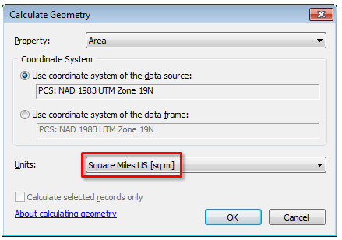

Click **OK** to run the geoprocess (and **Yes** if the same warning window pops up).

You now have the area (in square miles) for each distance band.

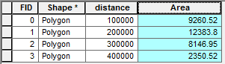

1. Intersect distance bands with income

Next, you will combine the Distances_clip layer with the Income layer using the *Intersect* tool.

Select **Geoprocessing >> Intersect**.

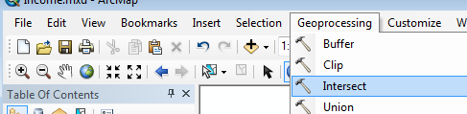

You will add two layers to the *Features* table: **Income** and **Distances_clip**. Each layer will be added one at a time by selecting it from the *Input Features* field. Name the output **Income_bands**.

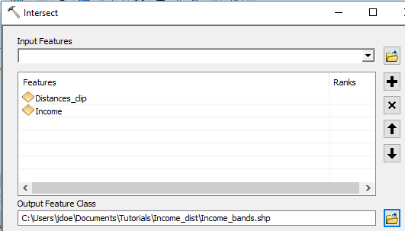

Click **OK** to run the geoprocess.

You should see both the counties outline and the bands outline in the new layer.

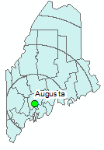

You will note that the intersection of the two layers created more polygons than the combined input polygons—29 output polygons vs 20 combined input polygons (16 counties + 4 distance bands polygons). This will allow us to recombine the polygons into the original bands later in this exercise.

To confirm that what *appears* to be split polygons are indeed *split polygons* select a record in the attributes table by clicking on that row’s grey box and note the selected polygon in the map.



In the following example, a piece of Penobscot county is selected.

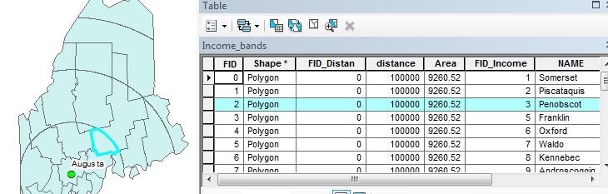

Before moving onto Step 5, make sure to clear any selected features by clicking on the **Clear Selected Features** icon. If this icon is ghosted out (i.e. inactive), then there are no selected features in your map and you are free to proceed to the next step.

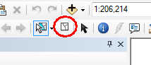

1. Computing weighted income values

The final step will involve *dissolving* the polygons into the original distance bands and computing the mean income values within each band. But before we do this, we will need to weigh each income polygon based on its aerial contribution to each distance band.

Open the Income_bands attribute table and create a new field called **IncArea** (following procedures outlined earlier in this exercise). You will set the data type to **Float**.

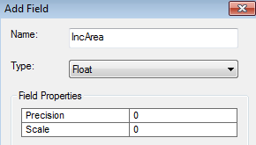

Next, in the **IncArea** field, calculate the **area** (in **square miles**) for each polygon (see Step 3).

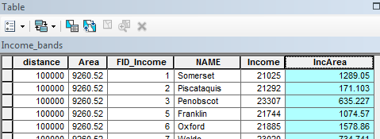

You will use the newly calculate area along with the distance band area (*Area* field) to compute the weighted income following the formula Income * (IncArea / Area).

In the *Income_bands* attributes table, create a new field called **IncWeight** and set its type to **Float**.

Right-click on the *IncWeight* field and select **Field Calculator**. Click **Yes** if a warning box pops up.

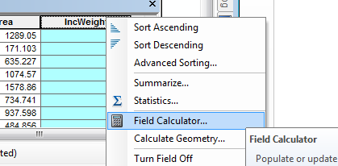

Type the following expression in the expression box: [Income] * ( [IncArea] / [Area]).



Now each polygon has its weighted income value. In the final step, you will combine all polygons that fall in a common distance bands and sum the weighted income values.

1. Dissolving polygons by distance band

Select **Geoprocessing >> Dissolve**.

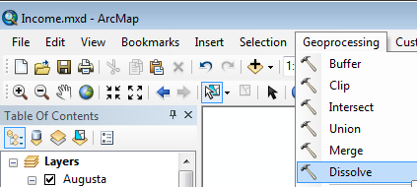

Select **Income_bands** as the input feature and name the output **Avg_Inc**.

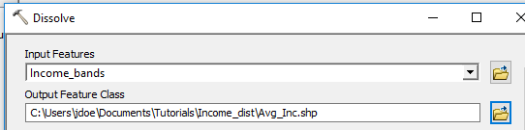

Next, you need to indicate which attribute field will be used to merge contiguous polygons. Since we want to reconstruct the distance bands, we will select the distance field as the dissolve field.

Check the **distance** layer in the *Dissolve_Fields* window.

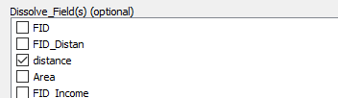

Finally, we will want to instruct ArcMap to sum the weighted income values within each distance band.

In the *Statistics* field, select **IncWeight** from the pulldown menu.

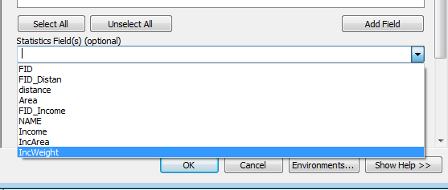

An error symbol will appear next to the *Statistics* field. This is simply warning us that a *Statistics Type* has not yet been selected.

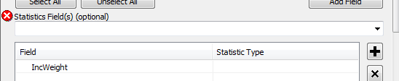

The *Statistic Type* field allows us to choose which aggregate statistic to use on the dissolved polygons. We will choose to *sum* the weighted values.

Click on the empty field next to IncWeight and select **SUM**.

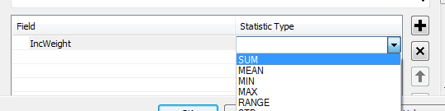

Click **OK** to run this last geoprocess.

Your final output may not look different from the Distances layer created earlier in this exercise, but if you bring up its attribute table, you’ll see the new column, **SUM_IncWei**, with the weighted mean income values per distance band.

**Symbolize** the AVG_Inc layer using the SUM_IncWei column.

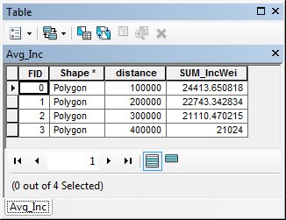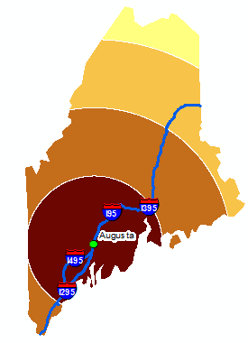

This ends this exercise.

 Manuel Gimond, last modified on 7/11/2018