**Labels and Annotations**

|  |
| --- |
| 1. Create a folder called **Labels**. On DIA 322 computers, you might want to create this folder in your user Documents folder (e.g. C:\Users\jdoe\Documents\Labels). On the DIA 222 computers, you might want to create this folder on the D: drive under D:*course number*\*user name*\ (e.g. D:\ES212\jdoe\Labels). 2. [Download the data](Labels_and_annotations_files/Labels.zip) for this exercise and [extract the contents](Opening_zip_files.htm) of **Labels.zip** file to your newly created **Labels** directory. |

In this exercise, you will annotate a reference map of the Maine mid-coast region. Steps will include generating dynamic labels (automatically placed by ArcMap) followed by their conversion to geodatabase annotation features. You will then learn how to manually edit/customize the annotations inside of an ArcMap session.

Contents

Step 1: Open the map project 2

Step 2: Add college labels 2

Step 3: Set the Map Scale 7

Step 4: Convert labels to annotation 9

Step 5: Edit college annotations 13

Step 6: Reposition other college annotations 16

Step 7: Create county boundary annotations 18

Step 8: Add rivers and streams annotations 22

Step 9: Create Urban Areas annotations 34

Step 10: Add custom annotation 42

Step 11: Add park annotations 45

Step 12: Adding road labels 48

Step 13: Convert road labels to annotations 56

Step 14: Make final adjustments 58

1. Open the map project

Open the **maps.mxd** located in your **Labels** folder.

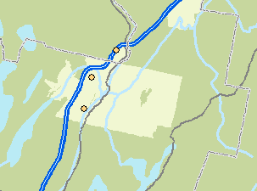

The map represents a section of Maine’s mid-coast region and delineates urban areas, parks, water bodies, counties, roads and Colleges. The goal of this exercise will be to label/annotate these features for the sole purpose of creating a reference map.

1. Add college labels

In this step you will have ArcMap automatically place college labels.

In the TOC, right-click on **Colleges** and select **Label Features**.

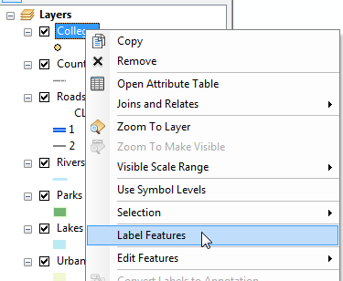

ArcMap uses a default font, color and placement rule to locate the labels. The location and label size (relative to map features) are dynamically adjusted as one pans around and zooms in and out of the map.

In this example, ArcGIS defaulted to the **Name** attribute field. However, as you will learn later in this exercise, you can select any other attribute value(s) to label.

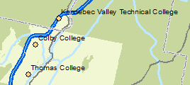

Next, you will modify the label settings for Colleges.

From the **customize** pull-down menu, select **Toolbars >> Labeling**.

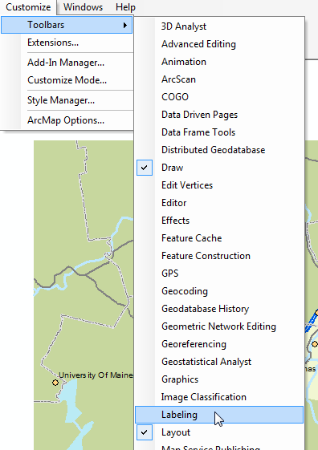

This will bring up the **Labeling** toolbar.

ArcGIS has an extension called Maplex that offers additional labeling options. This extension is normally purchased separately. All

In the **Labeling** toolbar, expand the **Labeling** pull-down menu and select **Use Maplex Label Engine**.

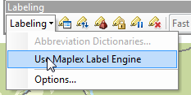

This enables the Maplex label engine. Maplex offers advanced labeling options.

Note that the label characteristics have changed now that we’ve switched to the Maplex label engine.

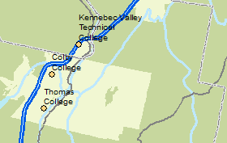

Next, you will fine tune the label placement options.

In the **Labeling** toolbar, click on the **Label Manager** icon.

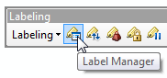

The **Label Manager** window provides access to all labeling properties. Click [here](http://help.arcgis.com/en/arcgisdesktop/10.0/help/index.html#//00s80000002m000000.htm) to learn more about the Label Manager window environment.

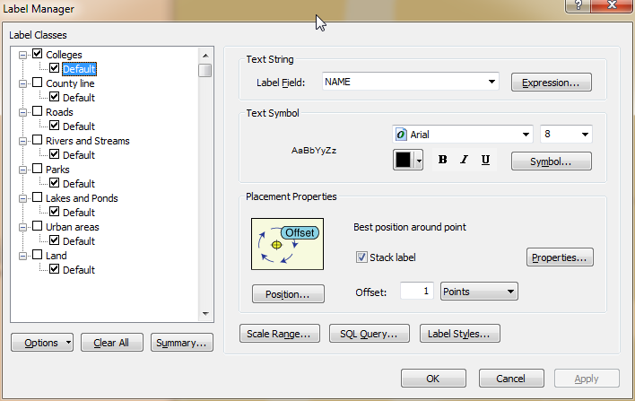

Next, you will change the **Colleges** label properties using the Label Manager window.

Make sure that the **Default** label class under **Colleges** is highlighted in the left window pane.

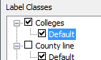

In the Label Manager window, change the following text settings for Colleges:

* Size: **9**
* Color: **Gray 60%**
* **Bold**

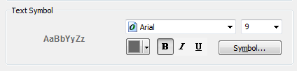

Click **OK** to accept the label changes.

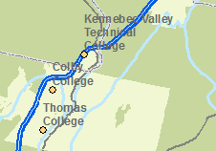

One downside to the automatic placement of labels is that you cannot manually modify individual labels. Label placement rules and settings apply to ALL labels within a label class with no exception.

A workaround to this limitation is to convert labels to annotations. But first, you will need to set the map’s final display scale (the reason will be made clear in subsequent steps).

1. Set the Map Scale

Set the map’s scale to 1:520,000 (this will be the scale at which the final map will be presented/published).



Next, you will make *this* the data frame’s default scale.

Open the data frame’s **Properties** window (right-click on **Layers** data frame).

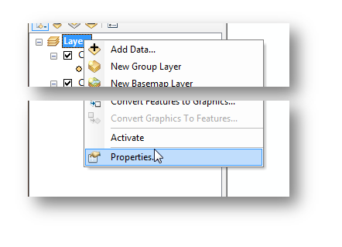

In the **General** tab, set the **Reference Scale** to **<Use Current Scale>** (this sets the scale to 1:520,000). Alternatively, you could type the scale directly.

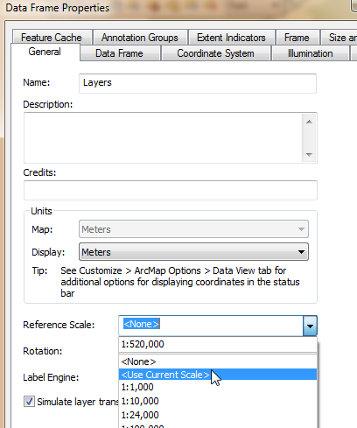

Click **OK** to accept the changes and close the data frame properties window.

You are now ready to convert the labels to annotations.

1. Convert labels to annotation

In the TOC, right-click on **Colleges** and select **Convert Labels to Annotation**.

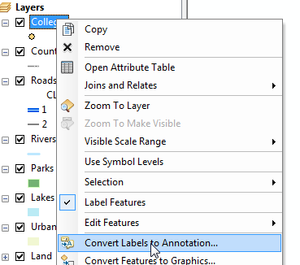

Uncheck **Feature Linked**.

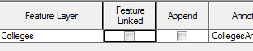

In the Convert Labels to Annotation window click on the little **folder** icon in the **Annotation Feature Class** column (this allows you to set the output location of the soon to-be created annotation).

Navigate to the **Labels** project folder.

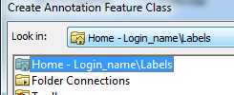

Create a **new file Geodatabase** under **d:\Login_name\Labels\** and name it **annotations.gdb**.

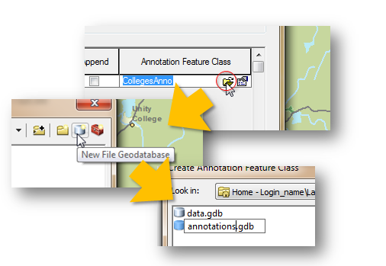

In the newly created annotations.gdb geodatabase, set the name of the new annotations to **CollegesAnno**.

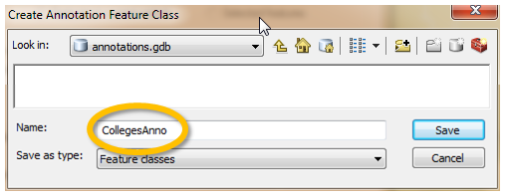

Click **Save** to close the window.

Make sure that the other settings appear as they do in the following graphic. Ensure that **Convert unplaced labels to unplaced annotation** is **unchecked**.

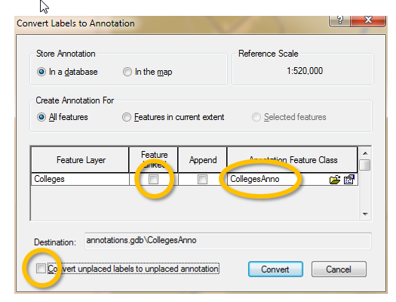

|  |
| --- |
| [From ArcGIS online help](http://help.arcgis.com/en/arcgisdesktop/10.0/help/index.html#/What_is_Annotation/000m00000001000000/):  *There are two kinds of annotation in the geodatabase—****standard*** *and* ***feature-linked****.* ***Standard annotation*** *is not formally associated with features in the geodatabase. An example of standard annotation is the text on a map for a mountain range. No specific feature represents the mountain range, but it is an area you want to mark.*  ***Feature-linked annotation*** *is associated with a specific feature in another feature class in the geodatabase. The text in feature-linked annotation reflects the value of a field or fields from the feature to which it's linked. For example, the water transmission mains in a water network can be annotated with their names, which are stored in a field in the transmission mains feature class.* |

Click **Convert**.

A new layer (CollegesAnno) should appear in the TOC

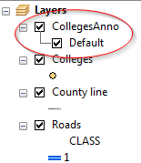

Geodatabase annotations are feature classes (much like vector and raster feature classes). And like feature classes, geodatabase annotations can be opened in other map documents (this facilitates transferring customized label placements to other MXD documents).

One difference between annotations and labels is that annotation scales are **fixed**. This means that as you zoom in, the text size gets bigger. Likewise, as you zoom out, text size gets smaller. That is why **setting the** **map’s presentation scale before converting labels to annotations is critical**!

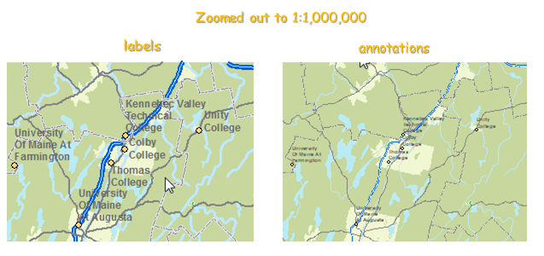

One advantage to working with annotations is that you can edit each label independently.

1. Edit college annotations

Right-click on the **CollegesAnno** layer and select **Edit Features >> Start Editing**.

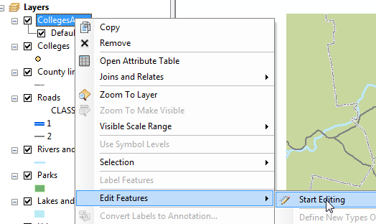

This brings up the **Create Features** window pane used for editing vector features.

Annotations have a unique set of editing tools. You therefore need to open an **Attributes editor** window pane.

From the **Editor** pull-down menu in the **Editor** **toolbar**, select **Editing Windows >> Attributes**.

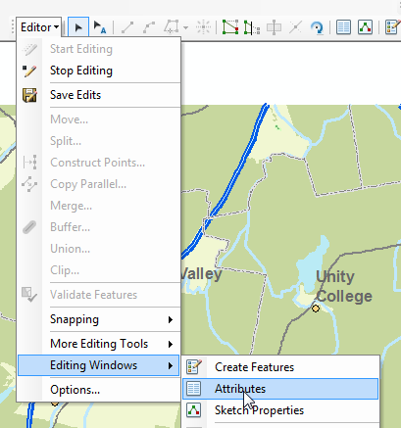

You are now ready to edit annotations. You will use the **Edit Annotation** Tool to select the annotation to be edited.

In the Editor toolbar, select the **Edit Annotation Tool** icon.

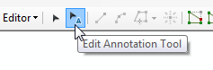

Using the Edit Annotation Tool pointer, **select** the **University of Maine at Augusta** annotation.

Move the text over to the left (just across from the interstate line feature).

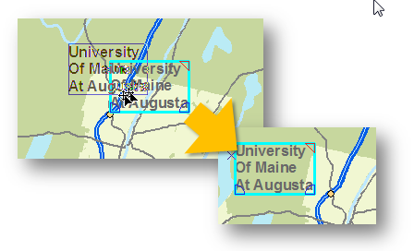

With the text still selected, set the text alignment to **right justified** (the text characteristics are set in the **Attributes editor** window pane on the right-hand side of the ArcMap application window)

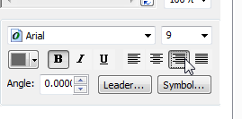

Click **Apply**.

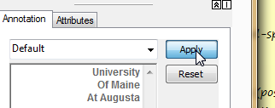

Note that the change **only** applies to the *University of Maine at Augusta* annotation. The other annotations remain unchanged.

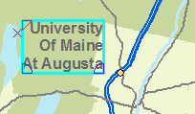

Clear the select annotation by clicking on the **Clear Selected Features** icon in the Tools toolbar.

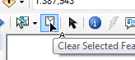

1. Reposition other college annotations

On your own, modify the other *Colleges* annotations as needed.

**NOTE**: if you find it difficult to precisely move an annotation because ArcMap’s ‘snapping to grid’ feature, press and hold the spacebar key as you move the annotation.

Examples of edits you might want to perform:

* Prevent annotations from crossing line features (particularly roads)
* Remove Beal College which may be too close to the map’s upper corner

Use the following map as a template.

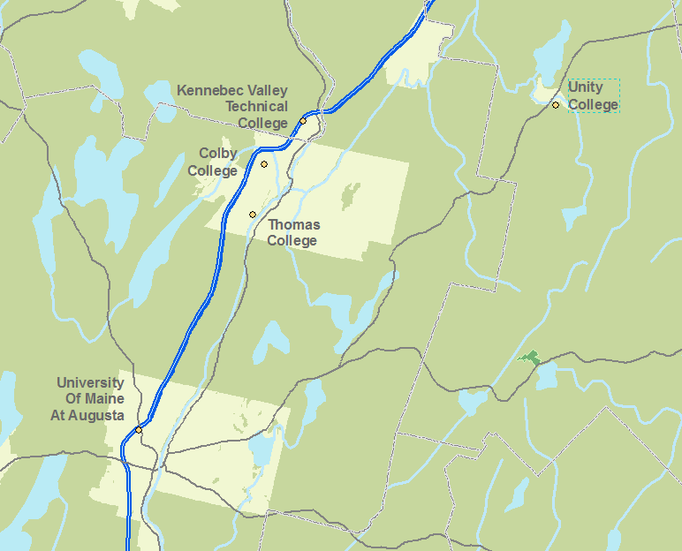

**Save** edits.

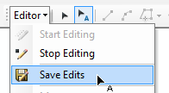

**Stop** the edit session.

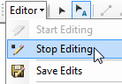

1. Create county boundary annotations

There are many ways in which one can have ArcMap label features. In an earlier step, you right-clicked on a layer and selected Label Features. In the following step, you will add labels via the **Labeling Manager** window.

In the **Labeling** toolbar, click on the **Label Manager** icon.

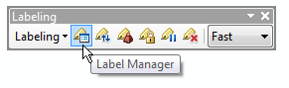

Find the **Land** layer and place a check in its box (this enables labeling for this layer).

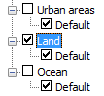

Note: the layer whose features will be labeled is called **Land**. It is different from the polyline feature **County line** which does **not** have county name attributes. In essence the latter is **only** used to display the line boundaries while the former is used to **label** the boundaries.

**Select/Highlight** the **Default** class just under the **Land** layer. *Note: make sure that the* ***Default*** *class under the* ***Land*** *layer is* ***selected****/****highlighted*** *before proceeding.*

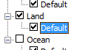

The layer’s labeling characteristics are displayed in the right pane.

Select **COUNTY** attribute as the label field and change the font color to **Gray 60%**.

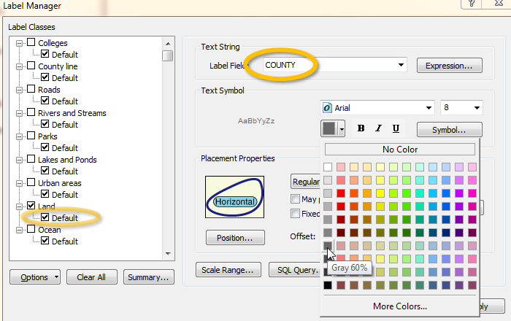

Next, you will change the placement of the labels. By default, polygon labels are placed at the center of the polygon (in our example at the center of the Land polygons). We will instead have ArcMap place the labels along the polygon boundaries.

Select **Boundary Placement** in the Placement Properties section.

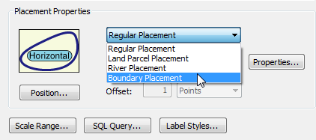

Click **OK** to have ArcMap draw the labels.

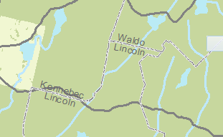

You might notice that the county labels are slow to display. This is because the software is computing the best label placements based on the county outline characteristics. This can be a nuisance for big maps and for lengthy workflows. As you will discover in the next step, annotations can be displayed at a much faster rate than labels.

We will now convert the county boundary labels to annotations following the method outlined in Step 4.

Following the procedures outlined in Step 4, convert **Land** **labels** to a new annotation feature class called **LandAnno**. You will place the annotation in the same geodatabase created in step 4 (CollegesAnno.gdb). Note that you are not given a chance to select the location for the new annotation until you unselect *Feature Linked*.

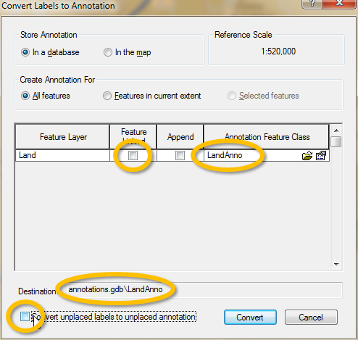

Click **Convert**.

Once the labels are converted to annotations notice how much faster the county names are displayed.

To minimize confusion, rename **LandAnno** to **CountyAnno** in the map’s TOC.

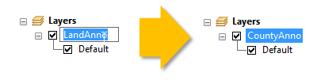

Unlike the College annotations, it seems that the county name annotations will not need major editing for now. We will now proceed to the rivers and streams annotations.

1. Add rivers and streams annotations

Labeling streams and rivers usually poses additional challenges as they often need to follow the outlines of meandering polyline features. See the following example from a DeLorme Gazeteer map:

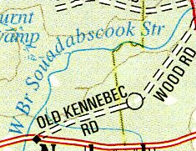

Use the Label Manager window (outlined in Step 7) to add **river and stream** labels. Use the following graphic as reference.

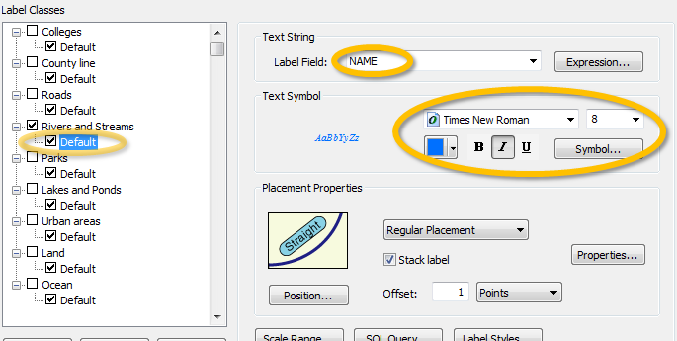

Click **OK** .

As you can see, the default label placements is not ideal.

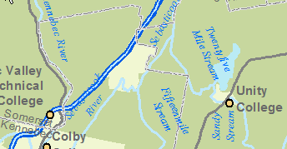

Following the procedures outlined in **Step 4**, **convert labels** to **annotations.** Save the new annotations in the same annotation geodatabase used earlier in the exercise (i.e. annotations.gdb). Name the new annotation feature class **Rivers_and_StreamsAnno**.

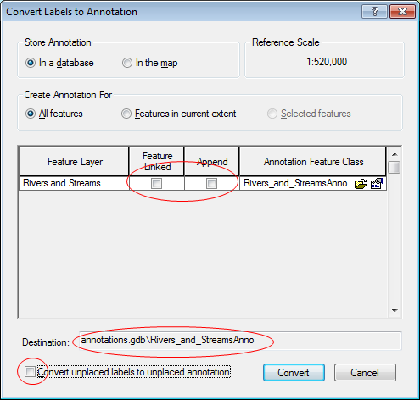

At this point, you should see a total of three annotation feature classes in the annotation geodatabase (you might need to expand the Catalog tab on the right-hand side of the ArcMap window and press the **F5** key to refresh its content).

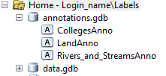

Next, you will force some of the rivers and streams annotations to follow the rivers and streams line features.

Right-click on the **River_and_StreamsAnno** layer and select **Edit Features >> Start Editing**.

Make sure that you display the **Attributes editor** pane.

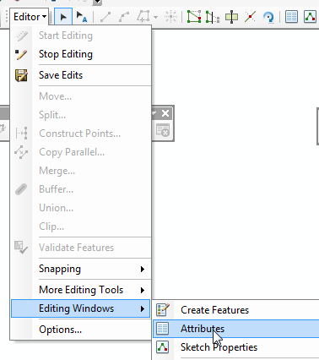

In the Editor toolbar, select the **Edit Annotation Tool** icon.



With the Edit Annotation Tool pointer **select** the **Belgrade Stream** annotation.

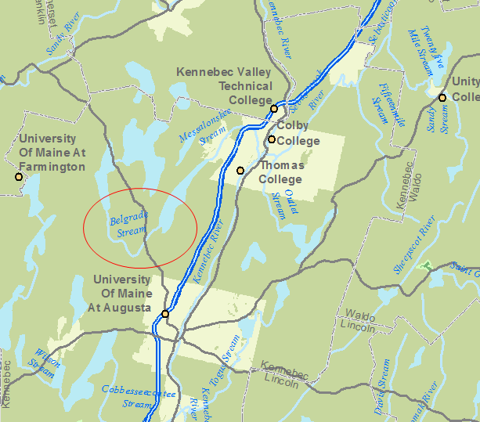

**Zoom in** on the Belgrade Stream annotation (recall that you can use the middle scroll wheel to zoom in and out).

Right-click on the feature and select **unstack**.

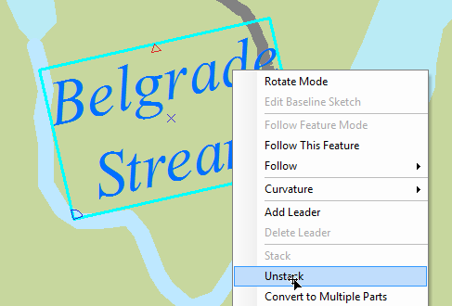

Next, you will instruct ArcMap to have the annotation follow the curvature of the river and stream feature.

Right-click on the Belgrade Stream annotation and select **Follow >> Follow Feature Options**.

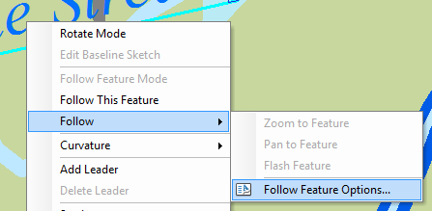

Choose **Curved** for *Make annotation* type and make sure that *Use placement properties defined in annotation class* is **unchecked**.

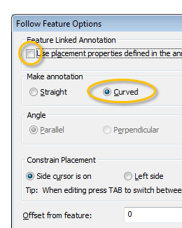

Click **OK**.

Make sure that the *Belgrade Stream* annotation is still selected.

**Right-click** somewhere along the Belgrade Stream **line feature** (and **not** the annotation) and select **Follow This Feature**.

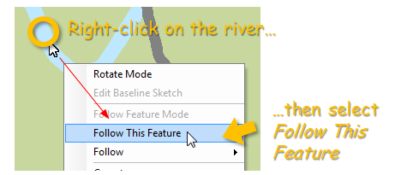

Now, **move** the annotation feature along the stream line feature as needed.

Note how the annotation curvature changes as you move the annotation up and down the stream.

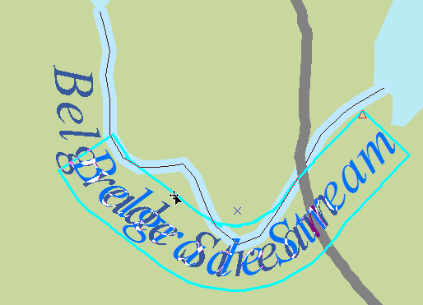

The final annotation placement may look like this:

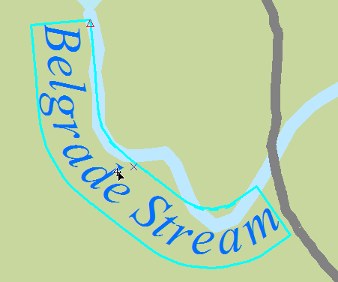

You can also manually adjust an annotation’s curvature. You will learn how with the Damariscotta river annotation.

**Zoom in** on **Damariscotta** river (southern end of the map).

If the label is *stacked*, right-click it and select **Unstack**.

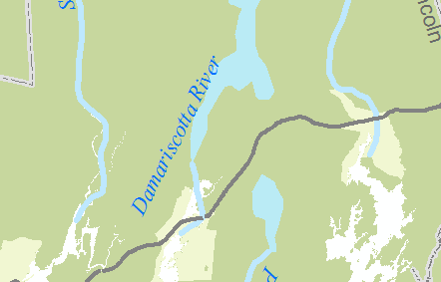

Make sure that the Damariscotta river annotation is still selected.

**Right-click** the annotation and select **Curvature >> Curved**.

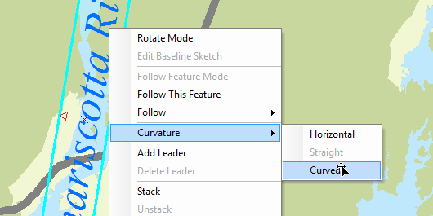

The annotation takes on a curved shape.

**Right-click** the annotation again and select **Edit Baseline Sketch.**

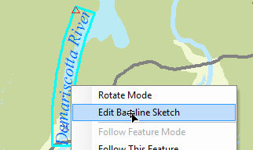

Note the spline vertices (you can add and remove vertices as needed). The vertices define the spline parameters.

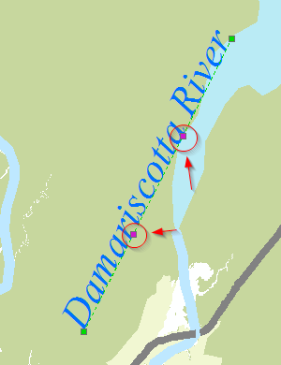

Select then move the vertices as needed to produce an annotation that follows the outline of the river.

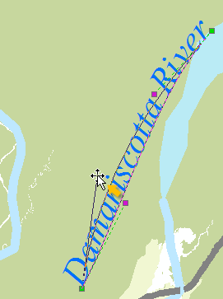

Attempt to replicate the following graphic.

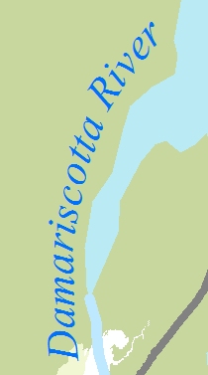

When you are done manipulating the spline vertices, right click the annotation and select **Finish Baseline Sketch**.

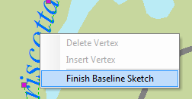

On your own, modify the remaining *streams and rivers* features as you see fit. Feel free to remove redundant annotations as needed.

Note: another annotation edit tool you might find useful is the rotate tool.

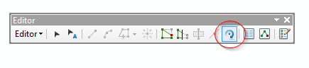

A few tips:

* **Remove** redundant annotations (i.e. **duplicates**) if needed.
* Use the **Identify tool** to ID rivers and streams if you are not sure which polyline feature the annotation belongs to.
* **Resize fonts** if needed (use this option sparingly). Do not use a font size less than 6.
* Remember that **not all** rivers and streams have to follow curvature.

Use the following map as a guide.

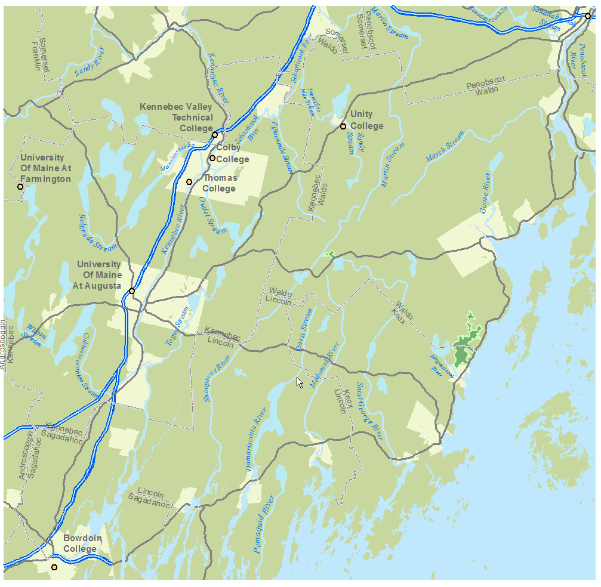

**Save** edits.



**Stop** the edit session.



1. Create Urban Areas annotations

Follow the procedure outlined in **Step 7** to add **Urban areas** labels. Use the following graphic as reference.

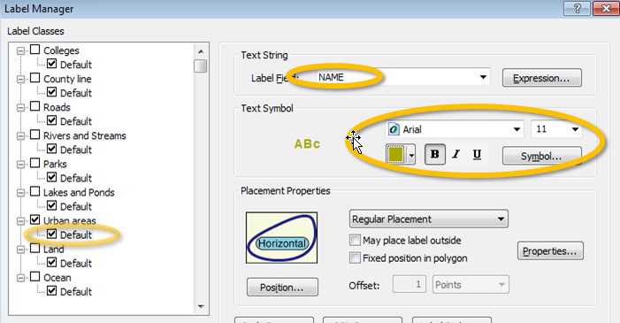

Use **Olivenite Green** for text color.

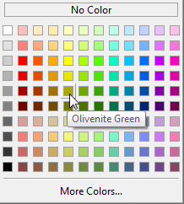

Click **OK** to close the Label Manager window.

You should see something like this:

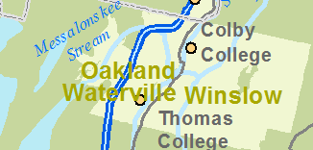

Following the procedures outlined in **Step 4,** convert **labels** to **annotations.** Save the new annotations in the same annotation geodatabase used earlier in the exercise (i.e. annotations.gdb) . Name the new annotation feature class **Urban_areasAnno**.

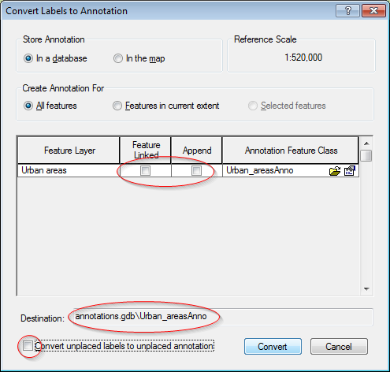

After converting the labels to annotations start an **Edit** session.

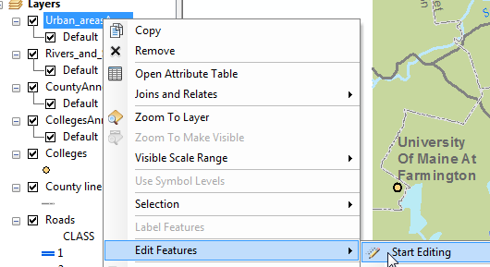

**Zoom** in on the **Waterville** annotation.

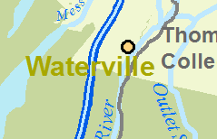

Note that the Waterville annotation crosses two road line features. This is not ideal. If you explore the remaining map extent, you come across other instances where annotations cross road features. One way to resolve this issue is to add a **halo** to all urban annotations.

Right-click the Urban annotation layer and select **Selection >> Select All**.

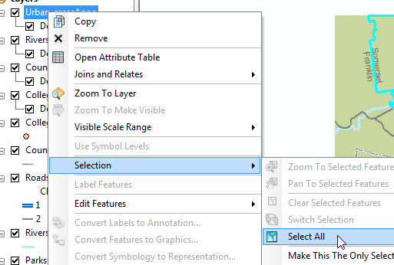

Make sure that you display the **Attributes editor** window pane.



In the **Attributes editor** window pane (on the right hand side of the ArcMap window), highlight **all** annotations (you can press and hold the **shift key** while you select the top and bottom name).

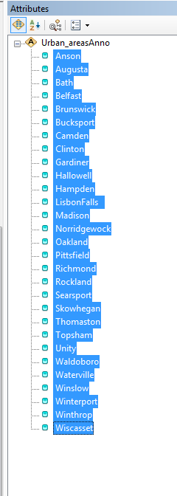

In the **Annotation tab** (below the list of selected names), click **Symbol** then **Edit Symbol**.

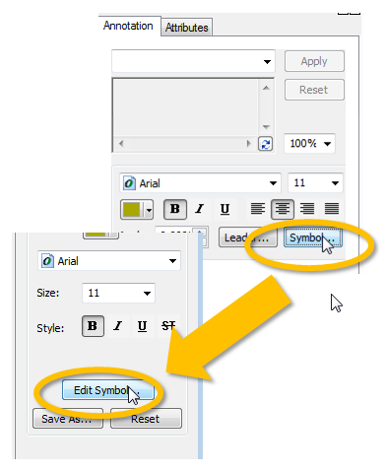

In the symbol editor click on the **Mask** tab.

Select **Halo** as the mask style and set the size to **1**.

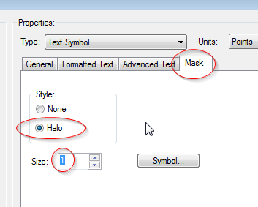

Click **OK** to close the symbol editor window.

Click **OK** to close the symbol selector window.

Click **Apply**.

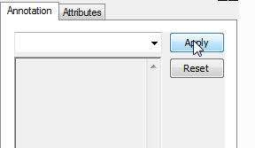

The halo provides a nice buffer between the text and background features.

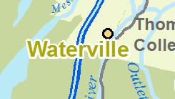

Unselect the annotations by clicking on the **Clear Selected Features** icon in the Tools toolbar.



On your own, make adjustments to the Urban annotation feature class as needed. Use the following map as a guide (note that you may need to remove redundant annotations).

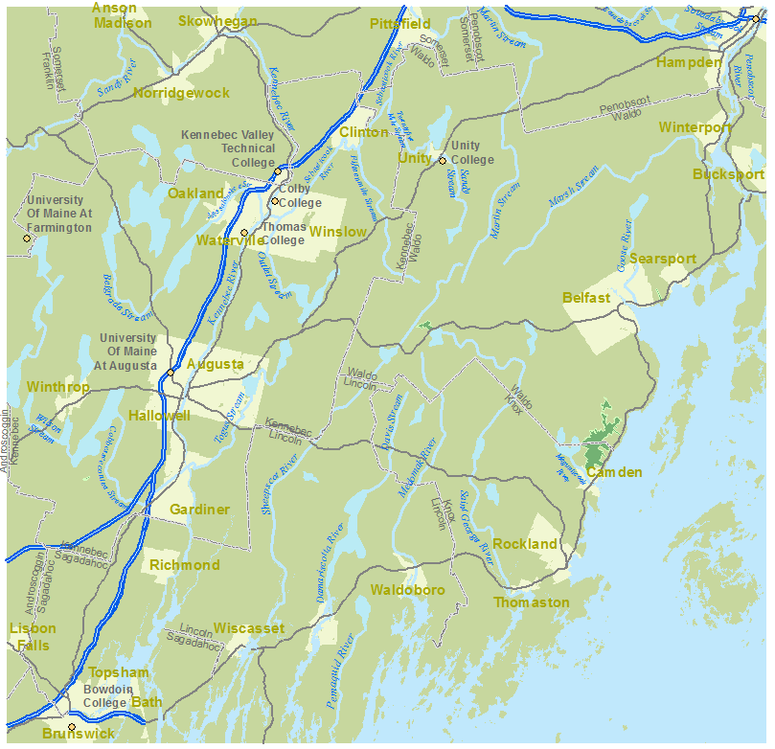

**Save** the edits .

**Stop** the edit session.

1. Add custom annotation

You don’t always need labels to create annotations. You can **manually** add annotations as needed to your map. In this step, you will add an annotation for the *Atlantic ocean*.

From the **Customize** pull-down menu select **Toolbars >> Draw**.

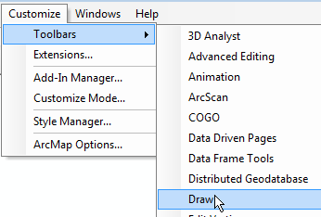

In the Draw toolbar, select the **New Text** icon.

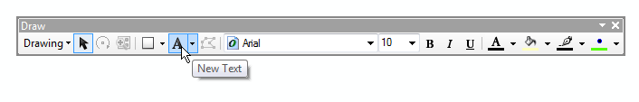

Set the font to **Times New Roman**, size **14**, posture to **italic** and color to **blue**.



In the lower area of the map extent, add the *Atlantic Ocean* Annotation.

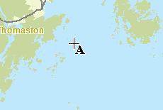

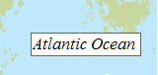

If needed, move the annotation so that it does not cross a land feature.

Right-click the annotation and select **Properties**.

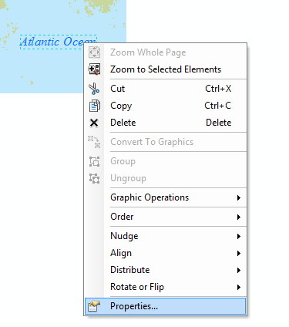

Next. you will span the annotation across a larger area.

Set the **character spacing** to **30**.

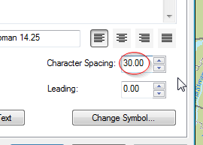

Click **OK**.

The text is now spread out over a wider area.

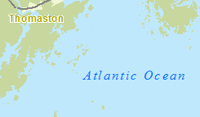

Note: the *Atlantic Ocean* annotation was not added to the annotation geodatabase created earlier in this exercise. By default, all manually created annotations are stored in the map document (i.e. the .mxd file). This can be verified by expanding **Drawing** and clicking on **Active Annotation Target**. The <Default> option refers to the built-in annotation group.

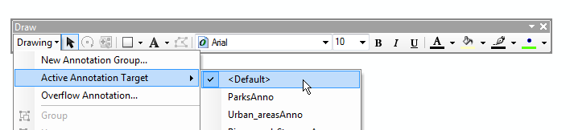

If you wanted to manually add an annotation to an existing annotation feature class (e.g. Rivers_and_StreamsAnno), you would select the target annotation feature class from the **Active Annotation Target** menu **prior** to adding the annotation to the map (these annotation classes can only be selected when an edit session is active).

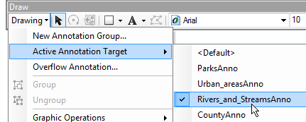

Next, you will add **Park** annotations.

1. Add park annotations

Follow the procedures outlined in **Step 7** to add **Parks labels**. Use the following graphic as reference.

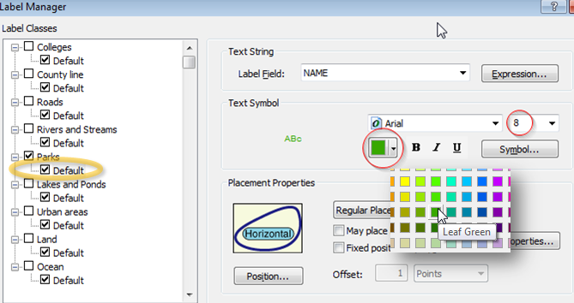

The labels should look something like this:

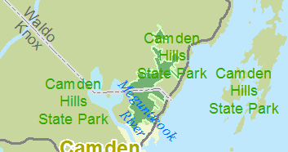

Following the procedures outlined in **Step 4**, convert **labels** to **annotations.** Save the new annotations in the same annotation geodatabase used earlier in the exercise. Name the new annotation feature class **ParksAnno**.

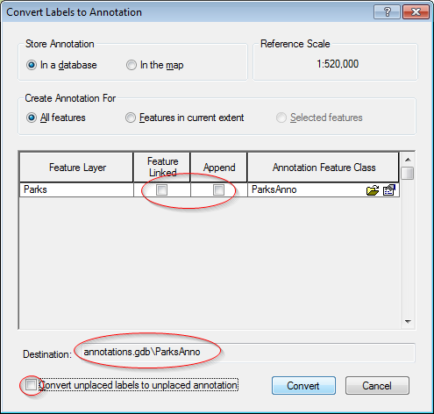

Start an **edit** session and **modify** the annotations as needed (e.g. right justify, remove duplicate annotations, etc…). Use the following graphic as a template.

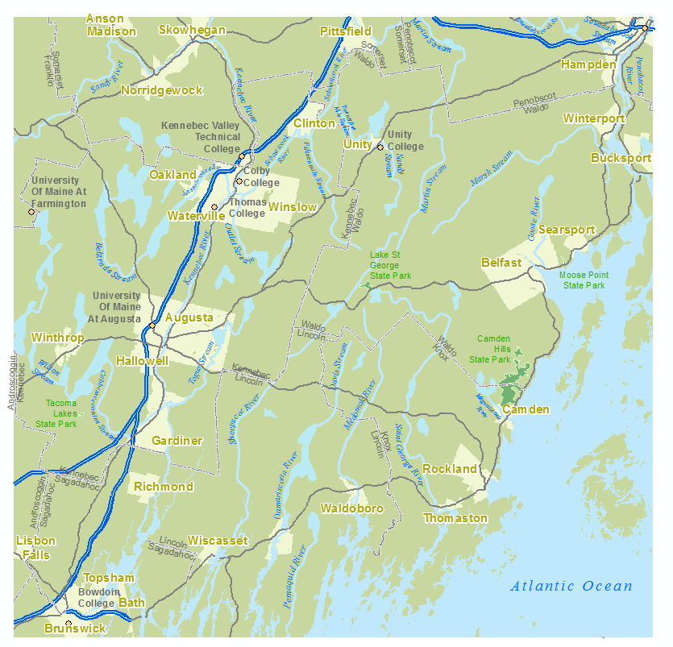

**Save** the edits.

**Stop** the edit session.

1. Adding road labels

In this step, you will add road symbols to the roads layer. However, unlike the labeling procedures adopted in previous steps, the roads labels will have two classes: an interstate class and a default class (for state and county roads). Defining separate classes allows you to customize labels for each.

Open **Label Manager**.



Highlight **Roads** in the left window pane. Type **Interstate** in the ***Enter class name*** field.

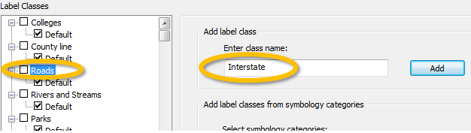

Click on the **Add** button (the one next to the class name Interstate).

You now have the Default class (for state and county roads) and the Interstate class to work with.



Select **Interstate**.



First, you need to instruct ArcMap to apply the Interstate class labeling scheme only to highways (i.e. those designated as Class 1 in the Roads layer). To do this, you will use a query expression which adopts the language of SQL (a popular database querying language). You can learn more about query expressions [here](http://help.arcgis.com/en/arcgisdesktop/10.0/help/index.html#//00s50000002t000000.htm).

Open the **SQL Query** window and type: “CLASS” = ‘1’

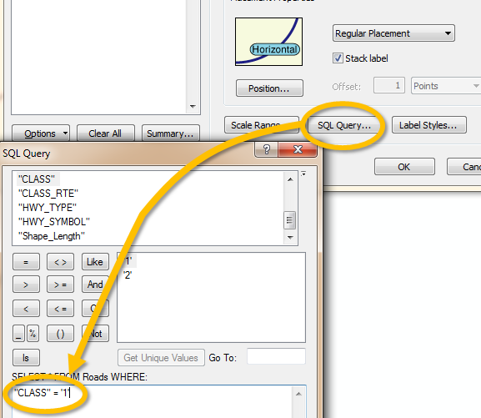

Click **OK** to close the SQL Query window.

Next, you will modify the Interstate label’s characteristics.

Modify the label characteristics for the **Interstate** class as follows:

* Select **HWY_SYMBOL** attribute for the label field
* Use the **US highway symbol shield** (accessed via the Symbol option)
* Position the label **horizontally** on the line features (defined under the Properties option)

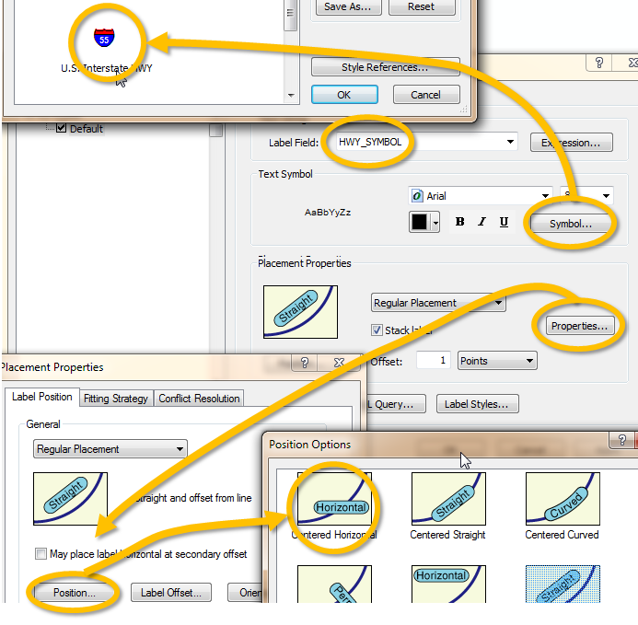

You will also want to prevent the labels from appearing too often along the line feature. You will instruct ArcMap to place labels no closer than 50 km of one another.

Click on the **Properties** button in the **Label Manager** window.

Select the **Label Density**  tab.

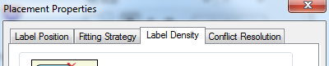

Check the **Remove duplicates** box and click on the **Options…** button.

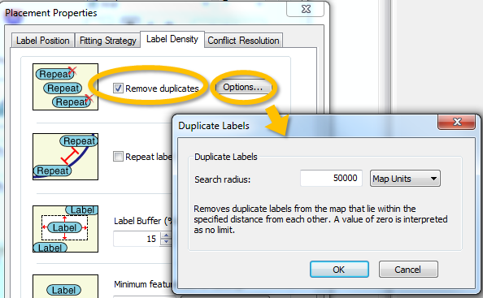

Set the search radius to **50000** ***map units*** (this is equivalent to 50,000 meters).

Click **OK**.

Click **OK** again to close the **Placement Properties** window.

If you haven’t done so already, check the box next to Roads in the left window pane.



The Label Manager window should look like this:

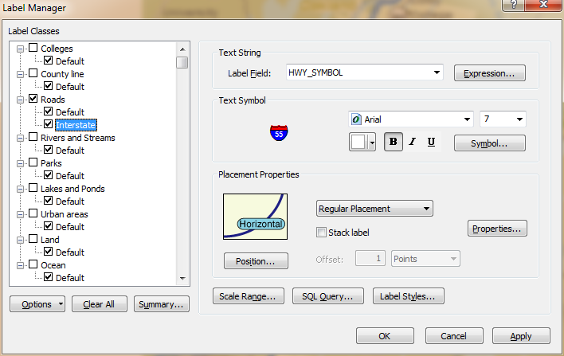

Click **Apply** to see the changes.

Next, you will define a symbol for the **Default** roads **class**.

In the left window pane, select (highlight) **Default** to display its label properties.



First, you need to instruct ArcMap to apply the Default class labeling scheme only to state and local roads (designated as Class 2 in the Roads layer).

Open the **SQL Query** window and type: "CLASS" = '2'

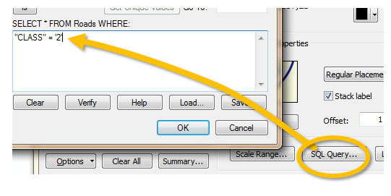

Click **OK** to close the **SQL Query** window.

Next, you will modify the label’s characteristics in the same way you modified the highway symbols.

Modify the label characteristics for the **Default** class as follows:

|  |  |
| --- | --- |
|  | * Use **HWY_SYMBOL** attribute for the label field * Use the **State Route HWY** symbol (acessed via the *Symbol* button). * Position the label **horizontally** on the line features * Have labels placed no closer than 20 km (20,000 map units) |

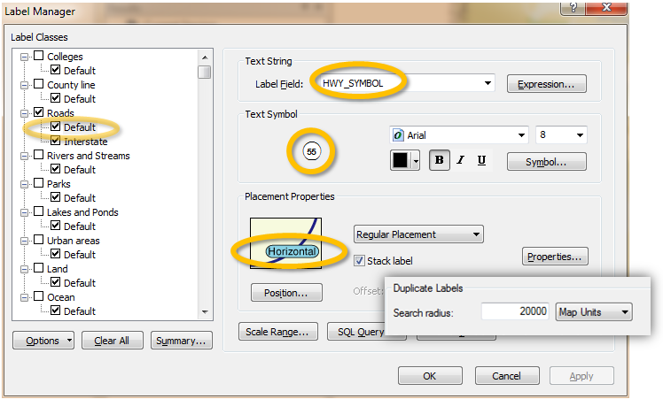

Click **OK**.

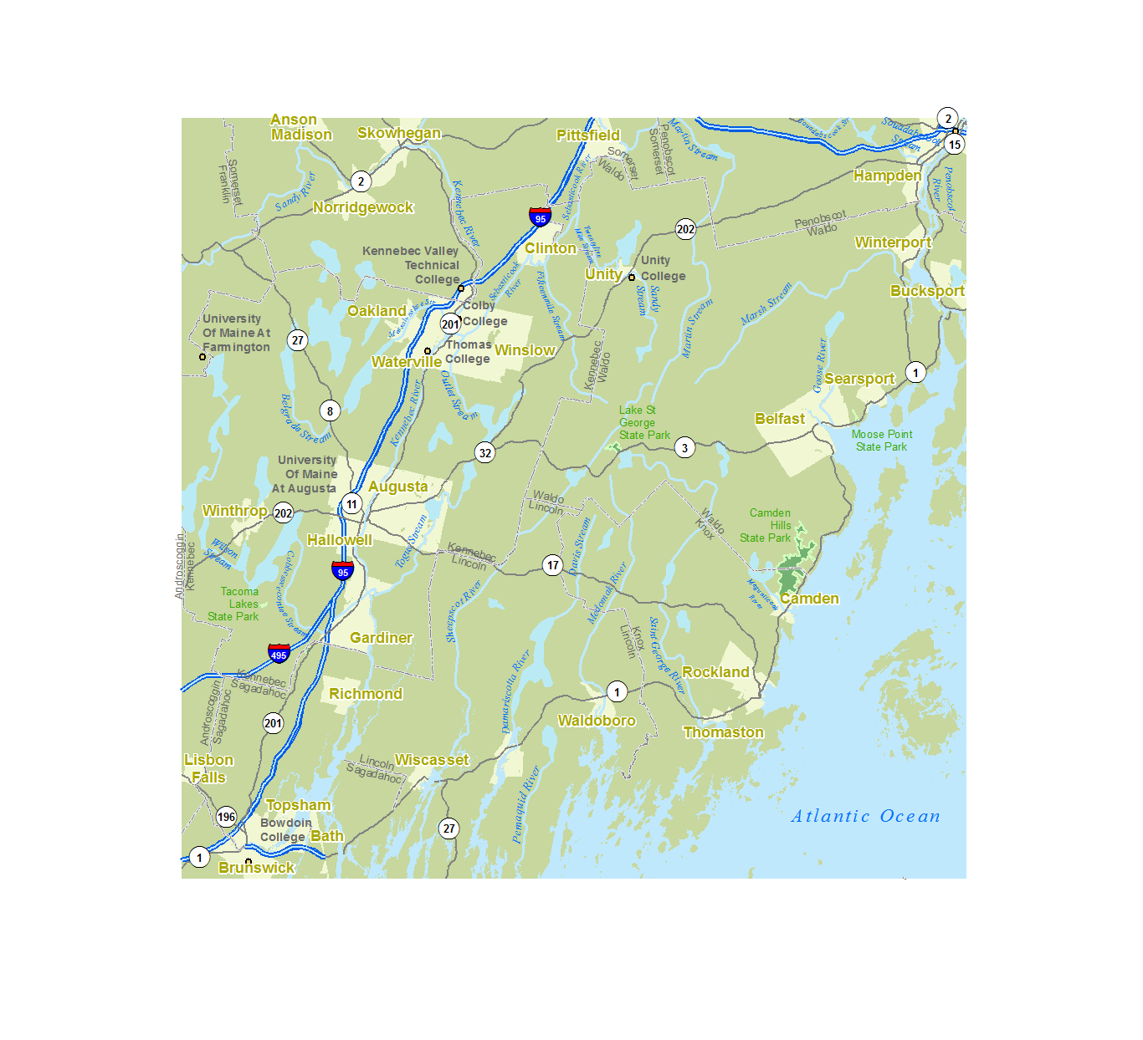

Next, you will convert the road labels to annotations.

1. Convert road labels to annotations

Following the procedures outlined in **Step 4**, convert the road  **labels** to **annotations.** Save the new annotations in the same annotation geodatabase used earlier in the exercise. Name the new annotation feature class **RoadsAnno**.

Note that in the conversion process, the two label/annotation feature classes (**Default** and **Interstate**) are preserved.

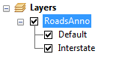

Start the edit session and **Edit** the road annotations as needed.

Examples of changes that can be made is the relocation of the **route 11** annotation (which may be masking the University of Maine at Augusta symbol) to the left of I-95. Note that this example my not apply to your map.

You may also want to **add** road symbols. Doing so is easy. Simply copy and paste an existing label. When pasting, you may be required to select the annotation feature class to which the pasted symbol will be added (i.e. RoadsAnno).

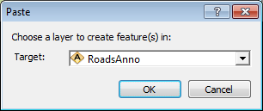

It sometimes helps to refer to a road atlas (Google maps, Gazeteer, etc..) to help fine tune the placement of road annotations.

Use the following template as a guide:

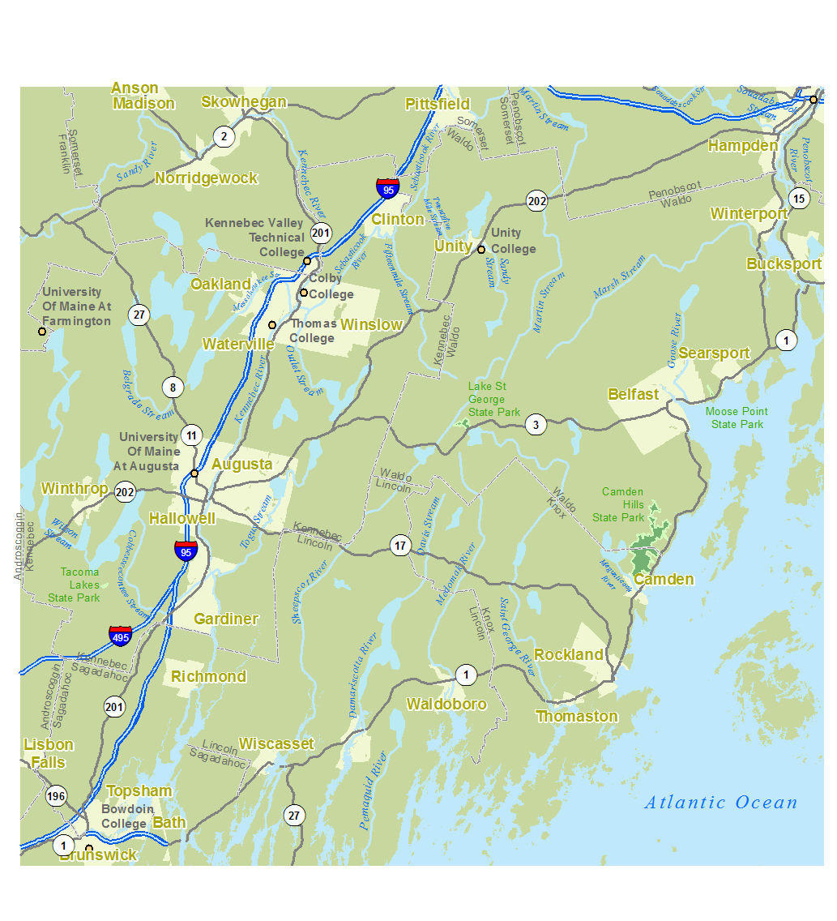

When done, done forget to **save** and **stop** your edit session.

1. Make final adjustments

On your own, make any final adjustments you think may be needed. Always remember to **start** and edit session and to open the **attributes pane** (from **Editor >> Editing Windows** in the **Editor** toolbar).

Examples of a few adjustments that may be needed:

* Assign a **halo** (whose color matches the Urban areas color) to the **Thomas College** annotation, then move the annotation closer to the point feature. NOTE: the urban color has an **RGB** values of **241, 247 and 210** respectively.  
  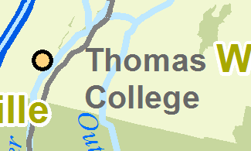 to 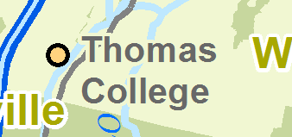
* Use the same technique to discern ‘Kennebec’ county annotation from the route 17 road line feature  
  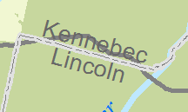 to 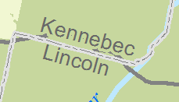

When done, **save** all edits and **save** your map document.

 Manuel Gimond, last modified on 8/24/2016