**Finding the least-cost path between two locations**

|  |
| --- |
| 1. Create a folder called **Least_cost_path** somewhere under your personal directory (e.g. C:\Users\jdoe\Documents\Tutorials\Least_cost_path). 2. [Download the data](Least_cost_path_files/Least_cost.zip) for this exercise then [uncompress](Opening_zip_files.htm) the **Least_cost.zip** file to your newly created **Least_cost_path** directory. |

In this exercise, you will identify the most cost effective path between two locations based on elevation slope and landuse type.

You will need to enable **Spatial Analyst** extension to complete most of the steps in this exercise.

Contents

Step 1: Open the ArcMap document 1

Step 2: Create a slope raster 2

Step 3: Reclassify the Slope Layer 4

Step 4: Reclassify Land Use Layer 6

Step 5: Create a Total Cost Layer 7

Step 6: Create a Cost-Distance and Cost-Direction layer 8

Step 7: Compute the Least Cost Path 11

1. Open the ArcMap document

Navigate to your **Least_cost_path** folder and open the **Least_cost.mxd** document in ArcMap.

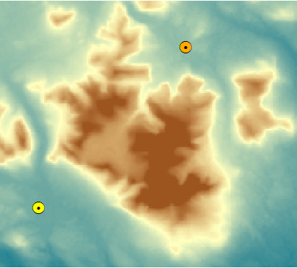

The map shows a section of Baxter State Park (Maine) that surrounds Mt. Katahdin. The two point features represent Kidney Pond and Russell Pond campsites (you might want to enable labeling for the two point layers).

The two other layers in the map document represent elevation (in meters) and land use. Both of these layers are rasters.

The purpose of this exercise is to find a path that links both campsites while minimizing the “cost” of travel (by foot). This cost (or impedance) is a factor of two variables: elevation slope and land cover. The steeper the slope or the denser the vegetation the more arduous the hike. We want to minimize this impedance, in other words we want to strike a balance between total distance walked and time spent overcoming obstacles.

This requires the creation of a “cost” layer that assigns a cost (or impedance) value for each pixel based on slope and land cover type. This cost layer will later be used to calculate a cost distance layer.

But first, we must create a slope raster layer.

1. Create a Slope Raster Layer

In ArcToolbox, open **Spatial Analyst Tools >> Surface >> Slope** tool.

In the Slope tool window, select **Elevation** as the input raster, **…\Least_cost_path\Slope.tif** as the output raster and **PERCENT_RISE** as output measurement.

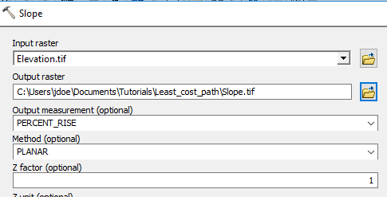

Note that if the elevation units were different from the horizontal units, a Z factor conversion would need to be applied. Since the Elevation layer you are using has vertical units of meters a conversion is not necessary (the horizontal units are also in meters).

Click **OK** to run the geoprocess.



Steep areas are symbolized with a red hue.

Next, you will convert the percent rise values to unitless reclassified “cost” values.

1. Reclassify the Slope Layer

In ArcToolbox open **Spatial Analyst Tools >> Reclass >> Reclassify** tool.

In the Reclassify tool window, set **Slope** as the *input raster* and **Value** as the *reclass* *field*.

You will use a standard classification scheme to recode the slope values.

Click on the **Classify** button.

Select **Equal Interval** as the classification method and choose to have the tool create **10 classes**. Click the **Tab** key to ensure that the 10 classes are applied to the data.

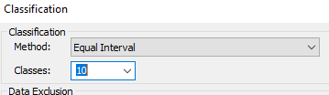

Click **OK** to close the Classification window.

Finally, set the output raster to **…\Least_cost_path\RecSlope.tif**.

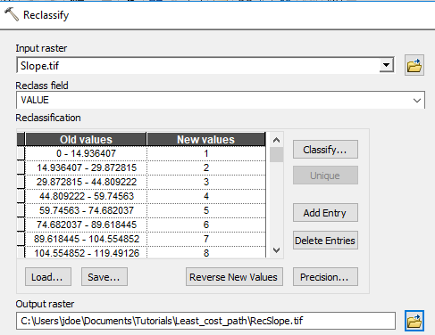

Click **OK** to run the Reclassify tool.

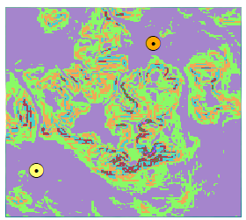

Next, you will reclassify the land cover layer to create another cost surface.

1. Reclassify Land Use Layer

In ArcToolbox open **Spatial Analyst Tools >> Reclass >> Reclassify** tool.

In the Reclassify tool window, set **LandUse** as the *input raster* and **Value** as the *reclass field*.

This time, you will use a predefined classification scheme to recode the slope values.

Click on the **Load...** button in the Reclassify window.

Navigate to your working folder and select the **lc_reclass** table.

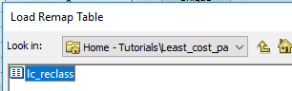

Click on the **Load** button to load the table into the reclassify tool.

The table automatically populates the recode fields for you.

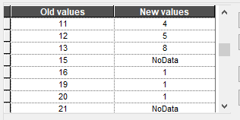

Finally, set the output raster to **…\Least_cost_path\RecLandUse.tif**.

Click **OK** to run the reclassify tool.

If you turn off all raster layers except the **RecLandUse** layer, you’ll note that several pixels have no data (they appear as transparent pixels in the map).

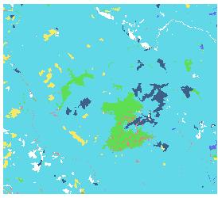

NoData pixels will tell the cost-path tool not to include them in the analysis. The NoData pixels were assigned to water bodies in the reclassify tool.

Now that we have created cost layers for slope and land use, we now must combine the two to create a total cost layer.

1. Create a Total Cost Raster Layer

In ArcToolbox open **Spatial Analyst Tools >> Map Algebra >> Raster Calculator** tool.

In the expression window, type the following expression:

("RecLandUse" + "RecSlope") / 2

Set the output raster to **…\Least_cost_path\Cost.tif**.

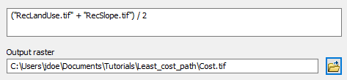

Click **OK** to perform the raster calculation.

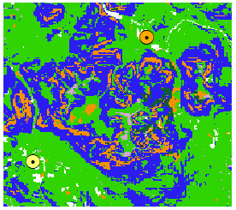

Your new raster layer incorporates both impedance layers (slope and land cover). Note that all NoData pixels remain NoData in the output.

Naturally, you could have added a weight to one of the two layers. In fact, the reclassification scheme used in this exercise is subjective. More objective approaches in defining the cost from the slope and land use layers should be investigated.

1. Create a Cost-Distance and Cost-Direction layer

In ArcToolbox, open **Spatial Analyst Tools >> Distance >> Cost Distance** tool.

The *feature source* data is **Kidney_Pond** (this is the feature we are computing the cost-distance from)

The **input cost** raster is the **Cost raster**.

Set the **output backlink** raster to **…\Least_cost_path\CostDirection**.

The backlink (optional) output is the cost-direction output. We could have computed the cost-direction output separately using the **Spatial Analyst Tools >> Distance >> Cost Back Link**. In essence, we are saving an extra step here.

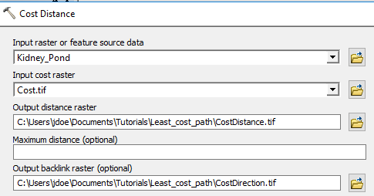

Before we run the tool, we need to tell ArcGIS that the new (to be created) raster’s extent should match that of the other rasters in the map document.

Click on the **Environments** button.

In the Environments Settings window, expand **Processing Extent**.

Set both the extent and the snap raster to **Cost**.

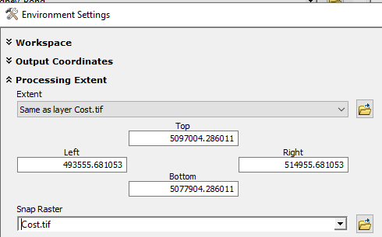

Click **OK** to close the Environment Settings window.

Click **OK** to run the Cost Distance tool.

When the geoprocess completes, you will see two new raster layers in your TOC.

The CostDistance layer shows the cumulative cost distance from Kidney pond to all pixels within the extent. Both the slope and land use impedances influence the results.



The CostDirection layer shows, for each pixel in the extent, the direction to take to follow the least cost path back to Kidney Pond.



It is the cost direction layer that is used in the final step to find the least cost path from Kidney Pond to Russell Pond.

1. Compute the Least Cost Path

In ArcToolbox, open **Spatial Analyst Tools >> Distance >> Cost Path** tool.

In the Cost Path tool, set the feature destination to **Russel_Pond**.

Set the Input cost distance raster to **CostDistance.**

Set the Input cost backlink layer to **CostDirection**.

Set the output raster to **LeastCostPath.tif** in your project folder.

Click **OK** to run the analysis.

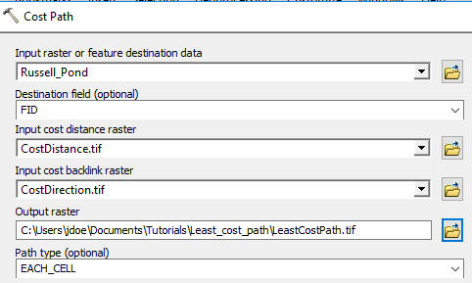

The LeastCostPath layer is a raster layer. It is close to a Euclidean distance except for a couple minor detours around wetlands (which were assigned a relatively high cost in this analysis).

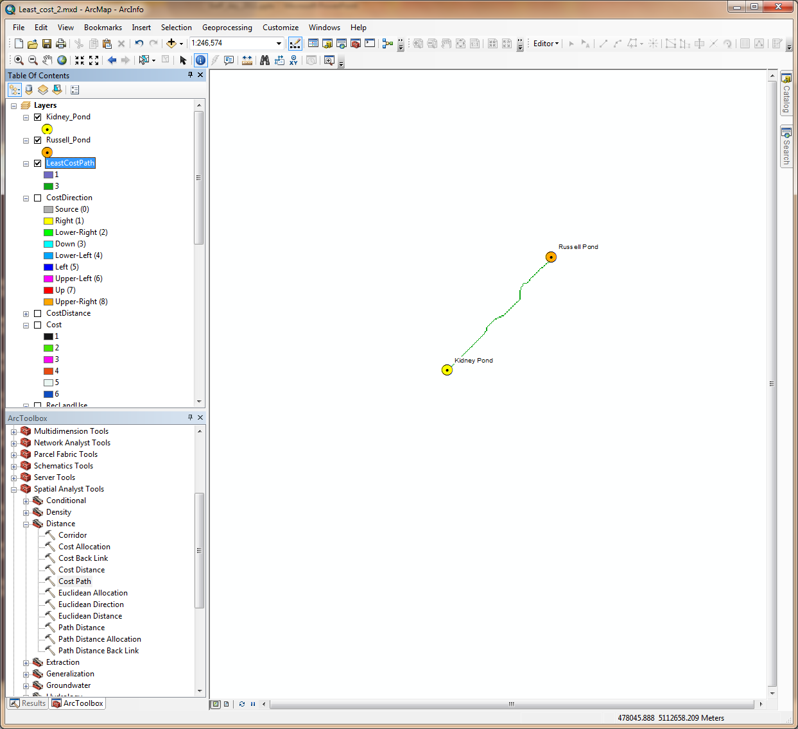

To create a more aesthetically pleasing feature, you can convert the raster path to a vector path.

In ArcToolbox, open **Conversion Tools >> From Raster >> Raster to Polyline** tool.

Set the field parameters as follows:

* Input raster: **LeastCostPath**
* Field: **Value**
* Output polyline features: …**\Least_cost_path\Path.tif**
* Background value: **NODATA**

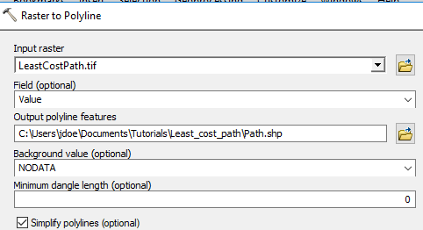

Click **OK** to convert the raster to a polyline.

The new feature is a vector layer.

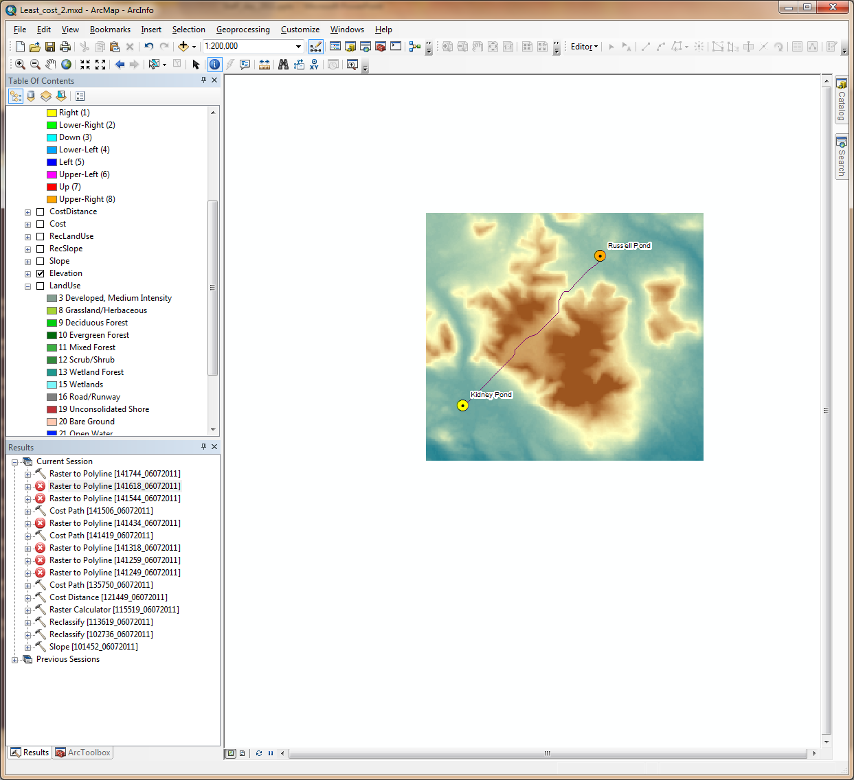

This ends this exercise

 Manuel Gimond, last modified on 7/13/2018