**Managing GIS Data**

|  |
| --- |
| 1. Create a folder called **Data_management_exercise**. On DIA 322 computers, you might want to create this folder in your user Documents folder (e.g. C:\Users\jdoe\Documents\Data_management_exercise). On the DIA 222 computers, you might want to create this folder on the D: drive under D:*course number*\*user name*\ (e.g. D:/ES212/jdoe/Data_management_exercise). 2. [Download the data](Managing_GIS_data_files/Data_management.zip) for this exercise and [extract the files](Opening_zip_files.htm) from the **Data_management.zip** file to your newly created **Data_management_exercise** directory. |

When working on an ArcMap document (one ending with a *.mxd extension) you are accessing one or more data files. These data features are not stored in the *.mxd file but instead can be located in separate folders, geodatabases or across a network connection. Knowing where your GIS data reside is critical when managing and sharing a GIS project.

For this tutorial, you’ll be working with data for the Acadia National Park area. You will learn to use ArcCatalog to copy and delete features from a workspace. You will also learn about folder connections and how to fix broken map document links.

Contents

Step 1: Create a Folder Connection 1

Step 2: Identifying layer source paths 5

Step 3: Creating a File Geodatabase 6

Step 4: Migrating files from one format to another 8

Step 5: Removing GIS files from a workspace 14

Step 6: Fixing broken links in ArcMap 15

1. Create a Folder Connection

Click the **Start** button on the Windows taskbar, point to **All** **Programs >>** **ArcGIS** and click on **ArcCatalog 10**.

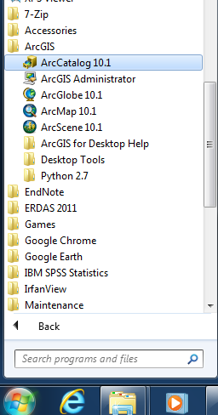

ArcGIS’s file management environment differs from that of a conventional file management environment common to different operating systems. For example, when you first open ArcCatalog, you will notice that your typical root directory structure is gone. For instance, you will not see a **Desktop** folder or a **C:** (or **D:)** drive letter designation. Instead, ArcGIS wants you to explicitly define your workspace(s) such as folders and geodatabases.

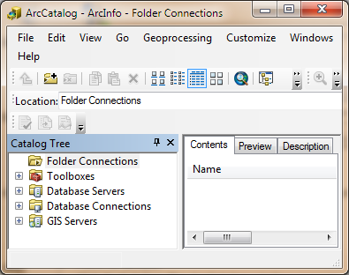

In this exercise, you will restrict your workspace to the **Data_management_exercise** folder.

**Right-click** on the **Folder Connections** folder in the Catalog Tree and click **Connect Folder**.

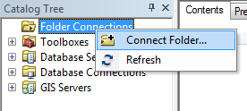

When you select a connection, you can access the data to which it’s linked.

* *Folder connections* let you access folders, or directories, on local disks or shared folders on the network.
* *Database connections* let you access the contents of a database (local or remote).

In the **Connect to Folder** window, navigate to this exercise’s project folder (**Data_management_exercise**) and click **OK**.

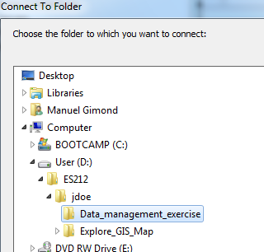

You now should see a new connection under Folder Connections. This connection will persist even when you log off from your desktop. But this connection is not transferable (i.e. if you move your map document to a different PC, the folder connection will not carry over).

In ArcCatalog, make sure that you have this exercise’s workspace selected. In the right window pane you should see a list of GIS files (three shapefiles and one raster) and a map document (Acadia_park).

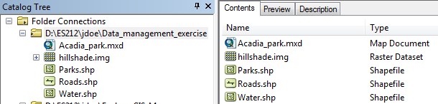

ArcCatalog views the contents of a folder (or database) differently from a standard file management window.

To see this for yourself, open **Windows Explorer** (**not** to be confused with Internet Explorer)

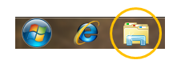Navigate to this exercise’s workspace folder.

Note how different the contents of the folder look between ArcCatalog and Windows Explorer. ArcGIS only displays file formats that can be used in a GIS. In this example, we have two different file formats: a **shapefile** vector format and an **Imagine** raster format. A shapefile format consists of anywhere between three and seven files. In our example, all three vector layers in our project consist of seven files each. Each file of a shapefile layer contains different bits of information. For example, a .prj file contains information about the shapefile’s coordinate system and a .dbf file contains information about the shapefile’s attribute(s).

At this point, it is important to note that GIS data management should be done exclusively inside of ArcCatalog and *not* inside of Windows Manager.

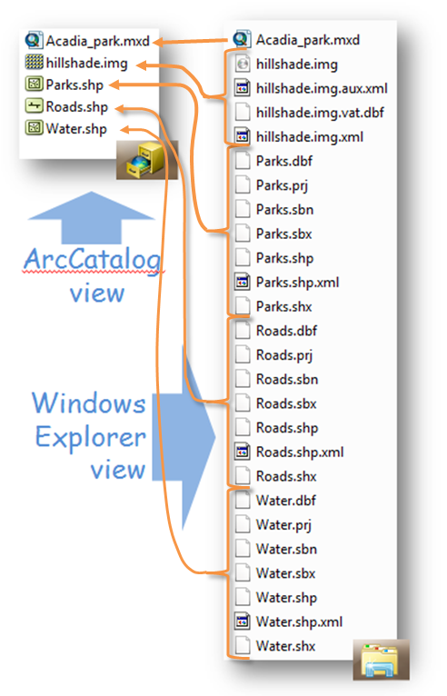

The four different features in the ./Data_management_exercise are used in the Acadia_park.mxd map document as you will discover in Step 2.

**Double-click** on the **Acadia_park** MXD fileto open the map document.

The MXD document should open up inside of Arcmap.

1. Identifying layer source paths

When opening an existing ArcMap document, it is always good practice to locate the source of each layer listed in the Table of Contents (TOC).

In the TOC **click** on the **List By Source** button.

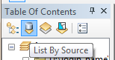

The listing in the TOC will look different. For each layer, the source location is identified. For example, the raster layer hillshade is located in the folder ./Data_management_exercise. The other vectors layers (Roads, Water and Parks) are also located in the .\Data_management_exercise folder. Remember that ArcMap does not store GIS data features in the .mxd document. Instead, it stores *information* about the *source location* for each feature. So when ArcMap draws the hillshade in the Map view window, it accesses the raster file hillshade.img located in the .\Data_management_exercise folder and grabs all the information needed to draw the hillshade layer. So it is vital that all location of all features used in a map document be properly sourced in the TOC.

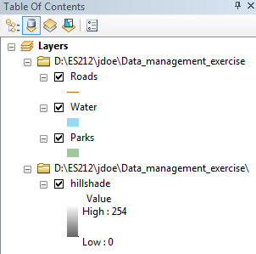

**Close** ArcMap. If asked to save changes, select **No**.

1. Creating a File Geodatabase

GIS data can be stored in many different formats. So far you have been exposed to **shapefile** and **Imagine** file formats. ArcGIS can also store GIS data in more complex data storage structures also known as **geodatabases**. Discussing the advantages/disadvantages of a geodatabase is beyond the scope of this exercise.

ArcGIS can read from many different geodatabases. Some common ones are ArcSDE, PosgreSQL and File Geodatabase. The latter can be easily implemented on personal computer. In the following steps, you will create a new **file geodatabase**.

Go back to your **ArcCatalog** window.

**Right-click** this exercise’s folder connection and select **New >> File Geodatabase**.

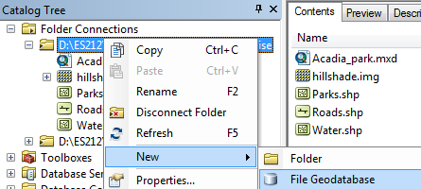

A new file geodatabase will be added to your Data_management_exercise folder.

**Right-click** on the newly created geodatabase and select **rename**.

You will rename the geodatabase **Acadia_data**.

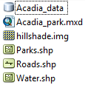

A File Geodatabase is nothing more than a folder. In fact, if you look at your project’s folder in Windows Explorer, you will see a folder called Acadia_data.gdb. The content of this folder may be indecipherable. This should be a reminder to **never** modify the contents of this folder in Windows Explorer.

|  |
| --- |
| NEVER modify the contents of a *.gdb folder outside of ArcCatalog !!! |

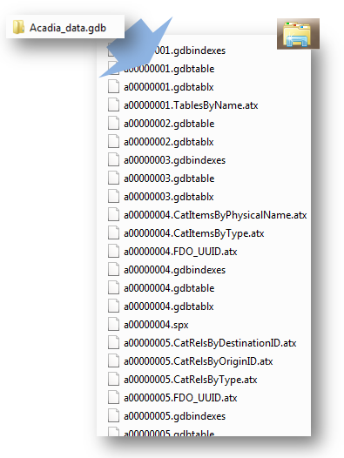

1. Migrating files from one format to another

Your next step will involve **migrating** the four GIS features to the newly created geodatabase **Acadia_data**.

First, you will create a feature dataset (think of this as a folder inside of a geodatabase). Feature datasets are used to spatially or thematically integrate related feature classes. See [here](http://resources.arcgis.com/en/help/main/10.1/index.html#//002300000001000000) for more information.

**Right-click** on the Acadia_data geodatabase and select **New** >> **Feature Dataset**.

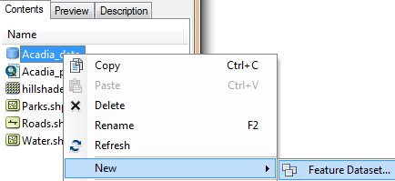

In the **New Feature Dataset** window, name the new feature dataset **Vector_data**.

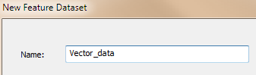

Click **Next**.

Select **Projected Coordinate Systems >> UTM >> NAD 1983 >> NAD 1983 UTM Zone 19N** for the dataset’s coordinate system.

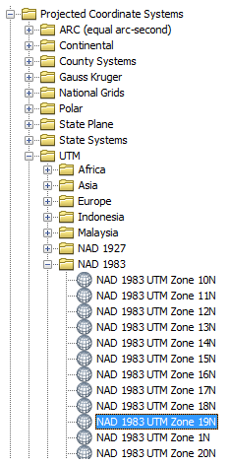

Any features created in or copied to the feature dataset will inherit the UTM NAD83 Zone 19 North coordinate system. If the data need to be reprojected, ArcGIS will reproject on the fly.

Click **Next**.

Click **Next** again (we won’t define a Vertical Coordinate System for this feature dataset).

Click **Finish**.

If you expand you folder connection in ArcCatalog, you should see the newly created Vector_data dataset.

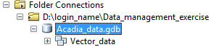

Next, you will copy all three vector files to this dataset.

**Right-click** the new **Vector_data** feature dataset and **select Import >> Feature Class (multiple).**

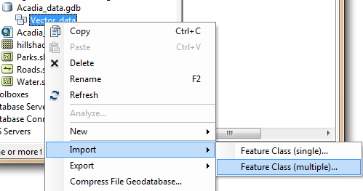

In the **Feature Class to Geodabase (multiple)** window, click on the folder icon  to the right of the **Input Features** field.

Navigate to your **Data_management_exercise** (remember that it is accessed from the *Folder Connections* folder) and **select** the three vector features.

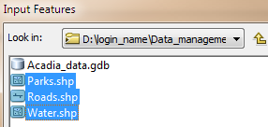

Click **Add**.

The three vector features should now be listed in the window.

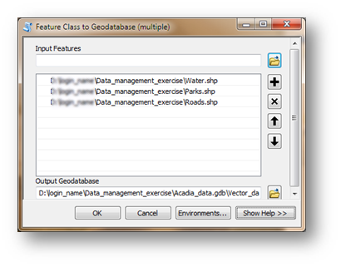

Click **OK** to begin the migration process.

After a few seconds, you should see a ticker-like status bar at the bottom of the ArcCatalog window. This ticker will disappear when the process of loading the features is complete (this may take 10 to 20 seconds)

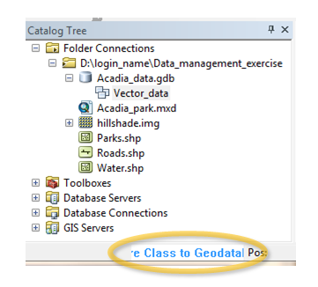

When the status bar disappears, expand the Vector_data feature dataset. You will see all three vector features now stored inside of the newly created geodatabase.

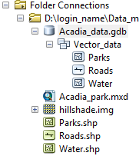

Next, you will copy the raster data feature into the geodatabase. Raster features cannot be stored inside of feature datasets, instead they are stored at the root level of the geodatabase.

**Right-click** on the **Acadia_data** geodatabase and select **Import >> Raster Datasets**.

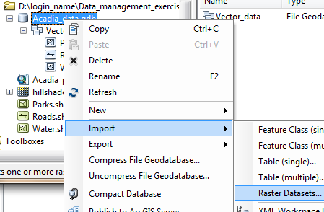

In the **Raster to Geodatabase** window, click on the folder icon  to the right of the **Input Rasters** field.

Navigate to your **Data_management_exercise** connection folder and **select** the **hillshade.img** raster file.

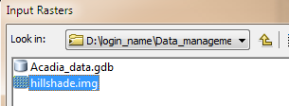

Click **Add**.

Click **OK** to start the Raster-To-Geodatabase process.

When the status bar disappears, expand the Acadia_data geodatabase. You should see the new hillshade raster feature.

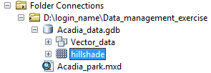

1. Removing GIS files from a workspace

Now that we have all four features (three vectors and one raster) inside of a geodatabase, we no longer need the shapefile and Imagine file versions of these features.

In ArcCatalog, select the **Data_management_exercise** folder connection.

In the right window pane of ArcCatalog you should see the **geodatabase**, the **shapefiles** and **Imagine** raster file.

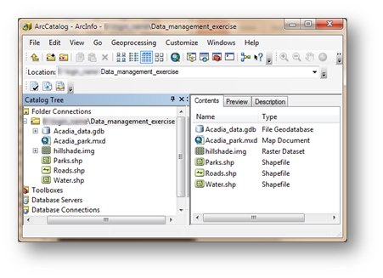

In the right window pane, **select** and **delete** the **hillshade**, **Parks**, **Roads** and **Water** features. (Note that if you did not close ArcMap earlier in the exercise you will need to do so before you attempt to delete the files).

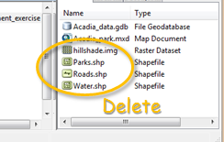

Your Data_management_exercise folder should now look like this:

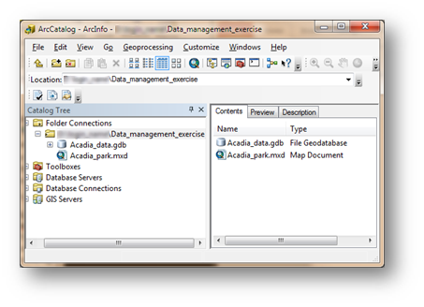

1. Fixing broken links in ArcMap

From inside **ArcCatalog**, double-click on the **Acadia_park** MXD file. This will open the map document in an **ArcMap** session.

You will notice that the Map view window is now blank! You should also notice red exclamation marks next to each layer in the TOC. This map opened fine earlier in this exercise, so what happened?

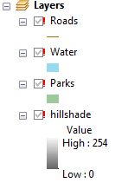

Remember that ArcMap does not store data, but instead points to features (that are stored in separate files or databases). Since we removed the original features (shapefile and raster files), ArcMap cannot find these files. It does not know that we moved the files to a geodatabase. Therefore, we must change the source paths for each layer (i.e. tell ArcMap that those layers now reside in a new geodatabase).

**Right-click** on **Roads** layer and select **Properties**.

In the Layer Properties window, select the **Source** tab.



The Data source window confirms that ArcMap is looking for a **shapefile** called **Roads** located in the Data_managament_exercise folder (the shapefile you deleted in an earlier step). We will provide ArcMap with the new location.

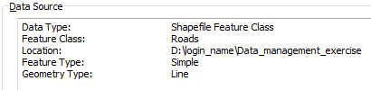

Click on the **Set** **Data Sources** button .

Expand the **Acadia_data.gbd>> Vector_data** and select the **Roads** feature.

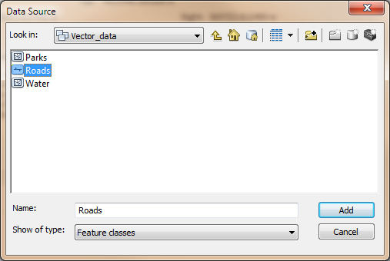

Click **Add**.

The Data Source window should now point to the correct the location.

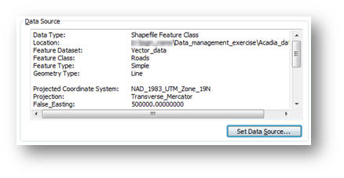

Click **OK** to close the Layer Properties window.

We will **repeat** the same process to fix the source paths for **Water**, **Parks** and **hillshade**.

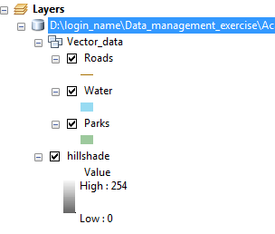

Next you will save the modified map document. But before you do, there is one more step that you will want to perform. ArcMap accepts full source path descriptions (e.g. D:\ES212\jdoe\Data_management_exercise\) or source paths **relative** to the MXD map document location. In most cases, you will want ArcMap to save the source paths using the **relative pathnames** option.

In **ArcMap**, select **File >> Map Document Properties**.

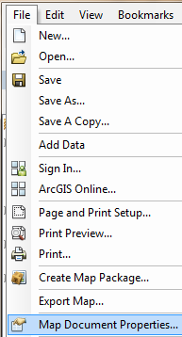

Make sure that **Store relative pathnames to data sources** is checked in the **Map Document Properties** window.



Click **OK** to close the Map Document Properties window.

Now Save your map document by clicking on **File >> Save**.

This completes this exercise.

 Manuel Gimond, last modified on 8/23/2016