**Working with Zip Files**

A *zip file* is a file format used for compressing and archiving files and folders. It facilitates moving and sharing multiple files and folders. This tutorial steps you through the extraction of files and folders from a zip file.

Contents

Step 1: Opening and viewing the contents of a zip file 1

Step 2: Extracting the zipped files to a permanent location 2

1. Opening and viewing the contents of a zip file

Click **here** to download the zip file used in this tutorial.

Depending on the browser used, you may be presented with the following window. If not, you will need to navigate to the Download folder on your PC and locate the map.zip file you just downloaded.

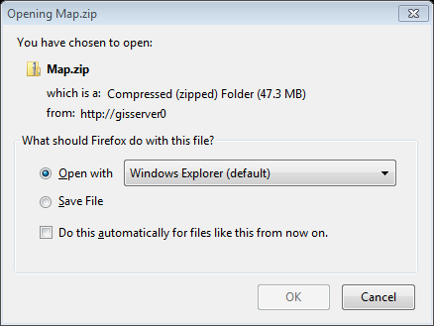

Click **OK**.

This will bring up the familiar Windows file manager environment. However, this window behaves a bit differently: it shows the *contents* of the *maps.zip* file. These files are not to be operated on; at least not until they are extracted. Therefore you should not attempt to open these files in ArcMap or any other application!

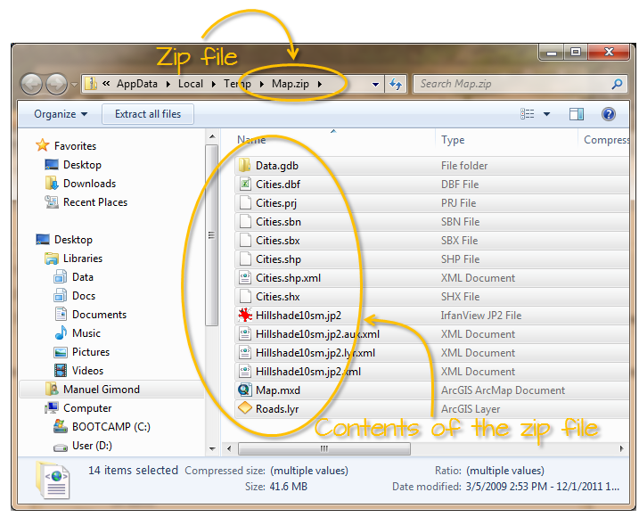

The next step is to extract the files from the zip file and copy them to your project folder.

1. Extracting the zipped files to a permanent location

Select all the files in the file manager window and click on **Extract all files**.

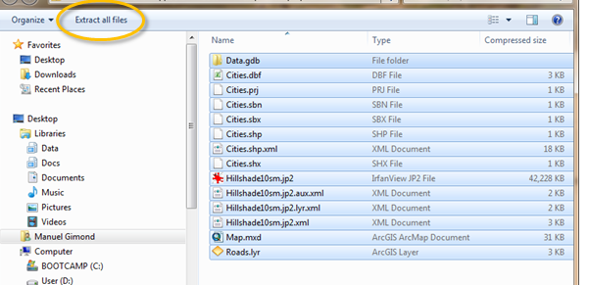

You are then presented with a *destination folder* window.

Click on the ***Browse…*** button and then navigate to the folder where you want to extract the files to. In this exercise, you will navigate to the **D:** drive.

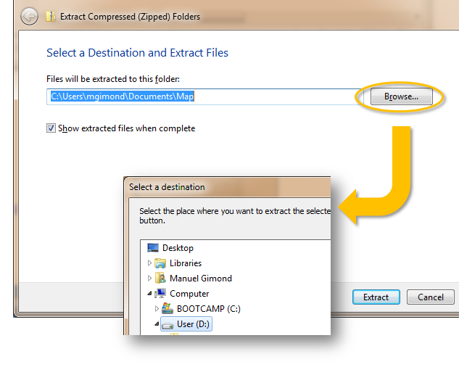

In the **Select a destination** window, click on **Make New Folder** button (near the bottom of the window). A new folder will get created on the D: drive, change the default name to *Zip_file_tutorial*  then click **OK**.

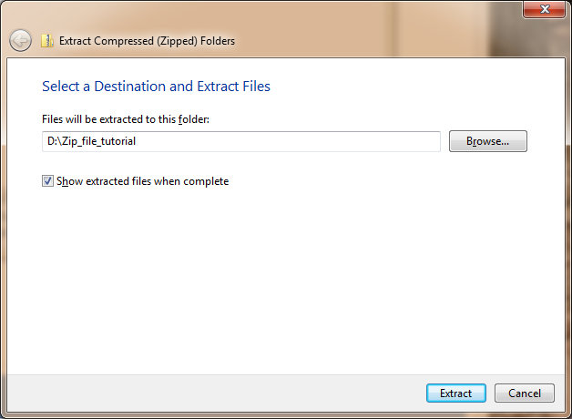

Click on the **Extract** button.

A new file manager window should pop-up showing the extracted contents of the zip files.

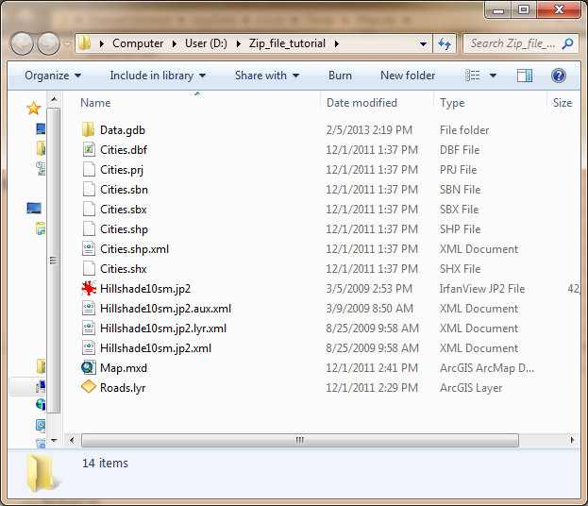

At this point, you can work on the extracted files as you would with any other files.

 Manuel Gimond, last modified on 2/5/2013