**Symbolizing Features**

|  |
| --- |
| 1. Create a folder called **Symbology**. On DIA 322 computers, you might want to create this folder in your user Documents folder (e.g. C:\Users\jdoe\Documents\Symbology). On the DIA 222 computers, you might want to create this folder on the D: drive under D:*course number*\*user name*\ (e.g. D:\ES212\jdoe\Symbology). 2. [Download the data](Symbolizing_features_files/Symbology.zip) for this exercise and [extract the files](Opening_zip_files.htm) from the Symbology.zip file to your newly created **Symbology** directory. |

In this exercise, you will learn how to symbolize features based on their geometric characteristics and their attribute type. You will also learn how to add data frames, modify their coordinate systems and generate a final map layout.

Contents

Step 1: Open Map document 1

Step 2: Symbolize counties by farm acreage 2

Step 3: Add river features and labels 13

Step 4: Add state boundaries 16

Step 5: Symbolize cities by population 18

Step 6: The map layout 21

Step 7: Adding additional elements to the map document 31

1. Open Map document

Navigate to your **Symbology** folder and open the map document **Symbology.mxd** in ArcMap.

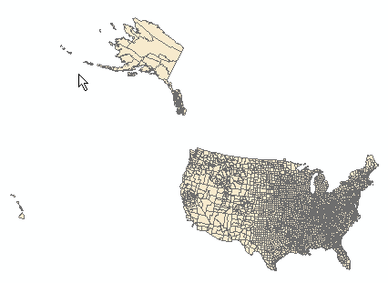

The map document is made up of a single data frame called “**Layers**”.

The data frame contains four layers: **Cities**, **Rivers**, **States** and **Counties**.

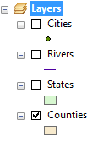

Next, you will create a [choropleth](http://en.wikipedia.org/wiki/Choropleth_map) map based on cropland distribution.

1. Symbolize counties by farm acreage

Right-click on **Counties** layer and select **Open Attribute Table**.

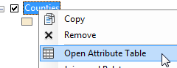

There is a field called CROP_MI07 that lists the total surface area of croplands within each county (units are in square miles). You will symbolize the counties using this field.

Close the attribute table.

Right-click on **Counties** layer and select **Properties**.

Select the **Symbology** tab .

Select **Quantities** in the left window pane then select **CROP_MI07** in the *Value* field. Choose a **green** color ramp.

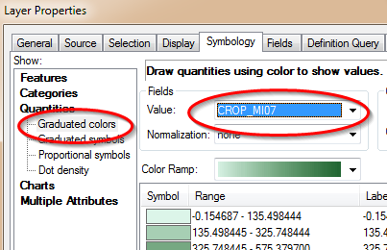

Click **OK** to accept the symbology changes and close the Layer Properties window.

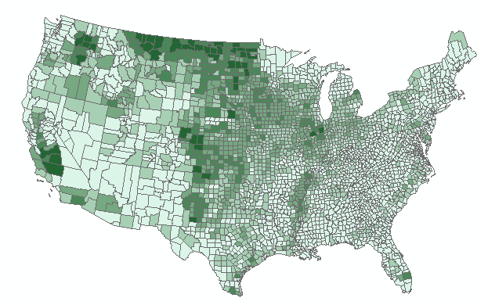

Note the distribution of “high” values around Montana and the Dakotas. Remember that we are looking at **total** acreage within each county. Also note that each county has **different** total area and shape. Symbolizing heterogeneous polygons using ‘count’ or ‘enumerated’ data can mislead the intended audience. It is therefore best to *normalize* such data by polygon surface area. The field that lists total county area in square miles is **SQMI**.

Open the **Counties** **Properties** window again (right-click Counties and select Properties).

Make sure that the **Symbology** tab is selected.

Under Normalization, select **SQMI**.

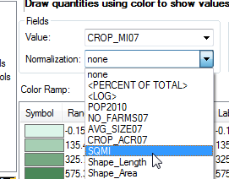

This instructs ArcMap to divide all crop area values (CROP_MI07) by the total area of each county polygon (SQMI).

Before we accept the changes, we will make a few changes to the symbols. We will remove the dark outline from each polygon to emphasize the distribution of cropland across the US and we will increase the number of classes to 7.

Change the number of **classes** from **5** to **7**.

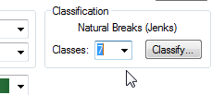

**NOTE**: in the following step, you are asked to open the **Properties for All Symbols** menu. As of version 10.4, the dialog box will not open. This is a known [bug](https://support.esri.com/en/bugs/nimbus/QlVHLTAwMDA5NDI4Mg==). The workaround is to select *all* color symbols then select the **Properties for selected symbol(s)** option instead. The original workflow is still shown in this tutorial for backward compatibility but should be replaced with the aforementioned workaround if using version 10.4 or later.

Click on the header **Symbol** (the column name just above the list of symbol swatches) and select **Properties** **for All Symbols**.

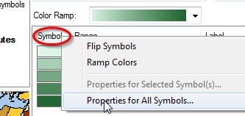

In the Symbol Selector window change the **Outline Color** to **No Color**. Be careful **not** to change the color settings for *Fill Colo*r!

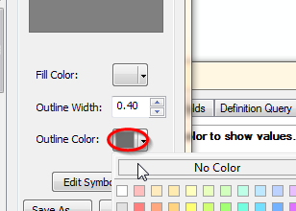

Click **OK** to close the Symbol Selector window.

Click **OK** to close the Properties window.

Looking at the legend, we notice some oddities in the range of values. The range starts off with a negative value (-0.077) but it’s clear that we cannot have ‘negative’ area!

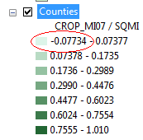

Open the **Counties** attribute table.

Looking a bit more closely at the data in the attribute table, we spot many ‘-99’ values under the **CROP_ACR07** field. Why does this matter? Well it turns out that **CROP_MI07** was calculated from the **CROP_ACR07** field by multiplying the CROP_ACR07 by 0.0015625 (conversion coefficient from acres to square miles). This explains the -0.1547 values found in the CROP_MI07 attribute field. Of course, this is information you could not glean from the data. This is something you obviously were not expected to know unless documentation for the data was readily available. This is an example why data documentation (metadata) is critical!

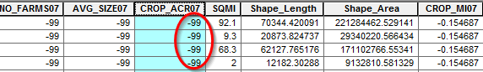

So what does the -99 value represent? Fortunately, this bit of information is documented in the Counties layer’s metadata.

You may need to change the view settings for your metadata window by accessing **ArcMap Options** from the **Customize** pull-down menu, then selecting the **Metadata** tab, and choosing the **FGDC CSDGM Metadata** style.

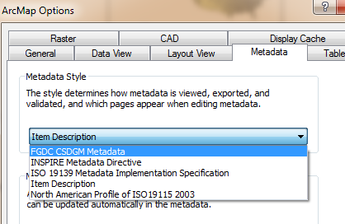

Click **OK** to close the **ArcMap** **Options** window.

Right-click **Counties** and select **Data** >> **View Item Description**.

Under the **ArcGIS Metadata** tag, scroll down (about ¾’s of the way down) to the **Fields** section**.**

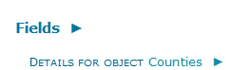

Then look for the attribute field **CROP_ACR07**.

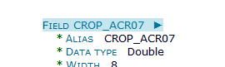

Looking at the list of values for the field CROP_ACR07, we discover that **-99** is a placeholder for **no data**. Therefore we should change the map symbology such that counties with no data are indicated as such in the map.

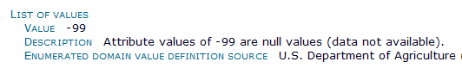

**Close** the Metadata window.

Also note that at the other end of the Counties layer range of values, we spot a value greater than 1.0 (which implies that there is more cropland area than county area). This is obviously an anomaly most likely due to error in measurements (i.e. crop area was probably computed at a different scale). Fortunately, only a single polygon (county) has a value greater than 1. Looking at an aerial view of the aforementioned county, it’s clear that the majority of that county is under cropland.

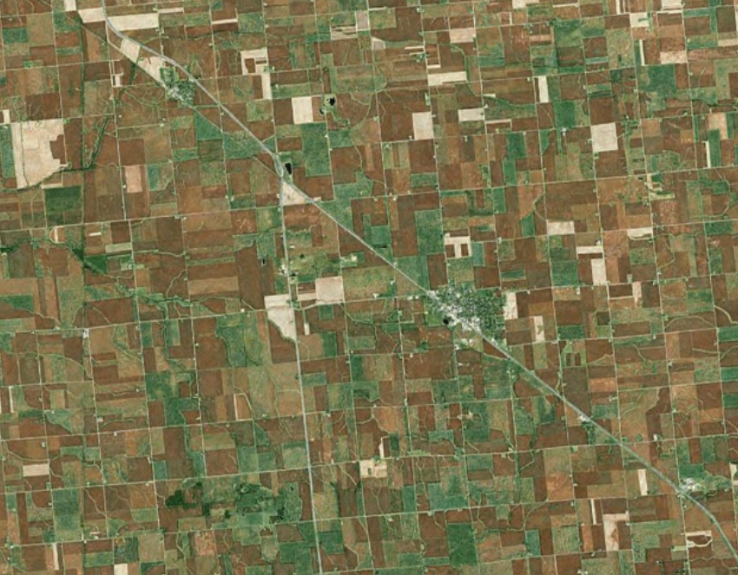

We will change the classification scheme to symbolize -99 as no data and round the value of 1.01 down to 1.

Open **Counties’** properties window.

Make sure that the **Symbology** tab is selected.

Click on the **Classify** button.

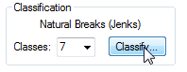

By default, ArcMap chooses a Natural Breaks classification scheme. We will change it to an equal interval scheme.

Select **Equal Interval** as the **Classification Method** type.

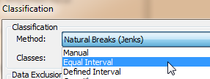

This ensures that intervals between each classification break are equal.

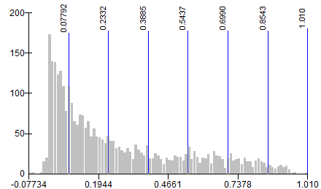

Next, you will add another classification break for all -99 crop land area features.

Right **click somewhere** on the far left side of the graph and select **Insert Break**.

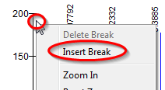

With the new break line still active (it should be colored red), type **0.0** in the **Break Values** window.

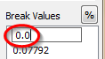

Click **OK** to close the Classification window.

In the Layer Properties window, click in the **Label** column header and select **Format Labels** from the pull-down option.

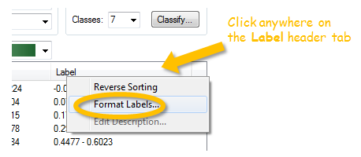

Change the category to **Percentage** and select the ***‘…number represents a fraction…’*** option.

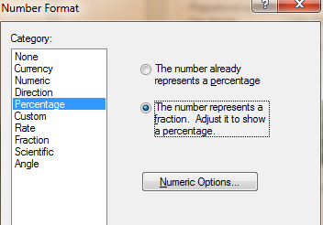

Click on the **Numeric Options**  button.

Set the Number of decimal places to 0.

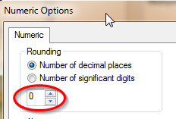

Click **OK** to close the Numeric Options window.

Click **OK** to close the Number Format window.

Change the first label name to **No Data** (just select the field to edit it).

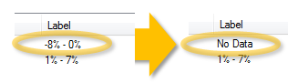

Likewise, change the last label to **86% - 100%.**

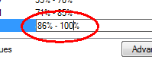

To isolate the No Data symbol, you will change its color to a more neutral color.

Double-click on the No Data symbol and change its color to 10% gray.

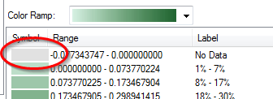

Click **OK** to close the Layer Properties window.

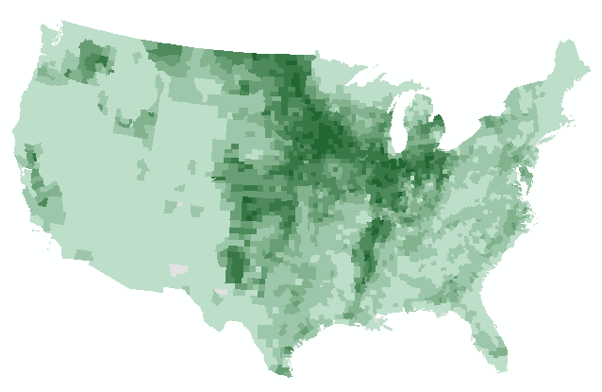

1. Add river features and labels

Turn on the **Rivers** layer in the TOC.

Open **Rivers**’ **properties** window.

Make sure that the **Symbology** tab is selected.

You will symbolize all river features with the same symbol type.

Click on the **symbol**.

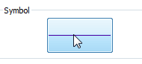

Change the color to **Cretan Blue**.

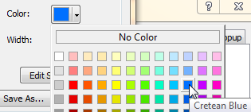

Click **OK** to close the Symbol Selector window.

Click **OK** to close the Layer Properties window.

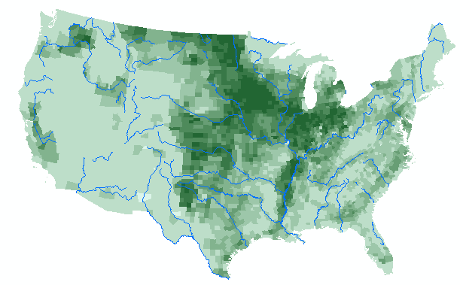

Next, you will have ArcMap automatically place the river labels.

Open the **Rivers**’ **properties** window.

Click on the **Labels** tab .

Check off the **Label features** box.

Select **Name** as the Label field.

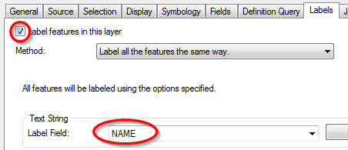

Click on the **Placement** **Properties** button.



Select **Curved** orientation.

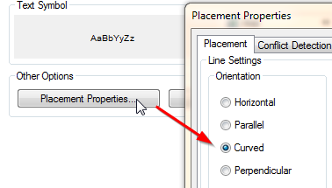

Click **OK** to close the Placement Properties window.

Change the label font to **Times New Roman**, ***Italic*** and **Cretan Blue**.

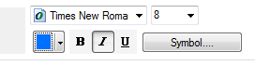

Click **OK** to close the Layer Properties window.

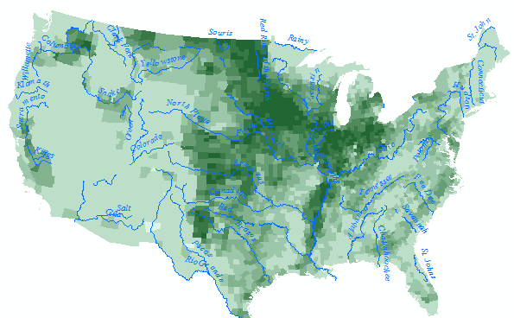

In the next step, you will add States outline.

1. Add state boundaries

Turn on the **States** layer.

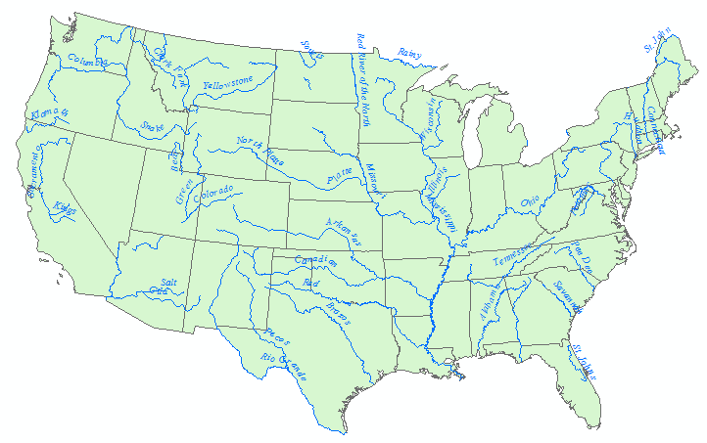

The States layer is masking out the farm cropland layer. Since we only want to display the boundaries, we will remove the fill color.

Open the States’ **Properties** window.

Select the **Symbology** tab.

Click on the Symbol.

For **Fill color**, select **No Color**.



Click **OK** to close the Symbol Selector window.

We will also have ArcMap label the States.

In the **Properties** window, select the **Labels** tab.

Set the label properties as follows (use Gray 40%).

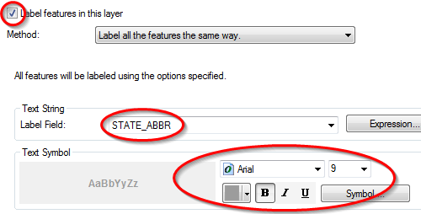

Click **OK** to close the Layer Properties window.

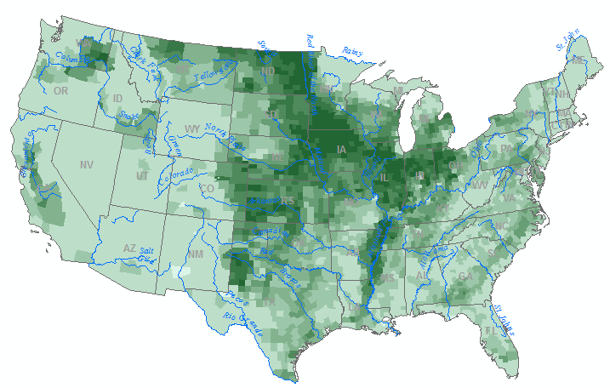

Next, you will symbolize cities by population count.

1. Symbolize cities by population

Turn on the **Cities** layer.

Open Cities’ **properties**.

Select the **Symbology** tab.

Select **Quantities >> Proportional symbols**.

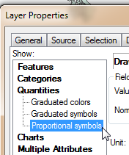

Use the **POP2007** value to define the symbol sizes.

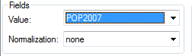

Click on the **Min** value button.



Set the color to **Electron Gold**.

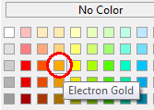

Set the **minimum** value circle size to **1.00**

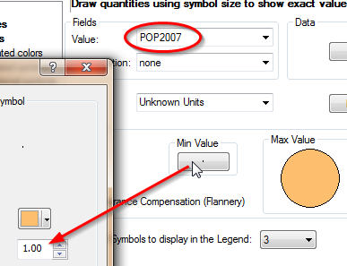

Click **OK** to close the **Symbol Selector** window.

Click on the **Display** tab and set the **transparency** value to **40%**.

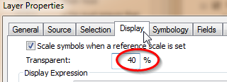

Click **OK** to close the Layer properties window.

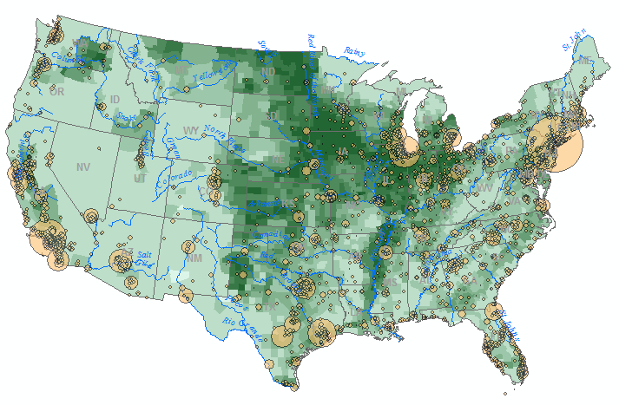

Next you will setup the map layout.

1. The map layout

From the **View** pulldown menu, select **Layout View**.

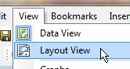

One challenge in displaying all 50 states is dealing with the vast amount of empty space between Hawaii, Alaska and the 48 contiguous states.

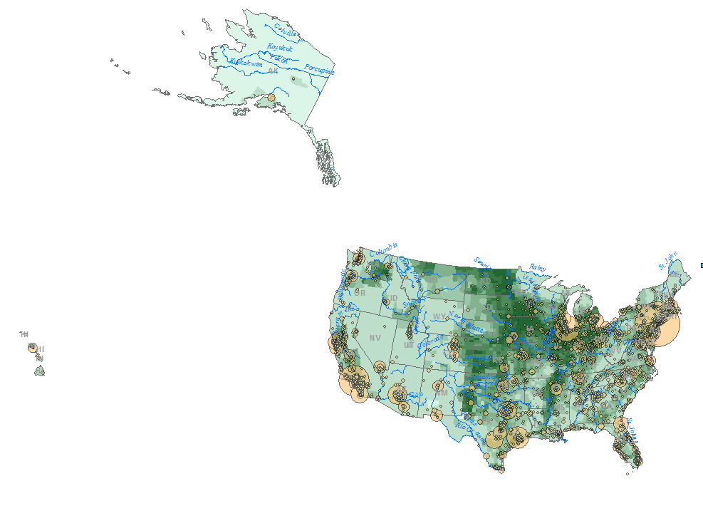

To resolve this issue, you will create three *separate* data frames: one for **Hawaii**, one for **Alaska** and one for the **48 states**.

So as not to have to recreate all the layer symbols for each data frame, you will copy and paste the existing data frame twice.

**Right-click** anywhere on the **data frame** in the TOC and select **Copy** (make sure that you are in layout mode!).

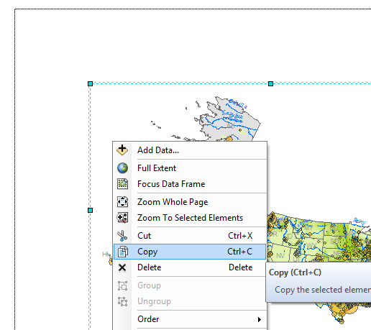

From the **Edit** pulldown menu, select **Paste**.

You should now see a duplicate of the original data frame in the TOC and in the map layout.

Rename the new data frame **Hawaii**.

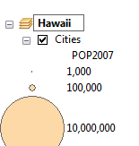

You will now paste another copy of the data frame for Alaska.

From the **Edit** pulldown menu, select **Paste**.

**Rename** the new data frame **Alaska**.

**Rename** the original data frame **48 States**.

Collapse all data frames in the TOC.

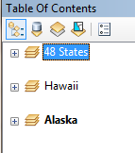

Right-click the **Alaska** data frame and select **Activate**.

This action make the Alaska data frame active in the Layout view.

Resize the Alaska data frame to about a quarter of the page.

Move it to the lower left hand corner of the map layout.

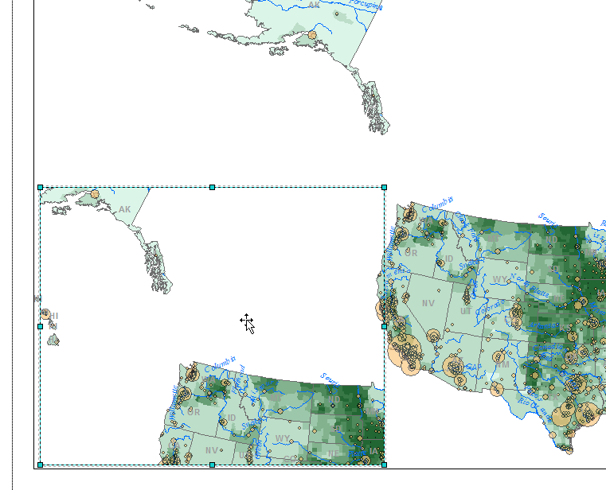

Next, you will resize and reposition the Hawaii data frame.

Selecting the correct data frame in a map layout when data frames overlap can be challenging. To ensure that you have selected the proper data frame, use the space bar.

Holding down the **space bar**, select a data frame in the data view window. Keep clicking on the overlapping data frames until you see **Hawaii** ‘**bolded’** in the **TOC**. (Alternatively, you could have **right-click** the **Hawaii** data frame in the **TOC** and selected **Activate**).

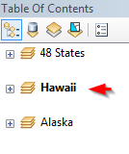

**Resize** the **Hawaii** data frame and **relocate** it to the bottom of the map layout (you will refine the positioning later).

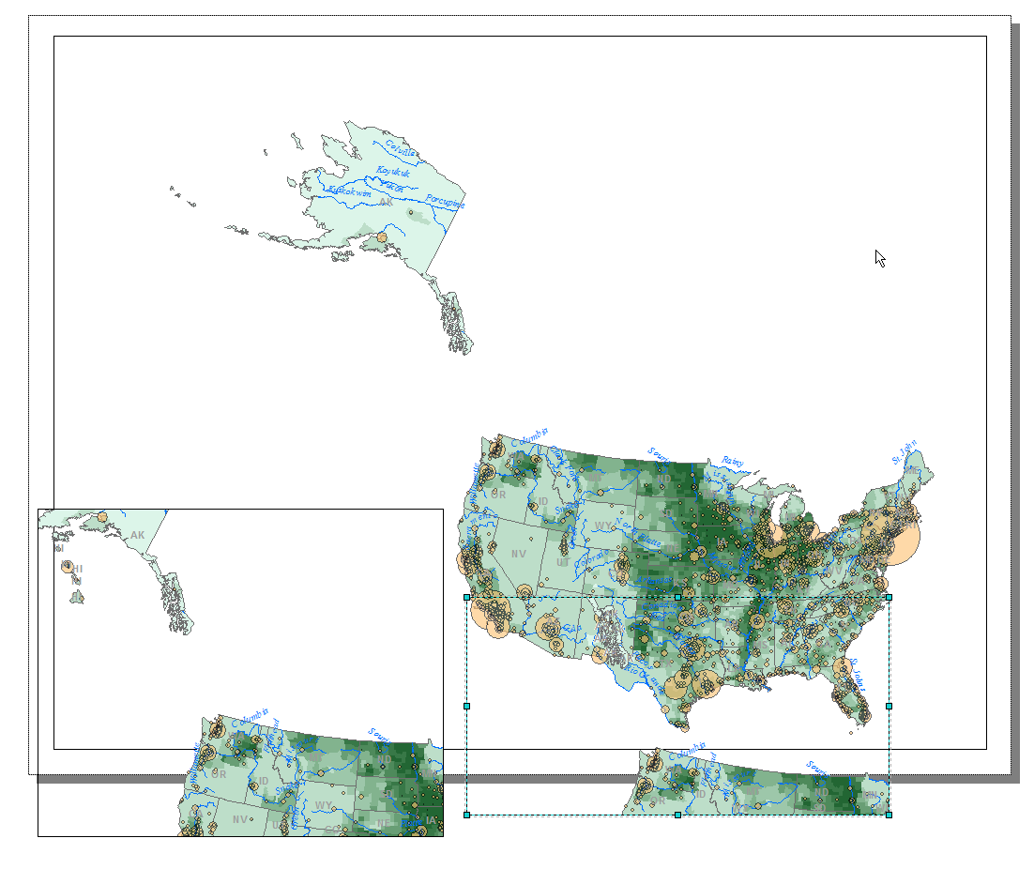

**Activate** the **48 States** data frame (right-click on the data frame and select activate).

From the **Tools** toolbar, select the **Zoom In** icon (be careful not to select the Zoom In icon from the layout toolbar).

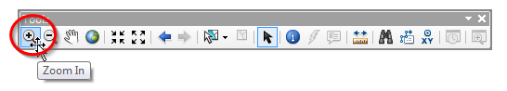

In the **48 States** data frame, **zoom in** on the 48 States.

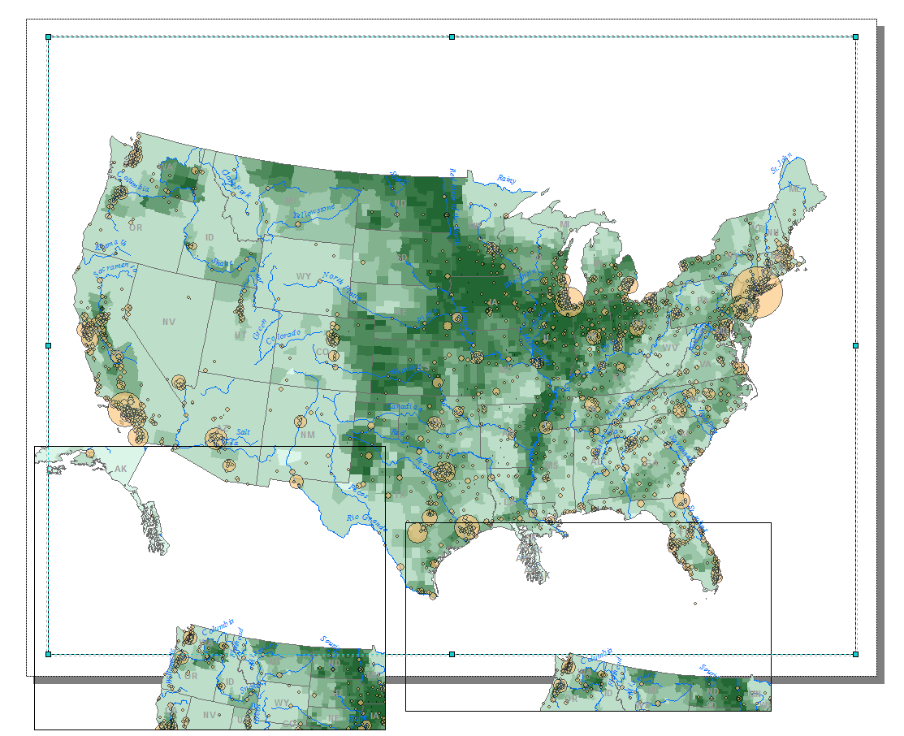

For the Hawaii and Alaska data frames zoom in on Hawaii and Alaska, respectively (don’t forget the **activate** the proper data frame).

Note: you will probably need to use the **Pan tool**  to move around within each data frame.

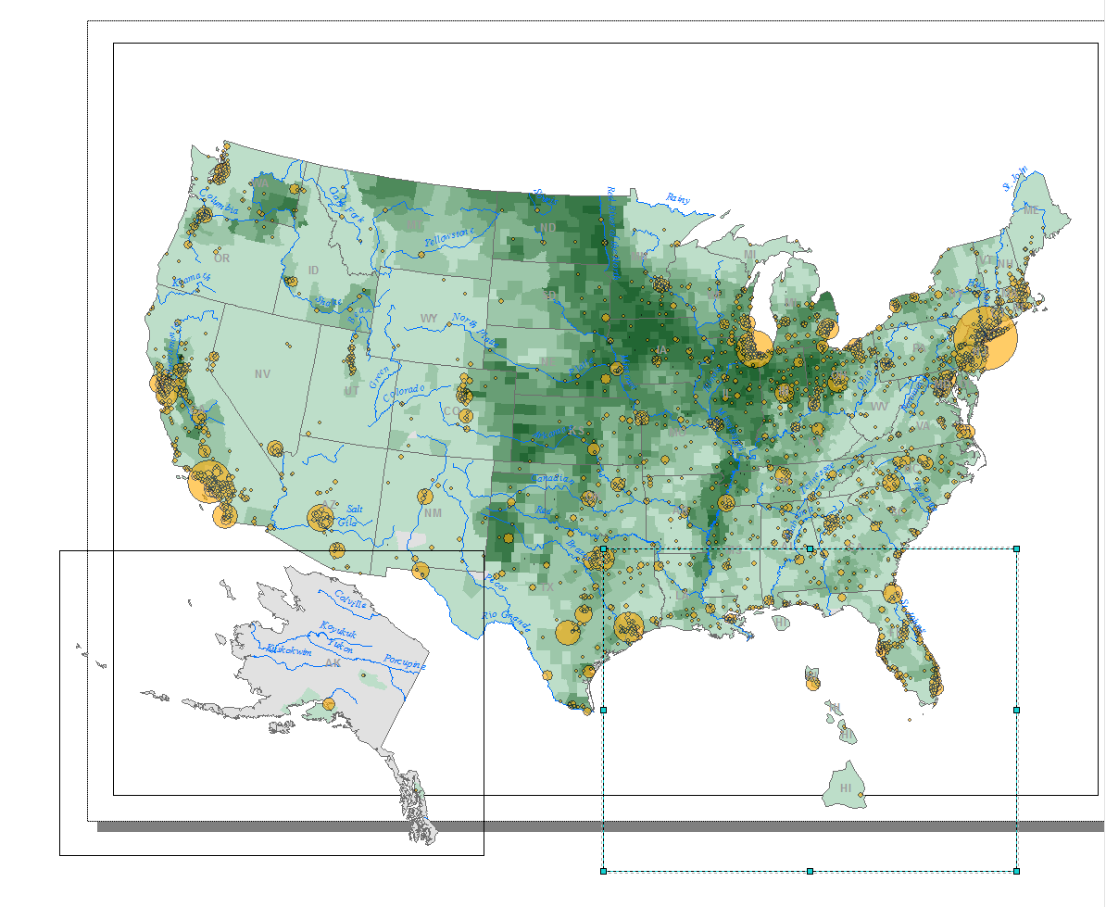

Clearly the orientation of both Hawaii and Alaska are not ideal. Also, you might note some slight distortion in their shapes. This is because they inherited a projected coordinate system best suited for the 48 states. To resolve this, you will define different coordinate systems for Hawaii and Alaska.

Right click on the **Hawaii data frame** and select **Properties**.

Select the **Coordinate System** tab.

Select the following **predefined coordinate system**:

**Projected Coordinate Systems >> Continental >> North America >> Hawaii Albers Equal Area Conic**

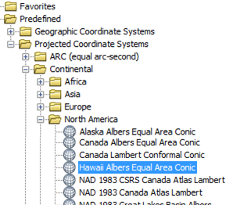

Click **OK** to close the Data Frame Properties window.

Click **Yes** to close a Warning window if it pops-up.

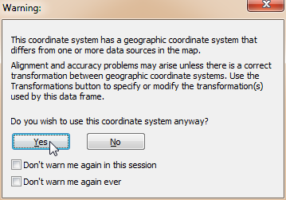

Right click on the **Alaska data frame** and select **Properties**.

Select the **Coordinate System** tab.

Select the following **predefined coordinate system**:

**Projected Coordinate Systems >> Continental >> North America >> Alaska Albers Equal Area Conic**

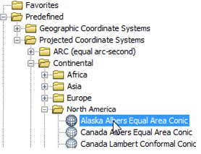

Click **OK** to close the Data Frame Properties window.

Next, you will set the scale to all three data frames so that they match (this is important if you are to place a scale bar in the final map layout).

For **each** data frame, set the **scale** to **1:25,000,000** (don’t forget to activate the data frame before changing the scale).

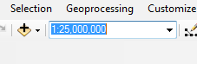

Next you will remove the data frame borders for all data frames.

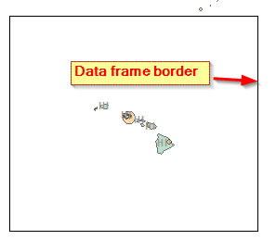

Open the **Hawaii** data frame **Properties** window**.**

Select the **Frame** tab.

Under the **Border** option, select **None**.

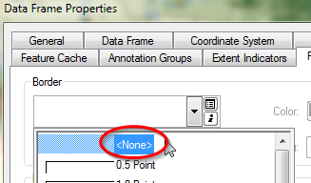

Click **OK** to close the Data Frame Properties window.

Using the procedure just outlined, **remove** the **Alaska** and **48 States** data frame **border**.

Rearrange the three data frames to match the following graphic.

Feel free to pan the maps  within each data frame as needed but **do not** change the scales (they should all remain at 1:25,000,000). For example, make sure that the southern tip of Alaska does not show up in the **48 States** data frame.

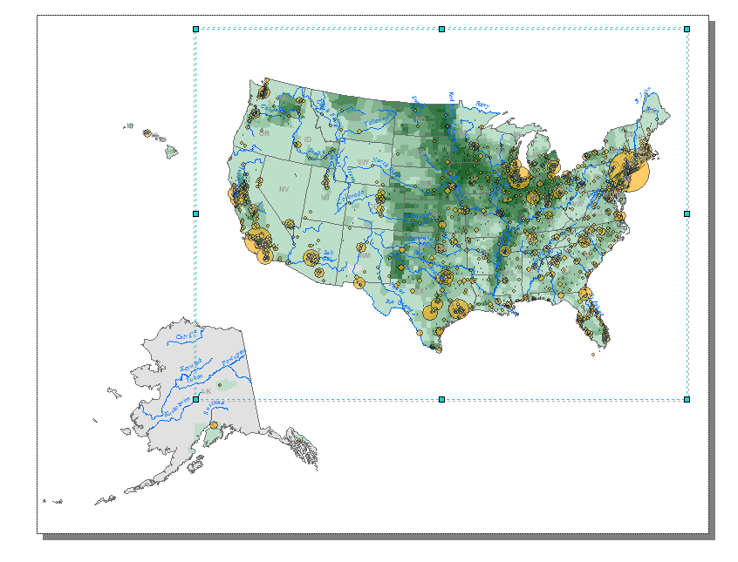

1. Adding additional elements to the map document

Next, you will add a title, legend and scale bar.

From the **Insert** pulldown menu, select **Title**.

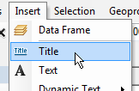

In the Insert Title window type ***Cropland distribution in the United States***.

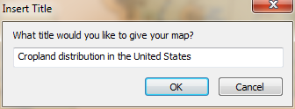

Click **OK**.

Move the title to the top of the page.

You can change the text properties by accessing its properties menu.

Right-click on the **title** and select **Properties**.

In the Properties window, click on the **Change Symbol** button.

In the Symbol Selector window, change the font size to **24**, **bold** and color to **60% Gray**.

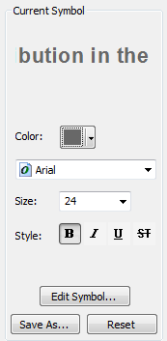

Click **OK** to close the Symbol Selector window.

In the Properties window, set the character **spacing** to **2.00**.

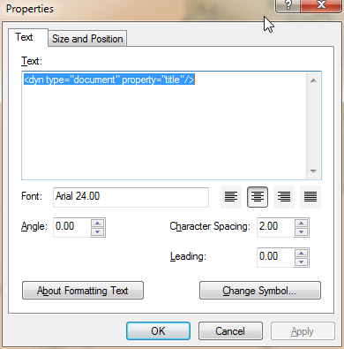

Click **OK** to close the Properties window.

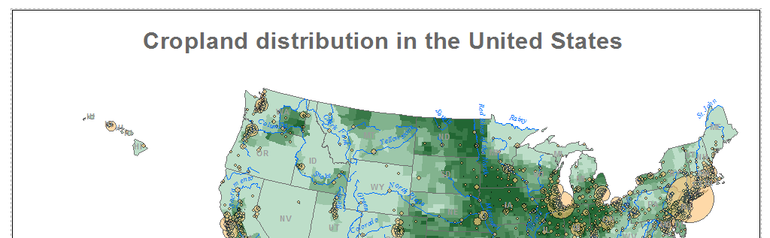

Next, you will add a legend.

From the **Insert** pulldown menu, select **Legend**.

In the Legend Wizard window, **remove** *Rivers* and *States* from the legend list by selecting them (select both while holding down the control key) and clicking the single left arrow button .

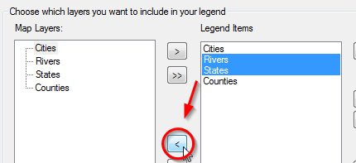

Click **Next**.

**Remove** the text **Legend** from the Legend Title (leave the field blank).

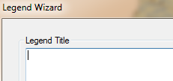

Click **Next**.

Click **Next** again.

And click **Next** one more time.

Click **Finish** to close the legend wizard window.

By default, the legend window is created as a single column. This will clearly not fit in our current map layout.

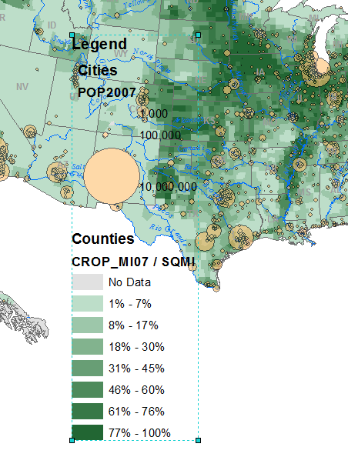

At this point you might be wondering which data frame’s legend element was added. ArcMap will only add the legend element associated with the selected data frame. Since all three data frames in our map document share the exact same layers and associated symbology, it does not matter which data frame was selected when we added the legend element.

Like all map elements, we can access the legend element properties.

Right-click on the **legend** element and select **Properties**.

Select the **Items** tab.

In the Legend Properties window, select **Counties** and check off ***Place in new column***.

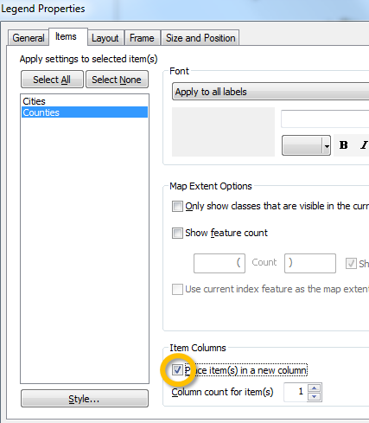

Click **OK**.

This last step placed the **Counties** legend element in a second column.

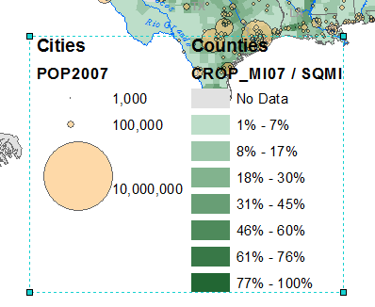

Resize the legend element so that it fits nicely under the 48 states data frame.

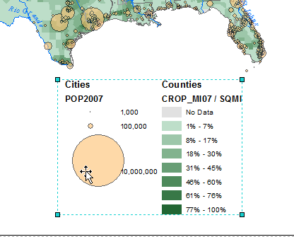

The legend elements are dynamically linked to the TOC. Therefore, to make changes to the legend labels/headers, one needs to change those items in the TOC.

Another way to change legend elements is to convert them to ‘graphic’ elements and make the edits within the layout view window. This provides more control over the placement of the legend elements. However, once the legend elements are converted, the dynamic link between the legend’s content and those inside the TOC is lost.

Right-click on the **Legend** element and select **Convert to Graphics**.

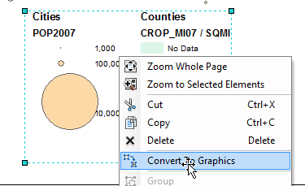

Next you have to ungroup the graphical elements.

Right click on the legend graphic and select **Ungroup**.

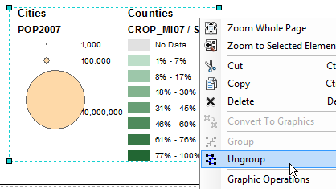

You can now edit the legend headings.

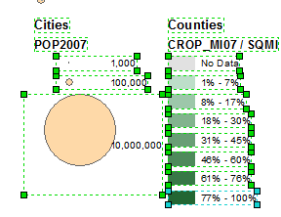

Right-click the **Counties** **text** graphic and select **Properties**.

In the Properties window, change the text to **Percent cropland**.

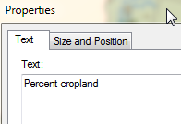

Click **OK**.

Select and **delete** the **Crop_MI07 / SQMI** text.



Likewise, rename the **Cities** text to **City population** and delete the **POP2007** text.

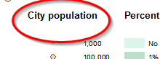

Now on your own, rearrange the legend elements as you see fit.

If you need to separate the text from the color swatch **right-click** the element and select **ungroup**.

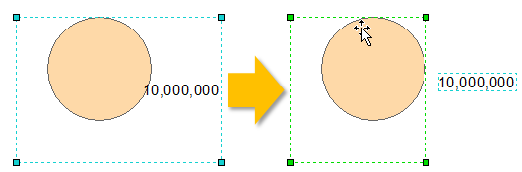

You can use this graphic as inspiration (note that the 1000 population symbol was removed in this example):

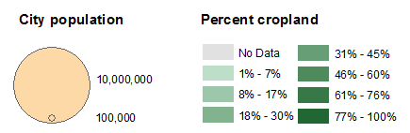

If you have **overlapping** graphics and wish to move the ‘front’ graphic to the ‘back’, right click on the graphic and **select order >> Send to Back**.

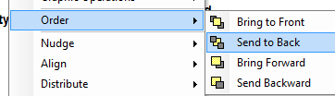

Next, you will add a scale bar.

Since all data frames inherent the same scale (1:25,000,000), it does not matter which data frame is selected when inserting a scale.

From the **Insert** pull-down menu, select **Scale bar**.

In the Scale bar Selector window, select **Scale Line 1** (the top scale symbol).

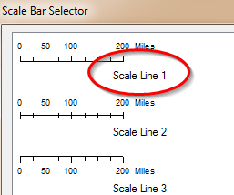

Click on the **properties** button.

Under the **Scale and Units** tab , select **Miles** for division units.

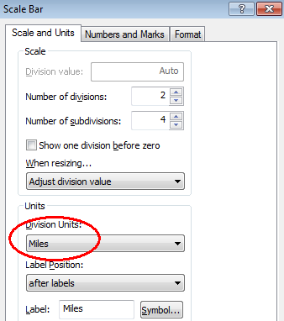

Click **OK** to close the Scale bar window.

Click **OK** again to close the Scale Line properties window.

Move and resize the scale bar as needed.

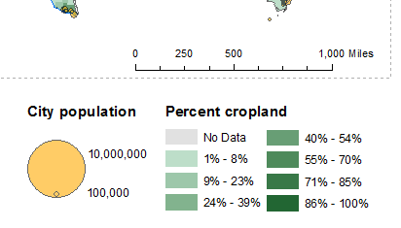

We could add a north arrow indicator, but given that the coordinate system used does not do a good job in preserving north-south direction across the map’s extent, we will opt not to add this graphic.

On your own, finalize the map by making any touch-ups you see fit.

Feel free to glean inspiration from the following graphic:

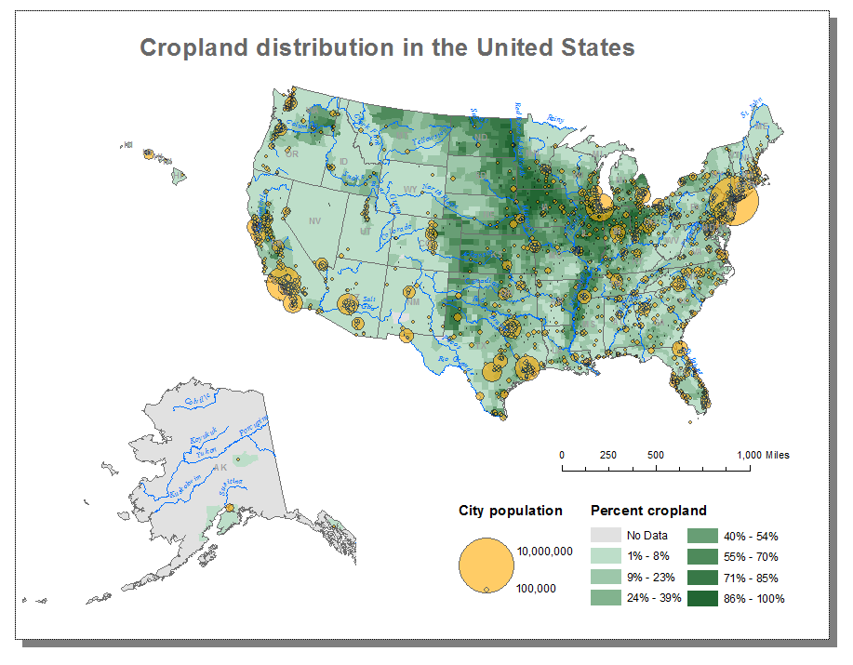

**Save** your map document.

 Manuel Gimond, last modified on 8/24/2016