**Tissot’s Indicatrix Circles**

|  |
| --- |
| 1. Create a folder called **Tissot**. On DIA 322 computers, you might want to create this folder in your user Documents folder (e.g. C:\Users\jdoe\Documents\Tissot). On the DIA 222 computers, you might want to create this folder on the D: drive under D:\course number\user name\ (e.g. D:\ES212\jdoe\Tissot). 2. [Download the data](Tissot_circle_files/Tissot.zip) for this then [extract the files](http://gisserver0.colby.edu/10/Opening_zip_files.htm) from the **Tissot.zip** file to your newly created **Tissot** directory on the D: drive. |

|  |  |
| --- | --- |
| In the nineteenth century, Nicolas Auguste Tissot developed a method to analyze map projection distortion.   Small circles on the earth's surface are projected using different projection types. The resulting ellipse of distortion, or indicatrix, shows the amount and type of distortion at the location of the ellipse.   For example, if an indicatrix is elongated from north to south, shape is correspondingly distorted at that location on the map. The same goes for east-west stretching or oblique stretching. On a conformal map, the indicatrices are all circles, but they vary in size. On an equal area projection, the indicatrices have varying ellipticity, but the same area.  [src: ESRI] |  |

In this exercise, you will create geodesic circles on a spheroid representation of the earth. These circles will be used as a reference to evaluate the distortion in shape and area that accompany most projected coordinate systems. You will be introduced to the following tools and concept:

* using the buffer tool to create geodesic circles,
* changing a data frame’s coordinate system,
* modifying a coordinate system’s parameters,
* measuring a feature’s surface area and dimensions using the measurement tool,
* ArcGlobe.

Contents

Step 1: Open ArcMap document 1

Step 2: Create Tissot Circles 1

Step 3: View the Tissot circles in ArcGlobe 1

Step 4: View Tissot’s circles in a modified orthogonal projection 1

Step 5: View Tissot’s circles in other projections 1

Step 6: Explore other projections on your own 1

**No table of contents entries found.**

1. Open ArcMap document

Navigate to your **Tissot** project folder and double click **Tissot.mxd**. This should launch Arcmap.

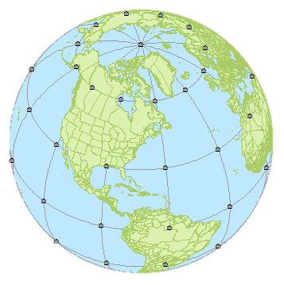

The map is composed of a political boundaries layer, a graticule layer and a 30° x 30° grid of points. The map is displayed using an **orthographic projection** (as seen from space). However, the data are all in a geographic coordinate system. ArcMap allows you to work with different coordinate systems within a project.

1. Create Tissot Circles

An easy way to create a circle from points is to use the buffer geoprocessing tool.

If ArcToolbox is not open, open it by clicking on .

In **ArcToolbox**, open **Analysis Tools >> Proximity >> Buffer**. (Note that the Buffer tool can also be accessed from the Geoprocessing pull-down menu).

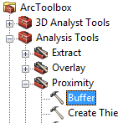

In the Buffer window, select the **Points** layer as the Input feature, name the output **Tissot_circle.shp** and specify **600 kilometers** for liner unit (this is the buffer’s radius value).

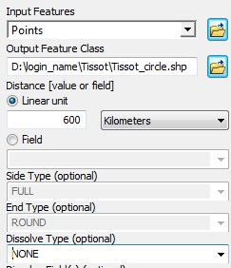

Buffer creation is sensitive to coordinate systems used. So if you want to create a perfect circle that covers a relatively large region and that avoids distortions that can accompany some projected coordinate systems, it’s best to use a geographic coordinate system as the output coordinate. This will result in a geodesic circle output.

As of ArcMap 10.4.1, the buffer tool provides you with an option to override the current coordinate system and to generate a geodesic buffer via the **Method** option.

If you are using **ArcGIS 10.4.1** or later, select **GEODESIC** from the **Method** pull-down menu.

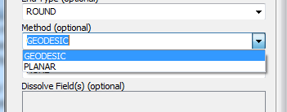

If you are using a version of ArcGIS *earlier* than 10.4 that does not have the **Method** option in the Buffer tool then proceed with the following steps, if not, **jump to** **Step 3**.

In the Buffer window, click on the **Environments** button.



In the Environment Settings window, expend **Output Coordinates** and select **As Specified Below** for *Output Coordinate System*.

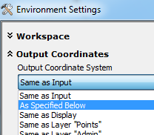

In the next field, click on the little icon  to the right of the empty field box.

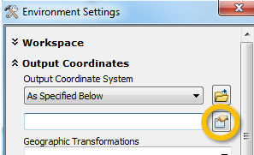

Select **Geographic Coordinate System >> World >> WGS1984**.

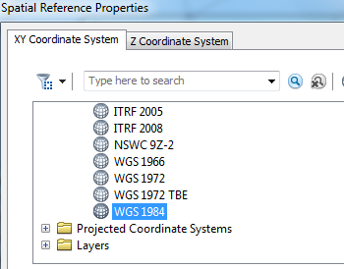

Click **OK**.

Click **OK** to close the Environment Settings window.

Click **OK** to start the Buffering process.

Once the buffer process is complete, a new layer called Tissot_circle will be added to your map.

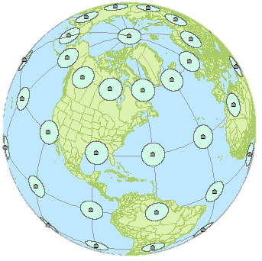

1. View the Tissot circles in ArcGlobe

**Save** the map document by clicking on the **Save** button .

Next, we take a closer look at the Tissot circles on a 3D globe

On your Windows desktop, click on the **Start** button, go to **All Programs >> ArcGIS** and click on **ArcGlobe**.

ArcGlobe is similar to Google Earth. It allows you to display all ArcGIS layers on a 3D globe.

If an **ArcGlobe - Getting Started** window pops up, click **OK** to accept the default settings.

Click the **Add Data** button .

You first will need to create a folder connection to your Tissot workspace.

In the Add Data window, click on the **Connect to Folder** button.

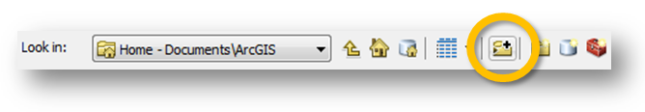

In the Connect to Folder window, navigate to your Tissot folder and select it.

In the Add Data window, navigate to your Tissot project folder and **select** **Tissot_circle.shp**.

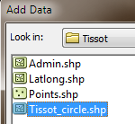

Click **Add** to close the Add Data window and load the Tissot_circle layer.

If an **Add Data Wizard** window pops up click **Finish** to accept all default settings.

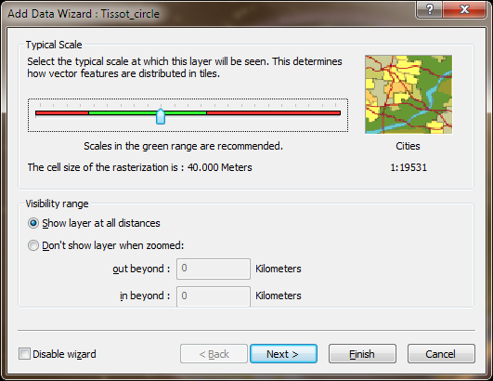

At this point, you will see the earth globe but you may not see the circles. This is because the Tissot_circle layer is hidden behind the Imagery layer.

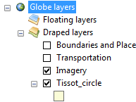

In the TOC, **drag** the **Tissot_circle** layer **above** the **Imagery** layer.

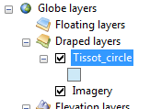

The circles should now appear. Rotate the globe with the cursor and note the perfectly round geodesic circles. You should not see any distortion in the circles.

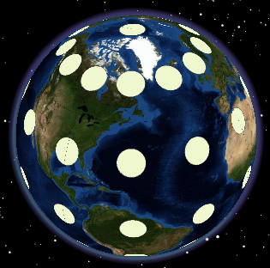

Next we will check the circle’s surface area. If true surface area is preserved, the area of each circle feature should approximate r² or 3.14 x 600² = 1,130,973 km².

In **ArcGlobe**, click on the **Measure** tool .

**Select** the **Measure a Feature** tool.

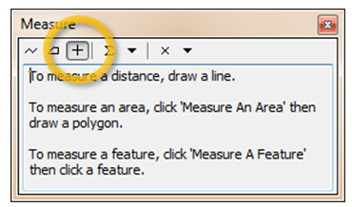

Change the area units to square kilometers by clicking on the “inverted” triangle and selecting **Area >> Kilometers**.

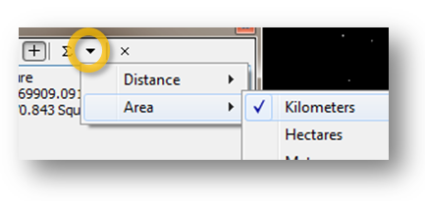

With the measure tool active, click on any circle except those at each pole (the polar circles are not perfect circles since they are generated across a boundary extent).

The values returned should be approximately 1,130,950 km², very close to the theoretical value of 1,130,973 km².

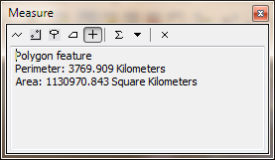

Now that we’ve confirmed that the circles generated in Step 1 are close-to-perfect geodesic circles, we can move on to the next step.

**Close** **ArcGlobe**. You do not need to save the ArcGlobe project.

1. View Tissot’s circles in a modified orthogonal projection

Navigate back to your **ArcMap** Tissot.mxd project (if you closed the ArcMap window in a previous step, re-open it).

To speed up the drawing time, **turn off** the **Points** and **Admin** layer for now.

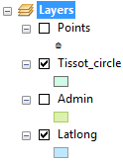

You will now study the circles’ shape and size in different projections.

In the TOC, **right-click** on the **Layers** data frame and select **Properties**.

In the Data Frame Properties window, select the **Coordinate System** tab.

Note that the Data frame’s current coordinate system is The_World_From_Space which is an Orthographic projected coordinate system.



This projection is used to visualize the earth as it would be seen from space. But, as you will learn in the following steps, even though the circles are displayed as they would be seen from space, Arcmap does not see the displayed circles from a 3D perspective but from a planar perspective instead.

Close the **Data** **Frame** **Properties** window by clicking **OK**.

If you get the following warning window, click **Yes** to close it.

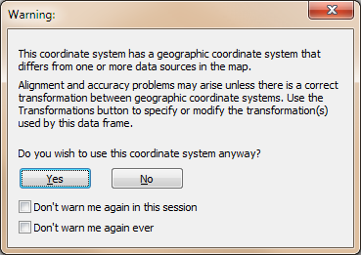

Click on the **Measure** tool .

**Select** the **Measure a Feature** tool.



Change the area units to square kilometers if the area value is in a different unit by clicking on the “inverted” triangle and selecting **Area >> Kilometers**.



With the measure tool active, click on any circle other than the ones at each pole.

You’ll probably note that each circle area is different. ArcMap is interpreting the shape of the circles as they are displayed in the View window (i.e. the features are now interpreted as different sized ellipses).

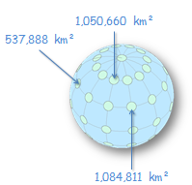

However, the closer the circle feature is to the center of the view extent, the closer its area value is to the theoretical area value. This is the nature of an orthographic (planar) projection. Features closest to the center of the map extent (i.e. the location where the projected plane touches the earth surface) suffer less distortion in area, shape and orientation than those further away.

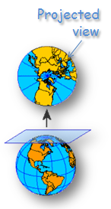

You can modify the location where the projected plane touches the earth surface in the coordinate system properties window.

In the TOC, **right-click** on **Layers** data frame and select **Properties**.

In the Data Frame Properties window, select the **Coordinate System** tab.

**Right-click** the **The** **World from Space** and select **Copy and Modify**.

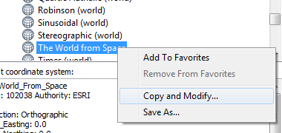

In the Projected Coordinate System Properties window, change the **Longitude_Of_Center** value to **-60.0** and the **Latitude_Of_Center** value to **30.0**.

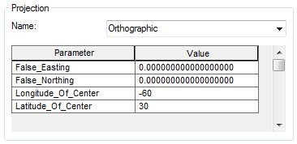

The above coordinates should place the center of the map extent at one of the Tissot circles.

Click **OK** to close the Projected Coordinate System Properties window.

Click **OK** to close the Data Frame Properties window.

If you get a warning window, click **Yes** to close it.

Click on the **Measure** tool .

With the measure tool active click on the circle closest to the extent center.

The areal value should be around 1,128,870 km². This is not quite the theoretical value of 1,130,973 km² we were expecting. The reason is that distortion increases as soon as you move away from the projection center (which is at 60°W and 30°N in our example). Since the circle features are polygons and not points, distortion will increase as their sizes increase.

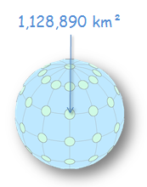

1. View Tissot’s circles in other projections

Now, we will explore other popular projections and observe the varying forms of distortions one should anticipate when using those projections.

The first projection we’ll explore is the popular **Mercator** projection (a cylindrical projection).

In the TOC, **right-click** on the **Layers** dataframe and select **Properties**.

Select **Projected Coordinate Systems >> World >> Mercator (world)**.

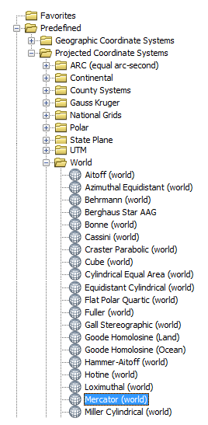

Click **OK** to close the Data Frame Properties window.

**Turn on** the **Admin** layer in the TOC for background reference. You might need to zoom to the map’s full extent .

Note the different sized circles. Remember that these are the original circles of equal area and shape. This Mercator projection distorts area but preserves shape. Using the measure tool, you’ll find that the circles vary from 4,568,681 km² at 60°N to 1,132,654 km² near the equator. The Mercator projection does a much better job preserving all features’ geometric attributes near the equator

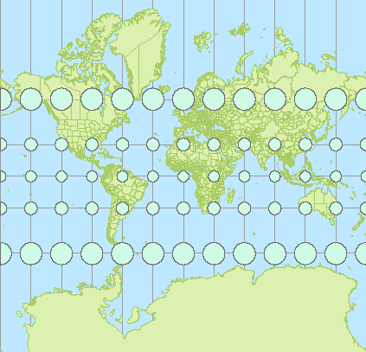

You may have also noticed bands similar in color to the Tissot circle’s at the top and bottom of the map extent. These are the polar indicatrices. Note their distortion!

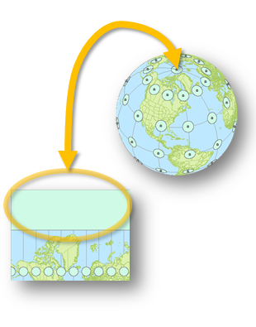

Let’s explore another projection: **Cylindrical Equal Area**.

In the TOC, **right-click** on the **Layers** data frame and select **Properties**.

Select **Projected Coordinate Systems >> World >> Cylindrical Equal Area (world)**.

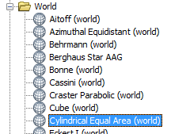

Click **OK** to accept the changes.

Like the Mercator projection, this is a cylindrical projection. However, instead of preserving shape like the Mercator projection, this one preserves area. Using the measure tool, you’ll find that the circles vary from 1,130,120 km² at 60°N to 1,130,110 km² near the equator. The values are less than 0.001% off from the theoretical value. Not bad!

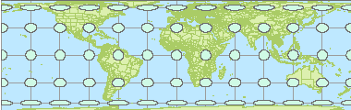

However, along with a relatively accurate area representation comes some serious distortion in shape.

**Zoom-in** on one of the circles along the 60° line of latitude.

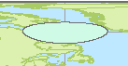

Click on the **Measure** tool .

In the Measure tool window, click on the **Measure Line** button .

In the View window, move the cursor near the top of the distorted circle until it ‘snaps’ near the top most vertex. Start the beginning of the line measurement by left-clicking at the snap location.

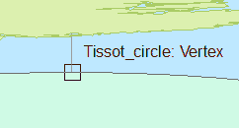

Next, move the cursor near the bottom of the circle until you feel it “snap” near the bottom most pixel. Once snapped, double-click on that point to end the line measurement segment.

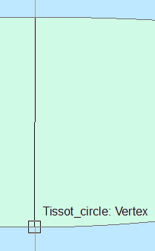

The distance between the top most and bottom most vertices should be around **600 km**. This makes sense since the cosine of 60° is 0.5 or half of the circle’s diameter (1200/2 = 600)

Now measure the distance between the left most and right most vertices of the distorted circle.

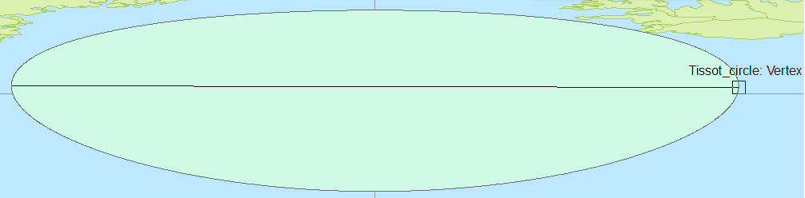

The distance between the left most and right most vertices should be somewhere around 2400 km.

If area and directions are two spatial properties that you want to preserve, a cylindrical equal-area projection is a good coordinate system candidate.

Let’s explore a continent based projected coordinate system.

In the TOC, **right-click** on the **Layers** data frame and select **Properties**.

Select **Projected Coordinate Systems >> Continental >> North America >> North America Lambert Conformal Conic**

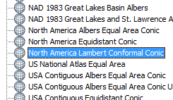

Click **OK** to close the Data Frame Properties window.

If a warning message window pops up, click **Yes**.

This projected coordinate system is a conical coordinate system. It is also a conformal coordinate system which preserves shape. Note how all of the circles remain perfect circles. But, as you probably noticed by now, the circle’s area is not preserved. However, the surface areas remain consistent along the lines of latitude. In our example, the surface area for the circles range from 37,038,898 km² (at 60°S) to 1,035,580 km² (at 30°N). For North America, the surface area measurement error can be as great as 8%.

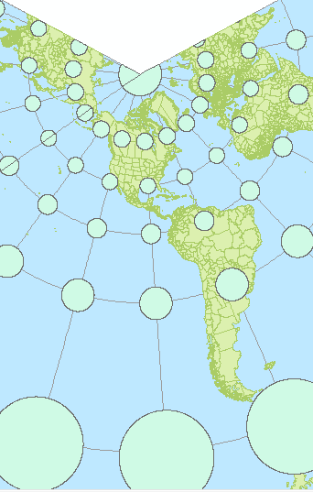

Let’s look at a more localized projected coordinate system.

In the TOC, **right-click** on **Layers** and select **Properties**.

Select **Projected Coordinate Systems >> Continental >> North America >> USA Contiguous Lambert Conformal Conic.**

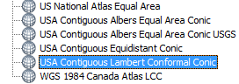

Click **OK** to close the Data Frame Properties window.

If a warning message window pops up, click **Yes**.

This conical projected coordinate system does a better job in preserving area for the US and southern Canada. In our example, the surface area for the circles in our region range from 1,147,807 km² (at 30°N) to 1,308,767 km² (at 60°N). The area measurement error for the 48 states falls well within 2%.

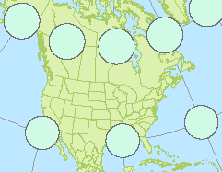

1. Explore other projections on your own

Feel free to explore the properties of other projected coordinate systems and note the type of distortions they present.

 Manuel Gimond, last modified on 1/16/2018