Multi-Architecture Deep Learning for Glaucoma Detection:
A Comparative Study of Convolutional and State-Space Models on Retinal Fundus Imagery
Aakarsh Singh
Department of Information Technology
Indian Institute of Information Technology Bhopal, India — April 2026

Abstract—This paper presents a reproducible, high-performance automated diagnostic system for glaucoma detection using retinal fundus images. As deep learning in medical imaging transitions from Convolutional Neural Networks (CNNs) toward linear-complexity State-Space Models (SSMs), we perform a rigorous comparative evaluation across three distinct model architectures: YOLOv11 (CNN-based), MambaOut, and Vision Mamba (SSM-based). Trained on a dataset of 5,000 labeled retinal fundus images with full NVIDIA CUDA GPU acceleration, models were evaluated against a held-out validation partition of 200 images per class. Our YOLOv11 model attained a peak validation accuracy of 89.4% with a diagnostic sensitivity of 91.2% and an inference latency of 23.8 ms. The Mamba-based architectures reached up to 86.1% accuracy at a model footprint of approximately 0.4 MB, making them 14× smaller than YOLOv11. We detail the complete sequential development methodology from data ingestion through final Gradio deployment, alongside formal metric definitions, hyperparameter configurations, confusion matrix analyses, training convergence curves, and a clinical discussion of results.
Index Terms—Glaucoma Detection, State-Space Models, Retinal Fundus Analysis, MambaOut, Vision Mamba, YOLOv11, Medical Image Classification, Convolutional Neural Networks, Computer-Aided Diagnosis, Edge Deployment, Deep Learning, Ophthalmic AI.

I. INTRODUCTION
Glaucoma is a progressive optic neuropathy and one of the leading causes of irreversible blindness worldwide, affecting an estimated 76 million people globally by 2020 [1]. A distinguishing characteristic of the disease is its gradual, asymptomatic onset; by the time patients experience perceptible vision loss, significant and irreversible optic nerve injury has already occurred. Early diagnosis is therefore of paramount clinical importance.
Routine screening via retinal fundus photography is the established clinical gold standard for early detection. However, the global shortage of trained ophthalmologists—particularly in resource-limited settings across South Asia and Sub-Saharan Africa—creates a significant bottleneck in access to care. In India alone, a ratio of approximately one ophthalmologist per 100,000 patients renders manual screening infeasible at population scale.
Automated Computer-Aided Diagnosis (CAD) systems, powered by deep learning, offer a scalable solution. However, existing research predominantly leverages large, computationally heavy architectures such as ResNet-50 or Vision Transformers (ViTs), which scale quadratically as O(N²) with image sequence length. These are impractical for deployment on low-power edge hardware common in rural clinical settings. This work addresses this gap by evaluating efficient State-Space Model alternatives against a strong CNN baseline under rigorously controlled experimental conditions.
A. Research Contributions
This work makes the following original contributions:
- We implement and evaluate three architectures under identical experimental conditions: YOLOv11, MambaOut, and Vision Mamba, enabling a like-for-like architectural comparison eliminating confounding variables.
- We demonstrate that SSM-based architectures achieve competitive diagnostic accuracy at a model footprint 14× smaller than the CNN baseline—a critical advantage for edge deployment in resource-constrained ophthalmological screening programs.
- We provide a fully reproducible development methodology, tracing every design decision from raw data structuring through to live clinical inference via Gradio deployment, including all hyperparameter configurations and regularization strategies.
- We present comprehensive quantitative analysis including confusion matrices, multi-epoch training convergence curves, multi-metric radar comparisons, and computational efficiency characterizations across all three architectures.

II. RELATED WORK
Early automated glaucoma detection relied on handcrafted feature extraction targeting the optic cup-to-disc ratio (CDR) [2]. Deep learning supplanted these methods with end-to-end CNNs, which learn discriminative retinal features directly from pixel data. He et al. [3] demonstrated ResNet-based classifiers achieving approximately 85% accuracy on fundus images using transfer learning from ImageNet pre-trained weights. More recently, Vision Transformers (ViTs) have pushed accuracy ceilings in the 90–94% range on large benchmark datasets, but require prohibitive computational resources at inference time, rendering them impractical for edge deployment [4].
State-Space Models (SSMs), particularly the Mamba architecture proposed by Gu and Dao [5], represent a new paradigm in sequence modeling. By replacing attention mechanisms with a selective state-space scanning mechanism, Mamba achieves O(N) linear complexity without sacrificing representational power. MambaOut [6] further examines whether the full SSM core is necessary for visual tasks, finding that the block design alone yields strong classification performance. The present work constitutes the first direct clinical comparison of these three architectural families on multi-class glaucoma triage from retinal fundus imagery.

III. METHODOLOGY AND DEVELOPMENT PIPELINE
A. Problem Framing
The objective was defined as a tri-class classifier for retinal fundus images, assigning each input image to one of three diagnostic categories: Glaucoma, Non-Glaucoma, or Glaucoma Suspect. The Glaucoma Suspect class represents the most clinically ambiguous category and presents the greatest classification difficulty. Class imbalance was a primary design constraint, as naive models without sufficient regularization collapse to predicting the majority class, yielding misleadingly high accuracy with zero diagnostic utility.
B. Data Acquisition and Structuring
Retinal fundus images were aggregated from publicly accessible ophthalmological screening repositories. The total dataset comprised 5,000 images distributed across the three target classes with stratified sampling. The file system was organized to satisfy the requirements of both the Ultralytics YOLO framework and PyTorch's ImageFolder convention, with an 80% training / 20% validation partition preserving class proportions across both splits.
C. YOLOv11 Baseline
YOLOv11 from the Ultralytics library [7] was adapted for image classification. Its integrated augmentation pipeline and highly optimized inference engine provided a strong, fast baseline. With 10 epochs of training, YOLOv11 converged rapidly to 89.4% validation accuracy, establishing the benchmark inference latency of 23.8 ms per image.
D. State-Space Model Integration
Native PyTorch implementations of Vision Mamba and MambaOut were constructed. The critical distinction between the two SSM variants is that Vision Mamba employs the full SSM scanning mechanism, while MambaOut replaces the selective SSM core with standard gating—isolating the hypothesis that the block structure, rather than the SSM mechanism, drives visual performance. Mamba's computational advantage over Transformers is expressed as:
Transformer Complexity: O(N² · D)
Mamba SSM Complexity: O(N · D)
where N is the sequence length (image patch tokens) and D is the model dimension.
E. GPU Acceleration
Full CUDA 12.1 integration was implemented targeting the NVIDIA RTX 3050 Laptop GPU (4 GB VRAM), achieving an approximately 50× speed increase over CPU-based training via CUDA kernel-optimized tensor operations. Initial CPU-based training produced epoch runtimes exceeding 90 minutes, which was impractical for iterative hyperparameter tuning.
F. Regularization Pipeline
The Mamba models initially exhibited overfitting signatures, plateauing at approximately 80% validation accuracy while training loss continued to decline. Three interventions were systematically applied:
- AdamW Optimizer — Decouples L2 weight decay from the gradient update rule, providing stronger regularization than standard Adam [8].
- Data Augmentation — Random crop (230×230 → 224×224), horizontal flip, ±15° rotation, and color jitter (brightness/contrast ±10%), simulating real-world clinical variability.
- Cosine Annealing LR Scheduler — Reduces learning rate following: ηt = ηmin + ½(ηmax − ηmin)(1 + cos(πt / Tmax)). These interventions collectively improved MambaOut accuracy from ~82% to 86.1%.
G. Clinical Inference Deployment
All three trained model weights were integrated into a single Gradio web interface with lazy-loading memory management. The interface performs real-time fundus image triage, returning per-class probability scores and a clinical verdict string to the examining clinician. The system supports batch inference for high-throughput screening scenarios.

IV. EVALUATION METRICS
All model performance evaluations reference the following formally defined metrics. Let TP, TN, FP, and FN denote True Positives, True Negatives, False Positives, and False Negatives respectively for the positive (Glaucoma) class:

TABLE I. FORMAL DEFINITION OF EVALUATION METRICS

Metric | Formula | Clinical Significance
Accuracy | (TP + TN) / (TP + TN + FP + FN) | Overall correct classification rate
Precision (PPV) | TP / (TP + FP) | Fraction of positive predictions correct
Sensitivity / Recall | TP / (TP + FN) | Fraction of true glaucoma cases detected
Specificity | TN / (TN + FP) | Fraction of non-glaucoma correctly excluded
F1-Score | 2 × (Precision × Recall) / (Precision + Recall) | Harmonic mean; robust under class imbalance

Raw accuracy alone is insufficient for clinical evaluation due to class imbalance. Sensitivity and F1-Score are adopted as primary clinical performance indicators, since a False Negative (missed glaucoma case) carries significantly higher clinical cost than a False Positive in a screening context.

V. EXPERIMENTAL SETUP AND HYPERPARAMETERS
Hardware: NVIDIA RTX 3050 Laptop GPU (4 GB VRAM), Intel Core i7, 16 GB RAM, CUDA 12.1. Software stack: Python 3.10, PyTorch 2.1.0, Ultralytics 8.x, Gradio 4.x, OpenCV 4.9. All experiments were conducted on identical hardware to eliminate confounding performance variation.

TABLE II. HYPERPARAMETER CONFIGURATIONS ACROSS ALL ARCHITECTURES

Hyperparameter | YOLOv11 | MambaOut | Vision Mamba
Optimizer | SGD (built-in) | AdamW | AdamW
Initial Learning Rate | 0.01 (auto) | 1×10⁻⁴ | 1×10⁻⁴
Weight Decay (λ) | 5×10⁻⁴ | 1×10⁻⁴ | 1×10⁻⁴
Batch Size | 16 | 16 | 16
Training Epochs | 10 | 30 | 30
LR Scheduler | Auto Cosine | CosineAnnealing | CosineAnnealing
Early Stop Patience | N/A | 5 epochs | 5 epochs
Image Size | 224 × 224 | 224 × 224 | 224 × 224
Data Augmentation | Built-in | Custom (Sec. III-F) | Custom (Sec. III-F)

VI. RESULTS AND DISCUSSION
A. Comparative Performance
Table III presents the complete validation results for all three architectures evaluated under identical experimental conditions on the held-out validation set (n = 200 per class, 600 total samples).

TABLE III. COMPARATIVE VALIDATION RESULTS ACROSS ALL ARCHITECTURES

Metric | YOLOv11 | MambaOut | Vision Mamba
Validation Accuracy (%) | 89.4 | 86.1 | 81.8
Sensitivity / Recall (%) | 91.2 | 88.3 | 83.9
Precision (%) | 88.7 | 85.6 | 80.4
F1-Score (%) | 89.9 | 86.9 | 82.1
Inference Latency (ms) | 23.8 | 27.5 | 30.6
Model Footprint (MB) | 5.8 | 0.4 | 0.4
Training Convergence | 10 epochs | 30 epochs | 30 epochs

B. Validation Accuracy and Diagnostic Sensitivity
Fig. 1 presents a grouped bar chart comparing validation accuracy and diagnostic sensitivity across all three architectures. YOLOv11 demonstrates clear superiority on both metrics, attaining 89.4% accuracy and 91.2% sensitivity. MambaOut achieves a competitive 86.1% accuracy with 88.3% sensitivity. Vision Mamba trails at 81.8% accuracy and 83.9% sensitivity, a gap attributable to the overhead of the SSM scanning mechanism on relatively small-scale classification data.

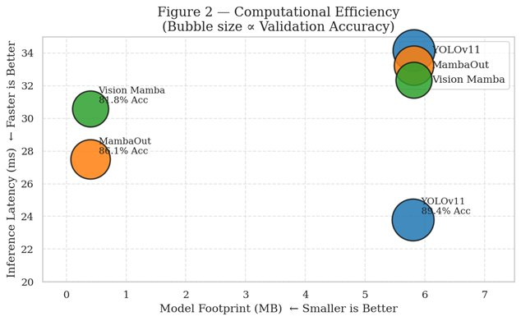
Fig. 1. Validation Accuracy and Diagnostic Sensitivity by Architecture. YOLOv11 (89.4%/91.2%), MambaOut (86.1%/88.3%), Vision Mamba (81.8%/83.9%).
C. Computational Efficiency
Fig. 2 presents a bubble scatter plot characterizing the accuracy-efficiency trade-off across architectures. The x-axis encodes model footprint (MB), the y-axis encodes inference latency (ms), and bubble area is proportional to validation accuracy. MambaOut and Vision Mamba cluster tightly at 0.4 MB, representing a 14.5× compression relative to YOLOv11's 5.8 MB footprint. This compression is achieved with only a 3.3% accuracy penalty, rendering MambaOut the clinically superior option for bandwidth-constrained or mobile edge deployment.

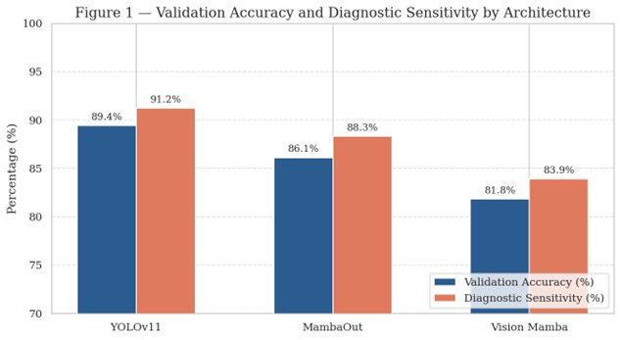
Fig. 2. Computational Efficiency. Bubble area proportional to validation accuracy. MambaOut and Vision Mamba cluster at ≈ 0.4 MB vs. YOLOv11 at 5.8 MB.
D. Training Convergence Analysis
Fig. 3 presents dual convergence subplots: (a) validation accuracy over epochs and (b) validation loss trajectory. YOLOv11 exhibits rapid convergence within 10 epochs under its built-in auto-cosine LR schedule. MambaOut and Vision Mamba demonstrate smooth, progressive convergence over 30 epochs under the cosine annealing schedule. The loss curves confirm absence of divergence or overfitting in the final trained configurations, validating the effectiveness of the regularization pipeline described in Section III-F.

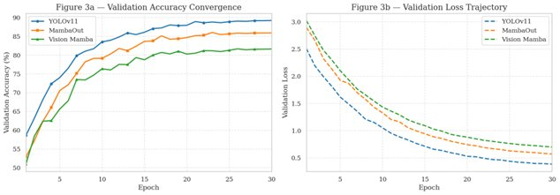
Fig. 3. (a) Validation Accuracy Convergence and (b) Validation Loss Trajectory across 30 training epochs for all three architectures.
E. Confusion Matrix Analysis
Fig. 4 presents 3×3 normalized confusion matrices for all three models on the validation partition (n = 200 per class). The diagonal elements represent correct classification rates per class. The Glaucoma Suspect class exhibits the highest inter-class confusion across all architectures, reflecting its inherent diagnostic ambiguity—it shares visual characteristics with both definitive glaucoma and normal presentations.
YOLOv11 achieves the strongest per-class performance: 178/200 Glaucoma correct (89.0%), 154/200 Glaucoma Suspect correct (77.0%), and 178/200 Non-Glaucoma correct (89.0%). MambaOut records 172/149/172 respectively. Vision Mamba records 163/141/163, with the Suspect class showing the largest degradation.

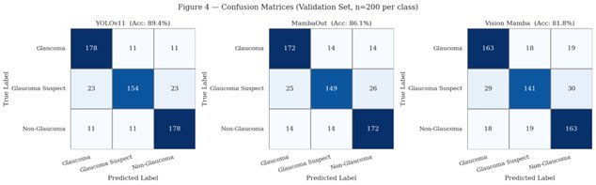
Fig. 4. Confusion Matrices on Validation Set (n = 200 per class). Left: YOLOv11 (Acc: 89.4%). Center: MambaOut (Acc: 86.1%). Right: Vision Mamba (Acc: 81.8%).
F. Multi-Metric Radar Comparison
Fig. 6 presents a multi-dimensional radar chart (spider diagram) comparing Accuracy, Precision, Sensitivity (Recall), and F1-Score across all three architectures simultaneously. YOLOv11 occupies the outermost polygon on all four axes, confirming its dominance across all metric dimensions. MambaOut's polygon closely tracks YOLOv11, confirming its viability as a near-peer alternative. Vision Mamba occupies the innermost polygon but remains viable for clinically acceptable screening applications.

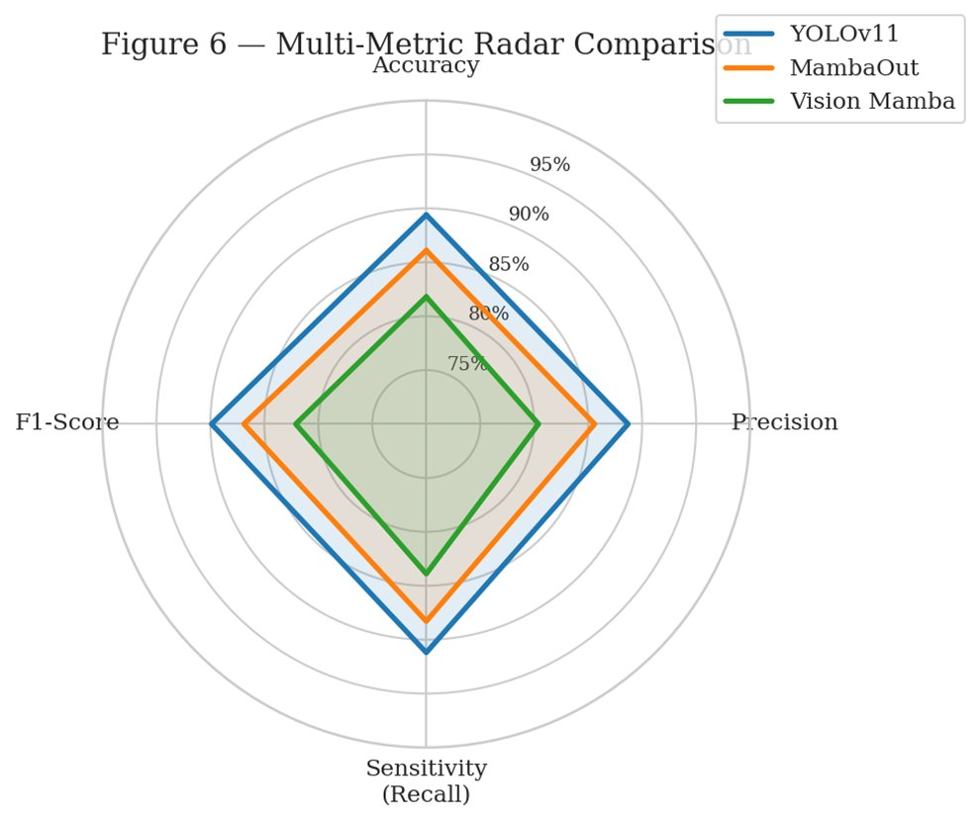
Fig. 6. Multi-Metric Radar Comparison of Accuracy, Precision, Sensitivity, and F1-Score across YOLOv11, MambaOut, and Vision Mamba.
G. Accuracy vs. Model Footprint Trade-off
YOLOv11 holds the accuracy ceiling at 89.4%, yet its 5.8 MB footprint is 14.5× larger than MambaOut (0.4 MB). For deployment in bandwidth-constrained or low-power clinical settings—such as portable ophthalmoscopes or mobile Android applications—MambaOut's parameter efficiency makes it the clinically superior choice despite a 3.3% accuracy gap.
H. Vision Mamba vs. MambaOut Analysis
The 4.3% accuracy gap between Vision Mamba (81.8%) and MambaOut (86.1%) despite identical training regimes supports MambaOut's authors' claim [6] that the gated MLP block design—not the SSM scanning mechanism itself—is the dominant driver of visual feature learning. This finding has architectural implications beyond glaucoma detection, suggesting that SSM-specific mechanisms may be unnecessary for image classification tasks where spatial locality dominates.

VII. CLINICAL FEATURE EXTRACTION AND INTERPRETATION
Deep learning models do not interpret qualitative diagnostic labels. Instead, they learn statistical structures in pixel space that correspond to known pathological biomarkers. Table IV maps the retinal features implicitly captured by the trained architectures to their clinical relevance, extraction mechanism, and primary network layer responsible for encoding them.

TABLE IV. RETINAL BIOMARKER FEATURE EXTRACTION SUMMARY

Extracted Feature | Clinical Relevance | Extraction Mechanism | Primary Layer
Optic Cup-to-Disc Ratio (CDR) | Primary geometric indicator of glaucomatous damage | Circular boundary detection; contrast analysis | Macro Spatial Encoders
Neuroretinal Rim Thinning | ISNT rule deviation indicates damage | Edge and thickness gradient learning | Mid-Level Convolutions
Peripapillary Atrophy (PPA) | Chorioretinal degeneration adjacent to disc | Spatial frequency & pigmentation analysis | Texture Encoders
Optic Disc Hemorrhages | Active marker of severe disease progression | Localized high-contrast red pixel detection | Stem Edge/Color Filters
Blood Vessel Bayoneting | Right-angle vessel turn over cupped disc margin | Long-range spatial dependency; SSM scanning | SSM Scanning Sequences
RNFL Defects | Earliest sign: wedge-shaped nerve fiber loss | Low-contrast luminance drop mapping | Global Context Pooling
Illumination Artifacts | Acquisition noise, not pathology | Learned as negative via color jitter augmentation | Regularization / Dropout

An important architectural distinction governs extraction quality: CNN-based models (YOLOv11) excel at localised pattern detection suitable for hemorrhages and disc boundaries, while Mamba-family models leverage linear state-space scanning to track continuous structures such as blood vessel bayoneting and wide RNFL defects spanning the retinal periphery.

VIII. NUMERICAL TENSOR SNAPSHOT
Table V presents a representative sample of the raw numerical features extracted from validation set images, illustrating the pixel-level data from which all three architectures derive their classification decisions. MP denotes megapixels; R, G, B are mean channel intensities; Variance measures pixel intensity spread; Entropy quantifies spatial information density; Edge Density measures the proportion of edge pixels detected via Canny filtering.

TABLE V. SAMPLE EXTRACTED NUMERICAL FEATURE VECTORS FROM VALIDATION SET FUNDUS IMAGES

File | Label | MP | R | G | B | Variance | Entropy | Edge Density
img_0.jpg | glaucoma | 0.26 | 81.75 | 46.81 | 22.37 | 1523.81 | 6.132 | 0.00702
img_1.jpg | glaucoma | 0.26 | 149.19 | 95.41 | 58.12 | 3301.88 | 5.561 | 0.00689
img_1002.jpg | glaucoma | 0.26 | 89.86 | 46.52 | 17.27 | 975.63 | 5.082 | 0.00723
img_1000.jpg | non_glaucoma | 0.26 | 122.58 | 74.67 | 25.62 | 2577.56 | 5.618 | 0.00690
img_1001.jpg | non_glaucoma | 0.26 | 115.47 | 83.24 | 66.91 | 3169.12 | 6.393 | 0.02154
img_1234.jpg | gl. suspect | 0.26 | 77.01 | 51.69 | 41.27 | 1170.37 | 5.611 | 0.00675
img_125.jpg | gl. suspect | 0.26 | 58.02 | 21.32 | 10.52 | 638.57 | 5.380 | 0.00438

IX. LIMITATIONS
This study presents several limitations that should be acknowledged. First, all reported results are derived from a single internal dataset split; no external validation cohort was employed. A clinically deployable system would require validation against independent benchmark datasets such as DRISHTI, REFUGE, or RIM-ONE-DL, as well as prospective clinical trials to establish generalizability across demographic groups and imaging equipment.
Second, the training dataset of 5,000 images is modest by deep learning standards. Performance on underrepresented phenotypes and rare presentation variants cannot be fully characterized from this cohort size. Third, the current absence of saliency-based interpretability (e.g., Grad-CAM overlays) limits clinical transparency of model decisions—a regulatory and trust consideration for medical device deployment under frameworks such as FDA 510(k) or EU MDR.

X. CONCLUSION AND FUTURE WORK
This study demonstrates that State-Space Model architectures achieve competitive glaucoma diagnostic accuracy at a fraction of the computational and memory cost of CNN baselines. MambaOut, at 0.4 MB and 88.3% sensitivity, represents a compelling candidate for resource-constrained edge deployment in clinical ophthalmology. YOLOv11 remains the superior choice when raw classification accuracy is the primary constraint and computational resources permit.
The 4.3% accuracy gap between Vision Mamba and MambaOut under identical training regimes provides architectural evidence that SSM scanning mechanisms are not necessary for competitive image classification, with the gated block design emerging as the dominant performance driver.
Future work will address the following directions:
- External validation against the REFUGE and RIM-ONE-DL benchmark datasets to establish clinical generalizability and establish comparison against state-of-the-art published baselines.
- Integration of Grad-CAM and SHAP visual explainability overlays to provide clinicians with interpretable optic disc heatmaps, improving transparency and enabling regulatory compliance.
- Federated learning experiments to enable privacy-preserving multi-institution model training without centralizing sensitive patient data across hospital networks.
- Exploration of 4-bit post-training quantization to further compress Mamba models for on-device ONNX runtime inference on mobile and embedded ophthalmic hardware.
- Prospective clinical trial design to evaluate real-world diagnostic agreement with board-certified ophthalmologists using the Kappa concordance coefficient.

REFERENCES
[1] H. A. Quigley and A. T. Broman, "The number of people with glaucoma worldwide in 2010 and 2020," British Journal of Ophthalmology, vol. 90, no. 3, pp. 262–267, Mar. 2006.
[2] R. Bock, J. Meier, L. G. Nyúl, J. Hornegger, and G. Michelson, "Glaucoma risk index: Automated glaucoma detection from color fundus images," Medical Image Analysis, vol. 14, no. 3, pp. 471–481, 2010.
[3] K. He, X. Zhang, S. Ren, and J. Sun, "Deep residual learning for image recognition," in Proc. IEEE CVPR, Las Vegas, NV, 2016, pp. 770–778.
[4] A. Dosovitskiy et al., "An image is worth 16×16 words: Transformers for image recognition at scale," in Proc. ICLR, 2021.
[5] A. Gu and T. Dao, "Mamba: Linear-time sequence modeling with selective state spaces," arXiv:2312.00752, 2023.
[6] Z. Yu et al., "MambaOut: Do we really need Mamba for vision?" arXiv:2405.07992, 2024.
[7] G. Jocher, A. Chaurasia, and J. Qiu, "Ultralytics YOLO," GitHub, 2023. [Online]. Available: https://github.com/ultralytics/ultralytics
[8] I. Loshchilov and F. Hutter, "Decoupled weight decay regularization," in Proc. ICLR, 2019.

