IOT MINI PROJECT REPORT

Topic: Cyclist Turn signal Indicator
Introduction: This is the report made under the subject of IOT; I Akarsh Singh has studied and interfaced cyclist turn signal indicator with an Arduino Uno microcontroller. Our group has also successfully interfaced the complete setup in real time. I have taken this topic for my mini project realizing some innovative prospects in terms of the cycling industry . In this report I have explained in depth the working, real time interfacing, coding and applications of my project. The following is the report for the same.
Definition: The Arduino Uno is a popular microcontroller board based on the ATmega328P microcontroller chip. The Arduino Uno board has a variety of input and output pins, including digital and analog input and output pins, PWM (pulse-width modulation) pins, and serial communication pins, that can be used to connect to sensors, actuators, and other electronic components. The board also has a USB port for programming and serial communication with a computer, a power jack for connecting an external power source, and an ICSP (In-Circuit Serial Programming) header for programming the microcontroller directly. It is programmed using the Arduino Integrated Development Environment (IDE), a user-friendly software that allows users to write, compile, and upload code to the board. The Arduino Uno board is popular for its ease of use, versatility, and accessibility, making it a great choice for beginners and advanced users alike.
An infrared (IR) sensor is an electronic device that detects and measures the presence of infrared radiation in its surroundings. Infrared radiation is a type of electromagnetic radiation that has longer wavelengths than visible light and is not visible to the naked eye. IR sensors are commonly used in a variety of applications, including motion detection, temperature sensing, remote control, and night vision. These sensors typically consist of a transmitter and a receiver, or a detector, that work together to detect the presence of IR radiation and convert it into an electrical signal that can be processed by a computer or other electronic device.
An 8x8 dot matrix LED grid is a display consisting of 64 individual LEDs arranged in an 8x8 grid formation. Each LED in the grid can be individually controlled to create a wide variety of patterns and designs. The LED grid is often used in electronic projects, such as digital clocks, scoreboards, and gaming devices, to display alphanumeric characters, symbols, and graphics. The LEDs can be either monochrome or RGB (red, green, blue) and can be driven using various circuitry, including microcontrollers or dedicated LED driver ICs. The 8x8 dot matrix LED grid is a popular and versatile display option due to its low cost, ease of use, and ability to display a wide range of information in a small space.

Necessity: Bicycling is a popular mode of transportation, but it can also be dangerous, particularly when sharing the road with motor vehicles. One common issue is the lack of clear communication between cyclists and drivers, which can result in accidents. To address this problem, we developed an IoT bicycle signalling system using an Arduino Uno board, an 8x8 dot matrix LED grid, and IR sensors. Our system allows cyclists to easily signal their turns, stops, and other maneuvers to nearby drivers, improving overall safety on the road. By providing clear and intuitive communication, our project aims to reduce the risk of accidents and promote safer cycling for everyone.

Materials required: An IR (infrared) sensor consists of an emitter and a detector along with a signal conditioning circuitry for amplifying the electrical signal, output circuitry used to provide a digital or analog output signal, optical components used to focus or filter the emitted and received radiation to optimize the sensor's performance.
An 8x8 dot matrix LED grid consists of an LED Matrix, driver ic, row and column pins, power supply, control circuitry.
The Arduino Uno board is the main component used in your IoT bicycle signalling system project. It is a microcontroller board based on the ATmega328P microcontroller, which provides a programmable platform for interfacing with different sensors, actuators, and other electronic components. Microcontroller: The ATmega328P microcontroller is the brain of the Arduino Uno board. It controls all the input/output operations and executes the code uploaded to it. It has a Digital and analog pins, USB port, Power supply, Crystal oscillator.
Block Diagram:
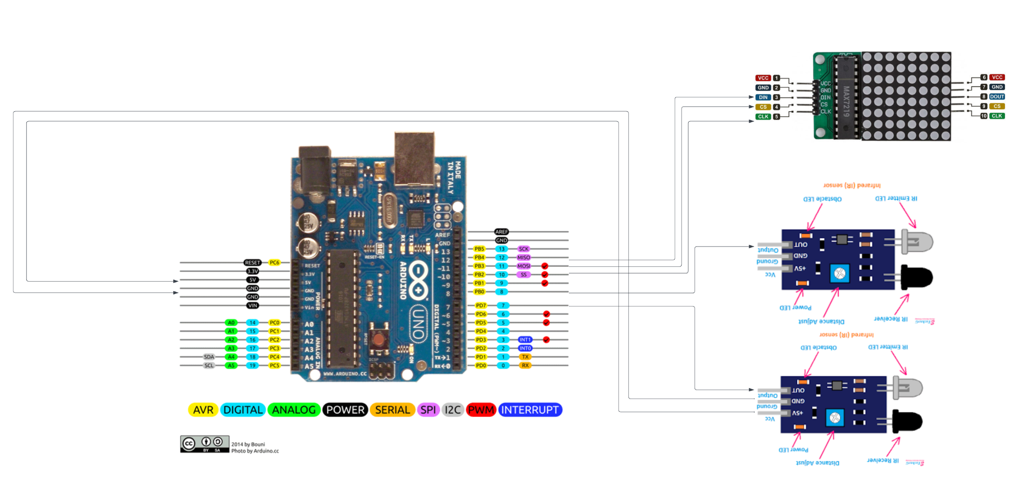

Components List:

Name | Quantity
8x8 lm7219 dot matrix grid | 1
IR sensor | 2
Arduino uno | 1

Code:
#include "LedControl.h"
#include "binary.h"

LedControl lc=LedControl(12,11,10,1);
#define IR1_Sensor 7
#define IR2_Sensor 8
int IR1;
int IR2;

// delay time between faces
unsigned long delaytime=600;
int bdelay=200;
// flashing light
byte blk[8]= {B11111111,B11111111,B11111111,B11111111,B11111111,B11111111,B11111111,B11111111};
byte nblk[8]= {B00000000,B00000000,B00000000,B00000000,B00000000,B00000000,B00000000,B00000000};
// left arrow
byte la[8]={B00001110, B00011100,B00111000,B01110000,B01110000,B00111000,B00011100,B00001110};
// right arrow
byte ra[8]= {B01110000,B00111000,B00011100,B00001110,B00001110,B00011100,B00111000,B01110000};

void setup() {
pinMode(IR1_Sensor, INPUT);
pinMode(IR2_Sensor, INPUT);
lc.shutdown(0,false);
// Set brightness to a medium value
lc.setIntensity(0,8);
// Clear the display
lc.clearDisplay(0);
}

void loop(){
IR1=digitalRead(IR1_Sensor); /digital read function to check IR pin status/
IR2=digitalRead(IR2_Sensor);
if(IR1==LOW) /If sensor detect any reflected ray/
{
for(int i=0;i<=8;i++)
{
rightarrow();
}
}
else if(IR2==LOW) /If sensor detect any reflected ray/
{
for(int i=0;i<=8;i++)
{
leftarrow();
}
}
else
{
blink();
}

}

void rightarrow()
{
// Display sad face
lc.setRow(0,0,ra[0]);
lc.setRow(0,1,ra[1]);
lc.setRow(0,2,ra[2]);
lc.setRow(0,3,ra[3]);
lc.setRow(0,4,ra[4]);
lc.setRow(0,5,ra[5]);
lc.setRow(0,6,ra[6]);
lc.setRow(0,7,ra[7]);
delay(delaytime);
lc.setRow(0,0,nblk[0]);
lc.setRow(0,1,nblk[1]);
lc.setRow(0,2,nblk[2]);
lc.setRow(0,3,nblk[3]);
lc.setRow(0,4,nblk[4]);
lc.setRow(0,5,nblk[5]);
lc.setRow(0,6,nblk[6]);
lc.setRow(0,7,nblk[7]);
delay(bdelay);
}
void leftarrow()
{
// Display neutral face
lc.setRow(0,0,la[0]);
lc.setRow(0,1,la[1]);
lc.setRow(0,2,la[2]);
lc.setRow(0,3,la[3]);
lc.setRow(0,4,la[4]);
lc.setRow(0,5,la[5]);
lc.setRow(0,6,la[6]);
lc.setRow(0,7,la[7]);
delay(delaytime);
lc.setRow(0,0,nblk[0]);
lc.setRow(0,1,nblk[1]);
lc.setRow(0,2,nblk[2]);
lc.setRow(0,3,nblk[3]);
lc.setRow(0,4,nblk[4]);
lc.setRow(0,5,nblk[5]);
lc.setRow(0,6,nblk[6]);
lc.setRow(0,7,nblk[7]);
delay(bdelay);
}
void blink()
{
// Display happy face
lc.setRow(0,0,blk[0]);
lc.setRow(0,1,blk[1]);
lc.setRow(0,2,blk[2]);
lc.setRow(0,3,blk[3]);
lc.setRow(0,4,blk[4]);
lc.setRow(0,5,blk[5]);
lc.setRow(0,6,blk[6]);
lc.setRow(0,7,blk[7]);
delay(bdelay);
lc.setRow(0,0,nblk[0]);
lc.setRow(0,1,nblk[1]);
lc.setRow(0,2,nblk[2]);
lc.setRow(0,3,nblk[3]);
lc.setRow(0,4,nblk[4]);
lc.setRow(0,5,nblk[5]);
lc.setRow(0,6,nblk[6]);
lc.setRow(0,7,nblk[7]);
delay(bdelay);
}

Result/Snapshot:
Left - Indicator:
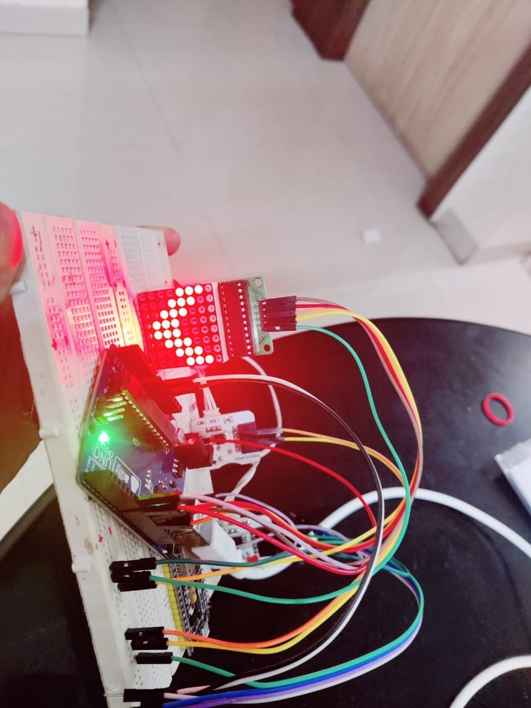

Right-Indicator:
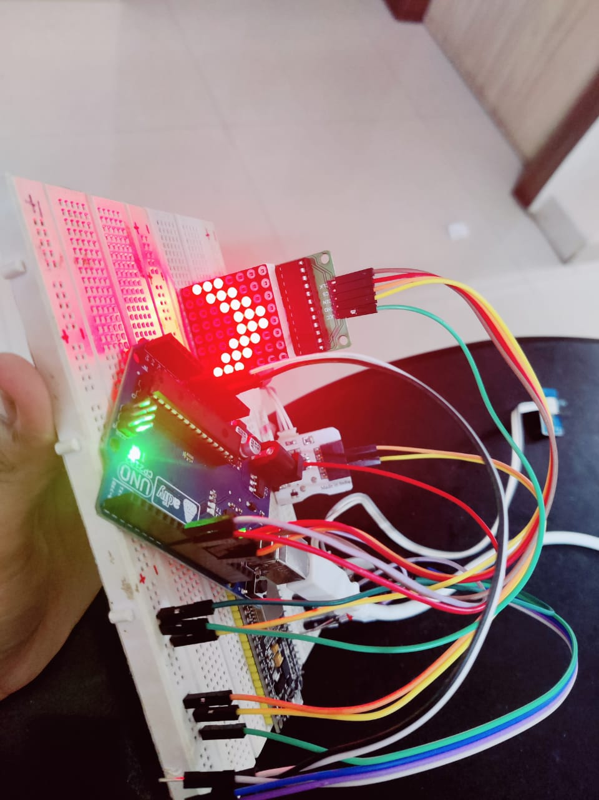

Working: The project uses an Arduino Uno board, IR sensors, and an 8x8 dot matrix LED grid to create a bicycle signalling system. The IR sensors are mounted on the bicycle to detect the motion of the cyclist’s hands. When the moton is detected, the system activates the appropriate LED signal on the 8x8 dot matrix LED grid to indicate the cyclist's intended maneuver. For example, if the cyclist wants to turn left, the left LED signal on the grid is activated. Similarly, if the cyclist wants to turn right, the right LED signal on the grid is activated.
The Arduino Uno board acts as the control unit for the system, processing the input from the IR sensors and activating the appropriate LED signals on the grid. The system is powered by a battery connected to the Arduino Uno board.
Overall, the system provides an innovative and safer way for cyclists to communicate their intentions on the road, helping to prevent accidents and improve road safety for everyone.

Applications:
Enhancing cyclist safety: One of the main benefits of this project is that it can significantly enhance cyclist safety. By using IR sensors and LED signals to communicate the cyclist's intended maneuvers, the system can alert other vehicles on the road to the cyclist's presence and intended movements. This can help prevent accidents and make it safer for cyclists to navigate through traffic.
Improving road efficiency: Another benefit of this project is that it can help improve road efficiency. By providing a clear and visible indication of the cyclist's intended movements, other vehicles on the road can react appropriately and adjust their driving accordingly. This can help reduce congestion and improve the overall flow of traffic.

Promoting sustainable transportation: Cycling is a sustainable form of transportation that can help reduce carbon emissions and promote a healthier lifestyle. By making cycling safer and more efficient, this project can encourage more people to choose cycling as a viable mode of transportation. This can help reduce the dependence on cars and promote more sustainable and eco-friendly transportation options.

Overall, this project has the potential to provide a range of benefits, from enhancing cyclist safety to promoting sustainable transportation. By leveraging the power of technology and innovative design, this project can help create a safer and more sustainable future for everyone.

Conclusion:
In conclusion, my IoT bicycle signalling system project has demonstrated the power of technology to create innovative and effective solutions to real-world problems. By using IR sensors and an 8x8 dot matrix LED grid, we have created a system that can significantly enhance cyclist safety and promote sustainable transportation.

Through the development and implementation of this project, we have gained valuable knowledge and experience in the areas of electronics, programming, and engineering. I have also gained a deeper appreciation for the potential of technology to create positive change in the world.
Overall, I am proud of what I have accomplished with this project and is excited to see how it can contribute to a safer and more sustainable future for everyone.
Limitations:
- Limited visibility of LED signals: The LED signals on the 8x8 dot matrix LED grid may be difficult to see in bright sunlight or from certain angles, which could limit their effectiveness.
- Limited power supply: The system is powered by a battery connected to the Arduino Uno board, which may have a limited lifespan and require frequent recharging or replacement.
- Limited weather resistance: The system may not be fully weather-resistant, which could limit its effectiveness in adverse weather conditions.
- Limited durability of components: The IR sensors, LED grid, and other components used in the project may be subject to wear and tear over time, which could impact the system's longevity and reliability.

Future Scope:
- Integration with smart city infrastructure: As cities become more connected and smart, there is an opportunity to integrate the bicycle signalling system with existing smart city infrastructure, such as traffic lights, cameras, and other sensors. This integration could improve the accuracy and effectiveness of the system, as well as enable new features and capabilities.
- Collaboration with bicycle manufacturers: Bicycle manufacturers could collaborate with the developers of the IoT bicycle signalling system to integrate the system directly into their bicycles. This would enable more seamless and widespread adoption of the system, as well as increase its accessibility and effectiveness.
References:
- https://www.google.co.in/imghp
- https://en.wikipedia.org/wiki/Arduino_Uno
- https://docs.arduino.cc/
- https://www.instructables.com/DOT-Matrix-8x8-Using-Arduino/
- https://randomnerdtutorials.com/guide-for-8x8-dot-matrix-max7219-with-arduino-pong-game/
- https://how2electronics.com/8x32-max7219-dot-matrix-led-display-with-arduino/
- https://github.com/squix78/MAX7219LedMatrix

Acknowledgement:
- We would like to express our sincere gratitude to our professor Smitha Paithankar for their guidance and support throughout the course of this project. Their expertise and insights have been invaluable in helping us to design and implement our IoT bicycle signalling system.
- Project based learning has helped us to understand theoretical concepts taught to us in a much deeper perspective.
- Therefore, our sincere gratitude for our department and college who engaged us in such innovative and engaging learning activities helping our overall development.
- Overall, we are incredibly grateful for the opportunity to work on this project, and we look forward to applying the knowledge and skills we have gained to future projects and endeavors.
Thank You!!

