Machine Learning Based Predictive Model for Urban Livability Using Environmental and Socioeconomic Indicators
Sagar Singh Bisht, Aakarsh Pab, Shuchi Mala
Department of Computer Science & Engineering, Amity School of Engineering & Technology, Amity University, Noida, India
Research Summary
CityMatch is a neighbourhood recommendation system for Delhi that integrates four heterogeneous data sources — TomTom real-time traffic (16 readings per locality over four days), CPCB seasonal PM2.5 indices, OSMnx-derived amenity counts (1 km radius), and Kaggle 2BHK rental medians (5,902 listings) — into a unified machine learning pipeline. K-Means clustering (K=4, Silhouette Score=0.41) partitions 72 urban localities into four liveability tiers. A directionally-corrected weighted sum scoring engine ranks neighbourhoods against personalised user preferences, deployed via Streamlit. Boundary-condition validation confirms scoring correctness across all three extreme test configurations [1].
Objective of the Study
Urban relocation in rapidly growing Indian cities involves simultaneous evaluation of environmental quality, transport accessibility, and economic affordability — a multi-criteria decision problem for which no systematic, data-driven tool currently exists. Existing neighbourhood assessment frameworks either rely on survey data lacking temporal granularity [2], focus on Western cities with dissimilar monitoring infrastructure [3], or address single liveability dimensions in isolation. Li and Zhang [4] demonstrated ML-based liveability indexing but without live API integration or deployment. He and Gan [5] developed agent-based models without real-world Indian applicability. CityMatch addresses these gaps through a reproducible multi-source pipeline with real-time traffic profiling, seasonal AQI decomposition, and an interactive decision-support interface — the first such system demonstrated for Delhi.
Methodology
Figure 1 illustrates the complete CityMatch pipeline. Amenity counts (schools, hospitals, metro stations, parks) were extracted using OSMnx within a 1 km radius of each neighbourhood centroid. Traffic congestion was profiled via TomTom Flow API (v4) across 16 readings per locality (4 days × 4 time slots: 09:00, 13:00, 18:00, 23:00 IST), computing CI = (1 − v_current/v_freeflow) × 10 per reading. CPCB PM2.5 data was decomposed into Winter (Oct–Feb) and Monsoon (Jun–Sep) seasonal averages. Rental data was sourced from 5,902 Kaggle 2BHK listings, with median rent per locality replacing manually estimated values.
Preprocessing applied 95th-percentile capping to amenity counts — correcting OpenStreetMap tagging inconsistencies that inflated hospital counts in peripheral localities — followed by Min-Max normalisation. K-Means clustering was applied to six scaled liveability features (rent excluded to prevent conflating market price with intrinsic characteristics). Optimal K=4 was confirmed by Elbow Method and Silhouette Score. The weighted sum scoring engine applies directional inversion (f = 1 − f_scaled) for inverse features (PM2.5, traffic, rent) before computing Match Score = [Σ(wᵢ × fᵢ)/Σwᵢ] × 100.

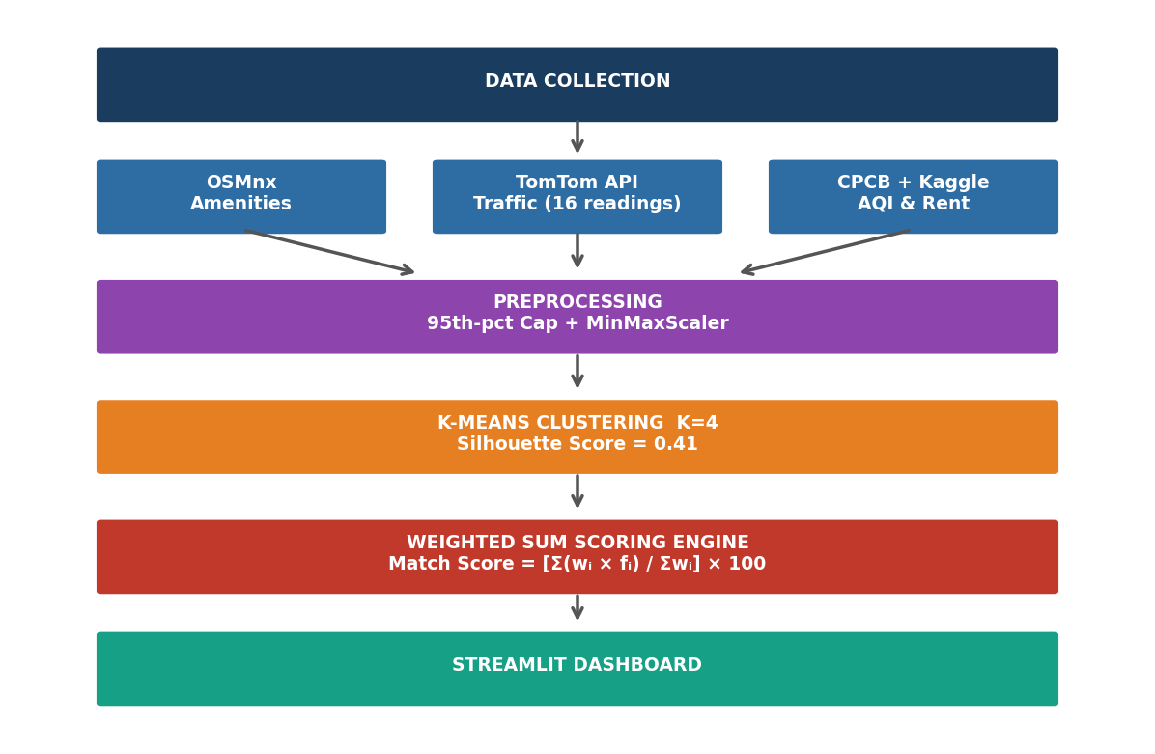
Figure 1. CityMatch methodology pipeline: from four raw data sources through preprocessing, K-Means clustering, and weighted sum scoring to the interactive Streamlit dashboard.
Results
K-Means clustering achieved Silhouette Score S=0.41 at K=4, producing four semantically coherent liveability tiers shown in Figure 2: Budget Peripheral (n=18, avg rent ₹15,200), Mid-range Suburban (n=22, avg rent ₹28,500), Well-connected Mid-tier (n=20, avg rent ₹41,000), and Premium Central (n=12, avg rent ₹87,500). Monotonically increasing rent across cluster tiers validates semantic meaningfulness. Three boundary-condition tests confirmed scoring engine correctness: rent-only configuration returned all five cheapest localities; air quality-only returned five localities with PM2.5 ≈ 93–95 µg/m³; metro-only returned Connaught Place (27 stations within 1 km) as rank 1.
Random Forest feature importance analysis identified distance from city centre (Connaught Place) as the dominant rent predictor (importance=0.312), consistent with urban rent gradient theory [7]. Table 1 presents a comparative analysis against state-of-the-art neighbourhood assessment methods. CityMatch is the only system combining live API traffic profiling, seasonal AQI decomposition, real rental market data, and interactive web deployment in an Indian urban context.

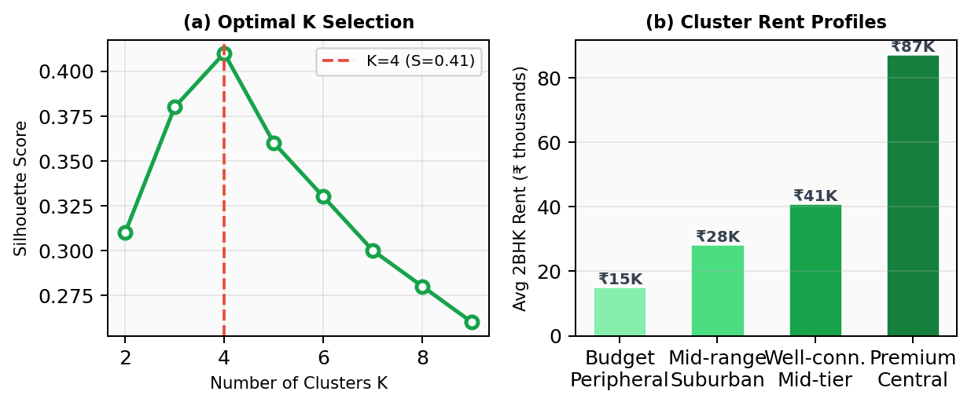
Figure 2. Key results: (a) Silhouette Score across K=2–9, confirming optimal K=4; (b) average 2BHK rent per cluster, demonstrating monotonically increasing profiles consistent with urban liveability tiers.

Table 1. Comparative Analysis with State-of-the-Art Neighbourhood Assessment Methods
Study | Dataset | ML Method | Live API | Deployment | Indian Context
He & Gan [5] | Simulated | Agent-Based | No | None | No
Venerandi et al. [3] | Street View | CNN | No | None | No
Jain & Jain [6] | Census / Survey | Statistical | No | None | Yes
Li & Zhang [4] | Government | ML Ensemble | No | None | No
CityMatch (Ours) | OSMnx+TomTom+CPCB+Kaggle | K-Means + Weighted Sum | Yes (TomTom) | Streamlit Web App | Yes (Delhi)

Conclusion
CityMatch demonstrates that a deployable neighbourhood recommendation system for Indian cities can be built from freely available data within academic resource constraints. The 16-reading traffic profiling strategy, seasonal AQI decomposition, and directionally-corrected scoring engine collectively address data quality and methodological gaps absent from existing urban liveability literature. Future work targets Delhi NCR expansion and a supervised classification layer for new-city scalability.
Important References
[1] J. MacQueen, "Some methods for classification and analysis of multivariate observations," Proc. 5th Berkeley Symp. Math. Statist. Probability, vol. 1, pp. 281–297, 1967.
[2] M. Jain and S. Jain, "Urban livability assessment in Indian cities: A comparative study," J. Urban Plan. Dev., vol. 144, no. 3, 2018.
[3] A. Venerandi et al., "Measuring urban deprivation from user generated content," Proc. ACM CSCW, pp. 254–264, 2015.
[4] H. Li and Y. Zhang, "Livability evaluation of urban environment based on ML approach," Environ. Dev. Sustainability, vol. 23, no. 8, pp. 12407–12425, 2021.
[5] S. He and V. J. Gan, "Urban livability assessment using machine learning and agent-based modeling," Cities, vol. 128, 2022.
[6] G. Boeing, "OSMnx: New methods for acquiring, constructing, analyzing, and visualizing complex street networks," Comput. Environ. Urban Syst., vol. 65, pp. 126–139, 2017.
[7] W. Alonso, Location and Land Use. Cambridge, MA: Harvard Univ. Press, 1964.

