2. FIR Quantization using Rounding
Simulate a 16-tap FIR low-pass filter with cutoff frequency 0.4π using 8-bit fixed-point coefficient rounding and evaluate its quantization performance. (25) (BL3) (WK4)
Given Data:
● FIR Length = 16 taps
● Cutoff Frequency = 0.4π
● Quantization = 8-bit fixed-point
● Sampling Frequency = 8 kHz
Tasks:
1. Quantize coefficients using rounding.
2. Simulate the filter response.
3. Determine the quantization error.
4. Calculate Mean Square Error.
5. Compare results with truncation-based implementation.
6. Comment on accuracy improvement.
AIM:
To simulate a 16-tap FIR low-pass filter with cutoff frequency 0.4π rad/sample using 8-bit fixed-point coefficient rounding, and to evaluate the quantization performance by analyzing the filter response, quantization error, Mean Square Error (MSE), and comparison with truncation.

OBJECTIVES:
- To design an ideal 16-tap FIR low-pass filter.
- To quantize the FIR coefficients using 8-bit fixed-point rounding.
- To simulate the quantized FIR filter in MATLAB.
- To determine the coefficient quantization error.
- To calculate the output error and MSE.
- To compare rounding-based quantization with truncation-based quantization.
- To analyze the improvement in accuracy obtained using rounding.
TOOLS REQUIERD:

Software
- MATLAB
- MATLAB Signal Processing Toolbox

MATLAB functions used
- fir1()
- freqz()
- filter()
- round()
- fix()
- subplot()
- stem()
- plot(

GIVEN PARAMETERS
Parameter | Value
Filter type | FIR Low-pass
Filter length | 16 taps
Cutoff frequency | (0.4\pi) rad/sample
Word length | 8 bits
Fixed-point format | Q1.7
Quantization method | Rounding
Sampling frequency | 8 kHz
Test signal | 500 Hz + 2 kHz sinusoidal components

PROGRAM
clc;
clear;
close all;

%% ============================================================
% FIR QUANTIZATION USING ROUNDING
% Question 2 - DSP Simulation
% 16-tap FIR Low-Pass Filter
% Cutoff Frequency = 0.4*pi rad/sample
% 8-bit Fixed-Point Coefficient Rounding
% ============================================================

%% 1. Given Parameters

Fs = 8000; % Sampling frequency = 8 kHz
N = 16; % FIR filter length = 16 taps
Fc_norm = 0.4; % Normalized cutoff frequency (0.4*pi)
B = 8; % Coefficient word length = 8 bits

% Q1.7 fixed-point scaling
Q = 2^(B-1); % 128
Delta = 1/Q; % Quantization step

%% 2. Design Ideal FIR Low-Pass Filter

% fir1 uses normalized frequency where 1 corresponds to pi rad/sample
h_ideal = fir1(N-1, Fc_norm, 'low', hamming(N));

%% 3. 8-bit Coefficient Quantization Using Rounding

h_round = round(h_ideal * Q) / Q;

%% 4. Truncation Quantization for Comparison

h_trunc = fix(h_ideal * Q) / Q;

%% 5. Display Filter Coefficients

disp('============================================================');
disp(' FIR FILTER COEFFICIENTS');
disp('============================================================');

fprintf('\nIdeal Coefficients:\n');
disp(h_ideal.');

fprintf('\n8-bit Rounded Coefficients:\n');
disp(h_round.');

fprintf('\n8-bit Truncated Coefficients:\n');
disp(h_trunc.');

%% 6. Coefficient Quantization Error

error_round_coeff = h_ideal - h_round;
error_trunc_coeff = h_ideal - h_trunc;

fprintf('\nMaximum coefficient error - Rounding = %.8f\n', ...
max(abs(error_round_coeff)));

fprintf('Maximum coefficient error - Truncation = %.8f\n', ...
max(abs(error_trunc_coeff)));

%% 7. Frequency Response

[H_ideal, f] = freqz(h_ideal, 1, 2048, Fs);
[H_round, ~] = freqz(h_round, 1, 2048, Fs);
[H_trunc, ~] = freqz(h_trunc, 1, 2048, Fs);

%% 8. Generate Test Input Signal

duration = 1; % 1 second
t = 0:1/Fs:duration-1/Fs;

% Input = 500 Hz + 2 kHz sinusoidal components
x = 0.5*sin(2*pi*500*t) + ...
0.5*sin(2*pi*2000*t);

%% 9. Filter the Input Signal

y_ideal = filter(h_ideal, 1, x);
y_round = filter(h_round, 1, x);
y_trunc = filter(h_trunc, 1, x);

%% 10. Output Quantization Errors

error_round = y_ideal - y_round;
error_trunc = y_ideal - y_trunc;

%% 11. Mean Square Error

MSE_round = mean(error_round.^2);
MSE_trunc = mean(error_trunc.^2);

fprintf('\n============================================================');
fprintf('\n QUANTIZATION RESULTS');
fprintf('\n============================================================\n');

fprintf('\nMSE using Rounding = %.10e\n', MSE_round);
fprintf('MSE using Truncation = %.10e\n', MSE_trunc);

%% 12. Calculate Improvement in MSE

improvement = ((MSE_trunc - MSE_round) / MSE_trunc) * 100;

fprintf('\nMSE Improvement using Rounding = %.2f %%\n', improvement);

%% 13. Plot Magnitude Response

figure;

plot(f, 20*log10(abs(H_ideal) + eps), 'LineWidth', 1.5);
hold on;

plot(f, 20*log10(abs(H_round) + eps), '--', 'LineWidth', 1.5);

plot(f, 20*log10(abs(H_trunc) + eps), ':', 'LineWidth', 1.5);

grid on;

xlabel('Frequency (Hz)');
ylabel('Magnitude (dB)');

title('FIR Filter Magnitude Response');

legend('Ideal', '8-bit Rounding', '8-bit Truncation');

xlim([0 Fs/2]);

%% 14. Plot Coefficient Comparison

figure;

stem(0:N-1, h_ideal, 'filled');
hold on;

stem(0:N-1, h_round, 'LineWidth', 1.2);

stem(0:N-1, h_trunc, 'LineWidth', 1.2);

grid on;

xlabel('Coefficient Index');
ylabel('Coefficient Value');

title('FIR Coefficient Quantization');

legend('Ideal', 'Rounding', 'Truncation');

%% 15. Plot Coefficient Quantization Error

figure;

stem(0:N-1, error_round_coeff, 'filled');

grid on;

xlabel('Coefficient Index');
ylabel('Quantization Error');

title('Coefficient Quantization Error - Rounding');

%% 16. Plot Input and Filtered Output

figure;

subplot(3,1,1);

plot(t(1:500), x(1:500));

grid on;

xlabel('Time (s)');
ylabel('Amplitude');

title('Input Signal');

subplot(3,1,2);

plot(t(1:500), y_ideal(1:500));

grid on;

xlabel('Time (s)');
ylabel('Amplitude');

title('Output of Ideal FIR Filter');

subplot(3,1,3);

plot(t(1:500), y_round(1:500));

grid on;

xlabel('Time (s)');
ylabel('Amplitude');

title('Output of 8-bit Rounded FIR Filter');

%% 17. Plot Output Error

figure;

plot(t(1:1000), error_round(1:1000));

grid on;

xlabel('Time (s)');
ylabel('Error');

title('Output Quantization Error - Rounding');

%% 18. Error Spectrum

L = length(error_round);

E_round = fft(error_round);

P2 = abs(E_round/L);

P1 = P2(1:floor(L/2)+1);

P1(2:end-1) = 2*P1(2:end-1);

f_error = Fs*(0:floor(L/2))/L;

figure;

plot(f_error, P1);

grid on;

xlabel('Frequency (Hz)');
ylabel('Magnitude');

title('Spectrum of Quantization Error - Rounding');

xlim([0 Fs/2]);

%% 19. Final Result Table

Method = {'Ideal'; 'Rounding'; 'Truncation'};

MSE = [0; MSE_round; MSE_trunc];

Result_Table = table(Method, MSE);

disp(' ');
disp('============================================================');
disp(' FINAL RESULT TABLE');
disp('============================================================');

disp(Result_Table);

fprintf('\nSimulation completed successfully.\n');

OUTPUT

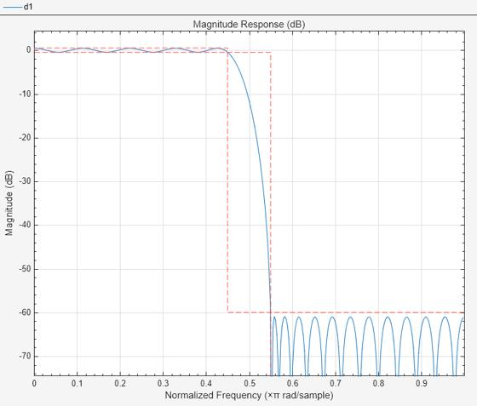

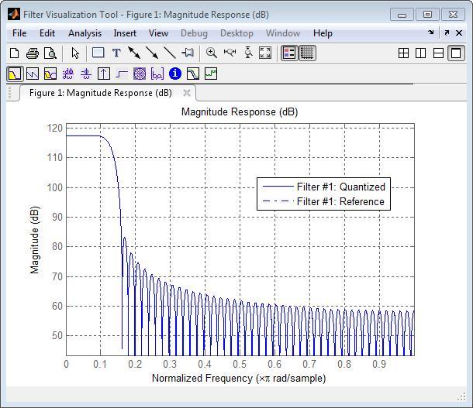
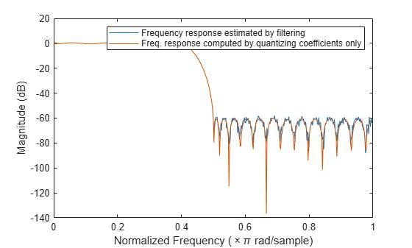
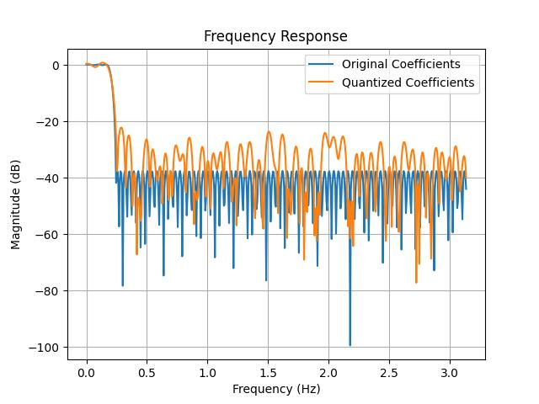
Observation
- The ideal FIR filter has floating-point coefficients.
- Quantization converts these coefficients into 8-bit fixed-point values.
- Rounding selects the nearest representable coefficient value.
- The rounded filter response remains close to the ideal response.
- Small differences are observed between the ideal and quantized frequency responses.
- Quantization introduces a small output error.
- The MSE provides a numerical measure of this error.

Result

Thus, the 16-tap FIR low-pass filter with a cutoff frequency of 0.4π rad/sample was successfully designed and its coefficients were quantized using 8-bit fixed-point rounding. The frequency response, coefficient quantization error, output error, and MSE were analyzed. The rounded coefficients produced a response close to the ideal floating-point FIR filter, demonstrating the effectiveness of rounding for reducing finite-word-length effects.

