Patient Risk Intelligence
Demo Video — Script & Production Guide
Target runtime: 4–5 minutes · Tone: confident, calm, professional

Overview
This document is the full production package for a demo video of the Patient Risk Intelligence platform: a governed, role-based clinical chat and dashboard built over five MCP-based data domains (vitals, labs, medications, clinical notes, radiology).
It covers: pre-recording setup, the narration script scene by scene, the architecture diagram to use as a visual aid, a shot list for quick reference while recording, on-screen caption text, and practical editing notes.
Recording setup: 1920×1080, 60fps if possible (chat streaming and typing look better), clean browser profile with no extensions or bookmarks bar visible.

Before you record
- Bring the full stack back up: docker compose up -d → bash scripts/start_mcp_servers.sh → register --all → start the runtime agent → cd frontend && npm run dev. Full command reference in docs/QUICK_TEST.md.
- Let it run for a minute so the dashboard has a few real audit events before filming — an empty dashboard looks unfinished.
- Pre-warm the LLM once, off camera, by asking the physician demo question before you start recording — the very first /ask call is sometimes a touch slower.
- Have a populated anomaly panel ready. If it's empty, run a restricted-role query against an excluded domain a couple of times first so the panel has something real to show.

Architecture diagram (for Scene 2)
Blue = the live request path a clinician's question travels. Gray = supporting platform infrastructure (identity, service discovery/audit, distributed tracing).
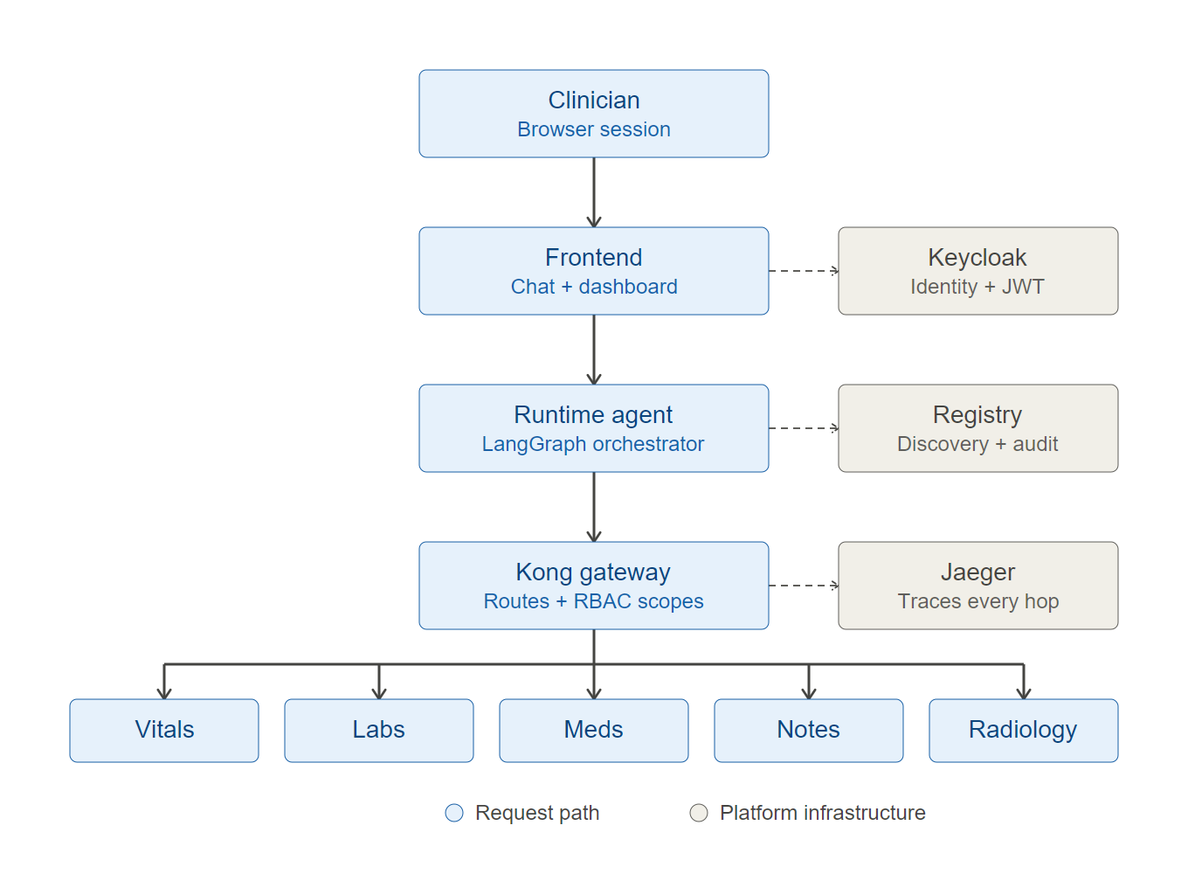
A clinician's browser talks to the Next.js frontend, which calls the LangGraph runtime agent, which routes through the Kong gateway to five domain MCP servers. Keycloak handles identity, the registry control plane handles service discovery and audit, and Jaeger traces every request end to end.

Full script

Scene 1 — Cold open / hook
Timing: 0:00–0:15
Screen: Title card or blank dark screen, then cut straight to the chat page already loaded (no login shown yet)
"A clinician needs a patient's full risk picture — vitals, labs, medications, notes, imaging. That data lives in five different systems, each with its own access rules. Today I'm going to show how we turned that into one governed conversation."

Scene 2 — The problem, briefly
Timing: 0:15–0:40
Screen: Architecture diagram (above), or narrate over a dimmed dashboard screenshot
"Five clinical domains — vital signs, labs and diagnoses, medications, clinical notes, radiology — each behind its own MCP server, each with different role-based access. A physician sees everything. A nurse sees vitals and labs only. A case manager sees only clinical notes. Every single access is authenticated, authorized, and audited — nothing bypasses that."
Note: if you don't have a polished diagram ready, skip this scene and fold the explanation into Scene 3's narration instead. A rough diagram is worse than no diagram.

Scene 3 — Login (real auth, not a mock)
Timing: 0:40–1:05
Screen: http://localhost:3000 login card → click “Sign in with Keycloak SSO” → real Keycloak login page → sign in as doctor-test / test123
"This isn't a mocked login — it's a real OIDC flow against Keycloak. I'll sign in as a physician."
- Type slowly enough that the audience can read the credentials on screen.
- Let the redirect back to /chat fully land before cutting.

Scene 4 — The chat: full-access physician answer
Timing: 1:05–2:00
Screen: /chat page
"Here's the clinician workspace. I select a patient, set my reason for access — that's logged too — and ask a natural question."
- Show the patient picker briefly (demo-patient-1, Chester802 Aufderhar910, 59 yrs).
- Show the Purpose of Access dropdown, select “Deterioration Review.”
- Type: “What is this patient's overall risk picture?” and send.
- Let the “Querying clinical data sources…” indicator show for a second or two — don't cut it, it proves it's live.
- When the answer lands, pause and let the camera sit on it for 3–4 seconds before narrating over it.
"One answer, fused from all five sources — and every single fact is cited back to the exact server it came from. Polypharmacy risk from medications, NEWS2 score from vitals, active diagnoses from labs, the latest radiology finding, all in one place. Nothing here is invented — if a source has no data, it says so."
- Hover or point at 2–3 of the colored citation pills as you say this.

Scene 5 — Role-based access, live
Timing: 2:00–2:50
Screen: Sign out → sign back in as nurse-test / test123 → ask the same question
"Now watch what happens with a different role. I'll sign out and back in as a nurse — a clinical viewer."
"Same question, same patient — but this role only has scope for vitals and labs. The system doesn't guess or fudge that — it tells the clinician exactly what it couldn't check, and exactly why."
- Let the “You have access to 2 of 5 servers — Physician role required for full access” notice sit on screen for a beat.
"That boundary isn't cosmetic. It's enforced with real JWT scopes at every single server, not just in this UI."

Scene 6 — The control plane: dashboard
Timing: 2:50–3:35
Screen: Navigate to /dashboard
"Behind the chat is a control plane. This is a live view of the platform — not a mockup."
- KPI cards (PHI touches, denials, active servers) — “Every PHI access, every denial, tracked in real time.”
- Registry table — “Every registered server, its health, its Kong route, which roles can reach it — and this health status is live-polled every 20 seconds, not a static flag.”
- Anomaly panel — “And the platform watches its own audit trail for patterns a compliance team would care about — repeated denials, off-hours access, a user probing across servers they're not authorized for.”
If you have a clean anomaly example on screen, let it show — a populated anomaly panel is far more convincing than an empty “No anomalies detected” state.

Scene 7 — (Optional bonus) Observability
Timing: 3:35–4:00
Screen: Click a trace ID link → Jaeger UI at :16686
"One more thing for the engineers watching — every request is traced end to end. Click any trace ID from the audit log and you land in Jaeger, seeing the exact path a single question took across the agent and every server it touched."
Cut this scene if you're running short on time — it's the least essential to a non-technical audience.

Scene 7.5 — (Optional) The factory: onboarding a new domain
Timing: +30–45 sec, insert after Scene 7
Screen: Sped-up terminal clip (2–3x) of the onboarding CLI: draft blueprint → human approval → generate server code → register → agent auto-discovers it
"This platform isn't fixed at five domains. Watch how fast we can bring on a sixth. A blueprint gets drafted, a human approves the access rules, the server code generates itself, it registers with the control plane — and the agent picks it up automatically. No redeploy, no manual wiring."
Include this if your audience is technical or a platform stakeholder — it's the actual differentiator of this project (it's literally called the “MCP Data Factory”), not just role-based chat over five fixed sources. Narrate over sped-up footage rather than real-time typing — it's a CLI flow, not a polished UI, and will drag at real speed. Cut it entirely if your audience is purely clinical/end-user focused.

Scene 8 — Close
Timing: 4:00–4:30
Screen: Back to /chat, or a clean end card
"One governed conversation instead of five disconnected systems — with role-based access, full audit, and live observability built in, not bolted on. That's the Patient Risk Intelligence platform."

Shot list (quick reference while recording)
# | Screen | Key action
1 | Chat page (loaded) | None — just sit on it
2 | Diagram or dimmed dashboard | Narration only
3 | Login → Keycloak → /chat | Sign in as doctor-test
4 | /chat | Patient picker, purpose selector, ask question, let answer render
5 | /chat | Sign out, sign in as nurse-test, same question, show restriction notice
6 | /dashboard | Scroll KPIs → registry table → anomaly panel
7 | Jaeger (:16686) | Click a trace ID, show waterfall
7.5 | Terminal (sped up) | Onboarding CLI: blueprint → approve → generate → register (optional)
8 | End card / final frame | Closing line

Should you show the onboarding agent?
Yes, but brief. This project's whole name is the “MCP Data Factory,” and the onboarding pipeline — blueprint, human approval, code generation, registration, automatic agent discovery — is the actual differentiator, not just the RBAC-governed chat you're already showing. Without it, the video proves “we built a governed chat over five fixed data sources.” With a 30–45 second bonus clip (Scene 7.5), it proves “we built a platform that can safely onboard a sixth domain in minutes.”
The tradeoff: it's a CLI flow, not a polished UI, so it won't look as slick on camera as the rest of the video.
Recommendation:
- Include Scene 7.5 if your audience is technical or a platform/engineering stakeholder — it materially strengthens the pitch.
- Narrate over sped-up (2–3x) terminal footage rather than real-time typing, to keep it brief and polished.
- Cut it entirely if your audience is purely clinical end-users — they care about the chat and dashboard, not the extensibility story.

On-screen captions / lower-thirds
Keep every overlay under about six words — anything longer competes with your narration instead of reinforcing it. Fade in/out over ~0.3s, on screen for 3–4 seconds max.
Scene | Timestamp | Lower-third text
1 | 0:00 | (none — let the hook line breathe)
2 | 0:15 | 5 clinical domains · 1 governed conversation
3 | 0:40 | Real OIDC login — Keycloak
4 | 1:05 | Role: Physician · Full access
4 | ~1:45 (answer lands) | Every fact cited to its source server
5 | 2:00 | Role: Clinical Viewer · Vitals + Labs only
5 | ~2:30 (restriction notice) | RBAC enforced at every server — not just the UI
6 | 2:50 | Control plane — live, not a mockup
6 | ~3:15 (anomaly panel) | Self-monitoring audit trail
7 | 3:35 | Distributed tracing — every hop, every request
8 | 4:00 | (none — let the closing line land clean)

Practical production notes
- Don't narrate live unless you're confident — record screen + a scratch narration track separately, then re-record voiceover against the final cut. Much easier to get pacing right.
- Pre-warm the LLM call once before recording Scene 4 off-camera — the first /ask call is sometimes a touch slower due to cold connections.
- Have a populated anomaly panel ready before Scene 6, not an empty one.
- Keep each narrated screen on-camera for a beat before you start talking over it — cutting straight to narration while the screen is still loading looks rushed.
- Don't caption Scene 1 or Scene 8 — a title-less open and a clean close read as more confident than bookending every scene with text.
- If adding a persistent corner logo, keep it small and static — don't animate it in/out per scene.

