**Manor Hill Advisors**

Please find steps below to see.

1. Please find the github link below where you can see the Springboot application microservice Backend code.

LINK :   https://github.com/aakash0456/ManorHillDemoApplication/tree/master

2. I have also developed a frontend UI. Please find front end UI code github link below.

LINK: https://github.com/aakash0456/ManorHillFrontEnd/tree/master

3. To check the output please run below link in any browser(EX- chrome)

LINK: https://example-mhaapplication.onrender.com/time?timezone=America/Chicago

I have given timezone America/Chicago to test the link. As a part of task, you will get th abbreviation, timezone, and DateTime fields in JSON format. You can also try other America timezone. Please find list

of all valid time zone below. If you hit any timezone outside United states you will get error as response.

Ex - America/New_York", "America/Chicago", "America/Denver", "America/Los_Angeles", "America/Adak" , "America/Anchorage", "Pacific/Honolulu","Pacific/Samoa", "Pacific/Guam", "America/Puerto_Rico", "America/Virgin"

Just change the timezone in the

LINK : https://example-mhaapplication.onrender.com/time?timezone=America/New_York

Hit the above link on browser you will get the New_York output response in json format. I have deployed in free hosting site render.com in free tier. So you might get delay in response since it is free.

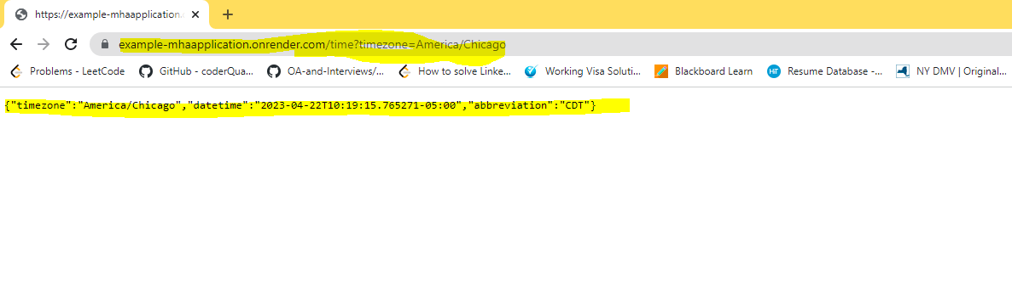

4. I have developed both front end UI and backend and host the website on cloud (netlify- front end and render.com – backend). Please hit below URL in browser to check the website.

LINK: <https://timezone-application.netlify.app/>

Steps to develop Springboot Application.

Step 1: Create a new Spring Boot project using Spring Initializr

* Go to start.spring.io
* Select Maven Project
* Select Java 11
* Add the Spring Web dependency
* Click on Generate
* Step 2: Implement the API endpoint

Open the project in your IDE

* Create a new Java class named "TimeController" .
* Add the "@RestController" annotation to the class to mark it as a Spring MVC controller.
* Add the "@GetMapping" annotation to a method named "getTime" that takes a "timezone" parameter.
* Add a check to validate that the timezone parameter is within the US timezones.
* If the timezone parameter is not valid or not a US timezone, throw an error using the "throw new IllegalArgumentException()" method.
* Use the "RestTemplate" class to make a GET request to the "http://worldtimeapi.org/api/timezone/{timezone}" endpoint, where {timezone} is the value of the timezone parameter.
* Map the response to a custom class containing only the abbreviation, timezone, and DateTime fields.