**ABSTRACT**

Our country India is an agricultural country. About 70% of the total population of India is, directly and indirectly, depend upon agriculture for their livelihood and other similar needs. The tremendously increasing population of our country has put extraordinary stress on the farming sector. The climatic conditions of South Asia are dependent upon Monsoon and our country is under the full influence of it. Therefore, the availability of water to crops at the time of requirement is an indispensable thing to get maximum production of crops to meet the food production target of the nation. At this stage, it becomes unrealistic to depend solely upon the natural source of water i.e rain. Hence at that time, artificial irrigation comes to the scenario. Presently in India, Drip & Sprinkler irrigation are being practiced. One of the modern method of irrigation which has yet to fetch the attention of Indian farmers. The Lateral Move Irrigation method of irrigation is a unique methodology to irrigate crops in fields. This method may also be referred as overhead sprinkler irrigation.

***KEYWORDS***- water requirement of crops, irrigation, soil erosion, cultivation, sandy soil

1. **INTRODUCTION**

Lateral moves are particularly popular in Australia and especially in the cotton industry. They are better suited to the rectangular shape of surface irrigated fields than the circular wetting area of the center pivot. In Australia, machines of up to 1200 m in length have been installed. LM machines are not as commonly used overseas, and, when used in other crops, are rarely greater than 500m long. LM’s are commonly 800-1000m long and indicatively cover an area of 165 ha. Compared to CP’s, LM’s require level, rectangular blocks, require more management as the driest ground is not always immediately in front of the areas requiring water most is at the opposite end of the field. Additional labor is also required to supervise the machine (ie guidance systems)and maintain supporting infrastructure such as channel supply systems.

Center pivots and lateral moves (CPLM) offer greater control and flexibility of irrigation management. Increasing pressure on water availability, potential yield improvements, more control of soil water within the root zone of the crop, reduced labor and potential for fertigation and chemigation are some of the factors which have created an interest in this technology.

**1.1 HISTORY:**

Center-pivot irrigation was invented in 1940 by farmer Frank Zybach who lived in Strasburg, Colorado It was recognized as a method to improve water distribution to fields. Centre Pivot irrigation is a form of overhead sprinkler irrigation consisting of several segments of pipes joined together by trusses to support each other. The whole assembly is mounted on tires due to which it rotates in a circular manner around a central point known as Pivot Point. The space between two tires is known as Span. The typical assembly is shown in figure 2 The arm of the system is connected with a number of pipes at fixed intervals of horizontal distance between them are known as sprinklers. The average quantity of water from a sprinkler can be controlled by the Control Unit.

Various modifications in the system have done time to time to achieve optimum performance from the original concept of the system and to suit various topographical and climatic conditions of different locations of the world. The Centre Pivot irrigation comes under the category of Self Propelled irrigation system and in the USA about 29% of the total irrigation is achieved by such a self-propelled system of irrigation.

**1.2 OBJECTIVE**

1] Ideal for under-utilized land and irregular fields.

2] Decreases energy costs through the low-pressure application.

3] 50% to 70% water conservation over furrow irrigation.

4] Reduces labor costs as much as 70%.

**1.3 METHODOLOGY**

1. **LITERATURE REVIEW**
2. **CENTRE PIVOT IRRIGATION SYSTEM:**

Centre Pivot is a self-propelled sprinkler system rotates around the pivot point and has the lowest labour requirements of the systems considered here. It is constructed using pipes attached to moveable towers. The amount of water applied is controlled by the speed of rotation. Centre pivots can be adjusted to any crop height and are particularly suited for lighter soils. With a computerised control system, the operator is able to program many features for the *irrigation* process. Furthermore, it is possible to install a corner attachment system (also called “end-gun”) that allows *irrigation* of corner areas missed out by conventional centre pivot systems.

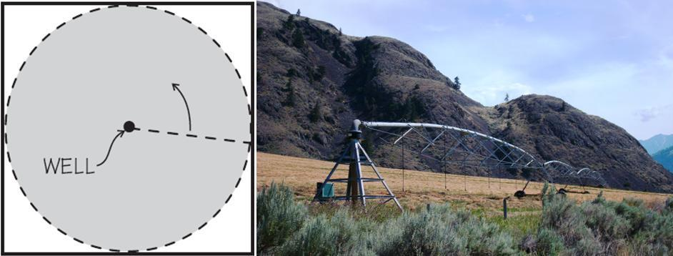

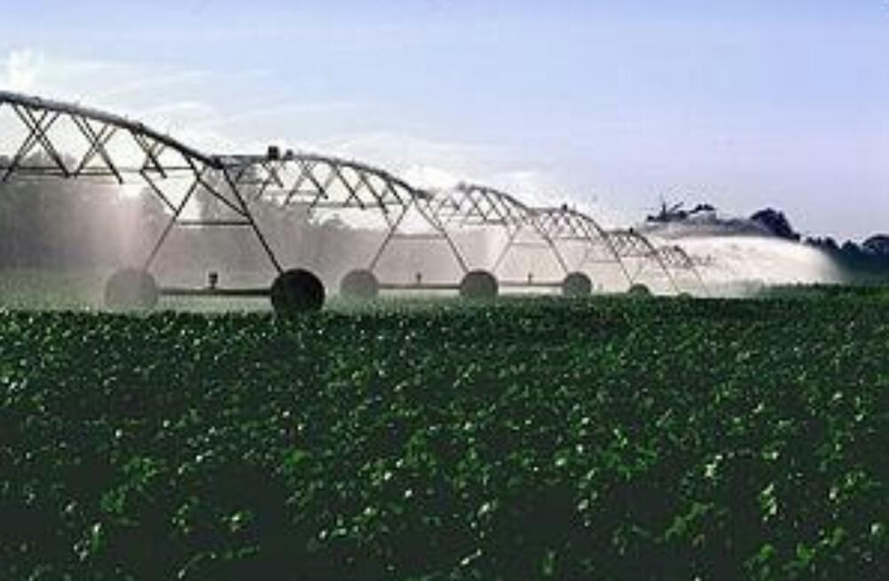

**3.1. LATERAL MOVE IRRIGATION SYSTEM :**

The linear move (also called lateral move) irrigationsystem is built the same way as a center pivot; that is moving towers and pipes interconnecting the towers. The main difference is that all the towers move at the same speed and in the same direction. Water is pumped into one of the ends or into the center. Due to the high capital investment, linear moves are used on high-value crops such as potatoes, vegetables, and turf.

A series of pipes, each with a wheel permanently affixed to its midpoint, and sprinklers along its length, are coupled together. Water is supplied at one end using a large hose. After sufficient irrigation has been applied to one strip of the field, the hose is removed, the water drained from the system, and the assembly rolled either by hand or with a purpose-built mechanism so that the sprinklers are moved to a different position across the field. The hose is reconnected. The process is repeated in a pattern until the whole field has been irrigated.

This system is less expensive to install than a center pivot but much more labor-intensive to operate – it does not travel automatically across the field: it applies water in a stationary strip, must be drained, and then rolled to a new strip.The pipe doubles both as water transport and as an axle for rotating all the wheels. A drive system (often found near the center of the wheel line) rotates the clamped-together pipe sections as a single axle, rolling the whole wheel line. Manual adjustment of individual wheel positions may be necessary if the system becomes misaligned.

Wheel line systems are limited in the amount of water they can carry and limited in the height of crops that can be irrigated. One useful feature of a lateral move system is that it consists of sections that can be easily disconnected, adapting to field shape as the line is moved. They are most often used for small, rectilinear, or oddly-shaped fields, hilly or mountainous regions, or in regions where labor is inexpensive.

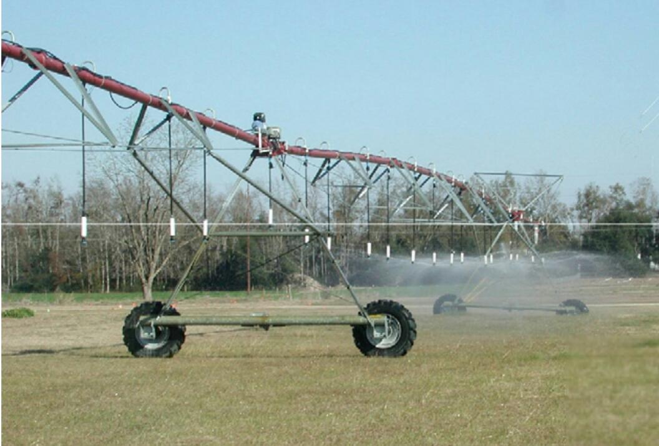

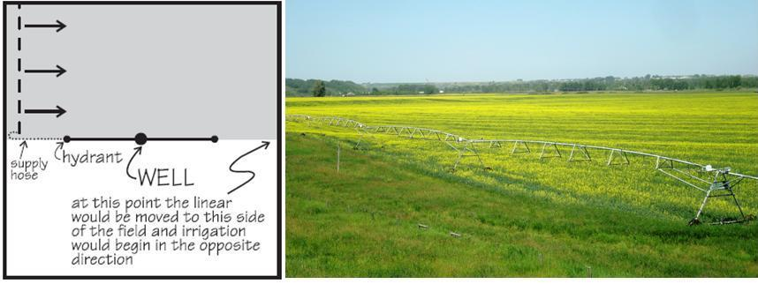

**3.2 KEY COMPONENTS OF LATERAL MOVE IRRIGATION SYSTEM:**

Centre Pivot or Lateral Move systems consist of the following components:

* A span is the pipe and framework between two towers
* A tower supports the spans and contains drive mechanisms and wheels
* Outlets are the points at which water exits the main pipes
* Emitters are attached at outlets either directly or on rigid or flexible droppers. Water is applied to the plants through emitters
* Droppers are rigid or flexible small diameter pipes that allow emitters to be placed closer to the ground

**4. APPLICATIONS WITH HEALTHY HEADWATERS(HH):**

CP and LM represent approximately 15% of the irrigated study area (grower survey), the second most significant irrigation system next to surface irrigation in the area.

CP’s and LM’s are most likely to be the most populate option where growers within the area are considering an infield irrigation system change. The major drivers for

adoption of CPLM include potential water savings, labor savings, and yield improvements. Other key advantages identified over traditional surface

irrigation systems include the ability to more precisely manage irrigations for eg apply smaller volumes on preseason irrigations, improved crop germination, more

uniform applications, better use of in-season rain events, the reduced potential of waterlogging and the ability to use deficit irrigation strategies.

**4. 1.WATER SAVINGS:**

**DOCUMENTED RANGE OF WATER SAVINGS:**

While efficiencies are strongly influenced by management practices, well-managed centre pivots/lateral moves commonly produce application efficiencies in excess of

90%. Low pressure, static plate sprinklers on center pivots/lateral moves typically operate at 80–90% application efficiency while moving plate sprinklers have application efficiencies up to 95%. Low energy precision application (LEPA) socks and bubbler emitters have been found to have application efficiencies up to 98% where surface run-off is controlled with furrow dikes. In many cases, these systems are managed to apply the same amount of water that would have been used in a surface system in order to attain higher yields based on the irrigation efficiency gains.

**FACTORS AFFECTING WATER SAVINGS:**

Generally, the performance of Centre Pivots and Lateral moves are less sensitive to factors directly affecting volumetric water savings and more sensitive to equivalent water savings through improved productivity. In terms of volumetric water savings, variation in water loss components such as deep drainage, evaporation losses, and runoff are limited in practice by the capacity of these systems. Modern sprinkler options also limit the variation in losses by reducing wind drift, evaporative losses, and runoff. The greatest potential for water losses and variation in volumetric water savings will most likely

occur as a result of surface runoff. This is particularly significant for Centre Pivots where the average application rate exceeds soils infiltration characteristics on the outer

spans. This can be improved by increasing the wetted footprint through different sprinkler options or configuring multiple sprinklers (i.e. same flow rate) on

spreader bars.

**ABILITY TO MEASURE AND QUANTIFY WATER SAVINGS:**

Measures of machine performance include Rate (System Capacity, Managed System Capacity, Average Rate, Instantaneous Rate), Uniformity and Efficiency.

**4.2 COSTS:**

**CAPITAL COST:**

Typical capital costs associated with Centre Pivot / LateralMove irrigation systems range from $2,500 to $5,500 / ha and $2,500 to $5,000 / ha respectively. The capital costs associated with the purchase of a Centre Pivot / Lateral move include the purchase of the machine and installation costs including earthworks. In addition to the cost of the

machine, other items include pipework, pumping equipment and the power plant (either diesel or electric) which are included in the costs above. Other capital costs

more site-specific could include power lines (and connection), supply channels, laser leveling, land clearing, and road construction. Laser levelling/land forming are

often limited to cut to drain as opposed to cut to grade. These additional items can add up to 50% of the system cost.

The unit cost (i.e. $ / ha) of both Centre Pivots and Lateral Moves is generally less for machines servicing a larger area. The most significant influence on machine price is

the pipe diameter of spans. Smaller pipe size, while reducing the purchase price of the machine will increase the ongoing operating costs which can be as significant

over the lifetime of the machine as the original purchase.

**OPERATIONAL COST:**

As a general rule of thumb, the operating pressure at the center of the machine or supply point shouldn’t exceed 205 kPa (30 psi). Operating at pressures higher than this

can result in significantly higher pumping costs. Conversely operating at pressures too low may be a bigger problem, by compromising the performance of the sprinkler package, therefore, leading to irrigation nonuniformity and poor crop performance. Other operating costs include labor. Labor requirements of lateral moves are 10 times less than surface irrigation while 50 to 80% more than a Centre Pivot.

**4.3 INSTALLATION CONSIDERATIONS:**

There are a number of factors to take into account prior to installation. These include consideration of financial, planning, design, operational and maintenance aspects.

Balancing the initial capital investment with the on-going operating costs is an important consideration at the design stage. These comparisons can be made by comparing the present value of ongoing costs with the purchase price to determine the best option.

System capacity is also a fundamental consideration in ensuring the machine is capable of meeting the crop demands. There are many examples where machines have suffered from inadequate system capacity and were not able to keep up with crop demands and user expectations.

On commissioning it is important to assess the performance of the system to ensure that the system is operating to specification. System checks include uniformity, flow rates, pressures, and machine calibration. The general advice is to include terms in the sales contract to withhold final payment until the performance of the machine is independently assessed and verified to meet the design specifications.

**4.5 BENEFITS**

* Improved Safety.
* Better Product Quality.
* Shorter workweeks for labor.
* Increased in Productivity.
* More efficient use of materials.

**5. ADVANTAGES**

1] It is an economical and efficient method of irrigation for large fields. It requires about 60% of the water than that of the traditional method of irrigation so considerably saves water.

2] Soil needs not to be in level because water flowing over the ground is not due to gravity effect.

3] Rubber tires with moderate shock absorbing arrangement make the system suitable even for the undulating field.

4] Indian farmer often suffer from a shortage of labor power so this system proves best because almost no labors are involved for operating.

5] The towers of the system can also be equipped with CCTV cameras to inspect the diseases on crop plant and for theft supervision for large fields.

6] As it is almost automatic so farmer needs not to present on the farm at the time of application of water. He can watch live footage of it on his own smartphone or computer.

7] Herbicides, pesticides, and soluble nutrient can be directly fed to each plant.

8] Since water washes the leaves of the plant so reduces the chances of diseases.

**6. DISADVANTAGES**

1] Very large initial cost involved.

2] All Indian farmers today are even hesitant to use Drip and Sprinkler method so it is very hard to for them to adopt such a system at large capital investment.

3] If proper service and maintenance is not taken then the system may lead to a breakdown.

4] Heavy constituent of salt may lead to blockages of sprinkle nozzles which may lead to the frequent replacement of them.

5] For clayey soil care has to be taken so as the wheel does not stick in the muddy wet soil.

6] Danger from thieves may be the major part of the total failure of the system in Indian purview.

**7. CONCLUSION**

- Various aspect of the Centre Pivot System are studied and looking towards this method in Indian perspective, it may be concluded that there are vast opportunities to practice it in India. Especially, when we note the advantages of this system, such as its effectiveness to irrigate large area of land, this could ultimately help Indian farmers in a great way.

**REFERENCES:**

1. Montero, J & Martínez, A & Valiente, M & Moreno, Miguel & M. Tarjuelo, J. . *Analysis of water application costs with a centre pivot system for irrigation of crops in Spain.* Irrigation Science (2012), DOI 31. 10.1007/s00271-012-0326-4.
2. Moreno, Miguel & Medina, D & F. Ortega, J & M. Tarjuelo, J. (2012). *Optimal design of center pivot systems with water supplied from wells.* Agricultural Water Management. 107. 10.1016/j.agwat.2012.01.016.
3. J. Han, Young & Khalilian, Ahmad & Owino, Tom & J. Farahani, Hamid & Moore, Sam. (2009). *Development of Clemson variable-rate lateral irrigation system*. Computers and Electronics in Agriculture. 68. 108-113. 10.1016/j.compag.2009.05.002.
4. Amir, Ilan & J. McFarland, Marshall & L. Reddell, Donald. (1986). *Energy analysis of lateral move irrigation machines. Energy in Agriculture.* 5. 325-337. 10.1016/0167-5826(86)90031-8.
5. Omary, M., Camp, C.R. and Sadler, E.J., 1997. *Center pivot irrigation system modification to provide variable water application depths.* Applied Engineering in Agriculture, 13(2), pp.235-239.
6. Tolson, H.N., Hlavinka Equipment, 2000. *Pivoting lateral move irrigation system which waters in the pivot mode.* U.S. Patent 6,068,197.
7. Cornelius, G., WADE AND CO RM, 1971. *Laterally moving automatic irrigation system*. U.S. Patent 3,583,428.
8. Haris, G. et. al. , *Central Pivot and Leteral Move Irrigation*, Queensland, Department of Employment Reports, 2011
9. Beat, S., Dorothee, S., *Sprinkler Irrigation*, Sustainable Sanitation and Management, 2010
10. Vispute, P., *Centre Pivot Irrigation-A Modern Method of Irrigation in Indian Perspective*, Journal of Advanced Research in S&T, Vol 2, Issue 12, 2016