# CONTENTS

# Introduction

# History

# Objective

# Literature Review

# Centre Pivot Irrigation System

# Lateral Move Irrigation System

# Key Components Of Lateral Move Or Centre Pivot Irrigation System

# Travelling Big Gun

# Side Roll

# The Design Of Centre Pivot Or Lateral Move Iirigation System

# System Capacity

# Capital Vs Operational Cost

# Diesel or Electric Operation?

# Sprinklers

# End Guns

# Towable Pivots

# Pumps

# Wheel Tracks

# Factors Affecting Lateral Move Irrigation And Centre Pivot Irrigation System

# Water Savings

# Documented range of water savings

# Factors affecting Water savings

# Ability to measure and quantify water savings

# Costs

# Capital Cost

# Operational Cost

# Installation Considerations

# Impediments to Adoption

# Benefits

# Applicability

# Advantages

# Disadvantages

# Conclusion

# References

# FIGURES

# A centre pivot system irrigates circular fields.

# A linear move system irrigates rectangular fields.

# INTRODUCTION

Lateral moves are particularly popular in Australia and especially in the cotton industry. They are better suited to the rectangular shape of surface irrigated fields than the circular wetting area of the center pivot. In Australia, machines of up to 1200 m in length have been installed. LM machines are not as commonly used overseas, and, when used in other crops, are rarely greater than 500m long. LM’s are commonly 800-1000m long and indicatively cover an area of 165 ha. Compared to CP’s, LM’s require level, rectangular blocks, require more management as the driest ground is not always immediately in front of the areas requiring water most is at the opposite end of the field. Additional labor is also required to supervise the machine (ie guidance systems) and maintain supporting infrastructure such as channel supply systems.

Center pivots and lateral moves (CPLM) offer greater control and flexibility of irrigation management. Increasing pressure on water availability, potential yield improvements, more control of soil water within the root zone of the crop, reduced labor and potential for fertigation and chemigation are some of the factors which have created an interest in this technology [1].

**1.1 History**

Center-pivot irrigation was invented in 1940 by farmer Frank Zybach who lived in Strasburg, Colorado It was recognized as a method to improve water distribution to fields. Centre Pivot irrigation is a form of overhead sprinkler irrigation consisting of several segments of pipes joined together by trusses to support each other. The whole assembly is mounted on tires due to which it rotates in a circular manner around a central point known as Pivot Point. The space between two tires is known as Span. The typical assembly is shown in figure 2 The arm of the system is connected with a number of pipes at fixed intervals of horizontal distance between them are known as sprinklers. The average quantity of water from a sprinkler can be controlled by the Control Unit. [2]

Various modifications in the system have done time to time to achieve optimum performance from the original concept of the system and to suit various topographical and climatic conditions of different locations of the world. The Centre Pivot irrigation comes under the category of Self Propelled irrigation system and in the USA about 29% of the total irrigation is achieved by such a self-propelled system of irrigation.

**2. OBJECTIVE**

1] To save water, energy and man power in the agriculture sector.

2] Handle the system manually as well as automatically.

3] Detect water level.

4] To design, which will be efficient and effort reducing of the former. [3]

**3. LITERATURE REVIEW**

Amir, Ilan & J. McFarland, Marshall & L. Reddell, Donald told several basic types lateral move irrigation machine (LMIM) are used at many locations and under a wide variety of conditions. Also the energy required to operate linear –move irrigation machines fed by flexible hoses is analyzed in the paper. [9]

J. Han, Young & Ahmad Khalilian, & Tom Owino & Hamid J. Farahani, & Sam Moore has introduced a variable-rate lateral irrigation system. It also introduced the variable speed control system allows the irrigation system to move faster over wet zones requiring a lighter irrigation amount, and slower over zones requiring a heavier irrigation amount. [8]

M. A,Moreno, P. Carrion, A. Izquiel, J & M. Tarjuelo introduced a tool to optimize the design and management of the water distribution and centre pivot systems seeking to minimize water application cost per unit area, including investment, operation, and maintenance costs.[7]

S, Ouazaa, B. Latorre, J. Burguete, A. Serreta, E. Playan, R. Salvador, P. Paniagua, N. Zapata told about the self propelled irrigation machines and explained their advantages such as high potential uniform and efficient for water application, high degree of automation as well as ability to apply water and nutrients over wide range of soil.[6]

**4.** **CENTRE PIVOT IRRIGATION SYSTEM**

Centre Pivot is a self-propelled sprinkler system rotates around the pivot point and has the lowest labour requirements of the systems considered here. It is constructed using pipes attached to moveable towers. The amount of water applied is controlled by the speed of rotation. Centre pivots can be adjusted to any crop height and are particularly suited for lighter soils. With a computerised control system, the operator is able to program many features for the *irrigation* process. Furthermore, it is possible to install a corner attachment system (also called “end-gun”) that allows *irrigation* of corner areas missed out by conventional centre pivot systems.[4]

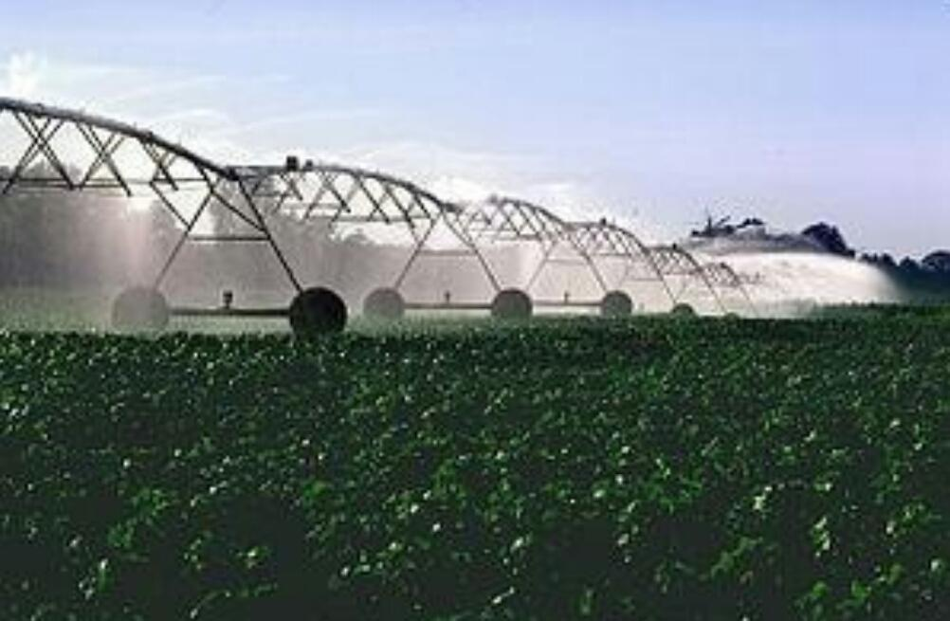

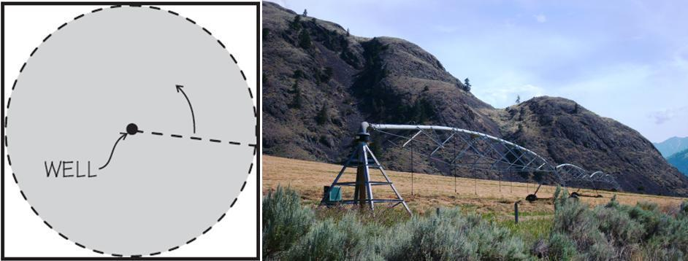

**Fig**. **A centre pivot system irrigates circular fields**

**5. LATERAL MOVE IRRIGATION SYSTEM**

The linear move (also called lateral move) irrigationsystem is built the same way as a center pivot; that is moving towers and pipes interconnecting the towers. The main difference is that all the towers move at the same speed and in the same direction. Water is pumped into one of the ends or into the center. Due to the high capital investment, linear moves are used on high-value crops such as potatoes, vegetables, and turf.

A series of pipes, each with a wheel permanently affixed to its midpoint, and sprinklers along its length, are coupled together. Water is supplied at one end using a large hose. After sufficient irrigation has been applied to one strip of the field, the hose is removed, the water drained from the system, and the assembly rolled either by hand or with a purpose-built mechanism so that the sprinklers are moved to a different position across the field. The hose is reconnected. The process is repeated in a pattern until the whole field has been irrigated.[4]

This system is less expensive to install than a center pivot but much more labor-intensive to operate – it does not travel automatically across the field: it applies water in a stationary strip, must be drained, and then rolled to a new strip. The pipe doubles both as water transport and as an axle for rotating all the wheels. A drive system (often found near the center of the wheel line) rotates the clamped-together pipe sections as a single axle, rolling the whole wheel line. Manual adjustment of individual wheel positions may be necessary if the system becomes misaligned.

Wheel line systems are limited in the amount of water they can carry and limited in the height of crops that can be irrigated. One useful feature of a lateral move system is that it consists of sections that can be easily disconnected, adapting to field shape as the line is moved. They are most often used for small, rectilinear, or oddly-shaped fields, hilly or mountainous regions, or in regions where labor is inexpensive.

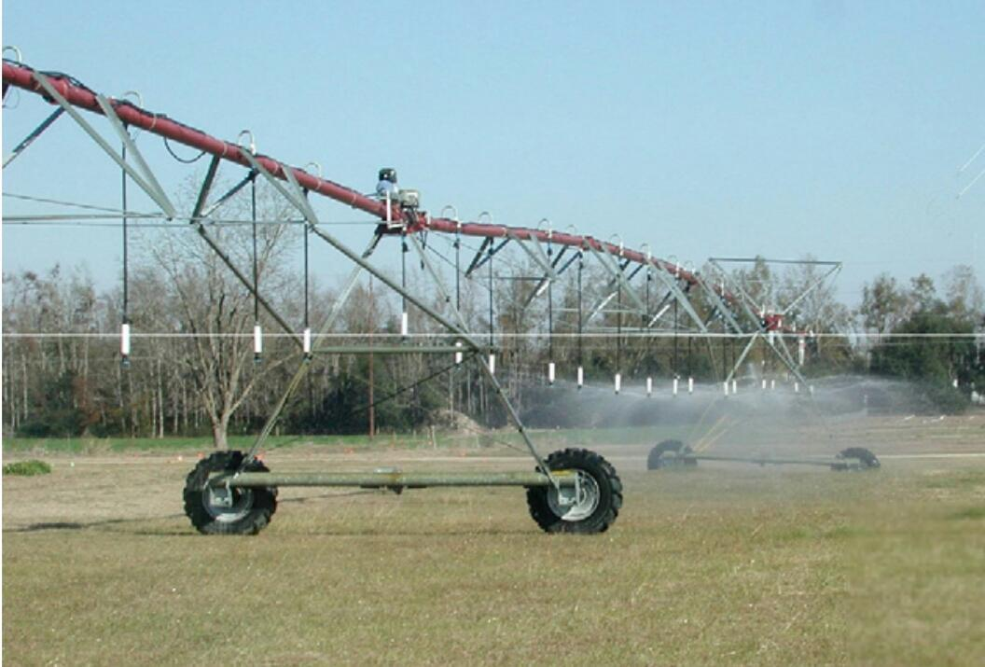

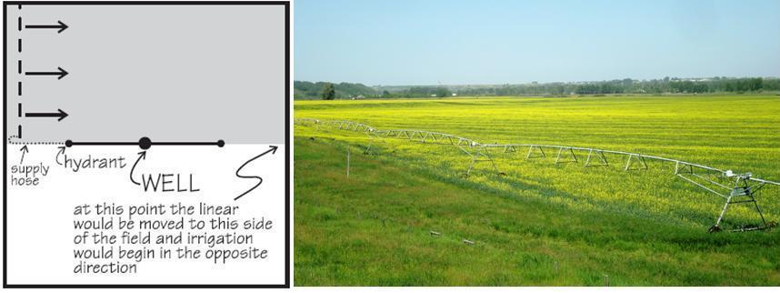

**Fig**. **A linear move system irrigates rectangular fields**

**5.1 Key Components Of Lateral Move Or Centre Pivot Irrigation System**

Centre Pivot or Lateral Move systems consist of the following components:

1] A span is the pipe and framework between two towers.

2] A tower supports the spans and contains drive mechanisms and wheels.

3] Outlets are the points at which water exits the main pipes.

4] Emitters are attached at outlets either directly or on rigid or flexible droppers. Water is applied to the plants through emitters.

5] Droppers are rigid or flexible small diameter pipes that allow emitters to be placed closer to the ground.

**5.2 Travelling Big Gun**

The travelling big gun system uses a large-capacity nozzle and high pressure to throw water out

over the crop as it is pulled through an alley in the field. Travelling big guns come in two main

configurations: hard-hose or flexible-hose feed. With the hard-hose system, a hard polyethylene

hose is wrapped on a reel mounted on a trailer. The trailer is anchored at the end or centre of the

field. The gun is connected to the end of the hose and is pulled towards the trailer. The gun is

pulled across the field by the hose winding up on the reel. With the flexible-hose system, the gun

is mounted on a four-wheel cart. Water is supplied to the gun by a flexible hose from the main line. A cable winch pulls the cart through the field towards the cart.[4]

**5.3 Side Roll**

The side roll (also called wheel roll) system consists of a lateral, usually a quarter mile long, mounted on 4 to 10 foot (1 to 3 meters) wheels in diameter and the pipe serving as an axle. When the desired amount of water has been applied to an area, a gasoline *engine* at the centre is used to move the side roll to the next. The sprinklers are generally mounted on weighted ,swivelling connectors so that no matter where the side roll is stopped, the sprinklers will always be on top. This type of system is not recommended for gradients greater than 5 per cent and should be used mainly on flat ground. Side roll systems are adapted only to low growing crops, have medium labour requirements and moderate initial investment.

**6. THE DESIGN OF CENTRE PIVOT OR LATERAL MOVE IIRIGATION SYSTEM**

**6.1 System Capacity**

System design can vary greatly for Centre Pivot or Lateral Move (CPLM) irrigation systems. Variations in design can have a large effect on capital and operating costs. Paddock shape, soil type, local climate, crops to be grown and power source will all influence design requirements. Understanding these climate requirements for selected site will enable to compare quotes from different suppliers and ensure get a machine that meets needs.[5]

This is the most important design criterion for CPLM systems. The system capacity of a Centre Pivot is the rate at which water can be supplied to the irrigated area, expressed in millimetres per day (mm/d). This is typically between 8 and 20 mm/d. It is the main criterion the pump, pipes and sprinkler design are based on, and for a given pivot can be calculated as follows:

System Capacity=ML/day x 100/Irrigated area (ha)

For example, with a pump flow rate of 6 ML/day irrigating 50 ha, system capacity is 12

mm/d.

If the system capacity is too low or under-designed, the system may not be able to supply enough water over a hot spell when at peak crop water requirements. A conservative system capacity ensures irrigation requirements can be met comfortably, even under extreme climatic conditions. However, this will increase the investment costs (larger pipes, pumps and / or pressure).

The desired system capacity depends on the water requirement of crop, the application efficiency of the irrigation system and the operating hours of the system. However, high system capacity can lead to high average application rates (AAR) especially on larger machines.

IF AAR exceeds soil infiltration rate, runoff will occur, and can cause waterlogging in some areas while other areas are under watered. AAR can be reduced by selecting sprinklers with a large throw diameter and installing spreader bars.

**6.2 Capital VS Operational Cost**

The selection of pipe sizes for the span-pipe and mainlines involves a compromise between the capital cost and the operating pressure. Operating pressure determines the ongoing operating costs, with higher operating pressure increasing pumping costs.

**6.3 Diesel or Electric Operation?**

Electric power is generally preferable for convenience, ease of operation and lower operating costs, particularly if off-peak power can be utilised. However Lateral Move systems that pump out of an open channel are generally powered by a diesel engine.

A main consideration in system power supply selection is the cost of connecting electricity to the pump site which can be a substantial cost.

**6.4 Sprinklers**

There are a wide array of sprinklers and nozzles available. Sprinklers represent less than 7% of the total cost but are responsible for more than 70% of the irrigation performance. There are many varieties of sprinklers and nozzles available.

Fixed plate sprinklers are the simplest and cheapest. They have a relatively small throw and are suitable for pastures provided the sprinkler spacing along the span-pipe is close enough and the average application rate is not excessive.

Moving plate sprinklers have greater throws and produce a more uniform droplet size and a better distribution uniformity.

Replacement of older poor performing sprinkler packages can provide a simple and cost effective performance improvement.

**6.5 End-Guns**

End guns are often fitted to CPLM systems, especially Centre Pivots as a cheap way to increase the area covered. However, end guns normally apply less water than the rest of the system and have poorer uniformity. This can result in poor crop performance compared to the rest of the machine.

Higher system pressure is required to operate an end-gun and this results in higher operating costs. For example, an end-gun may need 45 psi (31 m head) where 20 psi (14m head) or less is needed for the sprinklers. This could cost an extra $16.15/ML or $4845/year on a 50 ha pivot pumping 6ML/ha/year

(assumption: pump energy efficiency of 3.8 kW.hr/m and power cost $0.25/kW.hr).

The high velocity and large droplet size of water emitted from an end-gun can also damage soil structure, reducing infiltration.

Newer sprinkler technology such as end sprays' and low-pressure end guns provide reasonable uniformity over 6-15 m of additional radius without the need for booster pumps and are cheaper to install

If an end-gun is included, it should ideally be pressurised by a booster pump at the end of the pivot. End guns from the USA need 60hz, and therefore don't perform well in Australia with a 50 Hz electricity supply.

**6.6 Towable Pivots**

Most manufacturers offer towable pivot versions. This makes it possible to use one pivot structure to irrigate two or more circles. However, watering an additional circle effectively halves the system capacity of the machine. System capacity is further reduced by time taken to move the machine between circles which reduces the pumping utilisation ratio (the time available to irrigate).

Autumn and spring irrigation of annual pastures and winter crops may be possible over multiple circles, however growing summer crops on multiple circles is generally not recommended.

**6.7 Pumps**

Pump selection is critical for correct performance. Operating speed, total dynamic head (or pressure), flow rate and impeller trim are some of the key parameters. Many cases of poor centre pivot performance are due to incorrect pump and pipeline matching.

Large lateral move systems require very high flow rates which requires extra focus on certain details. Extra care must also be taken on channel design and roads for the cart to travel on.

**6.8 Wheel Tracks**

Bogging and or wheel ruts can be a significant problem. New installations should be fitted with a "dry-wheel pack" (half-throw sprinklers on solid drops or boombacks) to keep water off the wheel track. To avoid the formation of wheel ruts, wheel tracks should be built up and compacted during installation of the system and regular maintenance performed to prevent water from ponding on the tracks.

**7. FACTORS AFFECTING LATERAL MOVE IRRIGATION AND CENTRE PIVOT IRRIGATION SYSTEM**

CP and LM represent approximately 15% of the irrigated study area (grower survey), the second most significant irrigation system next to surface irrigation in the area. CP’s and LM’s are most likely to be the most populate option where growers within the area are considering an infield irrigation system change. The major drivers for adoption of CPLM include potential water savings, labor savings, and yield improvements. Other key advantages identified over traditional surface irrigation systems include the ability to more precisely manage irrigations for eg apply smaller volumes on preseason irrigations, improved crop germination, more uniform applications, better use of in-season rain events, the reduced potential of waterlogging and the ability to use deficit irrigation strategies.[1]

**7. 1 Water Savings**

**Documented range of water savings**

While efficiencies are strongly influenced by management practices, well-managed centre pivots/lateral moves commonly produce application efficiencies in excess of 90%. Low pressure, static plate sprinklers on center pivots/lateral moves typically operate at 80–90% application efficiency while moving plate sprinklers have application efficiencies up to 95%. Low energy precision application (LEPA) socks and bubbler emitters have been found to have application efficiencies up to 98% where surface run-off is controlled with furrow dikes. In many cases, these systems are managed to apply the same amount of water that would have been used in a surface system in order to attain higher yields based on the irrigation efficiency gains.

**Factors affecting Water savings**

Generally, the performance of Centre Pivots and Lateral moves are less sensitive to factors directly affecting volumetric water savings and more sensitive to equivalent water savings through improved productivity. In terms of volumetric water savings, variation in water loss components such as deep drainage, evaporation losses, and runoff are limited in practice by the capacity of these systems. Modern sprinkler options also limit the variation in losses by reducing wind drift, evaporative losses, and runoff. The greatest potential for water losses and variation in volumetric water savings will most likely

occur as a result of surface runoff. This is particularly significant for Centre Pivots where the average application rate exceeds soils infiltration characteristics on the outer spans. This can be improved by increasing the wetted footprint through different sprinkler options or configuring multiple sprinklers (i.e. same flow rate) on

spreader bars.

**Ability to measure and quantify water savings**

Measures of machine performance include Rate (System Capacity, Managed System Capacity, Average Rate, Instantaneous Rate), Uniformity and Efficiency.

**7.2 Costs**

**Capital Cost**

Typical capital costs associated with Centre Pivot / Lateral Move irrigation systems range from $2,500 to $5,500 / ha and $2,500 to $5,000 / ha respectively. The capital costs associated with the purchase of a Centre Pivot / Lateral move include the purchase of the machine and installation costs including earthworks. In addition to the cost of the machine, other items include pipework, pumping equipment and the power plant (either diesel or electric) which are included in the costs above. Other capital costs

more site-specific could include power lines (and connection), supply channels, laser leveling, land clearing, and road construction. Laser levelling/land forming are often limited to cut to drain as opposed to cut to grade. These additional items can add up to 50% of the system cost. The unit cost (i.e. $ / ha) of both Centre Pivots and Lateral Moves is generally less for machines servicing a larger area. The most significant influence on machine price is the pipe diameter of spans. Smaller pipe size, while reducing the purchase price of the machine will increase the ongoing operating costs which can be as significant over the lifetime of the machine as the original purchase.

**Operational Cost**

As a general rule of thumb, the operating pressure at the center of the machine or supply point shouldn’t exceed 205 kPa (30 psi). Operating at pressures higher than this can result in significantly higher pumping costs. Conversely operating at pressures too low may be a bigger problem, by compromising the performance of the sprinkler package, therefore, leading to irrigation nonuniformity and poor crop performance. Other operating costs include labor. Labor requirements of lateral moves are 10 times less than surface irrigation while 50 to 80% more than a Centre Pivot.

**7.3 Installation Considerations**

There are a number of factors to take into account prior to installation. These include consideration of financial, planning, design, operational and maintenance aspects. Balancing the initial capital investment with the on-going operating costs is an important consideration at the design stage. These comparisons can be made by comparing the present value of ongoing costs with the purchase price to determine the best option. System capacity is also a fundamental consideration in ensuring the machine is capable of meeting the crop demands. There are many examples where machines have suffered from inadequate system capacity and were not able to keep up with crop demands and user expectations.

On commissioning it is important to assess the performance of the system to ensure that the system is operating to specification. System checks include uniformity, flow rates, pressures, and machine calibration. The general advice is to include terms in the sales contract to withhold final payment until the performance of the machine is independently assessed and verified to meet the design specifications.

**7.4 Impediments to Adoption**

The main impediment to adoption of Centre Pivots and Lateral Moves is the increased operating costs associated with pumping when compared to existing surface irrigation systems. Higher skill requirements may also cause some impediments, particularly where there is limited access to labour. This is particularly important given the higher skill set is required to not only operate the system but to realise water savings. A broader barrier is a perception that Centre Pivots and Lateral Moves do not have sufficient capacity to meet crop demands particularly where surface irrigation systems are currently used.

**7.5 Benefits**

* Improved Safety.
* Better Product Quality.
* Shorter workweeks for labor.
* Increased in Productivity.
* More efficient use of materials.

**7.6 Applicability**

Sprinklers are suited best for sandy soil with high infiltration rates although they are adaptable to most soil types. The average application rate of the sprinklers (in mm/hour) is set lower than the basic infiltration rate of the soil so that surface ponding and *runoff* can be avoided. Sprinklers are not suitable for soils that easily form a crust or in case of risk of salinisation. Moreover, they can easily clog with the presence of sediments or debris. If *sprinkler irrigation* is the only method available, then light fine sprays should be used. Sprinklers producing larger water droplets should be avoided.[4]

**8. ADVANTAGES**

1] It is an economical and efficient method of irrigation for large fields. It requires about 60% of the water than that of the traditional method of irrigation so considerably saves water.

2] Soil needs not to be in level because water flowing over the ground is not due to gravity effect.

3] Rubber tires with moderate shock absorbing arrangement make the system suitable even for the undulating field.

4] Indian farmer often suffer from a shortage of labor power so this system proves best because almost no labors are involved for operating.

5] The towers of the system can also be equipped with CCTV cameras to inspect the diseases on crop plant and for theft supervision for large fields.

6] As it is almost automatic so farmer needs not to present on the farm at the time of application of water. He can watch live footage of it on his own smartphone or computer.

7] Herbicides, pesticides, and soluble nutrient can be directly fed to each plant.

8] Since water washes the leaves of the plant so reduces the chances of diseases.

9] No terracing required.

10] Suitable for almost all types of soil.[4]

11] Utilisation of the entire area with no need for channels.

12] Possibility of adding fertilisers or pesticides.

**9. DISADVANTAGES**

1] Very large initial cost involved.

2] All Indian farmers today are even hesitant to use Drip and Sprinkler method so it is very hard to for them to adopt such a system at large capital investment.

3] If proper service and maintenance is not taken then the system may lead to a breakdown.

4] Heavy constituent of salt may lead to blockages of sprinkle nozzles which may lead to the frequent replacement of them. [5]

5] For clayey soil care has to be taken so as the wheel does not stick in the muddy wet soil.

6] Danger from thieves may be the major part of the total failure of the system in Indian purview.

**10. CONCLUSION**

Various aspect of the Centre Pivot System are studied and looking towards this method in Indian perspective, it may be concluded that there are vast opportunities to practice it in India. Especially, when we note the advantages of this system, such as its effectiveness to irrigate large area of land, this could ultimately help Indian farmers in a great way.

**REFERENCES:**

1. Haris, G. et. al. , *Central Pivot and Lateral Move Irrigation*, Queensland, Department of Employment Reports, 2011
2. Vispute, P., *Centre Pivot Irrigation-A Modern Method of Irrigation in Indian Perspective*, Journal of Advanced Research in S&T, Vol 2, Issue 12, 2016
3. Giri, M., Wavhal, D.N., *Automated Intelligent Wireless Drip Irrigation Using Linear Programming*, IJARCET, Volume 2, Issue 1, 2013
4. Beat, S., Dorothee, S., *Sprinkler Irrigation*, Sustainable Sanitation and Management, 2010
5. Extension AUS, *The Design of a Centre Pivot or Lateral Move Irrigator*, Accessed on agriculture.vic.gov.au, September 2018.
6. S, Ouazaa, B. Latorre, J. Burguete, A. Serreta, E. Playan, R. Salvador, P. Paniagua, N. Zapata. *Effect of the start-Stop cycle of center-pivot towers on irrigation performance: Experiments and Simulations.* Agricultural Water Management (2014)
7. M. A,Moreno, P. Carrion, A. Izquiel, J & M. Tarjuelo, (2012). *Optimal reservoir capacity for centre pivot irrigation water supply :maize cultivation in Spain.* ScienceDirect
8. J. Han, Young & Ahmad Khalilian, & Tom Owino & Hamid J. Farahani, & Sam Moore(2009). *Development of Clemson variable-rate lateral irrigation system*. Computers and Electronics in Agriculture. 68. 108-113. 10.1016/j.compag.2009.05.002.
9. Amir, Ilan & J. McFarland, Marshall & L. Reddell, Donald. (1986). *Energy analysis of lateral move irrigation machines. Energy in Agriculture.* 5. 325-337. 10.1016/0167-5826(86)90031-8.
10. Tolson, H.N., Hlavinka Equipment, 2000. *Pivoting lateral move irrigation system which waters in the pivot mode.* U.S. Patent 6,068,197.
11. Cornelius, G., WADE AND CO RM, 1971. *Laterally moving automatic irrigation system*. U.S. Patent 3,583,428.