- New BME App Launching soon as CTA Section and BME charitable Trust
- Annual general meeting -september replace with BME Conclave 2026
- 4 +Zones
- Office Bearers & Board Of Directors
- Shri Sushil R. Kothari – President
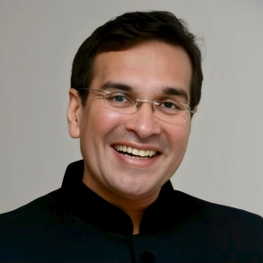
- Shri Rikab V. Mehta – Chairman Emeritus
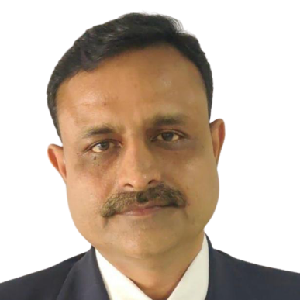
- Shri Mahendra K. Mehta – Sr. Vice President
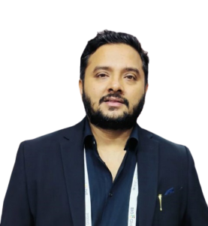
- Shri Manish P. Jain – Vice President
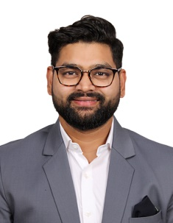
- Shri Atul L . Goyal – Hon. Secretary / Director
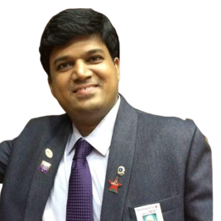

- Shri Alpesh P. Munot – Treasurer / Director
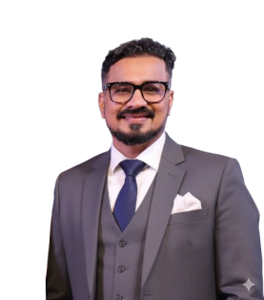
- Shri Mihir R. Parikh – Hon. Jt. Secretary / Director
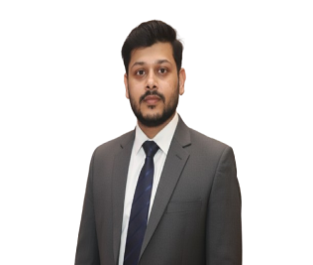
- Shri Sandeep T. Jain – Imm. Past President / Director
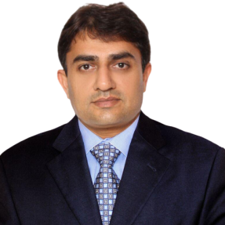
- Shri Hemant K. Parekh – Past President / Director

- Shri Abhineet V. Aggarwal – Director

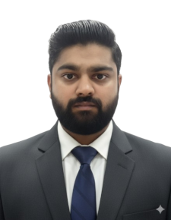
- Shri Amit R. Sangai – Director
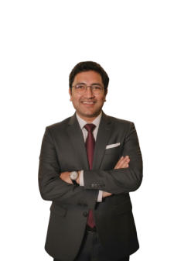

- Shri Gautam P. Parolia – Director
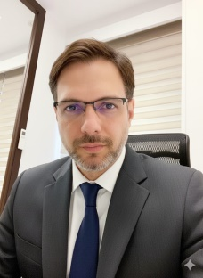
- Shri Gautam N. Jain – Director
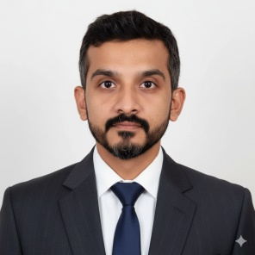
- Shri Chirag D. Majithia – Director
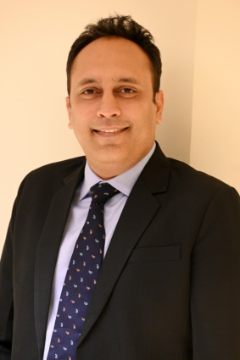
- Shri Akash S. Shah – Director

5)Events & Exhibitions
- BME-Cyclothon
- BME Diwali Functions
- BME- AGM

6)Annual Conclave
7)Circulars & Notices
- BME Benchmark Prices copper & Zinc
- BME Conclave 8-9 April

8) Membership Categories
- Annual Membership
- Life Membership
- International Membership

9)Contact Details and contact form needs to be submitted at info@bme.in
Address : Bombay Metal Exchange Ltd. BME House , 88/90, 1st Floor, Kika Street, Gulalwadi, Mumbai - 400 004, Maharashtra, India
Phone : 02249605039 , 02222421964
Emails : info @bme.in , membership@bme.in

