E-Commerce Product Entity-Resolution & Matching Platform
PRODUCT MATCHER
Project Report submitted for the partial fulfilment of grade for the course

Data Structures and Algorithms -3 (25CS2103E)
in

A.Y. 2026-2027

Submitted by
Rayabharapu Pranav (2520090109)
Burramukku Aakash (2520080039)

Team Number: 7 Section: 10

Under the guidance of

Ms. K. Chandusha

Assistant Professor, Department of CS&IT
Hyderabad-500090, Telangana, India.

K L (Deemed to be) University
DEPARTMENT OF COMPUTER SCIENCE ENGINEERING / COMPUTER SCIENCE AND INFORMATION TECHNOLOGY



DECLARATION

The Project Report entitled “E-Commerce Product Entity-Resolution & Matching Platform – Product Matcher” is a record of bonafide work of Rayabharapu Pranav – 2520090109, Burramukku Aakash – 2520080039 submitted in partial fulfillment of the requirements of the course Data Structures and Algorithms–3 (25CS2103E) for the award of B.Tech in Computer Science and Engineering / Computer Science and Information Technology at K L (Deemed to be) University. The results embodied in this report have not been copied from any other departments/University/Institute.

Name – Roll.No.
Rayabharapu Pranav – 2520090109
Burramukku Aakash – 2520080039

K L (Deemed to be) University
DEPARTMENT OF COMPUTER SCIENCE ENGINEERING / COMPUTER SCIENCE AND INFORMATION TECHNOLOGY
CERTIFICATE

This is to certify that the project report entitled “E-Commerce Product Entity-Resolution & Matching Platform – Product Matcher” is a bonafide work done and submitted by Rayabharapu Pranav – 2520090109, Burramukku Aakash – 2520080039 in partial fulfillment of the requirements for the award of the degree of BACHELOR OF TECHNOLOGY in Department of Computer Science Engineering / Computer Science and Information Technology, K L (Deemed to be University), during the academic year 2026-2027, under the guidance of Ms. K. Chandusha, Assistant Professor, Department of CS&IT.

Signature of the Supervisor

Signature of the HOD Signature of the External Examiner

ACKNOWLEDGEMENT

The success of this project would not have been possible without the timely help and guidance rendered by many people. We wish to express our sincere thanks to all those who assisted us in one way or the other in completing this project.

Our greatest appreciation goes to our guide, Ms. K. Chandusha, Assistant Professor, Department of CS&IT, for her tremendous support, encouragement and guidance throughout the development of Product Matcher.

We express our gratitude to Dr. Khaja Shareef (CSIT), Head of the Department of Computer Science and Information Technology, for providing us with adequate facilities, ways and means by which we were able to complete this project.

We thank all the members of the teaching and non-teaching staff of K L (Deemed to be) University and the Data Structures and Algorithms–3 course team, and also those who assisted us directly or indirectly in the successful completion of this project. Finally, we sincerely thank our parents, friends and classmates for their kind help and cooperation during our work.

Rayabharapu Pranav – 2520090109
Burramukku Aakash – 2520080039

TABLE OF CONTENTS

S.No. | Contents | Page no.
1. | Abstract | 6
2. | Introduction | 7
3. | Literature survey | 8
4. | Problem Statement and Objectives | 10
5. | Hardware and Software requirements | 11
6. | Implementation | 12
7. | Results & Discussion | 15
8. | Conclusion & Future Scope | 17
9. | References | 18
1. ABSTRACT
Product Matcher is an e-commerce product entity-resolution and matching platform designed to identify when seller listings with different titles refer to the same underlying product. In online catalogs, the same item may be described with differences in capitalization, punctuation, spacing, word order, abbreviations, or spelling. Exact string matching alone is therefore insufficient for reliable product comparison. Product Matcher addresses this problem through a staged pipeline that normalizes user input, searches candidate products, calculates similarity, ranks results, and presents matched-product information for comparison. The Java backend integrates a custom Trie for prefix-based candidate lookup and autocomplete, Rabin–Karp rolling-hash matching for substring evidence, Levenshtein dynamic programming for typo-tolerant similarity, and an Edmonds–Karp maximum-flow module for attribute/token matching. A composite score combines algorithm signals to rank possible matches. The frontend is built with HTML, CSS, and JavaScript, while Core Java and the built-in HTTP server provide backend processing and API endpoints. The academic version uses an in-memory catalog; optional online-search functionality depends on external API configuration and availability. The project demonstrates how data structures and algorithms can work together in an explainable application rather than as isolated exercises. It also supports price-comparison workflows after a product has been identified.
Team Members:
1. Rayabharapu Pranav, 2520090109
2. Burramukku Aakash, 2520080039
2. INTRODUCTION
2.1 Background
E-commerce catalogs contain many records created independently by sellers. A single physical product can appear under several titles, with variations in spacing, punctuation, abbreviations, or word order. For example, “Apple iPhone 15 Pro 128GB Natural Titanium” and “Apple iPhone15 Pro 128 GB Titanium” may describe the same device even though their strings are not identical.
2.2 Motivation
Before comparing prices, a buyer or catalog manager must first decide whether two listings represent the same product. If the system treats every differently written title as a different item, product catalogs become fragmented and price comparisons can be misleading. Entity resolution aims to link records that refer to the same real-world entity.
2.3 Proposed Solution
Product Matcher combines text preprocessing, candidate retrieval, string matching, dynamic programming, graph-based matching, and result ranking. The browser interface sends search or matching requests to a lightweight Java HTTP server. The backend runs the matching engine and returns structured results for display.
2.4 Scope
- Use a predefined in-memory product catalog for repeatable academic demonstrations.
- Normalize product text before comparing titles.
- Support prefix suggestions and candidate retrieval.
- Rank likely matches using multiple algorithmic signals.
- Present matched-product information and seller-price comparison where listing data is available.
- Keep the implementation understandable using Core Java without a heavyweight backend framework.
2.5 Project Workflow
User Input → Text Normalization → Candidate Search → Similarity Scoring → Ranking → Match Results → Price Comparison
3. LITERATURE SURVEY
The following systems and technical resources provide context for product search, catalog matching, and entity resolution. They are related references, not claims that Product Matcher uses their internal implementation.
3.1 Google Shopping
Google Shopping aggregates product offers from different retailers and allows users to discover products and compare available offers. This illustrates the user-facing value of bringing multiple offers for comparable products together. Product Matcher focuses on the DSA layer needed to determine whether differently named listings are likely to refer to the same product.
URL: https://shopping.google.com/
3.2 Amazon
Amazon's catalog and marketplace demonstrate the need to organize product pages and seller offers around recognizable product identities. Listings and offers may differ in seller-specific presentation, which motivates consistent product records and comparison workflows.
URL: https://www.amazon.com/
3.3 PriceRunner
PriceRunner is a price-comparison service that helps users compare product offers and prices. Its user problem is closely related to the final stage of Product Matcher: after identifying a common product, offers can be compared to support purchasing decisions.
URL: https://www.pricerunner.com/
3.4 idealo
idealo provides product discovery and price-comparison features across retailer offers. It is relevant as an example of how product identity and comparable offer data contribute to a useful comparison experience.
URL: https://www.idealo.com/
3.5 GS1 Global Data Model
GS1 develops standards for describing product attributes consistently across supply chains. Standardized identifiers and attributes can reduce ambiguity between records; Product Matcher instead demonstrates algorithmic matching when titles vary or standardized identifiers are unavailable.
URL: https://www.gs1.org/standards/gdsn
3.6 OpenRefine
OpenRefine includes clustering and reconciliation workflows that help users detect similar values and clean inconsistent data. These ideas are relevant to the normalization and near-duplicate detection stages of entity resolution.
URL: https://openrefine.org/
3.7 Record Linkage Toolkit
The Python Record Linkage Toolkit documents methods for indexing candidate record pairs, comparing fields, and classifying likely matches. It provides a useful conceptual reference for separating candidate generation from detailed comparison.
URL: https://recordlinkage.readthedocs.io/
3.8 Apache Lucene
Apache Lucene is a search library with indexing and retrieval facilities. It illustrates the importance of indexing for efficient text search. Product Matcher implements a small custom Trie and string algorithms to demonstrate the underlying DSA concepts directly.
URL: https://lucene.apache.org/
4. PROBLEM STATEMENT AND OBJECTIVES
4.1 Problem Statement
Different sellers describe the same e-commerce product using inconsistent titles, making it difficult to identify equivalent listings and compare their prices accurately.
4.2 Problem Description
Exact string matching fails when product titles contain differences in spelling, spacing, punctuation, abbreviations, or word order. Product Matcher must retrieve candidate products, calculate similarity from multiple signals, rank the candidates, and present results that help users judge a possible match.
4.3 Objectives
- Normalize text by converting it to lowercase, removing irrelevant punctuation, and standardizing whitespace.
- Use a Trie to support prefix lookup and autocomplete suggestions.
- Apply Rabin–Karp matching to detect exact patterns within normalized product text.
- Use Levenshtein dynamic programming to estimate character-level similarity and tolerate typographical differences.
- Use maximum-flow logic to demonstrate matching across query tokens and product-attribute slots.
- Combine matching signals into a composite relevance score and rank candidate products.
- Expose backend functionality through HTTP API endpoints and connect it to the browser frontend.
- Support product discovery and price-comparison workflows while clearly treating low-confidence matches as uncertain.
4.4 Expected Outcome
The expected outcome is a browser-based demonstration that accepts a product query or seller listing title and returns ranked candidate products, with score details where available. A high similarity score indicates a stronger candidate, but does not prove that two records represent the same physical product; users should review product attributes before making a final decision.
5. HARDWARE AND SOFTWARE REQUIREMENTS
5.1 Hardware Requirements
- Computer or laptop capable of running a modern web browser and Java Development Kit.
- Minimum 4 GB RAM recommended for the small academic catalog; 8 GB or more provides a more comfortable development environment.
- Dual-core processor or better.
- Keyboard, display, and network connection when optional online-search functionality is configured.
5.2 Software Requirements
- Operating system: Windows, Linux, or macOS.
- Java Development Kit (JDK) compatible with the source code; JDK 11 or later is recommended for the built-in HTTP client/server APIs used by the current implementation.
- Visual Studio Code or another Java-capable code editor.
- Modern browser such as Chrome, Edge, or Firefox.
- HTML5, CSS3, and JavaScript for the frontend.
- Core Java standard library, including collections and com.sun.net.httpserver.
- Optional SerpApi credentials/configuration for online search; this is not required for the in-memory catalog demo.
6. IMPLEMENTATION
The project uses HTML/CSS/JavaScript for the client interface and Core Java for the matching backend. The main Java modules are TextNormalizer, Trie, RabinKarp, LevenshteinDP, MaxFlow, MatchingEngine, and WebSearchService. Main initializes the engine and starts the web service on the configured port.
6.1 Text Normalization Module
TextNormalizer reduces superficial differences before matching. It converts text to lowercase, retains letters, digits and whitespace, removes other characters, collapses repeated whitespace, and tokenizes the normalized text. This makes comparisons less sensitive to capitalization and punctuation.
public static String normalize(String input) {
if (input == null) return "";
String lower = input.toLowerCase();
StringBuilder cleaned = new StringBuilder();
for (int i = 0; i < lower.length(); i++) {
char ch = lower.charAt(i);
if (Character.isLetterOrDigit(ch) ||
Character.isWhitespace(ch)) {
cleaned.append(ch);
} else {
cleaned.append(' ');
}
}
return cleaned.toString().replaceAll("\\s+", " ").trim();
}
6.2 Trie Prefix Search Module
The Trie indexes characters of product-related words and associates product identifiers with traversed nodes. Prefix lookup can return the product IDs associated with a prefix, which supports autocomplete and candidate retrieval without scanning every title for each keystroke.
public void insert(String word, int productId) {
if (word == null || word.isEmpty()) return;
TrieNode current = root;
for (int i = 0; i < word.length(); i++) {
char ch = word.charAt(i);
current.children.putIfAbsent(ch, new TrieNode());
current = current.children.get(ch);
current.productIds.add(productId);
}
current.isEndOfWord = true;
}
6.3 Levenshtein Dynamic Programming Module
Levenshtein distance measures the minimum number of single-character insertions, deletions, and substitutions needed to transform one string into another. The implementation uses a two-dimensional DP table and converts the distance into a normalized similarity score. Its time and space costs are O(mn) for strings of lengths m and n.
public static double computeSimilarity(String s1, String s2) {
if (s1 == null || s2 == null) return 0.0;
if (s1.equals(s2)) return 1.0;
int maxLen = Math.max(s1.length(), s2.length());
if (maxLen == 0) return 1.0;
int distance = computeDistance(s1, s2);
return 1.0 - ((double) distance / maxLen);
}
6.4 Rabin–Karp Pattern Matching Module
Rabin–Karp computes rolling hashes for a pattern and candidate text windows. When hash values match, the implementation verifies the characters to guard against hash collisions. It provides exact substring evidence and a match score used by the overall engine.
public static boolean search(String text, String pattern) {
if (text == null || pattern == null) return false;
if (pattern.isEmpty()) return true;
if (text.length() < pattern.length()) return false;
// Rolling-hash comparison and character verification
// are performed across candidate text windows.
...
}
The omitted lines above are the rolling-hash update and collision-verification logic; the complete implementation remains in RabinKarp.java.
6.5 Composite Matching Engine
MatchingEngine coordinates candidate search and similarity scoring. It normalizes the query, evaluates candidate product text, derives signals from Rabin–Karp, Levenshtein, maximum flow, and Trie-based matching, and combines them into a composite score. The current code's base weighting is:
totalScore = (0.35 * rabinKarpScore)
+ (0.30 * levenshteinScore)
+ (0.25 * maxFlowScore)
+ (0.10 * trieScore);
The engine ranks SearchResult objects so stronger candidates appear earlier. The web layer serializes results into JSON for the frontend. A confidence threshold in the interface can present a no-confident-match message instead of overstating a weak candidate.
6.6 HTTP Service and Frontend
WebSearchService uses Java's built-in HTTP server to serve frontend files and expose endpoints such as /api/search, /api/suggest, /api/products, and /api/online-search. The frontend uses JavaScript fetch requests to call the API and renders returned data into product cards and matching results. Online search is optional and depends on valid external API configuration.
6.7 Execution Steps
1. Open the project folder in Visual Studio Code or a terminal.
2. Keep one compatible version of each Java class in the same backend source folder; do not compile duplicate old and new versions together.
3. From the backend source directory, compile the Java files. For a flat backend folder, use: javac *.java. For the README's src layout, use: javac -d bin src/*.java.
4. Run the class that starts the HTTP service. In the advanced source set described here, run Main using the classpath/folder layout configured for the project.
5. Open http://localhost:8080 in a browser and test product search and Product Matcher.
Exact run commands depend on whether the selected project folder uses a flat backend layout or backend/src. Keep the source files, package declarations, and command consistent.
7. RESULTS & DISCUSSION
The supplied project screenshots show the browser interface running locally and demonstrate the dashboard and Product Matcher views. Screenshots are included as evidence of the implemented interface; they should not be interpreted as a formal benchmark or proof of production-scale matching accuracy.
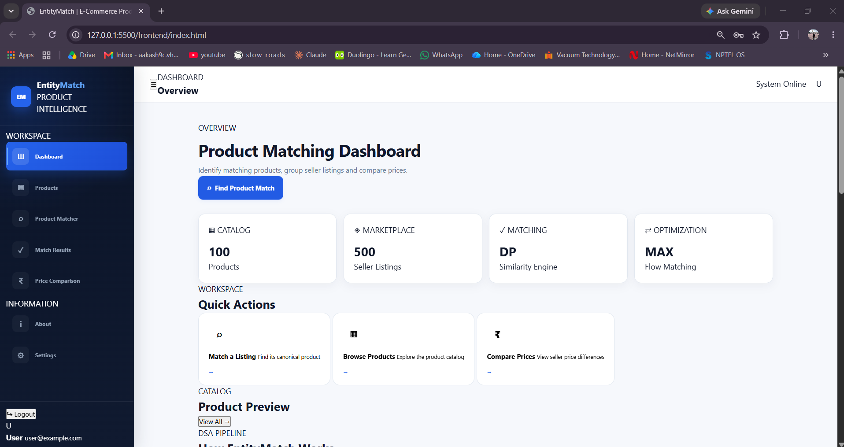
Figure 7.1: Product Matcher dashboard displaying the application's summary and navigation.
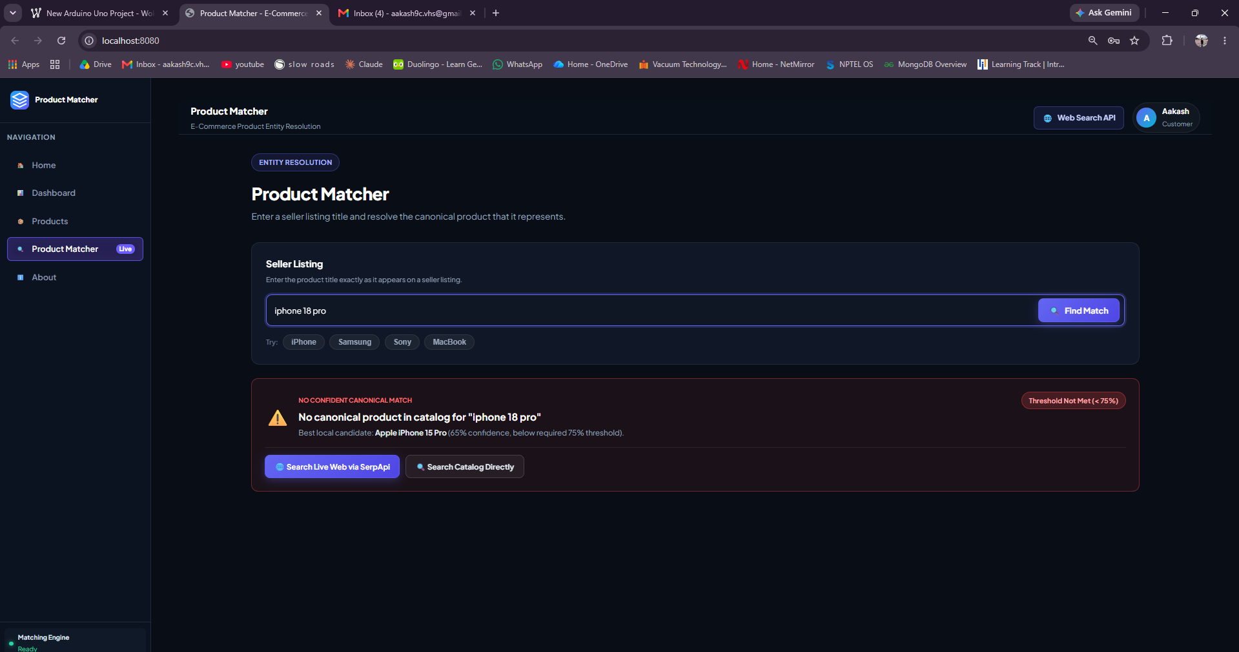
Figure 7.2: Product Matcher accepts a seller title and displays a low-confidence warning when the candidate does not meet the threshold.
7.1 Discussion
The interface separates general product discovery from entity resolution. The matcher screenshot illustrates an important design decision: the system can show the best available candidate while warning that the match confidence is below the configured threshold. This avoids presenting every nearest textual result as a confirmed identity.
The project demonstrates modular use of data structures and algorithms. Trie supports prefix-oriented retrieval, Rabin–Karp contributes substring evidence, Levenshtein DP estimates edit similarity, and MaxFlow models constrained matching between query tokens and product-attribute slots. The composite score allows these signals to be considered together.
7.2 Limitations Observed
- Results depend on the completeness and quality of the catalog.
- Text similarity can confuse products with similar names but different model numbers or specifications.
- A small in-memory dataset does not represent the scale or freshness of a commercial marketplace.
- Online search results require external API configuration and may fail because of network, quota, or credential issues.
- The displayed confidence score is an algorithmic ranking signal, not a calibrated probability.
8. CONCLUSION & FUTURE SCOPE
8.1 Conclusion
Product Matcher demonstrates an end-to-end application of Data Structures and Algorithms to e-commerce product entity resolution. It addresses the problem of inconsistent seller titles by normalizing input, retrieving candidate products, calculating multiple similarity signals, ranking likely matches, and exposing results through a browser-based interface. The project integrates a Trie, Rabin–Karp string matching, Levenshtein dynamic programming, and an Edmonds–Karp maximum-flow module in a single workflow. It also shows why low-confidence matches should be communicated carefully rather than treated as certain identities.
The objectives of building a modular matching pipeline, demonstrating core DSA techniques, and connecting Java processing to a web interface are addressed by the implementation. The present academic version is limited by a predefined catalog and should be evaluated on a larger labelled dataset before making quantitative claims about accuracy or scalability.
8.2 Future Scope
- Near-term: add more test cases for spelling variations, model numbers, missing attributes, and misleadingly similar titles.
- Near-term: report precision, recall, F1-score, response time, and confusion-matrix results on a manually labelled dataset.
- Medium-term: persist products and seller offers in a database and provide import/export facilities.
- Medium-term: strengthen matching with structured attributes such as brand, model, storage, color, dimensions, and product identifiers.
- Medium-term: make confidence thresholds configurable by category and provide an explanation of which attributes influenced each match.
- Long-term: integrate multiple marketplace feeds or compliant product-search APIs and schedule catalog refreshes.
- Long-term: evaluate scalable indexing, caching, distributed search, and human review of uncertain matches.
- Long-term: add user accounts and production-grade security, logging, rate limiting, and deployment monitoring if the application is extended beyond the classroom.
9. REFERENCES
1. Google Shopping. Product discovery and comparison service. https://shopping.google.com/
2. Amazon. Online marketplace and product catalog. https://www.amazon.com/
3. PriceRunner. Product and price comparison service. https://www.pricerunner.com/
4. idealo. Product search and price comparison. https://www.idealo.com/
5. GS1. Global Data Model and product data standards. https://www.gs1.org/standards/gdsn
6. OpenRefine. Data cleaning and clustering documentation. https://openrefine.org/
7. Python Record Linkage Toolkit. Documentation on indexing and comparing records. https://recordlinkage.readthedocs.io/
8. Apache Lucene. Search and indexing library documentation. https://lucene.apache.org/
9. Oracle. Java Platform documentation. https://docs.oracle.com/en/java/
10. Oracle. Java HTTP Server API (com.sun.net.httpserver) documentation. https://docs.oracle.com/en/java/javase/21/docs/api/jdk.httpserver/com/sun/net/httpserver/package-summary.html
11. Levenshtein, V. I. (1966). Binary codes capable of correcting deletions, insertions, and reversals. Soviet Physics Doklady, 10, 707–710.
12. Rabin, M. O., & Karp, R. M. (1987). Efficient randomized pattern-matching algorithms. IBM Journal of Research and Development, 31(2), 249–260.
13. Course project presentation: E-Commerce Product Entity-Resolution & Matching Platform (DSA-3), supplied project material.
14. Product Matcher source modules: TextNormalizer.java, Trie.java, RabinKarp.java, LevenshteinDP.java, MaxFlow.java, MatchingEngine.java, Main.java, and WebSearchService.java.

