PRACTICAL RECORD

First Flask Application
A simple Flask application is created with a basic route to display a welcome message.
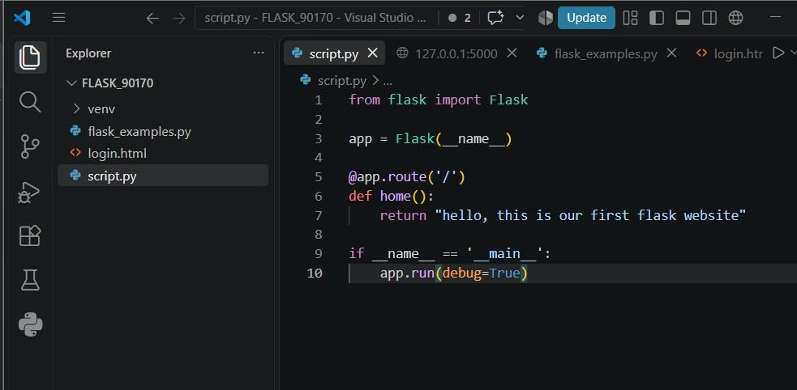
Figure 1: script.py - First Flask Application Code
The Flask app runs on localhost:5000 and displays "hello, this is our first flask website".
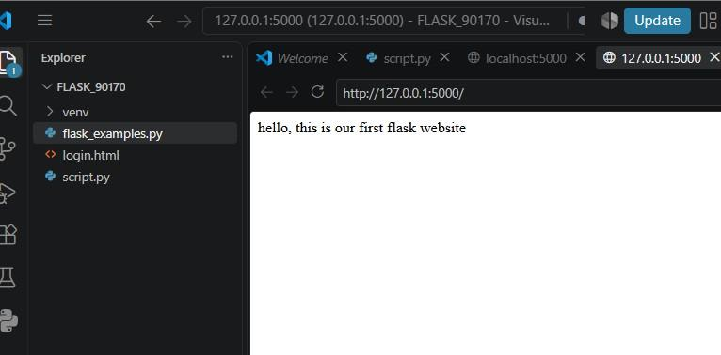

Basic Flask Routing

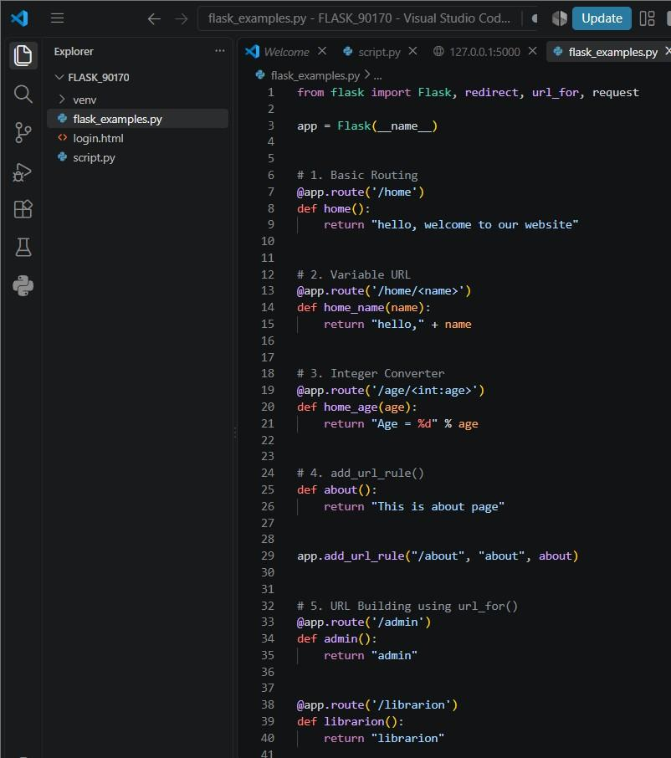

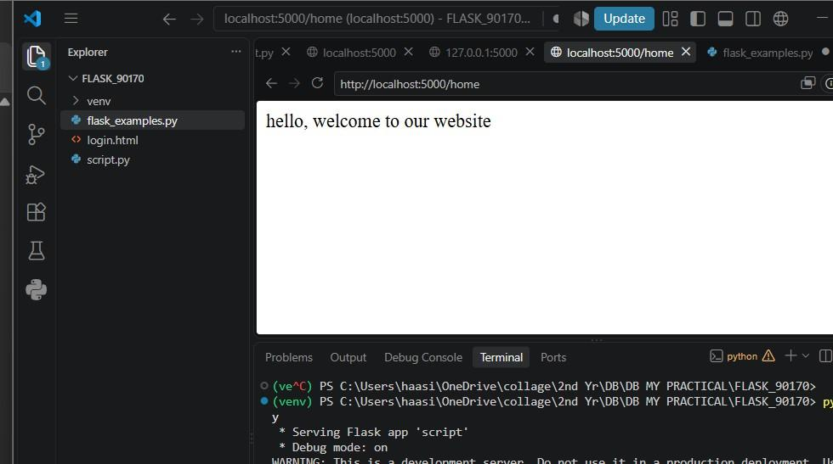

Variable URL Routing

Figure 5: flask_examples.py - Variable URL Routing (/home/<name> route)
Accessing /home/Haasini returns "hello,Haasini" by extracting the name parameter from the URL.
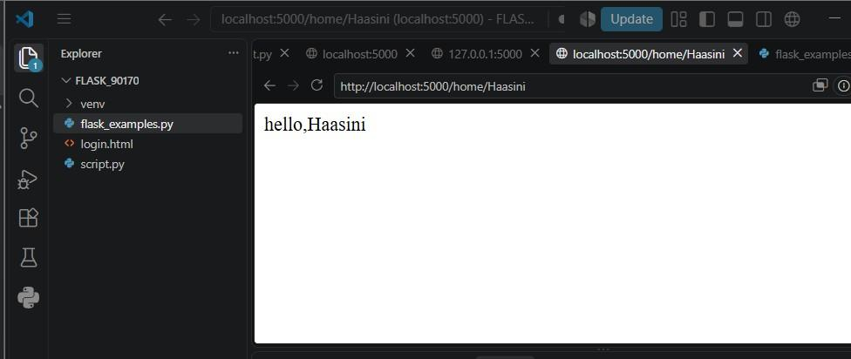
Figure 6: Variable URL Routing Output
- Dynamic URL Building using url_for()
The url_for() function is used to dynamically build URLs and perform redirects to different routes.
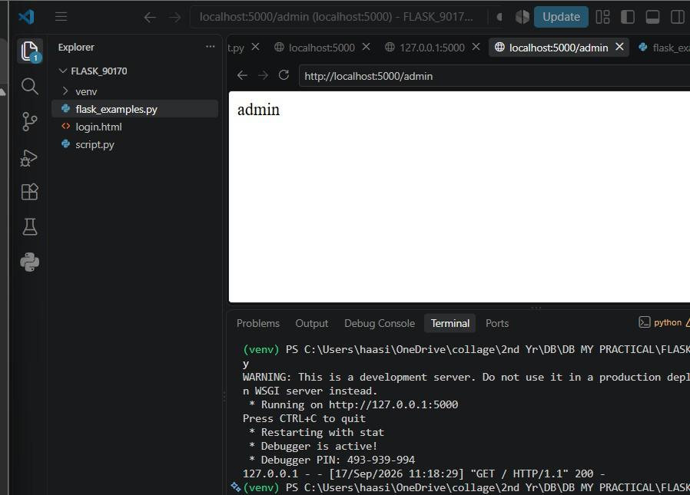

Flask Login Form
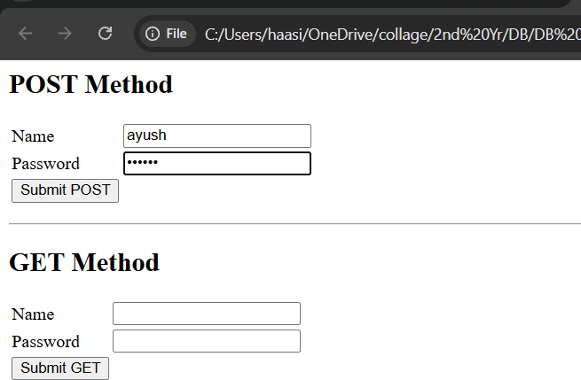

POST Method
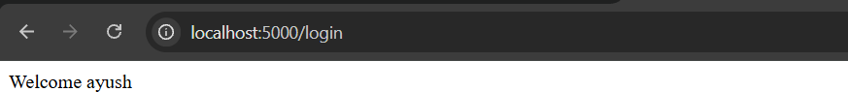

GET Method

