CREDIT CARD DEFAULT

PREDICATION

High Level Design

AAKASH BHUTE

**1.INTRODUCTION**

Sometimes, even debts that seem manageable, like credit card debt, can spiral out of control due to unexpected life events such as job loss, medical emergencies, or business failure. Credit card debt is especially susceptible to this due to high finance charges and penalties. Many people can relate to missing a credit card payment or two due to forgetfulness or cash flow issues, but what happens when this becomes a consistent problem? To mitigate the risk of default, a model has been developed to predict customer default based on demographic data such as gender, age, and marital status, as well as behavioral data like past payments and transactions.

**2.PROBLEM STATEMENT**

The financial industry has made incredible strides, but commercial banks still face the challenge of predicting credit risk. One of the biggest threats they face is predicting the likelihood of credit default among their clients. The objective is to develop a model that can accurately predict the probability of credit default based on the characteristics and payment history of credit card owners.

**3.DATASET INFORMATION**

**ID**: ID of each client

**LIMIT_BAL:** Amount of given credit in NT dollars (includes individual and family/supplementary = credit)

**SEX:** Gender (1=male, 2=female)

**EDUCATION:** (1=graduate school, 2=university, 3=high school, 4=others, 5=unknown, 6=unknown)

**MARRIAGE:** Marital status (1=married, 2=single, 3=others)

**AGE:** Age in years

**PAY_0:** Repayment status in September, 2005 (-1=pay duly, 1=payment delay for one month, 2=payment delay for two months, … 8=payment delay for eight months, 9=payment delay for nine months and above)

**PAY_2:** Repayment status in August, 2005 (scale same as above)

**PAY_3:** Repayment status in July, 2005 (scale same as above)

**PAY_4:** Repayment status in June, 2005 (scale same as above)

**PAY_5:** Repayment status in May, 2005 (scale same as above)

**PAY_6:** Repayment status in April, 2005 (scale same as above)

**BILL_AMT1:** Amount of bill statement in September, 2005 (NT dollar) **BILL_AMT2:** Amount of bill statement in August, 2005 (NT dollar) **BILL_AMT3:** Amount of bill statement in July, 2005 (NT dollar) **BILL_AMT4:** Amount of bill statement in June, 2005 (NT dollar) **BILL_AMT5:** Amount of bill statement in May, 2005 (NT dollar) **BILL_AMT6:** Amount of bill statement in April, 2005 (NT dollar) **PAY_AMT1:** Amount of previous payment in September, 2005 (NT dollar) **PAY_AMT2:** Amount of previous payment in August, 2005 (NT dollar) **PAY_AMT3:** Amount of previous payment in July, 2005 (NT dollar) **PAY_AMT4:** Amount of previous payment in June, 2005 (NT dollar) **PAY_AMT5:** Amount of previous payment in May, 2005 (NT dollar) **PAY_AMT6:** Amount of previous payment in April, 2005 (NT dollar) **default.payment.next.month:** Default payment (1=yes, 0=no)

**4.TOOLS USED**

Python programming language and frameworks such as NumPy, Pandas, Scikit-learn, Matplotlib, Seaborn are used to build the whole model.



**5.DESIGN DETAILS**

**5.1.Process flow**

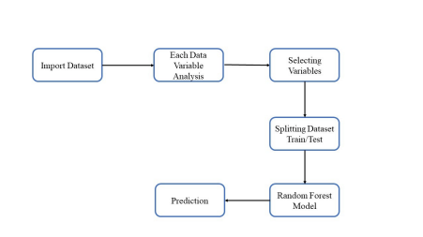**5.2.Deployment process**

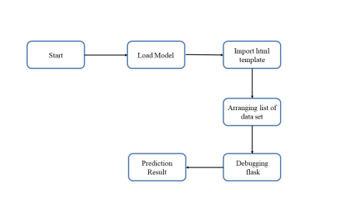

**6.CONCLUSION**

This project has been developed using Flask, making it easily accessible to everyone. The aforementioned design process is intended to assist banks and loan lenders in predicting whether or not customers will default on their credit card payments. Based on the model's predictions, the bank or relevant departments can take appropriate action. The user interface has been designed to be user-friendly so that users do not require extensive knowledge of any tools, but only need to provide information to obtain results.