BIRLA INSTITUTE OF TECHNOLOGY & SCIENCE, PILANI
Mid-Semester Progress Report
Green Fuel Intelligence System (GFIS): A Physics-Guided Hybrid AI Framework for Methane Yield Prediction, Soft Sensing and Digital-Twin-Ready Simulation in Anaerobic Digestion

Course | DISSERTATION (Tentative NSP 2)
Student | Akash Shivadas Chatake
BITS ID | 2024AB05226
Degree Program | M.Tech. Artificial Intelligence and Machine Learning
Supervisor | Dr. Dipti Jadhav
Work carried out at | Shri Siddheshwar Women's Polytechnic, Solapur, Maharashtra, India
Submission month | June 2026

Submitted in partial fulfilment of the M.Tech. Artificial Intelligence and Machine Learning dissertation requirements.

Abstract
This mid-semester report presents the progress of the Green Fuel Intelligence System (GFIS), a physics-guided AI digital-twin-ready simulation dashboard for methane-yield prediction and stability monitoring in anaerobic digestion. The abstract presentation was accepted by faculty with an Excellent remark. The evaluator specifically recognized the work as moving beyond black-box machine learning toward physics-informed machine learning, soft sensing, and digital-twin simulation, and the evaluator's PIML framing has been adopted as a key positioning guide for the mid-semester prototype. Here, PIML is used in its established meaning of Physics-Informed Machine Learning while acknowledging that the evaluator's feedback sharpened the terminology and research direction. In response, the current implementation has been organized as a working research prototype with a data pipeline, XGBoost tabular model, PyTorch LSTM branch, ensemble prediction, volatile-solids-based physics feasibility check, VFA/ALK soft sensor, FastAPI backend, Streamlit dashboard, browser-based control room, industrial simulation page, SQLite logging, Docker/AWS deployment preparation, and ROS2/Gazebo extension planning. The current evaluation on the synthetic anaerobic digestion dataset gives a tabular model R2 of 0.7556, RMSE of 6.7933, and MAE of 5.5517, with zero physics-bound violations in the physics-guided ensemble. Controlled 48-hour scenario experiments demonstrate nominal operation, organic overload warning, pH shock, low-temperature disturbance, reduced HRT washout risk, high-solids feedstock, and corrective recovery operation. The remaining work will focus on strengthening the digital twin with higher-quality data, uncertainty estimation, additional benchmark models, richer explainability, and final dissertation-grade validation.
Signature of Student: ___________________________ Signature of Supervisor: ___________________________
Name: Akash Shivadas Chatake Name: Dr. Dipti Jadhav

Contents
1. Background and Accepted Abstract Status
2. Evaluator Feedback and Response Plan
3. Work Completed up to Mid-Semester
4. Current System Architecture
5. Model Evaluation and Research Evidence
6. Digital Twin and Local Demonstration
7. Limitations, Risk Controls, and Ethics
8. Remaining Work Plan
9. Conclusion
Appendix A. Evidence and Demo Links

1. Background and Accepted Abstract Status
Anaerobic digestion converts organic waste into methane-rich biogas, but methane yield depends on interacting biological, chemical, and operational variables such as temperature, pH, organic loading rate, hydraulic retention time, total solids, volatile solids, carbon-to-nitrogen ratio, moisture, and prior reactor state. GFIS is designed to support this process through predictive modeling, process stability estimation, and digital-twin simulation rather than by returning only a single black-box prediction.
The abstract/outline presentation was accepted in the BITS abstract evaluation stage. The evaluator marked the work as Excellent and appreciated the shift from black-box machine learning to physics-informed machine learning. The evaluator also emphasized the PIML framing, which this report uses as a project-positioning term for Physics-Informed Machine Learning rather than as a claim of inventing the acronym. The same feedback suggested using high-quality industrial data, responding to current discussion on digital twins, and strengthening the project as a simulation dashboard rather than a simple web prediction tool. This mid-semester report is therefore positioned as the technical response to that feedback.
Evaluator point | GFIS response | Mid-sem evidence
Move beyond black-box ML | Use physics-guided feasibility checking and explicit violation reporting. | Physics violation count is zero in current evaluation.
PIML terminology and research framing | Adopt the evaluator's PIML framing as the mid-sem positioning for Physics-Informed Machine Learning. | Report, portal, and simulator now present GFIS as a PIML-guided digital-twin prototype.
Predict hard-to-measure chemical state | Implement VFA/ALK soft sensor and stability label output. | Stable/Warning/Critical outputs are generated by API and dashboards.
Use real/high-quality industrial data | Keep current synthetic data as controlled prototype and plan real data ingestion pipeline. | Remaining work includes public/lab/IoT/SCADA data calibration.
Build digital twin, not only web prediction | Expose plant-run traces, what-if simulation, optimization, and industrial simulator. | 48-hour scenario experiments and local demo surfaces are live.

2. Work Completed up to Mid-Semester
- Created a structured GFIS codebase with `gfis/`, `backend/`, `dashboard/`, `frontend/`, `data/`, `models/`, `reports/`, `deployment/`, and `tests/` folders.
- Generated synthetic anaerobic digestion dataset with process variables, methane yield, VFA/ALK ratio, and stability labels.
- Implemented preprocessing with missing-value handling, scaling, lag features, rolling means, process ratios, and interaction variables.
- Implemented XGBoost tabular methane-yield prediction with fallback model support.
- Implemented PyTorch LSTM training pipeline for future time-series plant data.
- Implemented ensemble prediction and physics-guided feasible-bound checking.
- Implemented VFA/ALK soft sensor and stability classification.
- Exposed FastAPI endpoints for prediction, simulation, plant run, soft sensor, optimization, evaluation, stress tests, and training.
- Built Streamlit dashboard, HTML model control room, and industrial simulation page.
- Generated evaluation report, demo evidence, and controlled scenario experiments.
- Prepared Docker, AWS App Runner, Ubuntu VM, and ROS2/Gazebo extension notes.

3. Current System Architecture
GFIS is organized as a layered digital-twin-ready simulation framework. The current architecture deliberately separates data, models, physics rules, soft sensing, simulation, interfaces, and deployment so that future plant data can be attached without rewriting the full system.
Layer | Implemented function | Status
Data layer | Synthetic AD data, raw/processed CSV, SQLite logging | Working
Preprocessing layer | Scaling, lag features, rolling means, ratios, interactions | Working
AI layer | XGBoost tabular model, PyTorch LSTM branch, ensemble | Working
Physics layer | VS-based methane upper-bound and violation reporting | Working
Soft sensor layer | VFA/ALK estimation and stability classification | Working
Digital twin layer | What-if simulation, 48-hour plant run, optimization | Working
Interface layer | FastAPI, Streamlit, browser control room, industrial simulator | Working
Deployment layer | Docker, AWS App Runner notes, Ubuntu/ROS2/Gazebo plan | In progress

4. Model Evaluation and Research Evidence
The current model evaluation uses a synthetic anaerobic digestion dataset with 2400 samples and 24 training epochs for the LSTM branch. These results are preliminary and are based on a synthetic/literature-inspired dataset prepared for controlled mid-semester validation. The tabular model currently performs strongest, while the LSTM branch is retained for future time-series plant data where temporal retention effects are expected to become more important.
Model | R2 | RMSE | MAE
LSTM | 0.2942 | 11.5712 | 9.0685
XGBRegressor | 0.7556 | 6.7933 | 5.5517
Validation-weighted ensemble | 0.7554 | 6.8114 | 5.5699
Physics-guided ensemble | 0.7554 | 6.8114 | 5.5699
Physics violation count during evaluation: 0. This is important because the physics-guided layer does not simply improve numerical metrics; it audits whether predictions remain feasible under the volatile-solids methane bound.
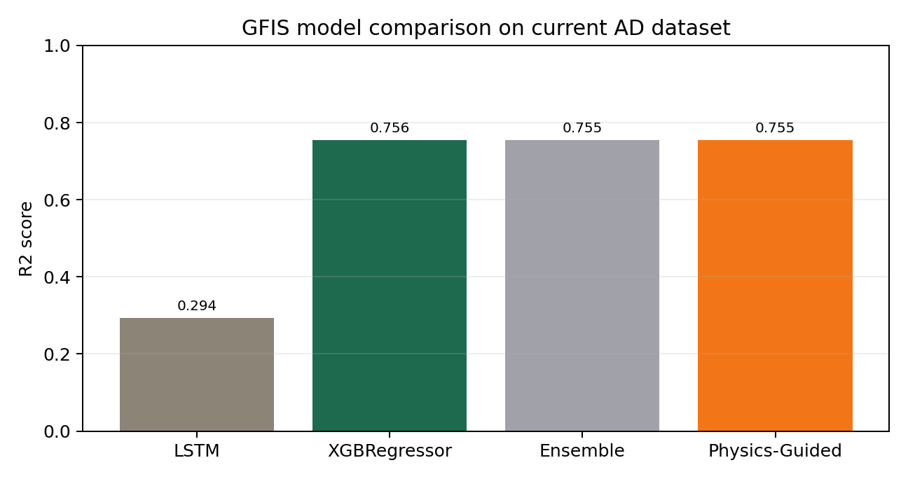
Figure 1. Current GFIS model comparison.

5. Digital-Twin-Ready Simulation Scenario Experiments
The digital-twin experiments evaluate plant behavior over controlled 48-hour windows. These scenarios demonstrate that GFIS can support operating decision analysis rather than only return point predictions.
Scenario | Mean methane | Max VFA/ALK | Final stability | Warning/Critical hours
Nominal mesophilic operation | 199.342 | 0.197 | Stable | 0
Organic overload | 200.932 | 0.335 | Warning | 48
pH acidification shock | 152.935 | 0.284 | Stable | 0
Low-temperature disturbance | 183.397 | 0.227 | Stable | 0
Reduced HRT washout risk | 194.579 | 0.278 | Stable | 0
High-solids feedstock | 213.273 | 0.251 | Stable | 0
Corrective recovery operation | 196.719 | 0.152 | Stable | 0
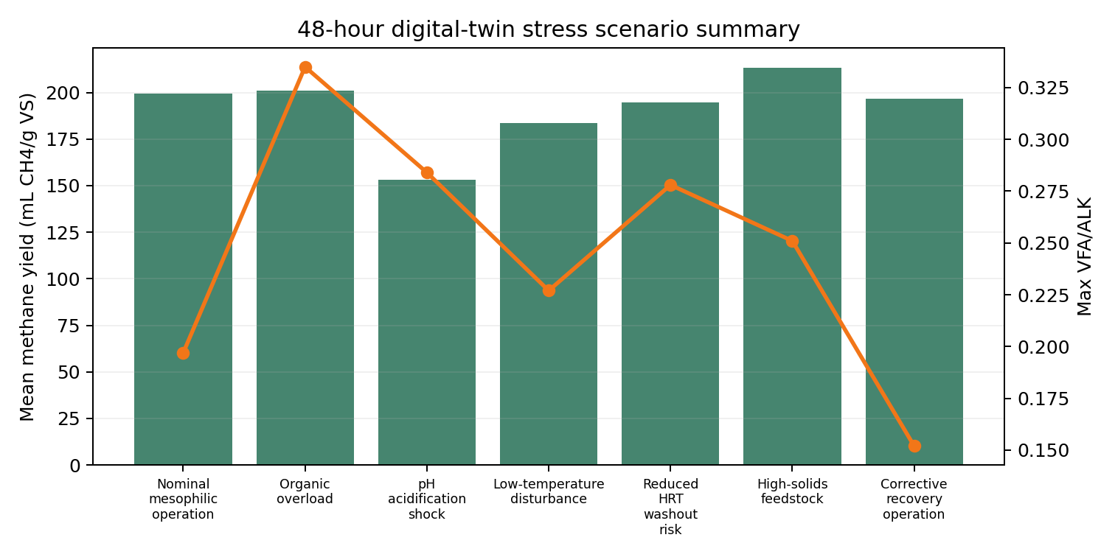
Figure 2. Scenario-level methane and VFA/ALK response across 48-hour plant runs.

6. Local Demonstration and Working Interfaces
The mid-semester prototype is demonstrable locally using the saved model bundle. The system exposes a backend API, a browser-based model control room, an industrial simulation interface, and a Streamlit research dashboard.
Surface | Local URL | Purpose
FastAPI backend | http://127.0.0.1:8010 | Core prediction and simulation API
API documentation | http://127.0.0.1:8010/docs | Interactive endpoint testing
Model control room | http://127.0.0.1:8520 | Browser digital twin interaction
Industrial simulation | http://127.0.0.1:8520/industrial_simulation.html | 48-hour process and plant-level simulation
Streamlit dashboard | http://127.0.0.1:8510 | Research dashboard for dataset, model, and scenario review

7. Limitations and Risk Controls
The current prototype is intentionally transparent about its limitations. The data is synthetic/literature-inspired and is suitable for controlled research demonstration, but final claims must not be presented as industrial plant validation until calibrated against public, laboratory, IoT, SCADA, or plant-specific data.
- Synthetic dataset limits external validity; mitigation is to add real or public AD datasets where available.
- LSTM performance is currently weaker than the tabular model; mitigation is to retain LSTM for genuine time-series data and expand benchmark comparison.
- Physics constraint is an upper-bound feasibility layer; mitigation is to add richer biochemical constraints and literature-backed equations.
- Soft sensor estimates VFA/ALK indirectly; mitigation is to calibrate against measured VFA/ALK values when real data is available.
- Dashboard and API are working prototypes; mitigation is to harden deployment with Docker, database migration, authentication, and logging.

8. Remaining Work Plan
Phase | Work item | Expected output | Priority
Mid-sem + 2 weeks | Add benchmark regressors and uncertainty estimate | Expanded metrics table | High
Mid-sem + 3 weeks | Strengthen physics equations and citation support | Final methodology section | High
Mid-sem + 4 weeks | Add or calibrate with public/industrial AD data if available | Dataset comparison evidence | High
Mid-sem + 5 weeks | Capture dashboard/control-room screenshots | Final report figures | Medium
Mid-sem + 6 weeks | Improve SHAP/explainability plots | Feature interpretation section | Medium
Final phase | Package report, viva deck, Turnitin-ready PDF, demo checklist | Final dissertation submission pack | High

9. Conclusion
At mid-semester, GFIS has progressed from an accepted abstract into a working research prototype. The system already demonstrates methane-yield prediction, physics-guided feasibility checking, VFA/ALK soft sensing, stability classification, simulation, optimization, and multiple interfaces. The evaluator's recommendation to position the work as a PIML-guided digital-twin-ready simulation framework has been incorporated directly into the prototype, portal language, and remaining work plan. The most important remaining task is to strengthen validation with better data and richer literature-supported biochemical constraints before final submission.

Appendix A. Evidence and Artifact Index
Evidence | Location
Accepted abstract evaluation screenshot | Phase_Workspaces/01_Abstract_Outline_Submission/Abstract_Viva_Evaluation
Viva transcript/supporting discussion PDF | Phase_Workspaces/01_Abstract_Outline_Submission/Abstract_Viva_Evaluation
Evaluation report | GFIS_Project/reports/evaluation_report.md
Demo evidence | GFIS_Project/reports/demo_evidence.md
Controlled scenario experiments | GFIS_Project/reports/research_scenario_experiments.md
Research report draft | GFIS_Project/reports/GFIS_Dissertation_Research_Report.docx
Deployment notes | GFIS_Project/docs/AWS_DEPLOYMENT_NOTES.md
ROS2/Gazebo extension blueprint | GFIS_Project/docs/ros2_gazebo/integration_blueprint.md

Supervisor Review and Signatures
This section is reserved for review, comments, and signatures if required during mid-semester evaluation.
Signature of Student: ___________________________
Name: Akash Shivadas Chatake
Date: ___________________________
Signature of Supervisor: ___________________________
Name: Dr. Dipti Jadhav
Date: ___________________________

